To identify dragonflies and damselflies, use their size, their colors, their behavior, their habitats and the time of year. Some species are around almost all season: Common Green Darners and Ebony Jewelwings. Some species are only around a short time: Painted Skimmers.

https://www.ohioodonatasociety.org/
https://wiatri.net/inventory/odonata/speciesaccounts/
Many dragonflies and damselflies are sexually dimorphic.

Common Whitetail – You will see these at the new ponds.
https://www.inaturalist.org/observations/371684547

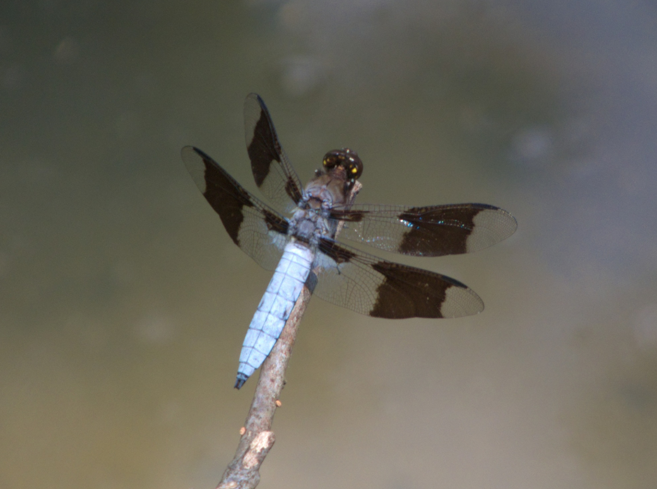

https://www.inaturalist.org/observations/372292509

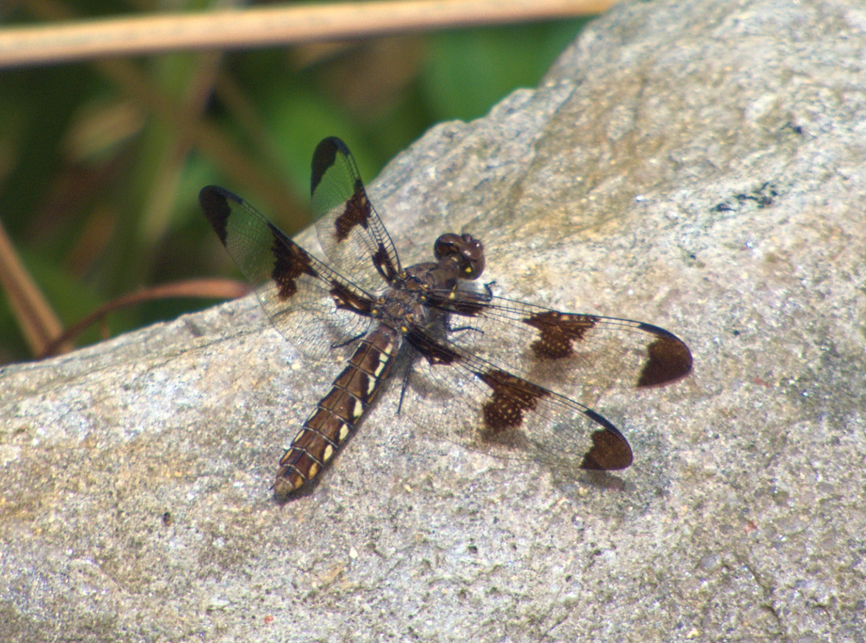

Ebony Jewelwing – You will not see these at the new ponds. They live in the woods along creeks. You will see them south in the park.
https://www.inaturalist.org/observations/380792201

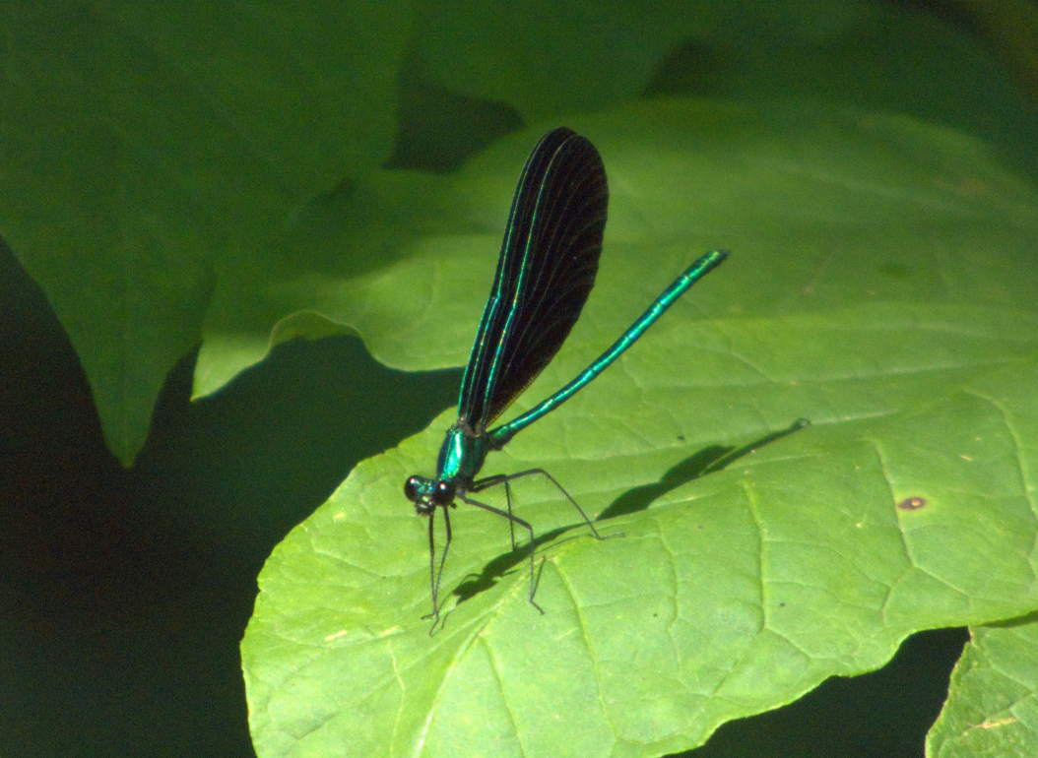

https://www.inaturalist.org/observations/369726091

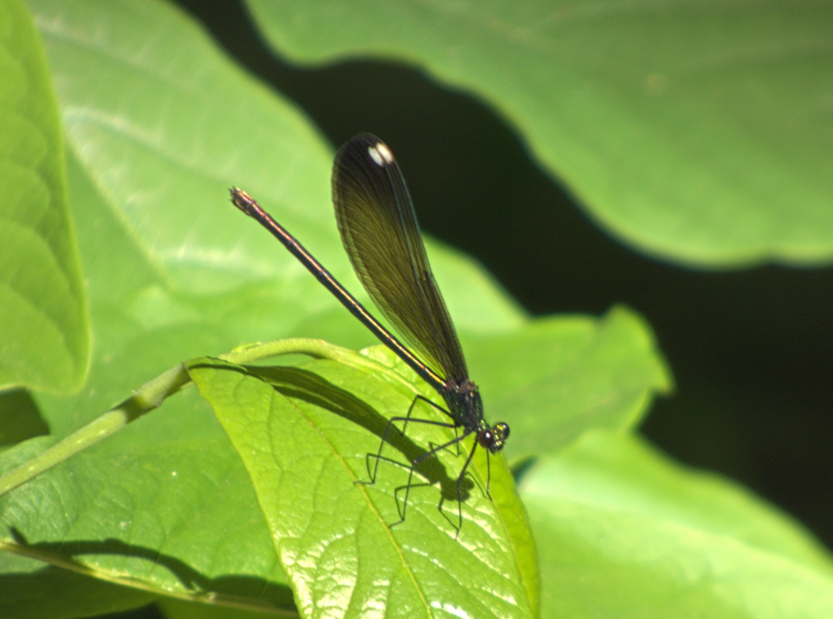

Many dragonflies change color as they mature.

The Eastern Pondhawk male is green like the female at first. But, it develops a blue waxy coating called pruinosity as it matures. You may see one partly green and partly blue. The Blue Dasher male also develops this blue waxy coating.

