analyses - egoNET

# Visualizations

## Density Plots

### Network Substance-Use Density by Ego Alcohol Problem Counts

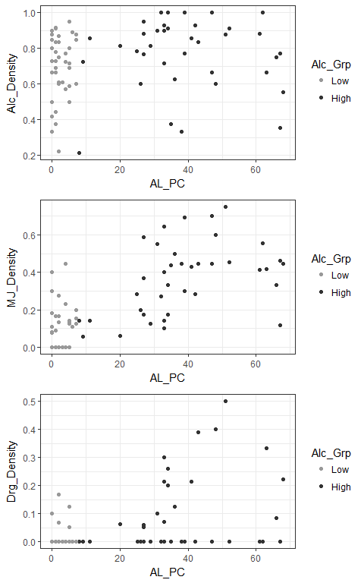

### Network Substance-Use Density by Ego Antisocial Problem Counts

