KariAnn Harjo

ITSE 1450

November 19, 2023

Service Information Management (SIM) System ERD Project

Overview

This document presents an Entity-Relationship Diagram (ERD) for a Service Information Management (SIM) system. The ERD illustrates the basic structure and relationships between various entities within the system.

Entities and Relationships

Entities

1. User: Represents the system users.

2. Ticket: For managing service tickets.

3. Inventory: To keep track of items or services.

4. Appointment: For scheduling and managing appointments.

Relationships

- Users can create Tickets.

- Tickets may use items from Inventory.

- Users can schedule Appointments.

- Tickets are related to Appointments.

ERD Illustration

Below is the Entity-Relationship Diagram for the SIM system:

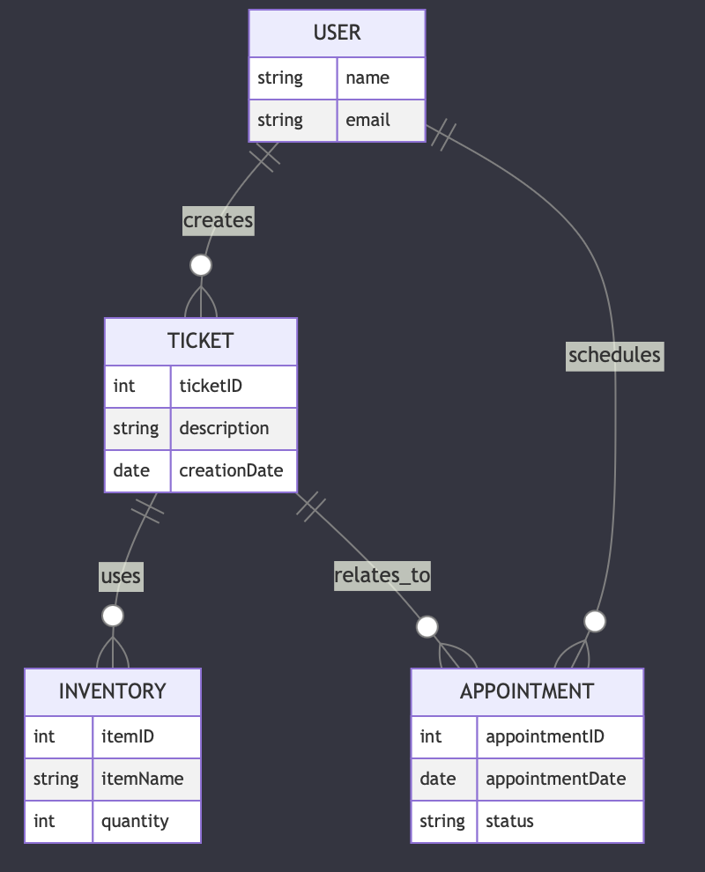

Conclusion

This ERD provides a foundational understanding of the SIM system's structure, highlighting the key entities and their interrelations. It serves as a crucial tool for analyzing and designing the system's database architecture.

Database Design in 3NF for SIM System

Overview

This section outlines the database design for the Service Information Management (SIM) system, structured in Third Normal Form (3NF) to ensure data integrity and minimize redundancy.

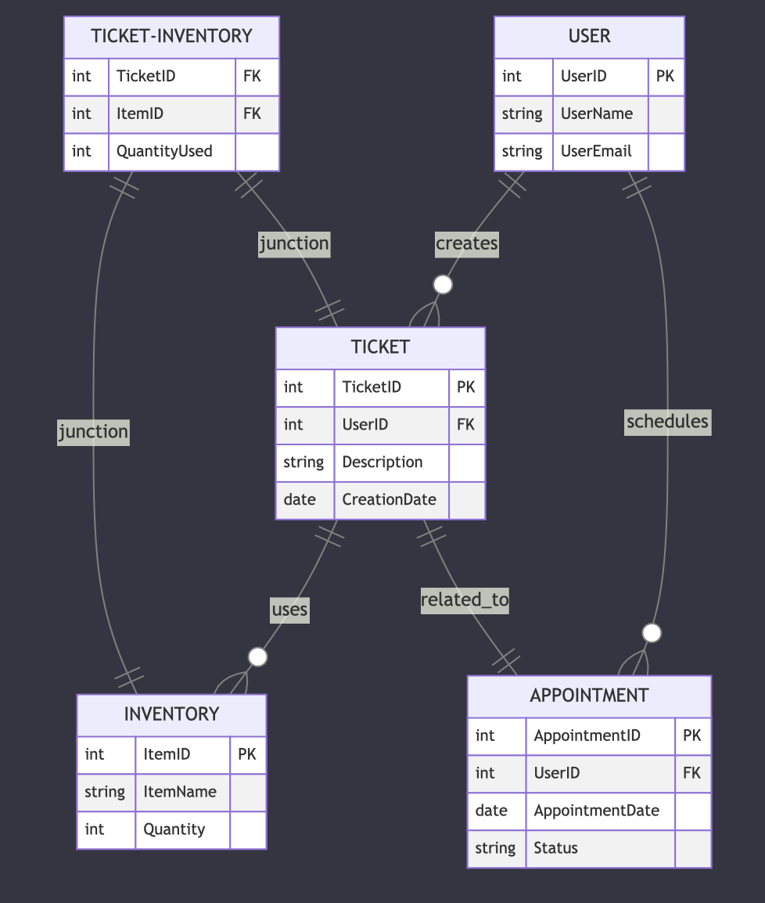

Table Structures

1. User Table

- UserID (Primary Key)

- UserName

- UserEmail

- Other user-related fields

2. Ticket Table

- TicketID (Primary Key)

- UserID (Foreign Key)

- Description

- CreationDate

3. Inventory Table

- ItemID (Primary Key)

- ItemName

- Quantity

4. Appointment Table

- AppointmentID (Primary Key)

- UserID (Foreign Key)

- AppointmentDate

- Status

5. TicketInventory Table (Junction Table for Ticket and Inventory)

- TicketID (Foreign Key)

- ItemID (Foreign Key)

- QuantityUsed

Conclusion

This database design follows the principles of 3NF to ensure that each table represents a single entity and its attributes, with relationships maintained through foreign keys. The design aims to reduce data redundancy and maintain data integrity within the SIM system.