Office Markdown Fixture - Word
Windows-focused DOCX sample with external hyperlink, table content, an inline image, and a synthetic embedded object relationship.
日本語テキスト: Windows 検証用の Unicode 行です。

Image and caption
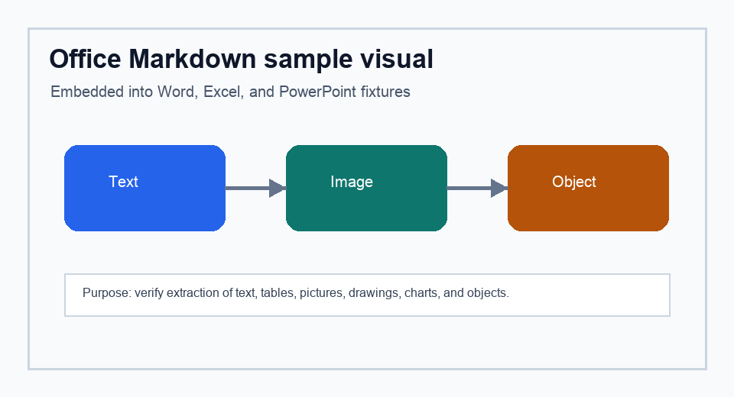
Figure 1. Embedded PNG image used by all three Office samples.

Conversion coverage table
Element | Expected Markdown signal | Notes
Heading | # Image and caption | Word heading style
Hyperlink | [external hyperlink](...) | External relationship
Image | doc-image-001.png | Inline drawing relationship
Object | doc-object-001.bin | Synthetic OLE relationship

Visible object placeholder
Embedded object placeholder: sample-object.bin is included in word/embeddings.

