Europeana Inside

Manual Mapping and Transformation Service – release 1

Introduction
This document describe the use of REST api developed to map and transform records from one format to another. The services of this api can be divide into two categories: Mapping Service and Transformation Service.
The mapping service can be used to convert XML to another XML. Currently we have implemented LIDO to EDM. MARC to EDM will be available in a few weeks. The mapping is defined in a text file with the specified mapping rules. The mapping rules consists of an action, input and output. Sometimes there is also a fixed value. The rules will be applied during the transformation.
The mapping service is only necessary if you want to make your own mapping. If you use the mapping rules specified by Linked Heritage project, then you don’t need this mapping service. In this case you need to use the transformation service instead of the mapping service.
Following diagram shows the workflow of both mapping and transformation service. It can be noticed that no mapping rules file is needed for transformation service.
Mapping Service | Transformation Service
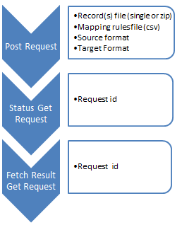 | 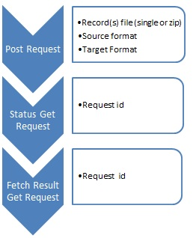

Mapping Service
Maps records from one format to another (currently from LIDO to EDM) based on the provided mapping rules.

1.1 Use of the service
You can send POST and GET requests to the server. The POST request is for sending the data, the GET request is for getting information about the data and fetching the data.

1.1.1 POST request
The POST request can be used to transform a record or records with the defined mapping rules.

URL
Following url along with the parameters in the body can be used to access this service:
http://www.heron-net.be/einside_test/dmt.php/DataMapping/<provider>/<batch>/Transform
- DataMapping: is the name of the module therefore it should remain the same.
- Provider: This is the name of the organization making this request.
- Batch: This is the name of the batch submitted for transformation.
- Parameters: This service accepts following three parameters:
  - records or record:
A ZIP file with XML records in them (records parameter) or an XML file with one or more records in the XML file (record parameter). You also have to provide the correct Content-type: ZIP: application/zip. XML: application/xml or text/xml (the XML content-type is not yet validated) You have to choose record or records. Supplying both results in an error.
  - mappingRulesFile:
A csv file (Content-type:text/csv) with mapping rules (See section 1.1.3 for an explanation about this file).
  - sourceFormat:
This is the source metadata format. At the moment only LIDO is supported.
  - targetFormat:
This is the target metadata format. At the moment only EDM is supported.
An example url is:
http://www.heron-net.be/einside_test/dmt.php/DataMapping/Libis/my_tansfer/Transform
Where ‘Libis’ is the name of the provider of the record(s) and ‘my_tansfer’ is the name of the batch.
The example url with required parameters is also shown in the following diagram.

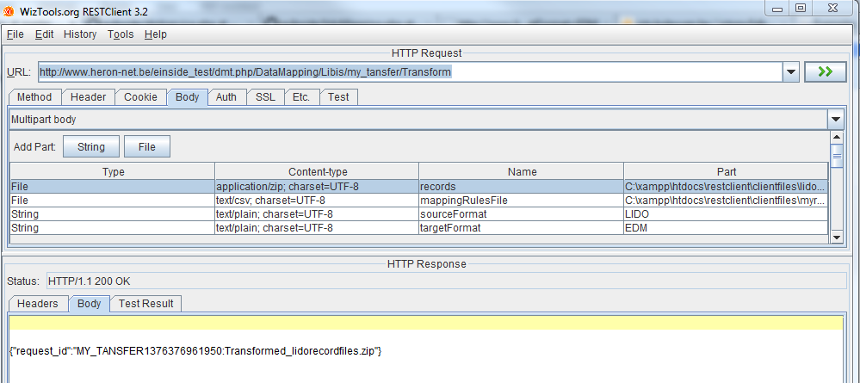

POST response
The response of the service is a request_id. E.g.:
{"request_id":"MY_TANSFER1376376799092:Transformed_lidorecordfiles.zip"}.
With this request_id you can get the status and download the Transformed files. (See further in the Get request). The MY_TRANSFER in the response comes from the my_transfer in the request url.

1.1.2 GET-request
You can use the GET request to get information from the service:

1.1.2.1 Status
Status gives back a status code about the processing of the records:
- 0: no request exist with this id
- 1: not yet mapped/transformed
- 2: ready to be fetch

URL
Example url: http://www.heron-net.be/einside_test/dmt.php/DataMapping/Libis/my_transfer/status?request_id=MY_TANSFER1376036187653:Transformed_lidorecordfiles.zip
The url is the same as the POST request, only the transform will become status and the required parameter needs to be added. The Url also needs to consist of Datamapping, organisation, batch name and action. Currently only the ‘action’ value is processed but other values are also needed in the url to make it a valid url.
Parameters:
- Request_id: is the request_id from the POST-response

1.1.2.2 Fetch
Fetch can be used to download the mapped/transformed files.

URL
Example url: http://www.heron-net.be/einside_test/dmt.php/DataMapping/Libis/my_transfer/Fetch?request_id=MY_TANSFER1376036187653:Transformed_lidorecordfiles.zip
Url for fetch request is the same as the status request only status becomes fetch. The parameter is also request_id.

1.1.2.3 List
This returns a list of supported metadata formats (currently only EDM and LIDO)

URL
Example url: http://www.heron-net.be/einside_test/dmt.php/DataMapping/Libis/my_transfer/List
The url is the same as the other GET requests, the action is List. There are no parameters.

1.1.3 Mapping Rules
The mapping rules are used to define which source field goes to which target field. You can also define an action to be executed on the source field before it is added to the source field.
The different components are separated by a comma, but the file is not a valid csv file as some actions need to have new lines in them. Commas are allowed in the values. The rules are processed from top to bottom. The supported mapping rules with appropriate examples are given at the end of this document in annex 1.

Source field
The source field (see table below) contains the field from the source metadata format (sourceFormat parameter in the POST request). The mapping service supports only LIDO as source format. MARC support will be added. For the LIDO format we use a XPath-like format. We didn’t find a more condense way to select the correct source field in LIDO. You can also select an attribute with an @. In MARC we will have a much shorter syntax.

Target field
The target field (see table below) contains the field from the target metadata format (targetFormat parameter in the POST request). The mapping service supports only EDM as target format.
There are some limitations in the current EDM support. The edm:isShownBy is not supported. You have to use edm:object instead. IsShownBy will be supported in some weeks. Also not yet supported are edm:Place, edm:Agent, edm:TimeSpan, and skos:Concept. This means if you supply a value that are places, persons, organisations or concepts they will be added to the dc or edm elements in for example ProvidedCHO, but we won’t create an extra edm:Place, edm:Agent or skos:Concept element yet. This won’t be implemented in the first release, because it is not required and we will need to think about how we can implement this in a user-friendly way without making the target field too complex.

Edm:rights and dc:rights are not processed correctly at the moment. This means that we create the elements, but it is possible they are not in the right element. Some values are still empty. The reason is this needs some further testing, because it depends on the context if the elements need to go to providedCHO, aggregation or webResource element.

Transformation Service
Transforms records from one format to another (currently from LIDO to EDM) based on a style sheet provided by Linked Heritage.

2.1 Use of the service
Like the mapping service you can send POST and GET requests for transformation service. The POST request is for sending the data (without mapping rules file), the GET requests are for getting information about the data and fetching the transformed data.

2.1.1 POST request
The POST request can be used to submit record(s) for transformation (without mapping rules).

URL
Following url along with the parameters in the request body can be used to access this service:
http://services.libis.be/euInside/dmt.php/DataMapping/<provider>/<batch>/Transform
- DataMapping: is the name of the module therefore it should remain the same.
- Provider: This is the name of the organization making this request.
- Batch: This is the name of the batch submitted for transformation.
- Parameters: This service accepts following three parameters:
  - Records or record:
A ZIP file with XML records in them (records parameter) or an XML file with one or more records in the XML file (record parameter). You also have to provide the correct Content-type: ZIP: application/zip. XML: application/xml or text/xml (the XML content-type is not yet validated) You have to choose record or records. Supplying both results in an error.
  - sourceFormat:
This is the source metadata format. At the moment only LIDO is
supported.
  - targetFormat:
This is the target metadata format. At the moment only EDM is supported.
Following is an example url:
http://services.libis.be/euInside/dmt.php/DataMapping/Libis/LeuvenLibData/Transform
Where ‘Libis’ is the name of the provider of the record(s) and ‘LeuvenLibData’ is the name of the batch.
Note that no mapping file (mappingRulesFile) is need for this service, a style sheet provide by Linked Heritage will be used to transform the record(s).

POST response
The response of the transformation service is similar to the response of the mapping service, that is a request_id in json format. An example response is:
{"request_id":"MY_TANSFER1378883070287:Transformed_lido1.xml"}
Subsequently, this request_id can be used to check the status of the submitted records and to fetch the transformed records. For this purpose following given GET requests can be used.

2.1.2 GET-request
You can use the GET request to get information about your submitted record(s):

2.1.2.1 Status
Status gives back a status code about the processing of the records. The status GET request is the same as described in section 1.1.2.1 except the base url which points to a different server.

URL
An example url is:
http://services.libis.be/euInside/dmt.php/DataMapping/Libis/LeuvenLibData/status?request_id=MY_TANSFER1378883070287:Transformed_lido1.xml
- Status: is the action which returns the status of the submitted records.
- request_id: is id of the transformation request.

2.1.2.2 Fetch
Fetch can be used to download the transformed records.

URL
An example url is:
http://services.libis.be/euInside/dmt.php/DataMapping/Libis/LeuvenLibData/fetch?request_id=MY_TANSFER1378883070287:Transformed_lido1.xml
The url is similar to the status request url except that action status changes to fetch.

Annex 1-Supported mapping rules

Action | Definition | Input | Output | Example
COPY | Copies the value from a source field to a target field. If different source fields are defined to be copied to the same target field a new occurrence of the target field will be created | Source metadata field | Target field | COPY,/lidoRecID,dc:identifier
APPEND | Append a source field to a target field. The specified source field will be appended to the target field. If there is already metadata in a field. The information will be added to that field and not replaced. | Source metadata field | Target field | APPEND,/category/term,dc:title
SPLIT | The source field will be split on the defined character and put in the target field. (In the example it will be split on space) | Source field and character to split on | Target field | SPLIT,/descriptiveMetadata/eventWrap/eventSet/event/eventMaterialsTech/displayMaterialsTech,,dcterms:medium
COMBINE | Multiple source fields can be combined in one target field. The fields are combined with a space | Source fields, separate by ; | Target field | COMBINE, /category/term;/lidoRecID, dc:title
LIMIT | Limit the number of characters in a source field | Source field and number of characters | Target field | LIMIT,/descriptiveMetadata/objectIdentificationWrap/objectMeasurementsWrap/objectMeasurementsSet/displayObjectMeasurements,9,edm:description
PUT | Add a value to a target field. The value can contain commas, but no 2 pipes (||), because this is used as replacement character | Value | Target field | PUT,"Koninklijke Musea voor Kunst en Geschiedenis, Brussel",edm:dataProvider
REPLACE | Replaces a value in the source field with a replace string in the target Field.  In the example d'Histoire will be replaced by History in the edm:provider element | Source field, value to be replace and replace value | Target field | /administrativeMetadata/rightsWorkWrap/rightsWorkSet/rightsHolder/legalBodyName/appellationValue,d'Histoire,History,edm:provider
CONDITION | With condition you can combine different actions and use a conditional flow.  Nested conditions are not yet implemented. IF can be used to define conditional action. With nested conditions also ELSE IF can be used.  The CONDITION actions starts and ends with curly brackets ‘{ ’. A new line is also mandatory.  See the Condition action table for a breakdown of the condition syntax |  |  | CONDITION,{  IF[/descriptiveMetadata/eventWrap/eventSet/event/eventType/term,EQUALS,Production,DO(COMBINE, /category/term;/lidoRecID, dc:title)]  }

Condition action
Part | Syntax | Definition | Example
IF and source field | IF[source field, comparator, value to compare, action] | The IF has the condition between squared brackets ‘[ ]’ | IF[/descriptiveMetadata/eventWrap/eventSet/event/eventType/term,…]
Comparator | EQUALS | For now only EQUALS is supported, but can be extended | IF[/descriptiveMetadata/eventWrap/eventSet/event/eventType/term,EQUALS,…]
Value to compare |  | The value is a string. Like all values this part can contain commas | IF[/descriptiveMetadata/eventWrap/eventSet/event/eventType/term,EQUALS,Production,…]
Action | DO(action) | The action starts with DO. Between the round brackets an action from the previous table is defined (expect of course condition) | IF[/descriptiveMetadata/eventWrap/eventSet/event/eventType/term,EQUALS,Production,DO(COMBINE, /category/term;/lidoRecID, dc:title)]

Example files:
Lido file: 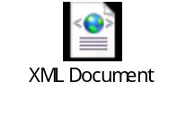
CSV file: 