Installing git and accessing it through the original command prompt on windows.

Download a git package, which may be zip file from any of your most trusted sites,
Unzip the zipped folder containing git[] = new {git bash, git gui}
Notice that by installing git via running the setup, you will have access to git bash which is a command prompt view of git where you can knowmally run git commands, while using that, i noticed that git bash complies to terminal commands mostly, which is good for linux users than window's

Now if yiu want to be able to run your git commands from the cmd, on windows, you will need to add the path to git bin, forexample: c:/program files/git/bin to your environmental variables, under path so that you can have something like:
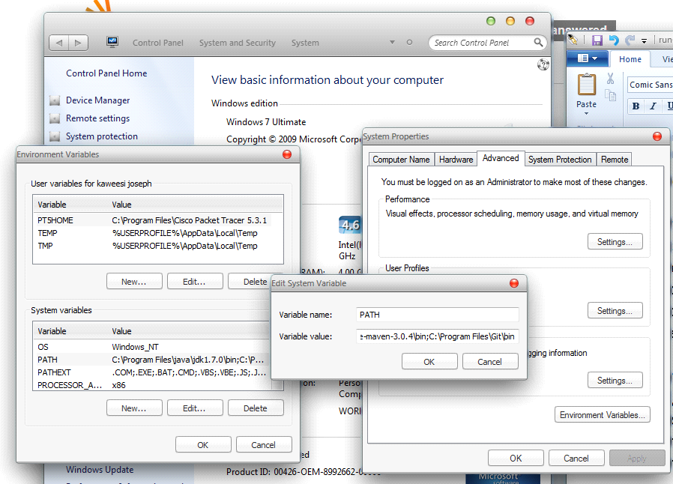

C:\Program Files\java\jdk1.7.0\bin;C:\Program Files\maven\apache-maven-3.0.4\bin;C:\Program Files\Git\bin; in Variable name:
notice that C:\Program Files\java\jdk1.7.0\bin is path for my jdk, C:\Program Files\maven\apache-maven-3.0.4\bin is path for maven and finally C:\Program Files\Git\bin which is path for git, we seperate the different paths with a semicolon, and put a semicolon at the end of the path so that we can keep on adding another path if any.

