kmeans

joshna katta

2022-11-06

#loading required packages  
library(flexclust)

## Warning: package 'flexclust' was built under R version 4.2.2

## Loading required package: grid

## Loading required package: lattice

## Loading required package: modeltools

## Loading required package: stats4

library(cluster)  
library(tidyverse)

## ── Attaching packages  
## ───────────────────────────────────────  
## tidyverse 1.3.2 ──

## ✔ ggplot2 3.3.6 ✔ purrr 0.3.4   
## ✔ tibble 3.1.8 ✔ dplyr 1.0.10  
## ✔ tidyr 1.2.0 ✔ stringr 1.4.1   
## ✔ readr 2.1.2 ✔ forcats 0.5.2   
## ── Conflicts ────────────────────────────────────────── tidyverse_conflicts() ──  
## ✖ dplyr::filter() masks stats::filter()  
## ✖ dplyr::lag() masks stats::lag()

library(ggplot2)  
library(dplyr)  
library(factoextra)

## Warning: package 'factoextra' was built under R version 4.2.2

## Welcome! Want to learn more? See two factoextra-related books at https://goo.gl/ve3WBa

pharma.df = read.csv("C:/Users/Pavan Chaitanya/Downloads/Pharmaceuticals.csv")  
colMeans(is.na(pharma.df))

## Symbol Name Market_Cap   
## 0 0 0   
## Beta PE_Ratio ROE   
## 0 0 0   
## ROA Asset_Turnover Leverage   
## 0 0 0   
## Rev_Growth Net_Profit_Margin Median_Recommendation   
## 0 0 0   
## Location Exchange   
## 0 0

#normalizing the data   
norm.pharma = scale(pharma.df[,-c(1:2,12:14)])

#using wss method finding the optimal k value

wss = fviz_nbclust(norm.pharma,kmeans,method = "wss")  
wss

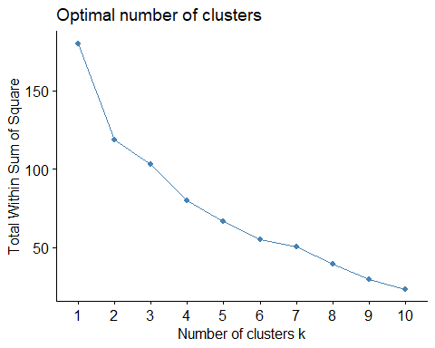 #finding the optimal k value from the silhouette method

silhouette = fviz_nbclust(norm.pharma,kmeans,method="silhouette")  
silhouette

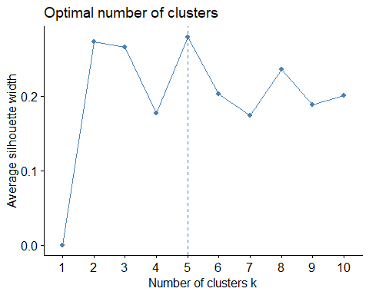

*here we got two different k values are from wss method is k= 2 and silhouette method was k = 5*

#formulating the kmeans with wss   
wss_kmeans = kmeans(norm.pharma,centers = 2,nstart=50)  
wss_kmeans

## K-means clustering with 2 clusters of sizes 11, 10  
##   
## Cluster means:  
## Market_Cap Beta PE_Ratio ROE ROA Asset_Turnover  
## 1 0.6733825 -0.3586419 -0.2763512 0.6565978 0.8344159 0.4612656  
## 2 -0.7407208 0.3945061 0.3039863 -0.7222576 -0.9178575 -0.5073922  
## Leverage Rev_Growth Net_Profit_Margin  
## 1 -0.3331068 -0.2902163 0.6823310  
## 2 0.3664175 0.3192379 -0.7505641  
##   
## Clustering vector:  
## [1] 1 2 2 1 2 2 1 2 2 1 1 2 1 2 1 1 1 2 1 2 1  
##   
## Within cluster sum of squares by cluster:  
## [1] 43.30886 75.26049  
## (between_SS / total_SS = 34.1 %)  
##   
## Available components:  
##   
## [1] "cluster" "centers" "totss" "withinss" "tot.withinss"  
## [6] "betweenss" "size" "iter" "ifault"

silhouette_kmeans =kmeans(norm.pharma,centers = 5,nstart = 50)  
silhouette_kmeans

## K-means clustering with 5 clusters of sizes 3, 4, 8, 2, 4  
##   
## Cluster means:  
## Market_Cap Beta PE_Ratio ROE ROA Asset_Turnover  
## 1 -0.87051511 1.3409869 -0.05284434 -0.6184015 -1.1928478 -0.4612656  
## 2 1.69558112 -0.1780563 -0.19845823 1.2349879 1.3503431 1.1531640  
## 3 -0.03142211 -0.4360989 -0.31724852 0.1950459 0.4083915 0.1729746  
## 4 -0.43925134 -0.4701800 2.70002464 -0.8349525 -0.9234951 0.2306328  
## 5 -0.76022489 0.2796041 -0.47742380 -0.7438022 -0.8107428 -1.2684804  
## Leverage Rev_Growth Net_Profit_Margin  
## 1 1.36644699 -0.6912914 -1.320000179  
## 2 -0.46807818 0.4671788 0.591242521  
## 3 -0.27449312 -0.7041516 0.556954446  
## 4 -0.14170336 -0.1168459 -1.416514761  
## 5 0.06308085 1.5180158 -0.006893899  
##   
## Clustering vector:  
## [1] 3 4 3 3 5 1 3 1 5 3 2 1 2 5 2 3 2 4 3 5 3  
##   
## Within cluster sum of squares by cluster:  
## [1] 15.595925 9.284424 21.879320 2.803505 12.791257  
## (between_SS / total_SS = 65.4 %)  
##   
## Available components:  
##   
## [1] "cluster" "centers" "totss" "withinss" "tot.withinss"  
## [6] "betweenss" "size" "iter" "ifault"

*therefore by performing the wss method wet get clusters of size 11 and 10.* *therefore by performing the silhousette method wet got 5 clusters of sizes are 8,3,2,4,4*

*cluster plot for wss*

fviz_cluster(wss_kmeans,data = norm.pharma)

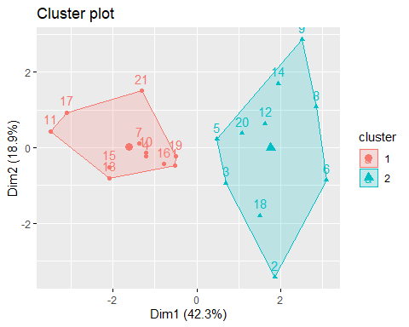

fviz_cluster(silhouette_kmeans,data = norm.pharma)

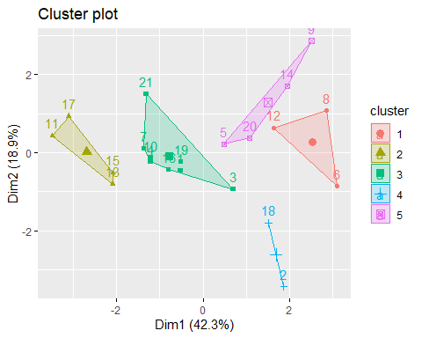 *5 clusters have been noticed from the above. The symbols/shapes in each cluster are ‘centroids’ of that specific cluster. Nstart value 25 and above is defined as no other centroid can be taken into consideration until new data is being added.* *(b) Interpret the clusters with respect to the numerical variables used in forming the clusters.*

#interpretation  
silhouette_clusters = silhouette_kmeans$cluster  
silhouette_cluster = as.data.frame(silhouette_clusters)  
silhouette_2 = cbind(pharma.df,silhouette_clusters)  
cluster_mean = silhouette_2 %>% group_by(silhouette_clusters) %>%  
summarise_all("mean")

cluster_mean

## # A tibble: 5 × 15  
## silho…¹ Symbol Name Marke…² Beta PE_Ra…³ ROE ROA Asset…⁴ Lever…⁵ Rev_G…⁶  
## <int> <dbl> <dbl> <dbl> <dbl> <dbl> <dbl> <dbl> <dbl> <dbl> <dbl>  
## 1 1 NA NA 6.64 0.87 24.6 16.5 4.17 0.6 1.65 5.73  
## 2 2 NA NA 157. 0.48 22.2 44.4 17.7 0.95 0.22 18.5   
## 3 3 NA NA 55.8 0.414 20.3 28.7 12.7 0.738 0.371 5.59  
## 4 4 NA NA 31.9 0.405 69.5 13.2 5.6 0.75 0.475 12.1   
## 5 5 NA NA 13.1 0.598 17.7 14.6 6.2 0.425 0.635 30.1   
## # … with 4 more variables: Net_Profit_Margin <dbl>,  
## # Median_Recommendation <dbl>, Location <dbl>, Exchange <dbl>, and  
## # abbreviated variable names ¹​silhouette_clusters, ²​Market_Cap, ³​PE_Ratio,  
## # ⁴​Asset_Turnover, ⁵​Leverage, ⁶​Rev_Growth

#c.pattern with variables 10 to 12.

library(hrbrthemes)

## Warning: package 'hrbrthemes' was built under R version 4.2.2

## NOTE: Either Arial Narrow or Roboto Condensed fonts are required to use these themes.

## Please use hrbrthemes::import_roboto_condensed() to install Roboto Condensed and

## if Arial Narrow is not on your system, please see https://bit.ly/arialnarrow

#median_recommendation vs cluster  
pharma2 = pharma.df[,c(12,13,14)]  
pharma3 =cbind(pharma2,silhouette_cluster)  
  
ggplot(pharma3,aes(x=silhouette_clusters,fill= Median_Recommendation))+geom_bar(position = "dodge")+labs(title = "Median_Recommendation vs cluster",  
 x ="cluster" ) +  
 theme_bw()

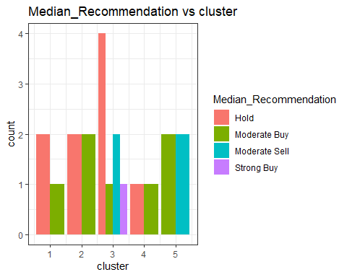

*location versus cluster*

ggplot(pharma3,aes(x=silhouette_clusters,fill = Location))+ geom_bar(position = "dodge")

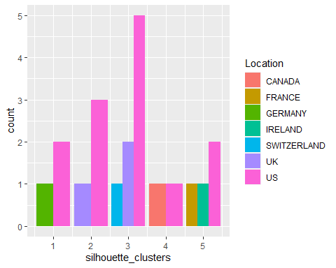

labs(  
 title = "location vs cluster",  
 x= "cluster"  
)+  
 theme_bw()

## NULL

*cluster versus exchange*

ggplot(pharma3,aes(x=silhouette_clusters, fill = Exchange,))+  
geom_bar(postion = "dodge")+  
labs(  
title ="exchange vs cluster",  
x="cluster"  
)+  
theme_bw()

## Warning: Ignoring unknown parameters: postion

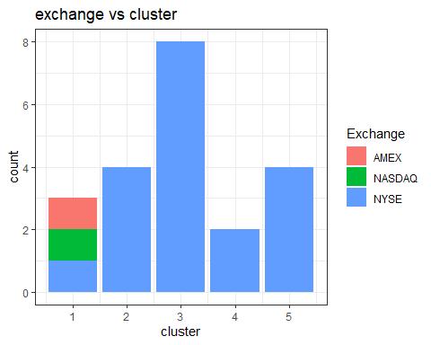

#D)

1. cluster 1 is “Poorly Performing Pharma”, has low performance across all features and extremely high BETA and Leverage values.

2.cluster 2 “Overpriced Pharma”, with a high PE ratio

3.cluster 3 “Currently Profitable Pharma,” which has the lowest revenue growth but a solid net profit margin.

4.”Big Pharma” is in Cluster 4, and it has high market capitalization, ROE, ROA, asset turnover, and net profit margin.

5.The Sil Cluster 5 with the highest Rev Growth is “Future Potential Pharma.”