IIHK(Interactive Intelligent Kitchen Helper) Specification

20222663 권기영

1. greeter class

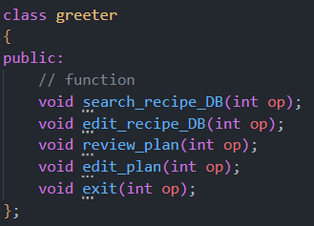

greeter class is the start window of this program. User enter input and according to input, functions performed.

In the greeter class, there are functions that perform about recipe database and plan. And also perform existing program.

2. recipe class

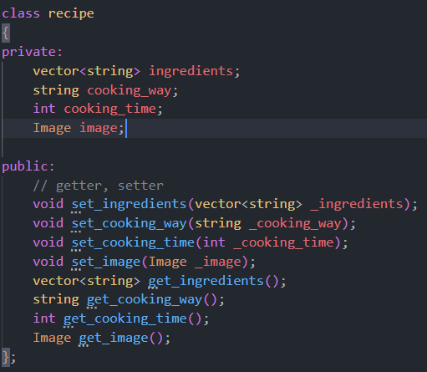

In recipe class, there are four member variable and getters, setters.

3. recipe_database class

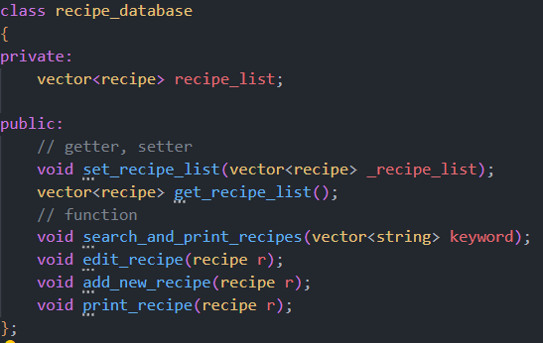

In recipe_database class, there is a member variable that is the list of recipe.

And there are 4 functions that perform about 1 recipe or recipes.

4. meal class

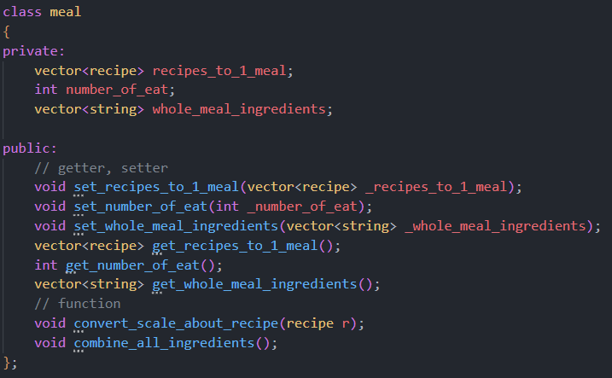

In meal class, there are 3 member variables and 2 member functions. 1 meal object includes a lot of recipe(recipe list) and ingredients about recipes.

Function changes 1 recipe’s scale for 1 person.

5. date class

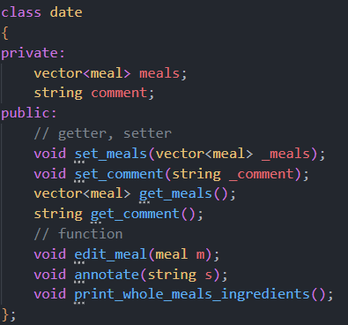

1 date class includes meals and date comment string. Functions perform to print whole meal’s ingredients, edit 1 meal and add a comment for this date.

6. plan_manager class

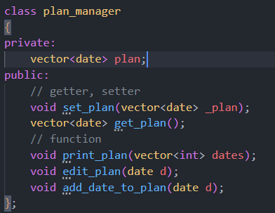

A plan_manager class has a plan, and plan is composed of dates. Functions edit or print plan.