Konark Karna
09 March 2021

Dear Sir/ Madam,

I am writing this letter of recommendation for Konark Karna to join your institution.
I worked with Konark Karna for over a year now in the Meet and Greet Team at Northumbria University. He was a Meet and Greet Officer under my management as the Co-ordinator and I only have positive things to say about his contribution to the team. From the outset Konark displayed a very enthusiastic and hardworking approach and he was an extremely reliable member of the team.

Konark displayed great dedication to representing Northumbria University and has a very professional outlook. He is always ready to assist others with advice and support and has taken on extra responsibility when working without others or supervision. His flexibility has been beneficial for the team when he has been called upon at short notice to work extra shifts or to cover the absence of others. The nature of the role means that often there have been long shifts with delays and complications with flight arrivals and Konark always remained positive and alert to maintain the high level of service he offers.

I can highly recommend Konark for the role or course he is applying for in the future.

Yours sincerely

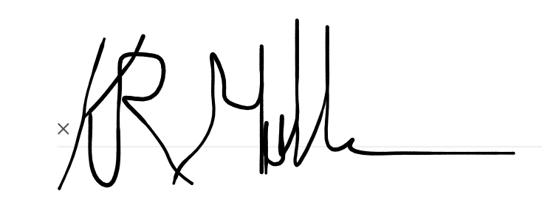
Keith Mullen

Keith Mullen
Meet and Greet Coordinator
Student Life and Wellbeing, Student Library and Academic Services
Northumbria University
E: keith.mullen@northumbria.ac.uk
Student Support and Wellbeing, Sandyford Building Northumbria University, Newcastle upon Tyne, NE1 8ST, United Kingdom

