NAME : KHUSHI KAVYA
ROLL NO.: 102118068 (BS3)
Compiler Design Assignment 4

Q1. Write lex program for
a. The set of all strings such that the 10th symbol from the right end is 1.
b. The set of all four digits numbers whose sum is 9

Code:
%{
/* Write lex program for
a. The set of all strings such that the 10th symbol from the right end is 1.
b. The set of all four digits numbers whose sum is 9 */
%}

d [0-9]

%%

(({d})*1{d}{9}) {printf("%s is a string having 1 as the 10th symbol from right end. \n",yytext);}

{d}{d}{d}{d} {
int num = atoi(yytext); //Converting matched digits to an integer
int sum=0;
int temp=num;
while(temp>0){
sum+=temp%10;
temp/=10;
}
if(sum==9){
printf("%s is a string such that sum of digits is 9. \n",yytext);
}
else{
printf("%s Invalid string \n",yytext);
}
}

%%

int yywrap(){
return 1;
}

int main(){
yylex();
return 0;
}

Output:

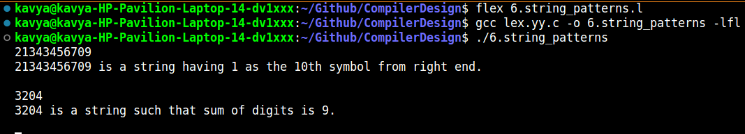

2. Write a LEX program to perform following operations.
Assume the file is containing a sequence of words (groups of letters) separated by white space. Every
time you encounter a word:
a. If the first letter is a consonant, move it to the end of the word and then add ay.
b. If the first letter is a vowel, just add ay to the end of the word. All non-letters are copied intact to
the output.

c[a-zA-Z]
vowel[aeiouAEIOU]
cons[^aeiouAEIOU]
%%
{vowel}{c}* {
/* First character is vowel */
/* copy yytext into an array and append &quot;ay&quot; to it */
char s[100];
strcpy(s,yytext);
strcat(s,&quot;ay&quot;);
printf(&quot;%s &quot;,s);
fprintf(yyout,&quot;%s&quot;,s);
}

Code:
%{
/*2. Write a LEX program to perform following operations.
Assume the file is containing a sequence of words (groups of letters) separated by white space. Every
time you encounter a word:
a. If the first letter is a consonant, move it to the end of the word and then add ay.
b. If the first letter is a vowel, just add ay to the end of the word. All non-letters are copied intact to
the output.*/
%}

c[a-zA-Z]
vowel[aeiouAEIOU]
cons[^aeiouAEIOU]

%%

{vowel}{c}* {
//copy yytext to an array and append "ay" to it
char s[100];
strcpy(s,yytext);
strcat(s,"ay");
printf("%s",s);
fprintf(yyout,"%s",s);
}

{cons}{c}* {
// move first letter to the end of word and then add "ay"
char s[100];
strcpy(s,yytext+1); // Copy everything except the first character
strncat(s,yytext,1); //same as strcat(s,yytext[0]) i.e. append the first character
strcat(s,"ay");
printf("%s",s); // Print the transformed word to the console
fprintf(yyout,"%s",s); // Print the transformed word to the output file
}

([^c]+) {
/*Non-letter characters are copied as it is*/
printf("%s",yytext);
fprintf(yyout,"%s",yytext);
}

%%

int yywrap(){
return 1;
}

int main(){
yyin=fopen("pigLatinInput.txt","r");
yyout=fopen("pigLatinOutput.txt","w");
yylex();
fclose(yyin);
fclose(yyout);
return 0;
}

Output:
