NAME : KHUSHI KAVYA
ROLL NO.: 102118068 (BS3)
Compiler Design Assignment 3

Q2. Write a LEX program to remove the comments from a c file.

Code:
%{
/*Lex program to remove comments from C program and save it in a file*/
%}

/*starting character sequence for multiline comment*/
start \/\*
/*ending character sequence for multiline comment*/
end \*\/

%%

\/\/(.*) {};
\/\*(.*\n)*.*\*\/ {};

%%

int yywrap(){
return 1;
}

int main() {
yyin=fopen("input.c","r");
yyout=fopen("output.c","w");

yylex();

fclose(yyin);
fclose(yyout);

return 0;
}

Output:

input.c output.c
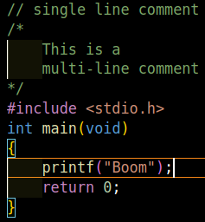
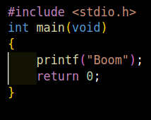

Q3. Write a LEX program to recognize the following tokens over the alphabets {0,1,..,9}
a) The set of all string ending in 00.
b) The set of all strings with three consecutive 222’s.
c) The set of all string such that every block of five consecutive symbols contains atleast two 5’s.

Code:
%{
/*Write a LEX program to recognize the following tokens over the alphabets {0,1,..,9}
a) The set of all string ending in 00.
b) The set of all strings with three consecutive 222’s.
c) The set of all string such that every block of five consecutive symbols contains atleast two 5’s.*/
%}

%%

[0-9]*00 {printf("String ending in 00 : %s\n",yytext);}
[0-9]*222[0-9]* {printf("String with three consecutive 222s : %s\n", yytext);}
([0-9]*5[0-9]*5[0-9]*)+ {printf("String such that every block of five consecutive symbols contains at least two 5's: %s\n",yytext);}

%%

int yywrap(){
return 1;
}

int main(){
yylex();
return 0;
}

Output:

