NAME : KHUSHI KAVYA
ROLL NO.: 102118068 (BS3)
Compiler Design Assignment 5

1. Write a Lex program to find and print all numbers in an input file that contain a specific digit, such as the digit 7.
2. Create a Lex program to identify and count binary numbers (numbers composed of only 0s and 1s)
in an input file.

Code:

%{
/*1. Write a Lex program to find and print all numbers in an input file that contain a specific digit, such as the digit 7.
2. Create a Lex program to identify and count binary numbers (numbers composed of only 0s and 1s) in an input file.*/

#include<stdio.h>
int binCount=0;
%}

digit [0-9]
bin [01]

%%

{digit}*7{digit}* {printf("Number %s contains 7\n",yytext);}

{bin}+ {binCount++;}

%%

int yywrap(){
return 1;
}

int main(){
yyin=fopen("5_12_input.txt","r");
if(!yyin){
printf("Error opening file\n");
return -1;
}

yylex();

printf("Binary Count: %d\n",binCount);
fclose(yyin);
return 0;
}
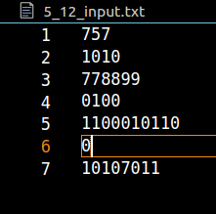
Output:

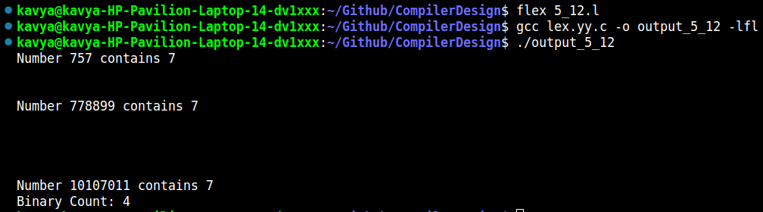

3. Write a Lex program to identify and count the number of even and odd numbers in a given input file.

Code:

%{
/*3. Write a Lex program to identify and count the number of even and odd numbers in a given input
file.*/

#include<stdio.h>
int ecount,ocount=0;

%}

digit [0-9]

%%

{digit}+ {
int num = atoi(yytext);
if(num % 2 == 0) {
printf("Even number: %d\n", num);
ecount++;
} else {
printf("Odd number: %d\n", num);
ocount++;
}
}

%%

int yywrap(){
return 1;
}

int main(){
yyin=fopen("5_3_input.txt","r");

yylex();

printf("Even Count: %d\n",ecount);
printf("Odd Count: %d\n",ocount);
fclose(yyin);
return 0;
}

Input:

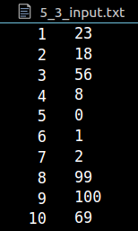

Output:

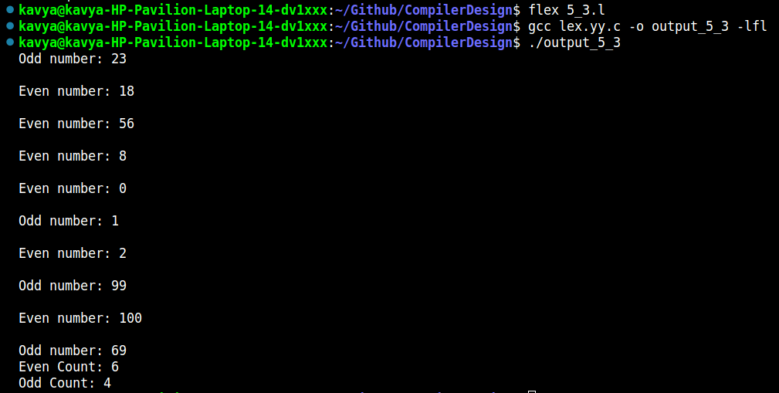

4. Write lex program to identify the numbers whose individual digits are in ascending order.

Code:

%{
/*4. Write lex program to identify the numbers whose individual digits are in ascending order.*/
%}

digit[0-9]

%%

{digit}+ {
int num = atoi(yytext);
int flag = 1;
int prev = num % 10;
num /= 10;
while(num > 0) {
if(num % 10 > prev) {
flag = 0;
break;
}
prev = num % 10;
num /= 10;
}
if(flag) {
printf("%s\n", yytext);
}
}

%%

int main() {
yyin = fopen("5_4_input.txt", "r");
yylex();
fclose(yyin);
return 0;
}

Input:

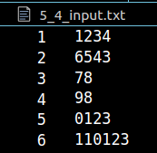

Output:

