**FLIGHT MANAGEMENT SYSTEM**

**Home page:**

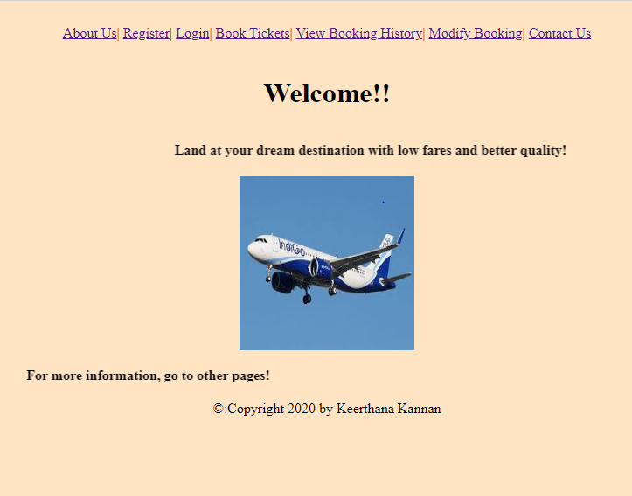

**About Us Page:**

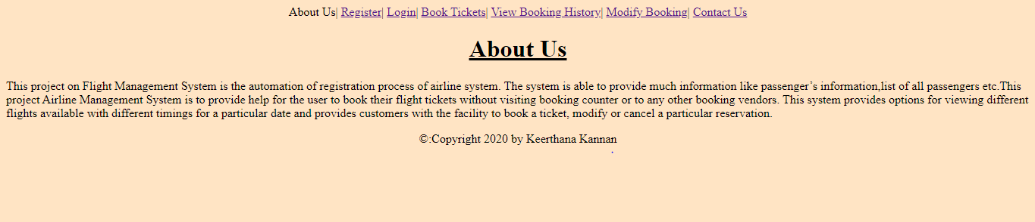

**Registration Page**

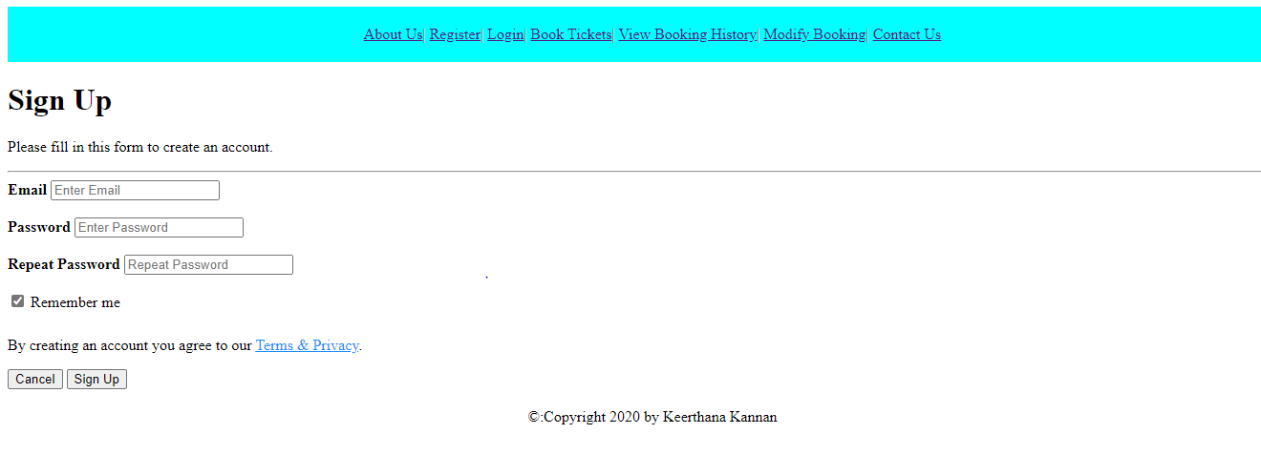

**Login Page:**

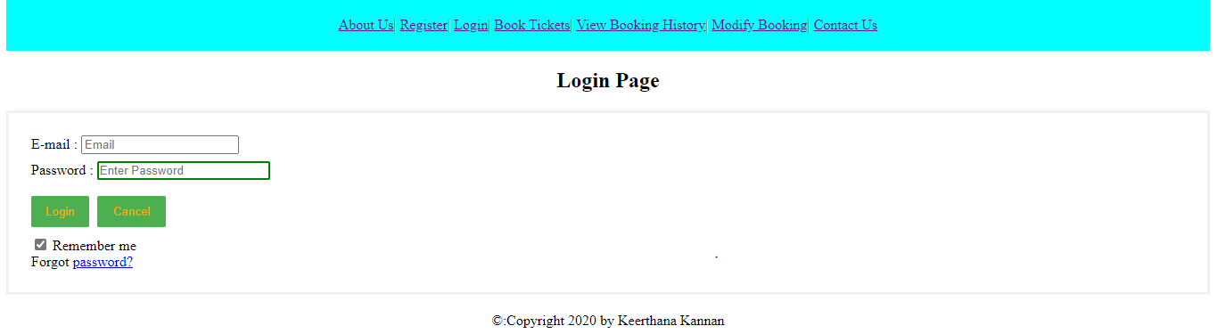

**Book tickets page:**



**Booking history page:**

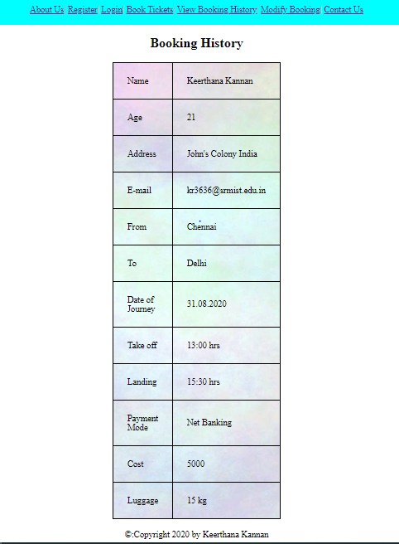

**Modify booking page:**

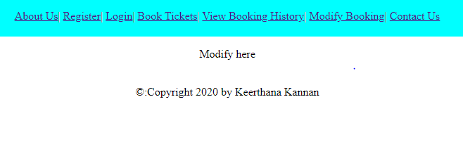

**Contact Us Page:**

