Keshav Krishna 2019CSB1224

README

# How to play

Upon executing TicTacToe.java, the following option appear:

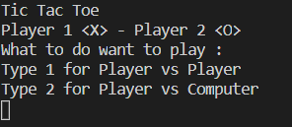

Out of the two options, the user selects 1 or 2 to play with player or computer, respectively.

If he chooses 1 or 2, the following option appears:

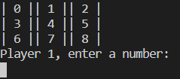

Out of the nine numbers, the player chooses a number to place his X on.

In case of player vs Player, the following screen appears on choosing the position of X by player 1:

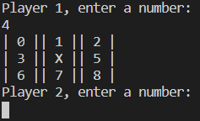

Then player 2 chooses a number and the game continues.

In player vs computer, the following screen appears after player 1 enters the number:

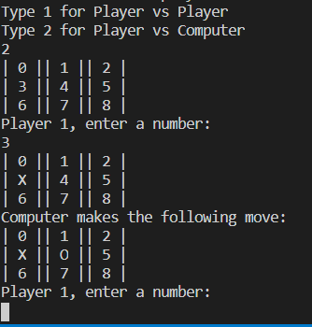

After the player makes a move, the computer responds with a move, which is displayed. Then player makes the move, followed by computer and this continues till the end of game.

# Game over

The game ends in a tie or a win.

The following screen appears in case of tie:

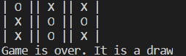

The following appears in case of a win:

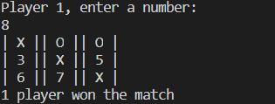

# EXCEPTION HANDLING

Two types of exceptions may occur, the user may enter the same number twice or he may enter a number greater than 8.

In both the cases, the following screen appears instructing the user to enter input again:

