SMARTLIB: A KIOSK-BASED SMART LIBRARY SYSTEM FOR ENHANCING ACADEMIC RESOURCE ACCESSIBILITY AT PHINMA ST. JUDE COLLEGE DASMARIÑAS
Kin Ira J. Bantiling
College of Management and Accountancy, PHINMA St. Jude College Dasmariñas, Cavite
Corresponding Email: bantilingkin@gmail.com

ABSTRACT
Libraries continue to play an important role in academic institutions; however, many students and faculty members encounter difficulties in searching, locating, and accessing library resources due to outdated and manual library processes. This study developed and evaluated SmartLib: Library Management System with Kiosk for PHINMA St. Jude College Dasmariñas Cavite. The system was designed to modernize library services through the integration of a touchscreen kiosk and a web-based librarian dashboard. The study utilized a Developmental–Descriptive Research Design and adopted the Iterative Waterfall Model as the software development methodology. SmartLib features Smart Search and Catalog Access, AI-Powered Recommendations, Book Locator, Borrowing and Receipt Generation, and Librarian Dashboard modules. The system was developed using PHP, MySQL, HTML, CSS, JavaScript, Bootstrap, and XAMPP, while Figma was used for interface prototyping. Evaluation was conducted among 109 respondents composed of students, teachers, librarians, and IT professionals using ISO 25010-aligned software quality criteria. Results revealed excellent ratings in Functional Suitability (4.70), Performance Efficiency (4.61), Compatibility (4.32), Usability (4.71), Reliability/Maintainability (4.44), and Portability (4.37), with an overall grand weighted mean of 4.55 interpreted as Excellent. The findings indicate that SmartLib is an effective and feasible solution for improving accessibility, efficiency, and user experience in academic library management.
Keywords: Smart Library, Kiosk, Library Automation, Resource Access

INTRODUCTION
Libraries remain essential learning spaces in academic institutions; however, many students and faculty members still experience difficulties in locating and accessing library resources due to outdated and inefficient library processes. Traditional catalog systems commonly rely on manual searching, which consumes time, limits accessibility, and discourages users from maximizing available academic materials. As educational institutions continue to embrace digital transformation, there is an increasing demand for technology-driven library services that improve accessibility, efficiency, and user engagement [1].
Recent studies emphasize that smart library systems, kiosk-based services, and automated catalog platforms significantly improve operational efficiency and user experience within academic libraries [1], [2]. The integration of intelligent technologies enables libraries to provide faster catalog access, simplified borrowing procedures, and improved resource visibility while reducing repetitive tasks for librarians [3], [4]. These advancements highlight the importance of adopting automated systems that support both library management and student accessibility.
Despite the availability of digital technologies, the library of PHINMA St. Jude College Dasmariñas Cavite still encounters challenges related to resource searching, catalog visibility, and borrowing management. Students often depend on manual assistance from librarians to locate books and verify availability, resulting in delays and inefficiencies during library transactions. To address these concerns, the researchers developed SmartLib: A Kiosk-Based Smart Library Management System designed to modernize library operations through the integration of a touchscreen kiosk and a web-based management dashboard.
The SMARTLIB system incorporates two major components: a touchscreen kiosk interface and a web-based administrative dashboard. The kiosk enables users to independently search the library catalog, receive AI-powered recommendations, locate physical books, and process borrowing transactions. Meanwhile, the administrative dashboard provides librarians with tools for catalog management, transaction monitoring, analytics, and reporting.
Specifically, this study aimed to:
- Identify the existing challenges encountered by students, faculty members, and librarians in accessing and managing library resources;
- Design and develop a library management system with kiosk integration tailored to institutional needs;
- Evaluate the developed system based on ISO 25010 software quality standards;
- Assess the system’s acceptability in terms of functionality, usability, performance efficiency, compatibility, reliability, maintainability, and portability;
- Determine the feasibility of implementing SMARTLIB as a modern academic library solution.
This study contributes to the growing adoption of digital transformation in academic institutions by presenting a localized smart library implementation that combines automation, accessibility, and data-driven resource management. The findings may serve as a foundation for future enhancements in library technologies and similar automation initiatives in educational environments.
METHODOLOGY
This study employed a Developmental–Descriptive Research Design in developing and evaluating SmartLib: A Kiosk-Based Library Management System for PHINMA St. Jude College Dasmariñas Cavite. The developmental approach was used in designing and developing the proposed library management system, while the descriptive approach was utilized in evaluating the system’s quality and acceptability among users.
The study adopted the Iterative Waterfall Model as the software development methodology [7], consisting of Requirement Analysis, Design, Coding, Testing, Deployment, and Maintenance phases. The model enabled systematic development while allowing revisions and improvements after each phase.
Primary data were gathered through interviews conducted with the librarian of PHINMA St. Jude College Dasmariñas to identify existing problems and operational challenges within the library. Secondary data were obtained from journals, related studies, online articles, and other academic resources related to library automation, smart libraries, kiosk systems, and digital transformation.
SmartLib was developed using PHP, MySQL, HTML, CSS, JavaScript, Bootstrap, and XAMPP. The system includes a touchscreen kiosk for students and a web-based dashboard for librarians. The kiosk provides Smart Search and Catalog Access, AI-Powered Recommendations, Book Locator, and Borrowing and Receipt Generation functionalities.
The system evaluation involved 109 respondents composed of students, teachers, librarians, and IT professionals selected using Stratified Random Sampling. The developed system was evaluated based on ISO 25010 software quality standards [6], including Functional Suitability, Performance Efficiency, Compatibility, Usability, Reliability, Maintainability, and Portability.
A five-point Likert Scale was used to interpret the respondents’ evaluation of the system. Weighted mean analysis was applied to determine the overall acceptability and performance of SmartLib.
Formula for weighted mean:
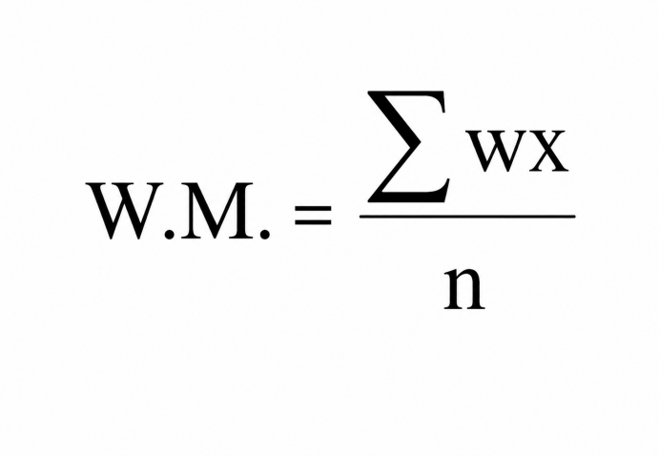
Where:
w.m. = Weighted Mean
∑wx = Sum of the product of frequency and responses
n = Total number of respondents
The computed weighted mean was interpreted using the following scale:
4.21 – 5.00 = Excellent
3.41 – 4.20 = Very Good
2.61 – 3.40 = Good
1.81 – 2.60 = Fair
1.00 – 1.80 = Poor
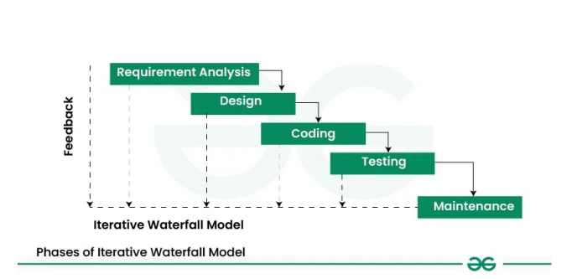Figure 1. Iterative Waterfall Model (S. Kumar Pal)

RESULTS AND DISCUSSION
The developed SmartLib system successfully integrated a touchscreen kiosk and a web-based management dashboard designed to improve accessibility, efficiency, and user experience within the library environment of PHINMA St. Jude College Dasmariñas Cavite. The system provided Smart Search and Catalog Access, AI-Powered Recommendations, Book Locator, and Borrowing and Receipt Generation functionalities to support faster and more organized library operations.
The Smart Search and Catalog Access module enabled users to locate books efficiently using keywords, categories, and filters such as title, author, and subject. The AI-Powered Recommendation feature improved awareness of available resources by displaying Most Borrowed Books, New Arrivals, and Course-Specific Highlights. Meanwhile, the Book Locator module assisted users in identifying the physical location of books inside the library through shelf and section guidance. These features reduced the need for repetitive librarian assistance and improved the overall borrowing experience of students and faculty members.
Table 1. System Evaluation Results
Criteria | Weighted Mean | Interpretation
Functional Suitability | 4.70 | Excellent
Perfomance Efficiency | 4.61 | Excellent
Compatibility | 4.32 | Excellent
Usability | 4.71 | Excellent
Reliability and Maintainability | 4.44 | Excellent
Portability | 4.37 | Excellent
Overall Weighted Mean | 4.55 | Excellent

The evaluation results indicate that SmartLib achieved excellent performance across all ISO 25010 software quality criteria. Usability obtained the highest weighted mean of 4.71, indicating that respondents found the system user-friendly, accessible, and easy to navigate. Functional Suitability also received a high rating of 4.70, showing that the developed system effectively met the operational requirements of the library.
Performance Efficiency obtained a weighted mean of 4.61, demonstrating that SmartLib responded quickly during searching, browsing, and borrowing transactions. Compatibility and Portability also achieved excellent ratings, indicating that the system operated properly across different devices and environments. The overall weighted mean of 4.55 interpreted as Excellent confirms the acceptability and effectiveness of SmartLib as a modern library management solution.
The findings support previous studies emphasizing that smart library systems and automated kiosk technologies improve operational efficiency, resource accessibility, and user satisfaction within academic institutions [2], [3], [5]. The integration of automation and intelligent recommendation features enabled SmartLib to modernize traditional library processes while minimizing repetitive manual tasks for librarians.
CONCLUSION
The study successfully developed and evaluated SmartLib: A Kiosk-Based Smart Library Management System for PHINMA St. Jude College Dasmariñas Cavite. The developed system improved the process of searching, locating, borrowing, and managing library resources through the integration of a touchscreen kiosk and a web-based librarian dashboard.
The evaluation results demonstrated that SmartLib achieved excellent ratings in terms of functionality, usability, efficiency, reliability, compatibility, and portability based on ISO 25010 software quality standards. The findings indicate that the system effectively modernized traditional library operations, improved accessibility of academic resources, and reduced repetitive manual tasks for librarians.
The study concludes that SmartLib is a feasible and effective solution for enhancing library services within academic institutions through the use of automated and user-friendly technologies.
Acknowledgments
The researcher expresses sincere gratitude to PHINMA St. Jude College Dasmariñas Cavite for the support and guidance provided throughout the completion of this study. Special appreciation is also extended to the research adviser, librarians, respondents, faculty members, family, and friends whose encouragement and contributions greatly helped in the development and evaluation of SmartLib.
References
[1] V. J. Hema Reji, “Digital Transformation: Libraries Implementing Advanced IT Solutions like AI and Data Analytics to Improve Services,” International Journal of Scientific Research, vol. 12, no. 3, pp. 45–52, 2025.
[2] A. Cebotari, “Smart Library Systems and Digital Transformation in Academic Institutions,” Journal of Library Innovation, vol. 8, no. 2, pp. 21–30, 2022.
[3] T. Ikwuanusi, M. Okolie, and J. Eze, “Revolutionizing Library Systems with Advanced Automation,” International Journal of Information Technology, vol. 14, no. 1, pp. 88–97, 2024.
[4] M. Rahman and S. Abbas, “Enhancing User Experience in Digital Library Management Systems,” Journal of Educational Technology, vol. 10, no. 4, pp. 55–63, 2023.
[5] M. Islam, R. Khan, and A. Karim, “Implementation of Touchscreen Kiosk System in Academic Libraries,” International Journal of Computer Applications, vol. 182, no. 15, pp. 12–18, 2023.
[6] ISO/IEC 25010, Systems and Software Engineering — Systems and Software Quality Requirements and Evaluation (SQuaRE) — System and Software Quality Models. Geneva, Switzerland: International Organization for Standardization, 2011.
[7] S. Kumar Pal, “Iterative Waterfall Model for Software Development,” International Journal of Computer Science and Engineering, vol. 5, no. 4, pp. 15–20, 2019.

