CLEARSORT: AI-POWERED IOT PAPER BIN
FOR SJCDC GREENER FUTURE

A Thesis
Presented to the Faculty of Management and Accountancy
St. Jude College Dasmariñas Cavite Inc.

In Partial Fulfilment
of the Requirements for the Degree
Bachelor of Science in Computer Science

Rogene M. Sanchez
APRIL 2026

Approval Sheet

This research study, CLEARSORT: AI-POWERED IOT PAPER BIN FOR SJCDC GREENER FUTURE, prepared and submitted by ROGENE M. SANCHEZ in partial fulfillment of the requirements for the subject Computer Science Thesis was examined and approved by the panel during the final defense.
MS. ALVINA RAMALLOSA
Research Adviser

APPROVAL
Approved by the Panel on Final defense on April 20, 2026, with the grade of
______.

MS. JENJELYN E. NUÑEZ, CPA, MBA, JD, CHRA
Chair

MS. MARICON D. OLFINDO, CRS MS. ABBY C. SAPITANAN
Member Member

Accepted in partial fulfillment of the requirements for the degree of Bachelor of
Science in Computer Science.

MS. MARICON D. OLFINDO
Program Chairperson

MS. JENJELYN E. NUÑEZ, CPA, MBA, JD, CHRA
Dean, College of Management and Accountancy

BIOGRAPHICAL DATA
Rogene M. Sanchez is a Computer Science student at St. Jude College Dasmariñas Cavite, where he began his academic journey in 2023. He is recognized for his dedication, perseverance, and strong commitment to completing his studies and continuously improving his technical skills.
He completed his Senior High School education at Rosario Institute under the Information and Communications Technology (ICT) strand. During this time, he developed a growing interest in technology, particularly in hardware systems, embedded programming, and the integration of software with physical devices. As an aspiring technology professional, he has gained knowledge and practical experience in programming and hardware-based development.
He has experience in Java and Python, and has hands-on experience in Arduino programming, which he applied in the development of his thesis project, focusing on intelligent waste management and automation. Driven by curiosity and determination, he continues to explore the field of hardware technology, embedded systems, and Internet of Things (IoT).
He aspires to pursue a career in IT-related hardware and embedded systems engineering, where he can contribute to the development of innovative, efficient, and intelligent technological solutions. With a strong willingness to learn and adapt, he aims to further enhance his skills and gain deeper expertise in both software and hardware integration. He may be contacted through mobile number 09918171381 and email sanchezrogene@gmail.com.

Acknowledgement
First and foremost, I offer my sincerest gratitude to our Almighty God for His endless guidance, blessings, and divine providence throughout this journey. His grace has been my constant source of strength, wisdom, and perseverance, allowing me to overcome challenges and remain steadfast in achieving this goal.
I would like to express my deepest appreciation to my beloved family and friends for their unwavering support, understanding, and encouragement. Their constant motivation has given me the strength to continue despite the difficulties encountered along the way.
A special and heartfelt thanks to my girlfriend, Kin Ira J. Bantiling, for her unconditional love, patience, and continuous support both emotionally and mentally. Her encouragement and belief in my abilities have been a significant source of inspiration, pushing me to persevere and give my best in completing this study.
I am also profoundly grateful to all my professors and instructors for their invaluable knowledge, guidance, and mentorship from the beginning of my academic journey up to the completion of this research. Their insights, expertise, and dedication have greatly contributed to the development of this study.
Lastly, I extend my sincere appreciation to everyone who, in one way or another, contributed to the completion of this research.

Abstract
The study’s objective is to develop ClearSort: AI-Powered IoT Paper Bin for SJCDC Greener Future, an intelligent waste management system designed to promote proper disposal of paper cups and recyclable paper waste within St. Jude College Dasmariñas Cavite. Existing waste disposal practices in the institution often result in mixed waste segregation, delayed collection, sanitation concerns, and low participation among students and staff. The system was designed and created to address these challenges by integrating Artificial Intelligence (AI), Internet of Things (IoT), and an automated reward mechanism. The system offers significant benefits for both the institution and users by improving waste disposal efficiency, encouraging responsible behavior, and supporting environmental sustainability.
The study used the Rapid Application Development (RAD) methodology. This software and hardware development approach is suitable for ClearSort because it allows fast prototyping, continuous testing, and system refinement through user feedback. The RAD model consists of four phases: requirements planning, user design, construction, and cutover. The system was created using Arduino IDE for programming, ESP32-CAM for image recognition, ultrasonic sensors for waste-level detection, servo motors for automated movement, LCD display for output messages, and Wi-Fi connectivity for push notifications.

The system underwent assessment in accordance with the criteria established by ISO/IEC 25010. The system was evaluated in terms of Functional Suitability, Performance Efficiency, Compatibility, Usability, Reliability, and Portability. Functional Suitability obtained a mean of 4.50, Performance Efficiency 4.44, Compatibility 4.51, Usability 4.43, Reliability 4.43, and Portability 4.40. The system’s overall weighted mean was 4.45, verbally interpreted as Excellent. The evaluators were categorized into three groups: students, General Services Department personnel, and IT professionals.
The researcher recommends the following improvements for the system: adding support for other recyclable materials such as plastic bottles and cans, improving AI recognition accuracy, developing a web-based dashboard for reports and monitoring, deploying more units in strategic school areas, and integrating cloud-based storage for future scalability.
Keywords: Smart Waste Management; Internet of Things; Rapid Application Development

Table of Contents
Title Page I
Approval Sheet II
Biographical Data III
Acknowledgement IV
Abstract V
Chapter 1: The Problem and its Background 1
Introduction 1
Theoretical Framework 3
Research Paradigm 6
Statement of the Problem 7
Significance of the Study 7
Scope and Delimitation 8
Definition of Terms 9
CHAPTER 2: Review of Related Literature and Studies 10
Review of Related Literature and Studies 10
Foreign Studies 16
Local Studies 21
CHAPTER 3: Methodology 26
Research Design 26
Methods 27
Requirements Planning 28
User Design 29
Construction 29
Cutover 30

Participants of the Study 31
Sampling Technique 31
Data Analysis 32
CHAPTER 4: Results and Discussion 34
Results 34
Discussion 45
CHAPTER 5 46
Summary 46
Conclusions 48
Recommendations 49
References 51
List of Appendices 54
Appendix A. Gantt Chart of Activities 54
Appendix B. Interview Report 55
Appendix C. Research Instrument 57
Appendix D. Evaluation Form 61
Appendix E. Statistician’s Certification 64
Appendix F. System Cost 65
Appendix G. Sample Code......................................................................66
Appendix H. Curriculum Vitae 69

List of Tables
Table 1. Participants of the Study 31
Table 2. The Five-Point Likert scale was used in rating the software. 33
Table 3. Functional suitability assessment of the software 38
Table 4. Performance efficiency assessment of the software 39
Table 5. Compatibility assessment of the software 40
Table 6. Usability assessment of the software 41
Table 7. Reliability assessment of the software 42
Table 8. Portability assessment of the software 43
Table 9. Summary of software quality assessment results 44

List of Figures
Figure 1. Theoretical Framework of ClearSort 4
Figure 2. Shows the hardware requirements for the project. 5
Figure 3. Research Paradigm of the Study 6
Figure 4. Rapid Application Development (RAD) Model 28
Figure 5. The screen layout of the Admin Dashboard 36

Chapter 1
The Problem and its Background

Introduction
Solid waste management has become one of the most critical concerns for communities worldwide, directly affecting public health, environmental sustainability, and overall quality of life. According to the United Nations Environment Programme (2023), the world now generates around 2.3 billion tonnes of municipal solid waste annually, and this number is expected to continue increasing due to urban growth and rising consumption. In the Philippines, where rapid population expansion and industrialization contribute heavily to waste generation, communities and institutions continue to face significant challenges in enforcing effective waste segregation and collection practices.
Despite existing waste management programs, improper segregation and disposal remain persistent problems. Many individuals still mix biodegradable, recyclable, and residual waste, which contaminates recycling streams and reduces the potential for resource recovery. Collection systems are also often schedule-based rather than demand-driven, resulting in overflowing bins in some areas while others are collected inefficiently. These inefficiencies create

unpleasant odors, sanitation risks, and additional costs, while also contributing to greenhouse gas emissions and environmental degradation. The gap between growing waste generation and the effectiveness of current systems highlights the need for more innovative and sustainable solutions.
Several technological innovations, such as smart bins equipped with sensors and automated monitoring systems, have been developed globally to improve collection efficiency. These devices can track bin fill levels, send notifications, and even classify waste at the point of disposal. However, while these technologies address logistical issues, they do not automatically encourage behavioral change. Many individuals remain unmotivated to practice proper waste segregation, often because they see little to no personal benefit in doing so. This lack of active participation continues to limit the success of modern waste management systems.
This gap is also evident in educational institutions, where improper segregation among students and staff undermines sustainability efforts. At St. Jude College of Dasmariñas, waste disposal practices still face similar challenges. Mixing of different waste types, inefficient collection routines, and low compliance with proper segregation contribute to sanitation issues and reduced recycling potential within the school environment. While campaigns and programs are present, consistent participation remains a challenge.

Given these conditions, there is a pressing need for an integrated solution that not only classifies waste automatically but also encourages active participation through rewards. ClearSort:AI-Powered IoT Paper Bin for SJCDC Greener Future aims to address this gap by combining artificial intelligence for waste recognition, sensor-driven monitoring, and a structured reward system. Such a system would not only minimize improper disposal but also motivate the campus community to adopt sustainable practices by linking proper segregation with tangible benefits. By merging advanced technology with user engagement, this study seeks to promote responsible waste management, improve material recovery rates, and contribute to a cleaner, greener future for St. Jude College of Dasmariñas.

Theoretical Framework
This study is anchored on the Systems, which emphasizes the interaction of different components in achieving a common goal. In the proposed system, the administrator serves as the central user responsible for monitoring, managing, and maintaining the functionality of the system. The modules Automated Reward, Reports, and Notification as interconnected parts that contribute to efficient waste management and monitoring.
The Automated Reward System serves as the core module that motivates students to participate actively in proper waste disposal. Every time a user correctly disposes of a paper cup into the IoT-enabled bin, the system

automatically records the transaction and activates an alcohol spray mechanism. This provides users with an automatic hand-sanitizing spray as an immediate reward after each proper disposal, reinforcing consistent participation and promoting hygiene.
The Monitor System Activity A provides accurate, timely, and relevant data to aid in decision-making. By generating detailed summaries, the administrator can evaluate system performance, monitor user activity, and identify areas that require improvement in waste management practices.
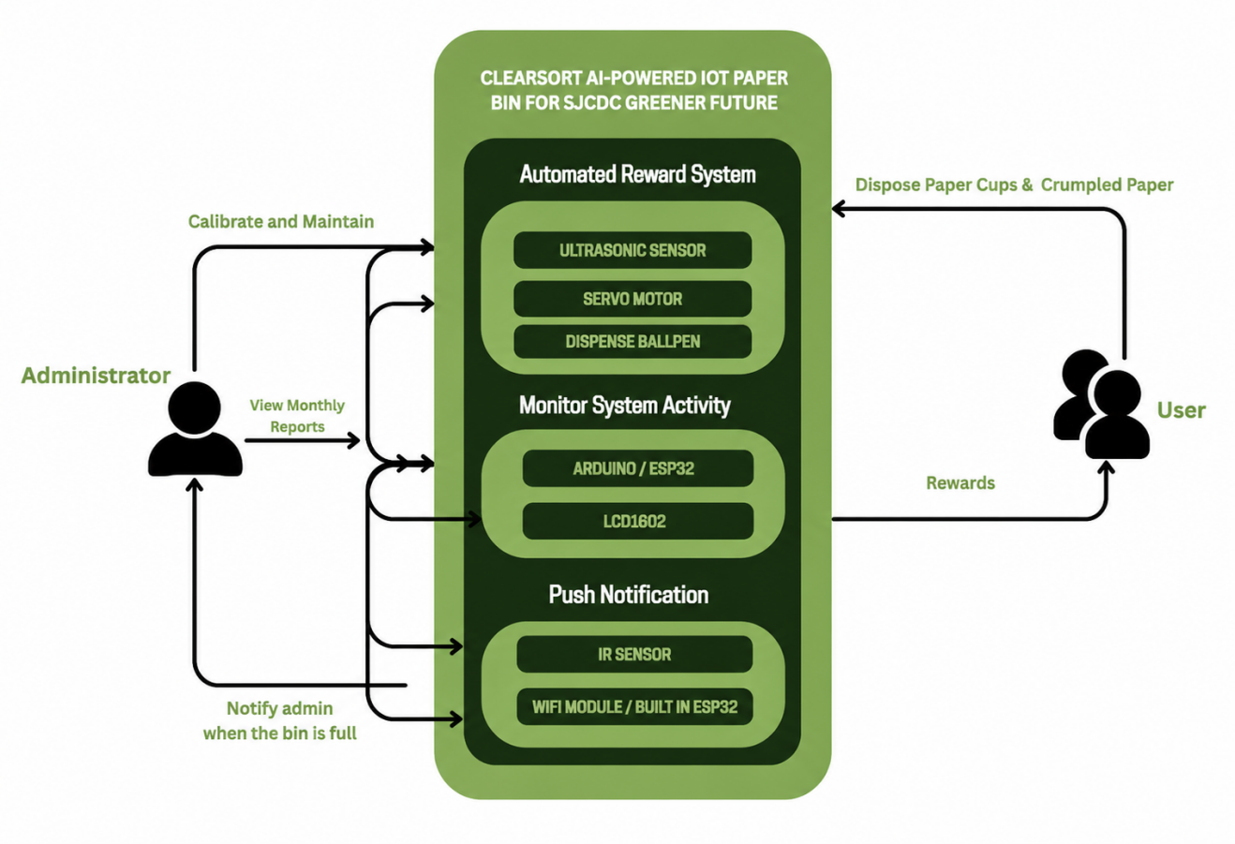
The Push Notification module serves as a real-time alert system that notifies the administrator when the bin is full.

Figure 1. Theoretical Framework of ClearSort:AI-Powered IoT Paper Bin for SJCDC Greener Future

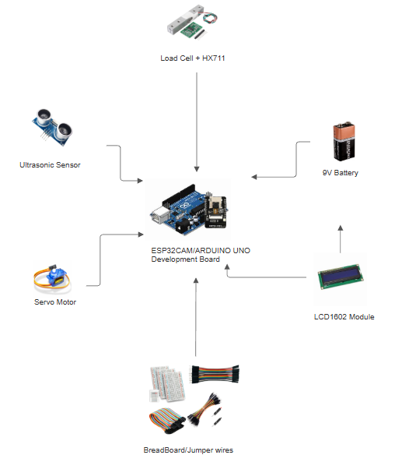
Figure 2. Shows the hardware requirements for the project.

Research Paradigm
The study's conceptual framework used the input-output process model for ClearSort: AI-Powered IoT Paper Bin for SJCDC Greener Future
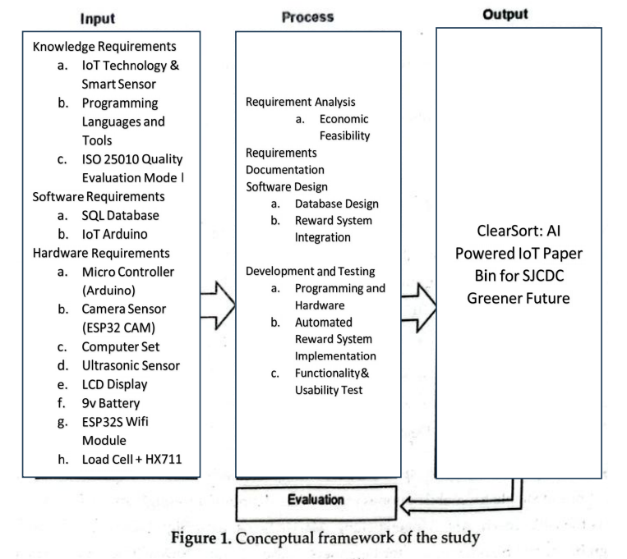
Figure 3. Research Paradigm of the Study

Statement of the Problem
Generally, the study aimed to develop an ClearSort: AI-Powered IoT Paper Bin for SJCDC Greener Future System for the community of PHINMA St Jude College of Dasmarinas Cavite This system intends to promote proper waste disposal by integrating technology with incentives, thereby encouraging active community participation in sustainable waste management.
Specifically, it aimed to answer the following questions:
- What are the existing problems encountered by the community in practicing proper waste disposal?
- How will the identified problem be analyzed?
- How will the website and kiosk be designed?
- How will the system be developed?
- How will the system be evaluated?

Significance of the Study
The study was conducted to be beneficial to the following:
For the Local Government and Waste Management Units, the system may ease the burden of waste collection and disposal by minimizing improper segregation. It can also reduce operational costs through optimized collection schedules and promote sustainable practices that align with environmental policies and goals.

For the Students, the system provides not only a convenient way of disposing of waste but also tangible benefits through the rewards program. The incentives can encourage consistent participation, create awareness about responsible waste management, and inspire behavioral change in everyday disposal habits.
For the Proponents of the Study, the research will help the developers gain valuable experience, knowledge, and skills in IoT integration, system design, and sustainability-focused innovations. It will also provide fulfillment as they contribute to addressing real-world community problems through technology-driven solutions.
For Future Researchers, this study may serve as a reference and guide for those interested in smart technologies, waste management, and sustainable development projects. It may inspire innovation and improvements in similar fields, especially in developing IoT-based community systems.

Scope and Delimitation
The proposed system focuses on promoting proper waste disposal within St. Jude College of Dasmariñas, managed solely by an Administrator. It features three main modules: Automated Reward, Reports, and Push Notification. The Automated Reward module records proper waste disposal and grants corresponding reward points to encourage consistent segregation practices. The Reports module allows the administrator to monitor and evaluate disposal activities through generated summaries and data analysis. The Push Notification

module provides real-time audio alerts for full bins, ensuring immediate feedback. The system is limited to a prototype level and intended for use only within St. Jude College of Dasmariñas. It is restricted to administrator access and does not include multi-user functions, mobile applications, or third-party reward integrations. Testing will be confined to the developed smart bin prototype within the school premises.

Definition of Terms
Arduino IDE. Used to write and upload code to the microcontroller such as Arduino. It supports various programming languages like C/C++ and controls the overall logic of the system, including sensor data processing and motor control.
Personal Computer. Used to write, test, and upload code to the Arduino board, and monitor or control the system.
ESP32. A low-cost and energy-efficient microcontroller developed by Espressif Systems that features built-in Wi-Fi and Bluetooth connectivity.
Resistor. Used to protect components by controlling voltage and current, ensuring that sensors and motors are not damaged by excessive current.
LCD Display. Used to display the waste materials that counts
Servo Motor. Used for activating the slope the waste to automate the sorting process.

CHAPTER 2

Review of Related Literature and Studies
The chapter's researcher gathered relevant domestic and international literature and studies to establish a context for the current investigation. It provides the researcher with a quick overview of the study's premises.
Raising Awareness on Solid Waste Management through Formal Education for Sustainability: A Developing Countries Evidence Review
Solid Waste Management (SWM) has become an increasingly critical issue in developing nations, where rapid population growth and urbanization place heavy demands on local resources and infrastructure. According to Debrah, Vidal, and Dinis (2021), despite growing awareness of environmental challenges, there remains a wide gap between knowledge and actual waste management practices among students and teachers. The researchers found that while formal education provides theoretical understanding of waste management, it often fails to translate into real-world sustainable habits. This is largely due to the lack of hands-on SWM training for educators, which limits their ability to demonstrate and enforce proper waste segregation practices within schools. As a result, many students understand the environmental consequences of waste mismanagement but lack the behavioral discipline and exposure necessary to act sustainably in everyday life.
To bridge this gap, Debrah et al. (2021) emphasized the integration of sustainability and practical waste management lessons across all levels of
education. By equipping teachers with technical skills and implementing activity-based learning, students can develop a stronger environmental ethic that extends beyond the classroom. This approach builds long-term habits and fosters eco-consciousness in future generations. In relation to ClearSort, this study supports the importance of education in building sustainable habits. ClearSort integrates technology with learning by serving as both a waste segregation tool and an educational platform that promotes environmental responsibility through active participation and visual reinforcement of proper waste disposal.
The Waste Management Program of 3R (Reduce, Reuse, Recycle) by Economic Incentive and Facility Support
Ineffective waste management is often linked to human behavior and insufficient understanding of the 3R (Reduce, Reuse, Recycle) principle. A study by Anua (2022) implemented a 3R education program for 155 primary students in Kelantan, Malaysia, to evaluate their knowledge, attitude, and practice (KAP) before and after a structured learning program. The research revealed that students showed notable improvement in their knowledge of 3R concepts following the intervention. However, changes in attitude and actual practice were less significant, suggesting that awareness alone may not be enough to ensure behavioral change. The study identified the need for consistent, hands-on engagement and accessible waste management facilities to reinforce the 3R concept among young learners.
Anua (2022) concluded that education should be complemented by economic incentives and facility support to motivate consistent participation in sustainable practices. For instance, providing convenient segregation bins and rewarding proper disposal behavior can strengthen environmental responsibility among students. Regular awareness campaigns and workshops were also recommended to sustain behavioral change over time.
Waste Disposal Management Practices in Selected Senior High Schools within the Wa Municipality of Ghana
Ampofo (2020) examined waste disposal practices in three senior high schools in Ghana’s Wa Municipality, using mixed-method data collection involving surveys, interviews, and observations. The study found that food waste, rubbish, and ashes were the most common types of solid waste produced in schools, often disposed of in open spaces without segregation. Both students and teachers expressed concern over the unsanitary conditions, noting the lack of proper disposal sites and sufficient dustbins. The research concluded that poor infrastructure, minimal supervision, and limited education on waste management contributed to the prevailing problem of improper waste disposal in these institutions.
Based on the findings, Ampofo recommended the installation of adequate dustbins, regular waste collection, and closer monitoring by local authorities to maintain cleanliness and prevent disease outbreaks. The study also emphasized the importance of instilling waste management education at the institutional level to create a sense of accountability among both students and staff.
Compared to this study, ClearSort introduces an innovative technological solution that addresses the very problems identified by Ampofo. Through its AI-based segregation system and IoT monitoring, ClearSort eliminates the need for manual sorting and promotes a cleaner, more efficient, and automated approach to waste management in educational institutions.
Assessment of Solid Waste Management Practice in the University Campus
Dahlawi (2021) conducted an extensive assessment of solid waste management (SWM) practices at Imam Abdulrahman Bin Faisal University in Dammam, Saudi Arabia. The study aimed to identify the types and quantities of municipal solid waste generated on campus and evaluate how effectively the waste was managed. The results revealed that 80% of the university’s waste consisted of recyclable materials—primarily paper and plastic—while 19% was compostable and only 1% was non-recyclable. The findings underscored the importance of implementing comprehensive SWM programs that emphasize segregation at source, recycling, and composting to reduce the environmental footprint of educational institutions.
The research concluded that proper segregation and recycling systems could significantly reduce waste volumes destined for landfills. It recommended introducing separate bins for various waste categories, establishing partnerships with recycling companies, and conducting periodic audits to monitor progress.
This study supports the rationale behind ClearSort’s development, as it confirms that a significant portion of school or university waste is recyclable—especially paper and plastic. ClearSort directly responds to this need by automating the segregation of recyclable materials, particularly paper waste, and promoting data-driven monitoring for institutional waste reduction.
Solid Waste Management Awareness and Practices among Junior High School Students
Corporal (2024) examined the level of awareness and actual waste management practices among junior high school students in the Philippines, aiming to understand how well young learners translate environmental knowledge into concrete actions. Using a descriptive quantitative approach and stratified random sampling, the study collected responses from students across various grade levels to ensure balanced representation. Results revealed that while students demonstrated a high level of understanding about solid waste management—particularly regarding waste segregation and reduction—their practices were often inconsistent. Many students were aware of the importance of sorting recyclables from non-recyclables but still tended to mix them due to convenience, lack of available bins, or insufficient monitoring within school premises. The findings also indicated that awareness campaigns and classroom discussions had a positive impact on students’ environmental attitudes, but the absence of practical reinforcement limited the development of long-term habits.
The study further emphasized that effective solid waste management education should be experiential rather than purely theoretical. It suggested that schools should invest in visual learning tools and interactive systems that allow students to engage directly with segregation processes. Providing accessible and clearly labeled bins, incorporating sustainability into extracurricular activities, and reinforcing accountability through school policies were identified as key strategies to sustain student participation. Corporal concluded that for environmental education to create meaningful behavioral change, it must be supported by accessible infrastructure and technology-driven initiatives that bridge the gap between awareness and consistent waste management behavior among the youth.
Awareness and Compliance of the Students, Faculty, and Staff of Kalinga State University on the Solid Waste Management Program
Bona (2023) investigated the level of awareness and compliance of students, faculty, and staff at Kalinga State University regarding the institution’s solid waste management program. The study involved 367 respondents, the majority of whom were students, and focused on their familiarity with the 3Rs (Reduce, Reuse, Recycle) and local waste disposal protocols. Using a descriptive-correlational research design, the study examined whether knowledge of waste management regulations translated into actual compliance. Results showed that while most respondents were moderately aware of the program, their adherence to proper segregation and recycling remained inconsistent. Limited availability of waste bins, insufficient signage, and lack of regular monitoring contributed to low compliance rates, particularly in common areas like cafeterias and hallways.
The study recommended strengthening the university’s information and education campaigns through seminars, posters, and digital reminders to increase participation. It also proposed better coordination with local waste authorities and the creation of a centralized Materials Recovery Facility (MRF) to support proper waste segregation and recycling. According to Bona, ensuring visible and functional facilities is critical to fostering sustainable habits, as students are more likely to comply with programs that are convenient and well-supported by the institution. The results highlight that compliance improves when environmental awareness is coupled with accessible technology, structured programs, and accountability measures that make sustainability part of the university routine.
Related Studies
Foreign Studies
A 5G-Enabled Smart Waste Management System for University Campus
Longo et al. (2021) designed an advanced smart waste management system integrating 5G connectivity to improve the efficiency and sustainability of university waste collection. The study introduced an intelligent bin system equipped with sensors, cameras, and machine learning algorithms to classify, monitor, and manage waste in real-time. The integration of 5G technology enabled faster data transmission between waste bins and the central control unit, which facilitated instant updates on bin capacity and collection needs. The research team analyzed waste management across several university buildings, identifying inefficiencies in collection scheduling and improper segregation as common problems. Their system optimized collection routes and reduced operational costs by predicting when bins would reach full capacity using data analytics.
The researchers highlighted that applying 5G and Internet of Things (IoT) technologies in educational institutions can greatly enhance sustainability and efficiency. Through real-time data collection and automation, the system reduced unnecessary waste collection trips and improved recycling accuracy. Longo et al. emphasized that intelligent infrastructure not only makes operations smoother but also raises awareness among students and staff about the importance of responsible waste management. This study demonstrated how merging advanced connectivity, automation, and education can help academic institutions evolve into sustainable environments where technology supports environmental responsibility.
Arduino-Based Smart Dustbin for Waste Management during COVID-19
Chand (2021) addressed India’s growing waste management crisis during the COVID-19 pandemic, where increased waste generation from households, hospitals, and quarantine facilities posed serious health risks to sanitation workers. The study developed a smart dustbin prototype using Arduino technology, equipped with ultrasonic and infrared sensors to detect the presence and level of waste inside the bin. Once the bin reached a specific capacity, a GSM module automatically transmitted notifications to waste collection authorities. The system minimized human contact with waste, thereby reducing the risk of infection spread, while maintaining operational efficiency. It also demonstrated the use of low-cost components, making it suitable for developing regions with limited resources.
Beyond its practical application during the pandemic, the project illustrated the potential of automation in managing public hygiene and environmental cleanliness. The researchers observed that implementing automated bins could significantly reduce overflow and unsanitary conditions in crowded areas. The success of this system showed that affordable technologies such as Arduino and GSM could be adapted for community-level waste management, combining safety with environmental sustainability. The study reflected the growing global shift toward contactless and automated waste systems, which are particularly vital during health crises and in environments that require strict sanitation control.
Solar-Powered Smart Bin: Revolutionizing Waste Classification for a Sustainable Future
Hesham (2023) explored the development of a solar-powered smart bin that combines renewable energy with artificial intelligence to promote sustainable waste management. The study proposed a system that operates autonomously by using solar panels to power the sensors and cameras responsible for sorting waste into recyclable and non-recyclable categories. The AI algorithm within the system identifies the type of material through image recognition, enabling proper segregation without human intervention. In addition to reducing the strain on municipal waste systems, the bin was designed to function in areas with limited power access, making it highly adaptable to urban and rural environments alike.
The research found that solar-powered waste systems can drastically lower operational costs and environmental impact while maintaining high accuracy in segregation. The integration of clean energy technology not only makes the system sustainable but also reduces dependence on traditional electricity sources. Hesham’s study demonstrated how renewable energy can be harnessed to enhance smart city initiatives, turning everyday waste bins into efficient, self-sustaining systems. It also emphasized the importance of incorporating technology into waste management to improve community cleanliness, reduce manual labor, and promote environmental awareness among citizens.
IoT-Based Intelligent Route Selection of Waste Segregation for Smart Cities Using Solar Energy
Ashwin (2021) introduced a smart waste management model that combines IoT sensors and solar energy to enhance the efficiency of urban waste collection. The study developed a smart bin that can automatically open and close its lid using proximity sensors and classify waste into dry and wet categories. Once the bin approaches its full capacity, it sends an alert to the collection center through IoT-based communication. The system uses solar panels to power its operations, ensuring sustainability even in areas without stable electricity. To further optimize collection logistics, the researchers employed a route selection algorithm that determines the shortest and most efficient path for waste trucks, thereby minimizing fuel consumption and collection time.
The study emphasized that integrating renewable energy with intelligent communication systems can transform waste management into a cleaner and more energy-efficient process. It also highlighted that automation and real-time monitoring significantly reduce human workload and improve responsiveness in waste management systems. Ashwin’s findings showed that combining IoT and solar technologies not only benefits environmental sustainability but also supports the development of smarter, more adaptive urban infrastructures capable of maintaining cleaner public spaces through minimal human intervention.
Strategic Waste Management Practices for Environmental Sustainability: A Case of an Indian University
Sawalkar (2023) conducted a case study at a university in Pune, India, to assess how higher education institutions can adopt strategic waste management practices to foster environmental sustainability. The research explored waste generation sources within the campus, including classrooms, cafeterias, and dormitories, and developed a waste reduction and recycling framework tailored to university operations. Through interviews with staff and environmental officers, the study found that poor segregation habits and lack of accountability were key barriers to effective waste management. The proposed model introduced a “closed-loop” system where materials are reused and recycled within the institution, significantly reducing landfill contributions.
The study concluded that universities play a crucial role in setting examples for sustainable waste management and should implement structured systems that combine policy, technology, and awareness. By establishing clear waste collection mechanisms and recycling programs, universities can reduce environmental impact while educating students about sustainability. Sawalkar emphasized that environmental management should be viewed not as a separate initiative but as an integral part of institutional development, ensuring that waste reduction becomes part of daily operations. The case demonstrated how strategic planning and community engagement can create sustainable, waste-conscious academic environments that balance growth with environmental care.

Local Studies
e-TapOn: Solar-Powered Smart Bin with Path-Based Robotic Garbage Collector
Samonte (2021) conducted a study that explored how the Internet of Things (IoT) could be applied to improve waste management through automation and renewable energy. The research introduced e-TapOn, a solar-powered smart bin equipped with color sensors, ultrasonic modules, and a robotic garbage collector capable of following a programmed path to collect and transport waste. The system was designed to reduce human involvement in waste collection while maintaining efficiency and hygiene in public and institutional environments. It also included a web-based interface where users could monitor bin status in real time, allowing maintenance personnel to efficiently schedule collection tasks. By utilizing solar energy, the system demonstrated sustainability and cost-effectiveness, especially for locations with limited power infrastructure.
Testing results revealed that the e-TapOn system successfully detected waste types based on color and navigated autonomously using a path-based robotic mechanism. The combination of IoT integration and renewable energy provided a practical solution to managing solid waste in urban areas. Samonte’s findings showed that applying smart automation in waste management could significantly reduce human labor, improve cleanliness, and support environmental sustainability. This study highlights how innovation and technology can align to address persistent waste issues in communities and schools, creating systems that are both efficient and eco-friendly while promoting environmental awareness among users through visible technological engagement.
EcoCharge: Innovative Solar and Wind Charging Station Enabled by Solid Waste Contributions
Gomez (2023) presented an innovative approach to combining renewable energy with waste management through the EcoCharge system. The project proposed a dual-purpose charging station powered by solar and wind energy that collects and processes waste materials as part of its operational input. Waste sensors detect when users deposit trash, which triggers an energy allocation system that converts stored power into available charging time for users’ devices. The system promotes environmental consciousness by allowing people to contribute waste in exchange for utility—an incentive-based approach to responsible waste disposal. Data gathered from testing revealed that optimal energy generation occurred between 11:00 a.m. and 1:00 p.m., aligning with peak sunlight and wind activity. The researchers concluded that the system functioned efficiently even with varying waste inputs, proving its potential as a sustainable urban infrastructure innovation.
The study demonstrated how renewable energy systems can be creatively integrated into waste management programs to encourage participation and environmental stewardship. By linking waste disposal with direct user benefits such as charging access, the EcoCharge system redefined waste from being a pollutant to a valuable resource. The project’s emphasis on self-sufficiency and clean energy generation highlighted a future direction for sustainable technologies in the Philippines. Beyond its technical contributions, the research also underscored the importance of promoting public engagement in sustainability projects through visible and interactive designs that transform everyday waste disposal into an educational and eco-positive experience.

Design and Implementation of Automated Waste Segregator with Smart Compression
Endaya (2020) developed an automated waste segregation and compression system that aimed to improve the efficiency of waste disposal through automation. The study used Arduino Uno microcontrollers to manage various system components, including sensors, stepper motors, and linear actuators. Users could select waste type through buttons that triggered the rotation of bins on a circular plate to the appropriate position. Once filled, the bins automatically compress the waste using a linear actuator, optimizing space and reducing the frequency of collection. LEDs provided real-time status indicators, signaling whether a bin was full or still operational. The researchers emphasized that automation could simplify waste handling, making it faster and less labor-intensive for both households and institutions.
The study demonstrated that integrating electronic and mechanical components could result in a fully functional smart segregation system that promotes efficiency and sustainability. Results from testing indicated high accuracy in waste categorization and significant reduction in waste volume after compression. The design’s modular structure made it scalable and adaptable for schools, offices, and residential areas. The researchers concluded that such a system could support government and community initiatives to maintain cleaner environments while raising public awareness of proper waste management. The study reinforced the importance of using automation not only to enhance efficiency but also to foster responsibility and participation among citizens by simplifying the segregation process.

Automated Waste Segregation System Using Arduino Uno R3
Tan (2024) designed a system to automatically sort waste using sensors and servo motors, controlled by an Arduino Uno R3 microcontroller. The device categorized waste into dry and wet materials, significantly improving sorting accuracy compared to manual methods. Moisture sensors detected wet waste, while infrared sensors identified dry materials, directing them into corresponding bins. During testing with twenty participants, the system achieved a high accuracy rate in waste identification and sorting. Participants reported that the
automated process was not only faster but also reduced unpleasant exposure to unsorted garbage, making the system more hygienic and efficient.
The study emphasized how automation could streamline waste segregation by removing human error and increasing overall efficiency. Tan’s design provided a strong foundation for integrating further technologies such as AI and IoT to enhance system intelligence and remote monitoring. The research highlighted that small-scale innovations like this could be expanded to schools, local communities, or even municipal facilities, significantly improving solid waste management in the country. By demonstrating how accessible electronic components can create effective environmental solutions, the study contributed to the broader national effort to modernize waste handling practices through innovation and sustainable engineering.

CHAPTER 3
Methodology
The chapter explains how the research is carried out. It includes the research technique, the respondents, the data sources, the instrument used in the study, and the statistical treatment for data interpretation and analysis.

Research Design
This study will utilize a Developmental–Descriptive Research Design. Developmental research is appropriate because the study involves the design, development, and evaluation of an Automated Smart Waste Bin System equipped with a load cell, ultrasonic sensor, servo motor, ESP32 controller, and push notification functionality. The developmental phase focuses on system analysis, component integration, circuit design, prototyping, programming, and iterative testing to ensure that the smart bin accurately detects waste level, measures bin weight, and automates lid control while sending real-time notifications.
A descriptive component will follow to evaluate user perceptions regarding the system’s usability, functionality, accuracy, responsiveness, and reliability. Descriptive research allows the researchers to systematically gather quantifiable feedback that describes how effectively the system performs in real-world use, as experienced by end-users such as students, custodians, or facility personnel.
Together, the developmental–descriptive approach ensures that the study (1) produces a fully functional prototype of the Automated Smart Waste Bin System,

and (2) assesses its acceptability, efficiency, and effectiveness based on structured user evaluation.

Methods
To determine an appropriate method, a realistic time-frame for the project is established, as well as detailed specifications for all software and hardware components. Various techniques for creation are proposed and considered. Rapid Application Development (RAD) is the perfect methodology for this project.
Rapid Application Development is a software development model that emphasizes quick prototyping, iterative testing, and user feedback. It allows the researcher to rapidly develop a functional system that can be improved through continuous user evaluation. According to James Martin (1991), the RAD model focuses on the fast delivery of prototypes by combining well-defined phases with short development cycles. It is suitable for projects that require flexibility, immediate feedback, and continuous system enhancement.
The key motivation for adopting the RAD model is the need for quick adaptation and system refinement. The methodology allows the researcher to modify the system anytime based on the results of testing and evaluation. Since the ClearSort system integrates both software and hardware components, RAD provides an efficient approach for iterative design, construction, and testing. The Rapid Application Development Life Cycle consists of four main phases: Requirements Planning, User Design, Construction, and Cutover.
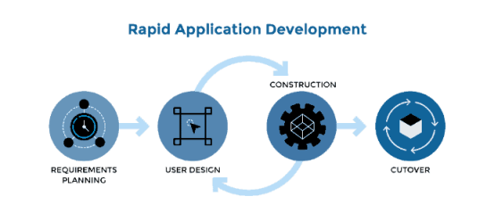
Figure 4. Rapid Application Development (RAD) Model (James Martin)

Requirements Planning
The Requirements Planning phase focuses on defining the project’s scope, objectives, and system needs.
The researcher meets with the General Services Department (GSD) Head of St. Jude College Dasmariñas, Cavite (SJCDC) to identify the issues related to improper paper waste disposal. To obtain a comprehensive understanding of the problem, both primary and secondary data are collected. Primary data consist of interviews and on-site observations within the school, allowing the researcher to analyze existing waste management practices and identify inefficiencies suitable for automation. Secondary data include journal articles, research papers, and online resources related to artificial intelligence (AI), Internet of Things (IoT), and sustainable waste management practices. Based on the findings, the functional and non-functional requirements of the system are established. Key requirements include the use of an ESP32-CAM for image capture, TensorFlow

Lite for AI-based waste classification, servo motors for automated bin movement, and ultrasonic sensors for waste-level detection. These specifications serve as the basis for the succeeding design activities.

User Design
In the User Design phase, the system’s structure and workflow are being developed according to the gathered requirements. The researcher is creating analytical diagrams such as Fishbone Diagrams to determine the root causes of improper waste disposal and HIPO (Hierarchy Input-Process-Output) Diagrams to illustrate the system’s functional processes.
Both hardware and software components are being designed. The hardware design includes the ESP32-CAM module, ultrasonic sensors, microcontroller, and servo motors, while the software design focuses on integrating the AI classification model and structuring the operational flow.
Prototyping will be conducted to assess usability and performance. Feedback and testing results will guide iterative refinements to ensure that the design meets user expectations and project requirements. This continuous improvement process will prepare the system for full development.

Construction
During the Construction phase, the actual development of the system will take place. The researcher will assemble the prototype and will program the ESP32-

CAM using the Arduino IDE for image capture and waste classification. Servo motors will be configured to manage bin movements, while ultrasonic sensors will
be programmed to monitor waste levels.
Throughout this phase, continuous testing and debugging will be performed to ensure that all components function accurately and reliably. Hardware connections, AI performance, and software operations will be refined through multiple iterations. By the end of this phase, the Clear-Sort prototype will be fully functional and ready for deployment testing.

Cutover
In the Cutover phase, the system will be deployed in its actual environment for final testing. The prototype will be installed in a designated area within SJCDC, where users will interact with the system by placing various waste items for detection and sorting.
During this stage, the researcher will gather feedback through direct observation and user evaluation. System performance will be assessed in terms of accuracy, speed, reliability, and overall user satisfaction. Any issues or malfunctions will be documented and will be corrected immediately.
Once the system shows stable and consistent performance, the researcher will finalize the setup and will conduct an orientation for users regarding operation and maintenance. This phase will conclude with the system being ready for full scale deployment.
Participants of the Study
The respondents were divided into groups based on the provided important metadata regarding the samples required for each target group.
Table 1 illustrates the breakdown of the respondents required to be the source of the researchers' surveys.
CLASSIFICATION | FREQUENCY | PERCENTAGE
Students | 84 | 84%
GSD | 6 | 6%
IT Professional | 10 | 10%
TOTAL | 100 | 100%

Table 1. The following is a representation of the responses to the software evaluation.

Sampling Technique
This study will employ Stratified Random Sampling to ensure that feedback on the Automated Smart Waste Bin System is gathered from participants who represent different user groups within the school. Stratified sampling is appropriate because the target population is composed of distinct subgroups that interact with the waste disposal system in different ways.
The population will be divided into strata, such as students and GSD members. Each stratum will contribute participants proportionally. After grouping,

respondents will be selected randomly within each stratum, ensuring that every member of each group has an equal chance of being included.
This technique increases the representativeness of the sample, reduces sampling bias, and ensures that the evaluation of the system reflects perspectives across all relevant user categories. By using stratified random sampling, the study can obtain more reliable and balanced insights regarding the system’s usability, efficiency, and overall acceptability.

Data Analysis
1. Proportion. The researchers used the term proportion to characterize the demographic profile of the study's participants.
Formula:

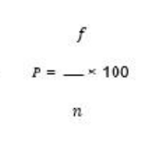
Where:
P = Proportion
F = The number of observations in each class or frequency
n = The sample size refers to the total number of observations in the study.
2. Weighted Mean. The researchers used weighted means to assess the respondents involved in the study.

Formula:
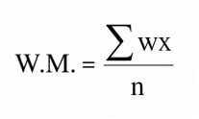

Where:
w - number of respondents who answered specific scale/item
x = values of the Likert scale
Likert Scale – The data was evaluated using the five-level Likert scale method as a criterion, which served as the foundation for the data interpretation. The rate and interpretation of data are shown in Table 2.
Table 2. The Five-Point Likert scale was used in rating the software.
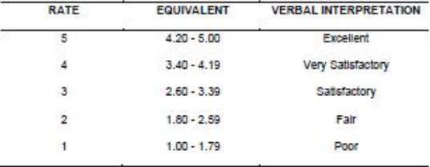

CHAPTER 4

Results and Discussion
This chapter presents the results, analysis, and interpretation of the data gathered through the survey questionnaires conducted among the selected respondents. The study aimed to determine the effectiveness, acceptability, and overall performance of the developed system entitled ClearSort: AI-Powered IoT Paper Bin for SJCDC Greener Future. The respondents evaluated the system based on the ISO/IEC 25010 Software Quality Model, specifically in terms of Functional Suitability, Performance Efficiency, Compatibility, Usability, Reliability, and Portability.

Results
System Concepts and Requirements
The ClearSort: AI-Powered IoT Paper Bin for SJCDC Greener Future was developed to address the current waste management concerns inside the school, particularly the improper disposal of paper cups and recyclable paper waste. Based on the interview conducted with the General Services Department (GSD), the existing process of waste collection relies heavily on manual segregation and collection practices.
The identified issues include mixed waste disposal, lack of user discipline in following proper segregation procedures, delayed collection of full bins, and absence of incentive systems that encourage responsible disposal behavior.

To solve these concerns, the proponents developed ClearSort as an intelligent waste disposal system that integrates Artificial Intelligence (AI), Internet of Things (IoT), and automated reward mechanisms. The system was designed to recognize paper cups, record disposal activity, monitor bin levels, and provide user rewards after successful disposal.
Design Specification and Coding
The system was designed based on the requirements gathered during the planning phase. Both hardware and software components were integrated to ensure efficient system functionality.
The following tools and technologies were used in the development of the system:
- Arduino IDE for programming the microcontroller
- ESP32-CAM for image recognition and camera input
- Ultrasonic Sensor for waste level detection
- Servo Motor for automated mechanism movement
- LCD Display for output messages
- Wi-Fi Connectivity for push notifications
- Structured coding logic for AI classification and reward activation
The system interface and physical prototype were developed according to the desired operational flow of the project.

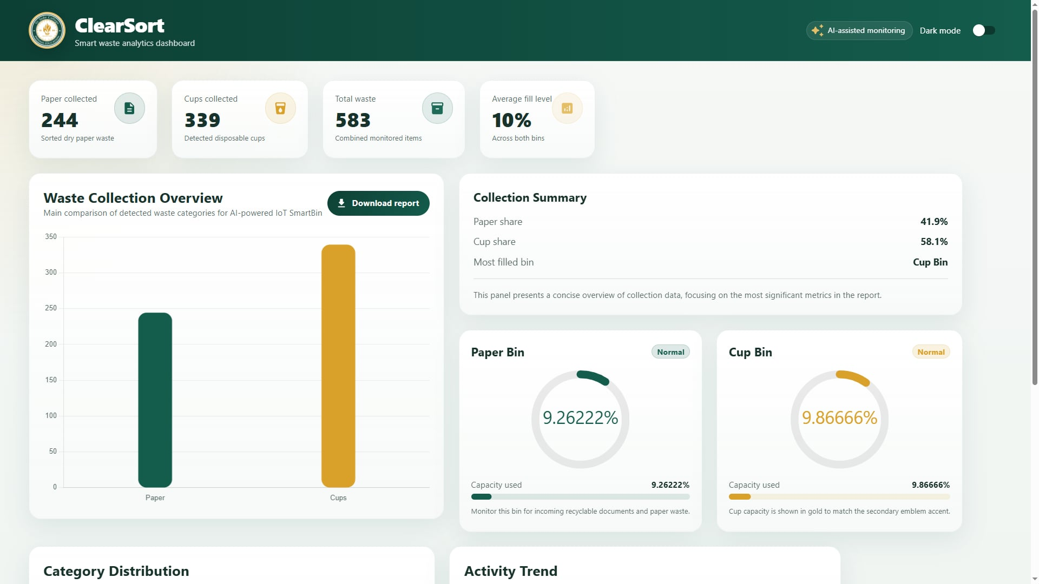
=

Figure 5. The screen layout of the Admin Dashboard
The admin dashboard contains a centralized monitoring panel that displays key waste management data such as total paper cups collected, total rewards dispensed, current bin capacity levels, and collection efficiency percentages. It also includes graphical summaries, real-time statistics, and system activity reports to help the administrator monitor overall performance, manage waste collection, and evaluate the effectiveness of the ClearSort system.

Module Construction and Prototype Refinement
The prototype underwent continuous construction and refinement using the Rapid Application Development (RAD) methodology. The system was divided into major modules:
- AI Waste Recognition Module – identifies accepted waste material such as paper cups.
- Automated Reward Module – activates alcohol spray after successful disposal.
- Monitoring and Reports Module – records user interactions and system usage.
- Push Notification Module – alerts administrators when the bin is already full.
Each module was tested individually before full integration. Necessary adjustments were made based on trial runs and user feedback.

Software Testing
The system was tested multiple times to ensure that the prototype responds correctly based on expected input conditions.
Testing included:
- Waste object recognition accuracy
- Servo motor response after classification
- Sensor detection for full bin monitoring

- Alcohol reward activation
- LCD output messages
- Notification trigger when bin is full
The results of testing showed that the system was functioning properly and was ready for user evaluation.

Software Evaluation

Based on the software testing results, ClearSort demonstrated stable and consistent behavior across functionality, efficiency, compatibility, usability, reliability, and portability checks. The following section presents the system evaluation results together with the interpretation of the weighted means.
Table 3. Functional suitability assessment of the software
Functional Suitability | Weighted Mean | Verbal Interpretation
1. The system performs its intended waste classification functions accurately. | 4.50 | Excellent
2. The system successfully recognizes and processes paper waste disposal activities. | 4.49 | Excellent
3. The features of the system effectively support proper waste segregation and monitoring. | 4.51 | Excellent
General Weighted Mean | 4.50 | Excellent

Table 3 shows the functional suitability assessment results of the software based on completeness, correctness, and appropriateness of the system functions. Functional completeness obtained a weighted mean of 4.50 with a verbal interpretation of Excellent, indicating that ClearSort provides the required features expected by the users. Functional correctness obtained 4.49, also interpreted as Excellent, which implies that the system produces accurate waste classification and monitoring outputs. Functional appropriateness obtained the highest indicator mean of 4.51 and was likewise rated Excellent, showing that the system features effectively support waste segregation activities within the school environment. Overall, the system achieved a general weighted mean of 4.50, resulting in an Excellent rating for functional suitability.

Table 4. Performance efficiency assessment of the software
Performance Efficiency | Weighted Mean | Verbal Interpretation
1. The system responds efficiently during waste detection and classification. | 4.45 | Excellent
2. The system performs without noticeable delays during operation. | 4.42 | Excellent
3. The system processes waste disposal activities smoothly and consistently. | 4.45 | Excellent
General Weighted Mean | 4.44 | Excellent

Table 4 presents the performance efficiency assessment results of the software. Response efficiency during waste detection obtained a weighted mean of 4.45 interpreted as Excellent, indicating that the system reacts quickly during operation. Delay-free performance obtained 4.42 with an Excellent interpretation, suggesting that users experienced minimal lag during usage. Smooth processing of disposal activities obtained 4.45, also rated Excellent, reflecting stable system performance during operation. Overall, the criterion achieved a general weighted mean of 4.44, interpreted as Excellent, indicating that ClearSort performs efficiently under expected operating conditions.

Table 5. Compatibility assessment of the software
Compatibility | Weighted Mean | Verbal Interpretation
1. The hardware and software components work properly together. | 4.53 | Excellent
2. The system allows smooth communication between sensors, modules, and monitoring components. | 4.49 | Excellent
General Weighted Mean | 4.51 | Excellent

Table 5 outlines the compatibility assessment results of the software. Compatibility between hardware and software components obtained a weighted mean of 4.53 with an Excellent interpretation, indicating that the integrated technologies function effectively together. Communication among sensors, monitoring modules, and system components obtained 4.49, also interpreted as Excellent, showing smooth coordination within the system. Overall, the criterion obtained a general weighted mean of 4.51, interpreted as Excellent, making compatibility the highest-rated criterion in the evaluation.

Table 6. Usability assessment of the software
Usability | Weighted Mean | Verbal Interpretation
1. The system is easy to understand and operate. | 4.45 | Excellent
2. The interface and output messages are clear and organized. | 4.42 | Excellent
3. Users can easily learn how to use the system. | 4.44 | Excellent
4. The operation flow of the system is simple and user-friendly. | 4.41 | Excellent
General Weighted Mean | 4.43 | Excellent

Table 6 presents the usability assessment results of ClearSort. Ease of understanding and operation obtained a weighted mean of 4.45 interpreted as Excellent, indicating that users can interact with the system with minimal difficulty. Clarity and organization of the interface and output messages obtained 4.42, while learnability obtained 4.44, both interpreted as Excellent. Simplicity of system operation obtained 4.41 and was likewise rated Excellent, reflecting user-friendly navigation and operation flow. Overall, the criterion achieved a general weighted mean of 4.43, interpreted as Excellent, indicating strong user acceptance of the system design.

Table 7. Reliability assessment of the software
Reliability | Weighted Mean | Verbal Interpretation
1. The system operates consistently during usage. | 4.44 | Excellent
2. The system performs accurately with minimal operational errors. | 4.41 | Excellent
3. The system maintains stable functionality during continuous operation. | 4.44 | Excellent
General Weighted Mean | 4.43 | Excellent

Table 7 shows the reliability assessment results of ClearSort. Consistent operation during usage obtained a weighted mean of 4.44 interpreted as Excellent, indicating stable system behavior throughout testing and evaluation. Minimal operational errors obtained 4.41 with an Excellent interpretation, suggesting dependable performance during waste classification and monitoring. Stability during continuous operation obtained 4.44 and was likewise rated Excellent, reflecting the system’s capability to maintain reliable performance over time. Overall, the criterion achieved a general weighted mean of 4.43, interpreted as Excellent.

Table 8. Portability assessment of the software
Portability | Weighted Mean | Verbal Interpretation
1. The system can be deployed in different school locations. | 4.42 | Excellent
2. The system can be adapted to different operational environments. | 4.39 | Excellent
3. The system components can be installed and maintained easily. | 4.39 | Excellent
General Weighted Mean | 4.40 | Excellent

Table 8 presents the portability assessment results of the software. Deployment capability across different school locations obtained a weighted mean of 4.42 interpreted as Excellent, indicating that the system can be implemented in various operational areas. Adaptability to different environments obtained 4.39, also interpreted as Excellent, suggesting flexibility in system deployment. Ease of installation and maintenance likewise obtained 4.39 with an Excellent interpretation. Overall, the criterion achieved a general weighted mean of 4.40, confirming that ClearSort is portable and practical for implementation within the institution.
Table 9. Summary of software quality assessment results
Criteria | W.M | Verbal Interpretation
Functional Suitability | 4.50 | Excellent
Performance Efficiency | 4.44 | Excellent
Compatibility | 4.51 | Excellent
Usability | 4.43 | Excellent
Reliability | 4.43 | Excellent
Portability | 4.40 | Excellent
Overall General Weighted Mean | 4.45 | Excellent

Table 9 summarizes the criterion-level assessment results of the software. All major quality dimensions obtained verbal interpretations of Excellent. Compatibility obtained the highest weighted mean of 4.51, indicating effective integration between the hardware and software components of the system. Functional Suitability followed with 4.50, showing that the system successfully meets its intended objectives. Portability obtained the lowest weighted mean of 4.40, although it still received an Excellent interpretation, suggesting a possible area for future enhancement. Overall, the grand weighted mean of 4.45 confirms that ClearSort achieved a high level of acceptability, effectiveness, and implementation readiness.

Discussion
The ClearSort: AI-Powered IoT Paper Bin for SJCDC Greener Future was developed to improve waste disposal discipline and promote sustainability inside the school campus.
The interview and observation process helped identify the major problems in the current waste management system, such as poor segregation habits, mixed waste disposal, delayed collection, and lack of motivation among users.
The developed system successfully addressed these issues through the integration of Artificial Intelligence, IoT sensors, automation, and incentive-based rewards.
The evaluation results revealed that the respondents rated the system with an overall weighted mean of 4.45, verbally interpreted as Excellent. This means that the respondents strongly agreed that the system meets its intended objectives and performs efficiently.
Among all criteria, Compatibility received the highest mean of 4.51, indicating that the hardware and software components worked effectively together. On the other hand, Portability received the lowest mean of 4.40, although it is still interpreted as Excellent.
The findings prove that the developed system is acceptable, functional, innovative, and suitable for school implementation.

CHAPTER 5

Summary, Conclusions and Recommendations

This chapter presents the summary of findings gathered from the development, testing, and evaluation of the proposed system. It also provides the conclusions derived from the results of the study and offers recommendations for future improvement, implementation, and enhancement of the developed system.

Summary

This study focused on the development and evaluation of ClearSort: AI-Powered IoT Paper Bin for SJCDC Greener Future, an intelligent waste management system designed to improve proper waste segregation, automate waste monitoring, and promote environmental awareness within the school campus. The study was conducted in response to the existing problems observed in the institution’s waste management practices, particularly improper paper waste disposal, mixed waste segregation, delayed waste collection, and the lack of user motivation in practicing responsible waste disposal.

ClearSort was developed with several intelligent and automated features intended to modernize waste management processes inside the school. These features include AI-based waste recognition for identifying paper cups and recyclable paper waste, automated waste segregation mechanisms, ultrasonic sensor monitoring for detecting bin capacity levels, automated alcohol reward activation, push notification functionality for full-bin alerts, and an administrative monitoring dashboard for tracking waste collection statistics and system performance. The system was developed using Arduino IDE, ESP32-CAM, ultrasonic sensors, servo motors, LCD modules, Wi-Fi connectivity, and AI-based classification logic.

The evaluation results revealed that ClearSort received Excellent ratings in all major criteria including Functional Suitability, Performance Efficiency, Compatibility, Usability, Reliability, and Portability, with an overall weighted mean of 4.45 interpreted as Excellent. The findings indicate that the developed system successfully achieved the objectives of the study and proved to be functional, reliable, efficient, and user-friendly for institutional waste management operations.

Overall, the study demonstrated that integrating Artificial Intelligence (AI), Internet of Things (IoT), automation, and reward-based mechanisms can significantly improve waste segregation practices, operational efficiency, and environmental awareness within academic institutions. ClearSort serves as a practical and innovative solution that supports sustainable waste management and promotes greener practices in St. Jude College Dasmariñas, Cavite.

Conclusions

Based on the findings, the study concludes that:

ClearSort is a feasible and acceptable solution for improving waste segregation, monitoring, and disposal practices within the school environment, as supported by the Excellent overall evaluation rating.

The strong functional suitability and performance efficiency results indicate that the system can accurately classify waste and perform efficiently during operation, consistent with the findings of Longo et al. (2021) and Chand (2021) regarding the effectiveness of intelligent and automated waste management technologies.

The integration of AI, IoT sensors, automation, and notification systems supports operational efficiency and environmental sustainability, aligning with the studies of Hesham (2023), Ashwin (2021), and Samonte (2021) on the importance of smart and sustainable waste management systems.

Although the system received Excellent ratings across all criteria, portability and usability still present opportunities for further enhancement and wider deployment. This finding is consistent with the studies of Endaya (2020) and Tan (2024), which emphasized the importance of scalable and adaptable automated waste segregation systems.

Sustained implementation of ClearSort requires continuous monitoring, maintenance, and future technological enhancement to maintain efficiency, reliability, and long-term usability. This supports the findings of Sawalkar (2023) and Bona (2023), which emphasized the importance of structured sustainability programs, maintenance support, and institutional participation in effective waste management initiatives.

Recommendations

Grounded on the conclusions, the study recommends the following:

Introduce additional system enhancements such as support for plastic bottles, cans, and other recyclable materials to further improve the waste segregation capability of the system.

Improve the AI recognition accuracy, processing speed, and sensor responsiveness to strengthen the overall operational efficiency and classification performance of the system.

Enhance the monitoring and reporting functions of the system through the development of a more advanced web-based or cloud-based dashboard for real-time monitoring, analytics, and maintenance management.

Expand the implementation of ClearSort to additional strategic locations within the school such as hallways, classrooms, canteen areas, and public spaces to maximize waste management efficiency and environmental awareness.

The researcher recommends the ClearSort: AI-Powered IoT Paper Bin for SJCDC Greener Future in St. Jude College Dasmariñas, Cavite to improve waste segregation practices, operational efficiency, and environmental sustainability within the institution. Additional details regarding the projected system cost, required hardware components, and implementation-related documents are presented in Appendix F and other supporting appendices of the study.

References
Asemi, A., Safari, A., & Asemi Zavareh, A. (2011). The role of management information systems (MIS) and decision support systems (DSS) in improving managerial decision-making processes and organizational efficiency. International Journal of Business and Management, 6(7), 164–173.
Bawden, D., & Robinson, L. (2012). Introduction to information science: Fundamental concepts, systems, and applications in modern digital information environments. London: Facet Publishing.
Breeding, M. (2015). Library services platforms as integrated systems designed to manage cataloging, circulation, and digital resources in modern academic libraries. Library Technology Reports, 51(4), 1–35.
Cruz, J., et al. (2025). Automated library system for Philippine colleges focusing on improving transaction efficiency, record management, and accessibility of academic resources.
Design and development of an intelligent automated waste segregation system using Arduino for efficient classification and sustainable waste management practices. Retrieved from https://ieeexplore.ieee.org/document/10847447
Design and development of a smart trash bin for recyclable wastes integrating automation and environmental sustainability concepts.
e-TapOn: Solar-powered smart bin with path-based robotic garbage collector integrating automation, smart navigation, and renewable
energy systems. Retrieved from https://ieeexplore.ieee.org/document/9436763
Gaur, R. C., & Bansal, P. (2022). Digital library automation and cloud integration for improving system scalability, accessibility, and centralized data management in academic institutions. Journal of Information and Knowledge Management, 21(3), 2250021.

Gupta, R., & Sharma, S. (2023). Enhancing academic libraries through cloud-based systems by enabling real-time data access, remote usability, and efficient resource management.
Habibi, M. R. M., Mohammadabadi, F., Tabesh, H., Vakili-Arki, H., Abu-Hanna, A., & Eslami, S. (2019). Effect of an online appointment scheduling system on operational efficiency, accessibility, and performance outcomes in service-based systems. Journal of Medical Systems, 43(8).
Ikwuanusi, E., et al. (2024). Revolutionizing library systems through advanced automation technologies to improve workflow efficiency, data accuracy, and service delivery.
Intelligent waste management system using IoT technologies to automate monitoring, waste segregation, and data-driven environmental management. Retrieved from https://www.ijisrt.com
Islam, M., Islam, M., & Noor, M. (2023). Implementation of touchscreen kiosk systems in academic libraries focusing on accessibility, usability, and automation of services.
Kumar, S. H., Kumar, V. D., Ambeth, V., Kiran, J. U., Saranya, G., & Ramalakshmi, V. (2019). Effective online system design for improving service efficiency, reducing delays, and enhancing user satisfaction.
Rahman, M., & Abbas, N. (2023). Enhancing user experience in digital library systems through improved interface design, navigation simplicity, and accessibility.
Rahmawati, D., et al. (2022). Portable library automation systems focusing on reducing manual workload, improving efficiency, and enhancing user accessibility.
Ramos, J., & De Vera, M. (2024). A data security framework for academic systems emphasizing authentication, encryption, and protection of sensitive user information.

Raising awareness on solid waste management through formal education for sustainability focusing on environmental responsibility and behavioral change in developing countries.
Reji, V. J. H. (2025). Digital transformation in libraries through artificial intelligence, data analytics, and advanced IT solutions to improve services and decision-making.
Solid waste management awareness and practices among students focusing on environmental education, behavior, and sustainability initiatives in academic institutions.
Solid waste management practices in universities analyzing institutional waste handling systems, sustainability programs, and environmental impact.
Strategic waste management practices for environmental sustainability focusing on policy implementation and sustainable development in academic institutions.
Sutrisno, A., et al. (2021). Smart library infrastructure integrating IoT, automation systems, and data analytics to create intelligent and adaptive academic environments.
Suryawanshi, P., et al. (2025). Reimagining library services through artificial intelligence by enabling predictive analytics, personalized recommendations, and intelligent resource management.
Villanueva, L., et al. (2023). Interactive AI information kiosk for academic institutions designed to improve user interaction, automate services, and support digital transformation.

List of Appendices
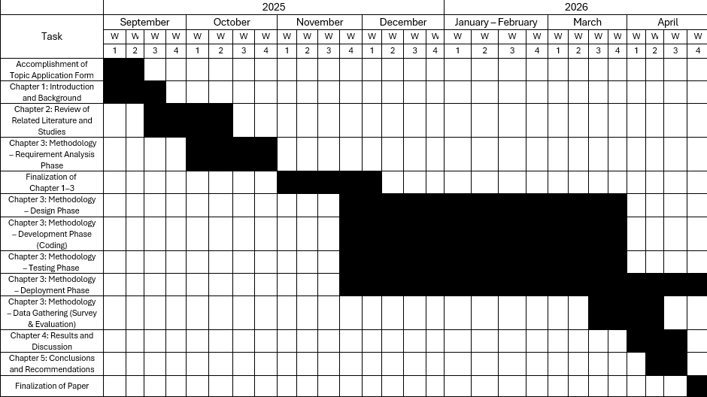
Appendix A. Gantt Chart of Activities


Appendix B. Interview Report

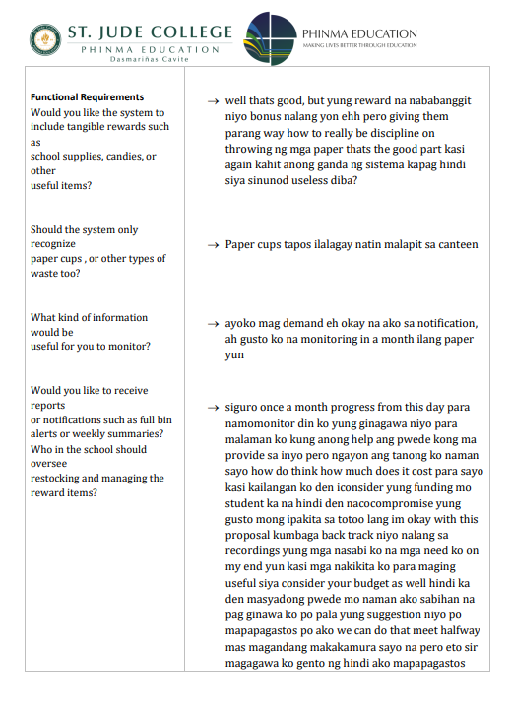

Appendix C. Research Instrument
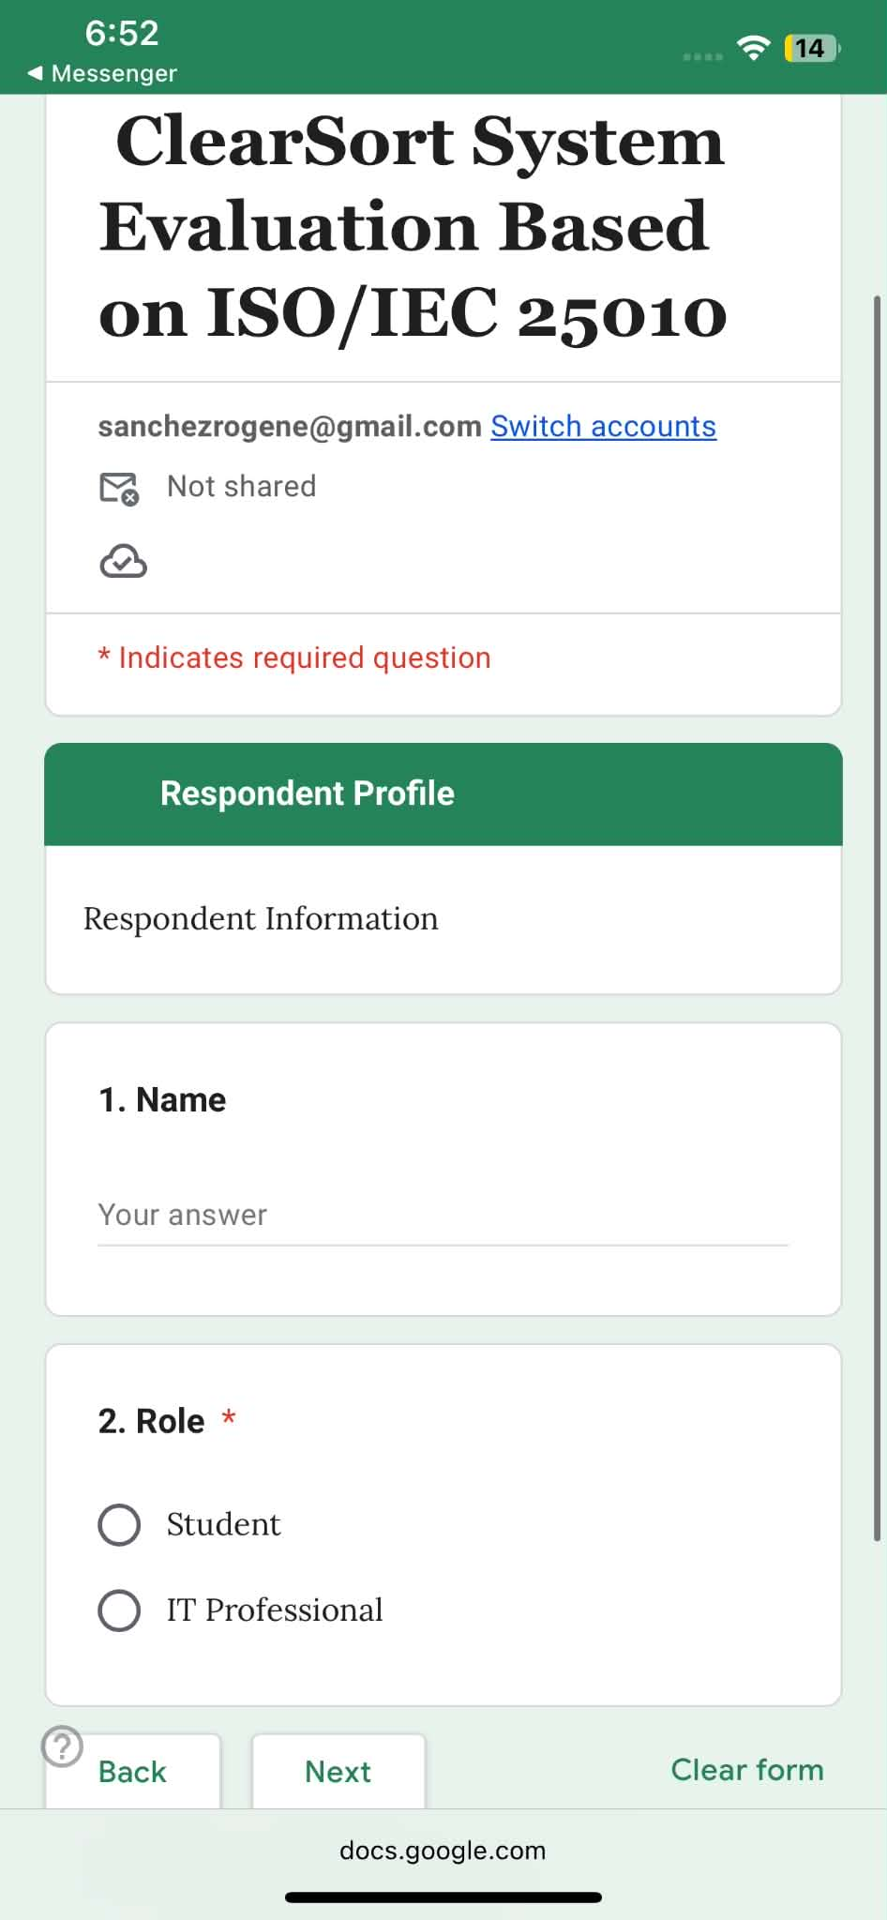
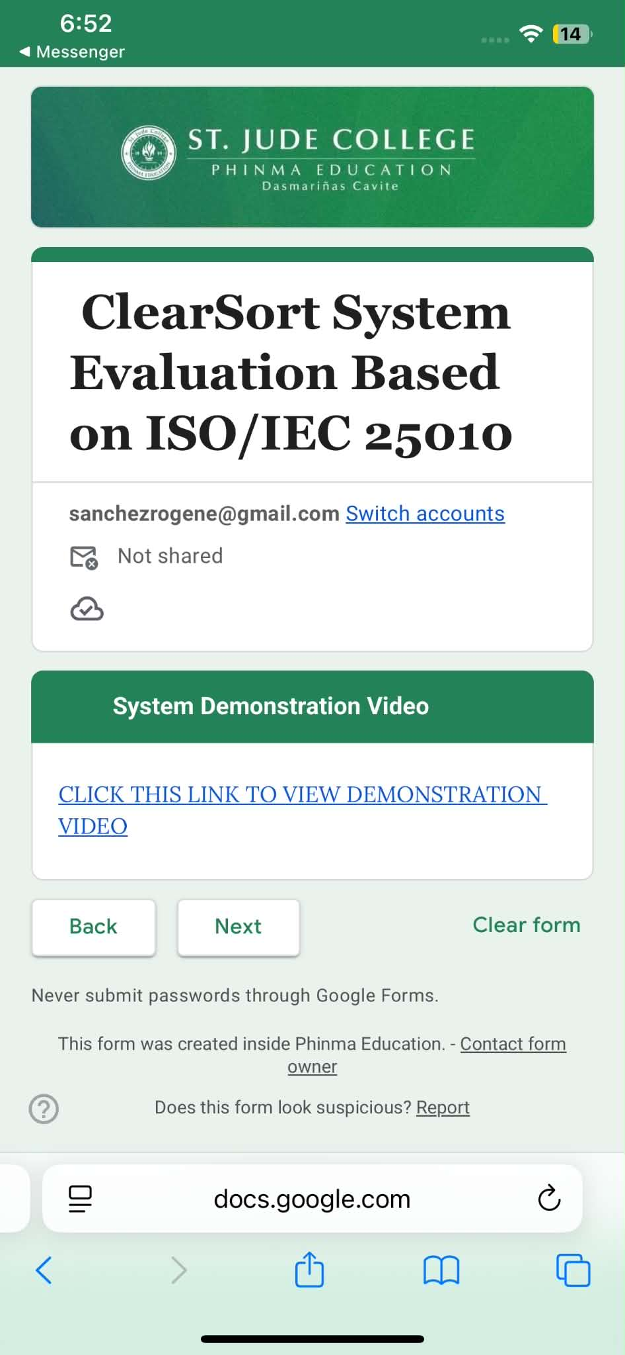

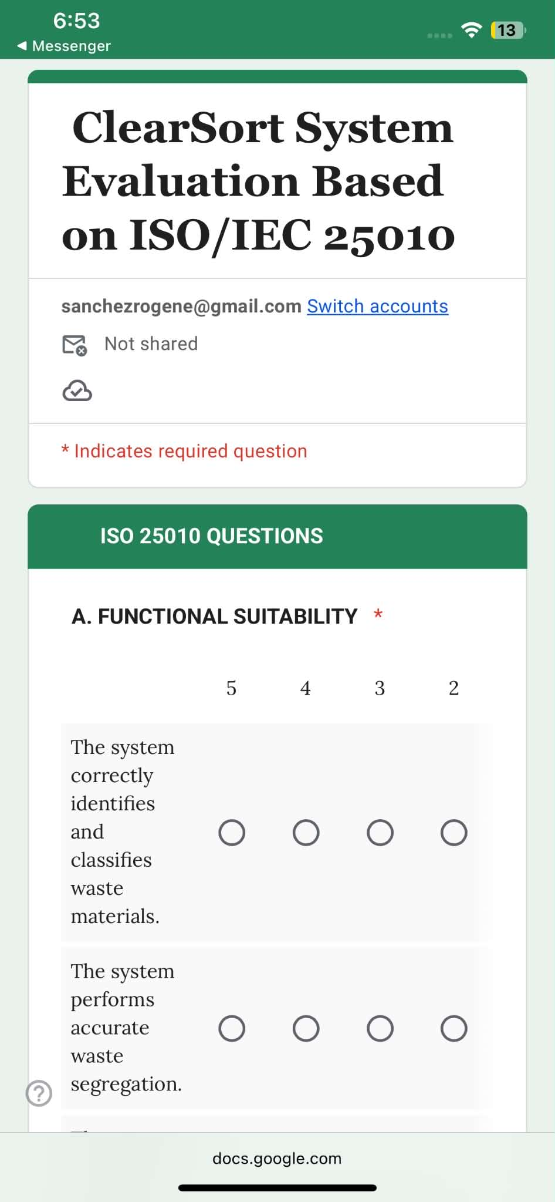
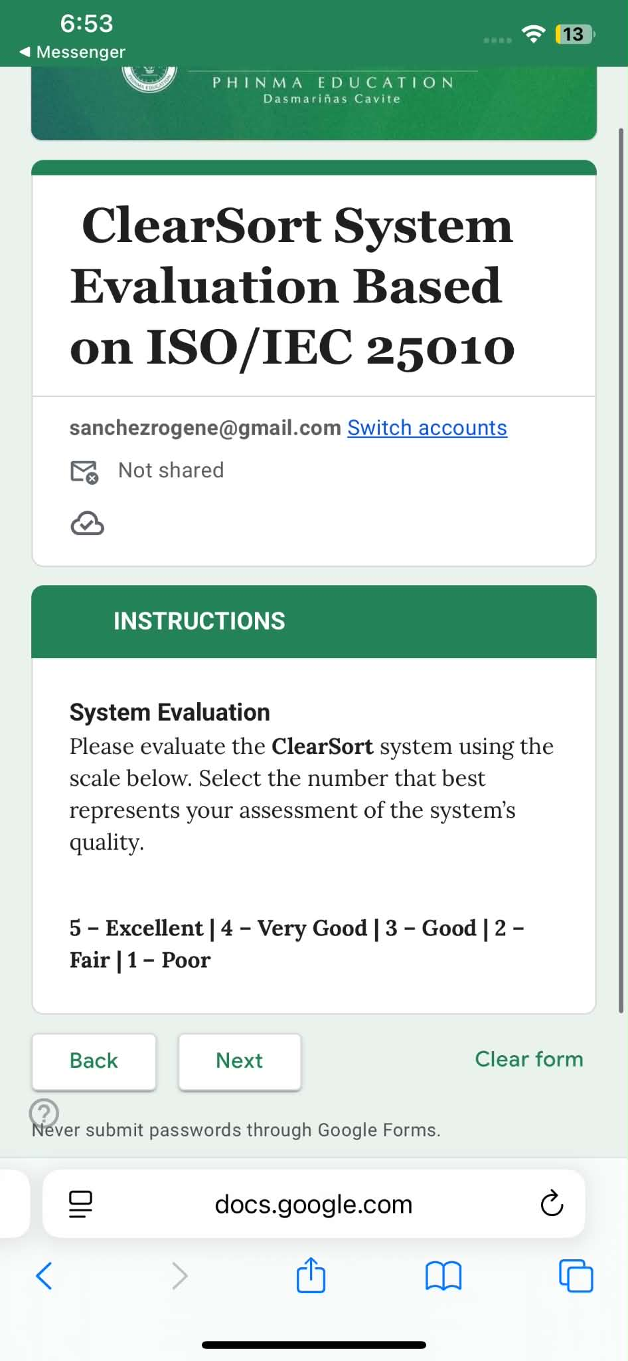
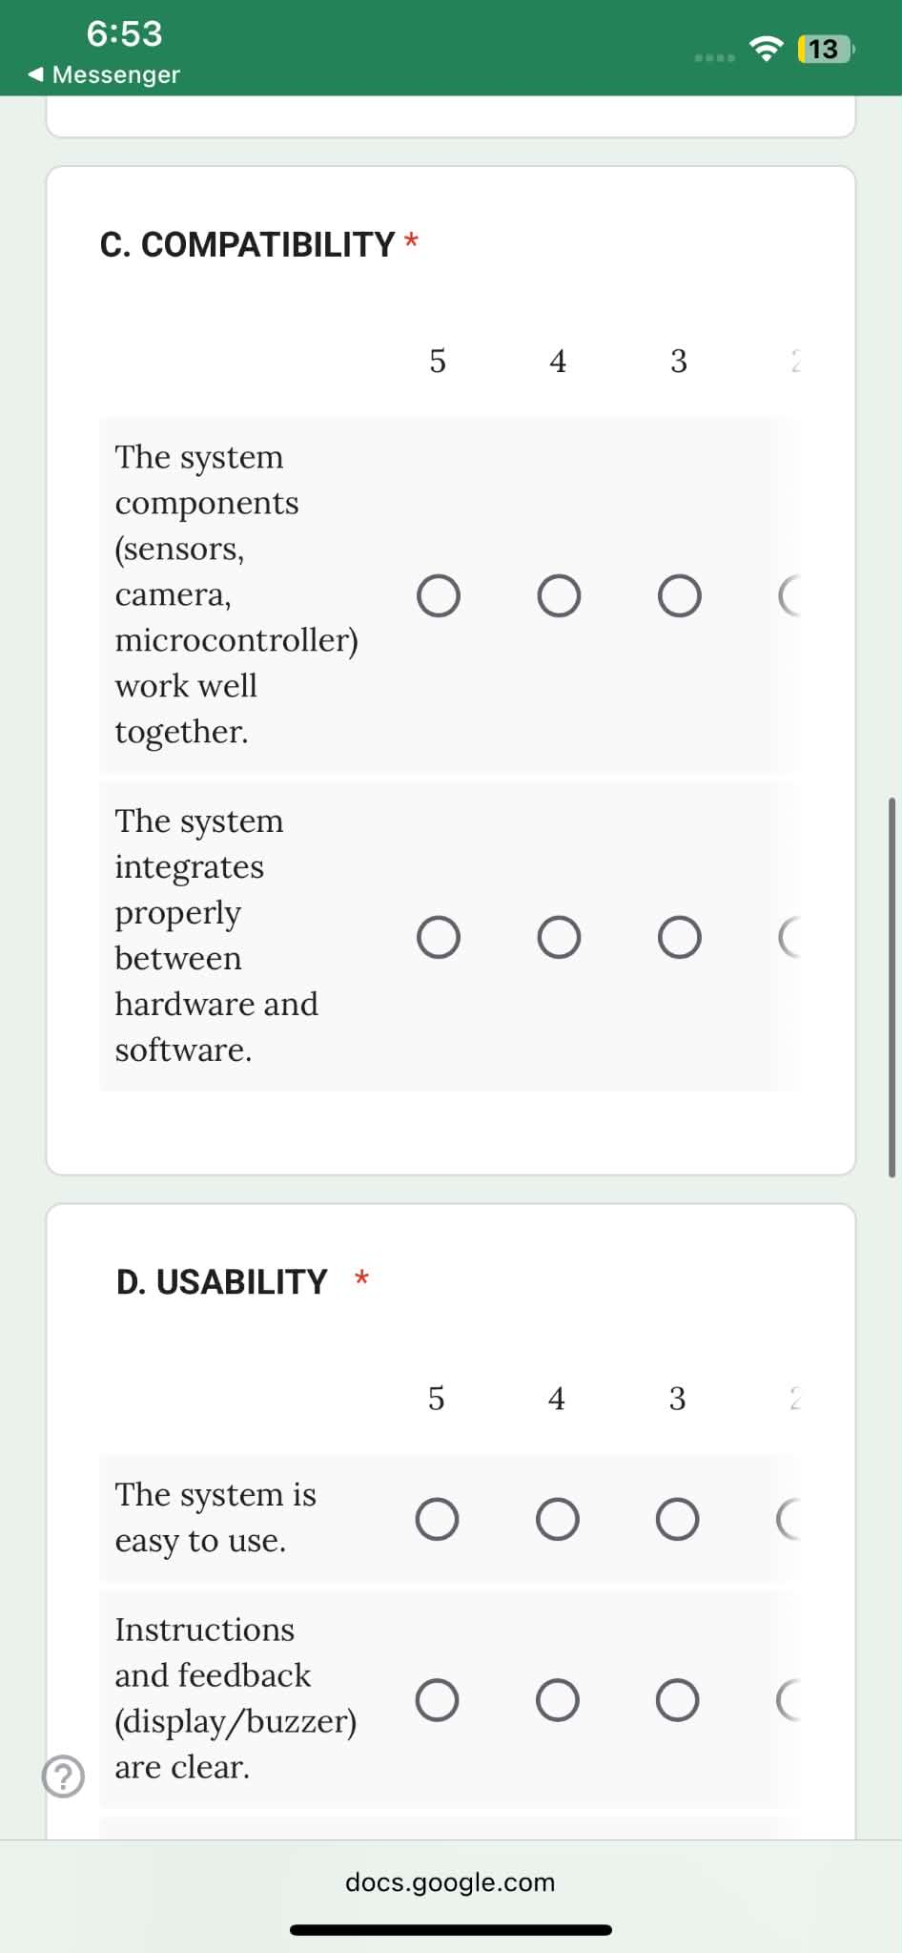
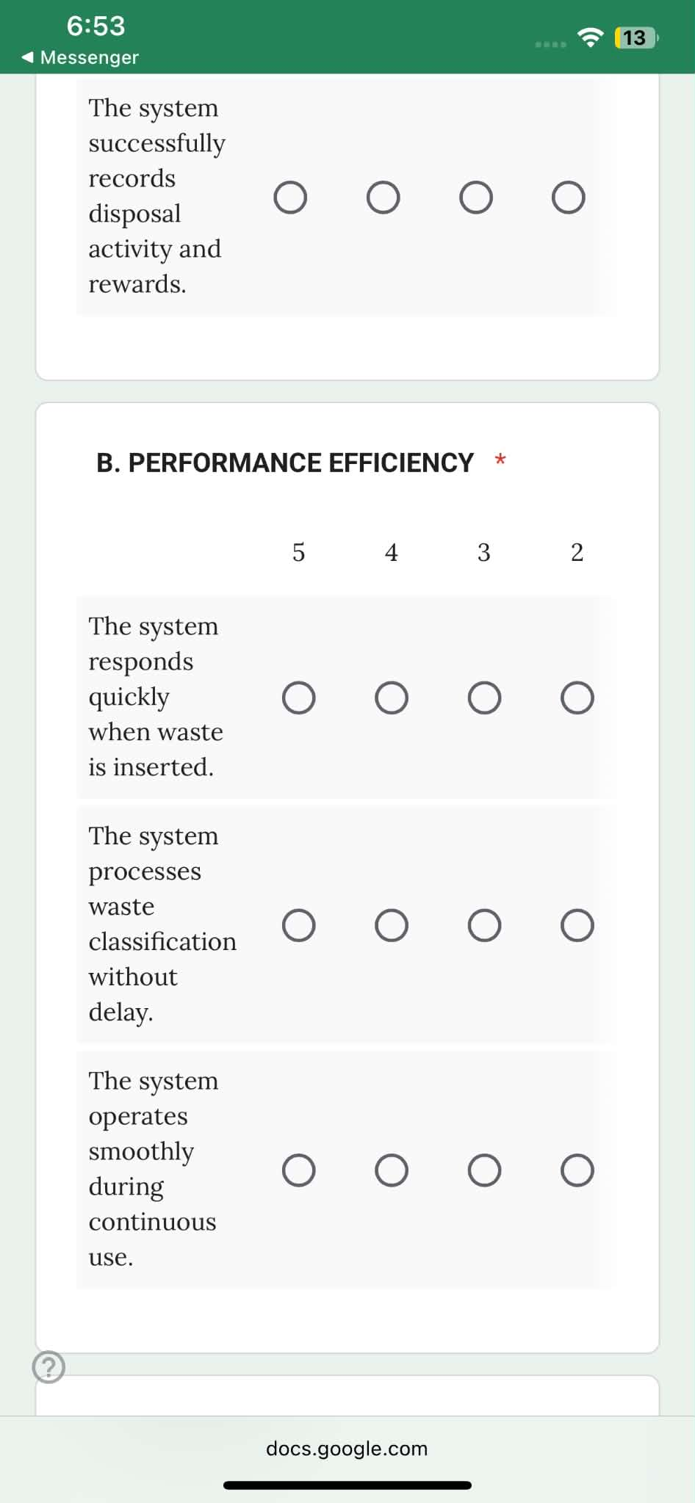
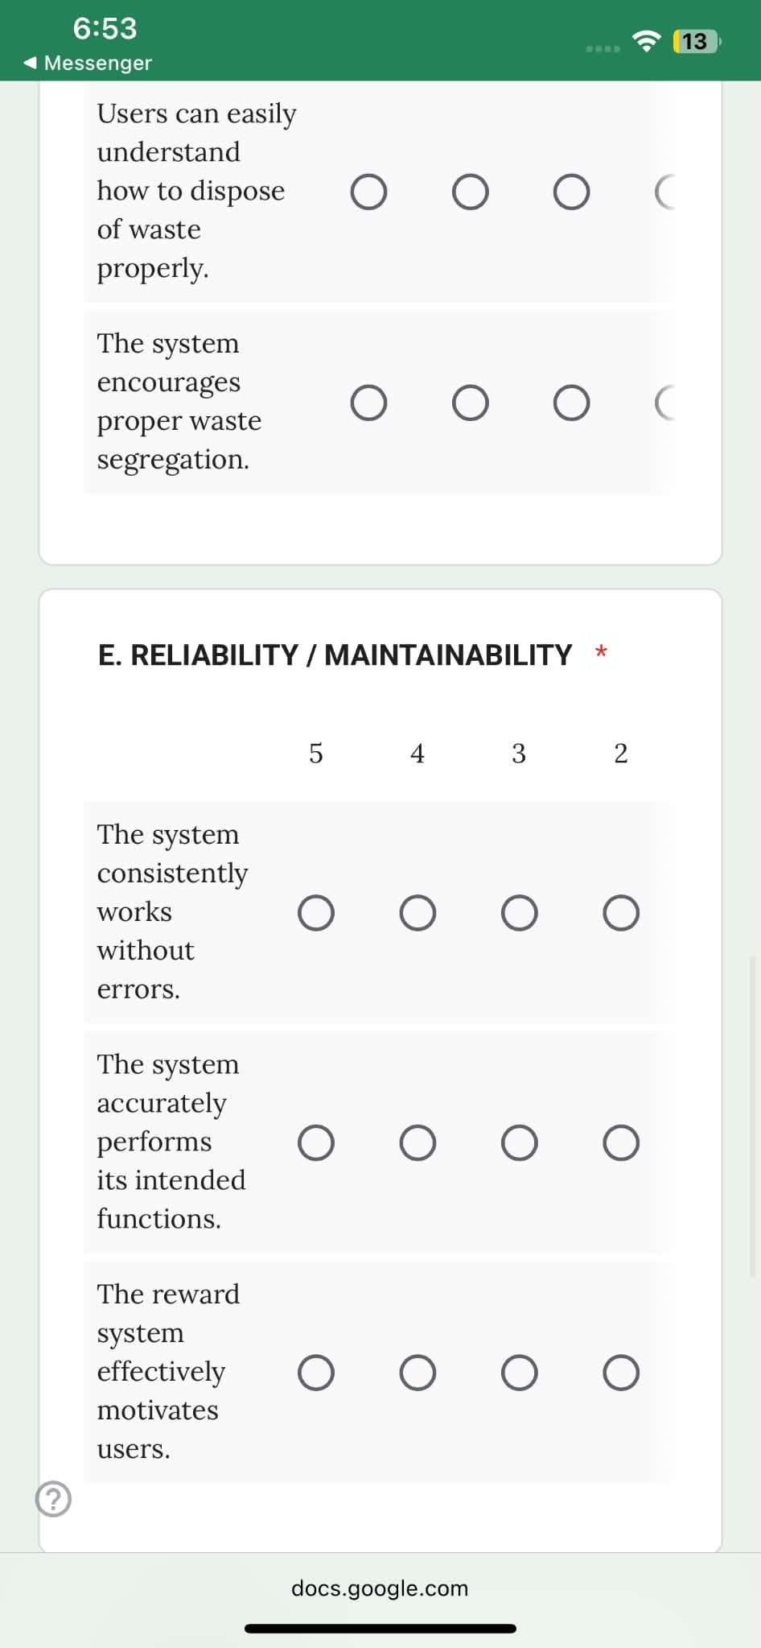
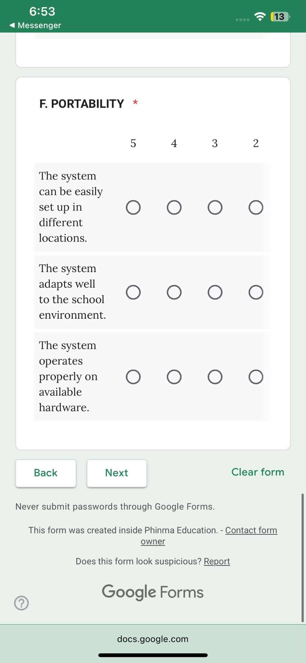

Appendix D. Evaluation Form

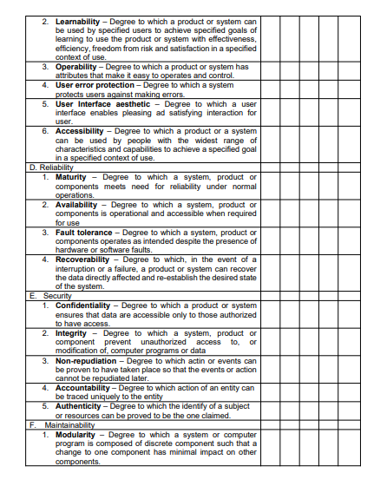
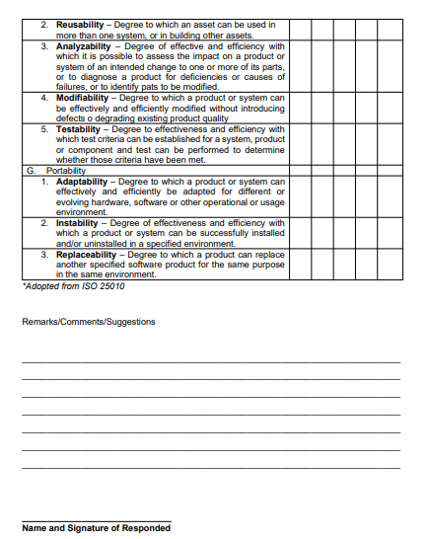

Appendix E. Statistician’s Certification

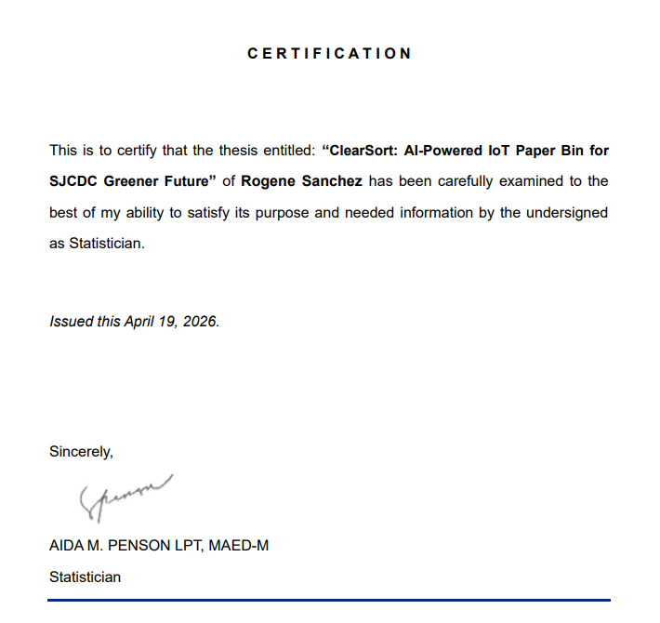

Appendix F. System Cost

Parts/Component | Price
Wood | ₱ 1,500
Ultra Sonic Sensor | ₱ 200
Servo Motor | ₱ 900
Micro USB Cable | ₱ 90
IR Sensor | ₱ 200
ESP32 Development Board | ₱ 500
ESP32 Cam | ₱ 300
Ballpens | ₱ 199
Arduino Set | ₱ 1,500
Annual Maintenance Cost | ₱ 2,000
Total: | ₱ 7,389

Appendix G. Sample Code
import { useEffect, useMemo, useState } from "react";
import { db } from "./firebase";
import { ref, onValue } from "firebase/database";

import {
Alert,
alpha,
Box,
Button,
Card,
CardContent,
Chip,
Container,
CssBaseline,
Dialog,
DialogActions,
DialogContent,
DialogTitle,
Divider,
Grid,
LinearProgress,
Stack,
Switch,
ThemeProvider,
Typography,
createTheme
} from "@mui/material";

import DescriptionRoundedIcon from "@mui/icons-material/DescriptionRounded";
import LocalDrinkRoundedIcon from "@mui/icons-material/LocalDrinkRounded";
import DownloadRoundedIcon from "@mui/icons-material/DownloadRounded";
import WarningAmberRoundedIcon from "@mui/icons-material/WarningAmberRounded";
import RecyclingRoundedIcon from "@mui/icons-material/RecyclingRounded";
import AnalyticsRoundedIcon from "@mui/icons-material/AnalyticsRounded";
import Inventory2RoundedIcon from "@mui/icons-material/Inventory2Rounded";
import AutoAwesomeRoundedIcon from "@mui/icons-material/AutoAwesomeRounded";

import { Bar, Doughnut, Line } from "react-chartjs-2";

import {
ArcElement,
BarElement,
CategoryScale,
Chart as ChartJS,
Filler,
Legend,
LineElement,
LinearScale,
PointElement,
Tooltip
} from "chart.js";

import { CircularProgressbar, buildStyles } from "react-circular-progressbar";
import "react-circular-progressbar/dist/styles.css";

import jsPDF from "jspdf";

ChartJS.register(
CategoryScale,
LinearScale,
BarElement,
ArcElement,
PointElement,
LineElement,
Tooltip,
Legend,
Filler
);

import { render, screen } from '@testing-library/react';
import App from './App';

test('renders learn react link', () => {
render(<App />);
const linkElement = screen.getByText(/learn react/i);
expect(linkElement).toBeInTheDocument();
});

Appendix H. Curriculum Vitae
