**ECE198 Design Document**

Plant Monitoring System Using STM32 Microcontrollers

Amber Malhotra

21140392

a66malho@uwaterloo.ca

Kevin Liang

21121843

k24liang@uwaterloo.ca

Needs Assessment

# Client/Customer definition

## Customer Challenge

* Inconsistent Soil Moisture: Many plant owners struggle with maintaining the optimal moisture level for each plant and determining when each plant should be watered. Incorrect watering can lead to issues such as root rot, wilting, or drought stress, ultimately affecting plant health and growth [1].
* Temperature Variability: Temperature is a vital environmental factor that influences plant metabolism and growth cycles. Indoor plants are particularly susceptible to indoor air temperature fluctuations, which can change the temperature of the soil and may lead to stunted growth, or even death of the plant [2].
* Resource Management: Effective gardening requires significant time and effort, especially in monitoring and adjusting environmental conditions manually. Gardeners with limited time may find it challenging to consistently check and adjust environmental parameters, leading to neglected plants [3].
* Light-weight aid: Many plant owners enjoy the process of devising solutions and changing environmental conditions for different types of plants [17], yet find it laborious to take measurements and often lack tools to do so [16].

## Target Market

### Demographic: Urban homeowners from ages 25-45

* Consists of individuals who recently purchased their homes and are looking to enhance living spaces
* Look to grow plants for aesthetic, health, or food production purposes
* May have young families and look to create a healthy environment at home
* Familiar with technology and specifically smart home devices, open to using technology to streamline their daily routine
* The target market size is estimated to be around 50,000 individuals, based on market trends that indicate a rise in home gardening activities.

### Geographic: Suburban areas of North America

* Homes in this area have more space: gardens, patios, balconies
* Backyards and large living space allows for both indoor and outdoor gardening
* Often face fluctuating weather conditions, making it difficult and time-consuming to maintain consistent plant care [4]

### Economic: Middle-income bracket

* Earn enough disposable income to invest in hobbies and lifestyle improvements such as gardening
* Seek solutions that can help them maintain their garden hobby while investing little effort

# Competitive landscape

## Smart Irrigation Systems – Rachio Smart Sprinkler Controller [14]

### Challenges Addressed

* Uses weather data to and sensors to automatically water plants
* Tracks temperature and soil moisture
* Addresses issue of inconsistent soil moisture

### Shortcomings

* Do not offer real-time feedback on individual plant conditions – users do not have a way to view measured sensor values
* Primarily designed for outdoor use
  + Costly for homeowners looking to monitor small indoor gardens
  + Does not accurately track indoor temperature
* Require integration with other smart home devices, adding complexity and additional costs
* [14] On the company’s website, Rachio sells individual sensor management systems which range from 99USD - 300USD, whereas the bundle product costs 500USD for both soil moisture and temperature sensors.

## Indoor Smart Planters – Click & Grow Garden [15]

### Challenges Addressed

* Manages resources using automated watering systems, built-in grow lights, and sensors monitoring temperature and soil moisture
* Allows gardeners to maintain plant health with minimal effort

### Shortcomings

* Not suitable for outdoor use where plants are grown in traditional soil beds
* Built-in features like automatic lighting do not cater to those who enjoy the creative aspect of customizing their plant care routines
* Costly: products start from 300 USD and reach up to 1300 USD

## Gardening Mobile Apps – PlantSnap [18]

### Challenges Addressed

* Provide plant care tips
* Resource management: users should adjust environmental conditions only when prompted to do so
* Aids users in developing creative care routines for plants

### Shortcomings

* Do not report soil conditions to user – user must measure soil conditions themselves, which is time-consuming
* Advice given is very generalized since plant condition is not known to the app, potentially leading to poor resource management

# Requirement Specification

## Functional requirements

### Wireless Communication Distance

* + Requirement: Maintain mutual connection between sensor (microcontroller 1) and user interface (microcontroller 2) over a range of 7 meters at baud rate 38400
  + Permitted Range: 2m ≤ distance ≤ 10m
  + Measurement: Test signal transmission success rates at different distances
  + Unit of measurement: meters (m)
  + Reference: [5] HC-05 Bluetooth modules support ranges of up to 30m.

### Temperature Measurement Accuracy

* + Requirement: Measure the average temperature of the soil with an accuracy of ±1˚C
  + Permitted Range: 10˚C ≤ Temperature reading ≤ 50˚C
  + Measurement: ˚C
  + Reference: [8] Most houseplants grow best in a soil temperature between 15-24°C

### Moisture Measurement Accuracy

* + Requirement: the microcontroller must measure humidity of soil within 5%VWC (Volumetric Water Content)
  + Permitted Range: 21% ≤ water moisture ≤ 80%
  + Measurement: VWC (volumetric water content)
  + Reference: [10] Most houseplants grow optimally with water moisture of 21% to 80%

## Technical requirements

### Thermistor Range & Error Range

* + Requirement: accurately measure temperature between 10˚C and 50˚C with accuracy of ±1˚C
  + Permitted Range: 10˚C ≤ temperature ≤ 50˚C
  + Measurement: ˚C
  + Reference: [7] NTC 10K B3950 measures temperature within ±1% of the actual temperature at the measuring junction, which is about 0.5˚C at temperature reading of 50˚C

### Soil Moisture Sensor Range & Error Range

* + Requirement: the microcontroller must measure humidity of soil within 5%VWC
  + Measurement: [measure the RH (relative humidity) of dry air and water to find the readings of 0%RH and 100%RH, and map other RH in between the readings.
  + Unit of measurement: VWC
  + Reference: [9] operating range of SKU:SEN0193 is between 10˚C and 60˚C, can read exact RH values

### Wireless Data Packet Size

* + Requirement: Packet Size should not exceed 64 bytes, transmission success rate above 98%
  + Permitted Range: packet size ≤ 64 bytes
  + Measurement: inspect and calculate packet size in firmware
  + Measurement unit: bytes
  + Reference: [11] HC-05 Bluetooth maximum packet size range from 1kb to 3kb depending on the distance

### Screen Size

* + Requirement: LCD screens must display 32 characters with character font size of at least 24 (~8.5mm)
  + Permitted Range: character size ≥ 8.5mm
  + Measurement: character size (mm)
  + Measurement unit: mm
  + Reference: [12] The recommended font size for comfortable reading from 10 feet away is 72, 1m is 3.3 feet and thus the recommended font size is 24.

## Safety requirements

### Environmental Resistance:

* + Requirement: Microcontroller must be encased in a water-resistant casing to protect against accidental water spills and high moisture levels (IPX4 rating).
  + Permitted Range: Must meet IPX4 water resistance standards.
  + Measurement: Test by exposing item to an oscillating spray for a minimum of 10 minutes, as per IPX4 guidelines
  + Reference: [13] IEC 60529:2013 Defines ingress protection ratings for  
    Enclosures.

### Energy Consumption:

* + Requirement: the system will not consume, transfer, or discharge more than 30W of energy
  + Permitted Range: power ≤ 30W
  + Measurement: use a voltmeter to measure voltage and current to calculate power consumption
  + Measurement Units: W
  + References: Project rubric

### Energy Storage:

* + Requirement: The system will not store more than 500 mW of energy at any point in time
  + Permitted Range: power stored ≤ 500 mW
  + Measurement: use equations for any necessary energy storage components (inductor, capacitor, etc) to calculate energy stored
  + Measurement Units: mW
  + References: Project rubric

Analysis

# Design

## Description & High Level Design

### Flowchart of the ​​interactions of the major components:

### System flow:

1. The transmitting microcontroller receives voltages from the sensors (thermistor & moisture sensors)
2. The transmitting microcontroller will map them to numerical values using calibration curves. The voltage from the thermistor will be translated into temperatures in ˚C, and the voltage in the moisture sensor will be translated into units of volumetric water constant (VWC)
3. The transmitting microcontroller will interface with a bluetooth module to send the temperature and constants to the receiver microcontroller
4. The receiving microcontroller will assess soil health based on the data, determining whether it requires watering or adjustment to temperature
5. The receiving microcontroller will display the recommendations and the soil sensor data on the LCD display

### Design depiction

* The completed product consists of a 3D-printed box with 2 protruding sensors that the user can insert into the soil to read soil health data.
* The box will house the majority of the electronics to shield from water damage. Inside will include:
  + Wires, for transmitting information and power to various components
  + An STM32 microcontroller, which is responsible for receiving sensor data, mapping it to useful values, and communicating it to the other STM32.
  + A 12V battery pack, which will be supplying the STM32 with power
  + An HC-05 bluetooth module to transmit data to another STM32
* Through the 2 holes at the side will be the wires for 2 sensors, the square one being for the SKU:SEN0193 soil moisture sensor, and the circle for the NTC 10K B3950 thermistor (measuring soil temperature). Both will be inserted into the soil
* The measured data will be displayed on the LCD Screen located on the second STM32, which may be placed as far as 10m from the transmitting STM32

## Detailed Implementation

### Circuit schematic

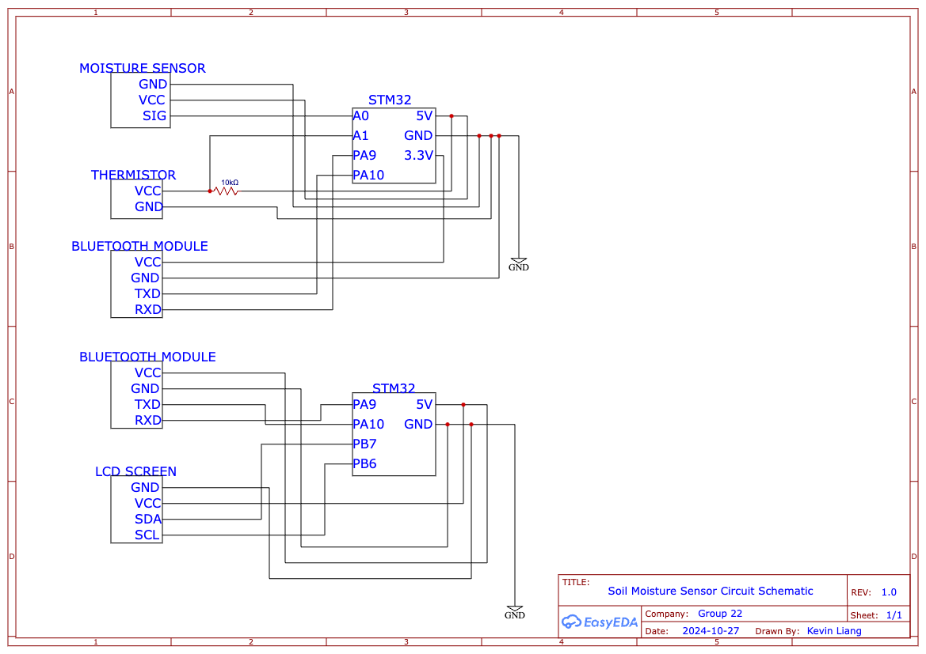

Other notes:

* In the circuit diagram, only the pins used on each component have been outlined.
* The sensors and extra components have all pins written out, The pin names can be found printed next to each pin on the STM32 microcontroller as well as next to each pin on the component itself

### Casing

NOTE: for the following diagrams, all measurement units are in cm

Main case top view:

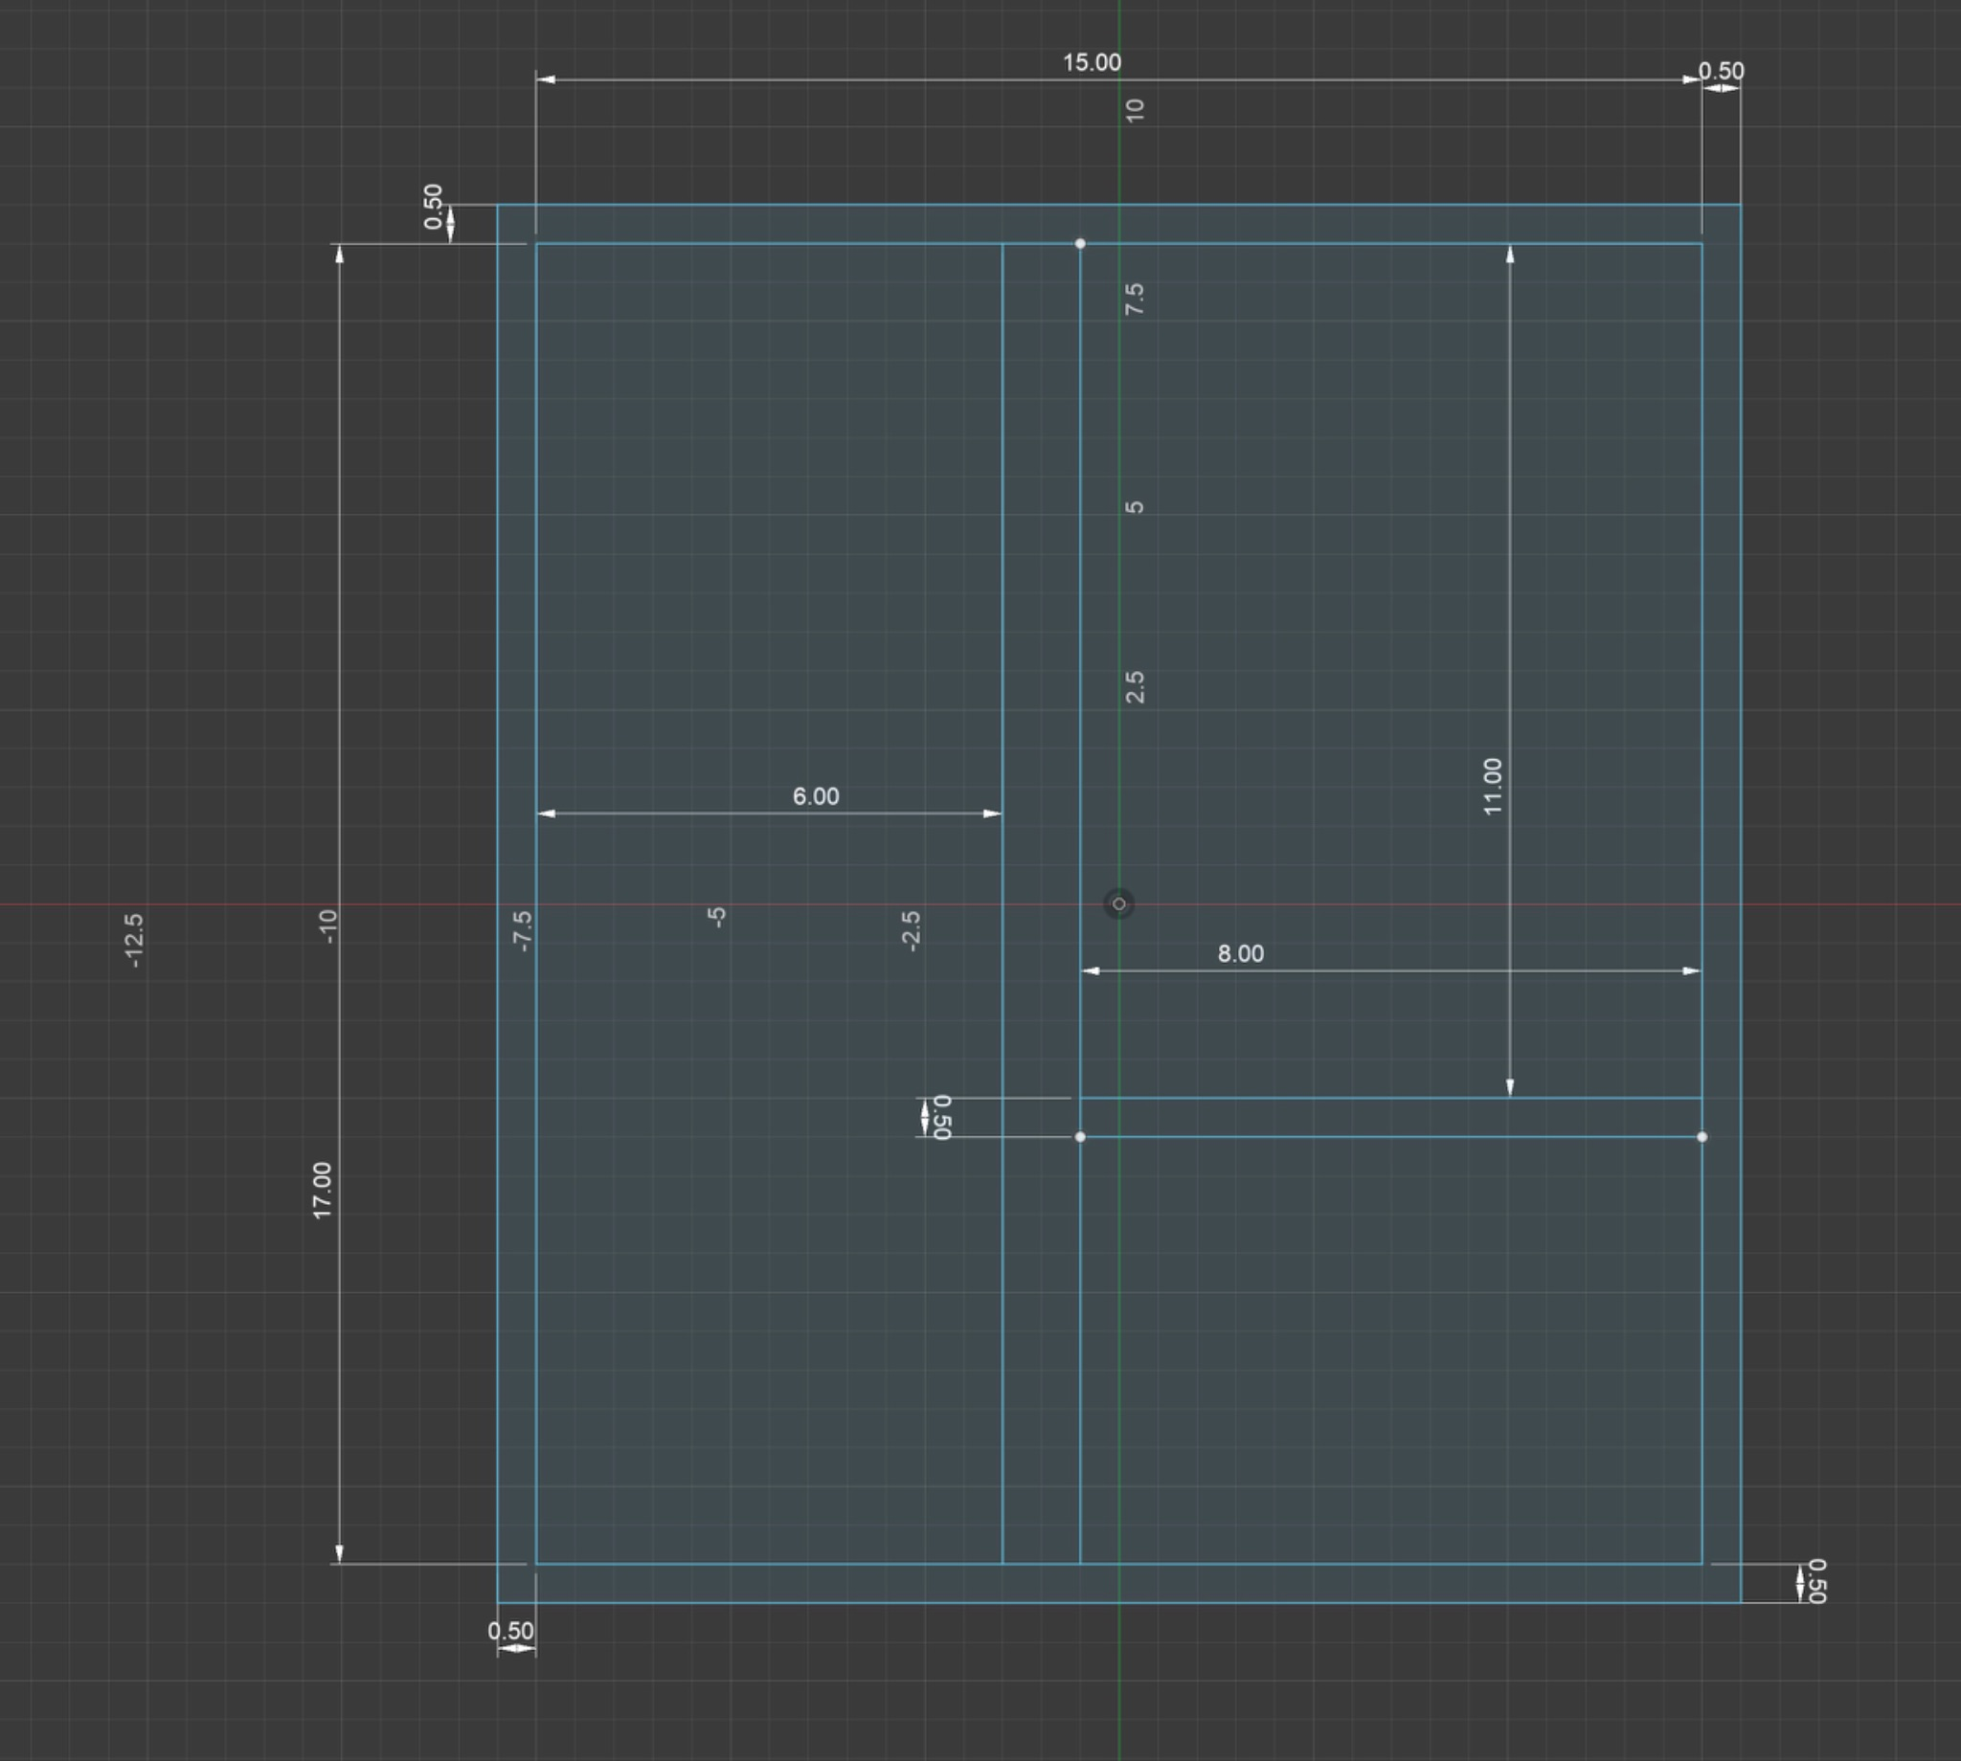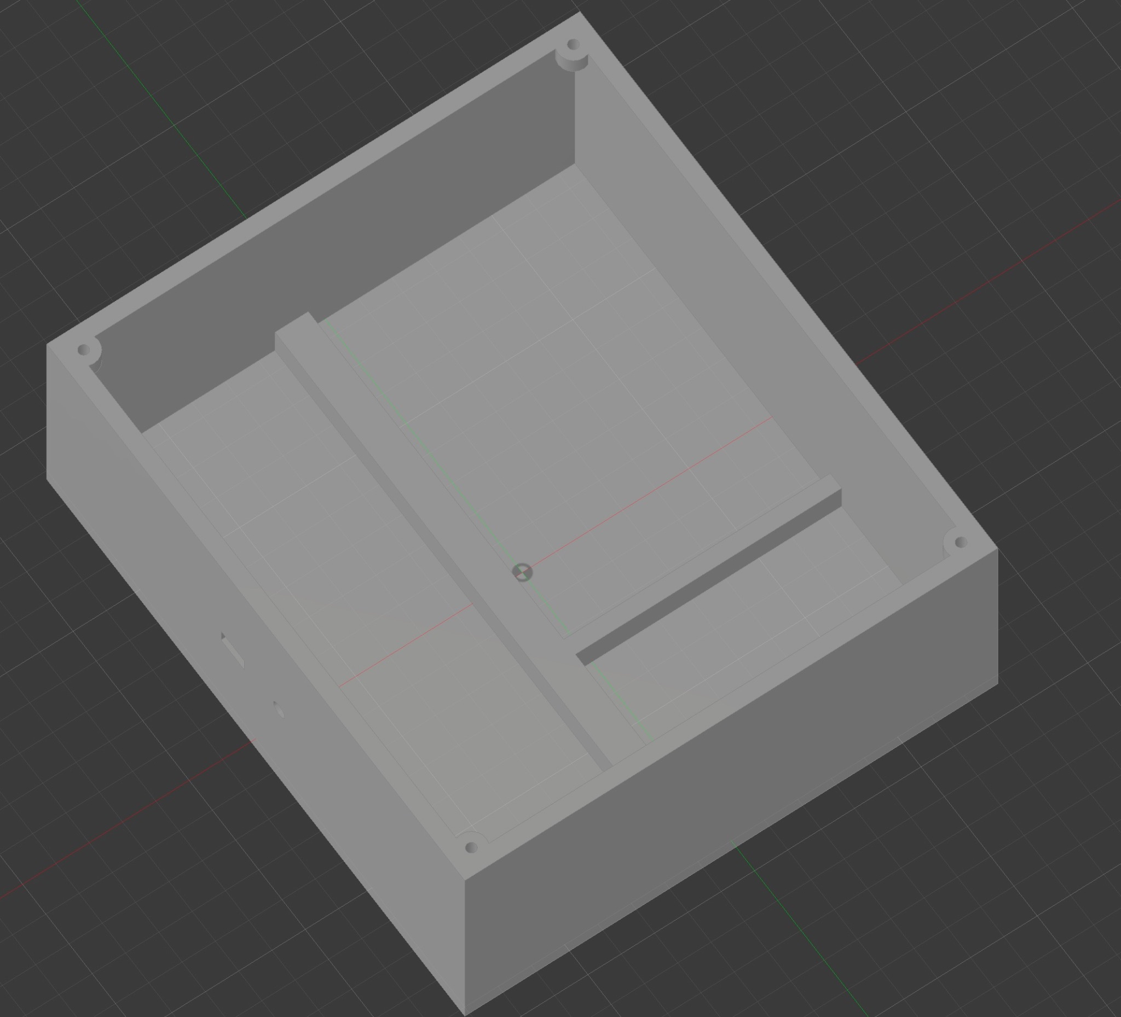

Main case side view

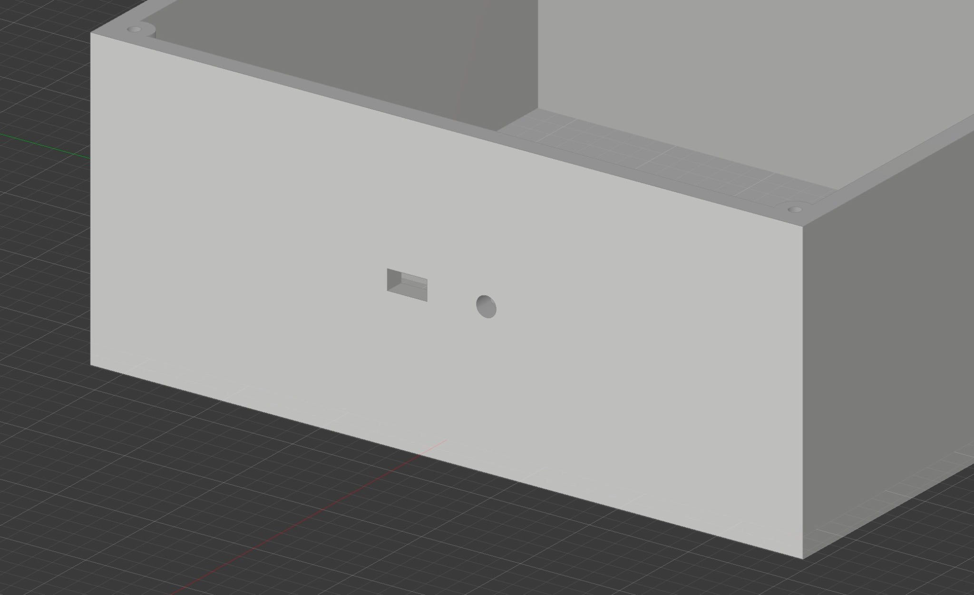

Top cover:

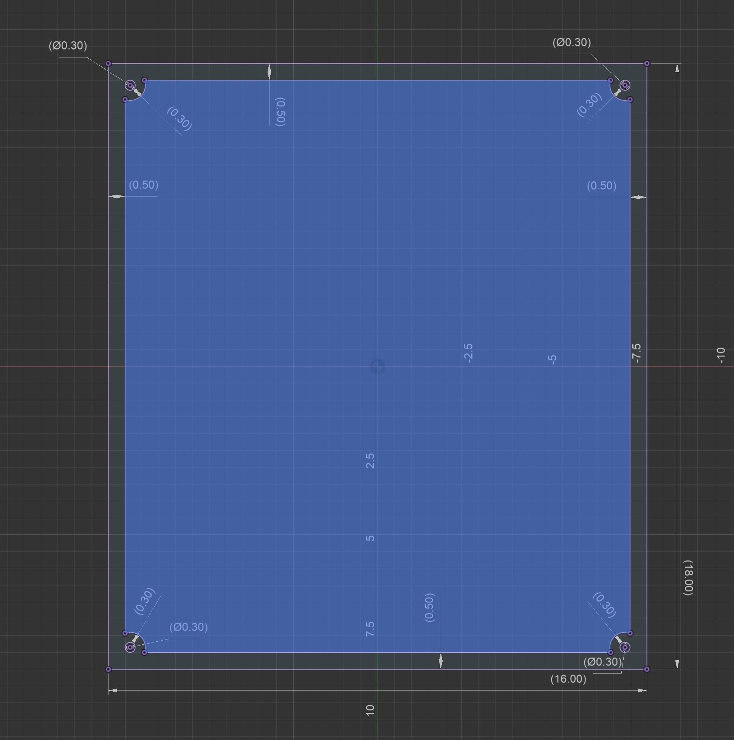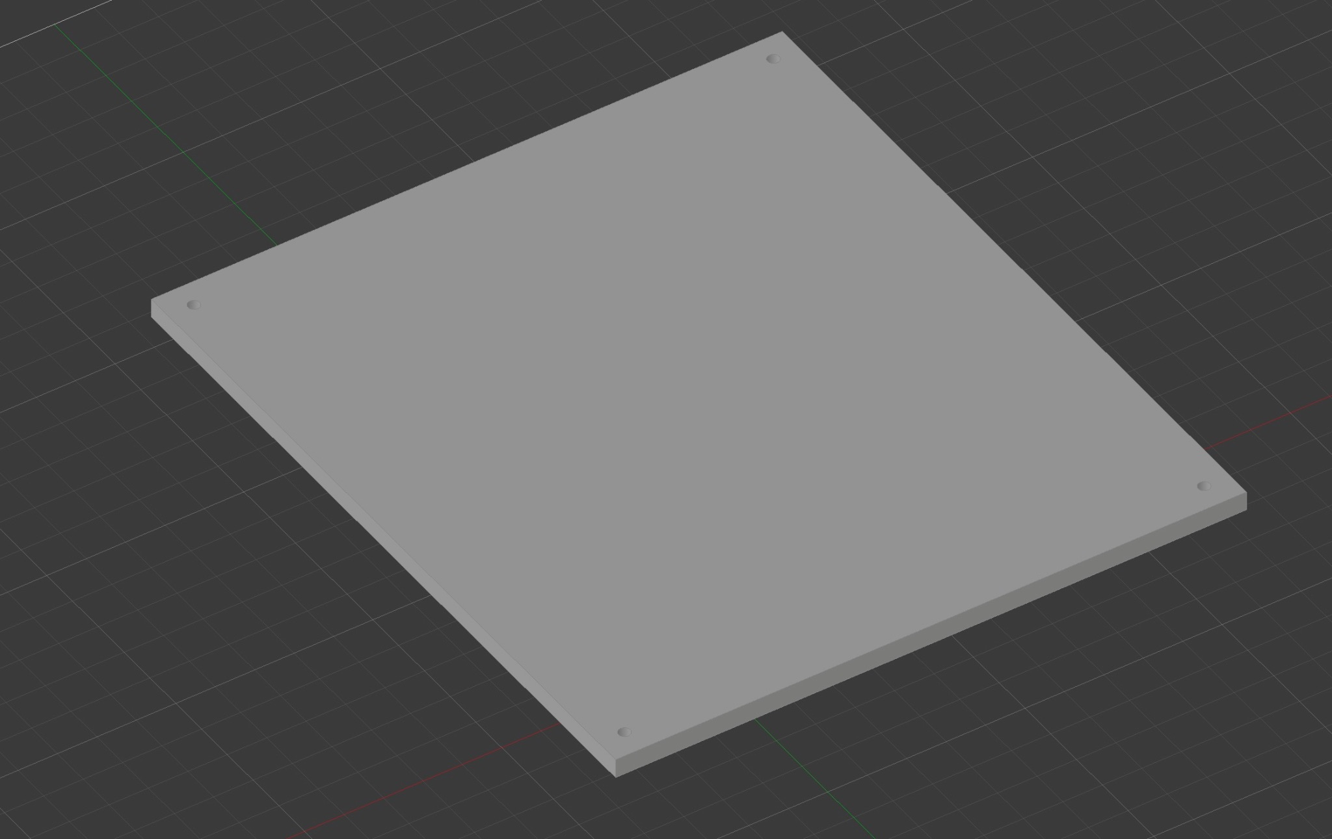

Moisture Sensor casing:

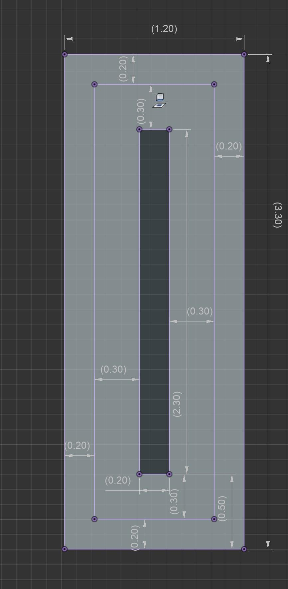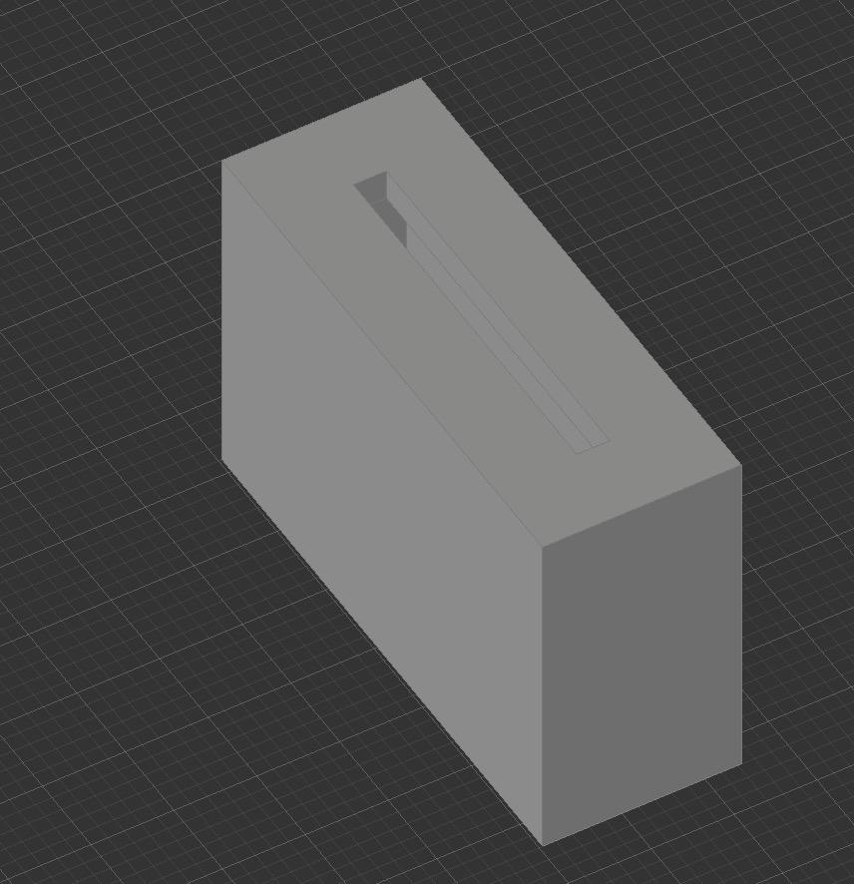

## 

### Operation

* Once installed and powered, the measurements of soil conditions will be displayed on the LCD Screen, it is then up to the user to act upon the information
  + For specifics of the installation, refer to the installation guide and user manual

## Requirements Satisfied & Technical Notes

### Requirements Satisfied

* Both STM32s are connected to a 12V power supply set a 0.3A, drawing a combined 12V*0.3A*2 = 7.2W of power, in compliance with the Energy Consumption Requirement
* The HC-05 bluetooth modules will interface with the STM32s with the USART1 communication protocol and transmit 1kb-3kb of data per packet, in compliance with the Wireless Data Packet Size requirement
* [7] The NTC 10K B3950 can measure temperature with an accuracy of ±1%, in compliance with the Thermistor Range & Error Range requirement

### Technical Notes (not required for an understanding of the operation of the system)

* Each component will have a VCC (power) pin, connected to a 5V or 3.3V pin on the STM32
* Each component will have a ground pin, connected to a common grounding pin on the STM32
* The NTC 10K B3950 thermistor will provide a variable resistance to an analog-digital converter pin in a voltage-divider circuit
* The LCD1602 (LCD Screen) will interface with the STM32 using I2C communication protocol
* The SKU:SEN0193 capacitive soil moisture sensor will supply a variable voltage to an analog-digital converter pin

## Alternatives

### Thermocouples for temperature measurement

* Difficult to interface with microcontroller in terms of signal conditioning: due to the nature of thermocouples and miniscule resistance change in the thermocouple element, [27] states that “​​additional amplification must be used to increase the signal level”
* Wiring & installation complexity: [28] Thermocouples required specialized alloy wiring to maintain measurement accuracy.
* Lower sensitivity: [27] Thermistors offer higher sensitivity in limited ranges compared to thermocouples. Most thermocouples have an accuracy of at best ±1˚C [29], not meeting our requirement for temperature reading accuracy, whereas thermistors such as the NTC 10K B3950 have an accuracy of ±1% [7] which is 0.25˚C at 25˚C, around our desired operating range.

### Infrared temperature sensors

* Irrelevant measurements: [30] IR Sensors only measure the surface temperature, which is not as relevant to soil health as it can vary drastically from internal soil conditions, which are more important when it comes to soil health
* Environmental sensitivity: [30] IR sensors are easily affected by environmental factors such as dust, fog, smoke, or moisture, which are all present in outdoor environments.

# Technical Analysis

## Power equation

* To test our energy consumption, power will be calculated using the equation: P=IV [19]
* Where:
  + P = power
  + V = the difference in voltage between the cathode and anode of the power supply
  + I = current

### Implementation

* + After wiring is completed, we will attach a voltmeter to the Voltage and ground and measure the difference in Voltage and current, then we will verify, using the above equation, that our system satisfies the safety requirements
  + In our design, a 12V battery pack will be attached to each STM32 board, supplying a current of 0.3A. By the power equation, the power consumed will be 12V*0.3A = 3.6W per STM32, totalling 7.2W.

## Ohm’s Law

* For our thermistor used to measure soil temperature, Ohm’s Law provides a means to calculate resistance based on the measured voltage. According to Ohm’s Law, V = IR , where: [22]
  + V is the voltage across the thermistor,
  + I is the current flowing through it, and
  + R is the resistance.

### Implementation

* + In our circuit design, the thermistor acts in a voltage divider configuration. The measured voltage across the thermistor can be used to solve for R , allowing us to accurately determine the resistance corresponding to specific temperatures. This approach supports real-time temperature readings since the thermistor’s resistance changes predictably with temperature.
  + Assuming the voltage across the thermistor is 3.3V and the current is 0.3A at 50˚C, we calculate the resistance R = V/I and arrive at resistance being 11ohms, which will allow us to verify our interpreted VWC values

## RH to VWC conversion equation

To measure we will be converting the readings from RH to VWC, which includes a multi-step equation: [20]

1. Calculating soil water potential: 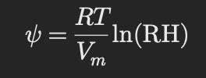
   * ψ = soil water potential
   * R = universal gas constant
   * Vm = molar volume of water
   * RH = relative humidity
2. Van Genuchten’s (1980) model to calculate VWC 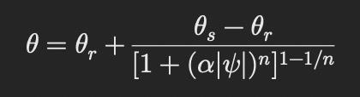
   * θ = VWC
   * θs = saturated water content for given soil type
   * θr = residual water content for given soil type
   * α: soil-specific constant for how easily soil pores begin to drain
   * n: soil specific constant
   * ψ = soil water potential
   * Refer to [21] for soil-specific constants

### Implementation

* + To prototype, we will purchase a specific type of soil, then we will research the soil-specific constants, and write a driver which converts the voltage measured into RH, then use the above equation to display soil humidity in VWC
  + For commercial purposes, this will be the formula that will be involved in translating the measured RH value into VWH

## Voltage divider equation

The thermistor will require a voltage divider. The STM32 will receive a reading of the signal voltage, and using the signal voltage, resistor resistance, and input voltage, the formula for a voltage divider circuit [43] will be used to calculate the thermistor resistance, which will be used to determine the corresponding temperature interpolated from a calibration curve

## IEEE 802.15.1

* Bluetooth Standard: [23] Specifies the requirements for Bluetooth communication, including transmission distance, baud rates, and data packet management. Relevantly, it outlines the core specification of Bluetooth 2.0, which we will refer to in our implementation of Bluetooth communication. We will also reference the text about Bluetooth Profiles, which define how applications use Bluetooth communication, including Serial Port Profile (SPP)

### Implementation

* + HC-05 bluetooth modules are IEEE 802.15.1 compliant, so we will be using these bluetooth modules for wireless communication
  + IEEE 802.15.1 specifies the protocols for creating wireless personal area networks (WPANs); it handles packet exchange in the form of small data packets, ensuring efficient communication within the 64-byte packet size. We will be implementing WPAN protocols by setting the baud rate to 38400 and using Bluetooth AT commands to configure the module to meet the transmission distance and packet size requirements

## ISO 9241-303

* Ergonomics of Human-System Interaction: [24] Provides guidelines for screen readability, including font size and character spacing, aligning with our LCD screen requirements for comfortable reading.

### Implementation

* + To be compliant with ISO 9241-303, we will select LCD screens which are able to display text that are 8.5mm large

User Manual

**Product Overview**

This device is designed to monitor the health of soil in home-grown plants by measuring moisture and temperature levels. The system comprises 2 STM32 microcontrollers, a moisture sensor, and a thermistor, housed in a durable 3D-printed case. Using a Bluetooth connection, it transmits real-time data to the second STM32, which interprets the data and displays recommendations for watering and soil health information on an LCD screen. This product helps users maintain optimal soil conditions by providing continuous feedback on moisture levels and temperature.

**Safety Precautions**

* Handle with Care: The sensors and microcontroller contain delicate electronic components. Avoid bending or applying pressure to the pins and connectors.
* Battery Safety: Use only the recommended battery type. Do not expose the battery to extreme temperatures or moisture, and avoid short-circuiting.
* Circuit Precautions:
  + Always ensure the device is powered off before connecting or disconnecting any components.
  + Double-check connections before powering on the system to prevent short-circuits or overheating.
* Moisture Sensor Handling: While placing the sensor in the soil, ensure it is inserted gently to avoid damage. Avoid pulling on the wires, as this may damage the connections.
* Temperature Monitoring: The thermistor should only be placed in soil and not in contact with water or any liquid that could corrode the component.

**Maintenance Tips**

* Regular Cleaning:
  + Wipe down the moisture sensor periodically to remove any dirt or mineral buildup from the soil. This helps maintain accurate readings and prolongs sensor life.
  + Gently clean the thermistor if it accumulates dirt or debris.
* Battery Care: Charge the battery fully before initial use and periodically thereafter to maximize lifespan. Store the device with a partially charged battery if unused for extended periods.
* Connection Checks:
  + Inspect wire connections every few months to ensure they remain secure and free from corrosion or wear.
  + Recalibrate sensors if readings appear inconsistent, as this can improve accuracy and reliability.
* Storage: Store the device in a dry, cool place when not in use to prevent moisture damage to internal components

Installation Guide

**Notes**

* For illustrations, please refer to the Design Document, which will include circuit schematics and the 3D-printed case illustrations
* Note that in the circuit diagram, only the pins used on each component have been outlined.
* The sensors and parts have all pins written out, The pin names can be found printed next to each pin on the STM32 microcontroller as well as next to each pin on the component itself

**Guide**

1. Wire each component according to the circuit schematic above, EXCEPT for the moisture sensor
   1. Note that in the circuit diagram, only the pins used on each component have been outlined.
2. The sensors and extra components have all pins written out, The pin names can be found printed next to each pin on the STM32 microcontroller as well as next to each pin on the component itself
3. Wire each component according to the circuit schematic, EXCEPT for the moisture sensor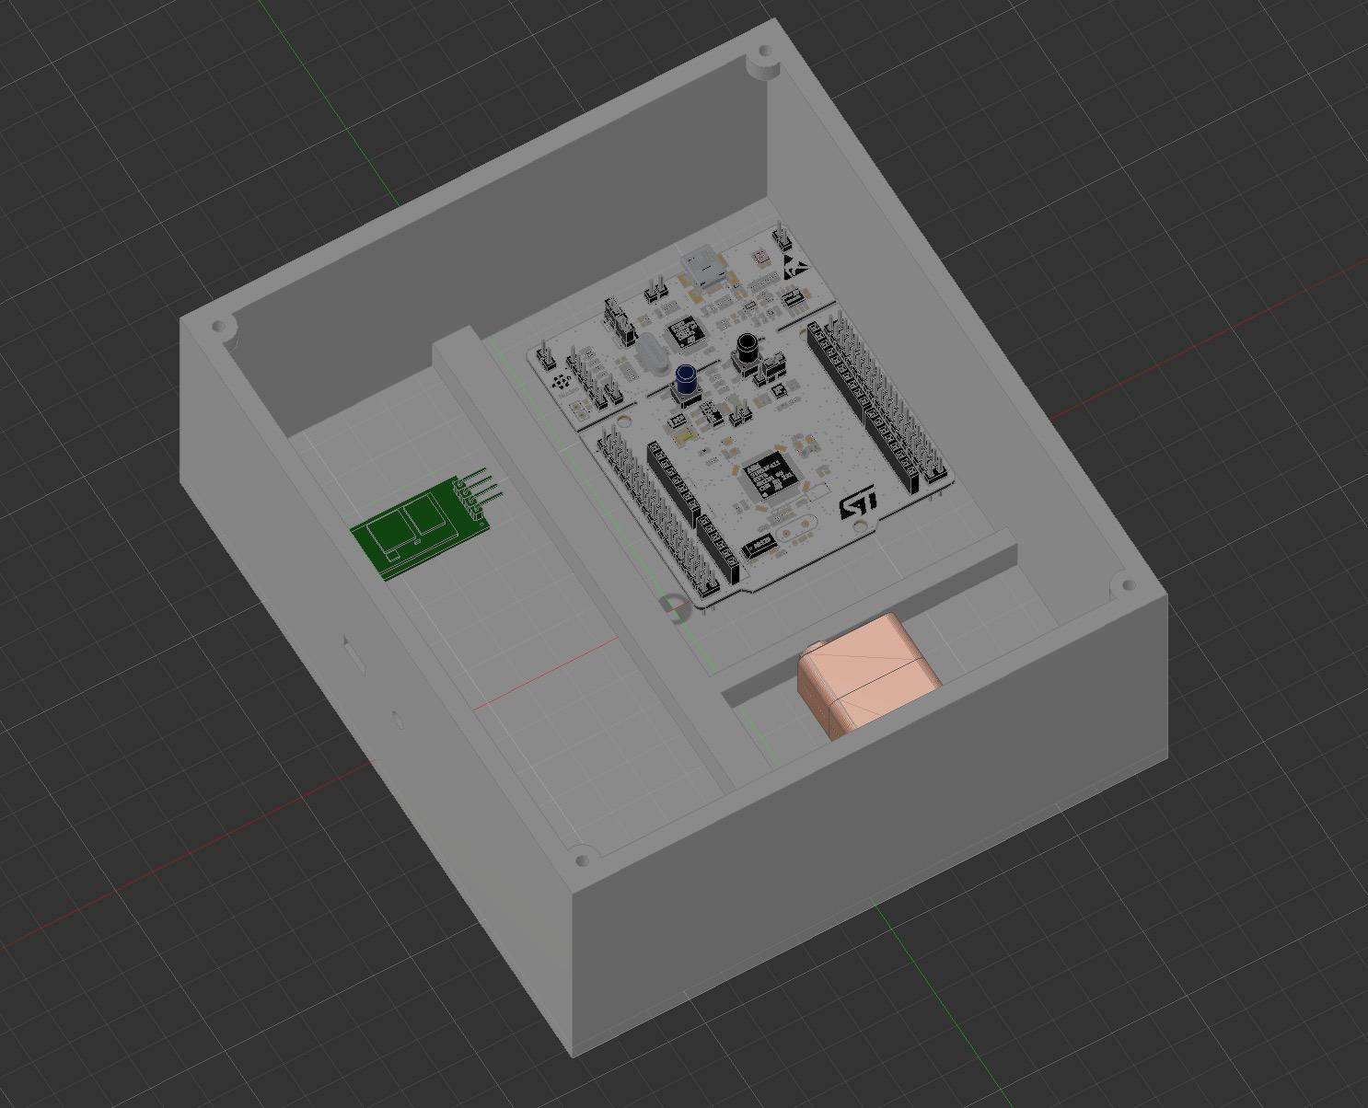
4. Place the first circuitry (the circuit on the top of the circuit schematic) inside the main case. The STM32 will sit in the top right slot, the power supply beneath it, and other components to the left
5. In the rectangular slot, slip through the moisture sensor wires and connect them according to the circuit schematic above
6. In the circular slot, slip through the thermistor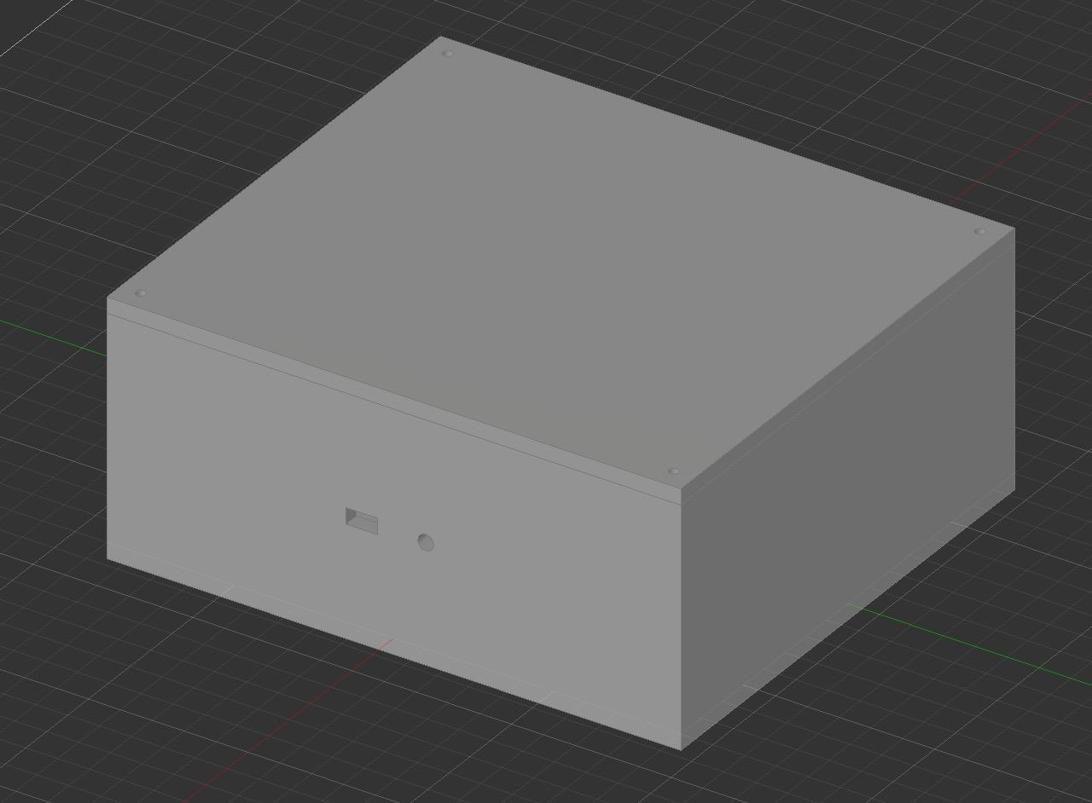
7. Connect the battery pack to the STM32 to the USB slot located at the short side of the STM32 to power it on and start collecting data
8. Cover the top of the box with the top cover, at each vertex, screw on M3 screws to secure the lid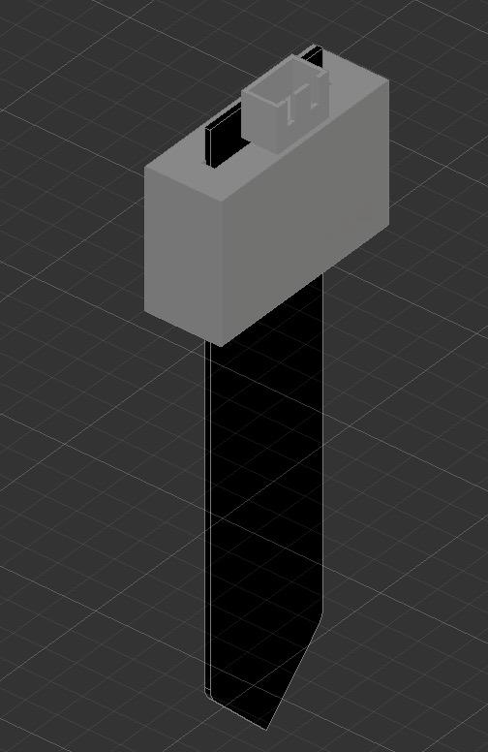
9. Slip the moisture sensor through the slot in the moisture sensor casing, and put it up as far as possible until it is no longer possible to due to the pin connector
10. Place the remaining part not covered by the moisture sensor cover into the soil, this will ensure that the right length of the sensor is inside the soil
11. Stick the metal part of the thermistor into the soil
12. Power the second circuit at the from the USB slot located at the short side of the STM32

Costs

# Manufacturing Costs

## Component Costs:

| [31] STM32 F446RE Microcontrollers (x2)   * Manufactured by STMicroelectronics, based in Switzerland, with distributors worldwide, including Mouser (USA) and Digi-Key (Canada). | $93.96 |
| --- | --- |
| [32] Thermistor (x1)   * Manufactured by Vishay, headquartered in the USA, distributed globally through Amazon and other electronics suppliers. | $2.12 |
| [33] LCD Screen & I2C Interface Module (x1)   * Manufactured by SunFounder, located in China, available through distributors like Amazon and Aliexpress. | $15.36 |
| [34] Moisture Sensor (x1)   * Produced by DFRobot, based in China, distributed through Digi-Key and other international electronics retailers. | $3.39 |
| [6] HC-05 Bluetooth modules (x2)   * Commonly produced by third-party manufacturers in China, widely distributed via platforms like Amazon and AliExpress. | $5.98 |
| Water-resistent casing (x1)   * Manufactured using 3D printers within the University of Waterloo | $5.00 |
| Total Cost | $125.81 |

Risks

# Energy analysis

The following energy analysis will reference the [“ST STM32F446 SERIES REFERENCE MANUAL”](https://data2.manualslib.com/cpdf/54/266/26549/6f29e0.pdf)

<https://data2.manualslib.com/cpdf/54/266/26549/6f29e0.pdf>

1. **Power consumption calculations**

## Power equation

* To test our energy consumption, power will be calculated using the equation: P=IV [19]
* Where:
  + P = power in watts
  + V = the difference in voltage between the cathode and anode of the power supply
  + I = current
* Operating Current: According to the STM32F446 documentation, typical operating current at 3.3V is approximately 100 mA in active mode.
  + Total power consumption per microcontroller: P = 3.3V x 0.1A = 0.66W
  + Total power consumption for both microcontrollers: 0.66W

Components

* Each component’s power draw will be considered, including:
  + **STM32 microcontrollers:**
    - Operating Current: According to the STM32F446 documentation, typical operating current at 3.3V is approximately 100 mA in active mode.
    - Total Consumption per microcontroller:
      * P = 3.3V x 0.1A = 0.33 W
    - Total Consumption for Both Microcontrollers: Since there are two microcontrollers running continuously, the combined power draw is approximately 0.66W
    - Maximum Operating Current:
      * In typical active mode (at 3.3V and 180 MHz), it consumes around 100-120 mA.
    - Power Consumption:
      * At 3.3V, the maximum power consumption in active mode (based on 120 mA) is approximately: P=3.3V x 0.12A = 0.4W
  + **HC-05 Bluetooth module:** 
    - Operating Voltage and Current: The HC-05 Bluetooth module operates at 3.3V and typically draws about 30 mA during transmission.
    - Total Consumption: Assuming continuous transmission:
      * P = 3.3V x 0.03A = 0.099W
  + **Thermistor**:
    - Operating Voltage and Current: The thermistor operates in a voltage divider circuit and typically consumes a negligible amount of power. For calculation, we assume a maximum draw of around 1 mA at 3.3V.
    - Total consumption:
      * P=3.3V x 0.001A = 0.0033W
  + **Soil moisture sensor**
    - Operating Voltage and Current: This sensor operates at 3.3V to 5.5V and typically draws around 5 mA.
    - Total Consumption: Assuming an operating voltage of 5V, the power consumption is:
      * P=5V x 0.005A = 0.025W
  + **LCD Display: 0.2W**
    - Operating Voltage and Current: The LCD operates at 5V and draws approximately 25 mA during operation.
    - Total consumption:
      * P= 5V x 0.025A = 0.125W

Total power consumption

* To determine the total power consumption of the system, we will add the power consumed by each component [25]
* Where:
  + Ptotal = PSTM32 + PBluetooth + PThermistor + PSensors + PLCD  = 0.9123W

1. **Power source**

Battery life calculation

* Based on power consumption, we can estimate the operational time of the device on a full charge [26]
* Where:
  + Battery Life (hours) = Battery Capacity (mAh) _

Total Power Consumption (mA)

* The system will be powered by a 12V Li-Ion battery with a capacity of 2000mAh, we can estimate the operation time:
  + Battery Life = 2000mAh = 6.67 hours

300mA

* Estimated Battery Life: Approximately 6.7 hours under continuous operation

1. **Efficiency enhancements**

1. Sleep mode for microcontrollers

* Implementing a low-power or sleep mode on the STM32 microcontrollers when sensor data is not actively being processed or transmitted can significantly reduce power consumption. STM32 microsontrollers have several low-power modes, such as stop mode, which can decrease energy use by approximately 50-70% during idle periods [41].

2. Duty cycling for sensors

* The thermistor and soil moisture sensors could operate in a duty-cycled mode, where they are activated at regular intervals (e.g., every hour) rather than continuously [42]. This approach minimizes the time sensors draw power, especially beneficial in this system where constant real time monitoring is not critical.

3. Reducing LCD backlight intensity

* Lowering the brightness or turning off the LCD1602 backlight when not actively in use (e.g., no recent data updates) can conserve additional power. This is achievable by using the microcontroller to control the backlight circuit, dimming it during non-essential periods.

4. Optimizing bluetooth transmission

* Adjusting the HC-05 Bluetooth module to transmit data at longer intervals or only when significant changes in sensor readings occur can reduce power drawn by Bluetooth communication.

1. **Energy storage**

Energy Storage in Capacitors

* The energy stored in a capacitor will be calculated using the equation: E=½ CV2 [22]
* Where:
  + E = energy in Joules
  + C= capacitance in Farads
  + V= voltage
* The STM32 F446RE only contains decoupling capacitors which have 4.7µF, which when supplied with a 3.3V voltage, will store 26µJ, which is 2.15 µAh, in compliance of the stored energy requirement

1. **Safety and compliance**

- The power consumption and energy storage align with the project requirements and are under these ideal limits, ensuring safe operation within defined limits.

# Risk analysis

Possible negative consequences of intended use

* The plant monitoring system is designed for indoor use, utilizing electronics such as sensors to monitor soil moisture and temperature. While the system includes water-resistant casings, accidental exposure to large volumes of water, such as from watering the plant directly into the casing, may compromise its safety. Prolonged exposure to high moisture levels could potentially cause corrosion or short circuit the internal components, presenting a minor electrical hazard [35].

Possible negative consequences of incorrect use

* Incorrect installation of sensors, such as improper placement in the soil, may result in inaccurate readings of soil moisture and temperature. Improper installation includes; the moisture sensor being placed on the soils surface or too deep into the soil, the temperature sensor being placed too far from the plant, mixing up the temperature and moisture level readings [36]. This can lead to inappropriate watering recommendations, causing plants to receive either too much or too little water, which may adversely affect the plants health [37]. Additionally, failure to secure the system properly may result in damage if it is dropped or exposed to excessive physical force.

Possible negative consequences of misuse or unintended use

* If the system is used outdoors without additional protective measures, it may be exposed to extreme weather conditions, including heavy rain and snow, and temperature fluctuations, which the design is not intended to withstand. This could lead to the failure of components like the LCD screen or bluetooth module, and in severe cases, may cause permanent damage to the microcontrollers due to water exposure or overheating [38].

Possible design malfunctions

* **Sensor failure**
  + Sensors (thermistor and moisture sensor) may fail over time due to wear or exposure to high moisture levels or temperatures, leading to inaccurate data readings [38].
* **Bluetooth Communication Loss**
  + Interference or obstructions could disrupt the wireless communication between the two microcontrollers, preventing data transmission [39].
* **Power Supply Interruption**
  + A sudden poss of power due to faulty power connection or an insufficient supply can halt system operation, risking incomplete data logging and display [40].

Consequences of each failure

* **Sensor failure**
  + If the thermistor fails, temperature readings may no longer be accurate, which could result in recommendations that either overhead or chill the soil. This could stress the plant and impact its growth. Similarly, a failed moisture sensor could lead to incorrect watering instructions.
* **Bluetooth Communication Loss**
  + Loss of communication between the microcontrollers may cause delays in data updateson the display, potentially leading to delayed responses to changes in the plant’s environment.
* **Power Supply Interruption**
  + An interrupted power supply might risk a short circuit if water leaks into the battery compartment, posing a minor fire hazard. Additionally, data logging could be disrupted, causing a loss of monitoring history.

Testing & Validation

# Test plan

## Temperature Measurement Accuracy Test (Room Temperature)

* **Objective**: Verify the thermistor accurately measures room temperature as a proxy for soil temperature.
* **Test Setup**: Place the thermistor in ambient test input (air or soil), and compare the reading digital thermometer measuring the same environment.
* **Environmental Parameters**: Conduct in a standard indoor room at a steady temperature.
* **Test Inputs**: Ambient room temperature, soil.
* **Measurement Standard**: The system should measure within ±5°C of the reference thermometer.
* **Pass/Fail Criteria**: Pass if the displayed temperature is within ±5°C of the reference thermometer’s reading; fail otherwise.

## Soil Moisture Measurement Accuracy Test (Moist/Dry Soil)

* **Objective**: Test the soil moisture sensor’s ability to differentiate between dry and moist soil.
* **Test Setup**: Prepare two small soil samples—one dry and one with added water the same volume of the soil sample (moist) to simulate varying soil moisture conditions.
* **Environmental Parameters**: Conduct in a controlled indoor environment that can prevent rapid changes in moisture.
* **Test Inputs**: Insert the moisture sensor into each sample and observe the readings.
* **Measurement Standard**: The system should show distinctly different VWC percentages for dry vs. moist soil.
* **Pass/Fail Criteria**: Pass if the moisture reading is within 25 of 100% for the moist soil than to the dry soil and if the moisture reading for dry soil is within 10 of 5%.

## Wireless Data Transmission Range Test (7-Meter Test)

* **Objective**: Confirm that the Bluetooth modules can maintain a connection within a 7-meter indoor range.
* **Test Setup**: Place the transmitting microcontroller at a fixed point and move the receiving device in increments up to 7 meters.
* **Environmental Parameters**: Conduct in a standard indoor setting with few obstructions.
* **Test Inputs**: Transmit data packets from the system’s sensors at 1-second intervals.
* **Measurement Standard**: Connection should be reliable with no significant data loss within the 7-meter range.
* **Pass/Fail Criteria**: Pass if the connection remains stable with minimal or no packet loss up to 7 meters; fail if the connection drops.

## Energy Consumption Test (Power Measurement)

* **Objective**: Confirm the system’s power consumption remains within acceptable limits.
* **Test Setup**: Connect a digital multimeter to measure the voltage drop across the power supply and the current drawn by the system during operation.
* **Environmental Parameters**: Conduct in a stable indoor environment at room temperature.
* **Test Inputs**: Operate the system under normal conditions, with sensors actively measuring and data being transmitted.
* **Measurement Standard**: Use the power equation (P = VI) to calculate power consumption.
* **Pass/Fail Criteria**: Pass if the calculated power consumption remains below 30W; fail if it exceeds this threshold.

## Enclosure Resistance Test (Basic Splash Test)

* **Objective**: Ensure the LCD screen remains legible from a distance of 1 meter
* **Test Setup**: Place the LCD screen at eye level and position the body 1 meter away with necessary myopia/hyperopia aids
* **Environmental Parameters**: Conduct in a well-lit room.
* **Test Inputs**: Display standard alphanumeric text with a font size of at least 8.5mm.
* **Measurement Standard**: Text should be legible at a distance of 1 meter.
* **Pass/Fail Criteria**: Pass if all characters are readable from 1 meter away; fail if the readings are illegible

Citations

[1] MyPlantIn, “Overwatered vs. Underwatered Plants,” [Online]. Available: https://myplantin.com/blog/overwatered-vs-underwatered-plants. [Accessed: Oct. 30, 2024].

[2] Plantsome, “Air Conditioning and its Impact on Indoor Plants: Tips and Tricks,” [Online]. Available: https://plantsome.ca/blogs/blog/air-conditioning-and-its-impact-on-indoor-plants-tips-and-tricks#:~:text=Temperature%20Fluctuations%3A%20Plants%20love%20consistency,leaving%20your%20plants%20feeling%20parched. [Accessed: Oct. 30, 2024].

[3] Joe Gardener, “Reducing Garden Overwhelm,” [Online]. Available: https://joegardener.com/podcast/reducing-garden-overwhelm/#:~:text=While%20in%20the%20middle%20of,forget%20what%20you%20had%20observed. [Accessed: Oct. 30, 2024].

[4] Nature, “Impact of Climate Variability on Agriculture,” Nature, vol. 554, p. 111, 2018. [Online]. Available: https://www.nature.com/articles/s41558-017-0007-7. [Accessed: Oct. 30, 2024].

[5] Automation Robotics Arduino, “HC-05 Bluetooth Module,” [Online]. Available: https://automationroboticsarduino.com/products/hc05-bluetooth-module#:~:text=This%20HC%2D05%20Bluetooth%20Module,of%20up%20to%2030%20meters. [Accessed: Oct. 30, 2024].

[6] AliExpress, “Capacitive Soil Moisture Sensor,” [Online]. Available: https://www.aliexpress.com/gcp/300000512/nnmixupdatev3?spm=a2g0o.productlist.main.3.2434dLVOdLVOLp&productIds=1005006861960027&pha_manifest=ssr&_immersiveMode=true&disableNav=YES&channelLinkTag=nn_newgcp&sourceName=mainSearchProduct&utparam-url=scene%3Asearch%7Cquery_from%3A. [Accessed: Oct. 30, 2024].

[7] Hands On Tec, “10K NTC Thermistor Data Sheet,” [Online]. Available: https://www.handsontec.com/dataspecs/sensor/NTC-10K-3950-HT.pdf. [Accessed: Oct. 30, 2024].

[8] Plantee, “How Soil Temperature Affects Houseplants,” [Online]. Available: https://plantee.com/blogs/growing-at-home/hot-or-cold-how-soil-temperature-affects-houseplants. [Accessed: Oct. 30, 2024].

[9] Digi-Key Electronics, “Capacitive Soil Moisture Sensor SKU:SEN0193 Data Sheet,” [Online]. Available: https://media.digikey.com/pdf/data%20sheets/dfrobot%20pdfs/sen0193_web.pdf. [Accessed: Oct. 30, 2024].

[10] Acurite, “Soil Moisture Guide for Plants and Vegetables,” [Online]. Available: https://www.acurite.com/blog/soil-moisture-guide-for-plants-and-vegetables.html. [Accessed: Oct. 30, 2024].

[11] Components101, “HC-05 Bluetooth Module Datasheet,” [Online]. Available: https://components101.com/sites/default/files/component_datasheet/HC-05%20Datasheet.pdf. [Accessed: Oct. 30, 2024].

[12] 48HourPrint, “Banner Font Size Guide,” [Online]. Available: https://www.48hourprint.com/banner-font-size.html?srsltid=AfmBOopGYwy6Rq41OniVU3SGyUf-KFGiO59Z8jHpEvK8xCrOPHJcAfg7. [Accessed: Oct. 30, 2024].

[13] Lisun Group, “IEC 60529:2013 Standard Free Download,” [Online]. Available: https://www.lisungroup.com/wp-content/uploads/2020/02/IEC60529-2013-Standard-Free-Download.pdf?srsltid=AfmBOoo3EFn7XgcRIpj-7IMuG0rvh8-XSp2DHRuIsNiegIjg4fY-Lked. [Accessed: Oct. 30, 2024].

[14] Rachio, “Rachio Smart Sprinkler Controller,” [Online]. Available: https://rachio.com/. [Accessed: Oct. 30, 2024].

[15] Click & Grow, “Indoor Smart Planters,” [Online]. Available: https://www.clickandgrow.com/. [Accessed: Oct. 30, 2024].

[16] Plant Methods, “Innovative Methods in Plant Monitoring,” vol. 15, 2019. [Online]. Available: https://plantmethods.biomedcentral.com/articles/10.1186/s13007-015-0083-5. [Accessed: Oct. 30, 2024].

[17] Medium, “Building a Garden is Its Own Creative Process,” [Online]. Available: https://medium.com/share-your-creativity/building-a-garden-is-its-own-creative-process-62312b0d8507. [Accessed: Oct. 30, 2024].

[18] PlantSnap, “Plant Identification and Care Tips,” [Online]. Available: https://www.plantsnap.com/. [Accessed: Oct. 30, 2024].

[19] Physics.info, “Electric Power Equations Summary,” [Online]. Available: https://physics.info/electric-power/summary.shtml. [Accessed: Oct. 30, 2024].

[20] American Society of Agronomy, “Soil Water Content Measurement and Analysis,” Soil Science Society of America Journal, vol. 44, no. 5, pp. 892-898, 1980. [Online]. Available: https://acsess.onlinelibrary.wiley.com/doi/epdf/10.2136/sssaj1980.03615995004400050002x. [Accessed: Oct. 30, 2024].

[21] U.S. National Agricultural Library, “UNSODA 2.0: Unsaturated Soil Hydraulic Database,” [Online]. Available: https://agdatacommons.nal.usda.gov/articles/dataset/UNSODA_2_0_Unsaturated_Soil_Hydraulic_Database_Database_and_program_for_indirect_methods_of_estimating_unsaturated_hydraulic_properties/24851832. [Accessed: Oct. 30, 2024].

[22] Fluke, “What is Ohm’s Law?,” [Online]. Available: https://www.fluke.com/en-ca/learn/blog/electrical/what-is-ohms-law. [Accessed: Oct. 30, 2024].

[23] IEEE, “IEEE Standard for Telecommunications and Information Exchange Between Systems - LAN/MAN - Specific Requirements - Part 15.1: Wireless Medium Access Control (MAC) and Physical Layer (PHY) Specifications for Wireless Personal Area Networks (WPANs),” [Online]. Available: https://standards.ieee.org/ieee/802.15.1/3513/. [Accessed: Oct. 30, 2024].

[24] ISO, “ISO 9241-303:2008 Ergonomics of Human-System Interaction - Part 303: Requirements for Electronic Visual Displays,” [Online]. Available: https://www.iso.org/standard/57992.html. [Accessed: Oct. 30, 2024].

[25] Vedantu, “Calculate Power in Series and Parallel Circuits,” [Online]. Available: https://www.vedantu.com/question-answer/calculate-power-in-series-and-parallel-circ-class-12-physics-cbse-606df25d477df81db103b24a. [Accessed: Oct. 30, 2024].

[26] All About Circuits, “Battery Lifetime Calculator,” [Online]. Available: https://www.allaboutcircuits.com/tools/battery-lifetime-calculator/. [Accessed: Oct. 30, 2024].

[27] CED Engineering, “Principles and Methods of Temperature Measurement,” [Online]. Available: https://www.cedengineering.com/userfiles/E02-012%20-%20Principles%20and%20Methods%20of%20Temperature%20Measurement%20-%20US.pdf. [Accessed: Oct. 30, 2024].

[28] Physics Instrumentation, “Measurement Systems and Application Design,” [Online]. Available: https://physicsinstrumentation.wordpress.com/wp-content/uploads/2015/03/measurement_systems_application_design.pdf. [Accessed: Oct. 30, 2024].

[29] Omega Engineering, “Thermocouple Types and Accuracy,” [Online]. Available: https://www.omega.ca/en/resources/thermocouple-types#:~:text=Accuracy%3A%20Type%20T%20thermocouples%20have,per%20ANSI%2FASTM%20E230. [Accessed: Oct. 30, 2024].

[30] Mouser, “Pros and Cons of Temperature Sensor Types,” [Online]. Available: https://www.mouser.com/blog/what-are-you-sensing-pros-and-cons-of-four-temperature-sensor-types. [Accessed: Oct. 30, 2024].

[31] Amazon, “STM32 Nucleo Development STM32F446RE,” [Online]. Available: https://www.amazon.ca/STM32-Nucleo-Development-STM32F446RE-NUCLEO-F446RE/dp/B01I8XLEM8/ref=sr_1_5?crid=26T4LU5UGSKM2&dib=eyJ2IjoiMSJ9.rwNMw7kdspdmZPNWd7F-Hqon0vIdgKeMcxQ2Ojx7K5vz4UZnDt6JyU4qmKU3Frjw7RTkt2gWFdzcCcfk34H9DNrAB5tdNxcrhqqjOWfJUk8YSiTAmif2ox5-FeoL_vjVcTRLnCG-l5_0odnATI5CbhpDF131-9twJCT3EmURz_pxxCc9r2xg0MHprtAhc5yhGd5c_38EOGS5EcXKhZmjxjeBf3rTg5coyVgVpAqeBfJwLWjkuCjnDTeKE1ACCFrn0f7h5a6OxO65qOfnQWGyF8tbZYCWxKTZjBcCngyNsgo._lV4B6oKuDIjGpBTiCHyS2W9oCLdV7CVWvWiL1XR9Vk&dib_tag=se&keywords=stm32&qid=1730257663&sprefix=stm32%2Caps%2C160&sr=8-5. [Accessed: Oct. 30, 2024].

[32] Amazon, “NTC Thermistor Fajoeda Temperature Digital Thermal Sensor,” [Online]. Available: https://www.amazon.ca/Thermistor-Fajoeda-Temperature-Digital-Thermal/dp/B0B2JHH8FC/ref=sr_1_6?crid=1DSKQQJRZJ4HT&dib=eyJ2IjoiMSJ9.jaN2fuC5RGhsSZPtzYzejhPg95YMwXVgbQfxsDETX_UtLE3AxkboMCIc73YGMyIDZ-T4aGqriEN7ItTAQQuQCTIqUiVt1KjS7zG7r2IWAv0CfRq5MklPzw34ZRqs_uaMnsoJX-uSmj4gEyA0WulJ6Jx39kjDo8N0gKV7MH4O-dF5SP64pDb0wK9ACnBguNVaXKOFJUGfv5p6tt89DGYeqRNQ0W9TGFaUX9tQMRZifmx-4H3DCRjm0xaXoCxXW9O_8xktkzqwqMxSDr3XeM8ZUrfxaIOIXU5XycJXJTLI4dw.Cbz8TRQ0QiKqP2nLwCLdHpjCG6i5hjZGkiDBySlpCbY&dib_tag=se&keywords=ntc+thermistor&qid=1729970846&sprefix=ntc+thermistor%2Caps%2C112&sr=8-6. [Accessed: Oct. 30, 2024].

[33] Amazon, “SunFounder I2C LCD1602 Display for Arduino,” [Online]. Available: https://www.amazon.ca/SunFounder-Serial-Module-Display-Arduino/dp/B019K5X53O/ref=sr_1_10?crid=2FTVTD9DAVQSC&dib=eyJ2IjoiMSJ9.Mn_RqxPHF5OepA3x5kOBfFHRZBShqiVvq05vr2n3msYhMc6nkiPFIWj670y0kYMHtvv60WgaWCLYGtXrOKu-yufEWGfEzmmPkFyR-IfUyIV0FOXYLNZSO2o7qf-8ZYZKV3KxCYwij7Xh7T8WPFESCaOIMUPOfY-7OLSWD6GbtJ8EU_7i2OUEhs878Inip_q9lqau6_dHzwGYe_ErvXjZqws6QYmtCdWhbZ2m7-1QybR8rheSIVoZDRvCmgiJuKq75YmwYrjkDI-wnNdA-x_OLgXfDrSIet2QNJYVSuDBr5A.tu_dNNtZvdTRisdy5rzCQVnaWVR3N4qoIq8EnQ9UEns&dib_tag=se&keywords=lcd1602+i2c&qid=1730257791&sprefix=lcd1%2Caps%2C135&sr=8-10. [Accessed: Oct. 30, 2024].

[34] Amazon, “Stemedu Capacitive Soil Moisture Sensor,” [Online]. Available: https://www.amazon.ca/Stemedu-Capacitive-Corrosion

[35] “Recovery and prevention of water damage in electronics - expert tips and solutions,” AdvantaClean, Jan. 15, 2024. https://advantaclean.com/ft-lauderdale-fl/about-us/blog/recovery-and-prevention-of-water-damage-in-electronics---expert-tips-and-solutions/#:~:text=Water%20is%20a%20conductor%20of,but%20also%20pose%20safety%20hazards. [Accessed: Oct. 30, 2024].

[36] K. Bollinger, “How to install soil moisture sensors—Faster, better, and for higher accuracy - METER Group,” METER Group, Jul. 24, 2024. https://metergroup.com/expertise-library/how-to-install-soil-moisture-sensors-faster-better-and-for-higher-accuracy/ [Accessed: Oct. 30, 2024].

[37] PlantIn, “Overwatered vs Underwatered Plants: Signs, fix Tips (Full Guide),” PlantIn. https://myplantin.com/blog/overwatered-vs-underwatered-plants [Accessed: Oct. 30, 2024].

[38] Roombanker, “Indoor vs outdoor PIR sensors, A complete comparison on key differences,” Roombanker, Sep. 24, 2024. https://www.roombanker.com/blog/indoor-vs-outdoor-pir-sensors/#:~:text=False%20Alarms%3A%20While%20tempting%20to,%2C%20rain%2C%20or%20small%20animals. [Accessed: Oct. 30, 2024].

[39] A. Support, “Why is my Bluetooth Connection Breaking Up? How Do I Fix It?,” Avantree, Apr. 11, 2024. https://avantree.com/blogs/news/why-is-my-bluetooth-connection-breaking-up-how-do-i-fix-it [Accessed: Oct. 30, 2024].

[40] J. Covington, “Top 10 signs of power supply failure,” Custom Gaming & Workstation PC Blog | Velocity Micro, Apr. 28, 2022. https://www.velocitymicro.com/blog/top-10-signs-of-power-supply-failure/ [Accessed: Oct. 30, 2024].

[41] Admin, “How to use the Low Power Modes in STM32,” ControllersTech, Sep. 18, 2024. https://controllerstech.com/low-power-modes-in-stm32/ [Accessed: Oct. 30, 2024].

[42] Fluke, “What is duty cycle?” https://www.fluke.com/en-ca/learn/blog/electrical/what-is-duty-cycle#:~:text=Duty%20cycle%20is%20the%20ratio,and%20OFF%20the%20other%2040%25. [Accessed: Oct. 30, 2024].

[43] Study.com, “Voltage Divider Circuit Rule & Bias Formula,” [Online]. Available: https://study.com/academy/lesson/voltage-divider-circuit-rule-bias-formula.html#:~:text=The%20voltage%20divider%20formula%20for,multiplied%20by%20the%20input%20voltage. [Accessed: Nov. 20, 2024].