Ex:No: 15

Date:

**HIGH LEVEL PROGRAMMING EXTENSIONS**

**(FUNCTIONS)**

**Program 1:**

Create a function that returns the level of a customer based on credit limit.(Use the IF statement to determine the credit limit). 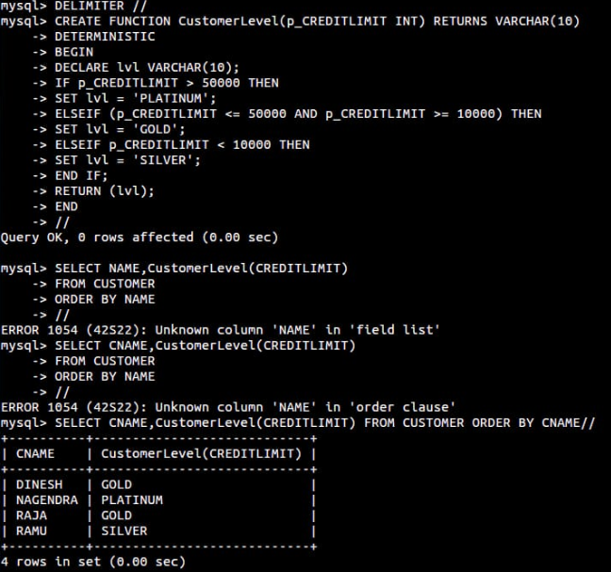

**Program 2**Write a recursive MySQL procedure compute the factorial of a numberx