# Phase 6: User Interface Development

The User Interface (UI) development phase focuses on designing an intuitive and user-friendly experience for healthcare professionals and patients. This phase ensures that the Lightning App is visually structured, easy to navigate, and integrates seamlessly with the backend logic.  
  
**Lightning App: Smart Healthcare CRM**  
The Smart Healthcare CRM Lightning App acts as the central hub for managing all healthcare operations. It provides access to dashboards, records, and analytics that allow doctors, administrators, and patients to interact within a unified system.

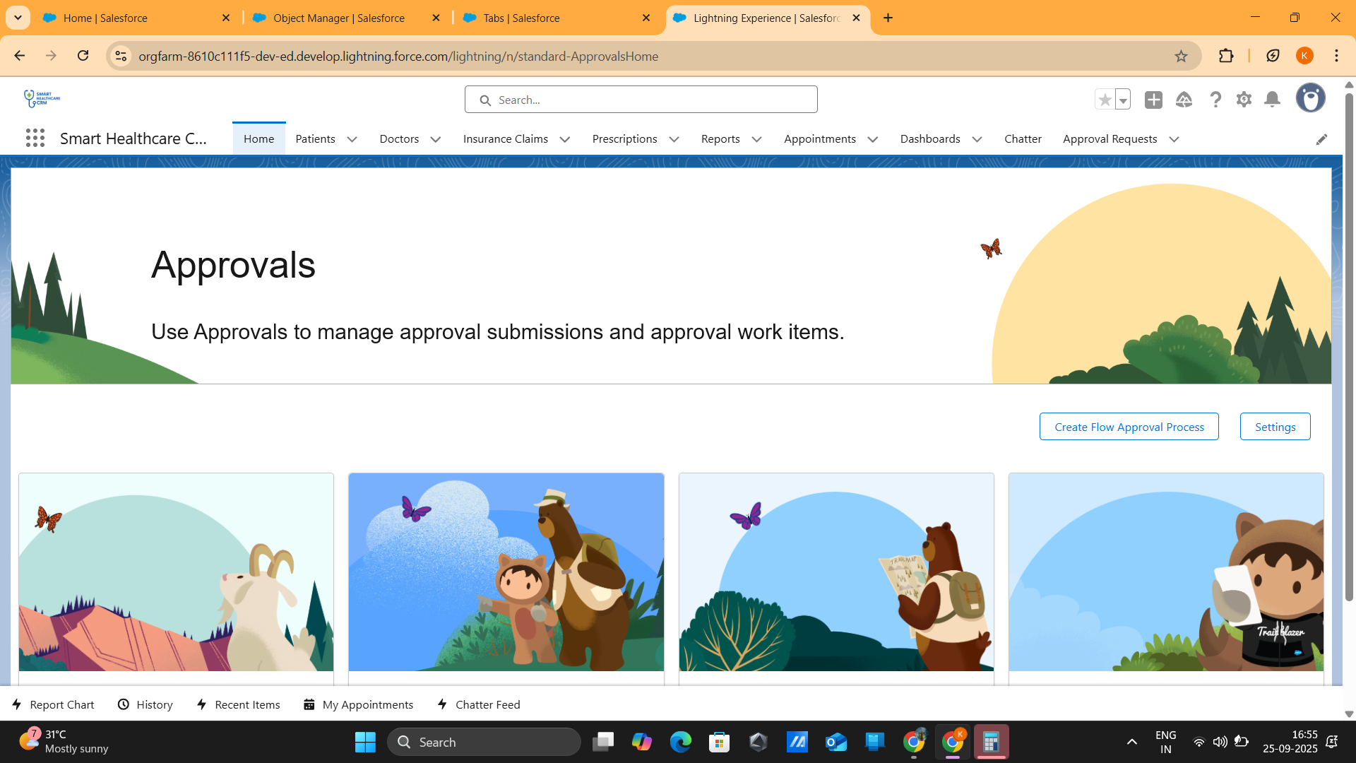  
  
**Home Page: Active appointments, insurance claims, pending approvals**  
The Home Page displays real-time updates of critical healthcare activities. Active appointments are shown in a summarized list to help doctors and patients manage schedules efficiently. Insurance claims and pending approvals are also highlighted for administrators, ensuring transparency and timely decision-making.  
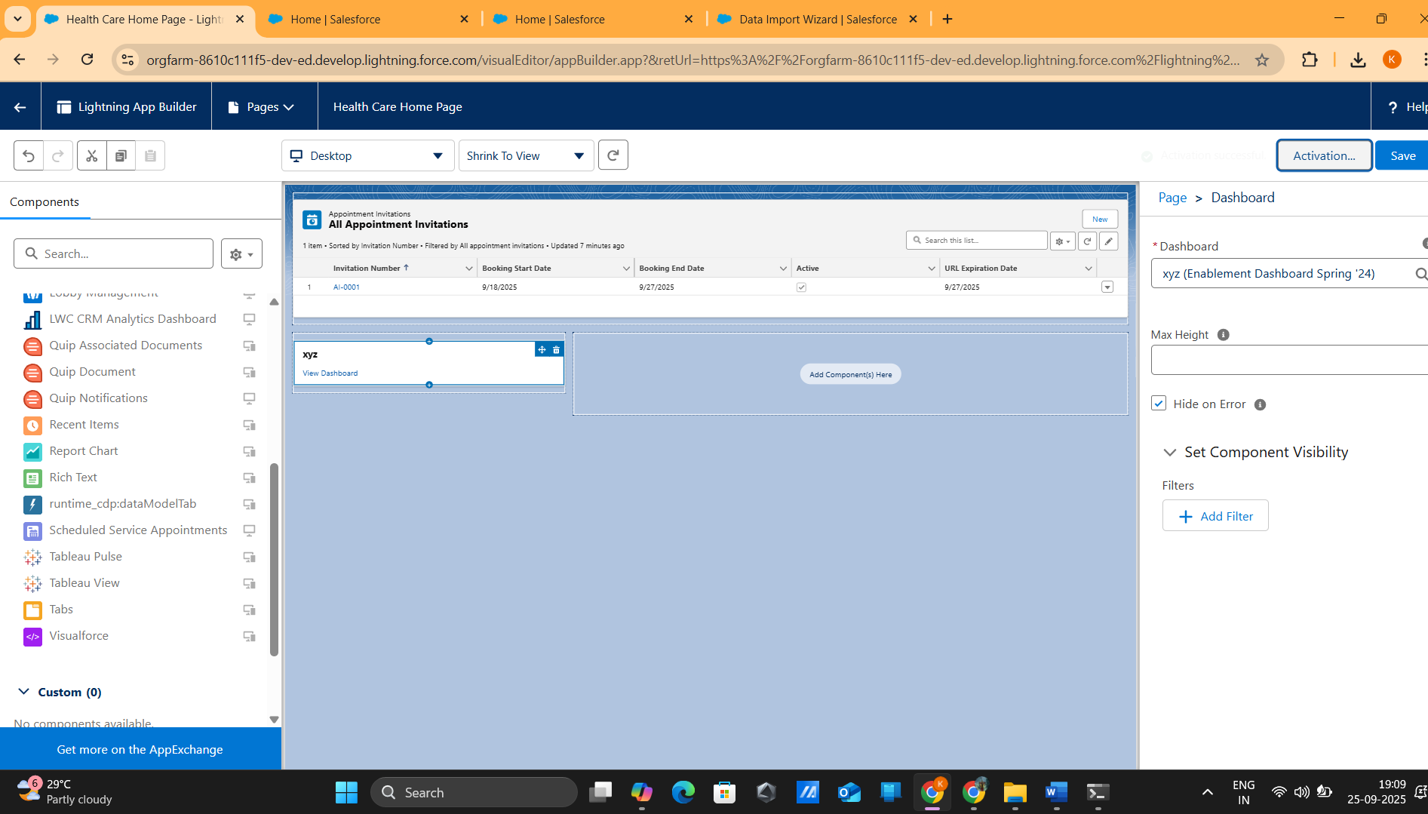

**Record Pages: Patient history, doctor schedule, claim details**  
Custom record pages are designed to provide detailed information in an organized manner.   
Patient history allows doctors to review previous consultations, diagnoses, and prescriptions. The doctor schedule page provides an overview of daily and weekly availability. Claim details pages help insurance staff track submission statuses, required documents, and processing progress.

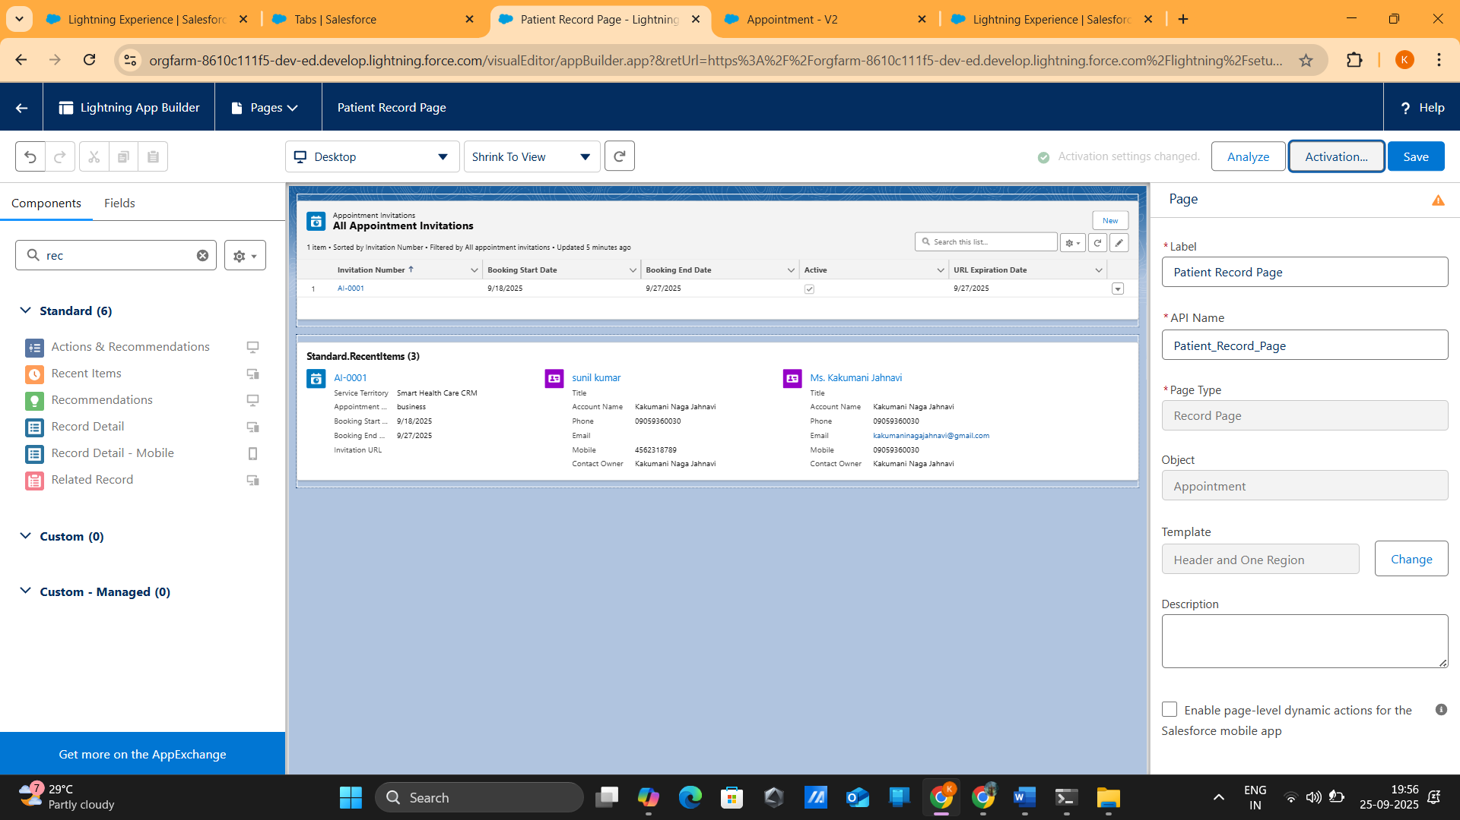  
  
**Tabs: Patients, Appointments, Doctors, Insurance Claims, Prescriptions**  
Tabs are implemented to ensure easy navigation between key entities of the system. Each tab leads to a list view with search, filter, and sort options for quick data retrieval. For example, the Appointments tab allows viewing of all scheduled, completed, or canceled appointments, while the Prescriptions tab contains details of medicines issued to patients.

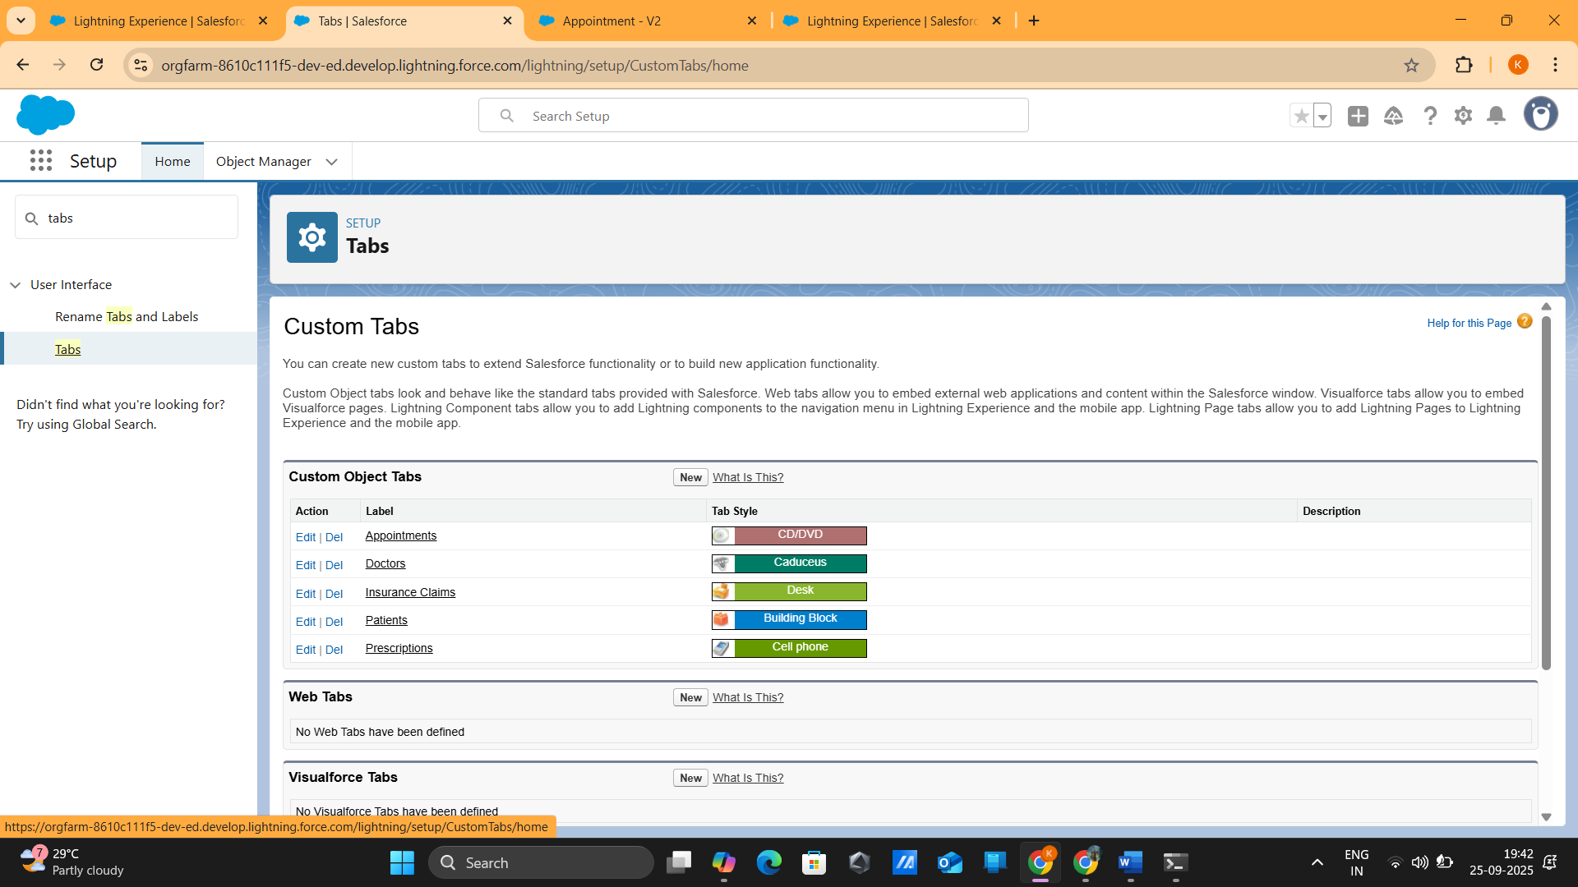  
  
**LWC Components: Appointment Booking Form, Patient Dashboard**  
Custom Lightning Web Components (LWCs) are built to provide interactivity and personalization. The Appointment Booking Form enables patients to book appointments by selecting departments, doctors, and available time slots. The Patient Dashboard acts as a personalized space where patients can track their appointments, prescriptions, and claim statuses in one place.

