Core Flows — Detailed Specification
Cross-Border Racehorse Transport System (CBRTS)
Flow 1 — Transport Request Creation & Approval · Flow 2 — Legal Documentation & Customs Clearance
This section expands the two required core flows into implementable epics. Each epic is described the same way: scope and actors, an activity (swimlane) diagram, the main flow, the alternate and exception flows, the state machine the system enforces, the business rules, and the user stories the team will build against. Flows 3 to 6 are referenced only where they consume the output of these two.

1. Why these two flows are the core
CBRTS supports six flows — four required, two optional. Flow 1 and Flow 2 are the core because together they create and legalise the unit of work that every other flow operates on:
- Flow 1 turns a customer enquiry into an approved Transport Job: a priced, owned, staffed piece of work with a unique code. Nothing exists to plan or drive before it completes.
- Flow 2 turns that job into a legally movable shipment: it derives the documents required by every country on the route, collects and verifies them, files them with the authorities, tracks quarantine, and finally opens the clearance gate.
The dependency is strict in both directions: Flow 2 cannot start without an approved job from Flow 1, and Flow 4 cannot record a departure until Flow 2 reports CLEARANCE_READY. A horse moved without that gate is an illegal border crossing, so the rule is enforced by the system rather than by procedure.
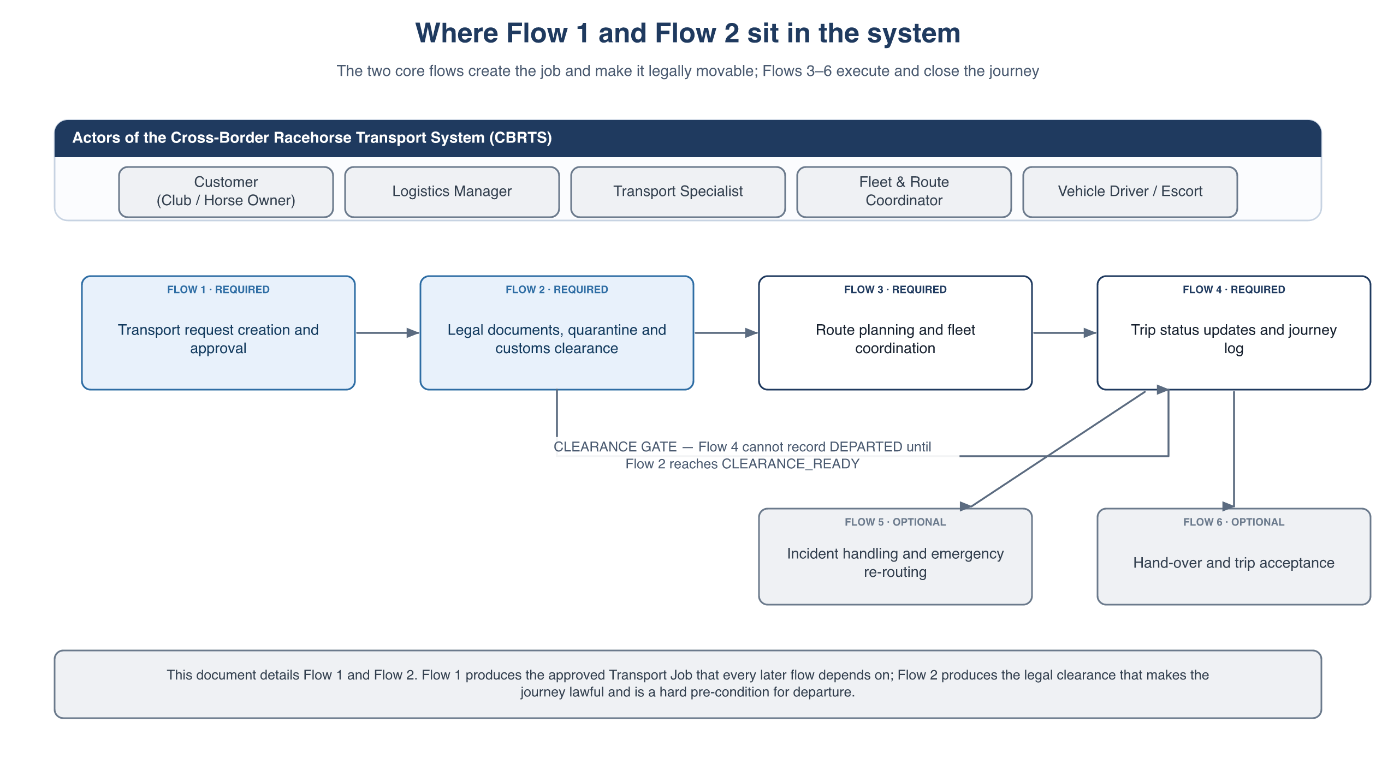
Figure 1 — The six flows of CBRTS and the position of the two core flows

1.1 Actors
Actor | Role in Flow 1 | Role in Flow 2
Customer  (Club / Horse Owner) | Creates the request, supplies horse details, accepts or declines the quotation, may cancel. | Uploads the legal and medical documents for each horse and re-uploads the ones that are rejected.
Logistics Manager | Owns the flow: reviews feasibility, asks for missing information, builds the quotation, approves or rejects. | Escalation point: decides whether to reschedule or cancel when a dossier is blocked or late.
Transport Specialist | Assigned to the job on approval. | Owns the flow: tunes the checklist, verifies every document, files the dossiers with the authorities, tracks quarantine.
Fleet & Route Coordinator | Consulted for vehicle, stall and air-cargo capacity in the requested window. | Consumes the clearance result — cannot start the journey until the gate is green.
System (CBRTS) | Validates input, checks lead time, routes the request, issues the quote, creates the job, notifies. | Derives the checklist from the regulation catalog, validates uploads, enforces deadlines and the clearance gate.
External authorities  (veterinary / agriculture, customs, quarantine facility) | — | Review the dossiers and issue permits outside the system; their progress is recorded manually by the Transport Specialist.

2. Flow 1 — Transport Request Creation & Approval

2.1 Epic summary
Field | Value
Epic ID | EPIC-F1
Goal | Let a customer request racehorse transport and let the Logistics Manager assess, price and approve it, producing an approved Transport Job that the rest of the system can plan and execute.
Primary actors | Customer (Club / Horse Owner), Logistics Manager
Supporting actors | Fleet & Route Coordinator (capacity confirmation), System
Trigger | A club or horse owner needs to move one or more racehorses, domestically or across a border.
Pre-conditions | The customer has a registered, active account. The Country Regulation Catalog holds an entry for the destination and every transit country.
Post-conditions — success | A Transport Job exists with a unique code, the agreed price is locked, a Transport Specialist and a Fleet & Route Coordinator are assigned, the per-horse document checklist is generated (Flow 2) and the job is in the planning backlog (Flow 3).
Post-conditions — failure | The request ends REJECTED, EXPIRED or CANCELLED with a recorded reason. No job is created and no capacity is held.
Out of scope | Payment settlement and invoicing, construction of the actual route (Flow 3), assignment of a specific driver (Flow 3).

2.2 Activity diagram
The flow is shown in two parts because of its length. Part 1 covers creation, validation and the feasibility decision; Part 2 covers quotation, acceptance, approval and the hand-off.
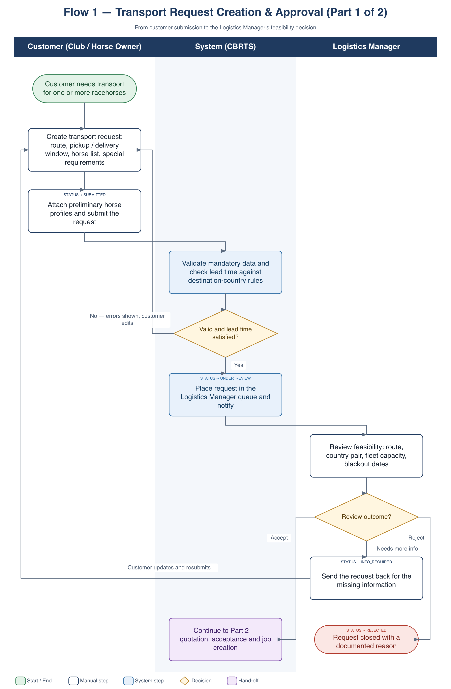
Figure 2 — Flow 1, Part 1 — creation, validation and feasibility review
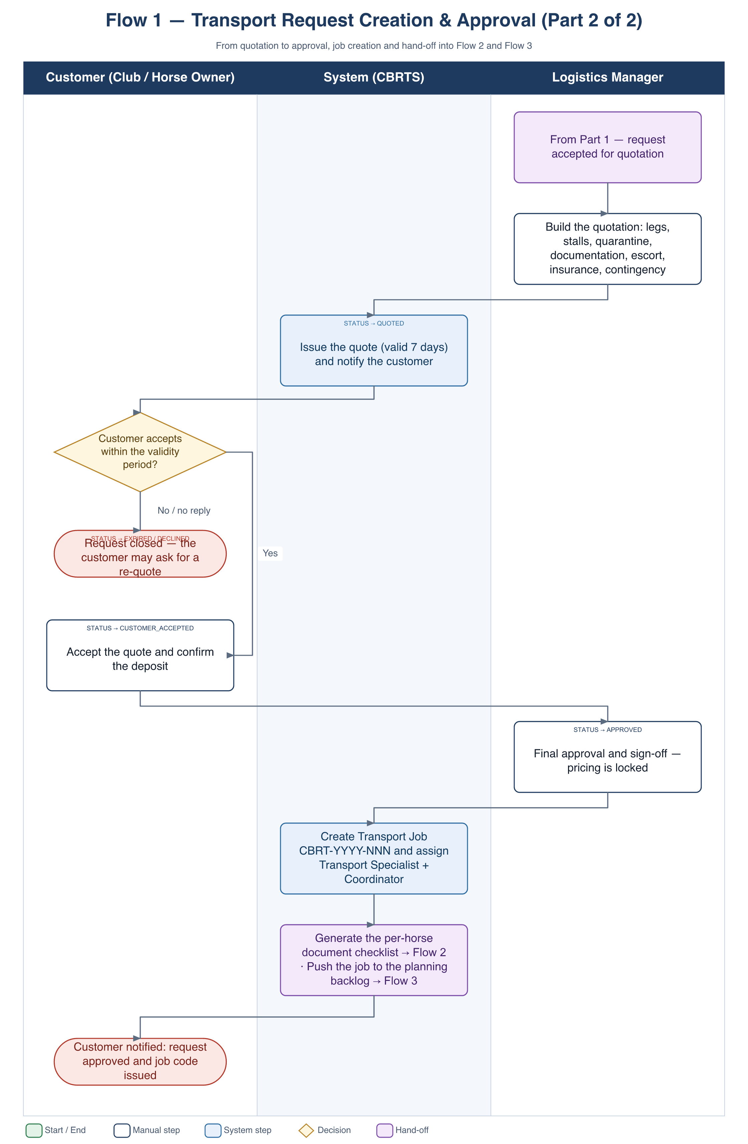
Figure 3 — Flow 1, Part 2 — quotation, acceptance, approval and hand-off

2.3 Main flow
- Customer. Opens “New transport request” and enters the origin and destination (country, city, stable or venue), the pickup and delivery window, the horse list (name, passport number, age, sex, height and weight, whether a mare travels with a foal at foot, temperament, special needs) and any special requirements — climate-controlled stall, veterinary escort, insurance level.
- Customer. Attaches the preliminary horse profile files that are already available and submits. The request is stored with status SUBMITTED.
- System. Validates the mandatory fields and compares the requested departure date with the minimum lead time of the destination and of every transit country in the Country Regulation Catalog.
- System. If validation fails the request stays with the customer and the errors are shown inline (see A1).
- System. On success it places the request in the Logistics Manager queue, sets UNDER_REVIEW and notifies the manager.
- Logistics Manager. Reviews feasibility: is the country pair served, is a vehicle, stall or air-cargo slot available in the window (confirmed with the Fleet & Route Coordinator), does the date fall inside a blackout period.
- Logistics Manager. If something is missing, returns the request with a note — status INFO_REQUIRED; the customer is notified, edits and resubmits (A2).
- Logistics Manager. If the job cannot be taken, rejects it with a documented reason — status REJECTED (A3).
- Logistics Manager. Otherwise builds the quotation: transport legs, stalls, quarantine fees, documentation fees, escort and veterinary fees, insurance and a contingency allowance.
- System. Issues the quotation with a seven-day validity, sets QUOTED and notifies the customer.
- Customer. Accepts inside the validity window and confirms the deposit — status CUSTOMER_ACCEPTED. A decline or an elapsed window ends the request as EXPIRED (A4).
- Logistics Manager. Gives the final approval — status APPROVED. The agreed price and the horse list are locked.
- System. Creates the Transport Job with code CBRT-YYYY-NNN and assigns a Transport Specialist and a Fleet & Route Coordinator.
- System. Generates the per-horse document checklist — the hand-off into Flow 2 — and pushes the job into the planning backlog — the hand-off into Flow 3.
- System. Notifies the customer that the request is approved and gives them the job code to follow.

2.4 Alternate and exception flows
ID | Trigger | Handling
A1 | Validation fails, or the requested departure is inside the minimum lead time. | Errors are shown inline and submission is blocked. A cross-border request inside the lead time can only continue with an express override granted by the Logistics Manager, which is recorded on the request.
A2 | The Logistics Manager needs more information. | Status INFO_REQUIRED. The request returns to the customer with the manager’s note; resubmission puts it back into the review queue and both versions stay visible.
A3 | The Logistics Manager cannot take the job (no capacity, restricted route, incomplete case). | Status REJECTED with a mandatory reason. The customer is notified and may duplicate the request into a new draft.
A4 | The customer does not answer the quotation. | A reminder is sent 24 hours before expiry. On expiry the status becomes EXPIRED; the customer may ask for a re-quote, which creates a new quotation version.
A5 | The customer cancels. | Allowed in every state before APPROVED. A cancellation fee band is applied according to the lead time remaining before the planned departure.
A6 | A change is needed after approval. | An approved request cannot be edited. The customer raises a change request; the Logistics Manager re-approves it, which creates a new quotation version and a new price lock.
A7 | Capacity disappears while the request is under review. | The manager either re-quotes with a different date or vehicle, or rejects with the reason “no capacity”.

2.5 State machine
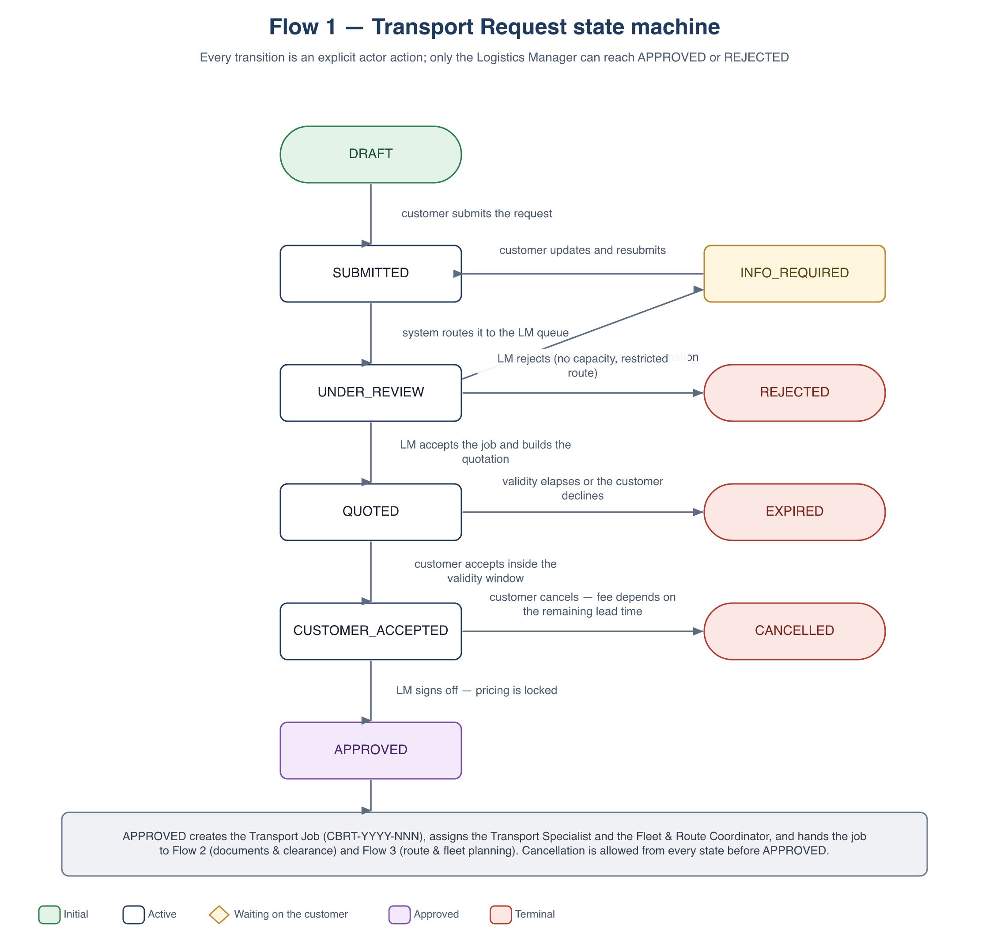
Figure 4 — Flow 1 — Transport Request state machine
Every transition is an explicit action by a named actor; nothing moves on its own except the expiry of a quotation. APPROVED is the point of no return for the price and the horse list — after it, changes only happen through a new approval cycle.

2.6 Business rules
ID | Rule
BR-F1-01 | A cross-border request must be created at least the destination country’s minimum lead time before the requested departure — default 21 days, configurable per country pair. The domestic default is 3 days.
BR-F1-02 | All horses in one request share the same origin, destination and time window. A different route or window requires a separate request.
BR-F1-03 | A quotation is valid for 7 days from the moment it is issued.
BR-F1-04 | Only the Logistics Manager role may set APPROVED or REJECTED, and a rejection always requires a reason.
BR-F1-05 | Exactly one Transport Job is created per approved request. The code format is CBRT-YYYY-NNN; it is unique and never reused.
BR-F1-06 | After APPROVED the price and the horse list are locked; any change goes through a change request that re-enters approval.
BR-F1-07 | Cancellation is allowed in every state before APPROVED; the fee band follows the lead time remaining before departure.
BR-F1-08 | Every status change is written to an audit trail with the actor, the timestamp and the reason.

2.7 User stories
ID | User story | Key acceptance criteria
US-F1-01 | As a Customer I want to create one request covering several horses so that I can move a whole string in a single booking. | At least one horse is mandatory; an incomplete horse row blocks submission; a successful submit sets SUBMITTED and shows a confirmation with the request code.
US-F1-02 | As a Customer I want to be warned when my requested date is too soon so that I do not book a trip that cannot be cleared in time. | When departure minus today is below the country minimum, submission is blocked and the message names the required lead time and the earliest valid date.
US-F1-03 | As a Logistics Manager I want a queue of the requests waiting for review so that nothing is forgotten. | The queue shows code, customer, route, horse count, requested date and the age of the request; the default sort is oldest first.
US-F1-04 | As a Logistics Manager I want to return a request for missing information so that the customer can complete it without losing history. | A note is mandatory; the status becomes INFO_REQUIRED; the customer is notified; resubmission returns it to my queue with both versions visible.
US-F1-05 | As a Logistics Manager I want to build the quotation from cost lines so that the customer sees a transparent price. | Cost lines can be added, edited and removed; the total is computed by the system; issuing the quote sets QUOTED and starts the 7-day validity.
US-F1-06 | As a Customer I want to accept or decline a quotation so that I control the commitment. | Acceptance is only possible before expiry; it sets CUSTOMER_ACCEPTED and freezes the quotation version that was accepted.
US-F1-07 | As a Logistics Manager I want approval to create the job and assign the team so that work starts immediately. | Approval creates exactly one job with a unique code, assigns a Transport Specialist and a Coordinator, generates the document checklist and notifies everyone assigned.
US-F1-08 | As a Customer I want to follow the status of my request so that I know what is happening and what is expected of me. | The request page shows the current status, the full history and the next expected action with its owner.

2.8 Screens
- Customer: new-request wizard, my-requests list, request detail with the quotation, quote acceptance.
- Logistics Manager: review queue, feasibility review, quotation builder, approval confirmation.
- Shared: notification centre and the request audit history.

3. Flow 2 — Legal Documentation & Quarantine / Customs Clearance
Industry grounding.
The flow below follows the document set a real cross-border equine shipper works with — the model used by specialist operators such as Peden Bloodstock. To take a horse out of the country it must carry an equine passport with a matching microchip, a current vaccination record, laboratory test results such as the EIA (Coggins) test, and a government-issued health certificate; the destination adds its own import permit. One clarification worth making early because it changes the design: TRACES is the EU’s TRAde Control and Expert System — the government platform through which the health certificate is issued and tracked, not a document type in its own right. In our model it is one of the external authorities in Part 2, and the certificate it produces is the document we store.
The operational pain this flow removes is chasing. Today the shipper telephones and e-mails the owner for missing paperwork and reads the dates by eye. Section 3.4 replaces that with a rule the system evaluates on every upload.

3.1 Epic summary
Field | Value
Epic ID | EPIC-F2
Goal | Collect, verify and file every legal, veterinary and customs document required by every country on the route, track the quarantine period, and prove that the shipment is legally allowed to depart.
Primary actor | Transport Specialist
Supporting actors | Customer (uploads), Logistics Manager (escalation), external authorities and the quarantine facility, System
Trigger | A Transport Job reaches APPROVED in Flow 1.
Pre-conditions | The job exists with a confirmed origin, destination, transit countries and a planned departure date; the Country Regulation Catalog holds an entry for each of those countries.
Post-conditions — success | The clearance dossier is CLEARANCE_READY: every mandatory document is approved and still valid at the arrival date, quarantine is complete and the issued permits are attached to the job. Departure is unblocked for Flow 3 and Flow 4.
Post-conditions — failure | The dossier is BLOCKED and escalated to the Logistics Manager. The job cannot depart; it is rescheduled or cancelled.
Out of scope | The authorities’ internal processing (external and tracked manually), payment of government fees, and the border-crossing events themselves, which are recorded per leg in Flow 4.

3.2 Activity diagram
The flow is shown in two parts. Part 1 covers checklist generation, customer uploads and verification; Part 2 covers the submission to the authorities, quarantine and the clearance gate.
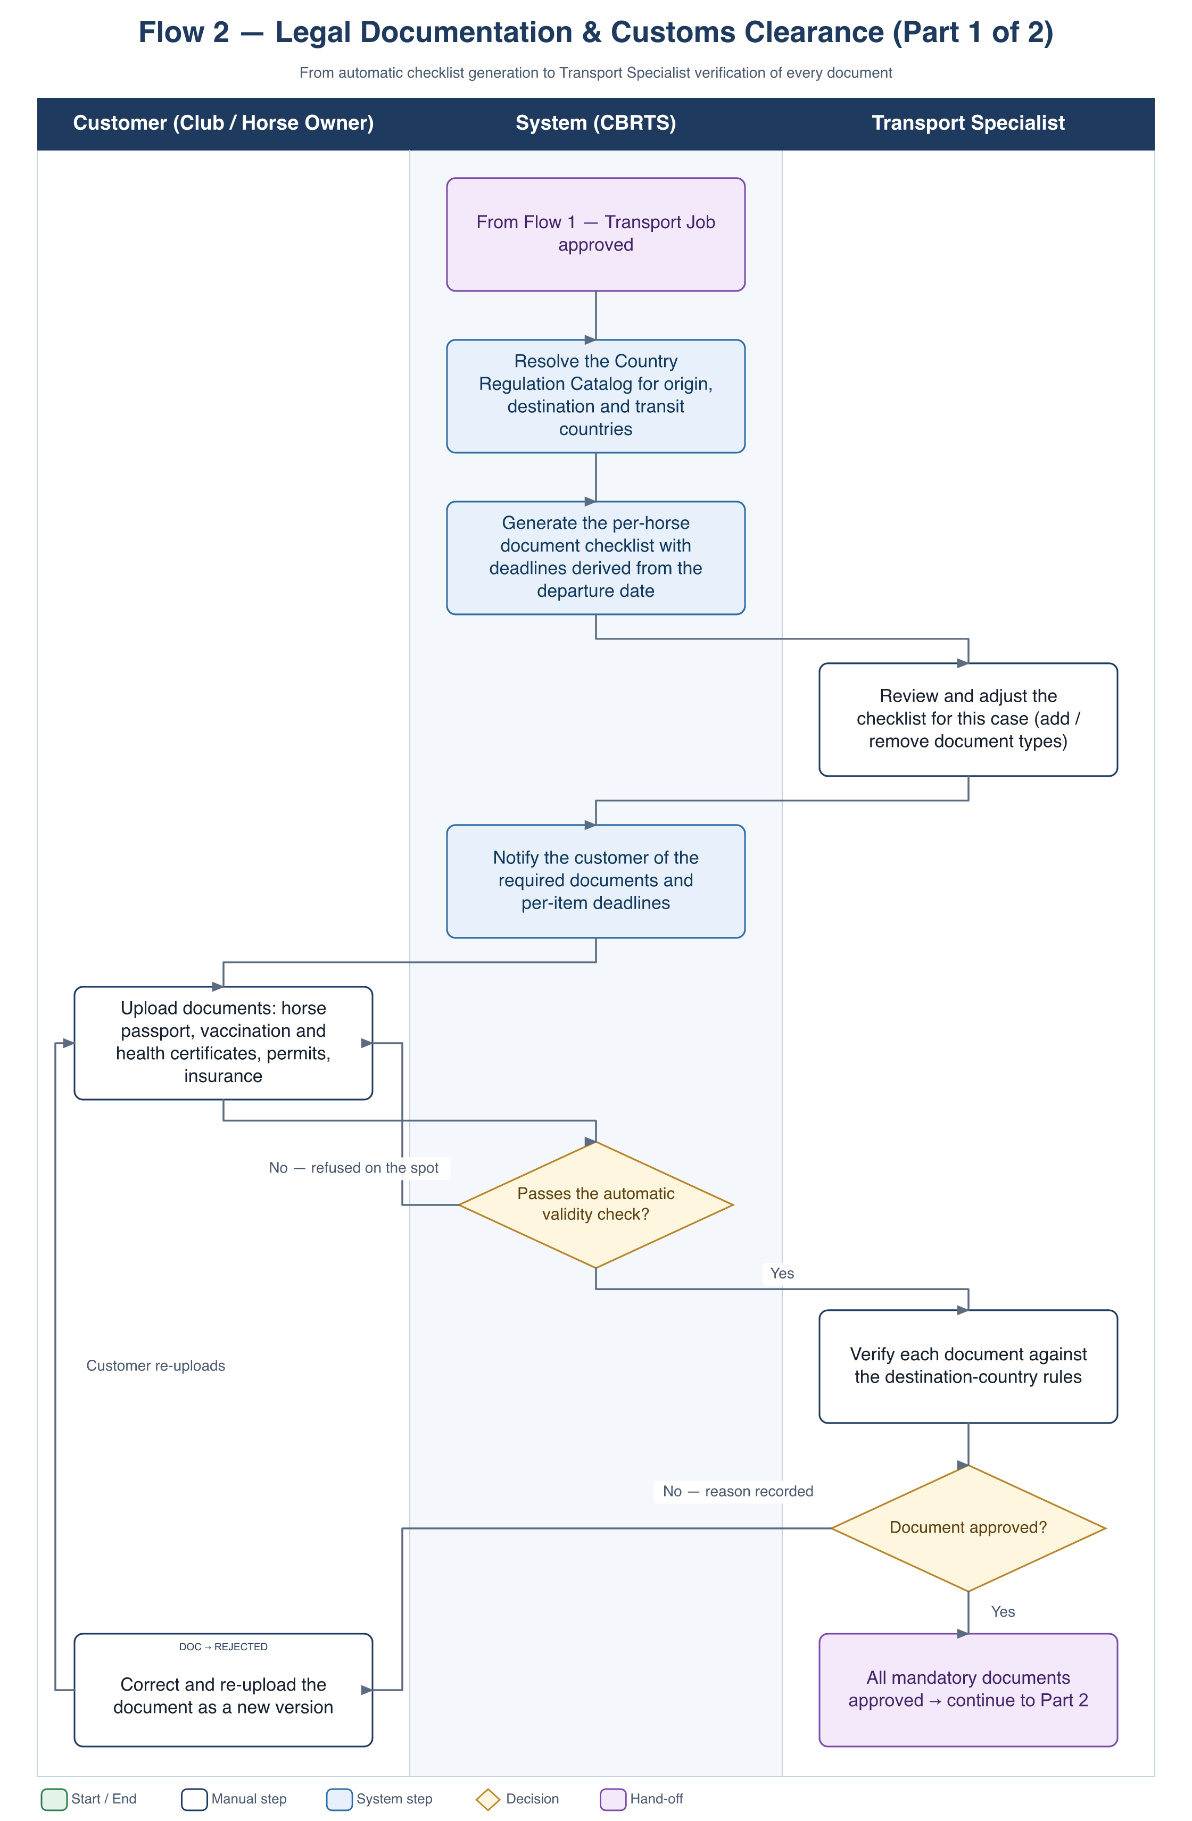
Figure 5 — Flow 2, Part 1 — checklist generation, upload and document verification
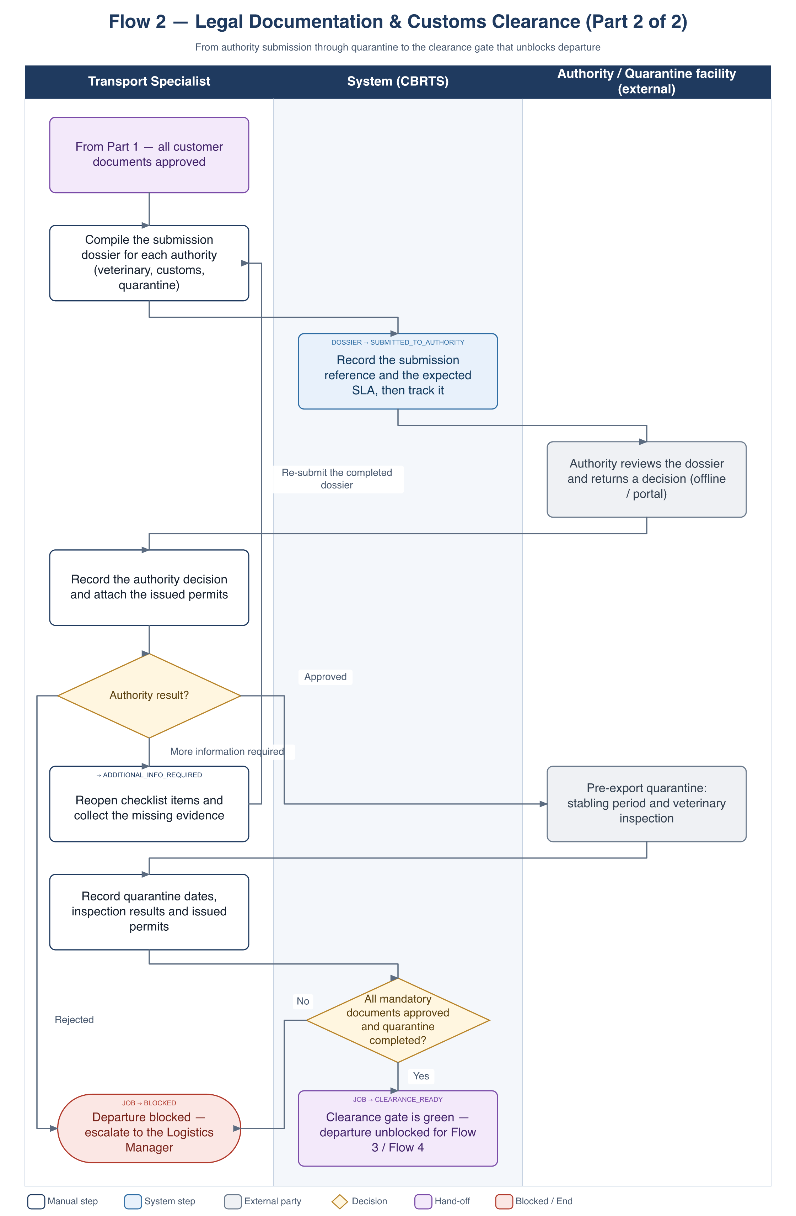
Figure 6 — Flow 2, Part 2 — authority submission, quarantine and the clearance gate

3.3 Main flow
- System. When the job is approved, resolves the Country Regulation Catalog for the origin, the destination and every transit country, and pins the catalog version it used to the job.
- System. Generates a document checklist for each horse — equine passport, vaccination record, EIA / Coggins test, health certificate, import and export permits, proof of ownership, insurance — each item carrying its validity rule and a deadline derived from the planned departure date.
- Transport Specialist. Reviews the generated checklist and adjusts it for the specific case: adds a test a particular border requires, removes an item that does not apply to this shipment.
- System. Notifies the customer of the required documents and of the deadline for each item.
- Customer. Uploads each document together with its issue date, expiry date and issuing body.
- System. Runs the automatic validity check described in section 3.4 and returns GREEN, AMBER or RED before any human sees the file. A RED file is refused at upload with the reason.
- Transport Specialist. Verifies each accepted document against the destination-country rules and either approves it or rejects it with a reason. A rejected item is re-uploaded by the customer as a new version; the previous version is kept.
- Transport Specialist. When every mandatory document is approved, compiles the submission dossier for each authority — veterinary or agriculture, customs, and the quarantine facility.
- Transport Specialist. Records the submission and its reference number. The system sets the dossier to SUBMITTED_TO_AUTHORITY and starts tracking it against the expected SLA.
- Authority (external). Reviews the dossier outside the system and returns a decision.
- Transport Specialist. Records the outcome and attaches the issued permits. If the authority asks for more evidence, reopens the affected checklist items, collects the evidence and re-submits (B3).
- Transport Specialist. On approval, books the pre-export quarantine. The horses are stabled for the minimum period required by the destination country and inspected by a veterinarian.
- Transport Specialist. Records the quarantine dates, the inspection results and the permits that were issued.
- System. When every mandatory document is approved and quarantine is complete, sets the job to CLEARANCE_READY. This opens the clearance gate and unblocks departure.
- Transport Specialist / Driver. During the journey, the clearance of each border crossing is recorded per leg as CLEARED or HELD; a HELD crossing is escalated to the Logistics Manager (Flow 5).

3.4 Automatic validity checking
This is the capability that distinguishes the system from a shared folder of scanned PDFs. Every equine transport document is only valid inside a time window, and the windows are relative to the travel date rather than absolute. A Coggins test taken five days too early is worthless on the day of departure, and nobody notices until the border does.
So each document type in the catalog carries a machine-evaluable rule, and the system evaluates it against the job’s planned departure and arrival dates at the moment of upload — not against today, and not by eye.
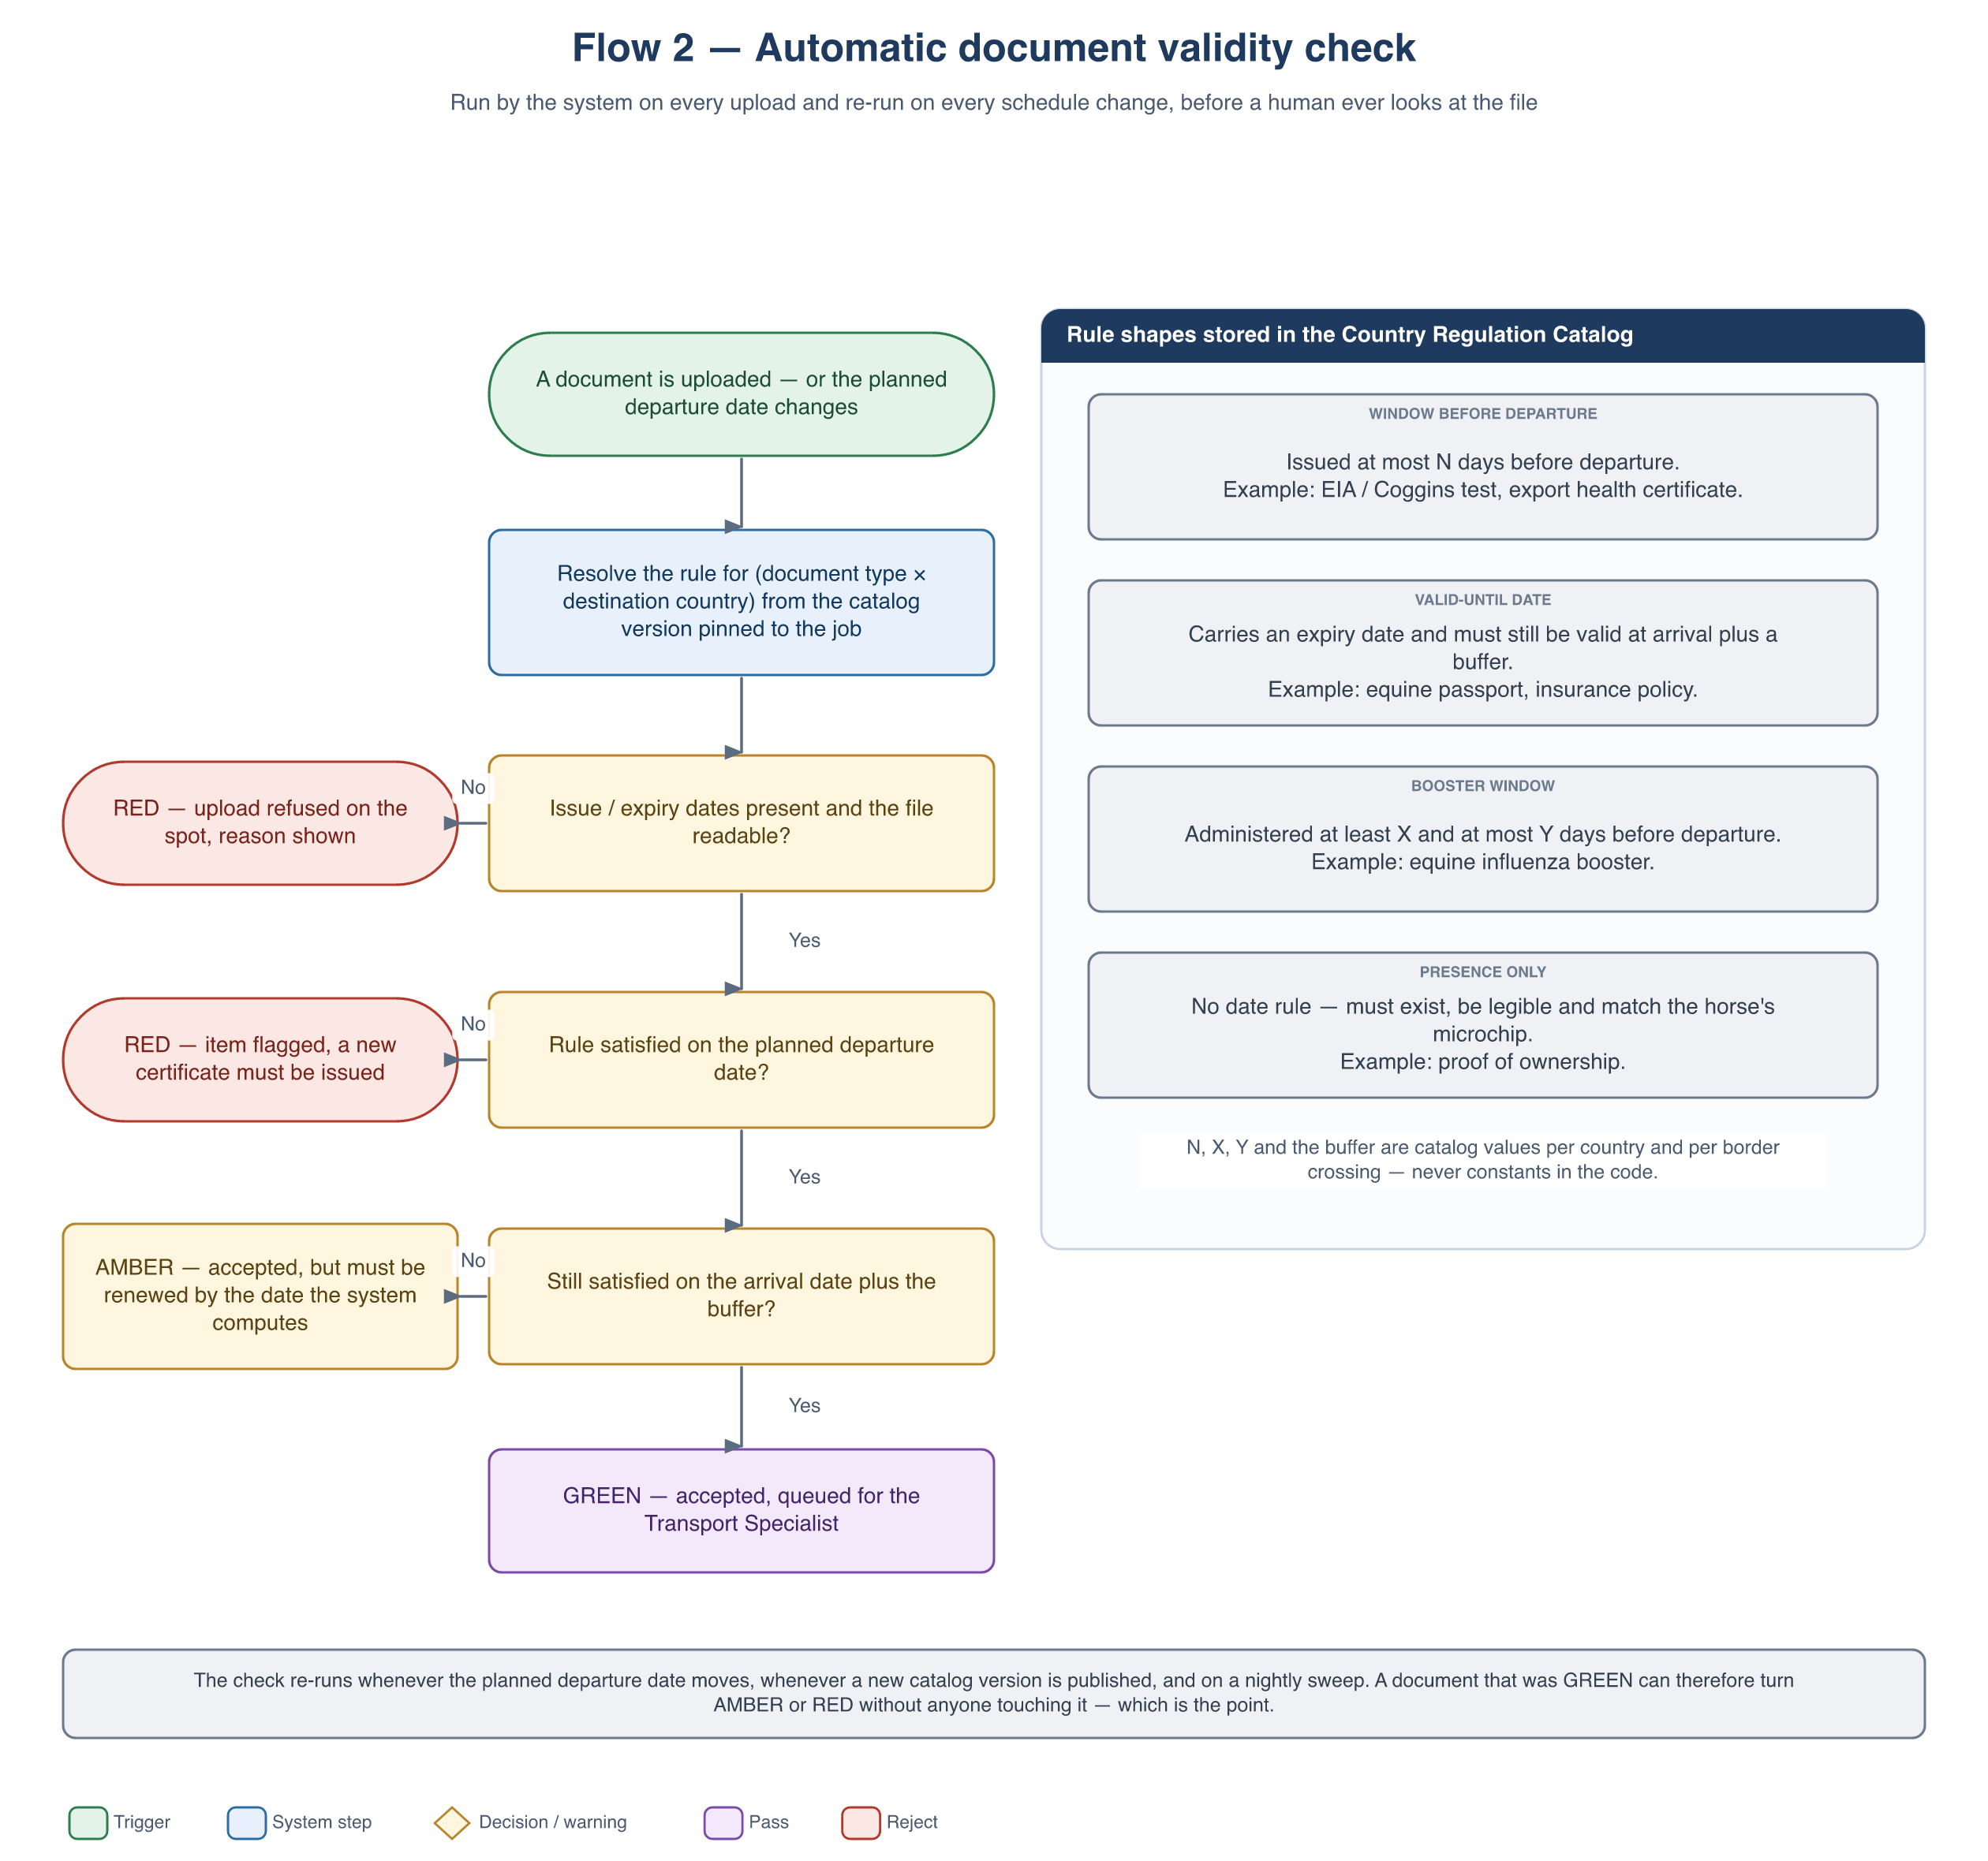
Figure 7 — Flow 2 — the automatic validity check applied to every upload

3.4.1 Result of the check
Result | Meaning | Effect
GREEN | The rule is satisfied both on the planned departure date and on the planned arrival date plus the buffer. | Accepted and queued for the Transport Specialist. Once the specialist approves it, the item counts toward the clearance gate.
AMBER | The rule is satisfied today, but will not be on the travel dates — for example a certificate that expires mid-journey, or a test taken so early that it ages out before departure. | Accepted and stored, but it does not satisfy the clearance gate. The system shows the date by which a replacement must be issued and warns the customer and the Transport Specialist.
RED | The rule fails. | At upload the file is refused on the spot with the reason, the value found and the value required. When produced by a re-evaluation, the file is kept, the item is flagged and returned to REQUIRED, and both the customer and the specialist are notified.

3.4.2 Document types and their rules
The catalog entries below are the starting set. The rule shape is fixed by the system; the numbers are configuration.
Document | Issued by | Rule shape | Blocks departure
Equine passport (identification + microchip / UELN) | National breeding authority or studbook | Presence + valid-until — the microchip must match the horse on the request | Yes
Vaccination record (equine influenza in particular) | Veterinarian, recorded in the passport | Booster window — administered inside the destination’s window and not immediately before travel | Yes
EIA / Coggins test certificate | Approved laboratory | Window before departure — issued within N days of travel | Yes
Health certificate for export | Government veterinary authority, issued through the destination’s certification system (TRACES for the EU) | Window before departure — typically a short window, a few days | Yes
Import permit | Destination country’s agriculture or veterinary ministry | Valid-until — must cover the planned arrival date | Yes
Proof of ownership | Owner or studbook | Presence only | Yes
Transport insurance | Insurer | Valid-until — must cover the whole journey window | Configurable
Customs / value declaration | Customer or customs agent | Presence only, per border crossing | Per crossing

The rule column states the shape of each rule, not a legal requirement. The concrete numbers — how many days before departure a Coggins test is accepted, how long an influenza booster remains valid — differ per destination and change over time, so they live in the Country Regulation Catalog and must be set from the destination country’s current published requirements before the system is used for a real shipment. That is exactly why the catalog is versioned and pinned per job (BR-F2-01).

3.4.3 When the check re-runs
A document is not checked once and forgotten. The same evaluation runs again whenever the facts behind it move:
- the planned departure or arrival date changes — a re-plan in Flow 3, or an incident re-route in Flow 5;
- a new Country Regulation Catalog version is published for a country on the route (exception B5);
- a horse is added to or removed from the job;
- a nightly sweep, so that a certificate quietly ageing out is caught by the system rather than by a border official.
A document that was GREEN can therefore become AMBER or RED without anyone touching it, and the clearance gate closes again automatically. This is deliberate: the gate reflects the current state of the paperwork, not the state it had when someone last looked at it.

3.5 Alternate and exception flows
ID | Trigger | Handling
B1 | A checklist deadline is approaching and the item is still outstanding. | Escalating reminders go to the customer at T-7, T-3 and T-1 days. If the item is still missing at T-1 the Logistics Manager is alerted as well.
B2 | A document fails or will fail its validity rule. | RED at upload refuses the file immediately with the reason. RED or AMBER produced by a re-evaluation flags the item, computes the date a replacement is needed by, and notifies the customer and the Transport Specialist. The dossier cannot progress while a mandatory item is not GREEN.
B3 | The authority asks for additional information. | The dossier moves to ADDITIONAL_INFO_REQUIRED with a deadline; the affected checklist items are reopened and the customer is chased for the evidence.
B4 | The authority rejects the dossier. | The dossier becomes BLOCKED and is escalated to the Logistics Manager, who reschedules the departure or cancels the job.
B5 | A country changes its regulations while the case is in flight. | A new catalog version is published. The system re-evaluates open checklists against it and flags newly required or newly failing items to the Transport Specialist, without invalidating what has already been approved.
B6 | A horse fails the veterinary inspection during quarantine. | That horse is removed from the manifest and the Logistics Manager decides whether the remaining horses travel as planned.
B7 | Someone tries to record a departure before clearance is green. | Flow 4 refuses the status change and lists the outstanding items that are blocking it.
B8 | The departure is re-planned to a later or earlier date. | Every document on the job is re-evaluated against the new dates (section 3.4.3); items that fall out of their window are flagged and the clearance gate closes until they are replaced.

3.6 State machines
Two lifecycles run in parallel: one per required document (there is one instance per horse and per document type) and one per transport job for the clearance dossier as a whole.
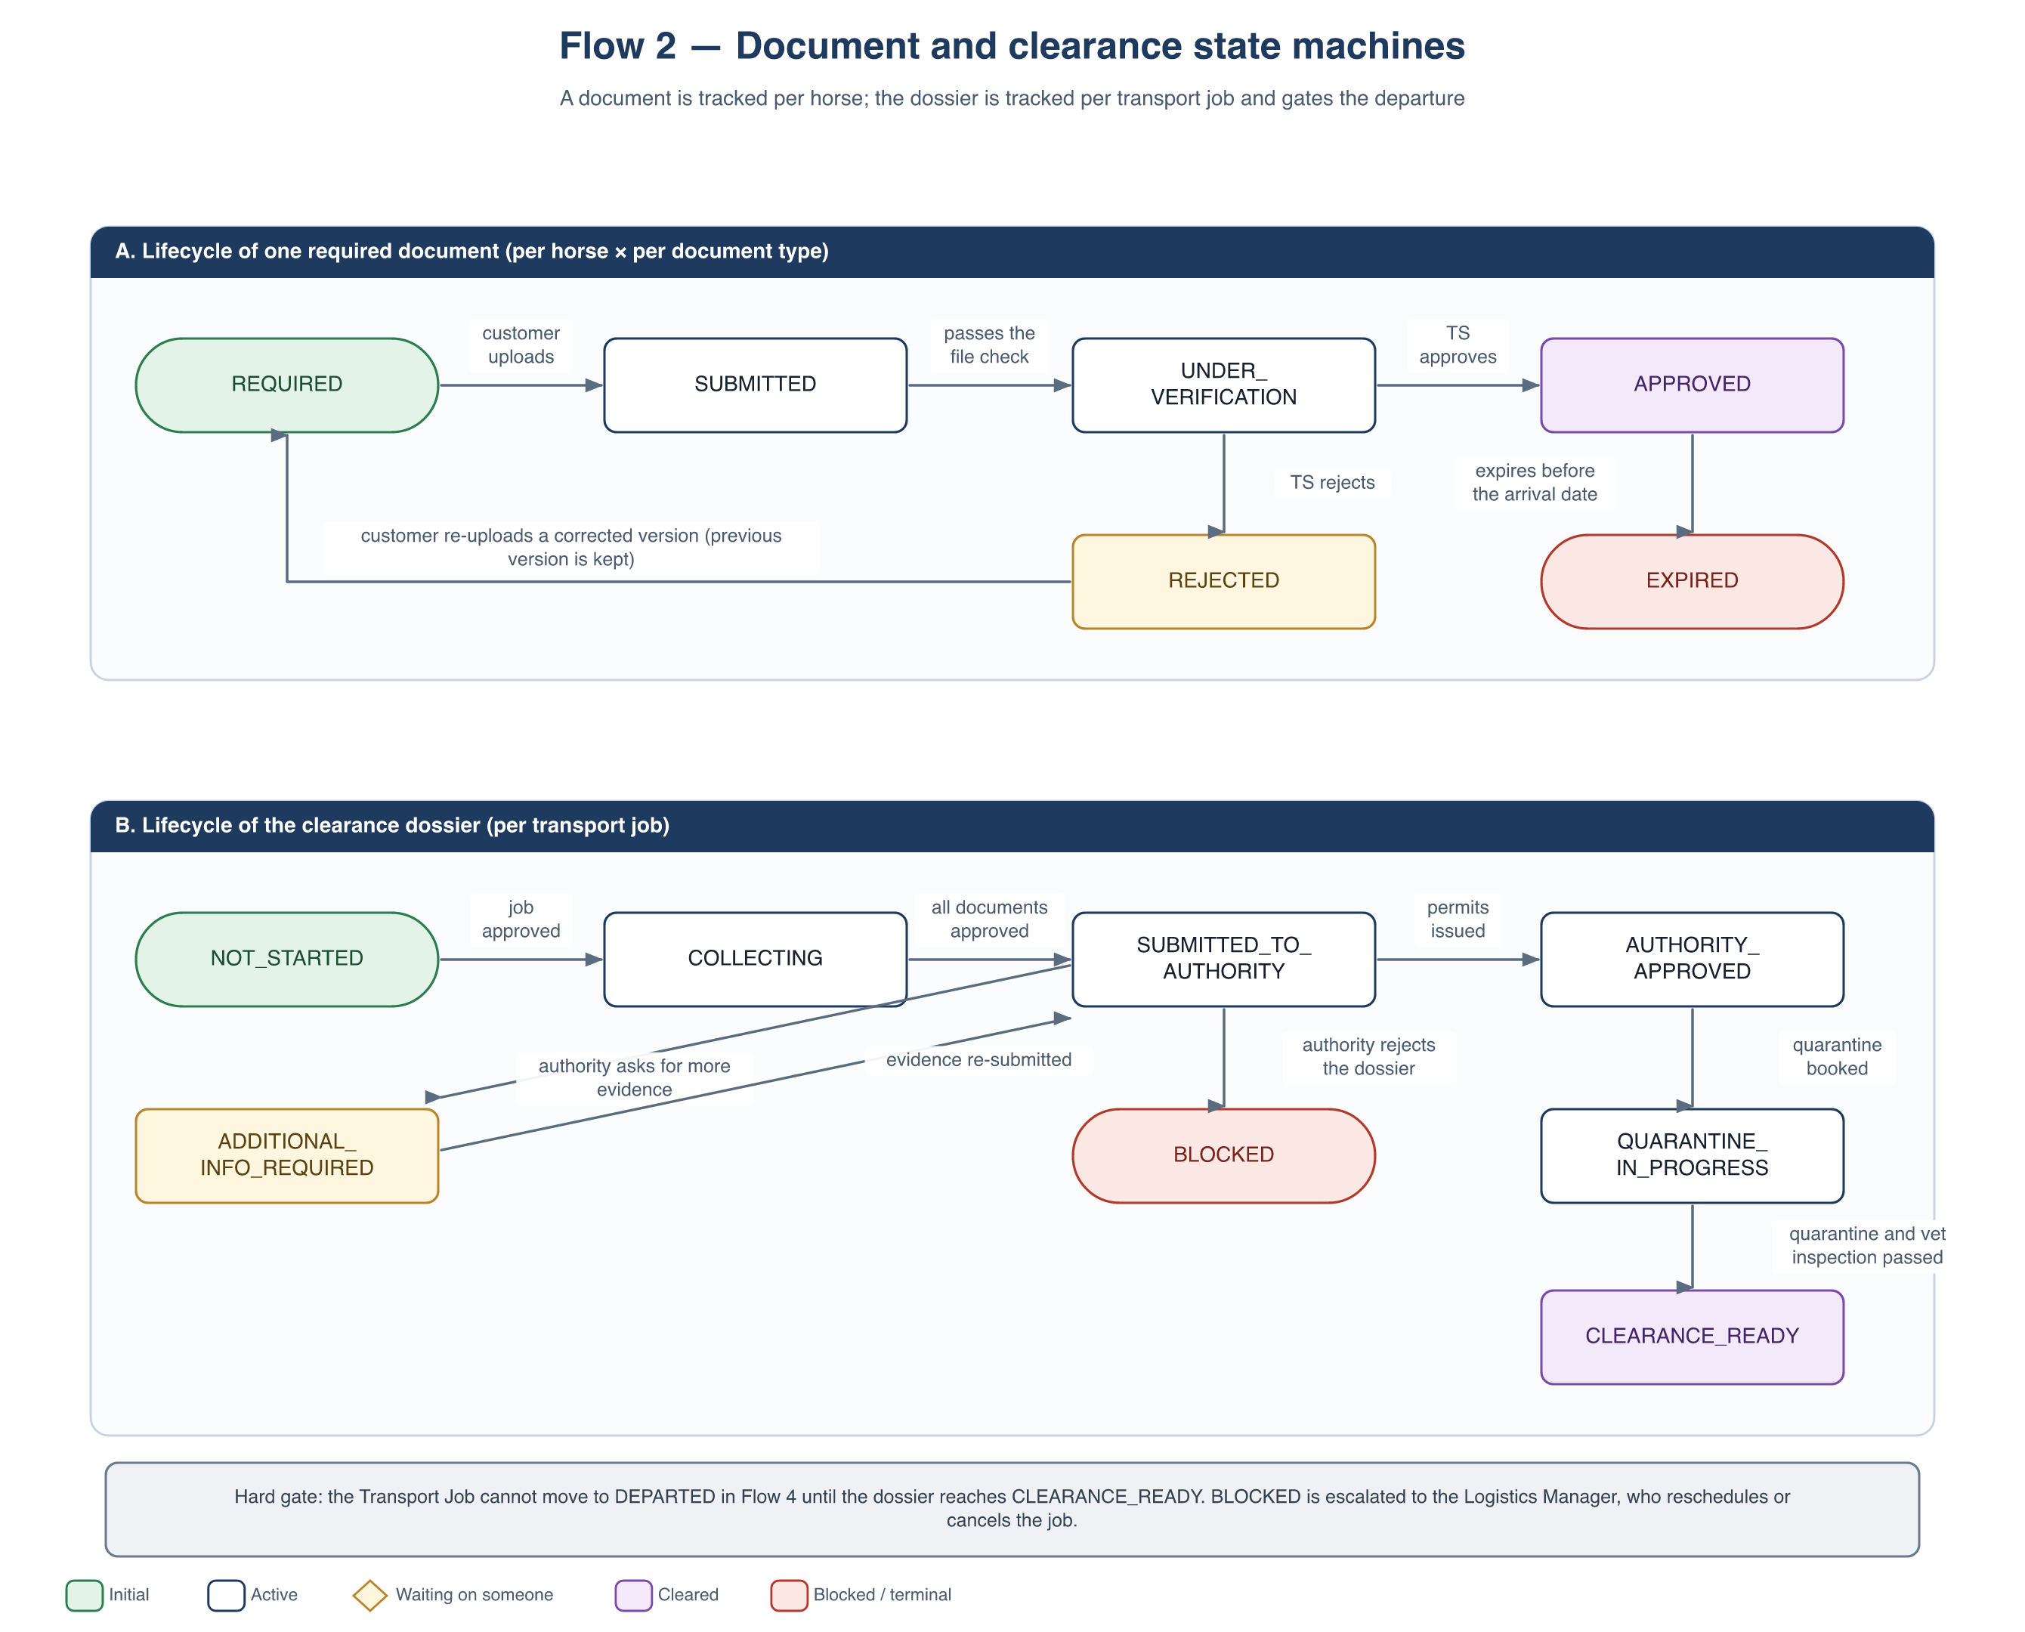
Figure 8 — Flow 2 — document lifecycle and clearance dossier lifecycle

3.7 Business rules
ID | Rule
BR-F2-01 | The checklist is derived from the Country Regulation Catalog for the origin, the destination and every transit country. The catalog version applied is pinned to the job so that later regulation changes never silently alter an in-flight case.
BR-F2-02 | Every mandatory document must satisfy its validity rule on the planned departure date and on the planned arrival date plus a safety buffer.
BR-F2-03 | Departure is blocked until the dossier reaches CLEARANCE_READY. This is a hard gate enforced by the system, not a warning.
BR-F2-04 | Only the Transport Specialist may approve or reject a document. The customer may only upload or replace.
BR-F2-05 | Re-uploading creates a new version; no version is ever overwritten or deleted, because the full history is the legal evidence for a cross-border movement.
BR-F2-06 | The recorded quarantine period must be at least the minimum the destination country requires.
BR-F2-07 | Every rejection — by the system or by the Transport Specialist — must carry a reason that is visible to the customer.
BR-F2-08 | Document access is limited to the customer who owns the horse, the assigned Transport Specialist and the Logistics Manager.
BR-F2-09 | Every document type in the catalog carries exactly one rule shape and its parameters. A type with no rule configured defaults to PRESENCE ONLY and is reported to the Transport Specialist as unconfigured rather than silently passing.
BR-F2-10 | The validity check is always evaluated against the job’s travel dates, never against today alone. A certificate that is valid at upload but expires in transit is not acceptable.
BR-F2-11 | An AMBER item does not satisfy the clearance gate. Only items that are GREEN and approved by the Transport Specialist count toward it.
BR-F2-12 | A validity result is recomputed, not cached: any change to the travel dates, the catalog version or the horse list re-runs the check on every affected document.

3.8 User stories
ID | User story | Key acceptance criteria
US-F2-01 | As a Transport Specialist I want the checklist generated automatically from the countries on the route so that I do not rebuild it by hand for every job. | On job approval a checklist exists for every horse; items and deadlines match the pinned catalog version; I can still add or remove items.
US-F2-02 | As a Customer I want to see exactly which documents I owe and by when so that I can prepare them in time. | The checklist shows item, horse, deadline and status; overdue items are highlighted; reminders arrive at T-7, T-3 and T-1.
US-F2-03 | As a Customer I want to upload a document together with its validity dates so that the transporter can check it. | File type and size are validated; issue and expiry dates are mandatory; the validity check runs before the file is stored.
US-F2-04 | As a Transport Specialist I want to approve or reject each document with a reason so that the customer knows exactly what to fix. | A rejection requires a reason; the customer is notified; the item returns to REQUIRED and the rejected version is retained in the history.
US-F2-05 | As a Transport Specialist I want to record a submission to an authority and its reference so that I can track progress against the SLA. | Authority, submission date, reference and expected SLA are captured; the dossier becomes SUBMITTED_TO_AUTHORITY; submissions past their SLA are highlighted.
US-F2-06 | As a Transport Specialist I want to record quarantine and inspection results so that the clearance file is complete. | Start date, end date, facility and result are captured; a period shorter than the destination-country minimum is refused.
US-F2-07 | As a Logistics Manager I want to be alerted when a dossier is blocked or late so that I can reschedule before it costs an air-cargo slot. | An alert is raised on BLOCKED, on an authority SLA breach, and on any mandatory item still missing at T-1.
US-F2-08 | As a Fleet & Route Coordinator I want the system to prevent departure until clearance is green so that we never move a horse illegally. | Setting the job to DEPARTED without CLEARANCE_READY is refused and the outstanding items are listed.
US-F2-09 | As a Customer I want an out-of-date certificate refused the moment I upload it so that I do not discover the problem a week before departure. | The rule for the document type and destination is evaluated at upload; a failing file is refused with a message naming the rule, the value found and the value required; an AMBER result is accepted with the renewal date shown.
US-F2-10 | As a Transport Specialist I want documents re-checked when the travel dates move so that a re-planned trip never departs on stale paperwork. | Changing the planned departure or arrival date re-evaluates every document on the job; items that become AMBER or RED are listed, the gate closes, and the customer and I are notified.
US-F2-11 | As a Transport Specialist I want to maintain the validity rule for each document type and country so that a regulation change is a configuration edit, not a code change. | Rule shape and parameters are editable per document type × country; saving publishes a new catalog version; jobs keep their pinned version until they are re-evaluated against the new one.

3.9 Screens
- Transport Specialist: job clearance workspace with the checklist per horse and its traffic light, document verification view, authority submission tracker, quarantine record.
- Customer: document centre showing what is required, what is approved, what is expiring and what is overdue.
- Logistics Manager: dashboard of blocked and at-risk dossiers.
- Administration: Country Regulation Catalog — document types, rule shapes and their parameters, lead times and quarantine minimums per country and per border crossing.

4. Quotation Builder — costing and the instant estimate
Flow 1, step 9 says the Logistics Manager “builds the quotation”. That sentence hides the single most error-prone task in the whole process, and it is the one step the system currently does not help with at all. This section specifies the tool that fills the gap.
The problem is well documented in the industry. The most common complaint about equine transport quotes is that they cover the flight and nothing else — the customer discovers quarantine, ground transport and customs clearance afterwards. Guidance written for buyers repeats the same advice: insist on a written, itemised quote covering every line, because a quote that shows only one component is misleading. An itemised quote is therefore not a nice-to-have output format. It is the product.
The second problem is arithmetic. The price is driven by things that are easy to get wrong by hand: grooms are staffed one per three horses, so the fourth horse adds a whole groom; quarantine cost depends on each horse’s sex rather than on headcount; insurance is a percentage of declared value rather than a fee; and a fuel surcharge applies to the air legs only. A spreadsheet gets these right until the day it does not.

4.1 What drives the price
Researched from published material by specialist equine shippers and from industry buying guides. The right-hand column is the design consequence — how the system represents each driver.
Driver | What the research shows | How the system models it
Stall class | The industry uses an airline-style class system: economy is three horses to an air stall, business two (“a stall and a half”), first class one. It is consistently described as the biggest cost lever the customer controls — published indications put a shared position roughly at half to a third of a dedicated stall on the same aircraft. | A service class on the request; a multiplier per class in the air rate table for that corridor.
Horse size and type | An air stall is a fixed container whose internal partitions are moved to suit the horses: the VRR HMC main-deck stall is 2,438 mm (96 in) wide with removable partitions for one-, two- or three-horse configurations, and road operators sell the same widths — 32 in single, 48 in stall-and-a-half, 96 in full box. “Three horses per stall” is therefore not a rule, it is what 96 inches divided by three standard horses looks like. Aerospace practice SAE ARP 1621C classifies horses by size for exactly this reason. Weight is a cap rather than a price driver: the same stall carries 5,504 kg of payload, far above three horses. | A size class per horse giving a width allowance in inches. Stall positions = total width ÷ 96, rounded up. Weight is validated against the stall and aircraft payload but does not price the line.
Number of horses | Per-head cost falls as horses share a shipment. Multi-horse moves are indicated around 10–20% cheaper per head, and larger charters considerably more. | A volume-break table per corridor. Changing the horse count re-prices every affected line.
Groom ratio | One groom per three horses is stated consistently across shippers as the industry standard. | A step function: grooms = horse count ÷ 3, rounded up. Never a per-horse rate.
Horse sex | Quarantine duration and cost depend on sex because of contagious equine metritis testing. Published facility tariffs show stallions materially more expensive than mares, and geldings cheapest; stallion protocols can run to weeks. | Sex is already captured per horse in Flow 1. It drives the quarantine day count and day rate, not a flat per-horse fee.
Quarantine duration | Pre-export isolation is commonly 21–30 days; post-arrival quarantine of 14–30 days applies to destinations such as Australia and Japan, while common corridors for mares and geldings can be a few days. | Day counts come from the Country Regulation Catalog used by Flow 2 — the manager does not type them.
Distance and corridor | High-volume corridors price lower than thin routes. Road legs are quoted per mile or kilometre with separate rates for a shared versus a private load, a lower rate for empty positioning mileage, and a minimum charge per movement. | Rate table keyed by corridor; road lines priced per km with a separate positioning rate and a floor price.
Lead time | Scheduled consolidated departures are cheaper than short-notice dedicated moves; last-minute booking is described as commanding a premium. | An urgency multiplier derived from the days between the quotation and the planned departure.
Insurance | Transit cover is quoted as a percentage of the horse’s declared value — published guidance indicates roughly 1.5–3% for a single international movement — and is described as frequently under-budgeted. | A percentage line computed on total declared value. Never a flat fee.
Fuel | Fuel surcharges move independently of base rates and are described as embedded in air pricing. | A percentage applied to the air lines only, not to the whole quote.
Border friction | Additional export and import certification on some corridors adds a fixed administrative cost per movement. | A per-crossing documentation line drawn from the catalog.
Waiting and access | Shippers publish hourly waiting fees, hard-loader fees, layover fees for journeys beyond roughly 72 hours, and surcharges for difficult access or a changed pick-up address. | Surcharge lines, tagged ESTIMATED — they may legitimately differ on the final invoice.

A note on the figures. The ranges above were used to check that the model has the right shape and to seed believable demo data. They are drawn from public marketing and buying guides, vary by a factor of three between sources for the same route, and date quickly. They are not a price list, they are not quoted in this system, and no number from them is hard-coded: every rate is a catalog value the operator maintains.

4.2 Epic summary
Field | Value
Epic ID | EPIC-F1B (sits inside Flow 1, between UNDER_REVIEW and QUOTED)
Goal | Replace the manager’s spreadsheet with a structured builder that assembles a complete, itemised, versioned quotation from catalog rates — and give the customer a non-binding estimate at request time so that enquiries with an impossible budget or date are filtered before they reach the review queue.
Primary actor | Logistics Manager
Supporting actors | Customer (estimate only), System, Transport Specialist (owns the rate and regulation catalogs)
Trigger | Manager accepts a request for quotation (Flow 1, step 9). The estimate is triggered by the customer filling in the request form.
Pre-conditions | The rate catalog holds an entry for the corridor and the service classes. Horse count, sexes and declared values are present on the request.
Post-conditions — success | A quotation version exists: itemised, totalled by the system, in one currency, with a validity date. Issuing it moves the request to QUOTED.
Post-conditions — failure | A corridor with no rate entry cannot be totalled. The builder refuses to issue, lists the missing entries, and reports the gap to the catalog owner.
Out of scope | Negotiating carrier rates, live capacity checking, invoicing and settlement, currency hedging, and choosing the cheapest carrier — the builder prices what the manager selects.

4.3 The cost model
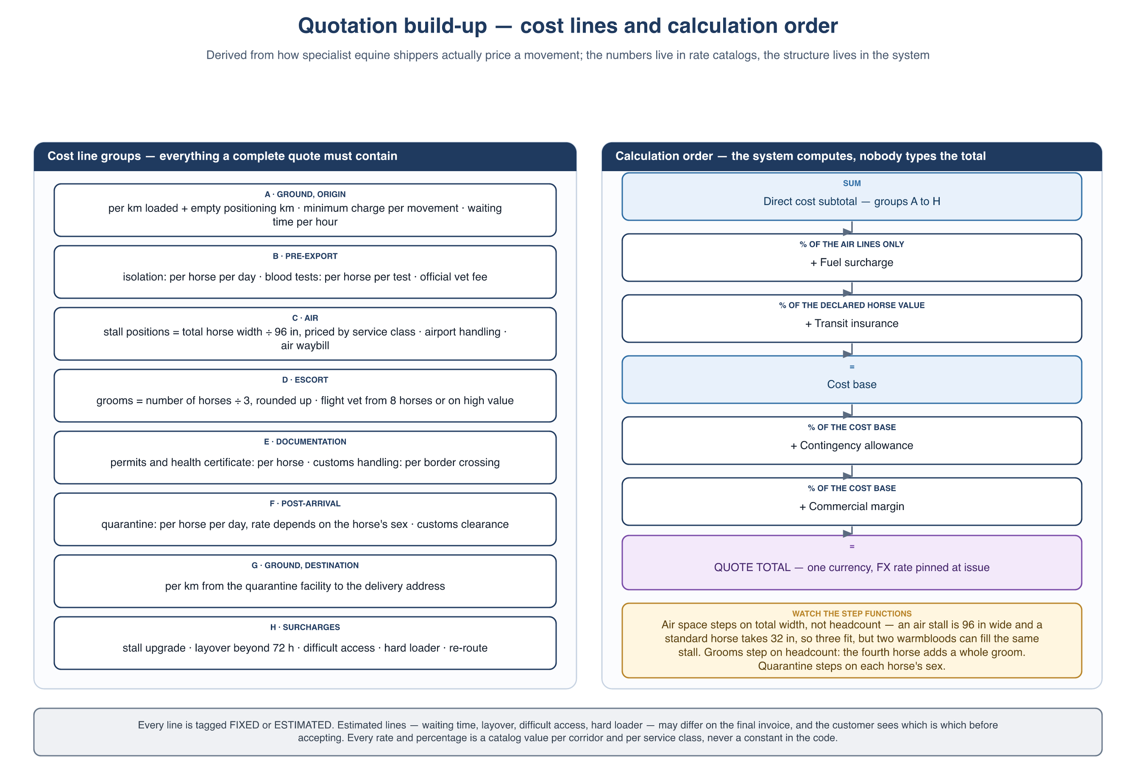
Figure 9 — How a quotation is built up: the cost line groups and the order the system applies them
Every cost line carries the same eight attributes, which is what makes the quote explainable and the calculation testable:
Attribute | Meaning
Code and group | Which of the groups A–H the line belongs to, so the quote can be presented and subtotalled by group.
Basis | One of: per horse, per shipment, per kilometre, per day, per border crossing, or a percentage of a named base.
Quantity | Derived by the system from the request — horse count, horse sexes, route distance, quarantine days, crossings — not typed.
Unit rate | Read from the pinned rate-catalog version for this corridor and service class.
Source | CATALOG or MANUAL. A manual line is one the catalog could not supply.
Certainty | FIXED or ESTIMATED. Estimated lines may differ on the final invoice and are shown to the customer as such.
Override | Empty, or a manager-entered value together with the mandatory reason.
Line total | Computed. Never entered.

4.4 Calculation rules
This ordering is the contract between the specification and the backend. Applying the percentages in a different order produces a different total, so the order is part of the specification rather than an implementation detail.
- Pin. Resolve the corridor, read the rate set, and pin the rate-catalog version to the quotation — the same pattern Flow 2 uses for the regulation catalog, for the same reason.
- Expand. Generate lines: per-horse lines once per horse, per-shipment lines once, per-crossing lines once per border crossing on the route, per-day lines from the quarantine day counts supplied by the regulation catalog.
- Measure. Resolve each horse’s size class into a width allowance, and sum them. Air stall positions = total width ÷ 96 in, rounded up; the chosen service class sets the maximum width allowed per position. Validate the total weight against the stall payload and refuse the configuration if it exceeds it.
- Step. Evaluate the remaining step functions: grooms = ⌈horses ÷ 3⌉ — on headcount, because care is per animal while space is per width; a flight veterinarian from eight horses upward or when any declared value exceeds the high-value threshold.
- Break. Apply the volume break for the horse count to the air and ground lines.
- Subtotal. Sum groups A to H. This is the direct cost subtotal.
- Fuel. Apply the fuel surcharge percentage to the air lines only.
- Insure. Apply the insurance percentage to the total declared value of the horses — not to the cost subtotal. These are different bases and confusing them is the classic error.
- Load. Apply contingency, then margin, each as a percentage of the cost base, in that order.
- Convert. Convert every line into the single quote currency using FX rates pinned at issue.
- Round. Round each line to two decimals and the total to the currency’s minor unit. Never round an already-rounded number a second time.
- Override. A manager may override any individual line with a mandatory reason. The system still computes the total from the overridden lines — the total itself is never typed.

4.5 Two surfaces, one rate catalog
The customer-facing estimate and the manager’s quotation read the same rates but are deliberately different products. Blurring them is the main risk this feature introduces.
 | Customer instant estimate | Logistics Manager quotation
When | While the request form is being filled in, before submission. | After the manager accepts the request (Flow 1, step 9).
Inputs | Route, horse count, sexes, size classes, service class, rough declared value. | The full request, the catalog, and the manager’s judgement.
Output | A range — a low and a high figure. No line detail. | Itemised lines grouped A–H, group subtotals, one total.
Binding | No. Not stored as a quotation, cannot be accepted, regenerated on every change. | Yes, once issued. Acceptance locks that specific version.
Rates | Same catalog, coarse corridor defaults, band widened deliberately. | Exact corridor and class rates, plus any manager overrides.
Purpose | Set expectations and filter out enquiries whose budget or date cannot work. | Produce the commercial offer.
Main risk | The customer reads an estimate as a promise. Mitigated by showing a range and never a single number, by labelling it on screen and in any export, and by keeping the band wide (BR-Q-11). | A quote issued with a missing rate. Mitigated by BR-Q-08.

4.6 Business rules
ID | Rule
BR-Q-01 | Every quotation is built from a rate-catalog version, and that version is pinned to the quotation. A later catalog change never alters an issued quote.
BR-Q-02 | The system computes every subtotal and the total. A manager may override an individual line but may never type a total.
BR-Q-03 | Every override requires a reason, and the quote shows that the line was overridden.
BR-Q-04 | A quotation is issued in exactly one currency, with the FX rates used pinned at the moment of issue.
BR-Q-05 | Every line is tagged FIXED or ESTIMATED, and the customer-facing quote shows which lines may still vary and why.
BR-Q-06 | Insurance is computed as a percentage of the declared value of the horses, never as a flat fee. The declared value is the customer’s own statement; verifying it is out of scope.
BR-Q-07 | Percentage lines are applied in the order defined in 4.4 — fuel on the air lines, then insurance on declared value, then contingency, then margin.
BR-Q-08 | A corridor with no rate entry cannot be auto-totalled. Issuing is blocked and the missing entries are listed.
BR-Q-09 | Quotation validity is configurable, defaulting to 7 days. Observed industry practice ranges from 72 hours to 30 days, which is why it is a setting and not a constant.
BR-Q-10 | The customer estimate is never stored as a quotation, can never be accepted, and is recomputed on every input change.
BR-Q-11 | The estimate is always presented as a range, never a single figure, and the band has a configurable minimum width. It may never be narrower than the underlying rate uncertainty.
BR-Q-12 | Re-quoting creates a new version. Earlier versions are retained, and acceptance in Flow 1 applies to one specific version.
BR-Q-13 | The deposit percentage and the cancellation fee bands are catalog values keyed to the notice period before departure, and both are shown on the quote before the customer accepts (supports BR-F1-07).
BR-Q-14 | Air and road space is allocated by width, not by headcount. Every horse carries a size class that resolves to a width allowance; the number of stall positions follows from the total width and the service class, not from the number of horses.
BR-Q-15 | A size class may make a service class unavailable. A mare travelling with a foal at foot requires a full box and therefore cannot be quoted economy; an oversize horse cannot be quoted at a width the partition layout does not permit. The builder refuses the combination and says which classes remain.
BR-Q-16 | Total weight is validated against the stall payload and the aircraft limit, and blocks the configuration when exceeded. It never prices a line on its own — for normal horses the binding constraint is width, not mass.

4.7 User stories
ID | User story | Key acceptance criteria
US-Q-01 | As a Logistics Manager I want a quotation assembled from catalog rates so that I am not rebuilding a spreadsheet for every job. | Choosing the corridor and service class populates every applicable line; quantities are derived from the horse list and the route; the total is computed; anything the catalog could not supply is listed separately.
US-Q-02 | As a Logistics Manager I want to override a line with a reason so that I can reflect something the catalog does not know. | An override requires a reason; both the catalog value and the override are retained; the quote marks the line as overridden.
US-Q-03 | As a Logistics Manager I want the quote broken into groups so that I can explain the price line by line to a customer. | Lines are grouped A–H with group subtotals; each percentage line displays the base it was computed on.
US-Q-04 | As a Logistics Manager I want to be stopped from issuing a quote that has a missing rate so that I never send an incomplete price. | Issuing is blocked; the missing corridor and class entries are listed with a route into the catalog to fix them.
US-Q-05 | As a Customer I want an indicative price range while I fill in the request so that I know immediately whether this is within my budget. | The estimate updates as route, horse count, sex and class change; it is shown as a range with a visible non-binding notice; no line detail is exposed.
US-Q-06 | As a Customer I want to see which parts of the quote could still change so that the final invoice does not surprise me. | The issued quote marks every ESTIMATED line and states why it can vary.
US-Q-07 | As a Logistics Manager I want to re-quote after a change without losing the previous version so that the negotiation history survives. | A new version is created; previous versions stay readable; the customer sees the current version; acceptance binds one named version.
US-Q-08 | As a Customer I want to see the deposit and the cancellation terms before I accept so that I know what I am committing to. | The quote shows the deposit percentage and the cancellation fee bands by notice period, taken from the catalog.
US-Q-09 | As a Logistics Manager I want the system to work out how many stall positions the horses actually need so that I do not under-quote a load of big warmbloods. | Each horse resolves to a width allowance from its size class; positions are computed from total width and the service class; a service class the horses cannot physically fit is refused with the reason and the achievable classes listed.
US-Q-10 | As a Transport Specialist I want to maintain rates per corridor and class so that a price change is a configuration edit rather than a code change. | Rates are editable per corridor × service class, with volume breaks and percentage defaults; saving publishes a new catalog version; quotations in flight keep the version they pinned.

4.8 Screens
- Logistics Manager: quotation builder (grouped line editor, live total, missing-rate panel, override dialog, issue action) and quote version history.
- Customer: inline estimate on the request form; issued-quote view with FIXED and ESTIMATED markers, deposit and cancellation terms, and accept or decline.
- Administration: rate catalog — per corridor × service class, volume breaks, percentage defaults, urgency multipliers, deposit percentage and cancellation bands.

4.9 Deliberately not automated
Stated explicitly so that the scope boundary is a decision rather than an omission:
- Carrier rate negotiation and live capacity. Rates are entered by the operator; the system prices what the manager has selected.
- Choosing the cheapest carrier. A broker comparing charter against shared positions is doing commercial work, not arithmetic.
- Currency hedging. The quote pins an FX rate; it does not manage the exposure that follows.
- Verifying the declared value of a horse. It is taken as the customer states it, and insurance is computed on that.
- Invoicing and settlement, which stay outside these flows.

4.10 Sources
Consulted September 2026 for the structure of the model and for indicative ranges. Marketing material from commercial shippers has an obvious interest in the numbers it publishes; it was used for the shape of a quote, not as a price reference.
- VRR — HMC main-deck horse stall specification and “how to choose the right stall”: stall dimensions (96 in wide), 5,504 kg payload, removable partitions for one-, two- or three-horse configurations, and the SAE ARP 1621C horse size classification. vrr.aero/products/hmc-horse-stable/
- Ari Jets — equine air cargo charter: service-class table, itemised quote components, groom and vet ratios. ariaviation.com/air-cargo/horses/
- European Horse Services — FAQ: why sex changes the cost, quarantine sequencing. ehs.be/en/faq/
- Horse-world — international shipping costs 2026: corridor ranges, pre-export and post-arrival quarantine durations, insurance at 1.5–3% of value, border-friction costs. horse-world.com/insights/international-shipping-costs-2026
- Dream Black Horse — import guide: the itemised-quote argument and the full list of cost components buyers are told to demand. dreamblackhorse.com/blog/shipping-horses-internationally-friesian-import-guide
- ForEquestrian — transport cost estimator: stall-class pricing, corridor effects, insurance as a percentage of declared value. forequestrian.com/horse-transport-shipping-cost/
- Horse Racing Sense — cost to fly a horse overseas: travel-class definitions and worked route examples. horseracingsense.com/how-much-does-it-cost-to-fly-a-horse-overseas/
- Highland Equine Transport — terms: per-mile rates for shared, private and empty mileage, minimum charge, 30-day quote validity, cancellation bands. highlandequinetransport.co.uk/terms-and-conditions
- Harrold Equine — terms: 72-hour quote validity, 50% deposit, hourly waiting fee. harroldequine.com/terms-and-conditions
- Elite Horse Transport — transport agreement: stall-size options, waiting and hard-loader fees, access surcharges, cancellation bands by notice period. elitehorsetransport.com/transport-agreement/
- Two Hearts Equine Transport — agreement: quoted rate as an estimate, layover fees beyond 72 hours. twoheartsequinetransport.com/transportation-agreement/

5. Hand-offs between the flows
From | To | What is carried | Effect
Flow 1 | Flow 2 | The approved Transport Job: code, route (origin, destination, transit countries), horse list, planned departure date. | The document checklist is generated and the clearance dossier starts.
Flow 1 | Flow 3 | The same approved job, placed in the planning backlog. | Route construction and vehicle assignment can begin in parallel with Flow 2.
Flow 2 | Flow 3 / Flow 4 | The CLEARANCE_READY flag and the issued permits attached to the job. | The departure status becomes available; before that it is refused.
Flow 3 / Flow 5 | Flow 2 | A changed planned departure or arrival date. | Every document on the job is re-evaluated; the gate re-closes if anything falls out of its validity window.
Flow 2 | Flow 1 (exception) | A BLOCKED dossier with the authority’s reason. | The Logistics Manager reschedules the departure or cancels the job, which re-opens the commercial conversation with the customer.
Flow 1 (quotation) | Flow 2 | The service class, quarantine days and document count the price was built on. | Flow 2 works to the real requirement. Where it differs from what was priced, the gap is reported to the Logistics Manager as a margin risk rather than absorbed silently.

6. Assumptions and open points
- The authorities expose no integration interface. Every interaction with them is offline and is recorded manually by the Transport Specialist, which is why the dossier states model a tracked external step rather than an automated one. TRACES and its equivalents are treated as external systems the specialist works in, not as APIs we call.
- The validity windows quoted in section 3.4.2 are catalog configuration, not regulatory advice. They differ per destination and change over time; each entry must be set from the destination country’s current published requirements before a real shipment is processed.
- The Country Regulation Catalog is maintained inside CBRTS by the Transport Specialist. Its accuracy is an operational responsibility, not a technical guarantee; the version pinning in BR-F2-01 exists to limit the damage when an entry is wrong or changes late.
- Document dates are entered by the uploader, not extracted from the file. Automatic extraction (OCR of a certificate) would remove a transcription error but is not assumed here.
- The rate catalog behind section 4 is maintained by the operator. The system owns the structure of a quotation and the arithmetic; it does not source carrier rates, check live capacity, or judge whether a price is competitive.
- The published price ranges quoted in section 4.1 were used to sanity-check the shape of the model and to seed demo data. They are not a price list and must not be presented as one.
- A deposit is acknowledged at quote acceptance in Flow 1, but payment collection and invoicing are treated as a separate concern and are not specified here.
- Lead times, quotation validity, the reminder schedule (T-7 / T-3 / T-1) and quarantine minimums are configurable values, not constants in the code.
- Notifications are assumed to be in-app plus e-mail; no SMS or messaging integration is specified for these two flows.

