Quotation Builder
New section 4 for “Core Flows — Detailed Specification” (CBRTS)
Paste after section 3 (Flow 2); the existing hand-offs and assumptions sections become 5 and 6

4. Quotation Builder — costing and the instant estimate
Flow 1, step 9 says the Logistics Manager “builds the quotation”. That sentence hides the single most error-prone task in the whole process, and it is the one step the system currently does not help with at all. This section specifies the tool that fills the gap.
The problem is well documented in the industry. The most common complaint about equine transport quotes is that they cover the flight and nothing else — the customer discovers quarantine, ground transport and customs clearance afterwards. Guidance written for buyers repeats the same advice: insist on a written, itemised quote covering every line, because a quote that shows only one component is misleading. An itemised quote is therefore not a nice-to-have output format. It is the product.
The second problem is arithmetic. The price is driven by things that are easy to get wrong by hand: grooms are staffed one per three horses, so the fourth horse adds a whole groom; quarantine cost depends on each horse’s sex rather than on headcount; insurance is a percentage of declared value rather than a fee; and a fuel surcharge applies to the air legs only. A spreadsheet gets these right until the day it does not.

4.1 What drives the price
Researched from published material by specialist equine shippers and from industry buying guides. The right-hand column is the design consequence — how the system represents each driver.
Driver | What the research shows | How the system models it
Stall class | The industry uses an airline-style class system: economy is three horses to an air stall, business two (“a stall and a half”), first class one. It is consistently described as the biggest cost lever the customer controls — published indications put a shared position roughly at half to a third of a dedicated stall on the same aircraft. | A service class on the request; a multiplier per class in the air rate table for that corridor.
Horse size and type | An air stall is a fixed container whose internal partitions are moved to suit the horses: the VRR HMC main-deck stall is 2,438 mm (96 in) wide with removable partitions for one-, two- or three-horse configurations, and road operators sell the same widths — 32 in single, 48 in stall-and-a-half, 96 in full box. “Three horses per stall” is therefore not a rule, it is what 96 inches divided by three standard horses looks like. Aerospace practice SAE ARP 1621C classifies horses by size for exactly this reason. Weight is a cap rather than a price driver: the same stall carries 5,504 kg of payload, far above three horses. | A size class per horse giving a width allowance in inches. Stall positions = total width ÷ 96, rounded up. Weight is validated against the stall and aircraft payload but does not price the line.
Number of horses | Per-head cost falls as horses share a shipment. Multi-horse moves are indicated around 10–20% cheaper per head, and larger charters considerably more. | A volume-break table per corridor. Changing the horse count re-prices every affected line.
Groom ratio | One groom per three horses is stated consistently across shippers as the industry standard. | A step function: grooms = horse count ÷ 3, rounded up. Never a per-horse rate.
Horse sex | Quarantine duration and cost depend on sex because of contagious equine metritis testing. Published facility tariffs show stallions materially more expensive than mares, and geldings cheapest; stallion protocols can run to weeks. | Sex is already captured per horse in Flow 1. It drives the quarantine day count and day rate, not a flat per-horse fee.
Quarantine duration | Pre-export isolation is commonly 21–30 days; post-arrival quarantine of 14–30 days applies to destinations such as Australia and Japan, while common corridors for mares and geldings can be a few days. | Day counts come from the Country Regulation Catalog used by Flow 2 — the manager does not type them.
Distance and corridor | High-volume corridors price lower than thin routes. Road legs are quoted per mile or kilometre with separate rates for a shared versus a private load, a lower rate for empty positioning mileage, and a minimum charge per movement. | Rate table keyed by corridor; road lines priced per km with a separate positioning rate and a floor price.
Lead time | Scheduled consolidated departures are cheaper than short-notice dedicated moves; last-minute booking is described as commanding a premium. | An urgency multiplier derived from the days between the quotation and the planned departure.
Insurance | Transit cover is quoted as a percentage of the horse’s declared value — published guidance indicates roughly 1.5–3% for a single international movement — and is described as frequently under-budgeted. | A percentage line computed on total declared value. Never a flat fee.
Fuel | Fuel surcharges move independently of base rates and are described as embedded in air pricing. | A percentage applied to the air lines only, not to the whole quote.
Border friction | Additional export and import certification on some corridors adds a fixed administrative cost per movement. | A per-crossing documentation line drawn from the catalog.
Waiting and access | Shippers publish hourly waiting fees, hard-loader fees, layover fees for journeys beyond roughly 72 hours, and surcharges for difficult access or a changed pick-up address. | Surcharge lines, tagged ESTIMATED — they may legitimately differ on the final invoice.

A note on the figures. The ranges above were used to check that the model has the right shape and to seed believable demo data. They are drawn from public marketing and buying guides, vary by a factor of three between sources for the same route, and date quickly. They are not a price list, they are not quoted in this system, and no number from them is hard-coded: every rate is a catalog value the operator maintains.

4.2 Epic summary
Field | Value
Epic ID | EPIC-F1B (sits inside Flow 1, between UNDER_REVIEW and QUOTED)
Goal | Replace the manager’s spreadsheet with a structured builder that assembles a complete, itemised, versioned quotation from catalog rates — and give the customer a non-binding estimate at request time so that enquiries with an impossible budget or date are filtered before they reach the review queue.
Primary actor | Logistics Manager
Supporting actors | Customer (estimate only), System, Transport Specialist (owns the rate and regulation catalogs)
Trigger | Manager accepts a request for quotation (Flow 1, step 9). The estimate is triggered by the customer filling in the request form.
Pre-conditions | The rate catalog holds an entry for the corridor and the service classes. Horse count, sexes and declared values are present on the request.
Post-conditions — success | A quotation version exists: itemised, totalled by the system, in one currency, with a validity date. Issuing it moves the request to QUOTED.
Post-conditions — failure | A corridor with no rate entry cannot be totalled. The builder refuses to issue, lists the missing entries, and reports the gap to the catalog owner.
Out of scope | Negotiating carrier rates, live capacity checking, invoicing and settlement, currency hedging, and choosing the cheapest carrier — the builder prices what the manager selects.

4.3 The cost model
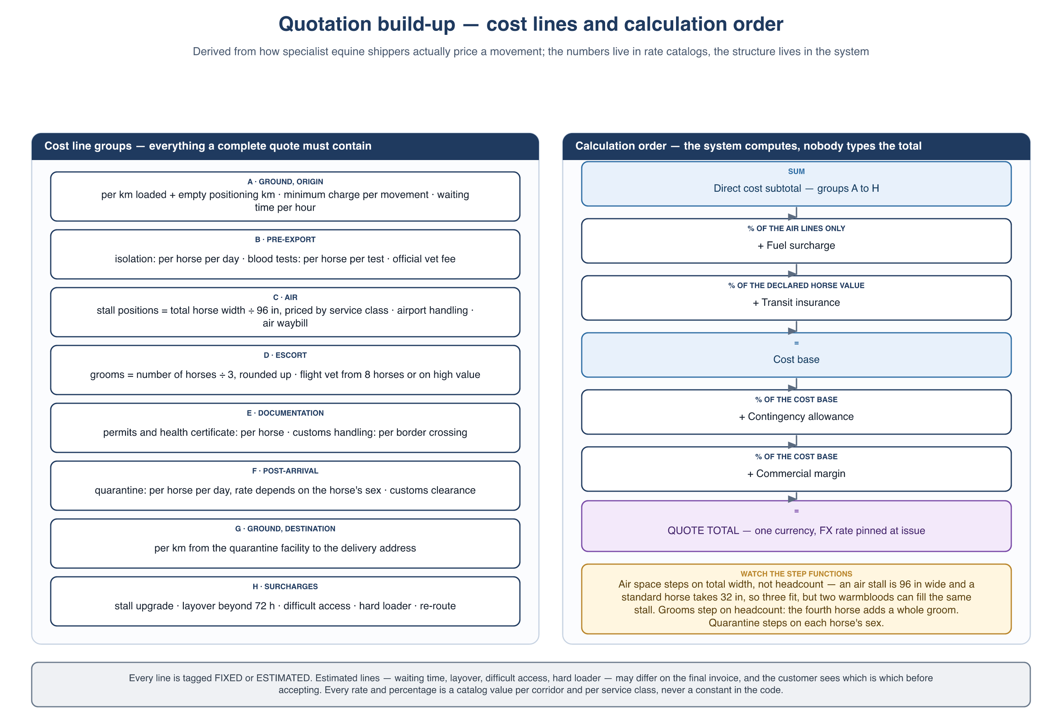
Figure 9 — How a quotation is built up: the cost line groups and the order the system applies them
Every cost line carries the same eight attributes, which is what makes the quote explainable and the calculation testable:
Attribute | Meaning
Code and group | Which of the groups A–H the line belongs to, so the quote can be presented and subtotalled by group.
Basis | One of: per horse, per shipment, per kilometre, per day, per border crossing, or a percentage of a named base.
Quantity | Derived by the system from the request — horse count, horse sexes, route distance, quarantine days, crossings — not typed.
Unit rate | Read from the pinned rate-catalog version for this corridor and service class.
Source | CATALOG or MANUAL. A manual line is one the catalog could not supply.
Certainty | FIXED or ESTIMATED. Estimated lines may differ on the final invoice and are shown to the customer as such.
Override | Empty, or a manager-entered value together with the mandatory reason.
Line total | Computed. Never entered.

4.4 Calculation rules
This ordering is the contract between the specification and the backend. Applying the percentages in a different order produces a different total, so the order is part of the specification rather than an implementation detail.
- Pin. Resolve the corridor, read the rate set, and pin the rate-catalog version to the quotation — the same pattern Flow 2 uses for the regulation catalog, for the same reason.
- Expand. Generate lines: per-horse lines once per horse, per-shipment lines once, per-crossing lines once per border crossing on the route, per-day lines from the quarantine day counts supplied by the regulation catalog.
- Measure. Resolve each horse’s size class into a width allowance, and sum them. Air stall positions = total width ÷ 96 in, rounded up; the chosen service class sets the maximum width allowed per position. Validate the total weight against the stall payload and refuse the configuration if it exceeds it.
- Step. Evaluate the remaining step functions: grooms = ⌈horses ÷ 3⌉ — on headcount, because care is per animal while space is per width; a flight veterinarian from eight horses upward or when any declared value exceeds the high-value threshold.
- Break. Apply the volume break for the horse count to the air and ground lines.
- Subtotal. Sum groups A to H. This is the direct cost subtotal.
- Fuel. Apply the fuel surcharge percentage to the air lines only.
- Insure. Apply the insurance percentage to the total declared value of the horses — not to the cost subtotal. These are different bases and confusing them is the classic error.
- Load. Apply contingency, then margin, each as a percentage of the cost base, in that order.
- Convert. Convert every line into the single quote currency using FX rates pinned at issue.
- Round. Round each line to two decimals and the total to the currency’s minor unit. Never round an already-rounded number a second time.
- Override. A manager may override any individual line with a mandatory reason. The system still computes the total from the overridden lines — the total itself is never typed.

4.5 Two surfaces, one rate catalog
The customer-facing estimate and the manager’s quotation read the same rates but are deliberately different products. Blurring them is the main risk this feature introduces.
 | Customer instant estimate | Logistics Manager quotation
When | While the request form is being filled in, before submission. | After the manager accepts the request (Flow 1, step 9).
Inputs | Route, horse count, sexes, size classes, service class, rough declared value. | The full request, the catalog, and the manager’s judgement.
Output | A range — a low and a high figure. No line detail. | Itemised lines grouped A–H, group subtotals, one total.
Binding | No. Not stored as a quotation, cannot be accepted, regenerated on every change. | Yes, once issued. Acceptance locks that specific version.
Rates | Same catalog, coarse corridor defaults, band widened deliberately. | Exact corridor and class rates, plus any manager overrides.
Purpose | Set expectations and filter out enquiries whose budget or date cannot work. | Produce the commercial offer.
Main risk | The customer reads an estimate as a promise. Mitigated by showing a range and never a single number, by labelling it on screen and in any export, and by keeping the band wide (BR-Q-11). | A quote issued with a missing rate. Mitigated by BR-Q-08.

4.6 Business rules
ID | Rule
BR-Q-01 | Every quotation is built from a rate-catalog version, and that version is pinned to the quotation. A later catalog change never alters an issued quote.
BR-Q-02 | The system computes every subtotal and the total. A manager may override an individual line but may never type a total.
BR-Q-03 | Every override requires a reason, and the quote shows that the line was overridden.
BR-Q-04 | A quotation is issued in exactly one currency, with the FX rates used pinned at the moment of issue.
BR-Q-05 | Every line is tagged FIXED or ESTIMATED, and the customer-facing quote shows which lines may still vary and why.
BR-Q-06 | Insurance is computed as a percentage of the declared value of the horses, never as a flat fee. The declared value is the customer’s own statement; verifying it is out of scope.
BR-Q-07 | Percentage lines are applied in the order defined in 4.4 — fuel on the air lines, then insurance on declared value, then contingency, then margin.
BR-Q-08 | A corridor with no rate entry cannot be auto-totalled. Issuing is blocked and the missing entries are listed.
BR-Q-09 | Quotation validity is configurable, defaulting to 7 days. Observed industry practice ranges from 72 hours to 30 days, which is why it is a setting and not a constant.
BR-Q-10 | The customer estimate is never stored as a quotation, can never be accepted, and is recomputed on every input change.
BR-Q-11 | The estimate is always presented as a range, never a single figure, and the band has a configurable minimum width. It may never be narrower than the underlying rate uncertainty.
BR-Q-12 | Re-quoting creates a new version. Earlier versions are retained, and acceptance in Flow 1 applies to one specific version.
BR-Q-13 | The deposit percentage and the cancellation fee bands are catalog values keyed to the notice period before departure, and both are shown on the quote before the customer accepts (supports BR-F1-07).
BR-Q-14 | Air and road space is allocated by width, not by headcount. Every horse carries a size class that resolves to a width allowance; the number of stall positions follows from the total width and the service class, not from the number of horses.
BR-Q-15 | A size class may make a service class unavailable. A mare travelling with a foal at foot requires a full box and therefore cannot be quoted economy; an oversize horse cannot be quoted at a width the partition layout does not permit. The builder refuses the combination and says which classes remain.
BR-Q-16 | Total weight is validated against the stall payload and the aircraft limit, and blocks the configuration when exceeded. It never prices a line on its own — for normal horses the binding constraint is width, not mass.

4.7 User stories
ID | User story | Key acceptance criteria
US-Q-01 | As a Logistics Manager I want a quotation assembled from catalog rates so that I am not rebuilding a spreadsheet for every job. | Choosing the corridor and service class populates every applicable line; quantities are derived from the horse list and the route; the total is computed; anything the catalog could not supply is listed separately.
US-Q-02 | As a Logistics Manager I want to override a line with a reason so that I can reflect something the catalog does not know. | An override requires a reason; both the catalog value and the override are retained; the quote marks the line as overridden.
US-Q-03 | As a Logistics Manager I want the quote broken into groups so that I can explain the price line by line to a customer. | Lines are grouped A–H with group subtotals; each percentage line displays the base it was computed on.
US-Q-04 | As a Logistics Manager I want to be stopped from issuing a quote that has a missing rate so that I never send an incomplete price. | Issuing is blocked; the missing corridor and class entries are listed with a route into the catalog to fix them.
US-Q-05 | As a Customer I want an indicative price range while I fill in the request so that I know immediately whether this is within my budget. | The estimate updates as route, horse count, sex and class change; it is shown as a range with a visible non-binding notice; no line detail is exposed.
US-Q-06 | As a Customer I want to see which parts of the quote could still change so that the final invoice does not surprise me. | The issued quote marks every ESTIMATED line and states why it can vary.
US-Q-07 | As a Logistics Manager I want to re-quote after a change without losing the previous version so that the negotiation history survives. | A new version is created; previous versions stay readable; the customer sees the current version; acceptance binds one named version.
US-Q-08 | As a Customer I want to see the deposit and the cancellation terms before I accept so that I know what I am committing to. | The quote shows the deposit percentage and the cancellation fee bands by notice period, taken from the catalog.
US-Q-09 | As a Logistics Manager I want the system to work out how many stall positions the horses actually need so that I do not under-quote a load of big warmbloods. | Each horse resolves to a width allowance from its size class; positions are computed from total width and the service class; a service class the horses cannot physically fit is refused with the reason and the achievable classes listed.
US-Q-10 | As a Transport Specialist I want to maintain rates per corridor and class so that a price change is a configuration edit rather than a code change. | Rates are editable per corridor × service class, with volume breaks and percentage defaults; saving publishes a new catalog version; quotations in flight keep the version they pinned.

4.8 Screens
- Logistics Manager: quotation builder (grouped line editor, live total, missing-rate panel, override dialog, issue action) and quote version history.
- Customer: inline estimate on the request form; issued-quote view with FIXED and ESTIMATED markers, deposit and cancellation terms, and accept or decline.
- Administration: rate catalog — per corridor × service class, volume breaks, percentage defaults, urgency multipliers, deposit percentage and cancellation bands.

4.9 Deliberately not automated
Stated explicitly so that the scope boundary is a decision rather than an omission:
- Carrier rate negotiation and live capacity. Rates are entered by the operator; the system prices what the manager has selected.
- Choosing the cheapest carrier. A broker comparing charter against shared positions is doing commercial work, not arithmetic.
- Currency hedging. The quote pins an FX rate; it does not manage the exposure that follows.
- Verifying the declared value of a horse. It is taken as the customer states it, and insurance is computed on that.
- Invoicing and settlement, which stay outside these flows.

4.10 Sources
Consulted September 2026 for the structure of the model and for indicative ranges. Marketing material from commercial shippers has an obvious interest in the numbers it publishes; it was used for the shape of a quote, not as a price reference.
- VRR — HMC main-deck horse stall specification and “how to choose the right stall”: stall dimensions (96 in wide), 5,504 kg payload, removable partitions for one-, two- or three-horse configurations, and the SAE ARP 1621C horse size classification. vrr.aero/products/hmc-horse-stable/
- Ari Jets — equine air cargo charter: service-class table, itemised quote components, groom and vet ratios. ariaviation.com/air-cargo/horses/
- European Horse Services — FAQ: why sex changes the cost, quarantine sequencing. ehs.be/en/faq/
- Horse-world — international shipping costs 2026: corridor ranges, pre-export and post-arrival quarantine durations, insurance at 1.5–3% of value, border-friction costs. horse-world.com/insights/international-shipping-costs-2026
- Dream Black Horse — import guide: the itemised-quote argument and the full list of cost components buyers are told to demand. dreamblackhorse.com/blog/shipping-horses-internationally-friesian-import-guide
- ForEquestrian — transport cost estimator: stall-class pricing, corridor effects, insurance as a percentage of declared value. forequestrian.com/horse-transport-shipping-cost/
- Horse Racing Sense — cost to fly a horse overseas: travel-class definitions and worked route examples. horseracingsense.com/how-much-does-it-cost-to-fly-a-horse-overseas/
- Highland Equine Transport — terms: per-mile rates for shared, private and empty mileage, minimum charge, 30-day quote validity, cancellation bands. highlandequinetransport.co.uk/terms-and-conditions
- Harrold Equine — terms: 72-hour quote validity, 50% deposit, hourly waiting fee. harroldequine.com/terms-and-conditions
- Elite Horse Transport — transport agreement: stall-size options, waiting and hard-loader fees, access surcharges, cancellation bands by notice period. elitehorsetransport.com/transport-agreement/
- Two Hearts Equine Transport — agreement: quoted rate as an estimate, layover fees beyond 72 hours. twoheartsequinetransport.com/transportation-agreement/

