DIGITAL SIGNAL PROCCESSING LAB REPORT

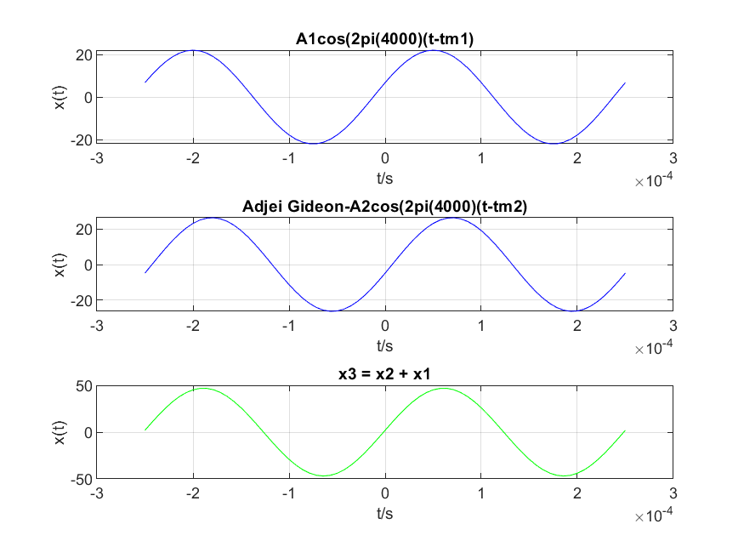

A1 = 22;

M = 1;

D = 24;

T = 1/4000;

A2 = 1.2\*A1;

tm1 = (37.2 / M)\*T;

tm2 = -(41.3/D)\*T;

t = -T:2\*T/70:T;

x1 = A1\*cos(8000\*pi\*(t-tm1));

x2 = A2\*cos(8000\*pi\*(t-tm2));

x3 = x1 + x2;

subplot(3, 1, 1);

plot(t, x1, 'b-'), grid on;

xlabel('t/s'), ylabel('x(t)'), title('A1cos(2pi(4000)(t-tm1)');

print('C:\Users\Freedom Academy\Documents\LAB\gideonx1', '-dpng');

%plot of x2

%with blue solid

subplot(3,1,2);

plot(t, x2, 'b-'), grid on;

xlabel('t/s'), ylabel('x(t)'), title('Adjei Gideon-A2cos(2pi(4000)(t-tm2)');

print('C:\Users\Freedom Academy\Documents\LAB\gideonx2', '-dpng');

subplot(3, 1, 3);

plot(t, x3, 'g-'), grid on;

xlabel('t/s'), ylabel('x(t)'), title('x3 = x2 + x1');

print('C:\Users\Freedom Academy\Documents\LAB\gideonx3', '-dpng');

NAME: GIDEON ADJEI

INDEX NUMBER: 3019520