

BlueJ Teamwork Tutorial

Version 0.2
for BlueJ Version 2.2.0

Bruce Quig,

Davin McCall
School of Engineering & IT,
Deakin University

Contents

1 Overview 3
2 Setting up a repository 3
3 Enabling teamwork features 4
4 Sharing a project 6
5 Checking out a project 8
6 Checking project status 10
7 Updating your local version 11
8 Committing changes 13
9 Checking project history 14
10 Resolving Conflicts 15
Appendix A 17

Overview
The BlueJ Teamwork features aim to provide tool support for students to be able to work in small teams on programming tasks, projects and assignments. This has been implemented by providing support for a subset of the version control functionality of CVS. BlueJ’s teamwork features do not expose students to the full variety of capabilities that version control systems such as CVS and Subversion possess.
A carefully chosen subset of capabilities is supported, allowing students to work together on projects. It supports the main teamwork activities of:
- sharing projects by placing them in a central repository,
- checking out copies of projects from the repository,
- updating local copies,
- committing local changes to the repository version,
- handling merge conflicts,
- providing project status queries,
- and viewing the project history/log.

The initial version is based upon the Concurrent Versioning System (CVS) and requires the presence of a suitably configured CVS repository. Our aim is to expose students to general version control concepts without exposing them specifically to the inner workings of CVS any more than is necessary. We would like to expand upon this in the future by also supporting Subversion as an alternative to CVS.

Setting up a repository
One of the key requirements needed to use BlueJ’s Teamwork features is a correctly configured CVS repository. There are many ways in which a CVS repository can be configured successfully. BlueJ supports communication with the CVS server via either the pserver protocol or the ext protocol using internal ssh libraries. In most circumstances we would strongly recommend the use of ext (with ssh) for the additional security that it provides.
Appendix A lists instructions to create a minimal CVS server repository that will allow the use of BlueJ team features. BlueJ should also work with existing repositories that are accessible via pserver or ext(ssh).
Setting up repositories effectively to be used in a teaching lab environment would involve additional security, account and repository configuration; and is beyond the scope of this document. Additional information outlining how this might be configured is provided in a separate document.
Unless you have an available CVS repository correctly configured and accessible, it is not possible to use BlueJ’s Teamwork features.

Enabling teamwork features
To help keep BlueJ’s user interface as clean and simple as possible, the teamwork features are hidden by default. To enable them, a user should choose the Tools>Preferences… menu option (BlueJ> Preferences... on Mac OS X). This will show BlueJ’s Preferences Dialog (Figure 1). Under the Miscellaneous tab there is a check box for Show teamwork controls which needs to be checked.

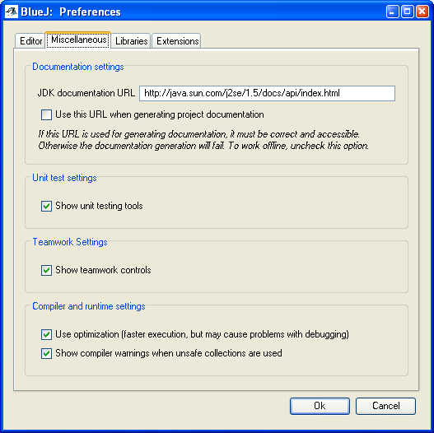
Figure 1 BlueJ Preferences Dialog: Show teamwork controls

Upon pressing Ok the Teamwork features should now be visible. In the main BlueJ window there will be three additional buttons (Update, Commit and Status) which are disabled for any project which is not currently being shared (Figure 2).

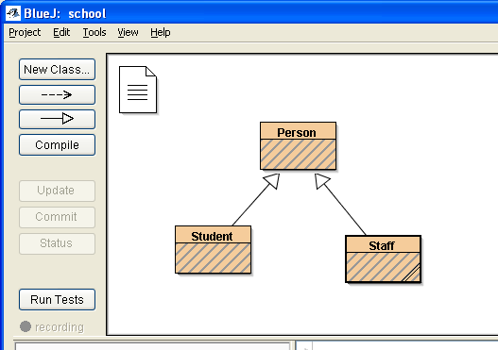
Figure 2 Greyed out teamwork controls in main BlueJ window

There is also an additional Team sub-menu under the Tools menu, which provides some additional Teamwork actions (Figure 3). Two of these will be enabled: Share this Project and Checkout Project.

Figure 3 Teamwork menu options

Sharing a project
The starting point for interacting with BlueJ’s Teamwork features for most users will be one of the two menu options mentioned earlier. These allow you to share an existing local project, or to checkout a copy of a project already in a repository. In this section we describe how to share an existing project. You will need to know the details of the repository that you want to place the project in.
Open the existing local BlueJ project that you would like to share (by placing into an existing repository). Select the Tools>Team>Share this Project menu option. At this point you will see a Team Settings dialog that requires information about the destination CVS repository (Figure 4).

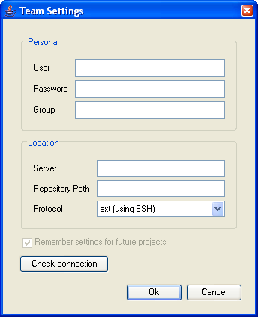
Figure 4 Team Settings Dialog
The following information is required:

User
This is your username that is required for access to the repository. This will typically be your username for the machine on which the CVS repository is located.

Password
This is the associated password for the username specified above to allow repository accessNote: At various stages when using the BlueJ Teamwork features you will be asked to provide a password for the repository before Teamwork operations are undertaken. These passwords are not permanently stored, and are asked for whenever a Teamwork operation is invoked upon a newly opened project. Once you have supplied this information it is remembered for any further operations during that session.

Group (optional)
Group is an optional field. It is not needed if you are only trying out BlueJ Teamwork features, or you are interacting with a single repository. It is a field that can be used by teachers or system administrators to allow for the specification of separate repositories for each student team. The group name is used to append another directory to the location of the repository path. This can be left blank if not required.

Server
This is the name or IP address of the server on which the repository is located. This can be a local or remote machine. Eg. cvs.myservername.org

Repository Path
This is the file system location on the Server at which the repository can be found. Eg. /home/subjectname/cvsroot

Protocol
This is the communication protocol to be used when communicating with the CVS server. Pserver is a cvs specific protocol that can be used for accessing a cvs repository. Ext, using SSH as a transport, is also supported and provides greater security and access through firewalls. In most cases, we would recommend the use of ext (using ssh) if it is available.
Once all of this information has been provided, it is possible to check whether a connection is possible with those settings by trying the Check Connection button. The success of creating a connection to the server using the specified username, password and protocol is then given (Figure 5).

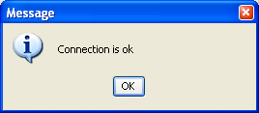
Figure 5 Successful connection

If the connection was successful, you can press the Ok button to proceed with sharing the project. As this operation may involve communications with a remote machine this may take some seconds. You will see an activity bar in the bottom right hand area of the main BlueJ window. Once the operation has successfully completed, this progress bar will be removed and the three Teamwork action buttons on the left side of the BlueJ main window will now be enabled.
Note: To help simplify the management of projects in repositories, BlueJ will always import the project into the repository using the existing project name as the name of the remote project module within the repository.
Not all of the project files are included in the repository. Some file types are excluded, the main ones being any compiled java class files found, and any generated Javadoc API documentation files for your project. These can easily be generated inside BlueJ by compiling source files and generating documentation for the project. Any other files that your project may require that are located within the project (such as image files) are automatically included. If your project uses a +libs subdirectory for accessing required libraries, this is also included in the repository.

Checking out a project
The other main way of initially interacting with BlueJ’s Teamwork features is to checkout a copy of an existing shared project that is located in a shared repository. The process of checking out a project downloads a copy of that shared project on to your computer.
If you choose the Checkout Project menu option you will be presented with a Team Settings Dialog similar to the one described above in Sharing a project. Once the required information is given and Ok is pressed a Project Selection dialog is presented (Figure 6).
If you know the exact name of the project that you want to checkout you can specify it in the upper text area and choose Ok.

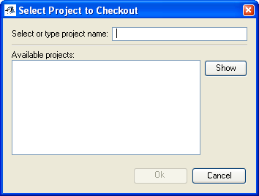
Figure 6 Project Selection dialog

Alternatively, if you are not sure of the exact project name or would like to browse the existing projects within the repository, you can select the Show button. This provides a list of all projects that have been placed in the repository. A project can then be selected for checking out. Once a project name is entered or selected the Ok button will become enabled.

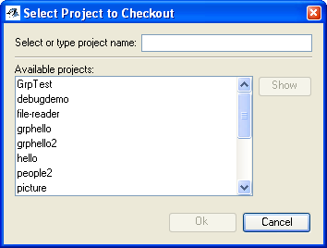
Figure 7 Browsing existing projects

The next step is to specify where on your local system you would like the project to be located. All of the project files will be downloaded inside a folder that has the same name as the project. You only need to specify where you would like this folder to be located.
Note: To try and simplify the process of managing projects within repositories, BlueJ will always give a checked out project the same name as the repository version. It is possible to make copies of a BlueJ project using Save as… which will allow you to change the name of the local copy of the project. It will however still be linked to the original repository version of the project which will continue to have the original name.

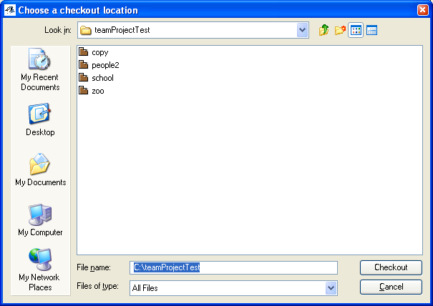
Figure 8 Choosing location for checked out project

Once you have selected the location for the checked out project (Figure 8), and selected the Checkout button, the project will be copied from the repository and a local BlueJ project created. You can now modify the contents of the project and make modifications and improvements to the project.

Checking project status
As you make modifications to a project, and also as other team members may make changes to the main project version in the repository, there is often a need to know what the status of the project is. The Status command, accessed by the Status Button in BlueJ’s main window allows you to do this. This command checks the available information on the files in your project and also checks the repository for information on all of the files it is managing. This information is then presented in a Status Dialog (Figure 9).

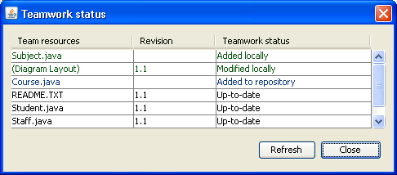
Figure 9 Teamwork status dialog
Figure 9 shows a Status dialog listing the resources for a project. The name of the resource is listed in the left column (Team Resources). The middle column shows the repository version number of each resource. Each time a resource is modified in the repository its version number is incremented. The status of each resource is shown in the right hand column (Teamwork status). In this case most of the files are listed as Up-to-date meaning that the repository version and your local version are exactly the same.
The “Course.java” resource is shown as having a status of Added to repository meaning that it is a file that has been added to the repository since the last project update, and there is no local version as yet. This file can be retrieved performing an Update from the repository, which is described in the next section.

“Subject.java” shows a different status: Added locally. As the name implies, this file has been created locally and does not yet have a repository version. You can place a copy into the repository by performing a Commit action, which is described in a following section.

Updating your local version
From time to time, as other team members make modifications to a project and commit those changes back to the repository, you will want to update your local version so that your version of the project contains those modifications. This is performed by performing an Update. Pressing the Update button in BlueJ’s main window will open the Update dialog (see Figure 10), which will first check for any conflicts and inform how to resolve them. If there are no conflicts, a list of files to be updated with changes from the repository will be displayed, and you can proceed with the update (by pressing the Update button in the dialog).

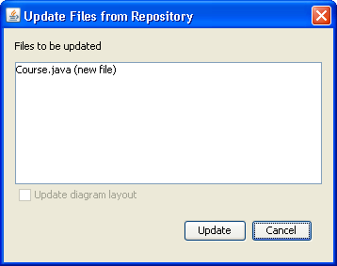
Figure 10 Update dialog

It is expected that from time to time more than one person will be modifying the same source file. It is therefore important that the version control system that enables you to work as a team does not overwrite any person’s work (unless desired).
The underlying version control system will do its best to merge all modifications of a file into the final source version. From time to time, if team members are simultaneously working on the same lines of code, the version control system cannot determine what the correct version to keep is. In this situation, a merge conflict occurs. How to handle conflicts is described later in this document (see Resolving Conflicts). One of the easiest ways to avoid conflicts is to update your local version reasonably regularly, and to always update your project before attempting to place your modifications into the repository.
Importantly, different types of files are handled slightly differently when updating (and also when committing). Image files, data files and class libraries are not handled as text files that could be merged. If changes are made by two team members simultaneously, a conflict will be created which must be resolved by one of the team (see Resolving Conflicts).
Performing an Update on the project whose Status dialog was shown in Figure 9 will download a copy of the Course.java from the repository and place it in your project. A new class icon appears in the BlueJ main window’s class diagram. Refreshing or re-opening the Status dialog will now show the Course.java resource as being Up-to-date (Figure 11).

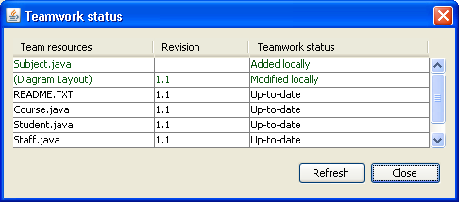
Figure 11 Status dialog after Update

Committing changes
Once you have made local changes to a project, you can choose to share those changes with others in your team by performing a Commit operation, which is initiated by pressing the Commit button in the main window. As mentioned in the Updating your local version section, it is advisable to perform an Update before committing your modifications. In any case, if you make changes to a class which is not up-to-date with the repository version, then you will upon initiating the commit operation be presented with an error message informing you that conflicts exist and that you must update first.
If there are no conflicts, the Commit Comments dialog (Figure 12) will be displayed after pressing the Commit button in BlueJ’s main window. This dialog is used to allow you to preview the files that will be committed into the repository, and to also add some comments describing the changes you have made.
Note: It is good programming practice to ensure that descriptive comments are added when committing changes. They provide a form of communication between developers as to the intent of changes, and an audit trail as to when, where and why certain behaviour was added (or removed).
The upper area of the Commit Comments dialog lists the files that have changed locally. These will also be changed in the repository once you have pressed the Commit button in the dialog. Afterwards, other team members can use Update to retrieve your changes into their own working copy of the project.
If you have deleted files from your local version of a project, there is still a need to confirm that you want to also make that deletion in the repository. This is done also using the Commit operation. It may seem strange at first that a file that has been removed locally is included in the Files to be committed area, however it provides an accurate list of all of the impending changes, some of which may have been otherwise been overlooked.
If there are no changes in your local project version, the Commit button will be disabled and not allow a Commit operation. Below the Commit comment area there is a check box which allows the inclusion of diagram layout information in the committed files area. By default this option is unchecked and is only enabled if there are differences between your current diagram layout and the layout information stored in the repository.

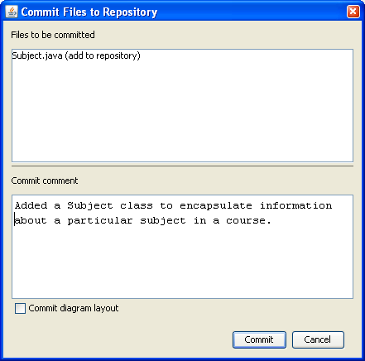
Figure 12 Commit comments dialog

Checking project history
During the description of the Commit operation, the Commit Comments Dialog showed an option (whose usage is strongly recommended), allowing the recording of comments that described the modifications to the resources that will be committed to the repository. This comment, along with data about which files were committed and who made the modifications forms a project history. This history can be viewed at any stage (assuming you can access the repository).
Under the Tools>Team submenu is the menu option: Show Project History. This will present a dialog (Figure 13) showing all changes to the project since placed in the repository. As the amount of information for larger projects with larger teams of developers can create a lot of entries, it is possible to filter and selectively view history data by filter by the User who has made the modification and/or the specific resource. For instance it is possible to list all changes made by UserX, or view all modifications to Course.java, or the combination of the two (all changes made by UserX to Course.java).

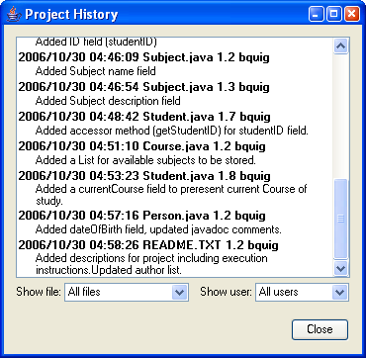
Figure 13 Project History

Resolving Conflicts
When updating your local project from the repository, there will be occasions where conflicts are identified between local and remote modifications. Conflicting changes in source files (merge conflicts) are handled by firstly alerting the user via a Conflict Dialog (Figure 14) and then through the mark-up of the 2 versions of the modified source code in the source code file (Figure 15).

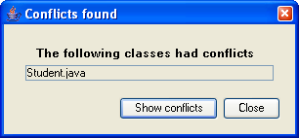
Figure 14 Update conflict dialog

If two versions of a section of source code file (such as Student.java) in the School project shown earlier were modified concurrently, a conflict would be identified. A Conflict Dialog (Figure 14) is then shown, identifying the files that contain conflicting segments. By selecting the Show Conflicts button in this dialog, the source code is shown in an editor window (Figure 15).

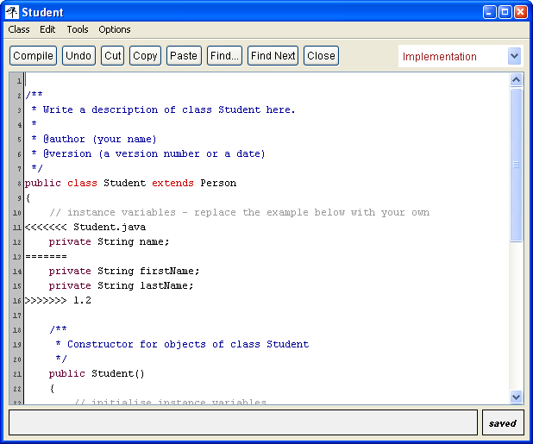
Figure 15 Conflicting code marked in source code.

From lines 11 to 16 of the source code, some additional characters have been inserted to clearly mark the conflicting segment. The segment is easier to understand once the meaning of several extra characters is understood. The conflicting segment commences with line 11:

<<<<<<< Student.java

The next lines contain the local version of the conflicting segment. The local version ends with the ======= line (line 13).

The next two lines contain the latest version from the repository. This section ends with line 16 which shows the >>>>>>> 1.2. This represents the end of the repository version (and its current version number).
To resolve the conflict you will need to choose which version (or combination of versions) of the changes you would like to keep. One other thing you will need to do is to delete the three marker lines:

<<<<<<< Student.java
=======
>>>>>>> 1.2

If the marker lines are not removed, you will get additional compilation errors, as they are not valid Java syntax. You now have a resolved merge of the file that can be used for further modifications or for committing your modifications to the repository.
There are various other types of conflict that can also occur, although they should be much less common than merge conflicts. One example is when a file has been deleted by one team member but modified by another member. Such contrary changes cannot be meaningfully merged together: Usually a conflict of this nature requires resolution by deleting the conflicting file and then performing an Update (in any case, the Commit and Update commands will inform you how to deal with any conflict.

Appendix A
How to set up a CVS Repository for testing the BlueJ teamwork features

On unix / linux:

1. You must have the CVS software installed on the machine you intend to use as a server. There is a good chance that it is already installed, but if not, your vendor or distribution provider will almost certainly provide packages that can be installed.

2. Setting up a repository is quite simple. :

cvs -d ~/cvsroot init

Here "~/cvsroot" is the CVS root directory, in which all files needed to maintain the repository will be stored. The directory need not exist, it will be created automatically by the command. You should choose a directory which doesn't previously exist and the path must be absolute (i.e. must begin with '/' or with '~'; the latter is a short-cut for your home directory).

3. In general, ssh access will already be enabled to access your unix/linux server, so you can now share projects using BlueJ. The repository location you need to specify in the BlueJ teamwork settings dialog is the same as used in the "cvs init" command in step 2 (but you cannot use the '~' as a short-cut for your home directory - this time, you must specify the path completely). Leave the "group" blank.

On Windows:

1. The suggested CVS server software is "CVSNT". You can download it for free from http://www.cvsnt.org - under the "free download" column, just select Windows as your operating system. You should log in as Administrator and double-click the downloaded installer in order to begin the installation. Once this is complete, you may be asked to restart the computer.

2. After CVSNT has been installed, you can set up a repository using the CVSNT control panel, which you can access from the start menu (Start / Programs / CVSNT / CVSNT control panel). In the "Repository configuration" tab, press the "add" button, and choose a directory for the CVS repository (it is recommended to create a new directory). You will be asked whether CVSNT should initialise the location as a repository, and you should choose "yes". The location "name" defaults to the repository path without the drive letter designation, which is generally a good choice.

3. By default CVSNT provides "pserver" access to the repository. If you want to use the ssh access method, which is generally recommended as it is somewhat more secure, you need to install an ssh server program. One such program can be found at the following location:

http://sshwindows.sourceforge.net/

4. The repository "name" is what you use as the repository path in BlueJ (in the team settings dialog). You can use the "pserver" access method or, if you have installed an ssh server, you should also be able to use the "ext" access method. As for unix / linux, you can leave the "group" field in the teamwork settings dialog blank.

