A Module is a single file of code that contains functions, classes, and variables. Modules help you organize your code into reusable, logical units, making it easier to manage and understand. Think of a module as a single tool in your toolbox; it's a file that holds a specific set of related functionalities.

How to Create a Module
To create a module in Python, you just need to create a new file with a .py extension. The file name becomes the module's name.
- Create the module file:
Let's create a file named my_calculator.py with some simple math functions.
Python
# my_calculator.py

def add(x, y):
"""Returns the sum of two numbers."""
return x + y

def subtract(x, y):
"""Returns the difference between two numbers."""
return x - y

def multiply(x, y):
"""Returns the product of two numbers."""
return x * y
- Use the module in another file:
Now, create another file (in the same directory) called main_program.py to use the functions from your new module.
Python
# main_program.py
import my_calculator

result_add = my_calculator.add(5, 3)
print(f"5 + 3 = {result_add}")

result_multiply = my_calculator.multiply(4, 6)
print(f"4 * 6 = {result_multiply}")
When you run main_program.py, the output will be:
5 + 3 = 8
4 * 6 = 24

What Is a Package? 📦
A package is a collection of related modules organized in a directory hierarchy. It's essentially a folder that contains one or more module files, and must include a special __init__.py file (which can be empty) to be recognized as a package. Packages provide a way to structure a large project and prevent naming conflicts.
- Analogy: If a module is a single tool, a package is a toolbox that holds a set of related tools (modules). For example, a "math" package could contain separate modules for geometry, algebra, and statistics.

What Is a Library? 📚
A library is a broader term for a collection of pre-written code that a programmer can use to perform common tasks without writing the code from scratch. A library can be a single module, a package, or a collection of multiple packages. Libraries are designed for reuse and can contain a wide range of functionalities, from data manipulation to machine learning.
- Analogy: A library is a comprehensive collection of toolboxes (packages) and individual tools (modules) that you can borrow to build your project more efficiently.
- Examples:
  - NumPy is a popular Python library for numerical computing. It's a collection of packages and modules that provide powerful tools for working with arrays and matrices.
  - requests is a library for making HTTP requests. It's much easier to use requests.get() than to write all the code for handling web communication yourself.

When you see a __pycache__ directory and .pyc files generated in your Python project, it's a normal part of the Python interpreter's process. Python creates these files to optimize performance. A .rtf file, on the other hand, is a common text document format.

What are __pycache__ and .pyc files?
- __pycache__: This directory is created by the Python interpreter to store compiled bytecode of your Python scripts. It acts as a cache.
- .pyc files: These files (inside the __pycache__ directory) are the compiled versions of your Python files (.py).

Why are they created?
When you run a Python script, the interpreter first compiles your human-readable code into a lower-level format called bytecode. This bytecode is much faster for the computer to execute. Instead of re-compiling the same script every time you run it, Python saves the bytecode in the __pycache__ directory.
The next time you run the script, Python checks if an up-to-date .pyc file exists. If it does, it skips the compilation step and runs the bytecode directly, which significantly speeds up the program's startup time.
You can safely delete the __pycache__ directory and its files. Python will simply recreate them the next time you run your script. It is also standard practice to add __pycache__/ to your .gitignore file so these temporary files are not included in your version control repository.
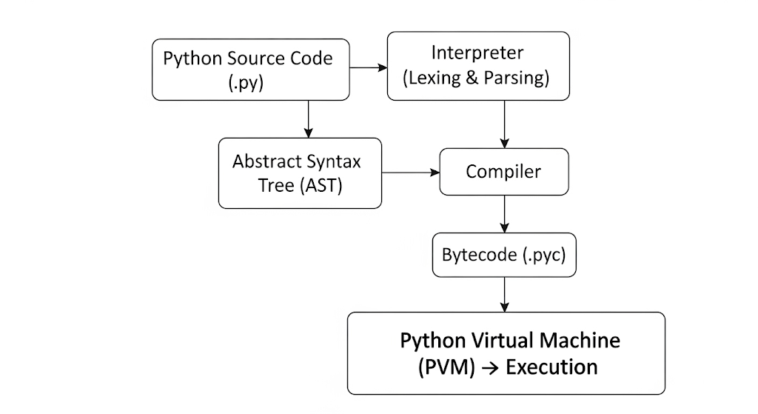
How a code is executed in Python

