Karen Soenen

[Email address]

Galapagos specific QGIS project

Data aggregated from the cruises DRIFT4, LV1007, AL15, NA06..

Galapagos GIS

Hands-on Guide for Cruise Planning

Contents

1 Getting around the qgis project 2

1.1 Set-up 2

1.2 Project properties 2

1.3 Move around the map 3

2 Folder structure and data location 3

2.1 Data aggregation 3

2.2 Data location 3

2.2.1 General outline Galapagos 4

2.2.2 DRIFT4 cruise, 2007 4

2.2.3 Melville cruise MV1007, 2010 5

2.2.4 Alucia cruise AL150801, 2015 5

2.2.5 OET-Galapagos 2015 6

2.3 Data sources in QGIS 6

3 Importing data 7

3.1 Data Source Manager 7

3.2 Delimited text 7

3.3 Rasters 7

3.4 Vector 7

3.5 Setting the data source 7

4 Identifying the data in your projects 8

5 Linking pictures 8

6 Making Maps 8

6.1 The layout manager 9

6.2 Adjusting Coordinate grids 10

# Getting around the qgis project

## Set-up

A qgis project starts in a folder has the extension .qgis. If qgis is installed on your computer, double clicking it will open the project.

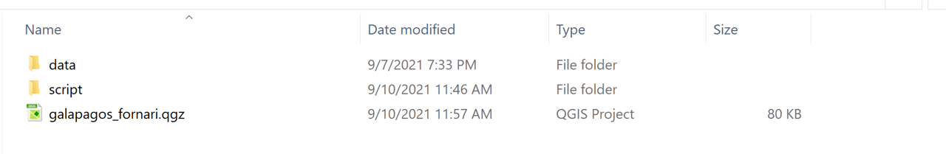Before starting with your project, make sure all the necessary toolbars and panels are visible and ready to use. Right click on an empty grey zone next to one of the toolbars in order to show a checklist of panels and toolbars to appear in the project.

The most important panels for this project are the "Layers Panel" and "Identify Results Panel".

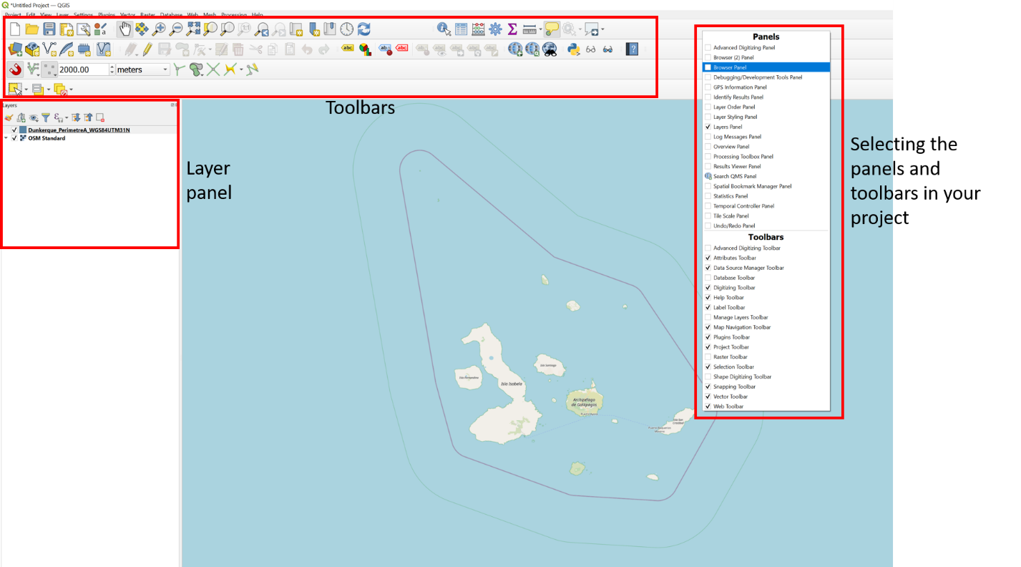

## Project properties

General project properties, like the project reference system and the author can be set in the project properties

The project coordinate reference system has been set to WGS84 UTM15N (epsg:32615). 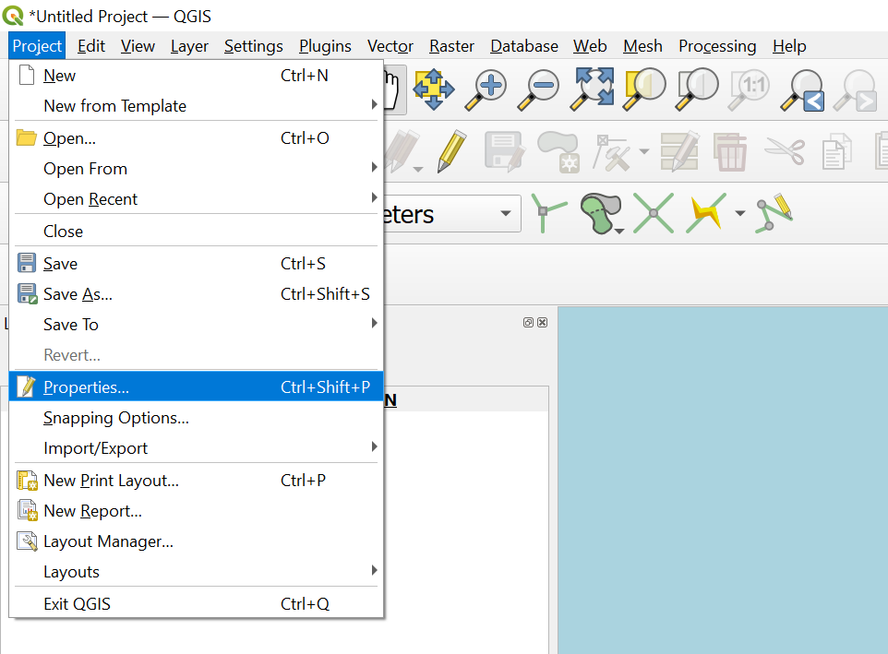

## Move around the map

[Insert items/buttons to move around the map]

# Folder structure and data location

## Data aggregation

The data in this project is aggregated from 4 different projects that have been carried out around the Galapagos in the Past:

* DRIFT4: 2007. Side scan sonar data and multibeam data has been acquired by shipboard. Dredges were taken during this cruise
* MV: MR1 is a Side scan system towed on its own right at the surface (under thermocline or something).EM122 is shipboard and should be imported too (second opinion EM122 does not really matter, Sept 8, 2021). Pictures were taking by using a tow system and
* AL15080: Alucia cruise in 2015. Pictures and samples have been taken with the submersibles Nadir and Deep Rover II. A Remus AUV acquired high resolution side scan sonar
* NA064: OET Galapagos 2015. There is multibeam data and seabed picture data

## Data location

The data has been imported from the external SSD, called GALAP. The qgis project has been build in this drive and it is important to keep the data at the same location and not change folder names. Below a list of folder paths per cruise and data type can be found in case the links break or a reference to data needs to be refound.

### General outline Galapagos

* D:\DRIFT4-2001-Revelle-Galapagos-Data-Figures\Galapagos-DRIFT4-cruise-data\Sheirer\Galapagos_compilation\coastline\Arc_files\gal_costa_poly_dddd.shp [CRS = EPSG:4326 (WGS84).

In order to be able to apply labels to the shapefiles, the data has been copied into and filtered by Island names that are necessary for this project

### DRIFT4 cruise, 2007

#### Side Scan Sonar imagery

* 8m:
  + D:\DRIFT4-2001-Revelle-Galapagos-Data-Figures\SSS_GeoTiff_WGS84; CRS=WGS84
  + The 8m grids are not complete: 40-01.8m; 50-01.8m to 50-12.8m and 50-16.8m to 50-20.8m [CRS = UTM15N]
  + Here are the missing 8m grids: D:\DRIFT4-2001-Revelle-Galapagos-Data-Figures\SSS_GeoTiff_WGS84 [CRS = WGS84] [processing: applied no data value =0 to these grids (transparancy add 0]
* 16m:
  + D:\DRIFT4-2001-Revelle-Galapagos-Data-Figures\DRIFT4_Galapagos_newGrids\DRIFT4_new 16m_MR1-grids ; CRS Unknown (ARcGIS says CRS = UTM15N)
  + D:\DRIFT4-2001-Revelle-Galapagos-Data-Figures\SSS_16m_GeoTiff_WGS84; CRS WGS84
  + The 16m grids are complete (= total of 8 grids) [CRS = UTM15N]

8m and 16m grids together here: D:\DRIFT4-2001-Revelle-Galapagos-Data-Figures\8M-DRIFT4-SS-GRIDS-PAUL CRS = UTM15N

#### Bathymetry

* D:\DRIFT4-2001-Revelle-Galapagos-Data-Figures\Galapagos-DRIFT4-cruise-data\Drift4Bathy_ArcImport
* D:\Galapagos-Bathy-Grids
* Bathymetry around Fernandia:
* D:\DRIFT4-2001-Revelle-Galapagos-Data-Figures\Galapagos-DRIFT4-cruise-data\Sheirer\Galapagos_compilation\bathy_topo\Fernandina.100m.Combined_filled.topo_bathy
* General bathy maps
* D:\DRIFT4-2001-Revelle-Galapagos-Data-Figures\galapagos-grids

#### Dredge data

The dredge start and end points could not be found on the drive. However, they were exported from a fleddermaus proect into a .xyz file. The location of this exported file is here: *D:\DRIFT4-2001-Revelle-Galapagos-Data-Figures\drift4-dredge-tracks.xyz.txt*

### Melville cruise MV1007, 2010

#### Side Scan Sonar

* EM122 - 50m: D:\MV1007-Melville-2010\MV1007-EM122-Sidescan
* MR1 - 10m (folders with 50)
* MR1 - 15m (folders with 100)
* MR1 - 25m (folders with 200)
* MR1 - 40m (folders with 400)

#### Bathymetry

D:\MV1007-Melville-2010\MV1007-EM122-Bathymetry\mv1007-60m-em122-june16.grd

#### TowCam data

MV Towcam logs are here: D:\MV1007-Melville-2010\MV1007-TowCam-Data\mv1007-TowCam-Logs

5 minute intervals, but needs to be interpolated to match the Mellevelle has tow cam data (pictures), but the nav file seems to be missing.

### Alucia cruise AL150801, 2015

Divide them up in Islands? Floreana, Fernandia, Santiage and Santa Cruz (no Remus data for the last one)

#### Hull mounted

* Hull mounted multibeam Alucia - gridded at 20m
* D:\AL150801-Alucia-2015-Galapagos-Data\AL150801-multibeam-data\Multibeam ->
* not sure with what this bathymetry got acquire, seems not to be cleaned out. stretch from 0 to -2600 with quantile color ramp
* WGS84
* Singleband pseudocolor

#### Remus bathymetry - 1m - TO DO**

* D:\AL150801-Alucia-2015-Galapagos-Data\kurras-Galapagos-AL1508-Remus-grids-geotifs
* Look in the "to WHOI" folders for the poststamp xyz bathymetry files, do not use the sss files
* 1m resolution?
* what gregg Kurass produced since REMUS couldn;t do it.
* Remus side scan sonar - 0.5m - HF and LF
* D:\AL150801-Alucia-2015-Galapagos-Data\kurras-Galapagos-AL1508-Remus-grids-geotifs\from_kurras_20210827 [high frequency and low frequency sss from remus]
* 0.5 m resolution?
* for both HR and LR (high and low resolution tiffs): qgis imports wrong color scheme, change to singleband grey and 255 as no data
* what gregg Kurass produced since REMUS couldn;t do it.

#### Nadir and Deep Rover II dive tracks

#### Nadir seabed pictures

* Dives happened with 2 vehicels: Deep Rover 2 (DR) and Nadir (N)
* date, xyz files of those vehicles can be found here: D:\AL150801-Alucia-2015-Galapagos-Data\AL150801-DIVE-DATA-DEPTH-NAV
* Use the .txt files from those folders, format is: YYYY,MM,DD,HH,MM,SS.S, Dec Long, Dec Lat, UTM X, UTM Y, -DEPTH (M)
* pictures can be found here: D:\AL150801-Alucia-2015-Galapagos-Data\AL150801-Nadir-GoPro-images

### OET-Galapagos 2015

* Pictures are here: D:\NAUTILUS-OET-Galapagos-2015\NA064-herc_MISO-gopro_corrected_time
* Correct nav files to use: "D:\NAUTILUS-OET-Galapagos-2015\NA064\processed\dive_reports\H1441\merged\H1441.NAV3D.M1.sampled.tsv"
* sampled dive resampled to 1 second intervals, with depth.

#### Seabed pictures

Seabed pictures are aggregated from the following cruises and sampling methods:

* OET Galapagos -NA064 Hercules ROV
* AL150801 - Nadir HOW
* MV1007 - TowCam Data

Picture locations are derived from the navigational files and joined based on the picture names (year, mm, dd, hh, mm, ss) and those same columns in the navigational files

## Data sources in QGIS

Right click on the layer to see where the data is located/referenced. -> information

# Importing data

This chapter will discuss the way of adding Ingest data per type. Adding data using the "Data Source Manager" and choose the correct type of data to ingest:

## Data Source Manager

## Delimited text

Apart from rasters, this is the most used data type there is in the whole disk.

The **format of the file** **to import** is important. It is easiest to work with a **.csv or .txt file** that has column headers in the file itself. Take this into account when exporting a .txt file from Fleddermaus or any other program.

Steps to import a .csv file with xy coordinates:

1. Data Source Manager -> Delimited text.
2. Fill in:

* file format:
* Geometry definition: will be the columns that represent the point locations. In the geographic system (WGS84), the Y is the latitude and X the longitude. In a projected system (UTM15N), X normally is X and Y normally Y. **Note**: Set the correct coordinate reference system! If this is wrong, the points will show up somewhere else on the map, i.e. will be projected at the wrong location.

## Rasters

The easiest format to work with when importing rasters into your qgis project is using GeoTiff for both side scan sonar and multibeam data. **Note**: side scan sonar will always be imagery data, while multibeam data can also be imported as gridded points or processed soundings and interpolated in QGIS.

The easiest way to import rasters is to drag/drop them into your project. This will work only with Geotiff rasters.

When doing the drag and drop way, you'll probably will have to set the CRS after import. To do this, do right click on layer -> CRS-> choose WGS84 or projected system used on the cruise.

It is easiest if the data processor imbeds the projection system in the filename so there is no confusion or guessing once of the vessel.

## Vector

## Setting the data source

If a file has been imported into your qgis project, but doesn't show up when you open the project again, it probably has been moved its location when the project was closed. You can always check the file you're working with by right clicking the layer-> properties.

Some data management principles to make life easier on and off the cruise shio:

* imbed the projection system in the file name, i.e utm15N or WGS84
* imbed the resolution in the filename i.e 15m

# Identifying the data in your projects

Identifying can happen on several different ways, mainly using the attribute toolbar.

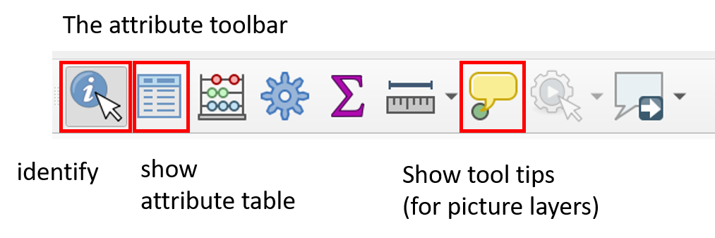

Using the attribute toolbar and click in the attribute you want to have identified. Make sure to click on the layer to identify, so the correct one will

The pictures in the project has been set up to be able to view pictures as a tool tip. Make sure you select the picture layer you want to see the pictures from

The attribute table for the pictures can also be helpful. The attribute table pops up when clicking on a point or by right clicking on a layer, then select "open attribute table"

# Linking pictures

* Set up an excel table with pictures and locations
* Import the table
* Set display tips and set interactive html

# Making Maps

Making maps in qgis is done using the tool "layout Manager"

Symbology in qgis lay-out itself

Right click on layer -> properties -> symbology

Cartography principles layout manager

## The layout manager

To get to the layout manager from the main QGIS project, click the layout manager button, which will open a new tab, you can either choose a template or create a new layout. 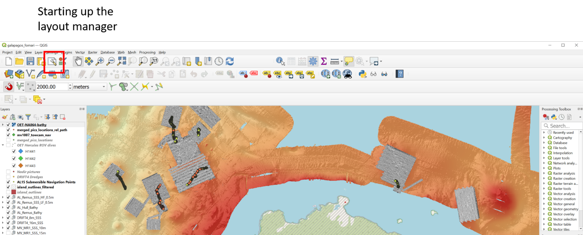

The fornari qgis project has several layout templates of which you can choose one based on the size of the print layout:

* Size 8.5x11
* Size A0

Each template contains the following items:

* Map
* Scalebar
* Legend
* North arrow

Interacting with the layout and adding items to the map is done by using the item bar on the left. When adding items to the map, they will appear in the "Items" list on the right. Each item has specific properties that can be adjusted in the Item properties box, under "Items". Make sure that the item you want to adjust is clicked on (=blue), before you can adjust that specific item.

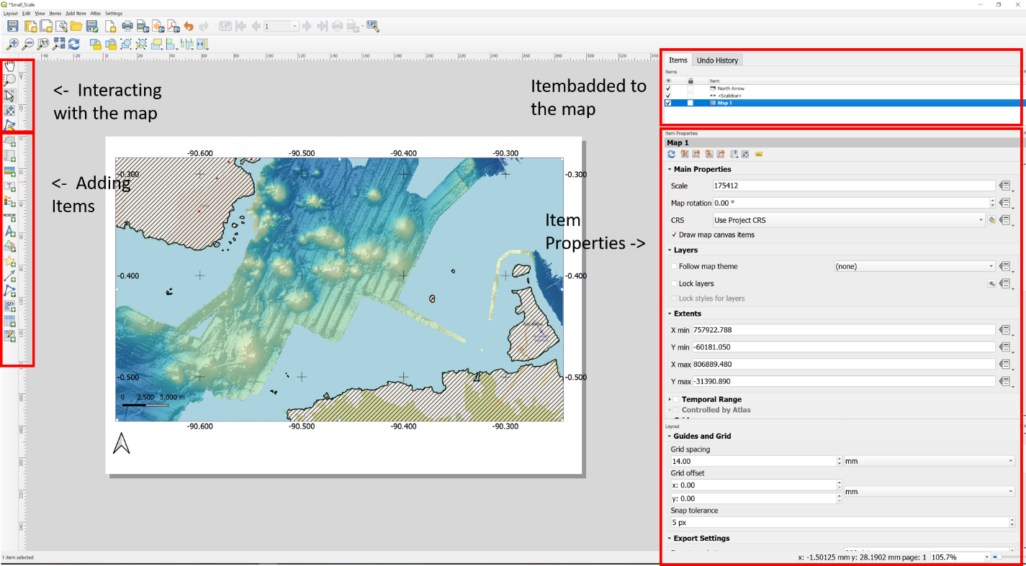

## Adjusting Coordinate grids

1. Select the Map Item
2. Select in the Item Properties of the map -> Grids
3. There should be 2 grid types set up and enables: The grid that shows ticks every degree and labels them. The other grid shows tick every minute (1degree/60) You can always set up your own grids by clicking the + sign (add new grids).

