IXIGO TRAINS · PRODUCT CAPSTONE

Supporting Artifacts
Best Way to Reach: turning a waitlisted ticket into a travel plan people trust
Rohit Kumar · Airtribe Product Management Launchpad · 6 November 2026
Deliverable | Link
Final presentation deck (PDF) | Rohit_Kumar_Product_Capstone.pdf (submitted separately)
Video walkthrough | Rohit_Kumar_Product_Capstone.mp4 (submitted separately)
Prototype (Lovable) – Prototype_Rohit_Kumar_Product | https://prototype-rohit-ixigo.lovable.app
AI Trip Resolver demo | https://claude.ai/artifact/KPxNPimZcUWhTTiMVHkK7B
Step 1 research doc | https://claude.ai/artifact/N44ZFHRrTX9A8tSE4TPxAY
Problem, solution and PRD doc (Steps 2–8) | https://claude.ai/artifact/XrM8yHwwUGXVJE8sBA51Pi

Contents
1. Interview log
2. Screenshots from user conversations (calls and WhatsApp)
3. Competitor analysis
4. UX flow: today vs new
5. Prototype annotated screens
6. OKRs and metric dashboard
7. Guardrails and event tracking
8. Raw research notes: survey
9. Raw research notes: interview themes and hypotheses

1 · Interview log
21 interview records (20 recorded calls and 1 WhatsApp interview, about 20 unique people) plus 7 survey respondents: 28 records, about 27 users. Insights are paraphrased; several call transcripts were noisy, so each record carries an evidence label. Record 12 may be the same person as record 07. Survey respondents are anonymised (S01–S07).
# | Name | Type | Channel | Route / context | Key insight | Evidence
01 | Shashikant Kumar | Unclear (ixigo + IRCTC) | Call | ixigo and IRCTC bookings | Waitlist uncertainty; wants to know what to do if a ticket doesn't confirm | Low
02 | Prince | Active ixigo user | Call | Train + hotel; family and friends; connecting trips | Values the confirmation % and 3X Refund; books for others | Low
03 | Amrish | Unclear | Call | ixigo vs IRCTC; Tatkal | Weighs Tatkal vs regular tickets, travel time vs cost | Low
04 | Diwakar | Active ixigo user | Call | Bookings for his father | Wants clear WL/RAC status; general ticket as a fallback | Low
05 | Nitin Anuj | Active ixigo user | Call | Mumbai; festival season | Needs alternatives in festival peaks; last-minute vs advance booking | Low
06 | Aditya | Active ixigo user (2 yrs) | Call | Varanasi; family; 2AC | Trusts about 85–90%; comfort first; would take a flight or bus; didn't know 3X Refund | Good
07 | Diwakar Durlabh | Active ixigo user | Call | Ahmedabad–Prayagraj | Books at about 80% chance; uses 3X Refund | Medium–Low
08 | Ashish | Active ixigo user, 12–15 trips/yr | Call | Mumbai–Delhi | Books at 80%+ and often gets RAC; wants short, on-time night trains; checks IRCTC for data mismatches | Good
09 | Avi Anika | IRCTC user (never booked on ixigo) | Call | Delhi–Prayagraj / Lucknow | Downloaded ixigo but books on official IRCTC | Good
10 | Anika | MakeMyTrip user | Call | Delhi–Kanpur | On-time arrival comes first; books only at 80%+, else goes by car | Good
11 | Alok Vishwakarma | IRCTC user | Call | Mumbai–Patna | Finds IRCTC easy; Tatkal and bus as alternatives | Low
12 | Durlabh* | Checks ixigo, books on IRCTC | Call | Patna–Delhi | Worried about extra charges, refund method and voucher terms | Low–Medium
13 | Priya | Active ixigo user | Call | Punjab–West Bengal | Books WL only at 80%+; otherwise IRCTC / Premium Tatkal; avoids long flight layovers | Good
14 | Sayantika | Active ixigo user | Call | Malda–Delhi; Durga Puja | Uses about 80%, 90% when urgent; plans ahead | Good
15 | Sandeep Ghosh | Using ixigo less | Call | Railway bookings | Wants 90–95%; a high-chance ticket didn't confirm; login friction cut his usage | Medium–Low
16 | Anup Mondal | Active ixigo user | Call | Bangalore–Kolkata; family | Values timings, availability and sorting; flight as an alternative | Medium–Low
17 | Abhay | IRCTC user | Call | Train tracking | General ticket as a last resort; bus and flight also considered | Very low
18 | Yashveer | Using ixigo less | Call | Shiv Ganga Express; night travel | Finds ixigo more complicated than IRCTC | Low–Medium
19 | Abhilash | Checks ixigo, books on IRCTC | Call | Varanasi–Delhi | Uses ixigo for information; books on IRCTC because it is official | Low
20 | Sushant | Checks ixigo, books on IRCTC | Call | Bangalore–Darbhanga | Checks ixigo, books on IRCTC; 3X Refund unclear | Very low
21 | Mamta Singh | Active ixigo user | WhatsApp | Mumbai–Agra; Rajdhani; family | Booked WL at 95%, confirmed about 4 h before departure; books only above 90%; prefers a flight to Tatkal; rates ixigo 4/5 | Good
S01 | Survey respondent | Uses IRCTC, ixigo, ConfirmTkt | Survey | Family function; 3–4 people; booked 1+ month ahead | Searched 3–5 times; got confirmed Tatkal on IRCTC; a high-chance ticket once ended as RAC; trust in % 2/5; top priority journey time | Survey
S02 | Survey respondent | Uses 6 apps incl. ixigo | Survey | Holiday; 2 people; 2–7 days ahead | Tatkal stayed WL, so flew (booked on ixigo); trust 1/5; too many options to compare; top priority comfort | Survey
S03 | Survey respondent | IRCTC, ixigo | Survey | No waitlist in the last 6 months | Screened out after Q1 | Survey
S04 | Survey respondent | IRCTC, ixigo, Paytm | Survey | Work; solo; same day | Confirmed Tatkal on ixigo after 3–5 searches; trust 1/5; found out too late; top priority journey time | Survey
S05 | Survey respondent | IRCTC, ixigo, ConfirmTkt, agent | Survey | Festival; 3–4 people; 2–7 days ahead | Tried every option, searched 10+ times, finally used an agent; didn't trust the prediction; top priority confirmation | Survey
S06 | Survey respondent | IRCTC, ixigo, MakeMyTrip | Survey | Work; solo; same day | Confirmed Tatkal on IRCTC; too many options to compare; trust 3/5; top priority arrival time | Survey
S07 | Survey respondent | IRCTC only | Survey | Family function; 5+ people; 1+ month ahead | Searched 10+ times and asked family; booked on IRCTC; trust 1/5; wants a comfortable family train | Survey

2a · Call recordings
All 20 calls were recorded with the iPhone call recorder and kept in one Notes folder; each has an audio file, a transcript and a summary.
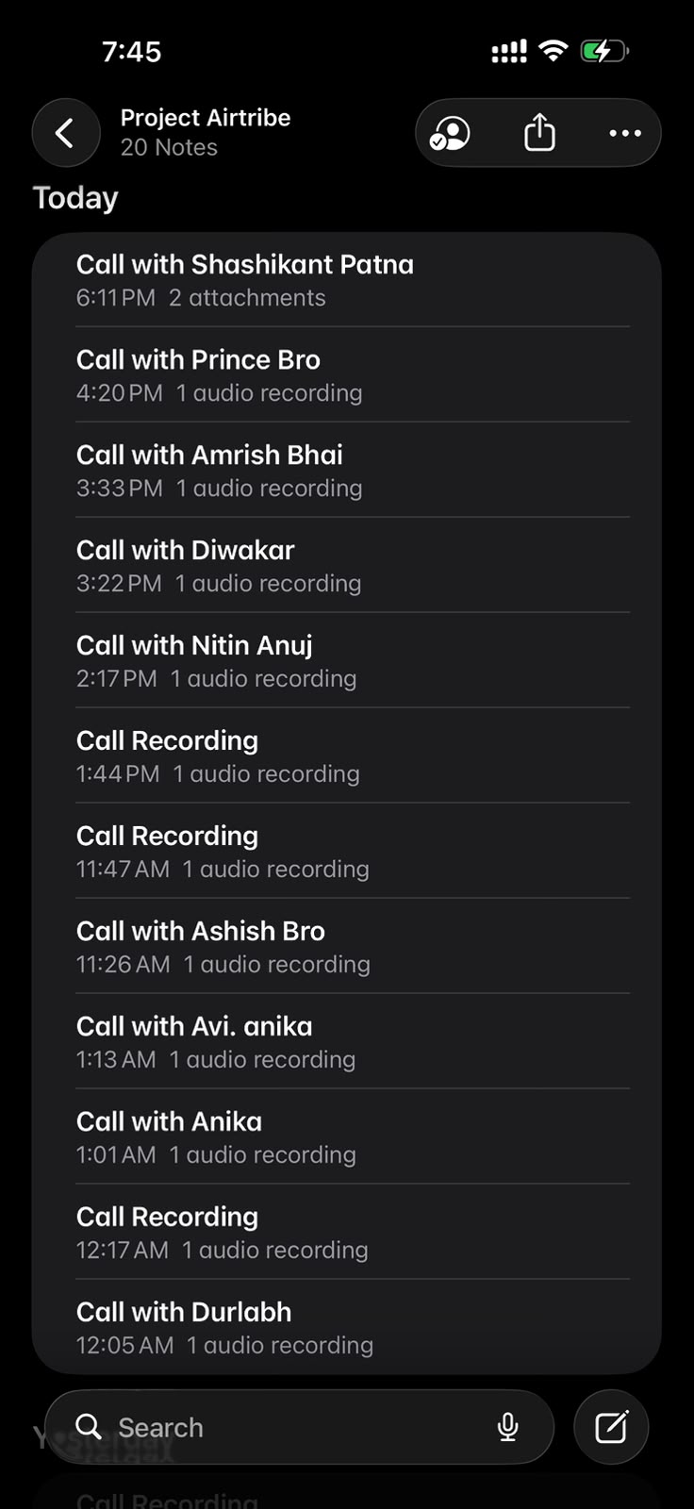  Notes › Project Airtribe: 20 recorded interview calls (latest) | 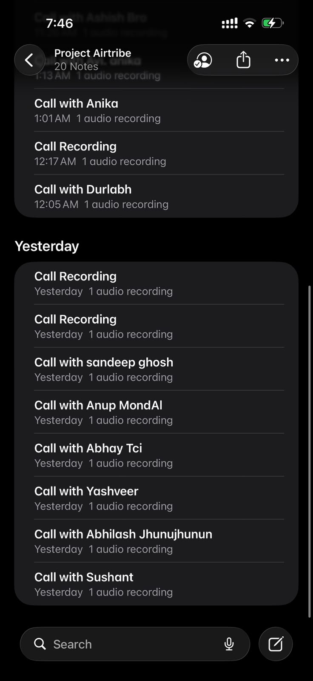  Same folder: earlier calls (Sandeep, Anup, Abhay, Yashveer, Abhilash, Sushant…) | 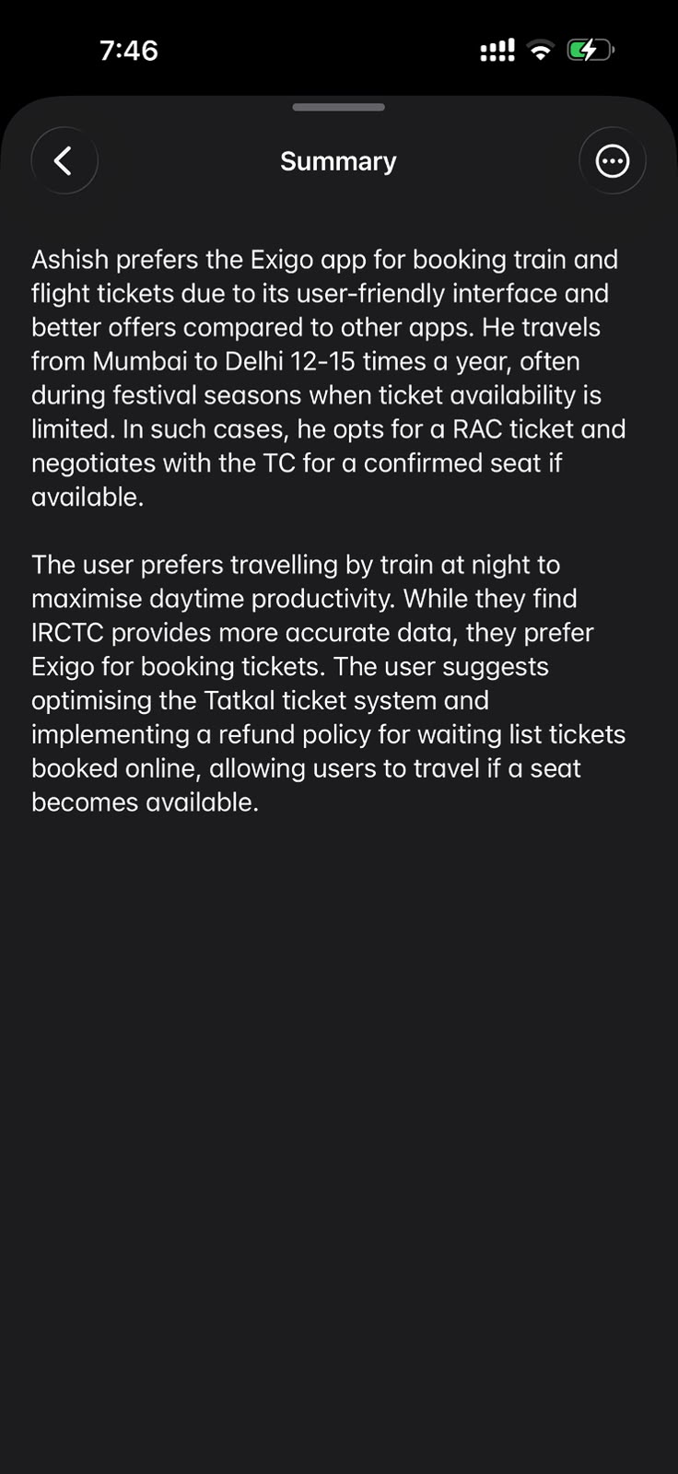  Call summary, Ashish: Mumbai–Delhi 12–15 times a year; takes RAC in festival season; finds IRCTC data more accurate; wants Tatkal improved (“Exigo” = ixigo)

2b · WhatsApp interview
One interview ran as a WhatsApp chat in English, using the same questions as the calls.
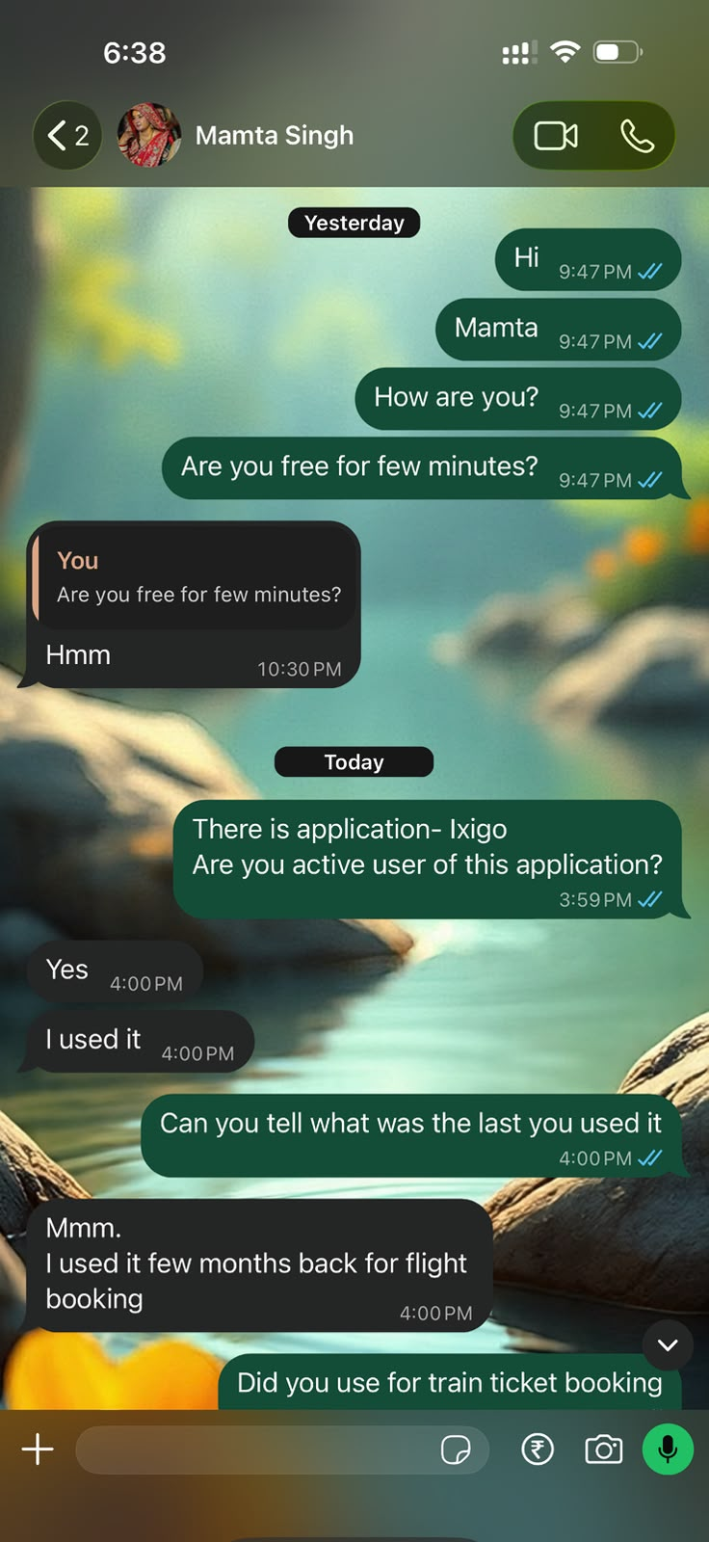  WhatsApp interview, Mamta Singh (1/3): active ixigo user; last used it for a flight | 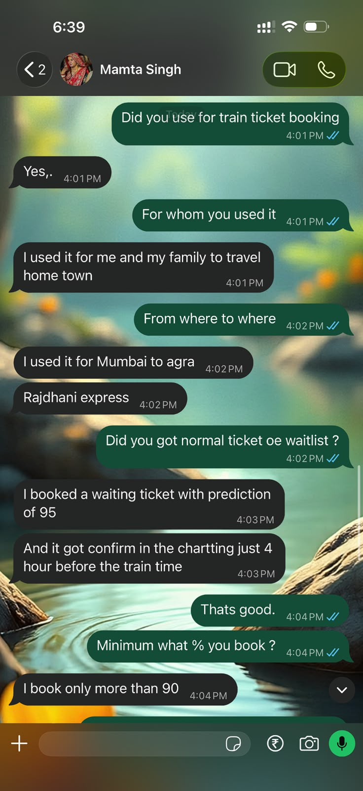  (2/3): booked WL at a 95% prediction, confirmed at charting 4 h before departure; books only above 90% | 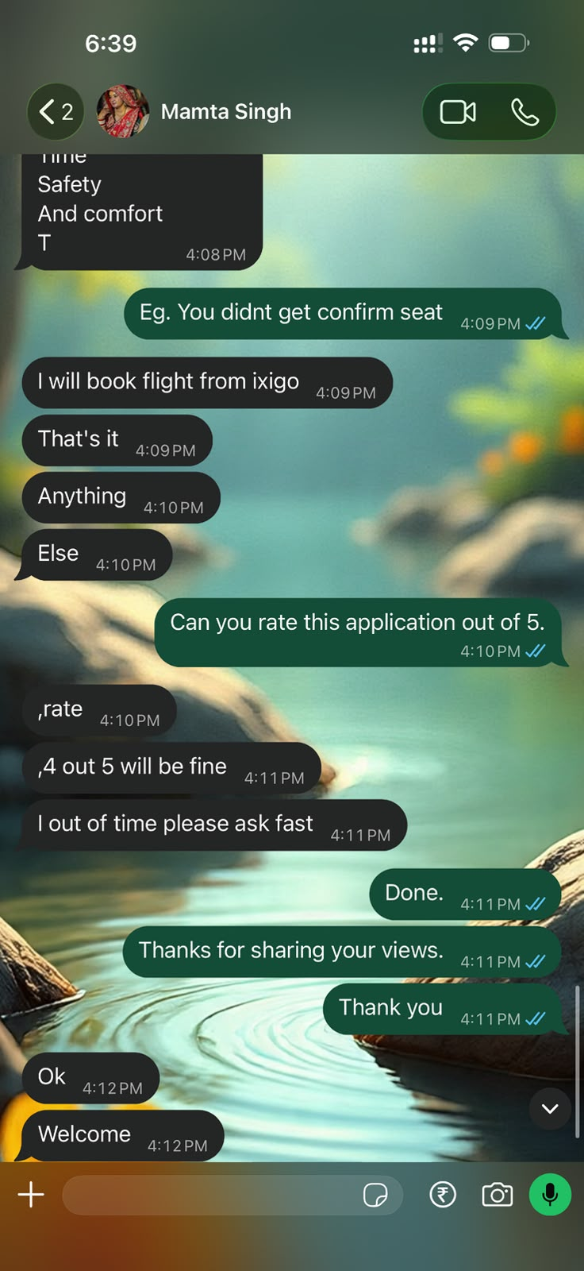  (3/3): if no confirmed seat, books a flight on ixigo; rates ixigo 4 out of 5

3 · Competitor analysis
Every major player pairs a prediction with paid protection; none helps the user compare alternatives and choose.
Player | When the train is waitlisted | Strength | Gap for the user
ixigo Trains | Waitlist prediction; Alternate Travel Plan pays 3X (flight/bus) or 2X (train) value if the ticket stays WL; Assured free cancellation | Strong prediction (ConfirmTkt) plus cross-mode inventory | Refund mostly a coupon, selected trains only; the user still has to find and book the alternative
ConfirmTkt (ixigo group) | Alternates: other-station quota on the same train, two-train splits, train + bus | Finds hidden confirmed seats | Many raw options with no ranking by the user’s priorities
IRCTC VIKALP | Free opt-in; auto-shift to another train on the same route if seats are free | Free, official | No choice after opting in; outcome known only at chart time
MakeMyTrip | Trip Guarantee 3X; same-train longer route and nearby-station suggestions | Smart route hacks in search | Trade-offs (arrival, station distance) not explained
redRail (redBus) | Confirmation probability; Alternate Trip add-on with 3X refund | Bus inventory built in | Protects money, not the journey
Airlines | Last-minute flights | Certain seat | Price spikes; not linked to the train search
Offline agents | Tatkal attempts, quota know-how, one clear answer | Trust and a single recommendation | Extra cost, no transparency
Sources: ixigo.com/trains/alternate-travel; YourStory (ConfirmTkt Alternates); LatestLY (IRCTC VIKALP); Travel Trends Today (MakeMyTrip); GrabOn (redRail Alternate Trip). Accessed October 2026.

4a · UX flow today
Users bounce between searches, apps and people; red notes show the pain points measured in research.
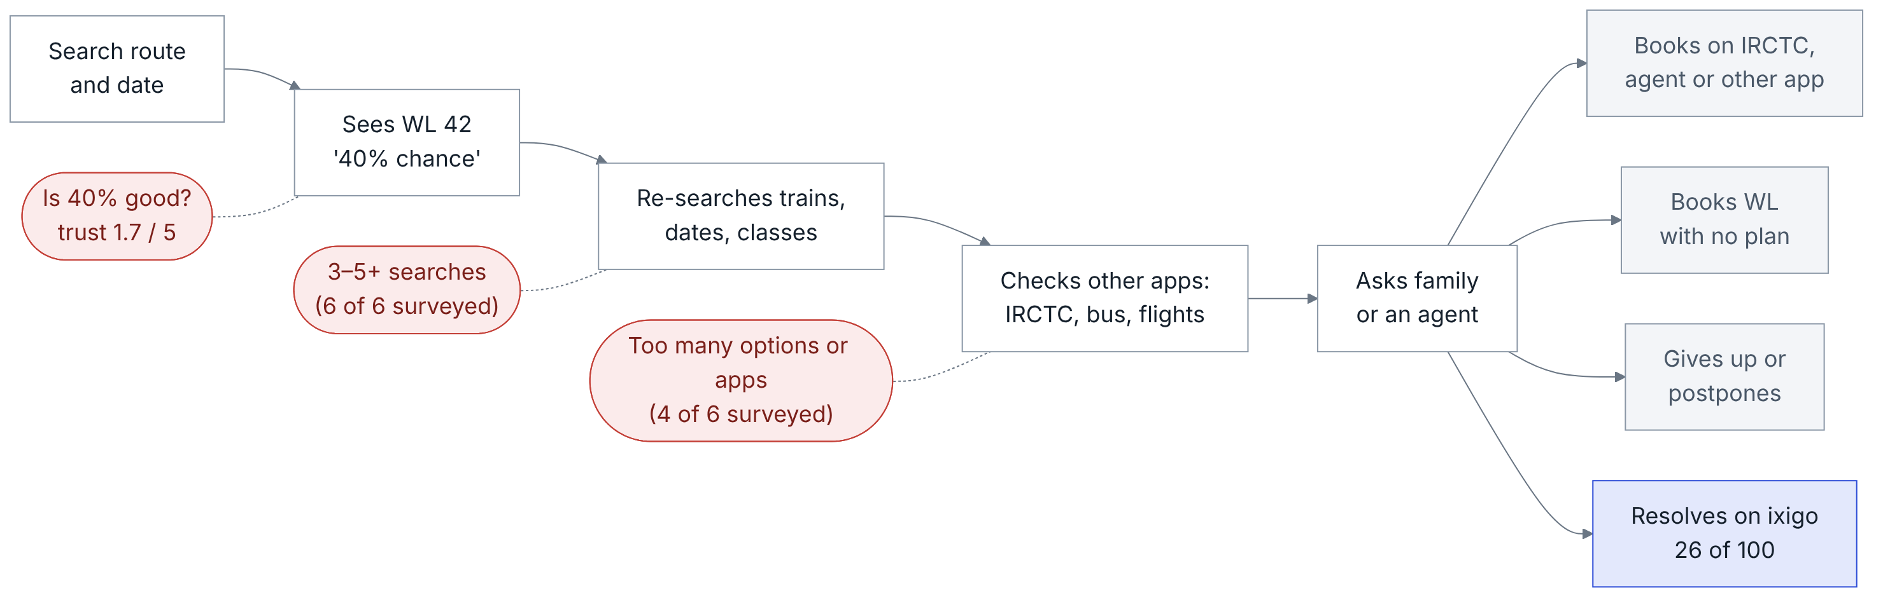

4b · UX flow with Best Way to Reach
One ranked list, honest odds and a ready backup replace the loop; trip outcomes feed back into the ranking.
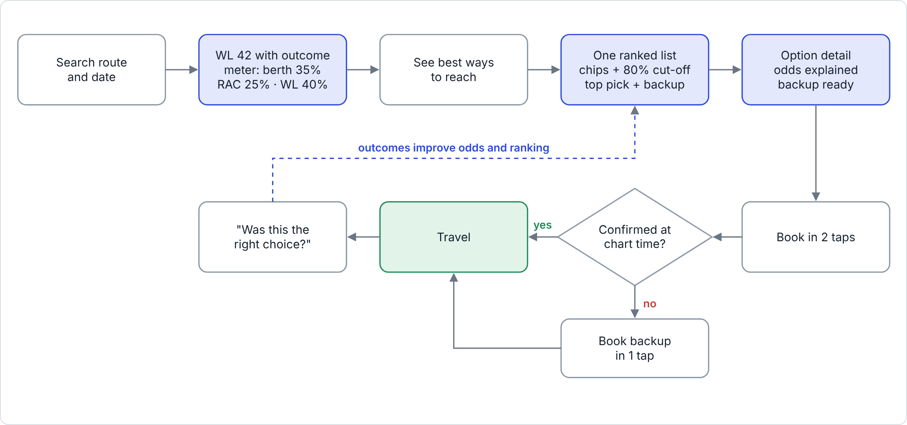

5 · Prototype annotated screens
Live prototype: https://prototype-rohit-ixigo.lovable.app

Screen 1 · Search result with an honest outcome
The WL 42 train shows own berth 35% · RAC 25% · stays WL 40% (pin 1) and one entry point to every alternative (pin 2).
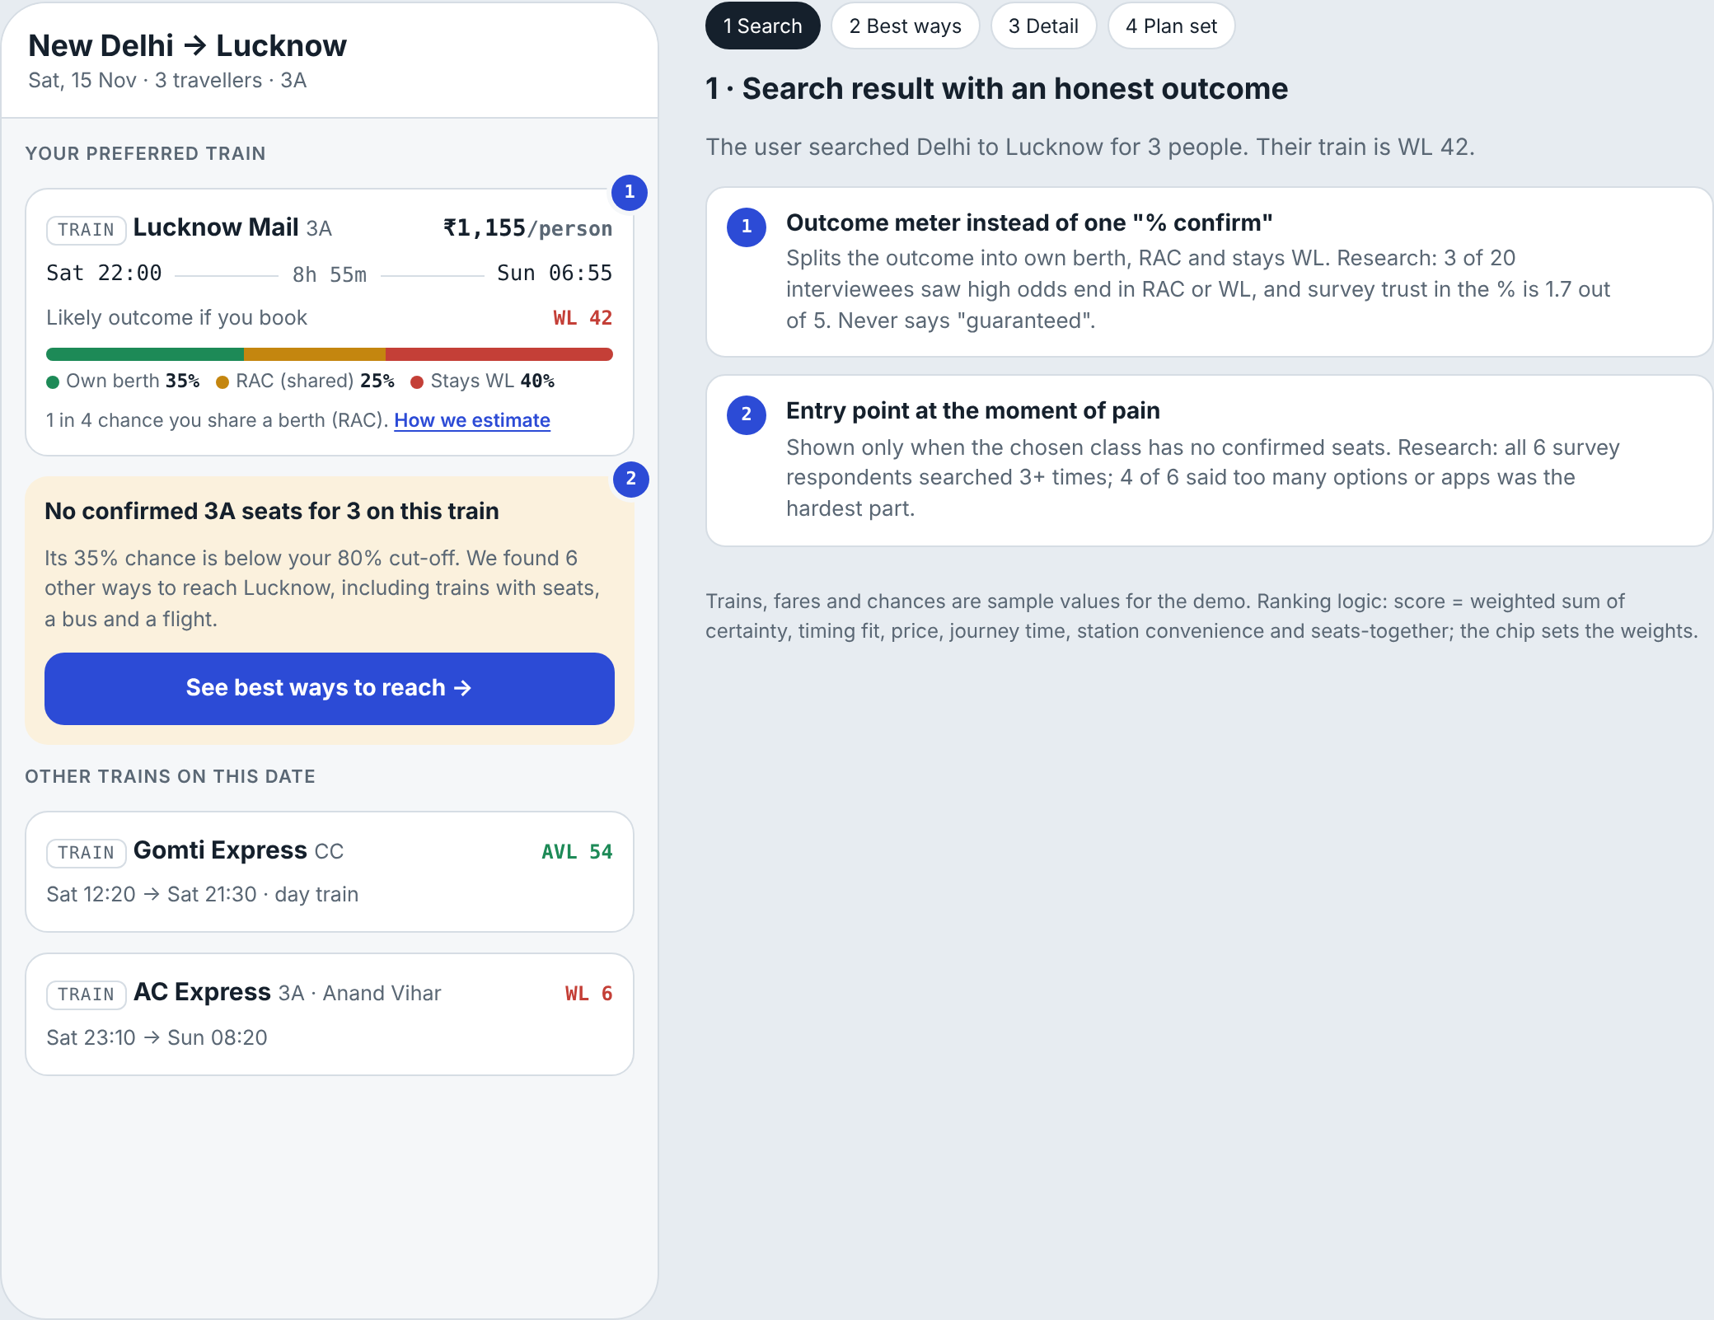

5 · Screen 2 · Best ways to reach
Priority chips (3), the 80% cut-off filter (4), a top pick with its reason (5) and a confirmed backup (6).
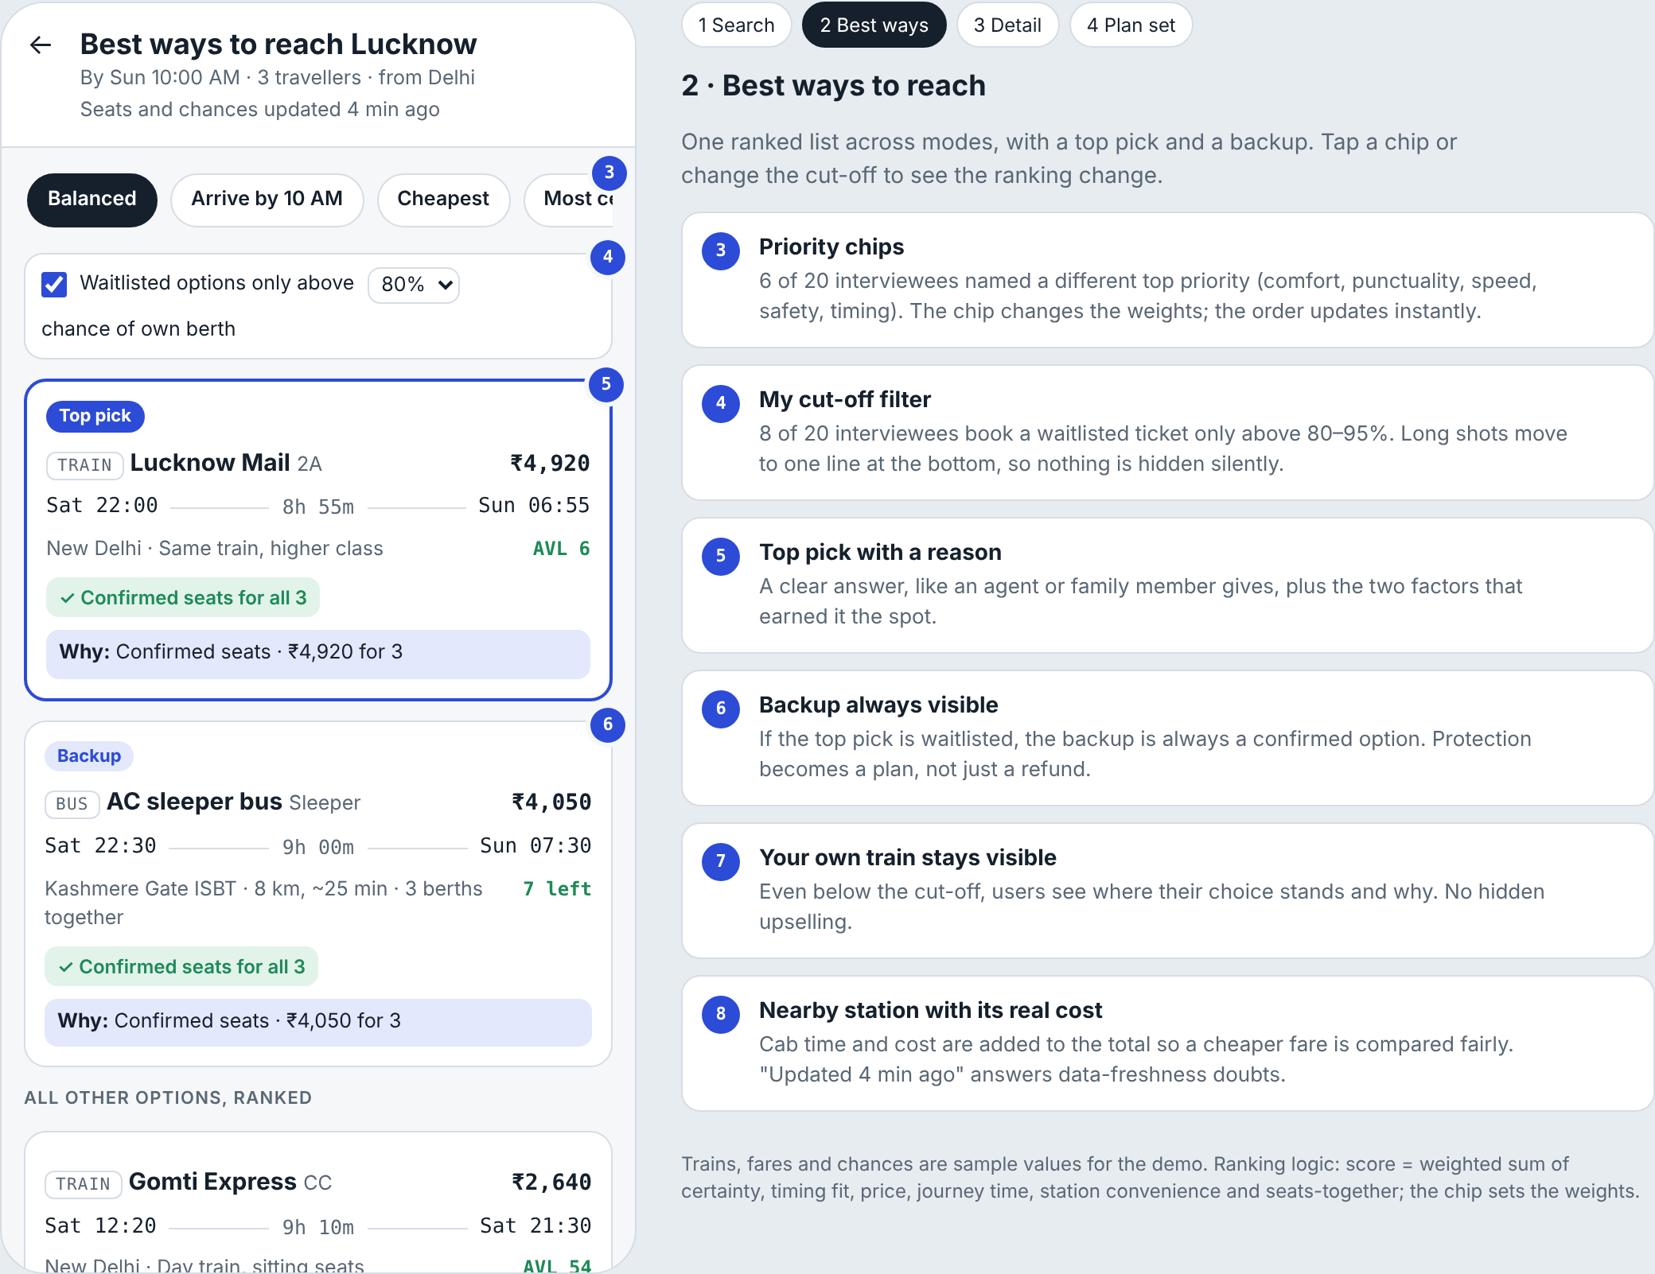

5 · Screen 2 (scrolled) · Nothing hidden silently
The nearby station carries its cab cost (8); options below the cut-off, including the user’s own train (7), sit in one line at the bottom.
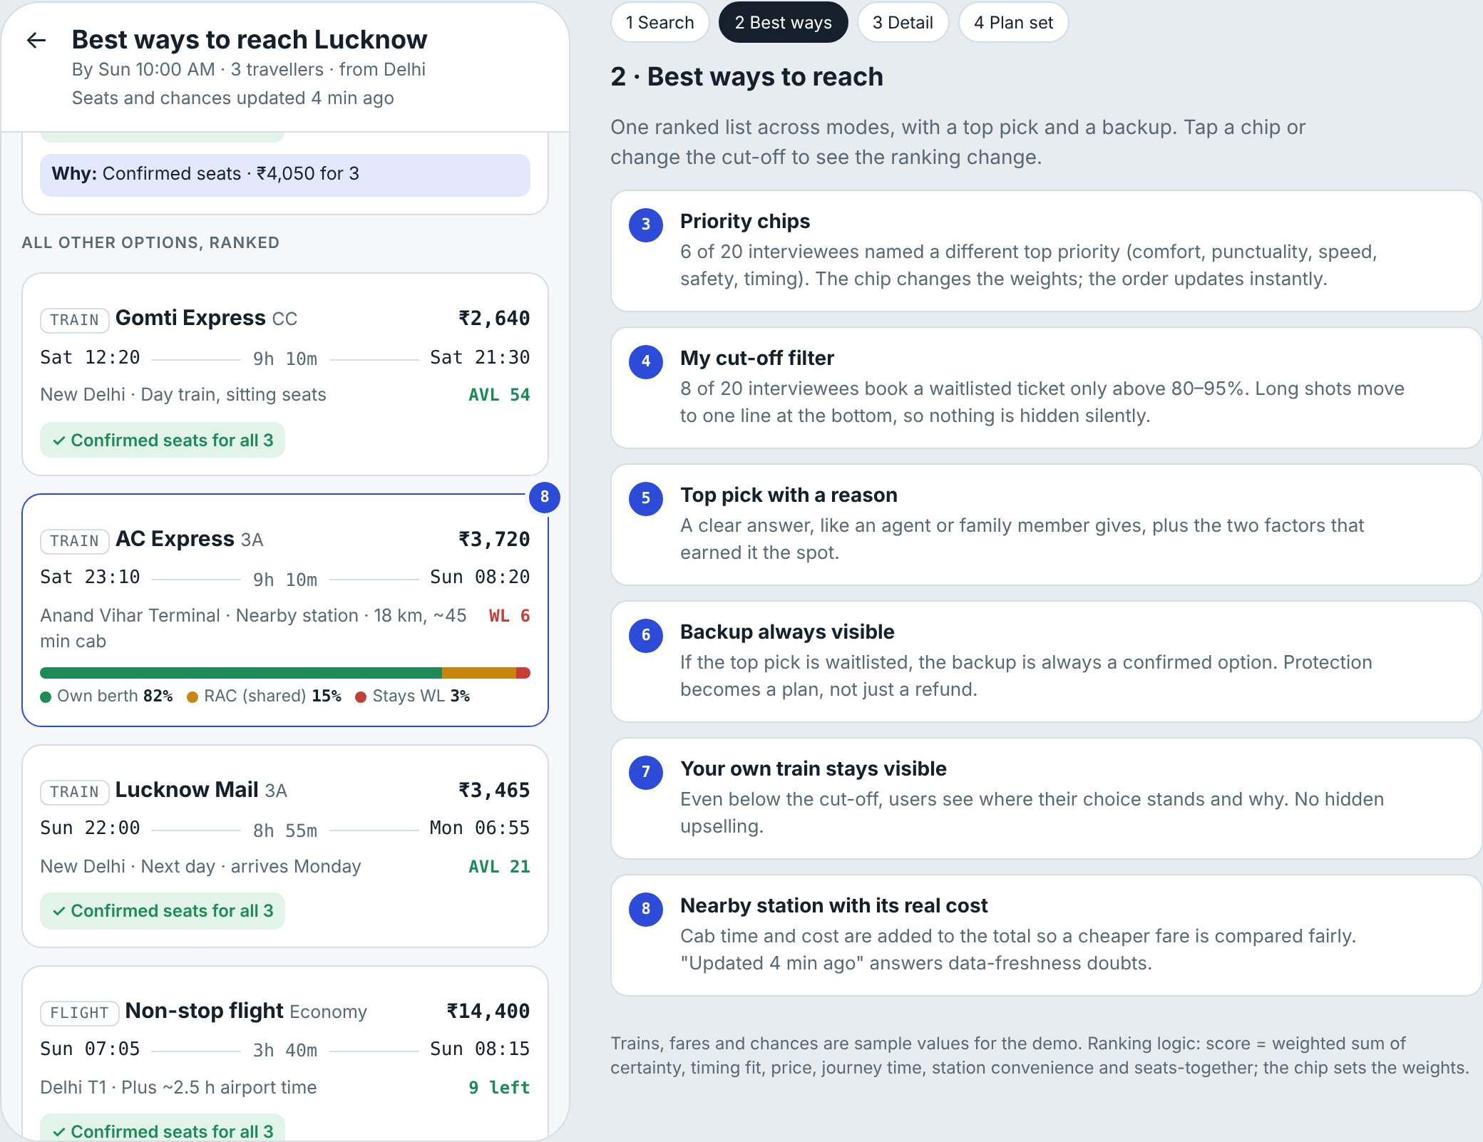

5 · Screen 3 · Option detail
The chance explained as the last 10 similar Saturdays (9); backup and protection in plain words (10).
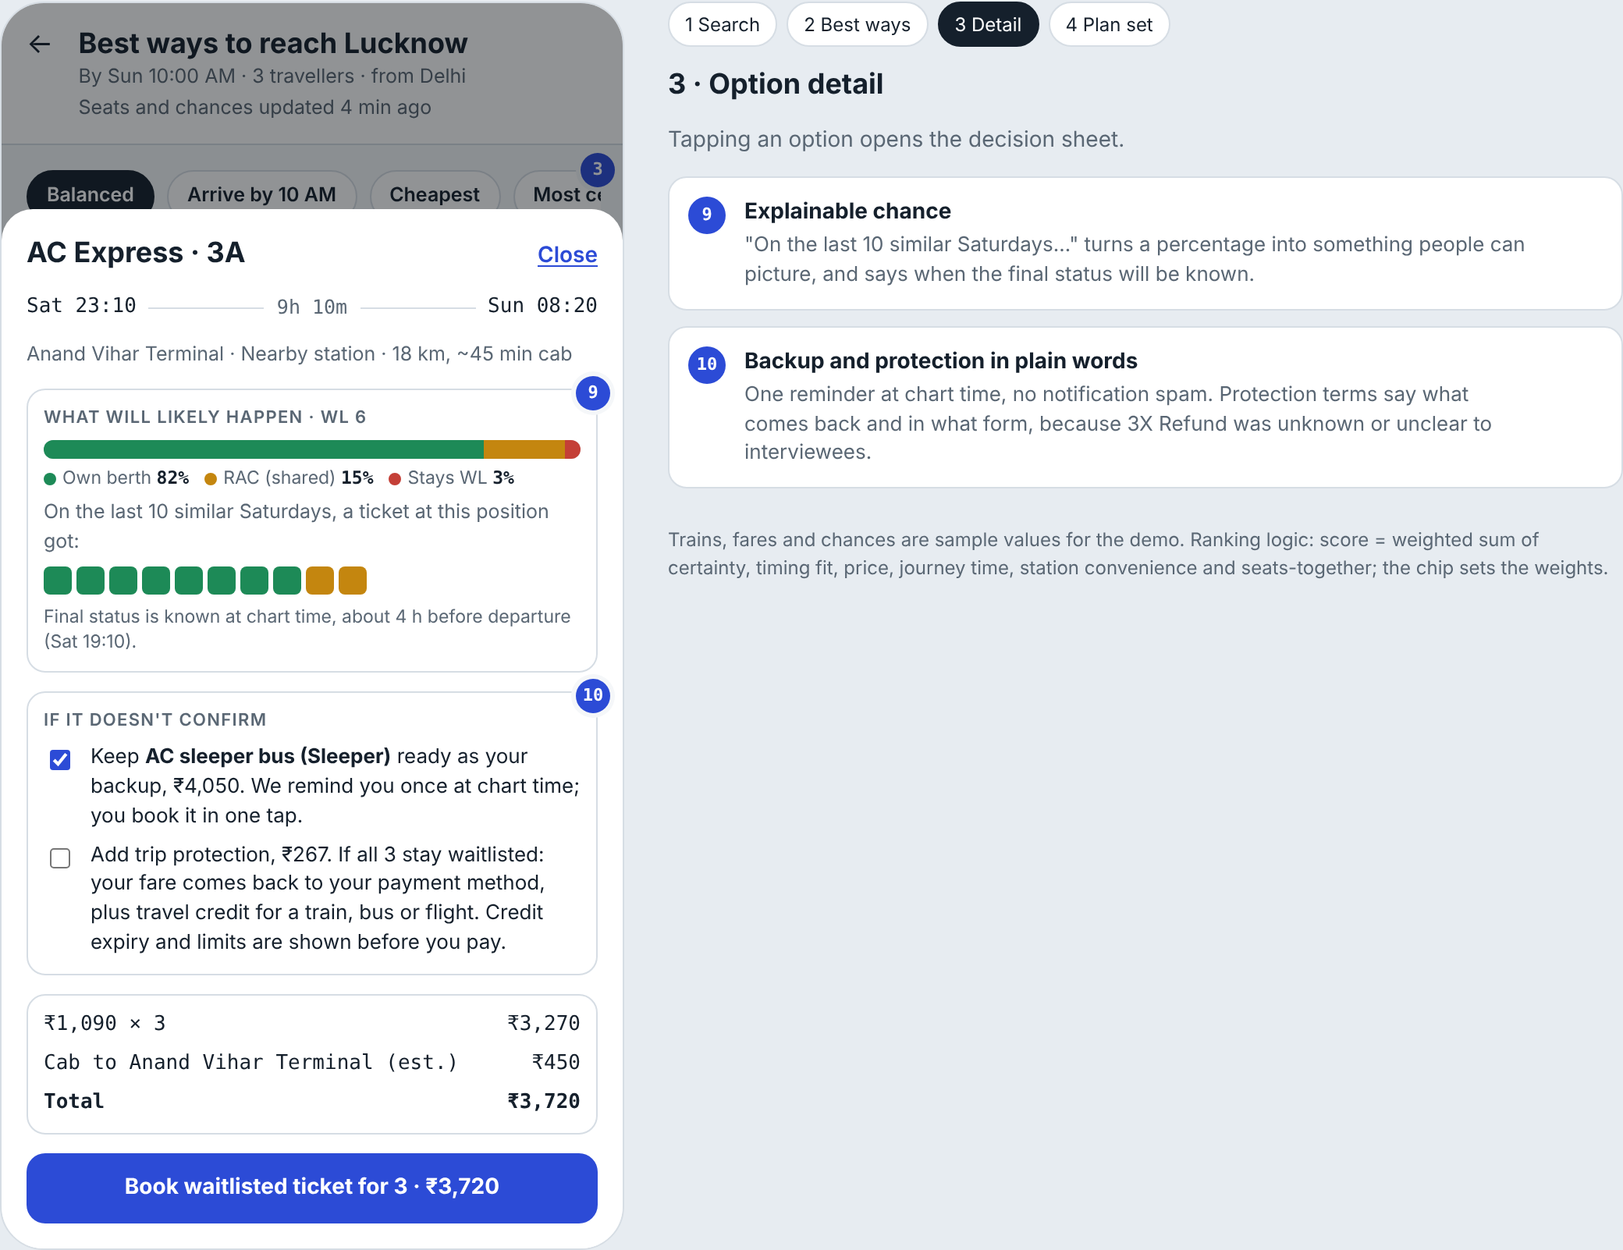

5 · Screen 4 · Plan set
Plan, ready backup, chart-time timeline and the post-trip regret question that feeds the ranking (11).
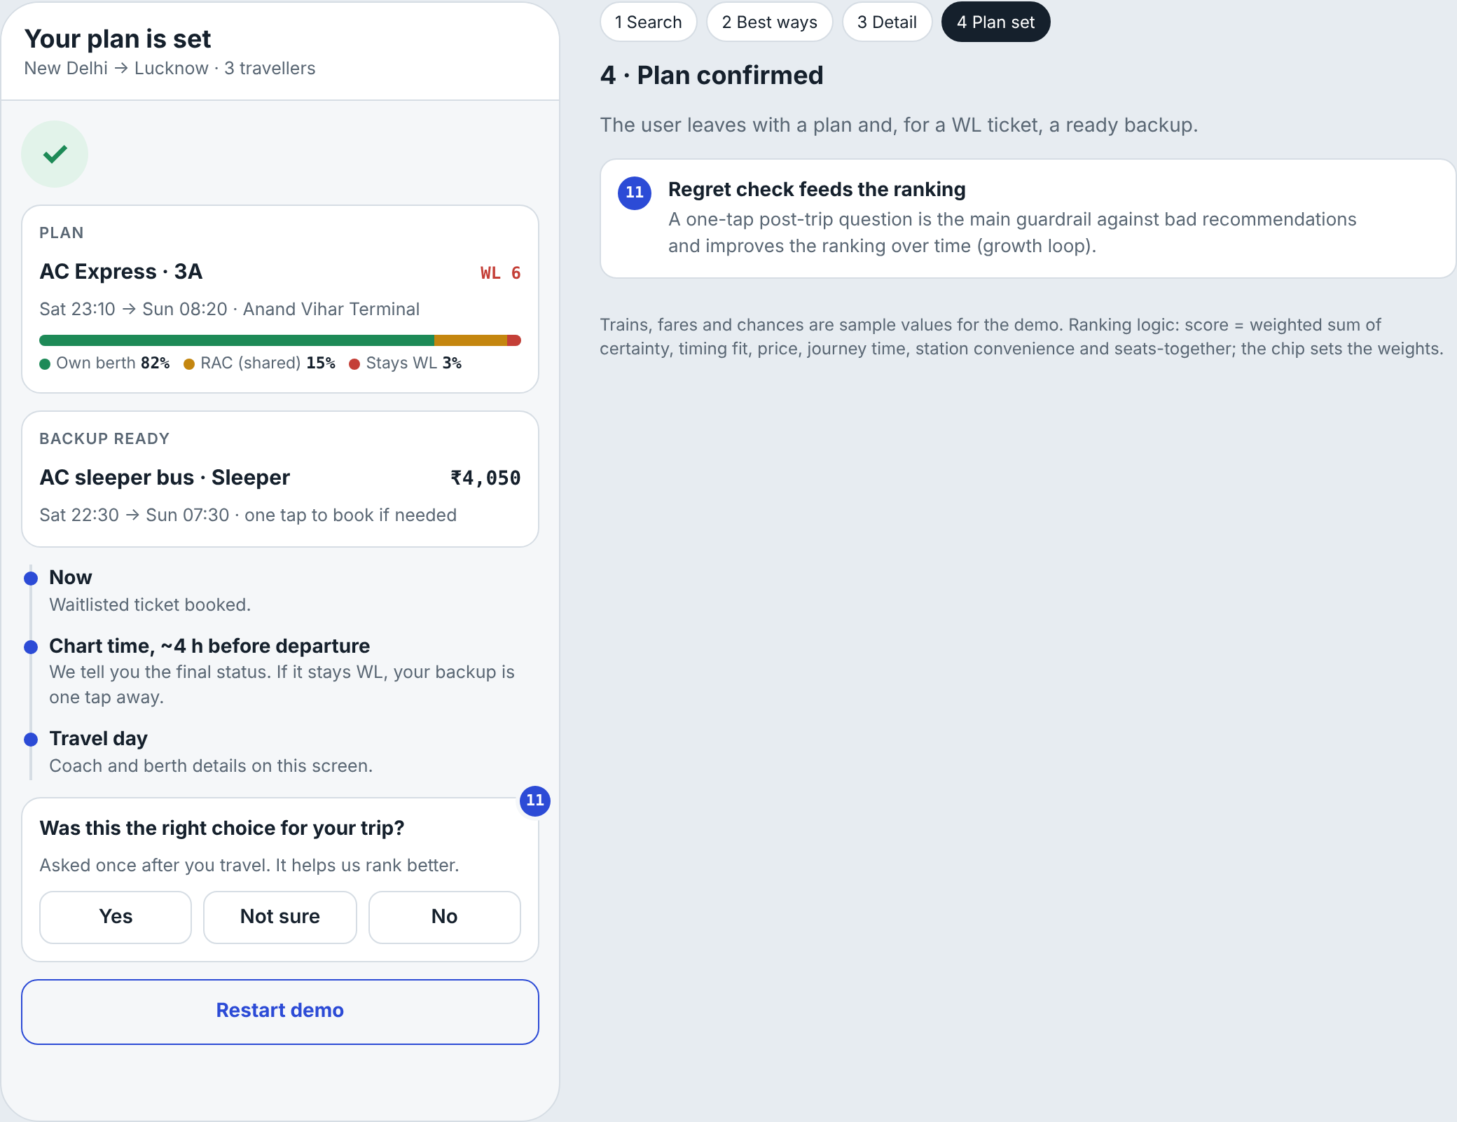

6 · OKRs and metric dashboard
Objective: turn a waitlisted search into a travel plan users trust, within 6 months.
KR | Key result | Baseline | Target | Source
KR1 | 24-hour resolved booking rate for users who hit WL (North Star) | 26% | 42% | Case brief
KR2 | Trust in the shown chance (in-app pulse, 1–5) | 1.7 | 3.5 | Survey Q13
KR3 | Searches before booking | 3–5 for most | 1–2 | Survey Q8
KR4 | Post-booking regret (“wrong choice”), guardrail | New | ≤ 8%, not above control | Regret question
KR5 | Cross-mode share of resolved bookings (bus + flight) | Today’s share | +10 pts | Booking data

North Star target path (users who see the feature)  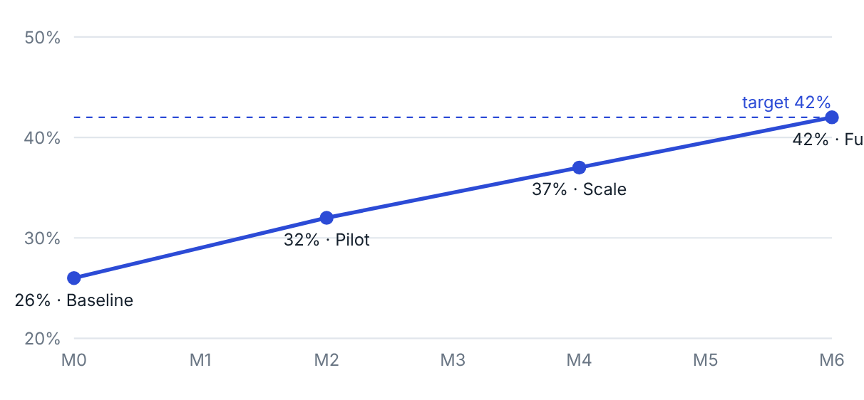 | Dashboard tiles
  Metric | Baseline → target
  Resolved in 24 h | 26% → 42%
  Trust in the % | 1.7 → 3.5
  Open rate of Best Way to Reach | 60%
  Bookings from top pick or backup | 50%
  Calibration gap (CNF / RAC / WL) | ≤ 5 pts
  90-day repeat booking | 85.6% → 88%
Rollout: pilot 5% of WL users on 20 routes (months 1–2), families (month 3), all WL users (months 4–6), then the PNR page. Path values are targets, not results.

7 · Guardrails and event tracking
Guardrail | Why | Threshold
Post-booking regret | Catches bad recommendations | ≤ 8%, not above control
Prediction calibration (predicted vs actual CNF, RAC, WL) | Catches overstated confidence | Gap ≤ 5 pts per bucket
Cancellation rate of recommended options | Users booked something that didn’t fit | Not above control
Complaints mentioning “prediction wrong” or RAC | Trust | −30%
Page load time | Experience on 4G and low-end phones | < 2 s

Event tracking
Event | Trigger | Key properties
wl_seen | WL / no seats shown on search or booking | route, date, train, class, wl_no, pax, p_cnf, p_rac, p_wl
bwr_opened | User opens Best Way to Reach | entry_point, options_count
chip_selected | Priority chip tapped | chip, position_before, position_after
cutoff_changed | Cut-off toggled or changed | on, value, options_hidden
option_viewed | Card opened | mode, rank, price, arrive_time, certainty
option_booked | Booking completed from the list | mode, rank, label (top_pick / backup / other), fare
backup_selected | Backup kept for a WL ticket | backup_mode, trigger_time
chart_outcome | Chart prepared | final_status (CNF / RAC / WL), predicted split
regret_answered | Post-trip question answered | answer, mode, rank

8 · Raw research notes: survey
Bilingual Google Form, 18 questions; 7 responses, 6 had hit a waitlist in the last 6 months. Directional only.
Finding | Result (n = 6)
Searched 3+ times before deciding | 6 of 6 (2 searched 10+)
Hardest part: too many options or too many apps | 4 of 6
Trust in an app’s “% chance” (1–5) | Average 1.7; nobody above 3
A 70%+ ticket ended differently | 2 of the 4 who remember (1 RAC, 1 stayed WL)
Tried Tatkal for this trip | 5 of 6 (3 got confirmed)
Final booking channel | IRCTC 3, ixigo 2, agent 1
Final outcome | Confirmed train 4, flight 1, agent 1
What a plan + backup must show (open text) | Confirmed seat; reserved seat; price and comfort; a good train for family comfort
What matters most (average rank, 1 = top)
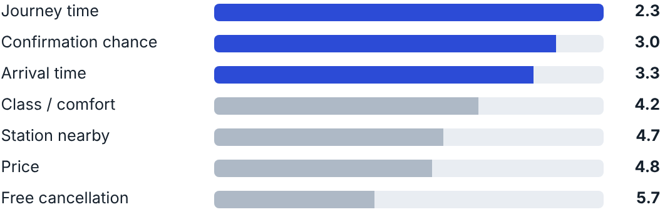
Price ranked 6th of 7: journey time, confirmation chance and arrival time matter more.

9 · Raw research notes: interview themes and hypotheses

Themes from the interview synthesis
 | Theme
A | Confirmation probability is a major decision aid: personal cut-offs of 80%, 85–90% and 90%+.
B | Familiarity and trust in IRCTC hold back booking on ixigo.
C | Login and flow friction reduce repeat use for some.
D | 3X Refund needs clear discovery and plain terms.
E | Users want a useful backup: flights, buses, other trains, Tatkal.
F | Priorities are personal: comfort, punctuality, speed, safety, timing.
G | Festival peaks and Tatkal add complexity.
H | Data freshness and status confidence matter.

Hypothesis check
# | Hypothesis | Verdict
H1 | Can’t compare alternatives | Supported
H2 | Don’t trust a bare % | Refined: relied on, not trusted
H3 | Options scattered across tabs | Partly
H4 | Price is not the main blocker | Supported
H5 | Late panic near chart time | Partly
H6 | One clear answer wins elsewhere | New angle: IRCTC habit and trust
H7 | CNF vs RAC gap hurts trust | Supported
Primary barrier: low decision confidence. Users can’t compare options on their own priorities, and they lean on a percentage they don’t trust.

