IXIGO TRAINS · PRODUCT CAPSTONE
Steps 1–8: research, problem, solution, PRD and AI extension
Best Way to Reach: turning a waitlisted ticket into a travel plan people trust
Rohit Kumar · Airtribe PM Launchpad · 6 November 2026
What’s inside
1. Part 1 – Step 1: Market & user research
Goal and hypotheses, research plan, survey and interview script, survey results, competitive analysis, personas and the barriers the research validated.
2. Part 2 – Steps 2–8: Problem, solution & PRD
Problem statement, funnel, primary barrier, business impact, RICE, shortlisted solutions, journey map, PRD, prototype, go-to-market, metrics, risks and the AI trip resolver.
3. Part 3 – Step 8: Trip Resolver screens
Two runs of the working AI demo, with example messages.
Links
Live prototype: https://prototype-rohit-ixigo.lovable.app
Also in the submission: final deck (PDF), video walkthrough and Supporting Artifacts (PDF).

Part 1 – Step 1: Market & User Research
Oct 22, 2026 · @Rohit Kumar

Research goal and hypotheses
Goal: find out why only 26% of ixigo Trains users who hit a waitlisted or unavailable preferred train resolve a travel booking within 24 hours, and what would move them to a confident plan.
# | Hypothesis | How we tested it
H1 | Users see alternatives but cannot compare them on what they care about (arrival time, station, certainty), so they keep re-searching instead of deciding. | Interviews (last-trip walkthrough); survey Q7, Q8, Q15
H2 | Users do not trust a confirmation % on its own; they want to know "what happens to me if it does not confirm". | Interviews; survey Q13 trust score
H3 | Alternatives are scattered across trains, buses and flights in separate tabs, so cross-mode comparison feels like too much work. | Interviews; survey Q7, Q15
H4 | Price is not the main blocker; arrival time, station convenience and family needs often matter more. | Interviews; survey Q12 ranking
H5 | Many users "park" a waitlisted ticket, then panic close to chart time and leak to Tatkal, buses or agents. | Interviews; survey Q6, Q9, Q10
H6 | Users who resolve elsewhere do so because an agent, family member or another app gave them one clear answer. | Interviews with segments B and D; survey Q3, Q11
H7 | A single "% confirm" blurs own berth (CNF), shared berth (RAC) and WL, so even a "correct" prediction feels wrong. Founder's own ticket at about 90% ended in RAC. | Interviews (expected vs actual outcome); survey Q14

Research questions
- When your preferred train showed WL or no seats, what did you do in the next 10 minutes, and in the next 24 hours? (H1, H5)
- Which factors decided your final choice: price, arrival time, journey time, station, class, confirmation chance, or cancellation refund? Rank your top three. (H4)
- When an app shows a confirmation probability, how much do you trust it, and what would make you trust it more? (H2)
- How did you compare other trains, dates, nearby stations, buses or flights, and what was hardest about that? (H1, H3)
- If you booked a waitlisted ticket, what was your backup plan if it did not confirm? (H2, H5)
- If you finally booked on another app, through an agent, or not at all, what made that option win? (H6)
- If an app could hand you one ready plan for this trip, what would it need to show before you would book it? (H1, H2)
- Has a high-chance ticket ever ended as RAC or stayed waitlisted? How did that change your trust in the prediction? (H7)

Research plan
Three methods ran between 22 Oct and 6 Nov 2026: interviews for depth, a bilingual survey for breadth, and desk research on five competitors.
Who we talked to: plan vs actual
Segment | Who | Planned | Actual
A | Active ixigo users | 6 | 10
B | Check ixigo, book elsewhere | 6 | 3
C | Using ixigo less | 4 | 2
D | IRCTC or MakeMyTrip users | 4 | 4
– | Unclear from audio | – | 2
Total |  | 20 | 21 records (about 20 people)
Methods: plan vs actual
Method | What it gives | Planned | Actual
Interviews (recorded calls, WhatsApp) | Real stories and decisions | 20+ | 20 calls + 1 WhatsApp chat
Bilingual Google Form, 18 questions | Breadth, rankings, trust score | 50+ responses | 7 responses, 6 qualified
Competitor desk research | Features and gaps | 4 apps | 5 players + offline agents
Play Store review mining | Unprompted complaints | 40–60 reviews | Not completed
Limits: the survey sample is small, so its numbers are directional; segments B and C are under-represented; several call transcripts were noisy, so quotes are paraphrased and each record carries an evidence-confidence label.

Survey questionnaire
A bilingual (English + Hindi) Google Form with 18 questions in 4 sections, about 4 minutes; anyone who had not hit a waitlist in the last 6 months skipped straight to submit.
# | Question | Type | Tests
1 | Did your preferred train show WL, RAC or no seats in the last 6 months? | Yes / No screener | –
2 | How often do you travel by train? | Single choice | –
3 | Which apps or channels do you use to book? | Multi-select | H6
4 | What was the trip for? | Single choice | –
5 | How many people were travelling? | Single choice | H4
6 | How many days before the journey were you booking? | Single choice | H5
7 | What did you do after seeing WL or no seats? | Multi-select | H1, H3
8 | How many times did you search before deciding? | Single choice | H1
9 | What did you finally do? | Single choice | H5
10 | Did you try Tatkal? What happened? | Single choice | H5
11 | Where did you finally book? | Single choice | H6
12 | Rank: price, arrival time, journey time, confirmation chance, station, comfort, free cancellation | Ranking grid | H4
13 | How much do you trust an app's "% chance"? | Scale 1–5 | H2
14 | Has a 70%+ ticket ever ended differently than you expected? | Single choice | H7
15 | What was the hardest part of finding an alternative? | Single choice | H1, H3
16 | If an app showed one plan plus a backup, what must it show for you to book? | Open text | Solution input
17 | Age group | Single choice | –
18 | Can I call you for a 15-minute chat? | Optional contact | Recruitment

Interview script and user tracker
Each interview took 15–20 minutes over a recorded call or WhatsApp, in English or Hindi, and walked through the person's last trip where the preferred train was waitlisted or unavailable.
Script
- Warm-up (2 min): How often do you travel by train? Which apps do you use to book?
- Last trip story (5 min): Tell me about the last time your train showed WL or no seats. Route, date, who was travelling?
- Next steps (4 min): What did you do right after? How many times did you search again? Did you check buses, flights, other dates?
- Decision (4 min): What did you finally do, and on which app or with whom? What made that option win?
- Trust (2 min): Did you see a confirmation % anywhere? Did you believe it? What happened in the end?
- Ideal fix (2 min): If the app gave you one ready plan, what would it have to show before you booked it?
Approach: asked for real stories rather than opinions, asked "why" twice on the final choice, and did not pitch any solution.
User interaction tracker
ID | Segment | Channel | Route / context | What they said (paraphrased) | Insight | Hypothesis | Evidence
P01 | Unclear | Call | ixigo + IRCTC | Waitlist uncertainty and what to do if it doesn't confirm | Needs clear WL status and fallback | H5 | Low
P02 | A | Call | Family, hotel, connecting trips | Values confirmation % and 3X Refund; books for family | Family and connecting journeys | H1, H2 | Low
P03 | Unclear | Call | ixigo vs IRCTC, Tatkal | Compared Tatkal vs regular, time vs cost | Trade-offs need to be visible | H4 | Low
P04 | A | Call | Father's trips | WL/RAC, possible 90% figure, general-ticket fallback | Clear WL/RAC status and alternatives | H5, H7 | Low
P05 | A | Call | Mumbai, festival season | Last-minute vs advance; festival alternatives | Festival peaks need alternatives | H1 | Low
P06 | A | Call | Varanasi, family, 2AC | Trusts ~85–90%; prefers 2AC comfort; would take flight or bus; unaware of 3X Refund | Comfort-led priority; refund discoverability | H2, H4 | Good
P07 | A | Call | Ahmedabad–Prayagraj | Books at ~80% chance; uses 3X Refund | Personal threshold | H2 | Medium–Low
P08 | A | Call | Mumbai–Delhi, 12–15 trips/yr | Books at 80%+, often gets RAC; wants short, on-time night trains; checks IRCTC for data mismatches | RAC surprise; punctuality priority; data trust | H4, H7 | Good
P09 | D | Call | Delhi–Prayagraj / Lucknow | Downloaded ixigo, never booked; prefers official IRCTC | Trust and habit block conversion | H6 | Good
P10 | D | Call | Delhi–Kanpur, MakeMyTrip | On-time arrival is top priority; books only at 80%+, else takes a car | Punctuality priority; threshold | H2, H4 | Good
P11 | D | Call | Mumbai–Patna, IRCTC | IRCTC feels easy; Tatkal and bus as alternatives | Established IRCTC habit | H6 | Low
P12 | B | Call | Patna–Delhi | Checks ixigo, books on IRCTC; worried about charges and voucher terms (may be P07) | Refund terms reduce trust | H2, H6 | Low–Medium
P13 | A | Call | Punjab–West Bengal | Books WL only at 80%+; else IRCTC / Premium Tatkal; avoids long flight layovers | Threshold; speed priority | H2, H4, H5 | Good
P14 | A | Call | Malda–Delhi, Durga Puja | ~80% chance, 90% when urgent; plans ahead; Premium Tatkal | Threshold rises with urgency | H2 | Good
P15 | C | Call | ixigo, reduced use | Wants 90–95%; a high-chance ticket did not confirm; login friction cut usage | Prediction miss; login friction | H2, H7 | Medium–Low
P16 | A | Call | Bangalore–Kolkata, family | Values timings, availability, sorting; flight as alternative | Needs sorting by own priority | H1, H4 | Medium–Low
P17 | D | Call | IRCTC, general ticket | General ticket as last resort; bus, flight | Last-resort fallbacks | H5 | Very low
P18 | C | Call | Shiv Ganga Exp., night | ixigo feels more complicated than IRCTC | Simplicity for IRCTC users | H6 | Low–Medium
P19 | B | Call | Varanasi–Delhi | Uses ixigo for info, books on IRCTC (official) | Info-to-booking leak | H6 | Low
P20 | B | Call | Bangalore–Darbhanga | Checks ixigo, books on IRCTC | Info-to-booking leak | H6 | Very low
P21 | A | WhatsApp | Mumbai–Agra, Rajdhani, family | Booked WL at 95%, confirmed ~4 h before; books only above 90%; sometimes RAC; prefers flight over Tatkal; rates ixigo 4/5 | Threshold; flight as fallback | H2, H5, H7 | Good
Segments: A = active ixigo user, B = checks ixigo but books elsewhere, C = using ixigo less, D = IRCTC / MakeMyTrip user. Full synthesis: interview report (6 Nov 2026). Quotes are paraphrased because several audio transcripts are noisy.
Hypothesis check after 21 records (about 20 people)
# | Hypothesis | Verdict | Evidence
H1 | Can't compare alternatives | Supported | 8 named fallbacks (flight, bus, Tatkal, car) but weigh them differently; P16 asks for sorting
H2 | Don't trust a bare % | Refined | 8 use the % as a personal cut-off (80–95%), so they rely on it; trust breaks when it misses
H3 | Options scattered across tabs | Partly | Fallbacks are found on IRCTC, flights or Tatkal separately; needs usability testing
H4 | Price is not the main blocker | Supported | 6 named comfort, punctuality, speed, safety or timing as top priority
H5 | Late panic near chart time | Partly | Tatkal / Premium Tatkal and general ticket as last resorts (P11, P13, P14, P17)
H6 | One clear recommendation wins elsewhere | New angle | 7 book mainly on IRCTC or MakeMyTrip, citing official status, habit, fees or refund terms
H7 | CNF vs RAC gap hurts trust | Supported | P08 often gets RAC at 80%+, P15 high-chance miss, P21 sometimes RAC, plus founder's 90% → RAC
New insights to carry into Steps 2–4: users have a personal threshold (show options above it first); 3X Refund terms need plain explanation before purchase; login and flow complexity push IRCTC-first users away.

Survey results
The bilingual survey got 7 responses; 6 had hit a waitlist in the last 6 months. The sample is small, so treat it as directional, but it matches the interviews: everyone searched repeatedly, trust in the % is low, and price matters less than time and certainty.
Finding | Result (n = 6) | Hypothesis
Searched 3+ times before deciding | 6 of 6 (2 searched 10+) | H1
Hardest part: too many options or too many apps | 4 of 6 | H1, H3
Trust in an app's "% chance" (1–5) | Average 1.7; nobody above 3 | H2
A 70%+ ticket ended differently | 2 of the 4 who remember (1 RAC, 1 stayed WL) | H7
Tried Tatkal for this trip | 5 of 6 (3 got confirmed) | H5
Final booking channel | IRCTC 3, ixigo 2, agent 1 | H6
Final outcome | Confirmed train 4, flight 1, agent 1 | –
What matters most (average rank, 1 = most important): journey time 2.3, confirmation chance 3.0, arrival time 3.3, class/comfort 4.2, station nearby 4.7, price 4.8, free cancellation 5.7. Price ranked sixth of seven, supporting H4.
Tension worth noting: interviewees use the % as a booking rule (8 of 20 have a cut-off), yet survey trust in it is 1.7/5. Users depend on a number they don't believe, which is why the Honest Outcome Meter explains it rather than just showing it.
What the app must show to book a plan + backup (Q16, open text): confirmed seat, reserved seat, price and comfort, a good train for family comfort.

Competitive analysis
Every major player now pairs a confirmation prediction with a paid 3X-refund protection, so protection alone is no longer a differentiator; none of them helps the user compare alternatives side by side and decide.
Player | How it helps when the train is waitlisted | Strength | Gap for the user
ixigo Trains | Waitlist prediction; Alternate Travel Plan pays 3X (flight/bus) or 2X (train) value if the ticket stays waitlisted; Assured for free cancellation | Strong prediction brand (ConfirmTkt) plus cross-mode inventory | Refund is mostly a coupon, only on selected trains; the user still has to find and book the alternative themselves
ConfirmTkt (ixigo group) | Alternates: same-train other-station quota, two-train splits, train + bus combinations | Finds hidden confirmed seats | Many raw options with no ranking by the user's priorities
IRCTC – VIKALP | Free opt-in; waitlisted passengers auto-shifted to an alternate train on the same route if seats are free | Free, official, no extra fare | No guarantee, no choice of train after opting in, outcome known only after chart
MakeMyTrip Trains | Trip Guarantee 3X value; same-train longer-route and nearby-station suggestions | Smart route hacks shown in search | Options are suggestions; trade-offs (arrival time, station distance) not explained
redRail by redBus | Confirmation probability; Alternate Trip paid add-on, 3X refund | Bus inventory built in | Add-on protects money, not the journey; does not raise confirmation chance
Airlines (direct) | Last-minute flights | Certain seat | Price spikes close to date; no link to the train search
Offline agents | Tatkal attempts, quota knowledge, one clear recommendation | Trust and a single answer | Extra cost, no transparency
Opportunity for ixigo: own the decision moment, a ranked, honest comparison of trains, dates, stations, buses and flights in one view, instead of only selling protection after the decision.

Travel decision personas
Four personas emerged from the 21 interview records; the first two are the main target for this project, and the other two shape trust and conversion work.
 | Threshold Planner | Punctual Frequent Traveller | IRCTC Loyalist | Lapsed User
Who | Active ixigo user who books ahead, often for family | 12–15 trips a year on one corridor | Checks ixigo or Paytm for information, books on IRCTC | Used ixigo for years, now books less
Evidence | P06, P07, P13, P14, P21 | P08, P10 | P09, P11, P12, P19, P20 | P15, P18
Decision rule | Books WL only above 80–95% | Short, on-time journey, ideally overnight | Books where it feels official | Wants 90–95% and an easy flow
Fallback | Flight rather than Tatkal; Premium Tatkal | Tatkal; car if below 80% | Tatkal, bus | Flight
What breaks | A high % ends in RAC; 3X Refund terms unclear | Often gets RAC; data mismatches with IRCTC | Fees, voucher terms, habit | Login friction; a high-chance ticket missed
What would help | Honest CNF / RAC / WL split; options above their cut-off shown first | Rank by arrival and on-time record | Clear fees and refund terms; official-status cues | Simple flow, honest odds, reliable login

Top barriers (validated by research)
The research confirms the primary barrier: low decision confidence. Users have options but can't compare them on their own priorities, and they lean on a percentage they don't trust.
- Can't compare options on their own priorities (primary). All 6 survey respondents searched 3+ times; 4 of 6 found too many options or too many apps the hardest part; 6 of 20 interviewees named a different top priority. (H1, H3, H4)
- Rely on a % they don't trust (primary). 8 of 20 interviewees book only above 80–95%, yet survey trust in the % averages 1.7 out of 5. (H2)
- RAC surprises. 3 interviewees, and 2 of the 4 survey respondents who remember, saw a high-chance ticket end as RAC or stay WL. (H7)
- Habit and trust pull bookings to IRCTC (secondary). 7 of 20 book mainly on IRCTC or MakeMyTrip; fees and 3X Refund terms add doubt. (H6)
- Friction for occasional users (secondary). 2 found login or the flow harder than IRCTC.
Late panic near chart time (H5) came up less than expected: only 1 of 6 survey respondents said they found out too late, while 5 of 6 tried Tatkal as a fallback.

Sources
- ixigo Alternate Travel Plan terms
- ConfirmTkt Alternates – YourStory
- IRCTC VIKALP scheme – LatestLY
- MakeMyTrip train features – Travel Trends Today
- redRail Alternate Trip – GrabOn

Part 2 – Steps 2–8: Problem, Solution & PRD
Nov 6, 2026 · @Rohit Kumar
This doc covers Steps 2–8 of the ixigo Trains capstone: the problem and its cost, the solution and PRD, launch, metrics, risks and the AI extension. Evidence comes from 21 interview records (about 20 people) and a 6-response survey, detailed in the Step 1 research (Part 1 of this file).

Step 2 – Refined problem statement
When an ixigo Trains user's preferred train or class shows waitlisted or no seats, they get many alternatives but no trusted way to compare them, so they re-search, hesitate and leave. Only 26% reach a resolved booking within 24 hours; the goal is 42% in 6 months.
Who: travellers who already know their route and date, most often booking for festivals, family trips and urgent work travel, often in groups.
What they need: one clear answer to "how do I get there with the least risk?", with the trade-offs (price, arrival time, station, certainty) visible in one view and a backup if the first plan fails.
What breaks today:
- Alternatives are spread across separate searches for trains, dates, stations, buses and flights.
- A single "% chance to confirm" hides the real outcome; a 90% ticket can still end as RAC (shared berth), which users read as the app being wrong.
- Protection products (Alternate Travel Plan, 3X refund) protect money, not the journey, so users still don't know how they will actually travel.
User voice (paraphrased from 21 interview records, about 20 people):
"I book a waitlisted ticket only if it shows 80% or more; otherwise I go by car." – P10, Delhi–Kanpur
"I usually book at 80%+, and I often end up with RAC." – P08, Mumbai–Delhi, 12–15 trips a year
"I book only above 90%. If there's no confirmed seat, I'd rather take a flight than fight for Tatkal." – P21, Mumbai–Agra
Evidence: 8 of 20 use a personal cut-off of 80–95%; 3 were let down by high odds (RAC or no confirmation); 6 named a different top priority (comfort, punctuality, speed, safety, timing); 7 book mainly on IRCTC or MakeMyTrip.
Survey (6 qualified responses, directional): all 6 searched 3+ times before deciding; average trust in the "% chance" is 1.7 out of 5; 4 of 6 said too many options or too many apps was the hardest part; price ranked 6th of 7 behind journey time, confirmation and arrival time.
Founder observation: a ticket shown at ~90% chance to confirm ended as RAC; the trip happened, but trust in the prediction dropped.

Step 2 – Funnel
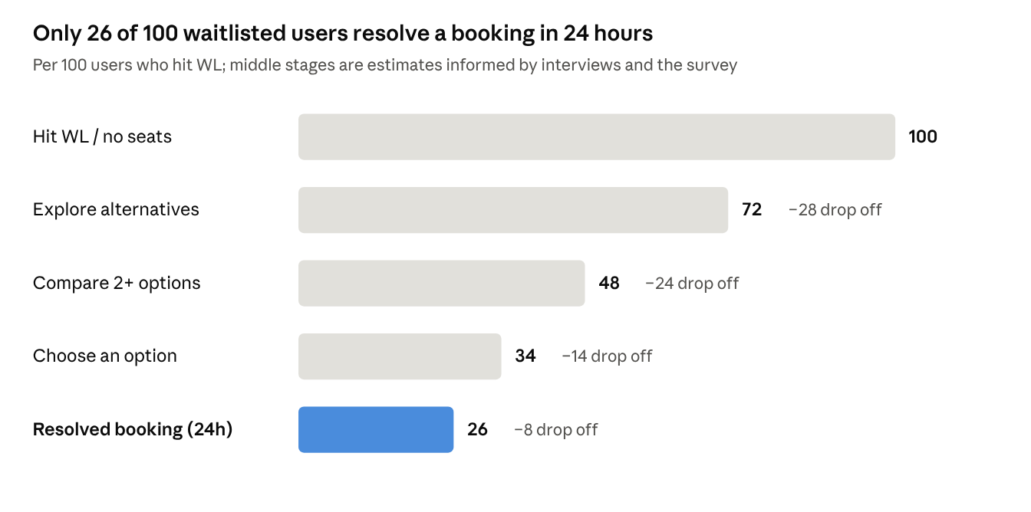
26% from the case brief; middle stages estimated from interviews and survey · per 100 users
The largest losses come between exploring and choosing (38 of 100), where users can't compare options or trust the odds; that is where both solutions act.

Step 2 – Primary barrier
The primary barrier is low decision confidence: users cannot compare alternatives on the trade-offs that matter to them, and they do not trust the certainty they are shown, so they keep searching instead of booking.
Why this barrier, not the others
Candidate barrier | Evidence | Fixable by ixigo? | Verdict
No inventory (no seats anywhere) | 8 of 20 interviewees named working fallbacks (flight, bus, Tatkal, car); all 6 survey respondents eventually travelled | Out of scope | Not primary
Price of alternatives | Price ranked 6th of 7 in the survey, behind journey time, confirmation chance and arrival time | Partly; discounts are out of scope | Secondary
Can't compare + don't trust certainty | All 6 survey respondents searched 3+ times; 4 of 6 say too many options or apps; 8 of 20 book only above 80–95%, yet trust in the % averages 1.7/5; 3 saw high odds end in RAC or WL | Yes, inside the app | Primary
Found out too late | Only 1 of 6 survey respondents; Tatkal is the usual fallback (5 of 6 tried it) | Yes, via one timely alert | Secondary, folded into the solution
Habit and trust in IRCTC | 7 of 20 book mainly on IRCTC or MakeMyTrip; fees and 3X Refund terms add doubt | Partly (clear fees and terms) | Secondary

Step 2 – Business impact
Moving resolution from 26% to 42% adds about 9.6 lakh resolved bookings a month and roughly ₹10 crore a month in net revenue at full run-rate, about ₹120 crore a year (assumptions below, to be tuned).
Assumptions (not ixigo data; state them as estimates)
- Users facing "no confirmed seat" each month: 60 lakh (from 104 M train passenger segments a year and high waitlist share on busy routes).
- Lift: 42% − 26% = 16 points → 9.6 lakh extra resolved bookings a month.
- Mode mix of extra bookings: 60% train, 30% bus, 10% flight.
Mode | Extra bookings / month | Avg ticket (₹) | Net revenue per booking (₹) | GMV / month (₹ cr) | Net revenue / month (₹ cr)
Train (alt train, class, date, protected WL) | 5,76,000 | 1,200 | 60 | 69.1 | 3.5
Bus | 2,88,000 | 1,100 | 110 | 31.7 | 3.2
Flight | 96,000 | 6,500 | 350 | 62.4 | 3.4
Total | 9,60,000 |  |  | 163.2 | 10.0
Other gains: fewer users lost to IRCTC, agents and other apps; higher repeat rate (already 85.55%) because users leave with a plan that worked; more cross-category users (train → bus/flight), which raises lifetime value.

Step 3 – Ideas and RICE prioritisation
Fourteen ideas were scored with RICE; the honest outcome meter, priority chips and the smart compare view lead because they reach every waitlisted user and attack the primary barrier directly.
RICE = Reach × Impact × Confidence ÷ Effort. Reach = lakh users a month who see it; Impact 0.25–3; Confidence %; Effort = person-months.
# | Idea | What it does | Reach (lakh/mo) | Impact | Confidence | Effort (PM) | RICE
1 | Honest outcome meter | Shows CNF / RAC / WL split instead of one "% confirm" | 60 | 2 | 80% | 2 | 48.0
2 | Priority chips | "Arrive by", "Cheapest", "Most certain", "Family together" re-rank options | 60 | 1 | 70% | 1 | 42.0
3 | Smart compare view | One screen ranking trains, classes, dates, stations, bus, flight | 60 | 3 | 80% | 4 | 36.0
4 | Chart-time decision nudge | "Decide by 6 PM tomorrow; after that flights rise" timeline | 40 | 1 | 60% | 1 | 24.0
5 | Explainable prediction | "WL 40 on this train cleared 7 of last 10 similar dates" | 60 | 1 | 70% | 2 | 21.0
6 | AI trip resolver (TARA) | Chat that explains trade-offs and recommends a plan | 60 | 2 | 50% | 4 | 15.0
7 | Group-fit filter | Shows only options with seats for all passengers together | 20 | 2 | 70% | 2 | 14.0
8 | Post-trip regret check | One-tap "Was this the right choice?" to calibrate ranking | 30 | 0.5 | 80% | 1 | 12.0
9 | Plan + backup bundle | Book WL and pre-select a bus or flight fallback with a clear trigger | 30 | 3 | 60% | 5 | 10.8
10 | Share plan on WhatsApp | Send the plan to family for a quick yes | 20 | 1 | 50% | 1 | 10.0
11 | Nearby station card | Shows a nearby station with cab time and cost | 30 | 1 | 60% | 2 | 9.0
12 | Tatkal readiness | Opening-time reminder and pre-filled passengers | 25 | 1 | 50% | 2 | 6.3
13 | Split-journey surfacing | Shows same-train longer route or two-train splits in compare | 25 | 1 | 50% | 3 | 4.2
14 | Fallback flight price hold | Hold a flight fare for 24 hours while WL is pending | 10 | 2 | 40% | 4 | 2.0
Scores are estimates for prioritisation, not forecasts; reach uses the 60 lakh users a month from the impact model.

Step 3 – Shortlisted solutions and trade-offs
Two solutions go forward: Best Way to Reach (ideas 2 + 3 + 9-lite) fixes comparison, and Honest Outcome Meter (ideas 1 + 5) fixes trust; together they turn "many options" into "one plan I believe".
Solution A – Best Way to Reach
When the chosen train is WL or full, the user sees one ranked list of every alternative (other trains, classes, dates, nearby stations, bus, flight, protected WL) with a top pick, a backup, and priority chips to re-rank.
- Why: removes re-searching across tabs and apps; all 6 survey respondents searched 3+ times, and 4 of 6 called too many options or apps the hardest part.
- Priority chips because 6 of 20 interviewees named a different top priority (comfort, punctuality, speed, safety, timing), and the survey ranked journey time, confirmation and arrival above price.
- Reuses: ConfirmTkt Alternates, AbhiBus inventory, ixigo flights, Alternate Travel Plan.
Solution B – Honest Outcome Meter
Every waitlisted option shows the likely outcome as three bars, e.g. Confirmed berth 55% · RAC 30% · Stays WL 15%, plus one line of reason and "what happens if not".
- Why: 8 of 20 interviewees use the % as a booking rule (80–95%), yet survey trust in it averages 1.7 out of 5; 3 saw high odds end in RAC or stay WL.
- Users judge a prediction by the outcome they expected (own berth), so a 90% "confirm" that ends in RAC breaks trust even when the trip happens.
- Guardrail built in: never says "guaranteed"; ranges shown when data is thin.
Trade-offs
Decision | Option chosen | What we gain | What we give up
One ranked list vs separate tabs | One list | Faster decision, cross-mode bookings | Busier screen; needs careful design
Recommend a top pick vs neutral list | Top pick + backup | Users get a clear answer, like an agent | Risk of a wrong pick hurting trust; needs regret tracking
Show CNF / RAC / WL split vs one % | Split | Honest, builds long-term trust | Numbers can look less "positive"; may lower WL bookings short term
Build AI chat (idea 6) now vs later | Later (Step 8 demo only) | Ship faster, lower risk | Less "wow" in v1
Plan + backup bundle full build vs lite | Lite: suggest backup, user books it | 1–2 months faster | Fewer automatic rescues in v1

Step 4 – User journey map
The biggest pain sits between "sees WL" and "decides": that is where Best Way to Reach and the Honest Outcome Meter act.
Stage | Today: user does | Thinks / feels | With the new experience
1. Search | Enters Mumbai → Patna, 5 Nov | Hopeful | Same
2. Sees WL | Preferred train shows WL 85, "40% chance" | Worried; "is 40% good?" | Outcome meter: CNF 25% · RAC 15% · WL 60%, one-line reason
3. Explores | Re-searches other trains, dates, then bus and flight apps | Overwhelmed, many tabs | "See best ways to reach" button opens one ranked list
4. Compares | Notes prices and times on paper or memory | Confused about trade-offs | Priority chips (Arrive by / Cheapest / Most certain / Family together) re-rank; top pick + backup
5. Decides | Calls family or agent, or gives up | Anxious, low trust | Books top pick in 2 taps, or protected WL with a named backup
6. Waits | Checks PNR many times | Stressed until chart | Chart-time nudge: "Your backup is ready if WL doesn't clear by 6 PM"
7. Travels / reflects | Feels the app was wrong if RAC | Trust drops | One-tap "Was this the right choice?" feeds ranking

Step 4 – PRD: Best Way to Reach + Honest Outcome Meter
Problem: waitlisted users can't compare alternatives or trust certainty, so only 26% resolve within 24 hours.
Goal: raise 24-hour resolved booking rate to 42% in 6 months without raising post-booking regret.
Users: ixigo Trains users with a known route and date whose preferred train or class has no confirmed seat. Priority personas: Threshold Planner and Punctual Frequent Traveller (Step 1 research doc).
In scope: alternate trains, classes, dates (±2 days), nearby stations (≤50 km), AbhiBus buses, ixigo flights, protected WL (Alternate Travel Plan / Assured).
Out of scope: inventory, IRCTC quota or Tatkal rules, pricing, refund policy, payments.
User stories
- As a waitlisted traveller, I want all ways to reach my destination in one list so I don't search five times.
- As a traveller with a deadline, I want to rank options by arrival time so I reach on time.
- As a family traveller, I want only options with seats for all of us together.
- As a cautious traveller, I want to see whether I'll get a berth, RAC or stay WL, so I'm not surprised.
- As any traveller, I want a backup ready if my WL doesn't confirm.
- As a traveller with a personal cut-off (say 80%), I want to see only options that meet it, so I don't waste time on long shots.
- As a cautious buyer, I want protection terms in plain words before I pay, so I know what I get back and in what form.
Functional requirements
ID | Requirement | Priority | Evidence
FR1 | When the selected train/class is WL or full, show a "See best ways to reach" entry on the result and on the booking page | P0 | 4 of 6 found too many options or apps the hardest part
FR2 | One ranked list across trains, classes, dates, nearby stations, bus, flight, protected WL | P0 | 8 of 20 named fallbacks across modes
FR3 | Each card shows price, depart/arrive time, duration, station distance, certainty, cancellation terms | P0 | Journey time, confirmation, arrival ranked top 3
FR4 | Priority chips re-rank instantly; default = "Balanced" | P0 | 6 of 20 named different top priorities
FR5 | "Top pick" and "Backup" labels with a one-line reason | P0 | Users turn to agents and family for one clear answer
FR6 | Outcome meter: CNF / RAC / WL % for every WL option; a range when data is thin | P0 | 3 saw high odds end in RAC or WL; founder's 90% → RAC
FR7 | Never use "guaranteed" or "sure" for a prediction; show a "how we estimate" link | P0 | Trust in the % is 1.7 out of 5
FR8 | "My cut-off" filter: show waitlisted options only above the user's chosen chance (default 80%) | P0 | 8 of 20 book only above 80–95%
FR9 | Group-fit toggle for 3+ passengers | P1 | Family bookings common (P02, P04, P16, P21)
FR10 | Chart-time decision nudge (max 1 push, user can switch off) | P1 | Tatkal is the usual last resort (5 of 6)
FR11 | Protection terms in plain words before purchase: what is refunded, cash vs voucher, expiry | P1 | 3X Refund unknown or unclear (P06, P12)
FR12 | Post-trip "Was this the right choice?" | P1 | Guardrail for wrong recommendations
FR13 | "Updated X min ago" on availability and chances | P2 | P08 checks IRCTC because of data mismatches
FR14 | Share the plan on WhatsApp | P2 | Families decide together (2 of 6 asked family or an agent)
Ranking logic (v1): score = weighted sum of certainty, arrival fit, price, journey time, station convenience; weights set by the chosen chip. Certainty for a confirmed seat = 1.0; for WL = P(CNF) + 0.5 × P(RAC).
Non-functional: list loads in under 2 seconds; works on 4G and low-end Android; Hindi and English copy.
Success metrics: see Step 6. Launch plan: see Step 5.
Open questions: latency of combining bus and flight inventory; whether RAC split data is available per train and quota.

Step 4 – Prototype and annotated screens
Clickable prototype: Best Way to Reach. Flow: search result → best ways to reach → option detail → plan set. Turn on "Show PM annotations" to see 10 numbered notes beside the screens.
Lovable prototype (submission link): prototype-rohit-ixigo.lovable.app. It includes the "My cut-off" filter (FR8), plain-language protection terms (FR11) and "updated 4 min ago" (FR13), with research evidence in each annotation.
Screen | Annotation | Design decision
1. Search result | Outcome meter | CNF / RAC / WL split replaces a single "% confirm"
2. Best ways to reach | Priority chips, top pick + reason, backup | One ranked list across train, bus, flight; reason shows the two factors that won
3. Option detail | "Last 10 similar Saturdays" history, backup toggle | Makes the odds concrete; backup turns protection into a plan
4. Plan set | Regret question | Guardrail and learning loop

Step 5 – Go-to-market
Launch inside the existing waitlist moment, not as a new product: the entry point appears only when a user hits WL or no seats, so there is no extra marketing cost.
Element | Plan
Target | Users whose preferred train/class shows WL or no seats on high-demand routes
Entry points | Search result card, booking page, PNR status page for existing WL tickets
Positioning | "See the best way to reach – with honest chances" / "पहुँचने का सबसे अच्छा तरीका देखें"
Channels | In-app only in v1; one opt-in chart-time push; no discounts or coupon blasts
Timing | Pilot before winter wedding season, scale before Holi (Mar) and summer vacation (May–Jun)
Partners | ConfirmTkt (prediction), AbhiBus (bus), ixigo flights; no new partners needed

Step 5 – Growth / behaviour loop
Each resolved trip makes the next one faster, because outcomes improve the ranking and the user learns to trust the app.
- User hits WL and opens Best Way to Reach.
- Gets a top pick + backup with honest odds, books in 2 taps.
- Trip outcome (CNF, RAC, WL, bus, flight) and the regret answer are logged.
- Prediction and ranking get better calibrated for that route.
- User trusts ixigo more and comes back first next time, often sharing the plan with family on WhatsApp.
- More users and outcomes → back to step 4.

Step 5 – Impact model by phase
Phase | Months | Users exposed | Resolution rate | Extra resolved bookings / mo | Net revenue / mo (₹ cr)
Baseline | 0 | 60 lakh | 26% | – | –
Pilot | 1–2 | 5% (3 lakh) | 32% | 18,000 | 0.2
Scale | 3–4 | 50% (30 lakh) | 37% | 3,30,000 | 3.4
Full | 5–6 | 100% (60 lakh) | 42% | 9,60,000 | 10.0
Revenue uses the Step 2 mix (60% train, 30% bus, 10% flight) at about ₹104 net revenue per extra booking.

Step 5 – Cohort rollout
Cohort | Who | Why first | Exit criteria to next cohort
1. Pilot | 5% of WL users on 20 top routes (Mumbai–Patna, Delhi–Lucknow, etc.), A/B test | Highest pain, enough data | +4 pts resolution vs control; regret ≤ control
2. Families | Bookings with 3+ passengers, all routes | Biggest group-fit pain | Group-fit used by 30%+
3. All WL users | 50% then 100% | Scale | Guardrails stable for 4 weeks
4. PNR-page users | People who already hold a WL ticket | Rescue before chart time | 10%+ book a backup

Step 6 – Metrics
The North Star is the 24-hour resolved booking rate for waitlisted users: 26% today, 42% in 6 months.
Definition: of users who hit WL or no seats for a route and date, the share who within 24 hours book a confirmed train, bus or flight for that journey, or knowingly book protected WL.
Supporting metrics
Metric | Type | Baseline → target
Best Way to Reach open rate among WL users | Leading | New → 60%
Searches before booking | Leading | 3–5 for most (survey) → 1–2
Time from first WL to booking | Leading | −40%
Chip or cut-off filter used | Leading | New → 35%
Top pick or backup booked | Leading | New → 50% of bookings from the list
Cross-mode bookings (bus + flight share) | Lagging | +10 pts
Trust in the shown chance (in-app pulse, 1–5) | Lagging | 1.7 (survey) → 3.5
90-day repeat booking rate | Lagging | 85.6% → 88%
Guardrails
Guardrail | Why | Threshold
Post-booking regret ("wrong choice") | Bad recommendations | ≤ 8%, not above control
Prediction calibration (predicted vs actual CNF, RAC, WL) | Overstated confidence | Gap ≤ 5 pts per bucket
Cancellation rate of recommended options | Users booked something that didn't fit | Not above control
Complaints mentioning "prediction wrong" or RAC | Trust | −30%
Page load time | Experience | < 2 s
Event tracking
Event | Trigger | Key properties
wl_seen | WL / no seats shown on search or booking | route, date, train, class, wl_no, pax, p_cnf, p_rac, p_wl
bwr_opened | User opens Best Way to Reach | entry_point, options_count
chip_selected | Priority chip tapped | chip, position_before, position_after
option_viewed | Card expanded | mode, rank, price, arrive_time, certainty
option_booked | Booking completed from the list | mode, rank, label (top_pick / backup / other), fare
backup_selected | Backup chosen for a WL ticket | backup_mode, trigger_time
chart_outcome | Chart prepared | final_status (CNF / RAC / WL), predicted split
regret_answered | Post-trip question answered | answer, mode, rank

Step 7 – Risks and mitigations
Risk | Likelihood | Impact | Mitigation
Wrong top pick (e.g. bus arrives late) | Medium | High | Regret tracking, conservative weights, always show a backup
Prediction overconfident, more RAC surprises | Medium | High | Show split + ranges, calibration guardrail, "how we estimate" link
Showing honest odds lowers WL bookings | Medium | Medium | Offer protected WL and backup on the same screen
Bus/flight inventory slow to load | Medium | Medium | Load trains first, stream bus and flight cards in
Users see it as upselling flights | Low | High | Default "Balanced" chip, cheapest option always visible
Notification fatigue | Low | Medium | Max one chart-time push, opt-out
Cannibalising train bookings with buses | Low | Low | Net revenue per bus booking is higher; overall resolution is the goal

Step 7 – Trade-offs
- Honesty over short-term conversion: a lower-looking % now buys trust and repeat use.
- Recommendation over neutrality: users want an answer like an agent gives, at the cost of owning wrong picks.
- Speed over completeness: v1 skips full plan-plus-backup automation and AI chat.

Step 7 – Constraints and assumptions
- Constraints: no change to railway inventory, IRCTC quota or Tatkal rules, pricing or refund policy; no reliance on discounts.
- Assumptions: 60 lakh WL users a month; ConfirmTkt can estimate RAC separately; AbhiBus and flight APIs return within 2 s; mode mix 60/30/10; interview findings from about 20 people generalise to the wider base.

Step 8 – AI trip resolver (vibe-coded)
Working artifact: Trip Resolver (screens in Part 3 of this file). The traveller types their situation in their own words (English or Hinglish); Claude turns it into priorities and limits; transparent code ranks the real options; the answer states chances honestly.
Where it fits the journey: it is the conversational front door to Best Way to Reach (journey stage 4, "Compares"). Instead of choosing chips, a user can say "we are 3, my mother is 65, need to reach by Sunday morning, budget ₹5,000" and get the same ranked list with the right weights. In ixigo this would live inside TARA / ixigo NEXT.
Logic
- AI understands, it does not invent: the model returns only weights (certainty, arrival, price, time, station, together, comfort), hard limits (budget, modes to avoid, arrive-by, no sitting overnight), a summary and reply language. It never sees editable prices and never names a train.
- Ranking is code: score = Σ weight × factor; options breaking a hard limit are removed and listed as "left out".
- Backup = best confirmed option other than the top pick.
- Honesty guardrail: answer shows own berth / RAC / stays WL; words like "guaranteed" are blocked.
- Fallback: a keyword parser (English + Hinglish) answers when AI is unavailable.
Prompt (abridged)
You help Indian train travellers whose preferred train is waitlisted. Read the traveller's message and turn it into ranking preferences. Do not recommend a specific train and do not invent options or prices.
Reply with only one JSON object:
{"understood": [3-5 bullets], "weights": {"cert","arrive","price","time","station","together","comfort": 0-1}, "travellers", "budget_total_inr", "arrive_by", "avoid_modes", "avoid_sitting_overnight", "reply_language"}
The full prompt is visible inside the artifact under "How it works".

Part 3 – Step 8: Trip Resolver screens
The Trip Resolver is the conversational front door to Best Way to Reach. The traveller describes the trip in their own words; the tool shows what it understood, the priority weights it applied, and a ranked plan with a top pick, a confirmed backup and honest odds. Sample trains and fares; the live AI run is shown in the video walkthrough.
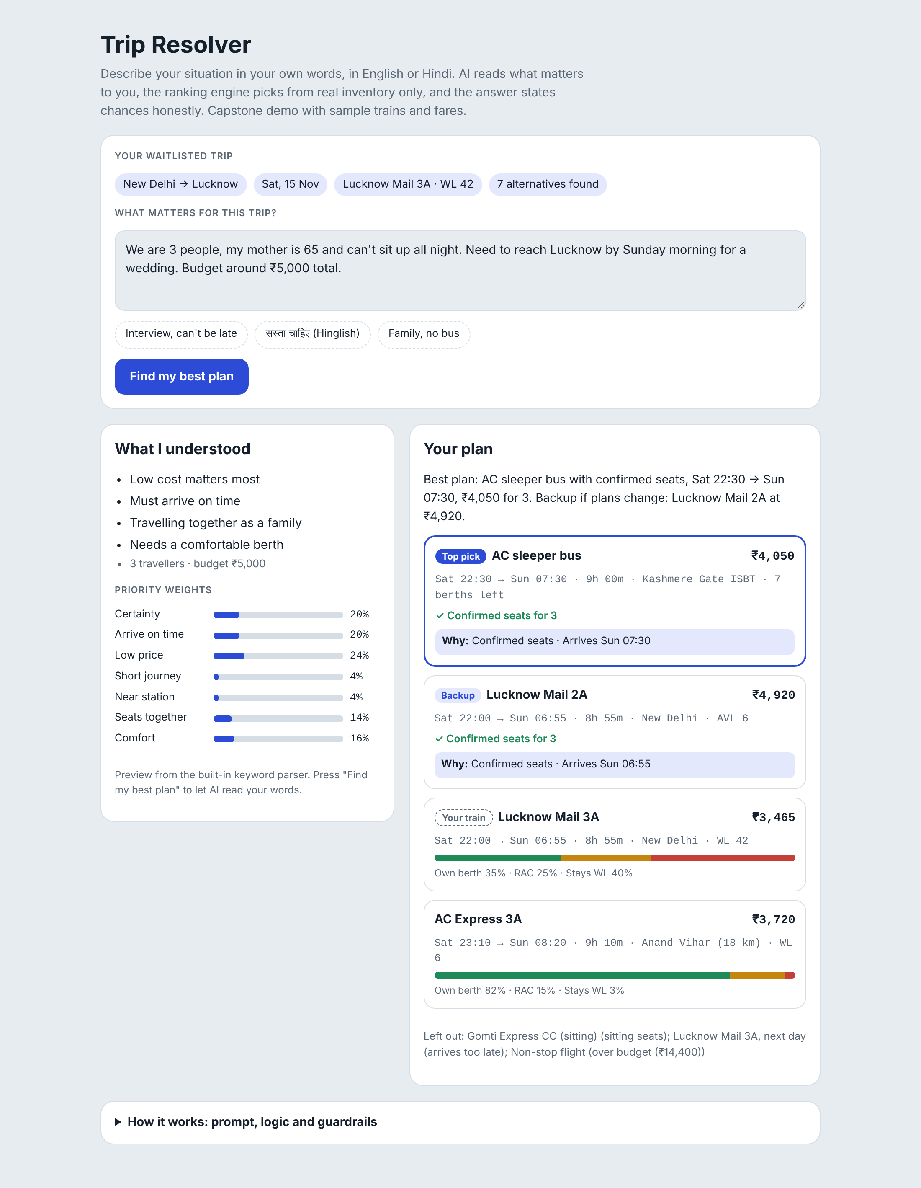
Run 1 · “We are 3 people, my mother is 65 and can’t sit up all night. Need to reach Lucknow by Sunday morning for a wedding. Budget around ₹5,000 total.” Result: AC sleeper bus with confirmed seats as the top pick, Lucknow Mail 2A as backup; the user’s WL 42 train shows own berth 35% · RAC 25% · stays WL 40%; options breaking the limits (sitting overnight, over budget, arriving late) are listed as left out.

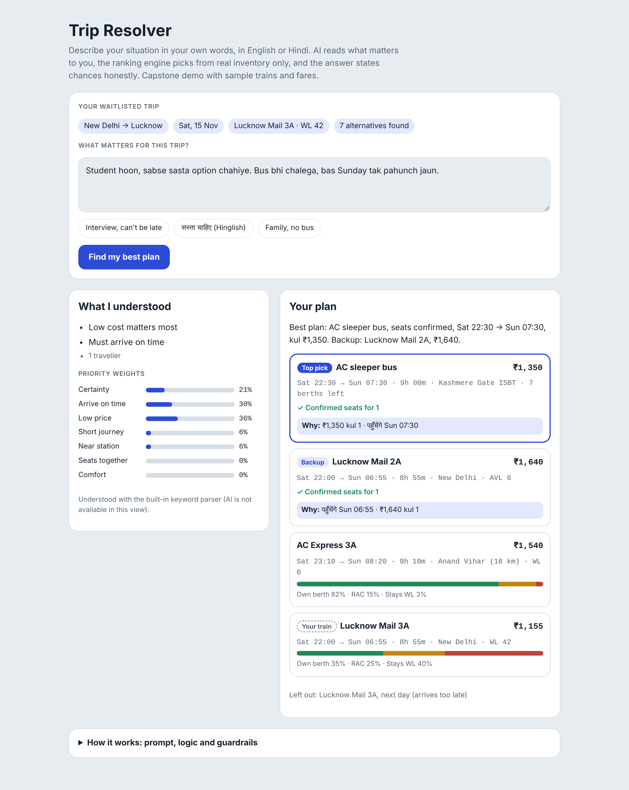
Run 2 (Hinglish) · “Student hoon, sabse sasta option chahiye. Bus bhi chalega, bas Sunday tak pahunch jaun.” Result: weights shift to low price, the cheapest confirmed option leads, and the reply mixes Hindi. This run used the built-in keyword parser, the fallback when AI is unavailable.
Other messages to try: “Solo trip for a job interview at 11 AM Sunday in Lucknow. I must not be late. Price doesn’t matter much.” · “Family of 3 with a small kid, we want to sit together and avoid buses. Fine with paying a bit more.”

