NIP Project — Submission Template
Section 1 — Your Details
Full Name | ROSHINI K
Email ID (registered on NIP) | roshinik.ad24@bitsathy.ac.in
Phone Number | 9487013746
College Name | Bannari Amman Institute of technology
Course (e.g. IT, CS) | AI & DS
State | TamilNadu
Project Chosen (Vehicle Service OR Movie Ticket Booking) | Movie Ticket Booking
Pega Application Name (e.g. NIP-VehicleService-YourName) | NIP_Ticketing and Booking_Roshini_K
Case Type Name (exact) | Movie Ticket Booking
Pega Instance URL | https://zyrgwajp.pegaacademy.net/prweb/app/ticketing-and-booking-1/CtYds566Y7jpC3dVa-OW-IOR_52hKA0l*/!STANDARD?pzuiactionzzz=CXtycX1iZjBiZjIyZjQyYmVjMmUxYTNiMTc3NzYwZTY0NjIwNTJlODQxYjBkOGM4M2FlMjM0YzNlNWU0NmVmOWUxZTU4MWVmZjI0YmI1OWUzZGU2OGMxMDJhMmM5OTMyYjg3ZTJmNDgwNTIxMzM1MDgwNmM4ZWRmZWRmOTZkYzk0ZjYwZQ%3D%3D*&AccessGroupName=Ticketing_1%3AAuthors&Location=pzuiactionzzz%3DCXtycX1lNTU3YzM4MTM3YTFjY2Y1NWU4N2NiMjYzMWY1ZjAxMGMzYzE4MTNiZmVhNWJjOTZkMjIzNGNmOWExOTYzODNiMTJkOGQxOTIyNWM0ZGMyNWUyNzA1YWNkMTBiM2Q4YTg%3D*
Operator Name (created in Pega with your full name) | Roshini_K
Section 2B — Movie Ticket Booking Management Application.

US-001 — Submit Movie Ticket Request
What is expected:
Screenshot — paste your screenshot below this line:
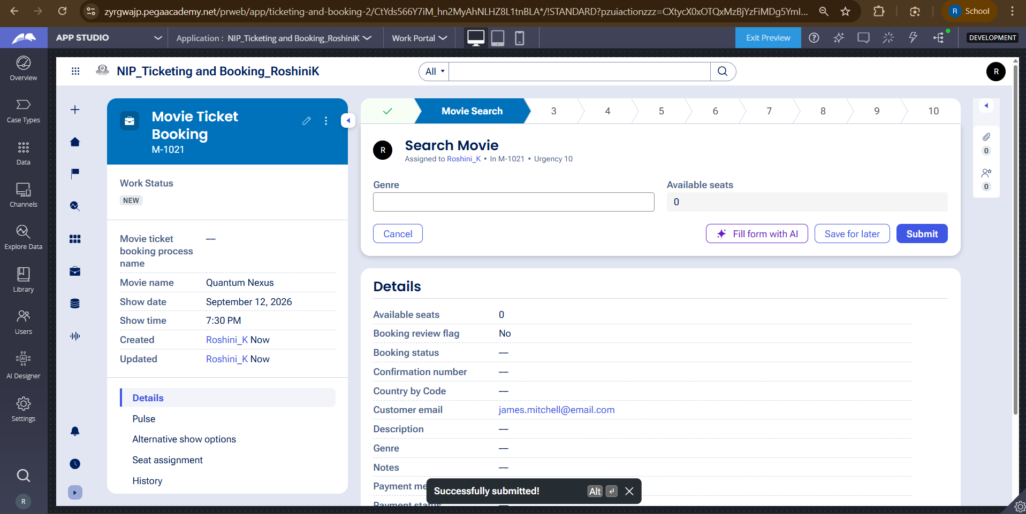

What I built for this :
Created a Movie Ticket Booking case that allows customers to submit movie name, show date, show time, and number of tickets with validation.

US-002 — Check Show Availability
What is expected:
Screenshot — paste your screenshot below this line:
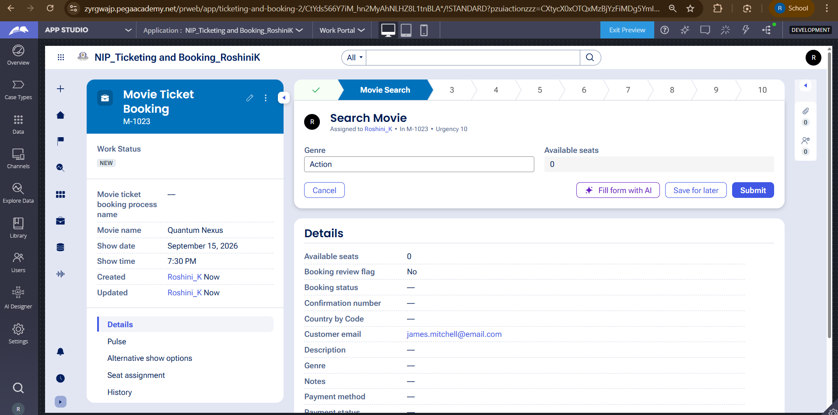
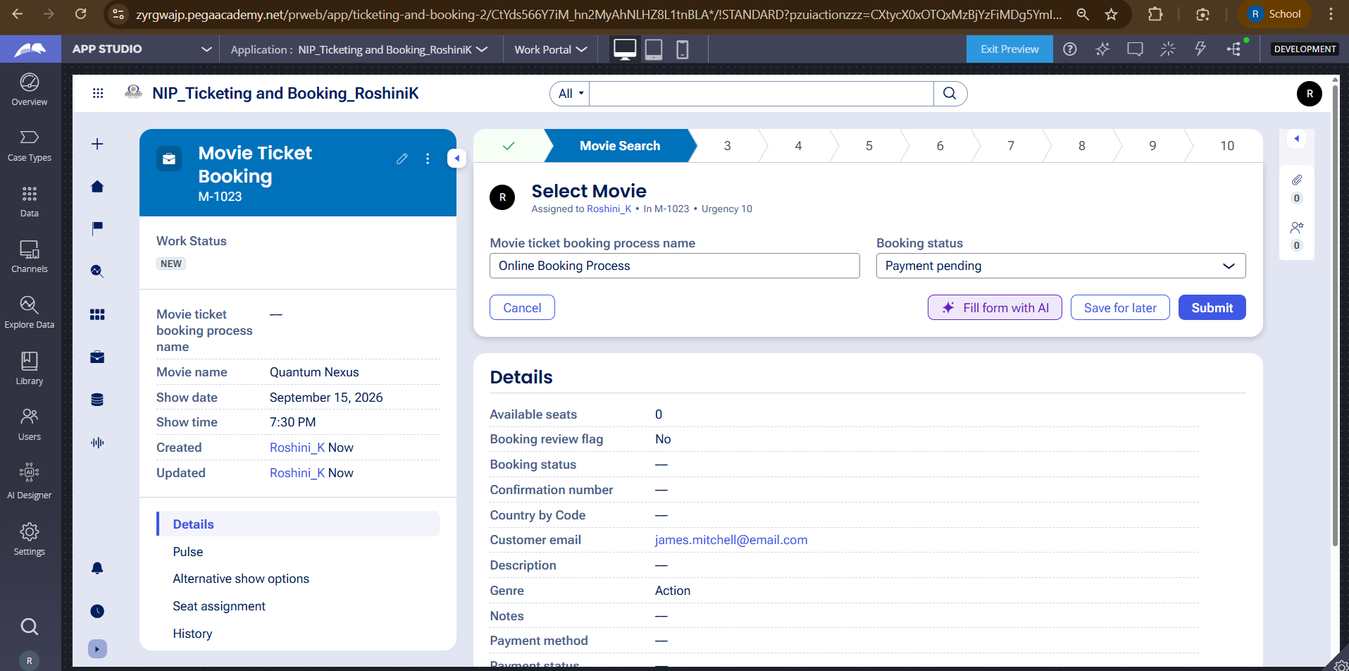
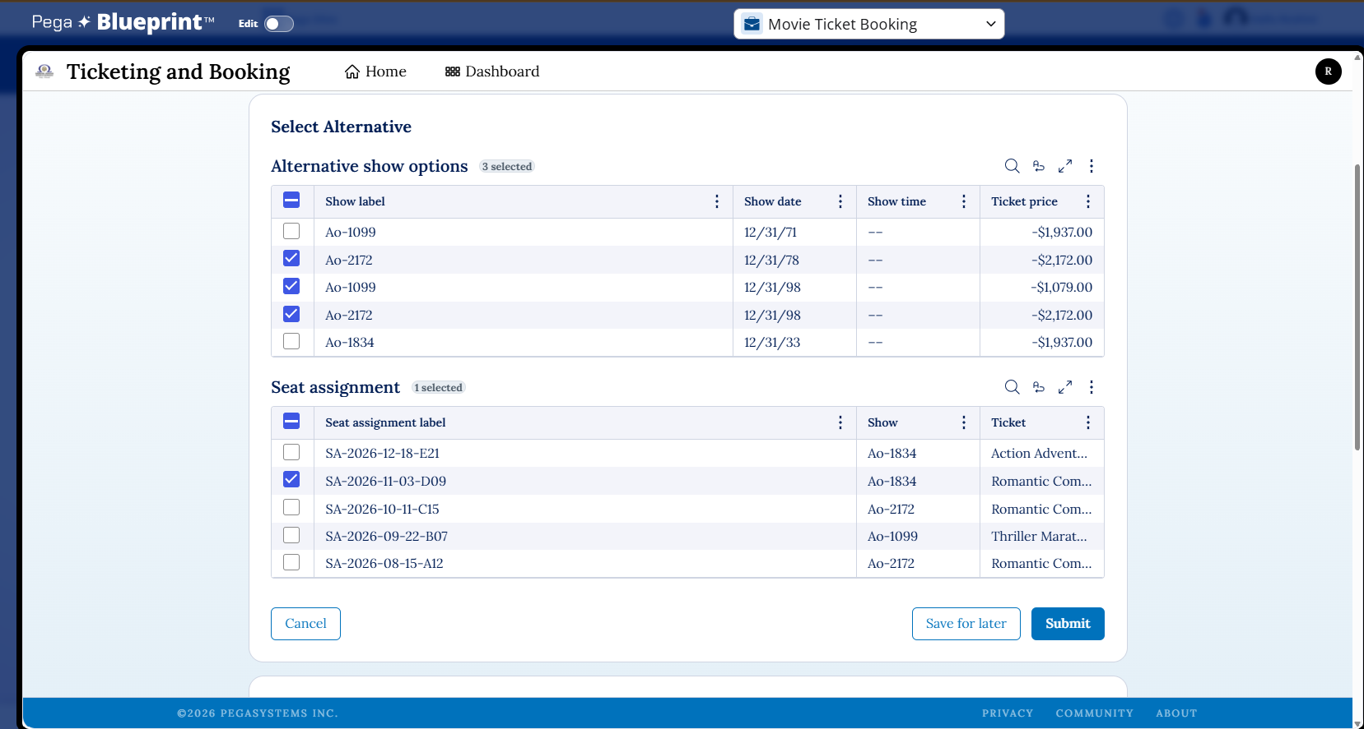

What I built for this (1–2 lines in your own words):
Implemented the show availability check to display available shows based on the selected movie, date, and time.

US-003 — Calculate Booking Cost
What is expected:
Screenshot — paste your screenshot below this line:
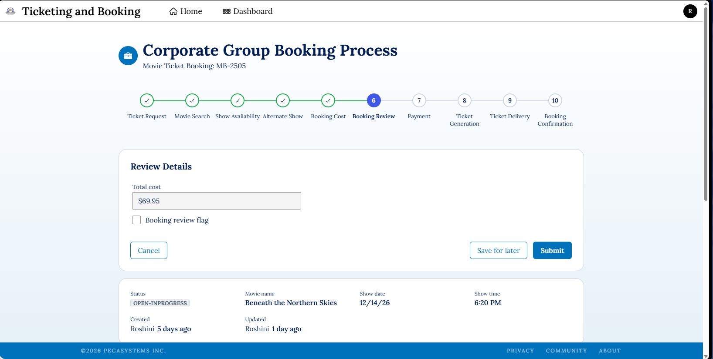
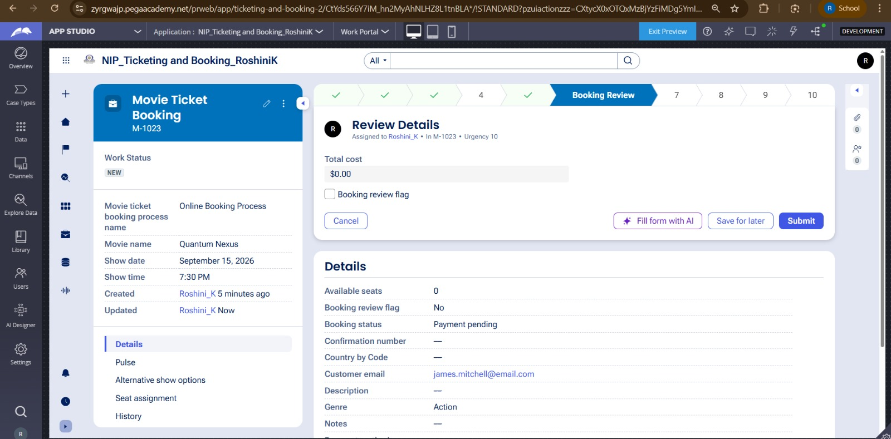

What I built for this (1–2 lines in your own words):
I implemented automatic calculation of the total booking cost using the ticket price and number of tickets selected by the customer.

US-004 — Confirm Booking Request
What is expected:
Screenshot — paste your screenshot below this line:
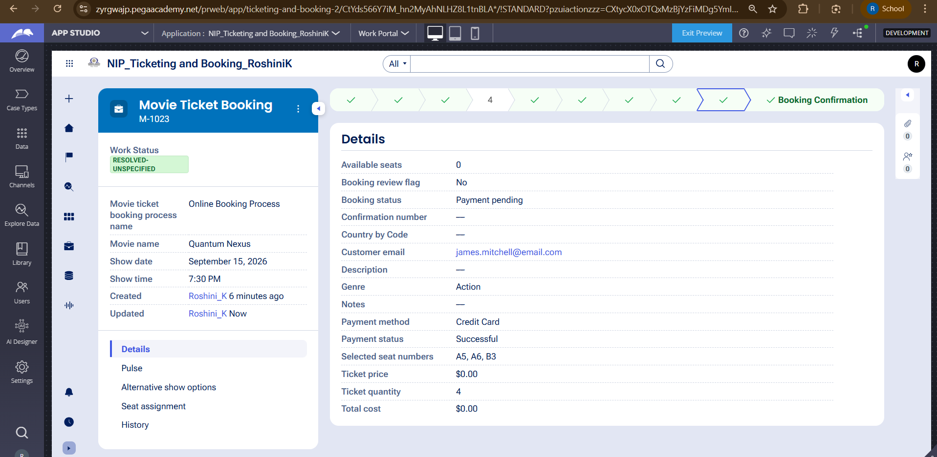

What I built for this (1–2 lines in your own words):
I implemented the booking confirmation step where the customer can confirm the booking or cancel the request before proceeding.

US-005 — Maintain Movie and Show Data
What is expected:
Screenshot — paste your screenshot below this line:
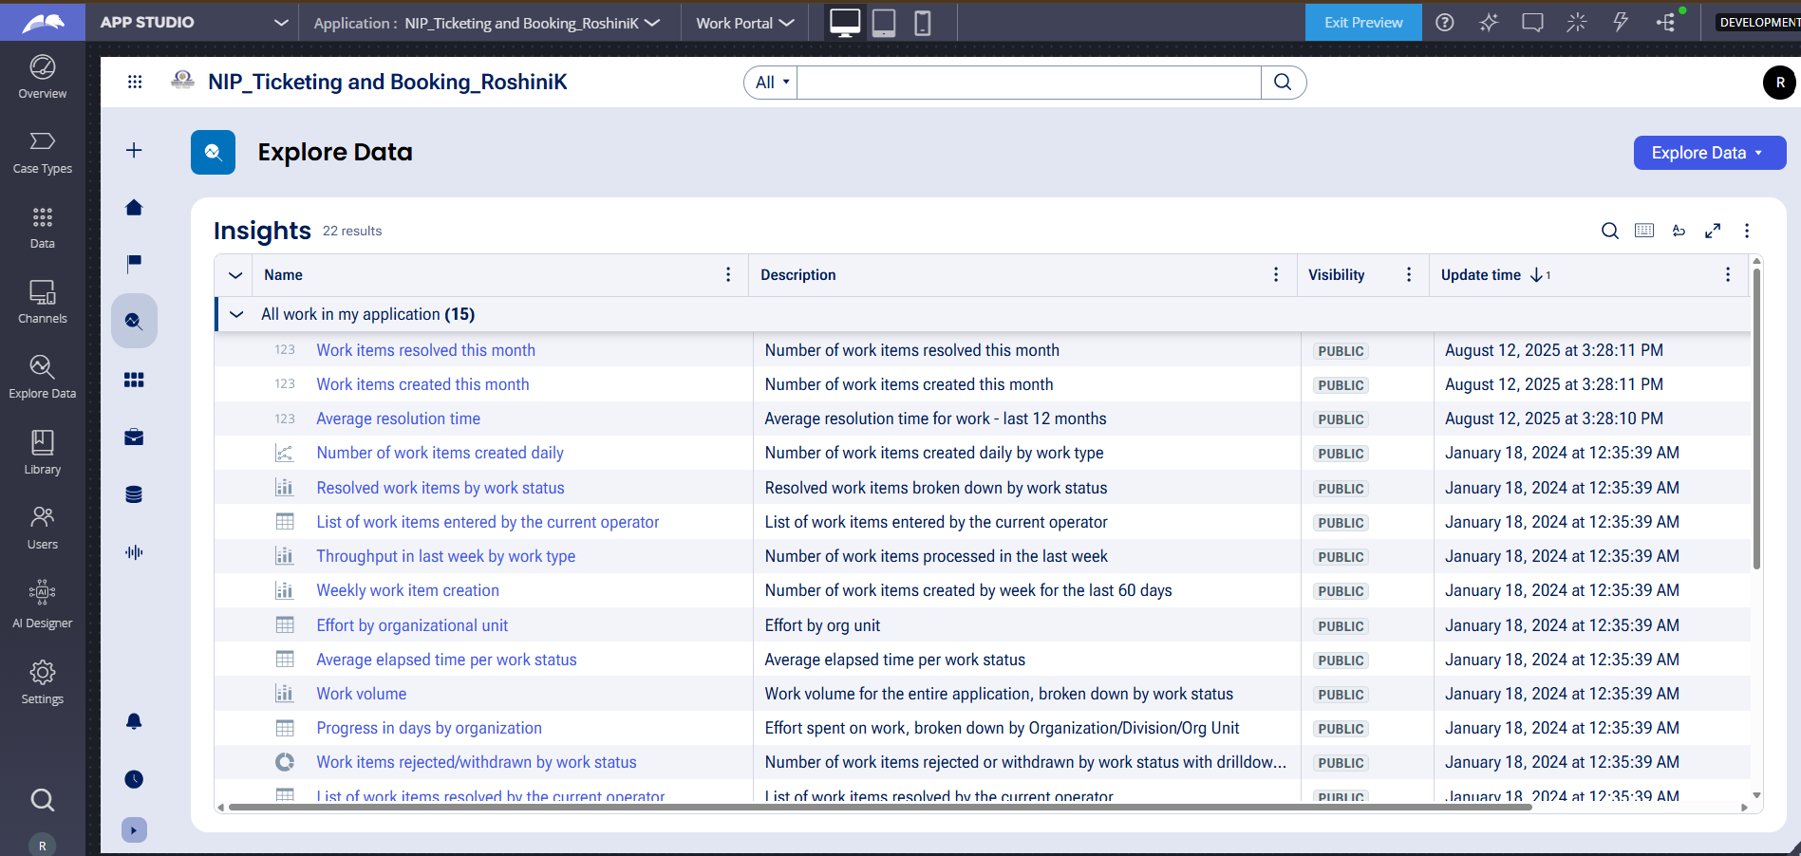

What I built for this (1–2 lines in your own words):
I created reusable Movie and Show data objects to maintain movie and show information such as movie name, genre, show date, show time, and seat capacity.

US-006 — Review Booking Details
What is expected:
Screenshot — paste your screenshot below this line:
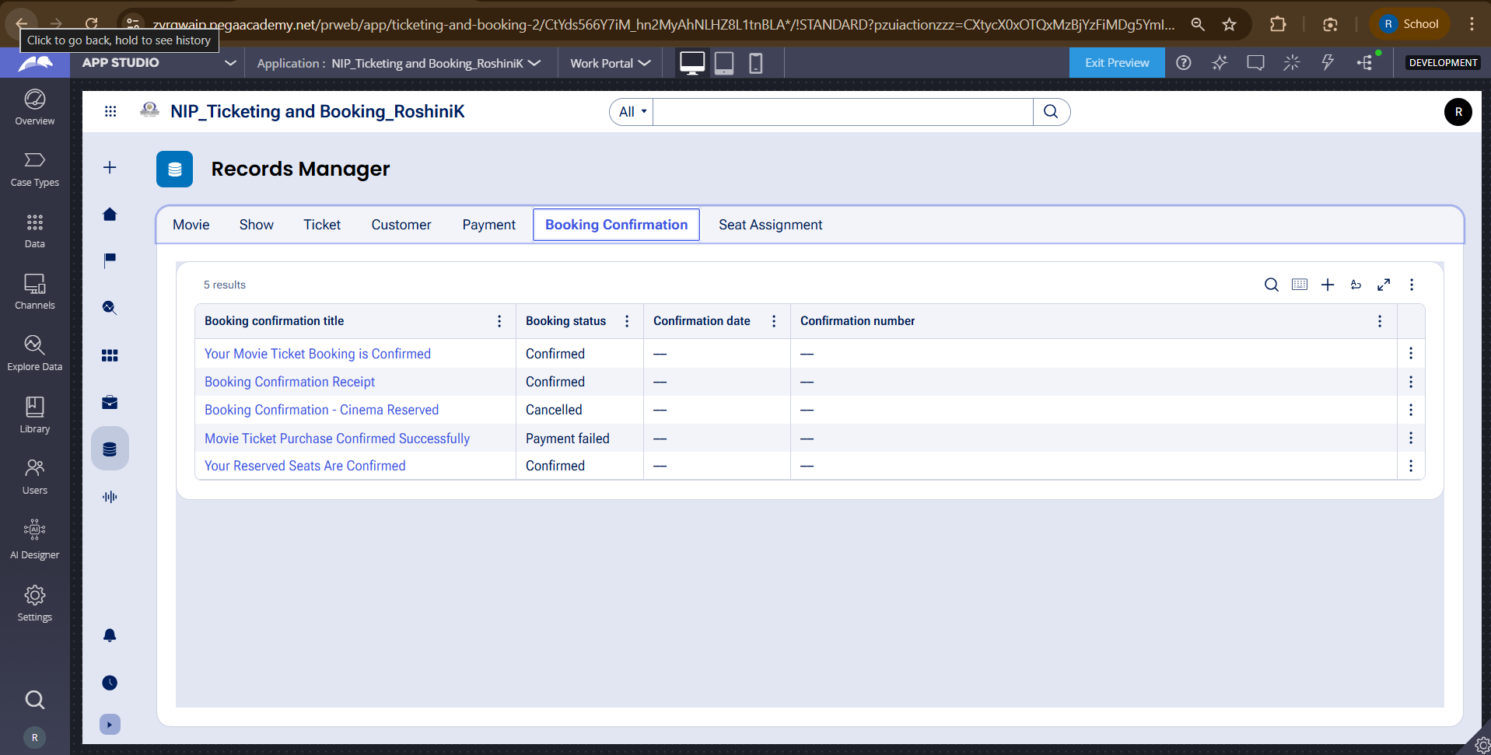

What I built for this (1–2 lines in your own words):
I implemented a booking review screen that allows the customer to verify the movie, show timing, number of tickets, and total cost before completing the booking.

US-007 — Process Ticket Booking
What is expected:
Screenshot — paste your screenshot below this line:
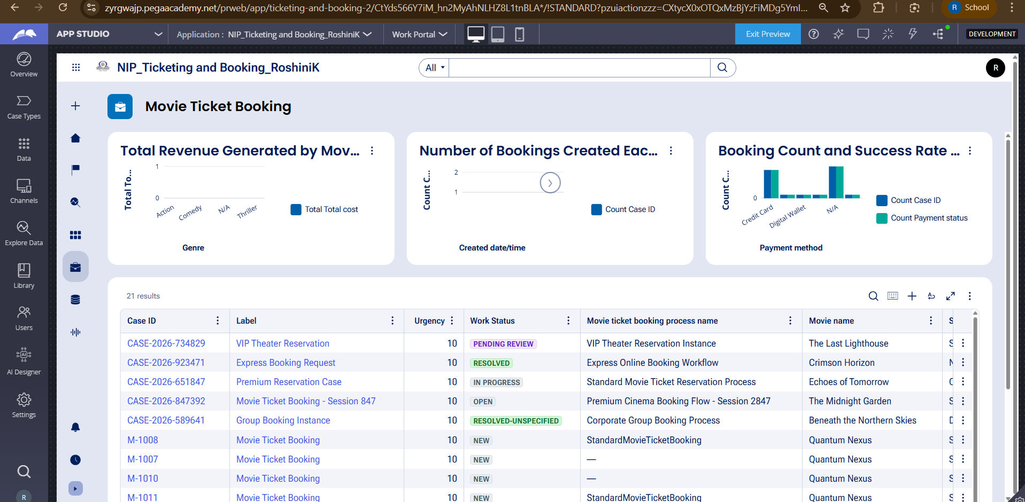

What I built for this (1–2 lines in your own words):
I implemented the booking execution process to maintain seat numbers, generate a ticket ID, and update the booking confirmation status.

US-008 — Notify Booking Confirmation
What is expected:
Screenshot — paste your screenshot below this line:
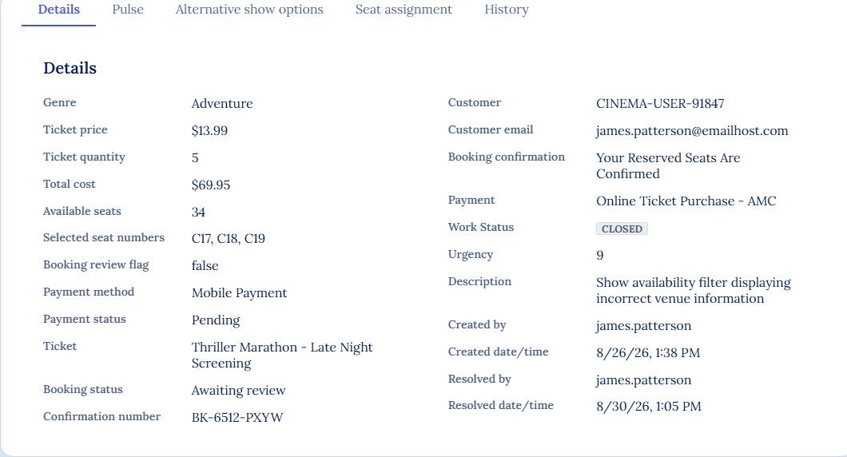
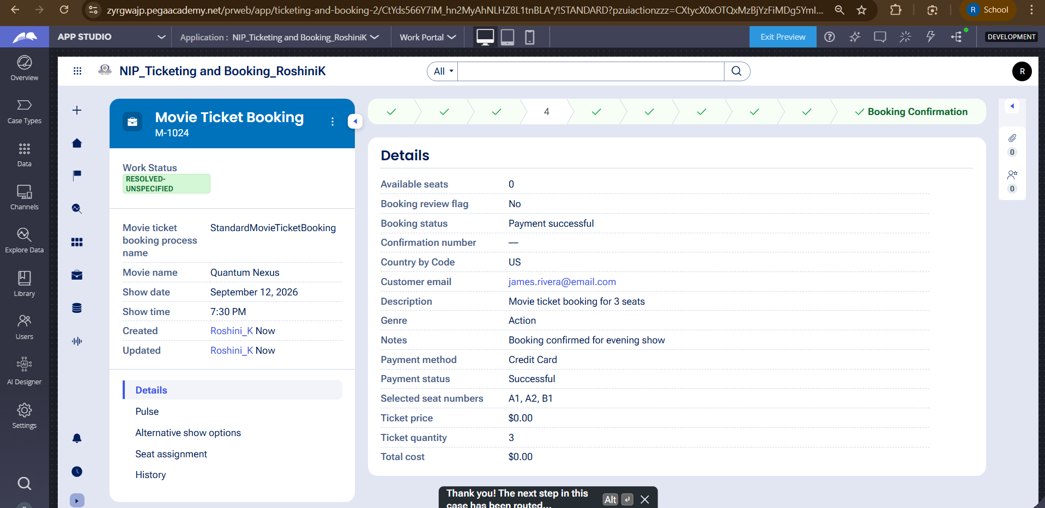

What I built for this (1–2 lines in your own words):
I configured booking confirmation notification functionality to provide the customer with the movie, show, seat, and cost details after successful booking.

US-009 — Define Booking SLA
What is expected:
Screenshot — paste your screenshot below this line:
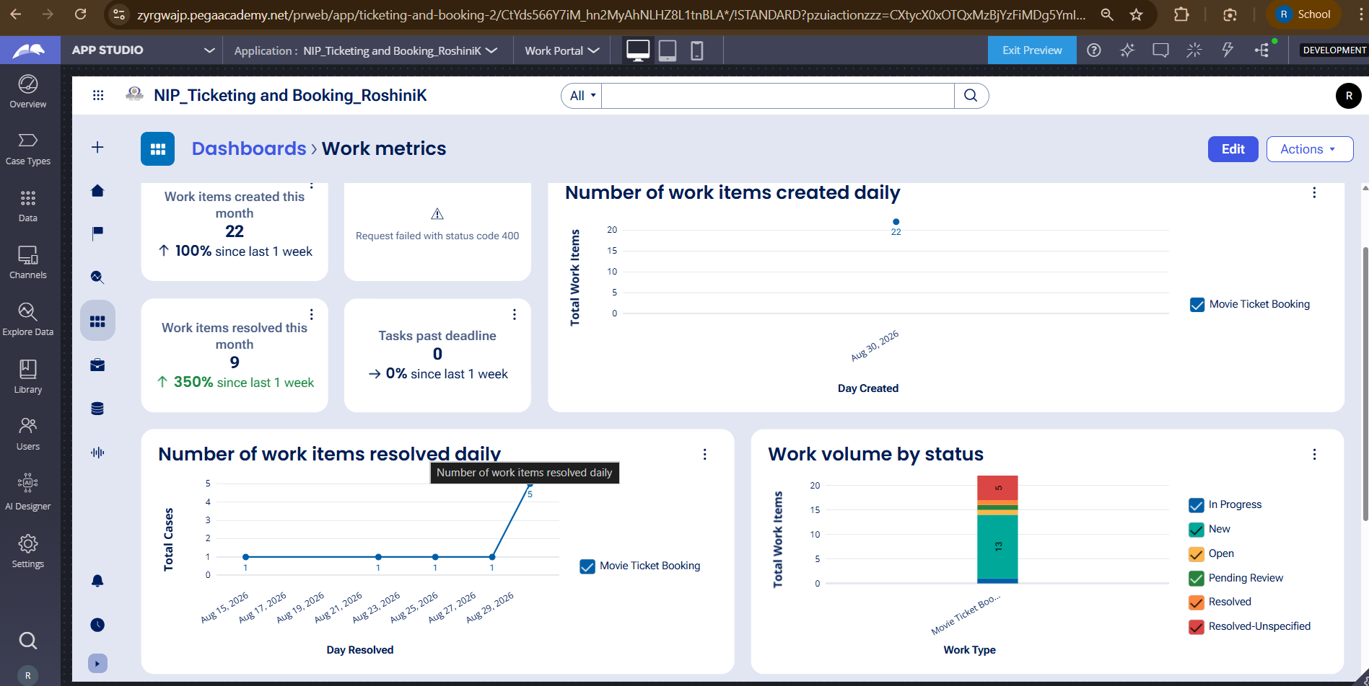

What I built for this (1–2 lines in your own words):
I configured a service-level agreement for the movie ticket booking case with a one-day goal and two-day deadline.

US-010 — Route by Show Type
What is expected:
Screenshot — paste your screenshot below this line:
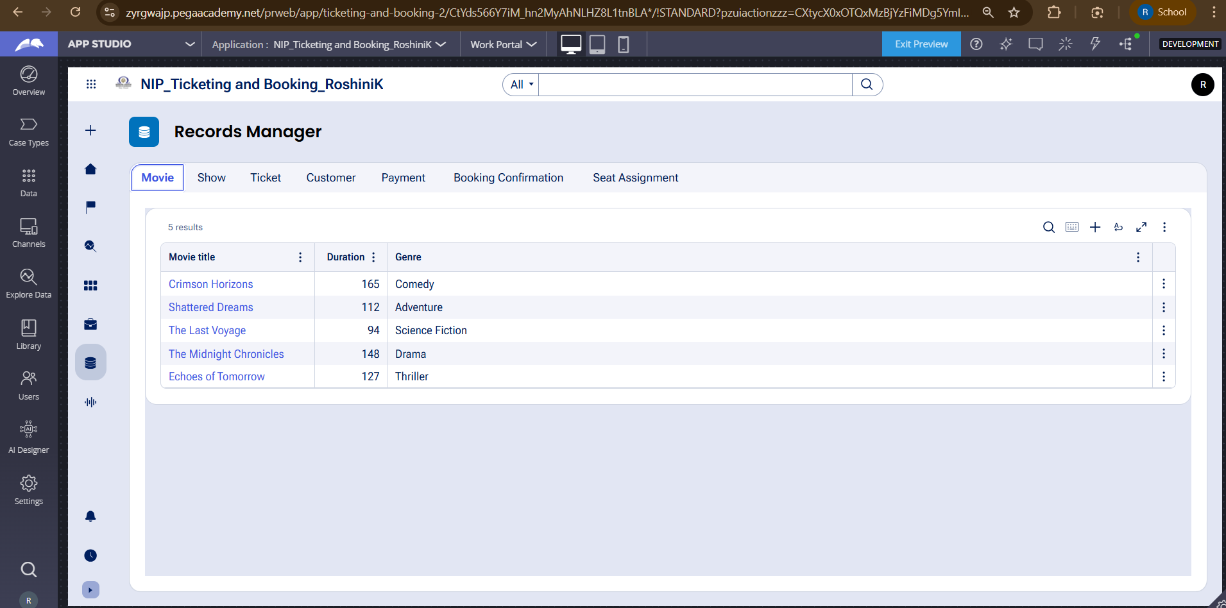

What I built for this (1–2 lines in your own words):
I implemented routing based on the show type so that Premium and Standard shows can be handled by their respective work queues.

Section 3 — About Your Application
Q1. List your stages in the order they appear in your case lifecycle.
Request Submission, Show Availability, Confirmation & Payment, Ticket Processing, Booking Confirmation
These are the stages from the Movie Ticket Booking workflow.

Q2. Name the data object(s) you created and the properties inside them.
Movie: Movie Name, Genre, Duration, Language.
Show: Movie, Show Date, Show Time, Ticket Price, Seat Capacity, Available Seats.

Q3. What is the exact name and type of the rule you used to calculate Total Cost?

Rule Name: TotalCost
Rule Type: Declare Expression
Properties used: Ticket Price and Ticket Quantity
Formula: Total Cost = Ticket Price × Ticket Quantity

Section 4 — Your Understanding
Q4. What did Blueprint generate for you, and what did you add or change yourself afterwards?
Blueprint generated the basic Movie Ticket Booking application structure, including the case type, workflow stages, process steps, data objects, and application structure. I then configured and refined the required fields, validations, booking cost calculation, availability handling, booking confirmation, SLA, routing, and notification-related requirements.

Q5. Was there anything Blueprint created that you had to correct or configure further? Describe one
Yes. Some generated data fields required further configuration after the Blueprint was created. For example, the Ticket Price and Available Seats values needed additional configuration so that meaningful values could be used during the booking process instead of remaining at their default values.

Q6. Explain your case flow from creation to resolution, in order.
The customer first submits a movie ticket booking request by providing the movie, show date, show time, and number of tickets. The application checks the availability of the selected show. If the show is unavailable, an alternate show can be suggested. If seats are available, the booking cost is calculated using the ticket price and number of tickets. The customer reviews the booking details and confirms the request. Payment is then processed. After successful payment, the ticket and ticket ID are generated, the ticket details are provided to the customer, and the booking status is updated to confirmed. The case is then completed.

Q7. Pick two design choices you made in your application and explain why you made them.

Design Choice 1 — Automatic Total Cost
What I implemented: I configured Total Cost to be calculated automatically from Ticket Price and Ticket Quantity.
Why: This avoids requiring the customer to manually calculate or enter the booking amount.
Benefit: It reduces calculation errors and provides the customer with an accurate amount before payment.

Design Choice 2 — Availability Check
What I implemented: I included a show availability check before proceeding with the booking.
Why: Customers should not be allowed to continue with a show when sufficient seats are unavailable.
Benefit: It prevents invalid bookings and allows an alternate show to be selected when necessary.

Q8. What was the hardest part, and how exactly did you fix it?
The hardest part was understanding how the Blueprint-generated workflow and data configuration were mapped to the Pega application. Some fields such as Ticket Price and Available Seats were initially displaying default values such as 0. I checked the Show data configuration and configured the required properties and values so that they could be used correctly during the booking process. I also verified the workflow through Preview to ensure that the booking flow worked as expected.

Q9. If the approval step was only needed when Total Cost is above a certain amount, what would you change in your application?
I would add a conditional decision in the booking workflow after Total Cost is calculated. The condition would check whether Total Cost is greater than the specified threshold. If the amount is above the threshold, the case would go to the Customer approval step. If the amount is below or equal to the threshold, the case would bypass approval and continue directly to the next booking step.

Q10. List three exact rule names from your application that you personally created or modified.
[Total Cose] — Declare Expression — Used to calculate Total Cost.
DecisionTable — Decision Table/Decision Rule — Used for show-type routing.
Notification — Correspondence/Notification Rule — Used for booking confirmation notification.

Q11. List all personas used in your application.
Customer

Q12. List all work queues used in your application and explain when each one is used.
PremiumShowQueue — Used for handling bookings associated with Premium shows.
StandardShowQueue — Used for handling bookings associated with Standard shows.

