EXPERIMENT-1

ROLL NO:240701221 NAME:KAARTHIKA S

USER INTERFACE AND DESIGN

COMPARISON OF UI DESIGN BETWEEN TWO FIGMA CREATION

BAD WEBSITE:

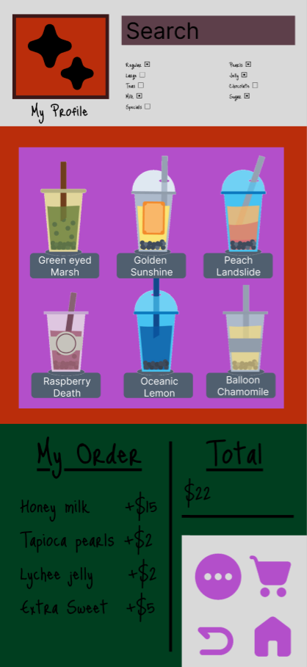

GOOD WEBSITE:

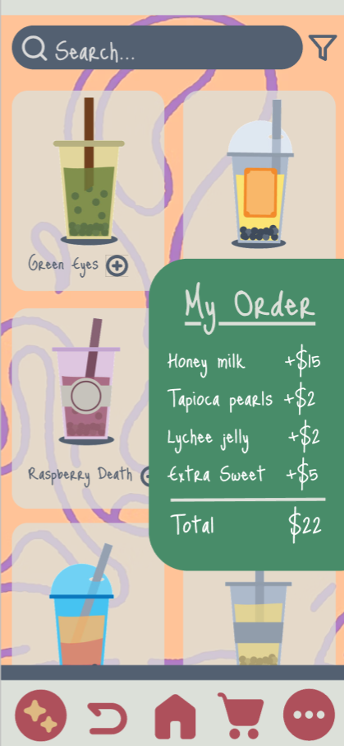

PROTOTYPE LINK: Bad/Good UI – Figma

The two apps have distinct designs and approaches. Here's a comparison:

BAD WEBSITE (BobaBoom)

Design Style:

o Uses too many bold and contrasting colors (red, purple, green) without harmony.

o Visual clutter due to crowded elements and inconsistent spacing.

o Icons, illustrations, and text styles do not follow a single design system.

Content:

o Displays multiple drink options at once, making it visually overwhelming.

o Text labels are small and hard to scan quickly.

o Order details are cramped and compete with product visuals.

Navigation:

o Navigation icons are present but not clearly distinguished or intuitive.

o Search and filter options are placed awkwardly and feel disconnected from the main content.

Purpose:

o Intended for ordering bubble tea, but poor hierarchy makes decision-making difficult.

GOOD WEBSITE (BobaBlast)

Design Style:

o Soft, pastel color palette with consistent tones throughout the app.

o Clean and balanced layout with proper spacing between elements.

o Playful illustrations that match the overall theme and enhance visual appeal.

Content:

o Drink options are clearly displayed with enough space to focus on each item.

o Order summary is highlighted in a dedicated section, improving readability.

o Prices and add-ons are easy to understand at a glance.

Navigation:

o Bottom navigation bar is clear, accessible, and visually consistent.

o Search bar is prominently placed, improving usability and flow.

Purpose:

o Designed to create a smooth and enjoyable ordering experience while maintaining aesthetic appeal.

Key Differences:

• Focus: The bad UI tries to show everything at once, while the good UI prioritizes clarity and flow.
• Design Aesthetics: The bad UI feels cluttered and chaotic; the good UI feels calm and cohesive.
• Content Hierarchy: The good UI clearly separates browsing from ordering, unlike the bad UI.
• User Experience: The bad UI may confuse users, while the good UI guides them naturally through selection and checkout.

