EXPERIMENT-2

ROLL NO:240701221 NAME:KAARTHIKA S

USER INTERFACE AND DESIGN

CHUNKING AND RECALLING VISUAL ELEMENTS
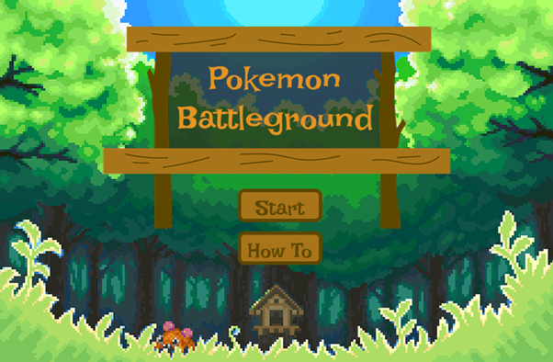
FRAME 1:
TITLE / START SCREEN
Chunking Analysis of the Title Screen
Chunking at the entry level helps users immediately understand the game structure and available actions without overwhelming them.
- Purpose of the Screen
• Acts as the entry point to the game.
• Introduces the game theme and sets user expectations.
• Allows users to choose between starting the game or viewing instructions.
- Clear Grouping of Actions
• The game title is visually separated from action buttons.
• Two primary options are provided:
o “Start” → Begin gameplay.
o “How To” → View instructions before playing.
• This separation prevents decision overload for first-time users.
- Visual Hierarchy and Design Elements
• Large wooden signboard displaying “Pokémon Battleground” immediately draws attention.
• Buttons are centrally aligned and clearly labeled.
• Forest-themed pixel background establishes consistency across all future screens.
- Cognitive & UX Benefits
• Minimal elements reduce cognitive load.
• Clear action paths improve usability and onboarding.
• Familiar Pokémon-style visuals increase engagement and comfort.
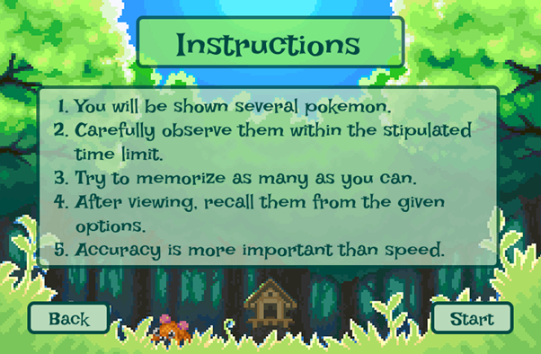
FRAME 2:
INSTRUCTION PAGE
Chunking Analysis of the Instruction Page
Chunking is a cognitive strategy that breaks down information into smaller, manageable units, making it easier to process and retain. The Pokémon Battleground instruction page applies chunking effectively in the following ways:
- Clear and Sequential Numbering
• The instructions are presented in numbered steps (1–5), ensuring a logical flow.
• Each step focuses on a single action, reducing confusion and cognitive overload.
- Logical Grouping of Information
• Exposure Phase (Steps 1–2) → Explains that multiple Pokémon will be shown within a time limit.
• Memorization Strategy (Step 3) → Encourages users to focus on remembering as many Pokémon as possible.
• Recall Phase (Step 4) → Informs users that they must recall Pokémon from given options.
• Performance Emphasis (Step 5) → Highlights that accuracy is prioritized over speed.
- Visual Hierarchy and Design Elements
• Prominent “Instructions” header → Clearly establishes the purpose of the page.
• Semi-transparent instruction panel → Separates text from the forest background for readability.
• Consistent Pokémon-themed visuals → Maintains immersion without distracting from the text.
• Clearly placed “Back” and “Start” buttons → Provide intuitive navigation options.
- Time Constraint Reinforcement
• The mention of a stipulated time limit sets expectations early.
• Prepares users mentally for the fast-paced memory challenge ahead.
- Simplicity and Clarity
• Instructions are short, direct, and written in simple language.
• The tone is instructional yet friendly, suitable for a game-based learning environment.
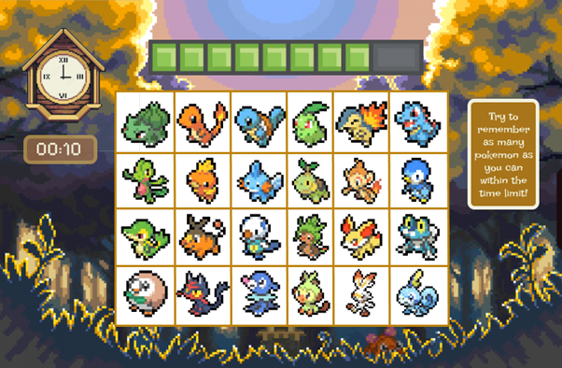
FRAME 3:
CHUNKING PHASE
Analysis of the Pokémon Battleground – Memorization Screen
This screen represents the Chunking (Encoding) Phase, where users visually process and memorize Pokémon within a limited time.
- Purpose of the Screen
• Serves as the memory encoding stage where users observe multiple Pokémon.
• Encourages mental grouping (chunking) to improve short-term memory retention.
- Key Elements and UI Components
⏳ Countdown Timer (Left Side – “00:10”)
• Displays the remaining time clearly, creating urgency.
• Encourages rapid visual scanning and focused attention.
🟩 Progress Indicator (Top Center)
• A segmented progress bar visually represents remaining time.
• Reinforces the time constraint without relying only on numbers.
🔲 Pokémon Grid
• Pokémon are displayed in a structured grid layout.
• Grid arrangement supports chunking strategies such as:
o Grouping by Pokémon type (fire, water, grass).
o Categorizing by color schemes or visual similarity.
o Remembering evolutionary patterns or familiar starters.
🟨 Instruction Tooltip (Right Side)
• Reminds users of the objective: “Try to remember as many Pokémon as you can within the time limit.”
• Reinforces task goals without interrupting gameplay.
- How the Chunking Phase Works
- Users scan the Pokémon grid and identify familiar or related characters.
- Time pressure encourages chunk-based memory strategies rather than individual memorization.
- Once time expires, the game transitions automatically to the recall phase.
- Cognitive and UX Benefits
• Improves memory retention through visual grouping.
• Reduces cognitive load by presenting items in a predictable grid structure.
• Familiar Pokémon designs enhance recall through prior knowledge.
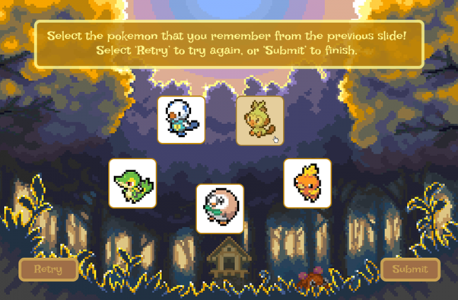
FRAME 4:
RECALL PHASE
Analysis of the Pokémon Battleground – Selection Screen
This screen represents the Recall Phase, where users retrieve stored information and identify Pokémon seen previously.
- Purpose of the Screen
• Tests short-term memory by requiring users to recognize previously shown Pokémon.
• Measures the effectiveness of chunking during the memorization phase.
- Key Elements and UI Components
📝 Instruction Prompt
• “Select the Pokémon that you remember from the previous slide!”
• Clear, action-oriented instruction reduces ambiguity.
🔲 Pokémon Selection Options
• A smaller set of Pokémon is shown, mixing correct answers with distractors.
• Users must differentiate between seen and unseen Pokémon.
• Visual selection boxes clearly indicate selectable items.
🟨 Action Buttons
• “Retry” button → Allows users to restart the recall process.
• “Submit” button → Finalizes selections and proceeds to scoring.
- How the Recall Phase Works
- Users mentally retrieve Pokémon from memory.
- They compare recalled images with the presented options.
- Distractor Pokémon test accuracy and resistance to false memory.
- Submission confirms the recall attempt.
- Cognitive and UX Benefits
• Strengthens retrieval practice, improving memory consolidation.
• Use of distractors evaluates true recall rather than guessing.
• Simple interaction design keeps focus on cognition, not controls.
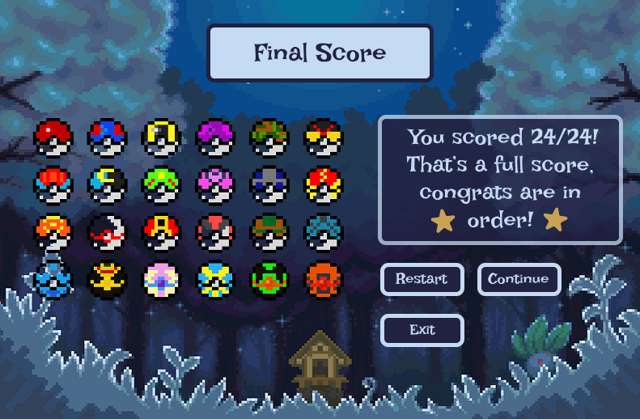
FRAME 5:
RESULT PAGE
Analysis of the Pokémon Battleground – Score & Feedback Screen
This screen represents the Feedback Phase, where users receive performance results and next-step options.
- Purpose of the Screen
• Communicates recall accuracy clearly and immediately.
• Encourages continued engagement through rewards and replay options.
- Key Elements & UI Components
📝 Final Score Display
• “Final Score” header clearly marks completion of the task.
• Numerical score (e.g., 24/24) is prominently displayed.
• Text feedback (“That’s a full score, congrats are in order!”) reinforces positive achievement.
⭐ Visual Rewards
• Star icons and Poké Ball graphics serve as motivational reinforcement.
• Visual celebration increases satisfaction and replay value.
🟦 Action Buttons
• “Restart” → Replay the game.
• “Continue” → Move to the next challenge or level.
• “Exit” → Leave the game.
- How This Phase Works
- The system evaluates recall accuracy.
- The final score is displayed with encouraging feedback.
- Users choose their next action based on motivation and performance.
- Cognitive & UX Benefits
• Immediate feedback supports learning and self-assessment.
• Positive reinforcement boosts confidence and motivation.
• Multiple exit paths respect user autonomy and reduce frustration.

PROTOTYPE LINK: Chunking – Figma

