**DFD level 0**

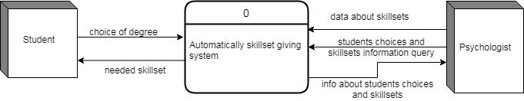

**DFD level 1**

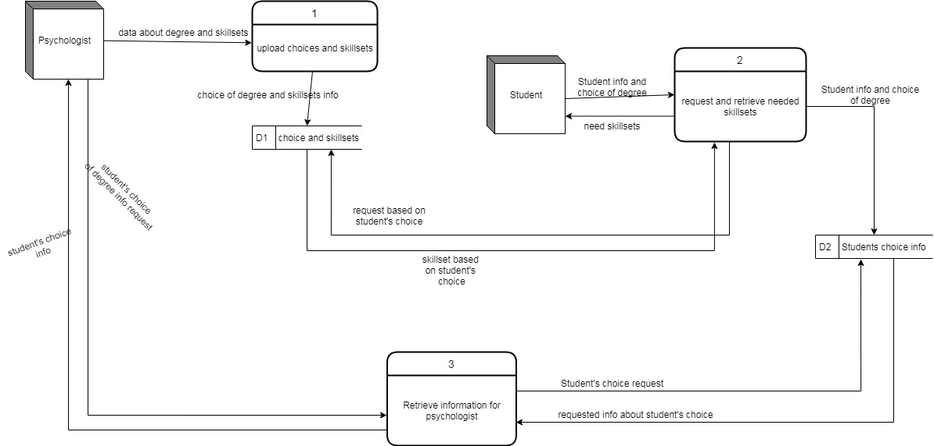

**Flowchart**

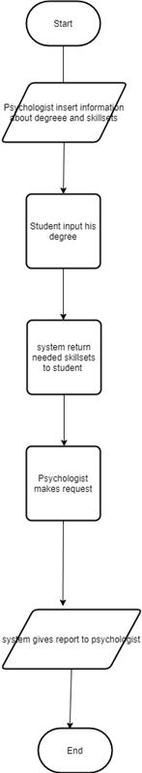

***SDLC MODEL: Waterfall.***

We selected waterfall SDLC model. The waterfall Model illustrates the software development process in a linear sequential flow. This means that any phase in the development process begins only if the previous phase is complete. So we selected because it is appropriate for mini project. In addition, it allows avoiding mistakes and it has such benefits as:

* Easy to understand. Because all the students need, to do is to input his/her degree into the system and then it displays you information about needed skillsets.
* Easy to improve/change. When we need to manage our project, we can easily go step back and change it without creating a new one from the beginning.
* We can see result gradually because each step has output so we can clearly see the inner part of the project.

SOFTWARE REQUIREMENTS

|  |  |
| --- | --- |
| Required software | reason |
| Operational system | To manage computer resources and to provide connection with user |
| Antivirus | To protect PC from external viruses and malicious software |

HARDWARE REQUIREMENTS

|  |  |  |
| --- | --- | --- |
| Type of the device | device | function |
| Input devices | Keyboard, mouse | For keyboard: Enter text/data/numeric symbols.  For mouse: Click on buttons or display |
| Output device | Monitor | Displaying result from the system and the actions from user and computer |
| Data storage devices | Hard disk | Program will be stored there |

***Benefits of the new system:***

* Fast and clear response. Because with psychologist you need to have more time and practice what degree suits you, but with that system, you will have response immediately.
* Easy to understand and comfortable interface for interacting with users. Because there are only two database, from which it takes data and only two processes of input and output data.

***Drawbacks of the new system:***

* Psychologist can argue the choice of the student and program does not have such ability.
* The program is installed on local school computer and it cannot be accessed on the personal PC.

***Prototypes***

*Authorization form*

This is main form of the system where user needs to log into his/her account in order to access the system. If user enters incorrect data then the program will show error message to the user. If username and password are correct, then user will be logged into the system as a student or a psychologist (depending on his/her account).

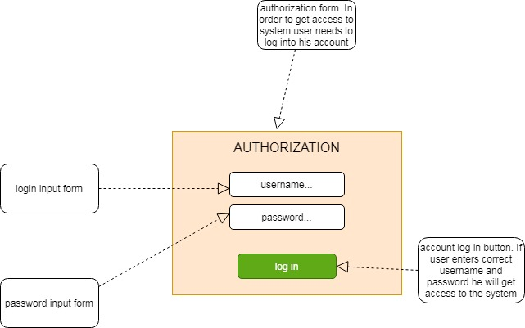

*Student input and output forms*

These are forms of the system for students. Input form will be opened when user logs into the system as a student. There student needs to input his/her choice of degree on the input form. Then student sees needed skill sets based on this choice on the output form.

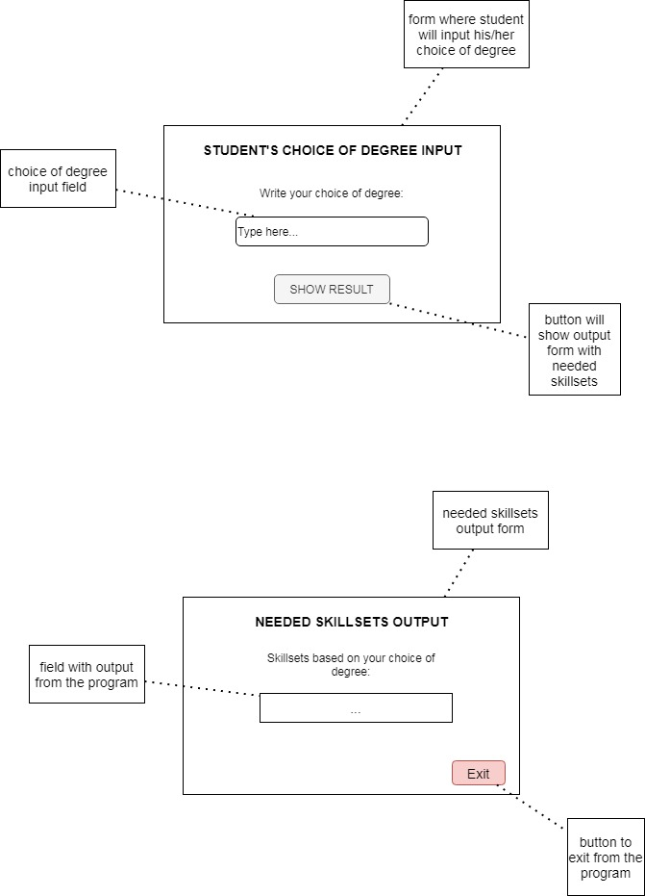

*Psychologist*

This form will be opened when user logs into the system as psychologist. There psychologist needs to choose what he/she will be using the system for.

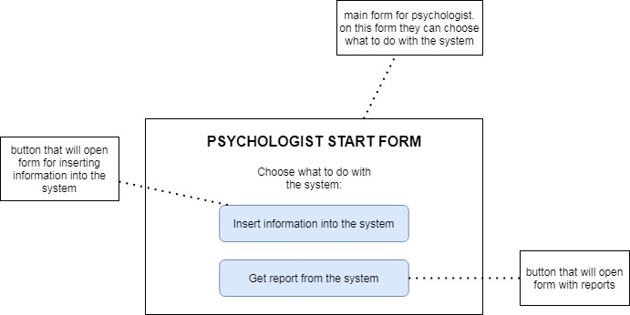

If psychologist chooses to insert information into the system, then ‘Insert Information into the System’ form will be opened. In this form psychologist can add new information, update existing information and delete information from the system’s first database.

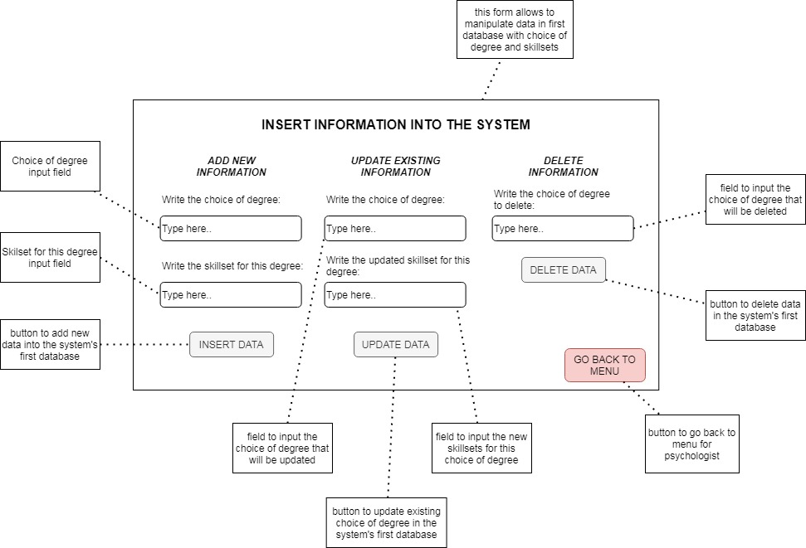

If psychologist chooses to get report from the system, then ‘Report Parameters’ form will be opened. There psychologist will choose what information to include in the report.

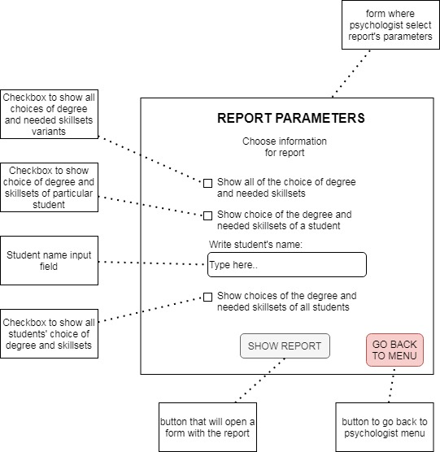

*Examples of reports:*

