Advanced Aircraft anti-collision system using Zigbee communication and reporting to ground station over internet of things (IoT)
Abstract:
With the proliferation of Internet of Things (IoT) devices such as smartphones, sensors, cameras. It is possible to collect massive amount of data for localization and tracking of Aircraft Collisions. An aircraft collision system is designed is to track the signal. Aircraft intelligent system better suits in all areas for tracking signal which is close to the aircraft device. It is necessary to have an intelligent system which identifies collision before it happens and informs the driver to alert or regulate the speed of the aircraft and to move if it is very close to collision.
This project is an advanced wireless zigbee communication by which it detects if any aircraft is coming nearer to another aircraft by giving an Led indication as well as buzzer sound along with LCD display. In this project we are using AT89S52 as its Controller.
In this project IR is placed to track various frequencies emitted. The system is provided with Led and buzzer. If user moves the aircraft, antenna tracks for a corresponding signal the rotation of antenna is based on the signal tracked by IR. Once the signal is traced Led blinks with a buzzer sound and the data is displayed on the LCD. In this way we can track the signal and can avoid the collision with the desired frequency signal.
This project uses regulated 5V, 750mA power supply. 7805 three terminal voltage regulator is used for voltage regulation. Bridge type full wave rectifier is used to rectify the ac out put of secondary of 230/18V step down transformer.
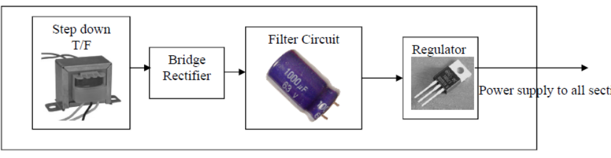

Block Diagram:

AT89S52
Aircraft 1:
16 x 2 LCD Display

Aircraft 2
Zigbee
Max 232
IR Tx Rx proximity
sensor

IOT
ESP8266

Aircraft 2:

AT89S52

16 x 2 LCD Display
Aircraft 1
IR Tx Rx proximity
sensor

IOT
ESP8266

Max 232
Zigbee

