Introduction
Osteomyelitis is an infection of the bone and bone marrow that can result in severe complications including bone necrosis, septic arthritis, amputation, and death.^{1–6} With an estimated prevalence of 2-5 per 10,000, a figure that is increasing, it poses a growing clinical and public health concern in the United States, particularly among older adults and individuals with common comorbidities such as diabetes.^{7,8} Despite its clinical significance, much of the existing literature on osteomyelitis focuses on incidence, management, and localized outcomes, while the mortality burden of this condition on a national scale remains understudied.

Methods
A population-based, cross-sectional study using national mortality data from the Centers for Disease Control and Prevention (CDC) Wide-ranging Online Data for Epidemiologic Research (WONDER) platform was conducted.⁹ The Multiple Cause of Death database was queried for all United States resident deaths from osteomyelitis with any of the following International Classification of Diseases, 10th Edition (ICD-10) codes appearing on the decedents’ death certificates: M46.2, M46.3, M46.4, and M86.¹⁰ Because this database compiles all death certificates filed during the study period of 1999 to 2020, no sampling was performed.¹¹
Age-adjusted mortality rates (AAMRs) were calculated per 100,000 population using the direct method and the 2000 United States population. Trends in AAMRs were modeled using log-linear regression to estimate the annual percent changes (APC). Additionally, trends were stratified by demographics including sex, race/ethnicity, and age group, although crude rates for mortality were used for the latter because AAMRs could not be calculated for them.¹² Trends were also determined for osteomyelitis and common comorbidities, including diabetes (ICD-10: E11-E14), non-pressure chronic ulcers of the lower limb (ICD-10: L97), peripheral vascular disease (ICD-10: I71 and I73), trauma (ICD-10: S00-S99, T00-T14, and T79), decubitus ulcers (ICD-10: L89), and vertebral osteomyelitis itself (ICD-10: M46.2-M46.4).
For the overall trend in AAMR for osteomyelitis from 1999 to 2020, separate analyses were also conducted for the years 1999 to 2015 and 2016 to 2020 to account for the switch in coding from the International Classification of Diseases, 9th Edition (ICD-9) to ICD-10.¹³
A p-value of <0.05 was held to be significant, and all analyses were performed using R version 4.5.0 (R Foundation for Statistical Computing, Vienna, Austria). All code that was used for statistical analysis is available at https://github.com/k-sanaka/cdcwonder_osteomyelitis.

Results
From 1999 to 2020, there were 98,770 deaths in the United States where osteomyelitis was listed as a contributing factor, while 42,495 (43%) had this condition as the underlying cause. Descriptive characteristics of osteomyelitis deaths are shown in Table 1. Over the study period, 54.8% of deaths were among male persons, and 74.4% of all decedents were Non-Hispanic White. The majority of decedents were 65 years or older (77.1%). Diabetes was the most common assessed comorbidity, presenting on 29% of death certificates, while non-pressure chronic ulcers of the lower limb, or infections of the foot, only presented on 0.9%.
The AAMR from osteomyelitis increased from 0.96 in 1999 to 2.13 in 2020, resulting in an APC of 2.91% (95% Confidence Interval [95% CI]: 2.26%, 3.59%; p < 0.01) (Table 2; Figure 1A). Most demographic subgroups also saw increases in AAMR over the study period. Male residents had an APC in their AAMRs of 3.4% (95% CI: 2.7%, 4.1%; p < 0.01), while female residents had an APC of 2.09% (95% CI: 1.33%, 2.85%; p < 0.01) (Figure 1B). Regarding racial and ethnic groups, Non-Hispanic White (APC: 3.19% [95% CI: 2.47%, 3.91%]; p < 0.01), Non-Hispanic Black (APC: 1.91% [95% CI: 1.03%, 2.8%]; p < 0.01), Hispanic (APC: 2.63% [95% CI: 1.93, 3.34]; p < 0.01), and American Indian/Alaska Native (APC: 3.39% [95% CI: 2, 4.79]; p < 0.01) experienced significant increases in AAMR, while Asians or Pacific Islanders were the only group studied to see no significant change (Figure 1C). Finally, while all studied age groups saw significant increases in their crude death rates, those aged 0-34 years (APC: 4.92% [95% CI: 3.58%, 6.28%]; p < 0.01) and 35-64 years (APC: 5.9% [95% CI: 5.34%, 6.47%]; p < 0.01) had greater rises than those aged 65 years or older (APC: 2.18% [95% CI: 1.51%, 2.85%]; p < 0.01) (Figure 1D).
Finally, of all the comorbidities assessed in the study, diabetes-associated osteomyelitis had the highest AAMR in both 1999 and 2020 (Table 3; Figure 2). However, it had a lower APC (APC: 2.85% [95% CI: 1.97%, 3.74%]; p < 0.01) than trauma-associated osteomyelitis (APC: 5.97% [95% CI: 3.96%, 8.03%]; p < 0.01), decubitus ulcer-associated osteomyelitis (APC: 5.3% [95% CI: 4.48%, 6.12%]; p < 0.01), and vertebral osteomyelitis (APC: 5.93%; [95% CI: 5.21%, 6.65%]; p < 0.01). Peripheral vascular disease-related osteomyelitis also saw a significant increase in AAMR from 1999 to 2020 (APC: 2.87% [95% CI: 1.68%, 4.08%]; p < 0.01), while foot infection-related osteomyelitis did not.

Discussion

References
1. Hofstee MI, Muthukrishnan G, Atkins GJ, et al. Current Concepts of Osteomyelitis: From Pathologic Mechanisms to Advanced Research Methods. Am J Pathol. 2020;190(6):1151-1163. doi:10.1016/j.ajpath.2020.02.007
2. Bury DC, Rogers TS, Dickman MM. Osteomyelitis: Diagnosis and Treatment. Am Fam Physician. 2021;104(4):395-402.
3. Masters EA, Trombetta RP, de Mesy Bentley KL, et al. Evolving concepts in bone infection: redefining “biofilm”, “acute vs. chronic osteomyelitis”, “the immune proteome” and “local antibiotic therapy.” Bone Res. 2019;7:20. doi:10.1038/s41413-019-0061-z
4. Ernat J, Riccio AI, Fitzpatrick K, Jo C, Wimberly RL. Osteomyelitis is Commonly Associated With Septic Arthritis of the Shoulder in Children. J Pediatr Orthop. 2017;37(8):547-552. doi:10.1097/BPO.0000000000000709
5. Johnson MJ, Shumway N, Bivins M, Bessesen MT. Outcomes of Limb-Sparing Surgery for Osteomyelitis in the Diabetic Foot: Importance of the Histopathologic Margin. Open Forum Infect Dis. 2019;6(10):ofz382. doi:10.1093/ofid/ofz382
6. Norris BL, Vanderkarr M, Sparks C, Chitnis AS, Ray B, Holy CE. Treatments, cost and healthcare utilization of patients with segmental bone defects. Injury. 2021;52(10):2935-2940. doi:10.1016/j.injury.2021.01.016
7. Huang CC, Tsai KT, Weng SF, et al. Chronic osteomyelitis increases long-term mortality risk in the elderly: a nationwide population-based cohort study. BMC Geriatr. 2016;16(1):72. doi:10.1186/s12877-016-0248-8
8. Huang JF, Wu QN, Zheng XQ, et al. The Characteristics and Mortality of Osteoporosis, Osteomyelitis, or Rheumatoid Arthritis in the Diabetes Population: A Retrospective Study. Int J Endocrinol. 2020;2020(1):8821978. doi:10.1155/2020/8821978
9. Centers for Disease Control and Prevention. CDC WONDER. Centers for Disease Control and Prevention. April 8, 2025. Accessed April 15, 2025. https://wonder.cdc.gov/
10. Multiple Cause of Death Data on CDC WONDER. Accessed May 18, 2025. https://wonder.cdc.gov/mcd.html
11. WONDER Help. CDC WONDER. April 8, 2025. Accessed April 15, 2025. https://wonder.cdc.gov/wonder/help/main.html
12. Age adjustment - Health, United States. August 16, 2024. Accessed May 18, 2025. https://www.cdc.gov/nchs/hus/sources-definitions/age-adjustment.htm
13. NVSS - Mortality - Historical Data - Comparability Between ICD Revisions. March 5, 2019. Accessed May 18, 2025. https://www.cdc.gov/nchs/nvss/mortality/comparability_icd.htm

Table 1. Descriptive characteristics of osteomyelitis-associated deaths, United States, 1999-2020.
Characteristic | Number (%)
Total deaths with osteomyelitis | 98,770 (100)
Underlying cause of osteomyelitis | 42,495 (43)
Sex
Male | 54,100 (54.8)
Female | 44,670 (45.2)
Race/Ethnicity
Non-Hispanic White | 73,446 (74.4)
Non-Hispanic Black | 16,059 (16.3)
Hispanic | 6,470 (6.6)
Asian or Pacific Islander | 1,505 (1.5)
American Indian/Alaska Native | 982 (1)
Age group (years)
0-34 | 872 (0.9)
35-64 | 21,769 (22)
65+ | 76,126 (77.1)
Comorbidities
Diabetes | 28,671 (29)
Non-pressure foot ulcer | 873 (0.9)
Peripheral vascular disease | 9,250 (9.4)
Trauma | 2,648 (2.7)
Decubitus ulcer | 8,922 (9)
Vertebral | 14,431 (14.6)
The table summarizes demographic characteristics (sex, race/ethnicity, age), the proportion where osteomyelitis was the underlying cause of death, and the prevalence of select comorbidities.
Table 2. Age-adjusted mortality rates and annual percent changes for osteomyelitis by demographic group.
Group | 1999 AAMR | 2020 AAMR | APC (%) | 95% CI | p-value
Overall | 0.96 | 2.13 | 2.91 | (2.26, 3.57) | <0.01
Sex
Male | 1.17 | 2.88 | 3.4 | (2.7, 4.1) | <0.01
Female | 0.83 | 1.55 | 2.09 | (1.33, 2.85) | <0.01
Race/Ethnicity
NH White | 0.88 | 2.04 | 3.19 | (2.47, 3.91) | <0.01
NH Black | 1.96 | 3.85 | 1.91 | (1.03, 2.8) | <0.01
Hispanic | 0.84 | 1.8 | 2.63 | (1.93, 3.34) | <0.01
Asian or Pacific Islander | 0.74 | 0.73 | 1.1 | (-0.29, 2.51) | 0.11
American Indian/Alaska Native | 1.38* | 2.83 | 3.39 | (2, 4.79) | <0.01
Age group (years)
0-34 | 0.02*† | 0.05† | 4.92 | (3.58, 6.28) | <0.01
35-64 | 0.42† | 1.62† | 5.9 | (5.34, 6.47) | <0.01
65+ | 6.27† | 12.22† | 2.18 | (1.51, 2.85) | <0.01
AAMR = age-adjusted mortality rate. APC = annual percent change. * Indicates that value is from 2000 due to value from 1999 being unavailable. † Indicates that value is crude rate because age-adjusted mortality rates are unavailable for age groups. Linear regression was used to determine all p-values.

Table 3. Age-adjusted mortality rates and annual percent changes for osteomyelitis by comorbidity.
Comorbidity | 1999 AAMR | 2020 AAMR | APC (%) | 95% CI | p-value
Diabetes | 0.28 | 0.66 | 2.85 | (1.97, 3.74) | <0.01
Non-pressure foot ulcer | 0 | 0.01 | 0.71 | (-0.5, 1.94) | 0.23
Peripheral vascular disease | 0.09 | 0.22 | 2.87 | (1.68, 4.08) | <0.01
Trauma | 0.02 | 0.07 | 5.97 | (3.96, 8.03) | <0.01
Decubitus ulcer | 0.07 | 0.22 | 5.3 | (4.48, 6.12) | <0.01
Vertebral | 0.08 | 0.38 | 5.93 | (5.21, 6.65) | <0.01
AAMR = age-adjusted mortality rate. APC = annual percent change. Linear regression was used to determine all p-values.

Figure 1. Overall and stratified trends in age-adjusted mortality rates for osteomyelitis in the United States, 1999-2000.
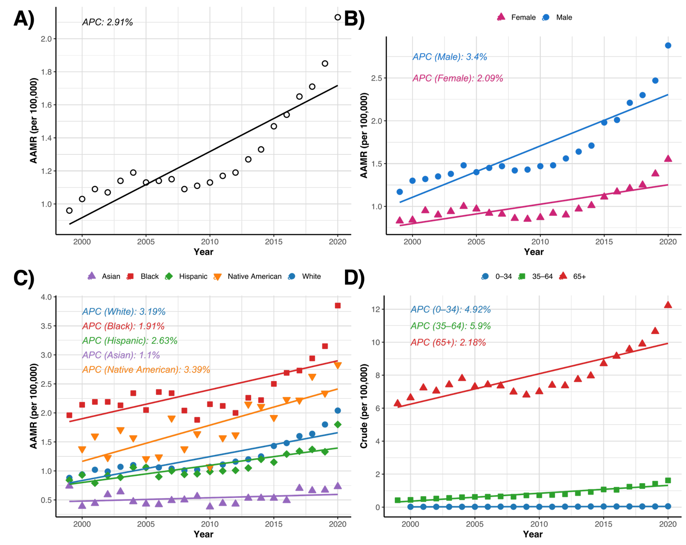
APC = annual percent change. A. Trend in age-adjusted mortality rates for all osteomyelitis deaths in the United States, 1999-2020. B. Trends in age-adjusted mortality rates for all osteomyelitis deaths in the United States stratified by sex, 1999-2020. C. Trends in age-adjusted mortality rates for all osteomyelitis deaths in the United States stratified by race, 1999-2020. D. Trends in crude mortality rates for all osteomyelitis deaths in the United States stratified by age group, 1999-2020.

Figure 2. Trends in age-adjusted mortality rates for subtypes of osteomyelitis in the United States, 1999-2000.
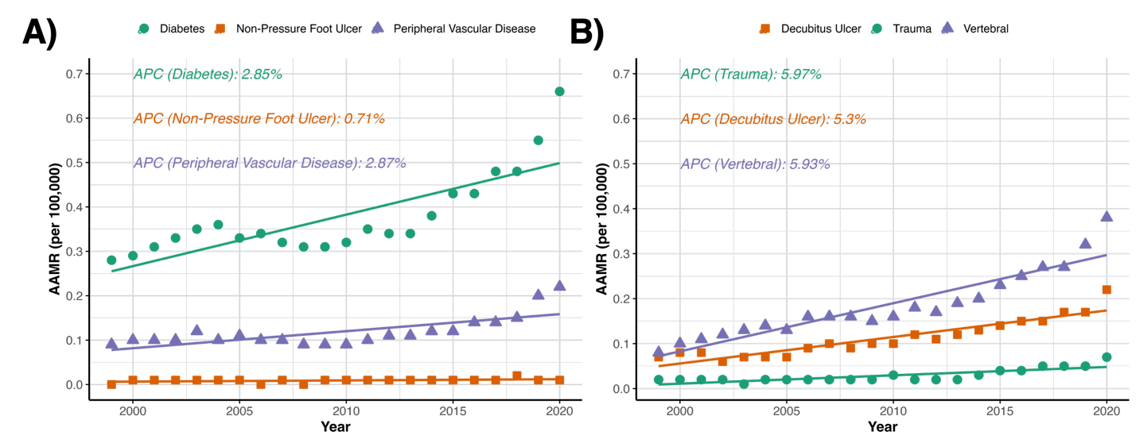
APC = annual percent change. A. Trends in age-adjusted mortality rates for osteomyelitis and diabetes mellitus, osteomyelitis and non-pressure lower limb ulcers, and osteomyelitis and peripheral vascular disease. B. Trends in age-adjusted mortality rates for osteomyelitis and traumatic injury, osteomyelitis and decubitus ulcers, and vertebral osteomyelitis.

