National Trends in Osteomyelitis-Associated Mortality in the United States, 1999-2020

Krishna O. Sanaka BS¹, Andrew L. Wang BS¹, Rodrigo M. Carillo Larco MD, PhD^{2,3}, Marcos Coutinho Schecter MD⁴

1. Emory College of Arts and Sciences, Emory University, Atlanta GA, USA
2. Emory Global Diabetes Research Center of Woodruff Health Sciences Center, Emory University, Atlanta, GA, USA
3. Hubert Department of Global Health, Rollins School of Public Health, Emory University, Atlanta, GA, USA
4. Grady Health System, Division of Infectious Diseases, Department of Medicine, School of Medicine, Emory University, Atlanta, GA, USA

Introduction
Osteomyelitis is an infection of the bone and bone marrow that can result in severe complications including bone necrosis, septic arthritis, amputation, and death.^{1–6} With an estimated prevalence of 2-5 per 10,000, a figure that is increasing, it poses a growing clinical and public health concern in the United States, particularly among older adults and individuals with common comorbidities such as diabetes.^{7,8} Much of the existing literature has focused on incidence, management, and localized outcomes, underscoring the complexity of treating this condition and preventing long-term sequelae.
Previous mortality studies have largely focused on vertebral osteomyelitis in the inpatient setting, finding that many patients had a high burden of comorbidities and noting a one-year mortality rate of around 10-20%.^{9–12} A study of osteomyelitis epidemiology in Brazil found that there were significant racial and regional differences in morbidity and mortality, revealing a demographic component to the condition.¹³ Despite these insights, the broader mortality impact of osteomyelitis in the United States remains poorly characterized.
Therefore, this study aimed to use United States mortality data from 1999 to 2020 to examine trends in age-adjusted mortality rates (AAMRs) for osteomyelitis. The objectives were to describe temporal patterns in osteomyelitis-related mortality, characterize demographic differences by age, sex, and race/ethnicity, and assess the prevalence of key comorbidities, including diabetes, peripheral vascular disease, and non-pressure foot ulcers.

Methods
A population-based, cross-sectional study using national mortality data from the Centers for Disease Control and Prevention (CDC) Wide-ranging Online Data for Epidemiologic Research (WONDER) platform was conducted.¹⁴ The Multiple Cause of Death database was queried for all United States resident deaths from osteomyelitis with any of the following International Classification of Diseases, 10th Edition (ICD-10) codes appearing on the decedents’ death certificates: M46.2, M46.3, M46.4, and M86.¹⁵ Because this database compiles all death certificates filed during the study period of 1999 to 2020, no sampling was performed.¹⁶
Age-adjusted mortality rates (AAMRs) were calculated per 100,000 population using the direct method and the 2000 United States population. This adjustment allows for comparisons between populations with different age distributions by removing age as a confounding factor.¹⁷ Trends in AAMRs were modeled using log-linear regression to estimate the annual percent changes (APC). Additionally, trends were stratified by demographics including sex, race/ethnicity, and age group, although crude rates for mortality were used for the latter because AAMRs could not be calculated for them.¹⁷ Trends were also determined for osteomyelitis and common comorbidities, including diabetes (ICD-10: E11-E14), non-pressure foot ulcers (ICD-10: L97), peripheral vascular disease (ICD-10: I71 and I73), trauma (ICD-10: S00-S99, T00-T14, and T79), decubitus ulcers (ICD-10: L89), and vertebral osteomyelitis itself (ICD-10: M46.2-M46.4).
For the overall trend in AAMR for osteomyelitis from 1999 to 2020, separate analyses were also conducted for the years 1999 to 2015 and 2016 to 2020 to account for the switch in coding from the International Classification of Diseases, 9th Edition (ICD-9) to ICD-10.¹⁸
A p-value of <0.05 was held to be significant, and all analyses were performed using R version 4.5.0 (R Foundation for Statistical Computing, Vienna, Austria). All code that was used for statistical analysis is available at https://github.com/k-sanaka/cdcwonder_osteomyelitis.

Results
From 1999 to 2020, there were 98,770 deaths in the United States where osteomyelitis was listed as a contributing factor, while 42,495 (43%) had this condition as the underlying cause. Descriptive characteristics of osteomyelitis deaths are shown in Table 1. Over the study period, 54.8% of deaths were among male persons, and 74.4% of all decedents were Non-Hispanic White. The majority of decedents were 65 years or older (77.1%). Diabetes was the most common assessed comorbidity, presenting on 29% of death certificates, while non-pressure foot ulcers only presented on 0.9%.
The AAMR from osteomyelitis increased from 0.96 in 1999 to 2.13 in 2020, resulting in an APC of 2.91% (95% Confidence Interval [95% CI]: 2.26%, 3.59%; p < 0.01) (Table 2; Figure 1A). Most demographic subgroups also saw increases in AAMR over the study period. Male residents had an APC in their AAMRs of 3.4% (95% CI: 2.7%, 4.1%; p < 0.01), while female residents had an APC of 2.09% (95% CI: 1.33%, 2.85%; p < 0.01) (Figure 1B). Regarding racial and ethnic groups, Non-Hispanic White (APC: 3.19% [95% CI: 2.47%, 3.91%]; p < 0.01), Non-Hispanic Black (APC: 1.91% [95% CI: 1.03%, 2.8%]; p < 0.01), Hispanic (APC: 2.63% [95% CI: 1.93, 3.34]; p < 0.01), and American Indian/Alaska Native (APC: 3.39% [95% CI: 2, 4.79]; p < 0.01) experienced significant increases in AAMR, while Asians or Pacific Islanders were the only group studied to see no significant change (Figure 1C). Finally, while all studied age groups saw significant increases in their crude death rates, those aged 0-34 years (APC: 4.92% [95% CI: 3.58%, 6.28%]; p < 0.01) and 35-64 years (APC: 5.9% [95% CI: 5.34%, 6.47%]; p < 0.01) had greater rises than those aged 65 years or older (APC: 2.18% [95% CI: 1.51%, 2.85%]; p < 0.01) (Figure 1D).
Finally, of all the comorbidities assessed in the study, diabetes-associated osteomyelitis had the highest AAMR in both 1999 and 2020 (Table 3; Figure 2). However, it had a lower APC (APC: 2.85% [95% CI: 1.97%, 3.74%]; p < 0.01) than trauma-associated osteomyelitis (APC: 5.97% [95% CI: 3.96%, 8.03%]; p < 0.01), decubitus ulcer-associated osteomyelitis (APC: 5.3% [95% CI: 4.48%, 6.12%]; p < 0.01), and vertebral osteomyelitis (APC: 5.93%; [95% CI: 5.21%, 6.65%]; p < 0.01). Peripheral vascular disease-related osteomyelitis also saw a significant increase in AAMR from 1999 to 2020 (APC: 2.87% [95% CI: 1.68%, 4.08%]; p < 0.01), while non-pressure foot ulcer-related osteomyelitis did not.

Discussion
In this national, population-based analysis of United States mortality data, AAMRs from osteomyelitis more than doubled from 1999 to 2020, with consistent increases across most demographic subgroups. Notably, younger persons, particularly those aged 0-34 years and 35-64 years, saw steeper increases in AAMRs than those aged 65 years and older, and male and Non-Hispanic Black persons generally had higher AAMRs throughout the study period. Diabetes was the most common comorbidity that was assessed, though trauma-associated osteomyelitis, decubitus ulcer-related osteomyelitis, and vertebral osteomyelitis showed the fastest growing mortality trends. This study is the first known national United States analysis of osteomyelitis mortality using CDC WONDER over multiple decades.
These findings suggest that osteomyelitis poses an increasing mortality burden in the United States, particularly among historically vulnerable demographic groups.¹⁹ The especially steep increase in AAMRs among younger populations may reflect rising rates of uncontrolled diabetes, barriers to early diagnosis and treatment, and substance use, which can lead to bacteremia and subsequent bone infections.^{20–24} Similarly, the elevated mortality in male compared to female persons may be associated with delayed care-seeking, a higher burden of comorbidities, or occupational risk factors.²⁵
The persistent burden of diabetes-related osteomyelitis from 1999 to 2020 aligns with previous studies.^{26,27} However, the more rapid rise in mortality burden associated with trauma and decubitus ulcers points to emerging clinical challenges in wound care and infection prevention.^{28–30} These findings point to a need for comprehensive, interdisciplinary care in managing patients at risk to avoid osteomyelitis and its associated complications.
Prior studies of vertebral osteomyelitis have consistently reported one-year mortality rates of 10-20%, often in the context of advanced age and multimorbidity.^{9–12} However, national mortality patterns associated with osteomyelitis, including both vertebral and nonvertebral forms, remain understudied. The use of CDC WONDER data over a 22-year period provides a broader view of population-level trends, capturing deaths where osteomyelitis was the underlying cause and a contributing condition.
References
1. Hofstee MI, Muthukrishnan G, Atkins GJ, et al. Current Concepts of Osteomyelitis: From Pathologic Mechanisms to Advanced Research Methods. Am J Pathol. 2020;190(6):1151-1163. doi:10.1016/j.ajpath.2020.02.007
2. Bury DC, Rogers TS, Dickman MM. Osteomyelitis: Diagnosis and Treatment. Am Fam Physician. 2021;104(4):395-402.
3. Masters EA, Trombetta RP, de Mesy Bentley KL, et al. Evolving concepts in bone infection: redefining “biofilm”, “acute vs. chronic osteomyelitis”, “the immune proteome” and “local antibiotic therapy.” Bone Res. 2019;7:20. doi:10.1038/s41413-019-0061-z
4. Ernat J, Riccio AI, Fitzpatrick K, Jo C, Wimberly RL. Osteomyelitis is Commonly Associated With Septic Arthritis of the Shoulder in Children. J Pediatr Orthop. 2017;37(8):547-552. doi:10.1097/BPO.0000000000000709
5. Johnson MJ, Shumway N, Bivins M, Bessesen MT. Outcomes of Limb-Sparing Surgery for Osteomyelitis in the Diabetic Foot: Importance of the Histopathologic Margin. Open Forum Infect Dis. 2019;6(10):ofz382. doi:10.1093/ofid/ofz382
6. Norris BL, Vanderkarr M, Sparks C, Chitnis AS, Ray B, Holy CE. Treatments, cost and healthcare utilization of patients with segmental bone defects. Injury. 2021;52(10):2935-2940. doi:10.1016/j.injury.2021.01.016
7. Huang CC, Tsai KT, Weng SF, et al. Chronic osteomyelitis increases long-term mortality risk in the elderly: a nationwide population-based cohort study. BMC Geriatr. 2016;16(1):72. doi:10.1186/s12877-016-0248-8
8. Huang JF, Wu QN, Zheng XQ, et al. The Characteristics and Mortality of Osteoporosis, Osteomyelitis, or Rheumatoid Arthritis in the Diabetes Population: A Retrospective Study. Int J Endocrinol. 2020;2020(1):8821978. doi:10.1155/2020/8821978
9. Ziarko TP, Walter N, Schindler M, Alt V, Rupp M, Lang S. Risk Factors for the In-Hospital Mortality in Pyogenic Vertebral Osteomyelitis: A Cross-Sectional Study on 9753 Patients. J Clin Med. 2023;12(14):4805. doi:10.3390/jcm12144805
10. Yagdiran A, Otto-Lambertz C, Lingscheid KM, et al. Quality of life and mortality after surgical treatment for vertebral osteomyelitis (VO): a prospective study. Eur Spine J. 2021;30(6):1721-1731. doi:10.1007/s00586-020-06519-z
11. Akiyama T, Chikuda H, Yasunaga H, Horiguchi H, Fushimi K, Saita K. Incidence and risk factors for mortality of vertebral osteomyelitis: a retrospective analysis using the Japanese diagnosis procedure combination database. Published online January 1, 2013. doi:10.1136/bmjopen-2012-002412
12. Kernich N, Abi-Chokami A, Jung N, et al. Early and late mortality in vertebral osteomyelitis: who dies within the first year after diagnosis. Infection. Published online May 9, 2025. doi:10.1007/s15010-025-02541-9
13. Sousa ALS de, Soto FG, Roque GM, et al. Osteomielitis en Brasil: Un análisis epidemiológico de 2019-2023. LUMEN VIRTUS. 2024;15(40):4577-4588. doi:10.56238/levv15n40-039
14. Centers for Disease Control and Prevention. CDC WONDER. Centers for Disease Control and Prevention. April 8, 2025. Accessed April 15, 2025. https://wonder.cdc.gov/
15. Multiple Cause of Death Data on CDC WONDER. Accessed May 18, 2025. https://wonder.cdc.gov/mcd.html
16. WONDER Help. CDC WONDER. April 8, 2025. Accessed April 15, 2025. https://wonder.cdc.gov/wonder/help/main.html
17. Age adjustment - Health, United States. August 16, 2024. Accessed May 18, 2025. https://www.cdc.gov/nchs/hus/sources-definitions/age-adjustment.htm
18. NVSS - Mortality - Historical Data - Comparability Between ICD Revisions. March 5, 2019. Accessed May 18, 2025. https://www.cdc.gov/nchs/nvss/mortality/comparability_icd.htm
19. 2022 National Healthcare Quality and Disparities Report. Accessed May 21, 2025. https://www.ahrq.gov/research/findings/nhqrdr/nhqdr22/index.html
20. Wittman JT, Bullard KM, Benoit SR. Trends in Preventive Care Services Among U.S. Adults With Diagnosed Diabetes, 2008–2020. Diabetes Care. 2023;46(12):2285-2291. doi:10.2337/dc23-1119
21. Inoue K, Liu M, Aggarwal R, Marinacci LX, Wadhera RK. Prevalence and Control of Diabetes Among US Adults, 2013 to 2023. JAMA. 2025;333(14):1255-1257. doi:10.1001/jama.2024.28513
22. Pihoker C, Braffett BH, Songer TJ, et al. Diabetes Care Barriers, Use, and Health Outcomes in Younger Adults With Type 1 and Type 2 Diabetes. JAMA Netw Open. 2023;6(5):e2312147. doi:10.1001/jamanetworkopen.2023.12147
23. Lu W, Lopez-Castro T, Vu T. Population-based examination of substance use disorders and treatment use among US young adults in the National Survey on Drug Use and Health, 2011–2019. Drug Alcohol Depend Rep. 2023;8:100181. doi:10.1016/j.dadr.2023.100181
24. Marks LR, Calix JJ, Wildenthal JA, et al. Staphylococcus aureus injection drug use-associated bloodstream infections are propagated by community outbreaks of diverse lineages. Commun Med. 2021;1(1):1-10. doi:10.1038/s43856-021-00053-9
25. Biswas A, Harbin S, Irvin E, et al. Differences between men and women in their risk of work injury and disability: A systematic review. Am J Ind Med. 2022;65(7):576-588. doi:10.1002/ajim.23364
26. Senneville É, Albalawi Z, van Asten SA, et al. IWGDF/IDSA Guidelines on the Diagnosis and Treatment of Diabetes-related Foot Infections (IWGDF/IDSA 2023). Clin Infect Dis. Published online October 2, 2023:ciad527. doi:10.1093/cid/ciad527
27. Ren J, Gao H, Luo W, et al. Risk Factors, Microbiology, and Prognosis of Diabetic Foot Osteomyelitis: A Retrospective Cohort Study. Endocr Pract. 2025;31(5):578-584. doi:10.1016/j.eprac.2025.01.007
28. Labeau SO, Afonso E, Benbenishty J, et al. Prevalence, associated factors and outcomes of pressure injuries in adult intensive care unit patients: the DecubICUs study. Intensive Care Med. 2021;47(2):160-169. doi:10.1007/s00134-020-06234-9
29. Glance LG, Stone PW, Mukamel DB, Dick AW. Increases in Mortality, Length of Stay, and Cost Associated With Hospital-Acquired Infections in Trauma Patients. Arch Surg. 2011;146(7):794-801. doi:10.1001/archsurg.2011.41
30. Kattouf N, Assaf M, Haidar S, Bachir R, El Sayed M, BouChebl R. The Risk Factors for Mortality among Septic Trauma Patients: A Retrospective Cohort Study Using the National Trauma Data Bank. Emerg Med Int. 2022;2022:6386078. doi:10.1155/2022/6386078

Table 1. Descriptive characteristics of osteomyelitis-associated deaths, United States, 1999-2020.
Characteristic | Number (%)
Total deaths with osteomyelitis | 98,770 (100)
Underlying cause of osteomyelitis | 42,495 (43)
Sex
Male | 54,100 (54.8)
Female | 44,670 (45.2)
Race/Ethnicity
Non-Hispanic White | 73,446 (74.4)
Non-Hispanic Black | 16,059 (16.3)
Hispanic | 6,470 (6.6)
Asian or Pacific Islander | 1,505 (1.5)
American Indian/Alaska Native | 982 (1)
Age group (years)
0-34 | 872 (0.9)
35-64 | 21,769 (22)
65+ | 76,126 (77.1)
Comorbidities
Diabetes | 28,671 (29)
Non-pressure foot ulcer | 873 (0.9)
Peripheral vascular disease | 9,250 (9.4)
Trauma | 2,648 (2.7)
Decubitus ulcer | 8,922 (9)
Vertebral | 14,431 (14.6)
The table summarizes demographic characteristics (sex, race/ethnicity, age), the proportion where osteomyelitis was the underlying cause of death, and the prevalence of select comorbidities.
Table 2. Age-adjusted mortality rates and annual percent changes for osteomyelitis by demographic group.
Group | 1999 AAMR | 2020 AAMR | APC (%) | APC (%) 95% CI | p-value
Overall | 0.96 | 2.13 | 2.91 | (2.26, 3.57) | <0.01
Sex
Male | 1.17 | 2.88 | 3.4 | (2.7, 4.1) | <0.01
Female | 0.83 | 1.55 | 2.09 | (1.33, 2.85) | <0.01
Race/Ethnicity
NH White | 0.88 | 2.04 | 3.19 | (2.47, 3.91) | <0.01
NH Black | 1.96 | 3.85 | 1.91 | (1.03, 2.8) | <0.01
Hispanic | 0.84 | 1.8 | 2.63 | (1.93, 3.34) | <0.01
Asian or Pacific Islander | 0.74 | 0.73 | 1.1 | (-0.29, 2.51) | 0.11
American Indian/Alaska Native | 1.38* | 2.83 | 3.39 | (2, 4.79) | <0.01
Age group (years)
0-34 | 0.02*† | 0.05† | 4.92 | (3.58, 6.28) | <0.01
35-64 | 0.42† | 1.62† | 5.9 | (5.34, 6.47) | <0.01
65+ | 6.27† | 12.22† | 2.18 | (1.51, 2.85) | <0.01
AAMR = age-adjusted mortality rate. APC = annual percent change. * Indicates that value is from 2000 due to value from 1999 being unavailable. † Indicates that value is crude rate because age-adjusted mortality rates are unavailable for age groups. Linear regression was used to determine all p-values.

Table 3. Age-adjusted mortality rates and annual percent changes for osteomyelitis by comorbidity.
Comorbidity | 1999 AAMR | 2020 AAMR | APC (%) | APC (%) 95% CI | p-value
Diabetes | 0.28 | 0.66 | 2.85 | (1.97, 3.74) | <0.01
Non-pressure foot ulcer | 0 | 0.01 | 0.71 | (-0.5, 1.94) | 0.23
Peripheral vascular disease | 0.09 | 0.22 | 2.87 | (1.68, 4.08) | <0.01
Trauma | 0.02 | 0.07 | 5.97 | (3.96, 8.03) | <0.01
Decubitus ulcer | 0.07 | 0.22 | 5.3 | (4.48, 6.12) | <0.01
Vertebral | 0.08 | 0.38 | 5.93 | (5.21, 6.65) | <0.01
AAMR = age-adjusted mortality rate. APC = annual percent change. Linear regression was used to determine all p-values.

Figure 1. Overall and stratified trends in age-adjusted mortality rates for osteomyelitis in the United States, 1999-2000.
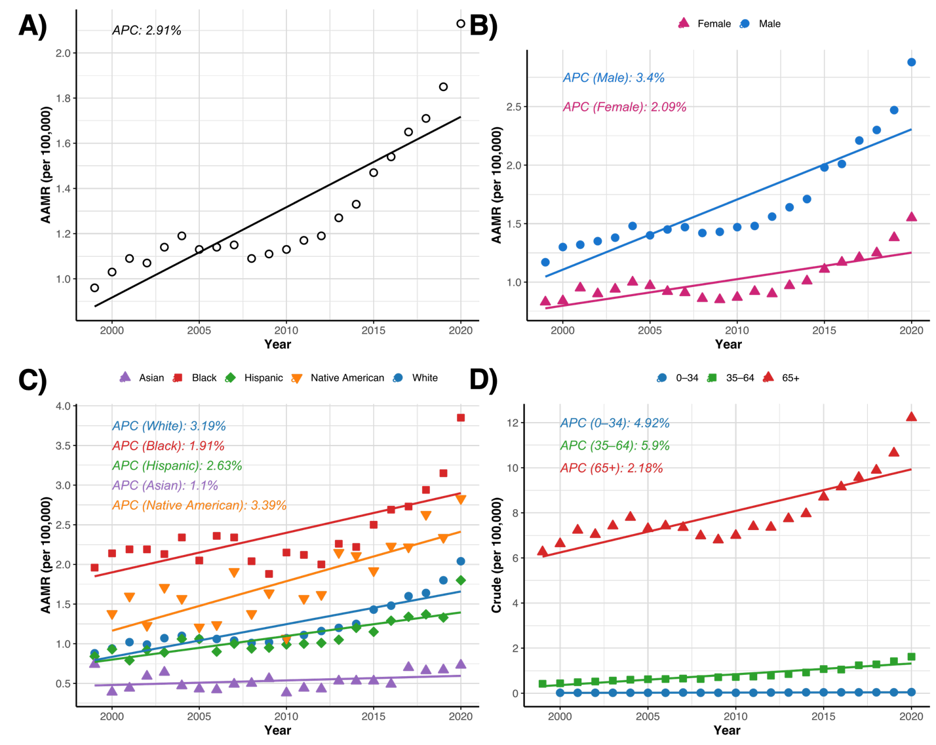
APC = annual percent change. A. Trend in age-adjusted mortality rates for all osteomyelitis deaths in the United States, 1999-2020. B. Trends in age-adjusted mortality rates for all osteomyelitis deaths in the United States stratified by sex, 1999-2020. C. Trends in age-adjusted mortality rates for all osteomyelitis deaths in the United States stratified by race, 1999-2020. D. Trends in crude mortality rates for all osteomyelitis deaths in the United States stratified by age group, 1999-2020.

Figure 2. Trends in age-adjusted mortality rates for subtypes of osteomyelitis in the United States, 1999-2000.
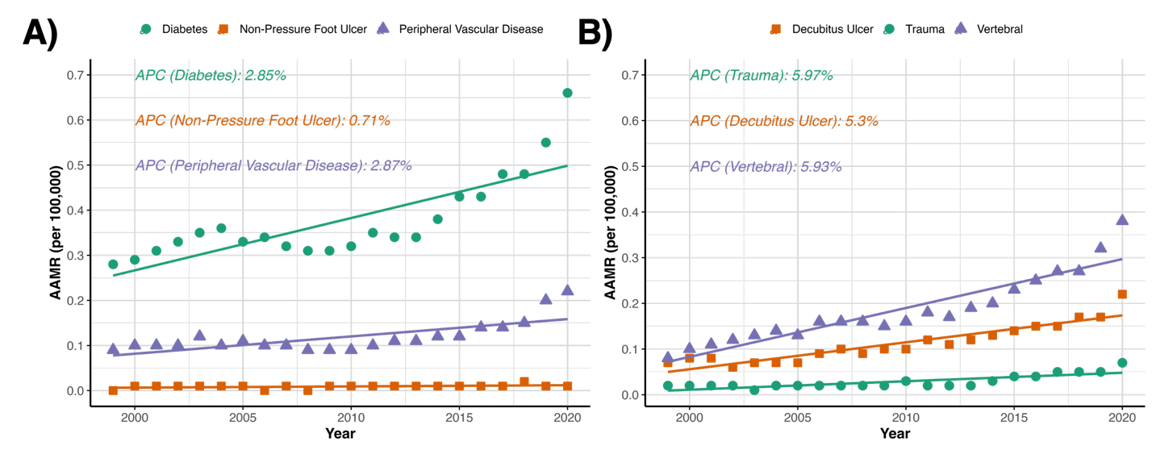
APC = annual percent change. A. Trends in age-adjusted mortality rates for osteomyelitis and diabetes mellitus, osteomyelitis and non-pressure lower limb ulcers, and osteomyelitis and peripheral vascular disease. B. Trends in age-adjusted mortality rates for osteomyelitis and traumatic injury, osteomyelitis and decubitus ulcers, and vertebral osteomyelitis.

