Trends in Osteomyelitis-Associated Mortality in the United States, 1999-2020: A Population-Based Analysis
Krishna O. Sanaka¹, Andrew L. Wang¹, Marcos C. Schechter, MD¹

1. Emory University, Atlanta, GA, United States.

Background: Osteomyelitis is a serious musculoskeletal infection associated with prolonged hospitalizations, amputation risk, and high mortality in vulnerable populations. Despite clinical advances, little is known about national trends in osteomyelitis mortality over time or across demographic groups. We aimed to characterize population-level mortality patterns associated with osteomyelitis in the United States from 1999 to 2020.

Methods: We conducted a retrospective, population-based analysis from the CDC WONDER Multiple Cause of Death database, covering the years 1999 to 2020. Death certificates with osteomyelitis as an underlying or contributing cause were identified using the M86 code in the International Classification of Diseases, 10th Revision. We fitted log-linear regression models to estimate the annual percent change (APC) in age-adjusted mortality rates (AAMRs) over time with stratifications for demographic subgroups. All analyses were conducted in R (v4.3.1).

Results: Throughout the study period, there were 85,474 death certificates with osteomyelitis listed as a contributing factor. The AAMR rose from 0.9 in 1999 to 1.8 in 2020, good for an APC of 2.57% (p < 0.01). AAMR appeared to rise more quickly in male patients, with an APC of 3.1% (p < 0.01) compared to 1.47% in female patients (p < 0.01). Racial groups also showed differences in their trends in AAMR over the study period. Native American patients showed the greatest increase, with an APC of 3.26% (p < 0.01), followed by White patients with 2.58% (p < 0.01), and Black patients with 1.35% (p < 0.01). Asian patients showed no significant change in their mortality rates over the study period. Overall, male patients demonstrated significantly higher AAMRs than female patients (1.52 vs. 0.88) and Black patients had significantly higher AAMRs (2.08) than Native American (1.61), White (1.09), and Asian patients (0.46).

Conclusion: Osteomyelitis mortality rates have steadily increased over the past two decades, with marked demographic disparities. These findings underscore the need for improved prevention, earlier diagnosis, and targeted intervention strategies, particularly in high-burden populations.
Figure 1.
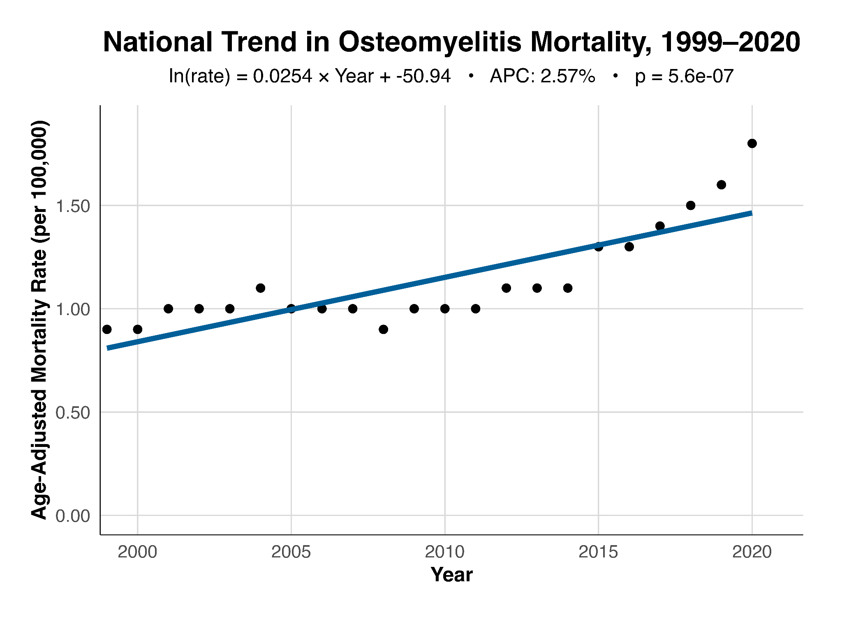
Figure 2.
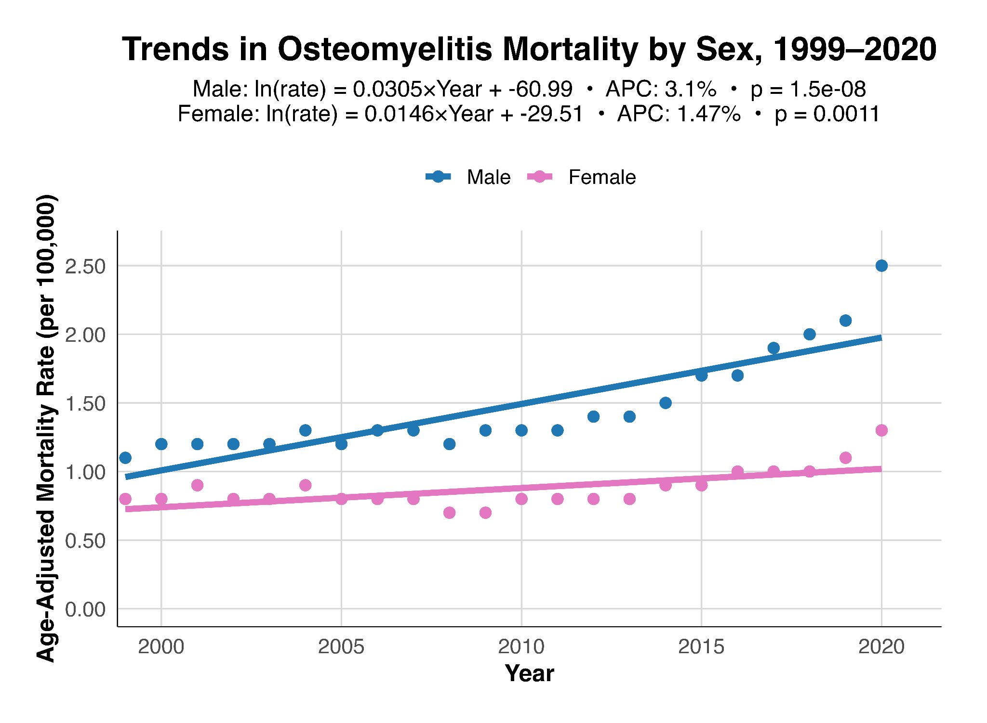
Figure 3.
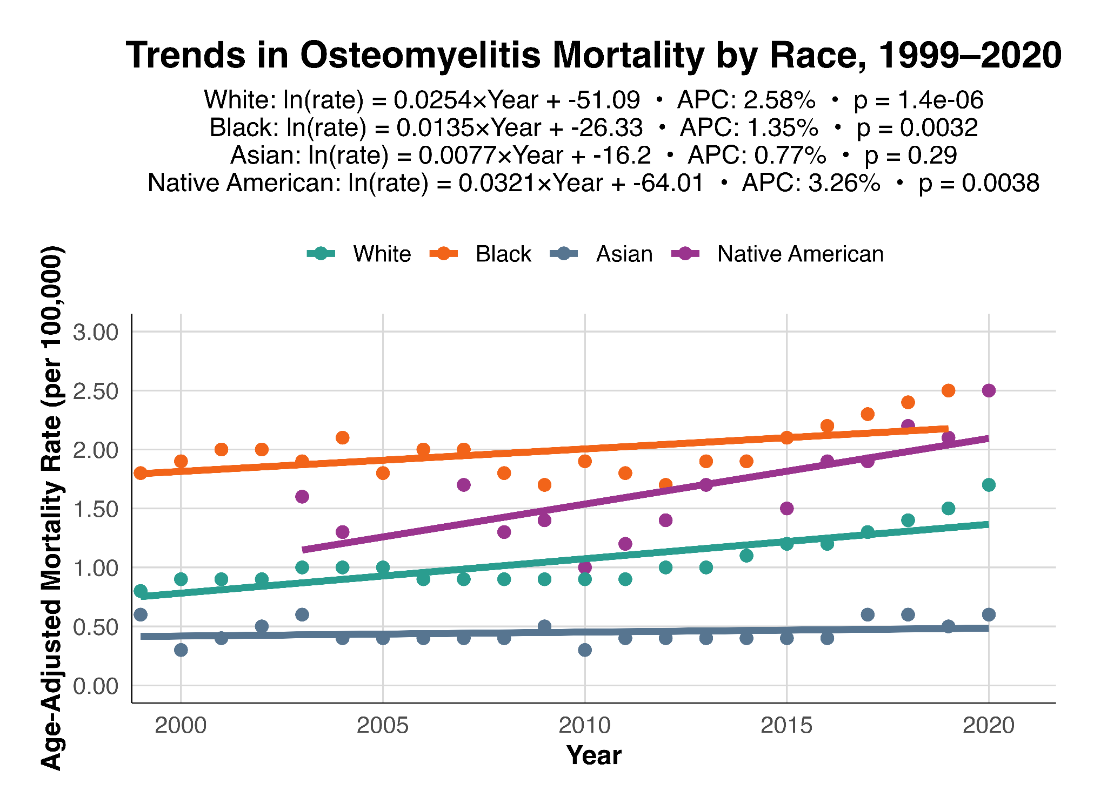
Figure 4.
