Introduction
Osteomyelitis is the inflammation of the bone and bone marrow generally caused by an infectious process.^{1,2} It can lead to significant clinical burden, with complications including chronic infection, amputations, and increased healthcare costs.^{3–5} The condition has an estimated prevalence of 2-5 cases per 10,000 people in the United States, a number that has risen over the past few decades in association with an older population and increases in the prevalence of common comorbidities such as diabetes.⁶
Despite this increase in prevalence, there remains a lack of literature regarding the national mortality burden of osteomyelitis in the United States. Previous American studies have examined the mortality burden of osteomyelitis as a complication of diabetes, finding that deaths in recent decades have seen the most pronounced rise among patients younger than 65 years old.⁷

Methods
We conducted a population-based, cross-sectional study using national mortality data from the Centers for Disease Control and Prevention (CDC) Wide-ranging Online Data for Epidemiologic Research (WONDER) platform. The study included all U.S. resident deaths from 1999 to 2020 in which osteomyelitis was listed as a multiple cause of death, meaning it appeared anywhere on the death certificate, either as the underlying or a contributing cause.⁸
Because the dataset represents the full population of death certificates filed during the study period, no sampling was performed.⁹ The data are drawn from the National Vital Statistics System (NVSS) and represent complete death records submitted by state vital registration offices.
Data were accessed and downloaded using CDC WONDER’s Multiple Cause of Death query tool.⁸ Osteomyelitis-related deaths were identified using ICD-10 code M86. The following variables were extracted: number of deaths; crude mortality rate (per 100,000 population); and age-adjusted mortality rate (AAMR), standardized to the 2000 U.S. standard population. We further stratified the data by: sex (male, female); race/ethnicity (non-Hispanic White, non-Hispanic Black, Hispanic, Asian or Pacific Islander, American Indian/Alaska Native); and age group (<45, 45–64, and ≥65 years). Population denominators were provided by CDC WONDER, based on bridged-race census estimates.
Descriptive statistics were used to summarize the burden of osteomyelitis-related mortality. We calculated crude and age-adjusted mortality rates for the overall population and for each demographic subgroup. To assess temporal trends, we plotted annual age-adjusted mortality rates from 1999 to 2020 and conducted linear regression while calculating annual percent change (APC). We calculated rate differences and rate ratios between demographic groups to identify disparities in osteomyelitis-related mortality. All statistical tests were performed using R (version 4.3.1).
Because this study used publicly available, de-identified data, it was considered not human subjects research and was exempt from institutional review board approval.

Results
Throughout the study period from 1999 to 2020, there were 56,806,341 death certificates recorded in the United States, and of these, 85,474 (0.2%) had osteomyelitis listed as a contributing factor. Furthermore, of those death certificates with osteomyelitis listed as a contributing factor, 35,192 (41.2%) had osteomyelitis as the underlying cause. Among all 85,474 death certificates with osteomyelitis listed as any contributing factor, 46,961 (54.9%) corresponded to a male individual and 69,154 (80.9%) to those who were White. The average age at death for the death certificates was 74.7 years.
The AAMR for osteomyelitis as a contributing cause of death rose from 0.88 (95% Confidence Interval [95% CI]: 0.85 – 0.92) per 100,000 in 1999 to 1.81 (95% CI: 1.76 – 1.85) per 100,000 in 2020, resulting in an APC of 2.57% (p < 0.01) (Figure 1). Male and female persons showed differences in how their AAMRs changed over the study period (Figure 2). For male persons, AAMRs rose from 1.07 (95% CI: 1 – 1.13) per 100,000 in 1999 to 2.47 (95% CI: 2.39 – 2.54) per 100,000, resulting in an APC of 3.1% (p < 0.01). In female persons, AAMRs rose from 0.77 (95% CI: 0.72 – 0.81) per 100,000 in 1999 to 1.27 (95% CI: 1.22 – 1.32), leading to an APC of 1.47% (p < 0.01). Racial groups also showed differences in their trends in AAMR over the study period (Figure 3). Native American persons showed the greatest increase in their AAMRs over the study period, from 1.62 (95% CI: 1 – 2.47) per 100,000 in 2003, when estimates were first reliable, to 2.53 (95% CI: 2.02 – 3.05) per 100,000 in 2020, resulting in an APC of 3.26%. They were followed by White persons with an APC of 2.58% (0.81 [95% CI: 0.77 – 0.84] per 100,000 in 1999 to 1.69 [95% CI: 1.65 – 1.73] per 100,000 in 2020; p < 0.01), and Black persons with an APC of 1.35% (1.77 [95% CI: 1.6 – 1.95] per 100,000 in 1999 to 3.15 [95% CI: 2.98 – 3.33] per 100,000 in 2020; p < 0.01). Asian persons demonstrated no significant change in their mortality rates over the study period.
Overall, male persons demonstrated significantly higher AAMRs than female persons (1.52 per 100,000 vs. 0.88 per 100,000) and Black persons had significantly higher AAMRs (2.08 per 100,000) than Native American (1.61 per 100,000), White (1.09 per 100,000), and Asian persons (0.46 per 100,000) (Figure 4).

Discussion

References
1. Hofstee MI, Muthukrishnan G, Atkins GJ, et al. Current Concepts of Osteomyelitis: From Pathologic Mechanisms to Advanced Research Methods. The American Journal of Pathology. 2020;190(6):1151-1163. doi:10.1016/j.ajpath.2020.02.007
2. Bury DC, Rogers TS, Dickman MM. Osteomyelitis: Diagnosis and Treatment. Am Fam Physician. 2021;104(4):395-402.
3. Masters EA, Trombetta RP, de Mesy Bentley KL, et al. Evolving concepts in bone infection: redefining “biofilm”, “acute vs. chronic osteomyelitis”, “the immune proteome” and “local antibiotic therapy.” Bone Res. 2019;7:20. doi:10.1038/s41413-019-0061-z
4. Johnson MJ, Shumway N, Bivins M, Bessesen MT. Outcomes of Limb-Sparing Surgery for Osteomyelitis in the Diabetic Foot: Importance of the Histopathologic Margin. Open Forum Infect Dis. 2019;6(10):ofz382. doi:10.1093/ofid/ofz382
5. Norris BL, Vanderkarr M, Sparks C, Chitnis AS, Ray B, Holy CE. Treatments, cost and healthcare utilization of patients with segmental bone defects. Injury. 2021;52(10):2935-2940. doi:10.1016/j.injury.2021.01.016
6. Osteomyelitis | Bone Infection Symptoms, Causes, Treatment. Accessed May 15, 2025. https://rarediseases.org/rare-diseases/osteomyelitis/
7. Huang JF, Wu QN, Zheng XQ, et al. The Characteristics and Mortality of Osteoporosis, Osteomyelitis, or Rheumatoid Arthritis in the Diabetes Population: A Retrospective Study. International Journal of Endocrinology. 2020;2020(1):8821978. doi:10.1155/2020/8821978
8. Centers for Disease Control and Prevention. CDC WONDER. Centers for Disease Control and Prevention. April 8, 2025. Accessed April 15, 2025. https://wonder.cdc.gov/
9. WONDER Help. CDC WONDER. April 8, 2025. Accessed April 15, 2025. https://wonder.cdc.gov/wonder/help/main.html

Figure 1. National Trend in Osteomyelitis Mortality, United States 1999-2020.
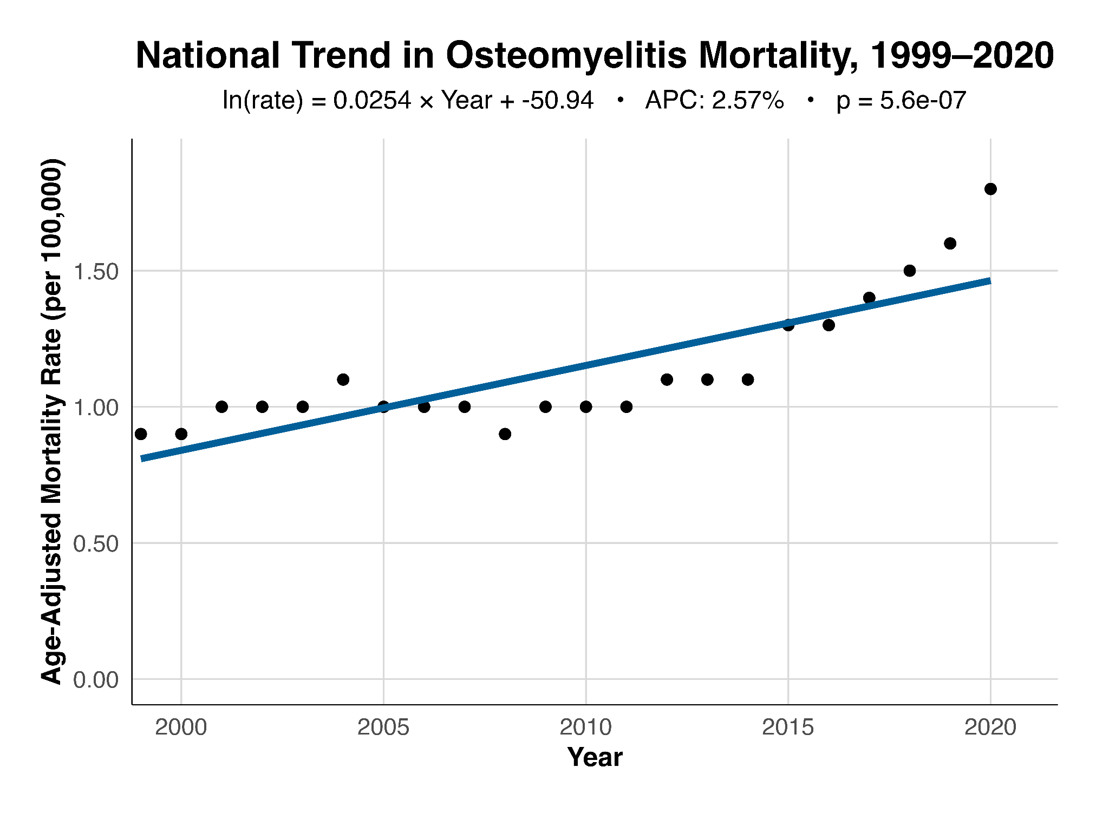
Figure 2. Trends in Osteomyelitis Mortality by Sex, United States 1999-2020.
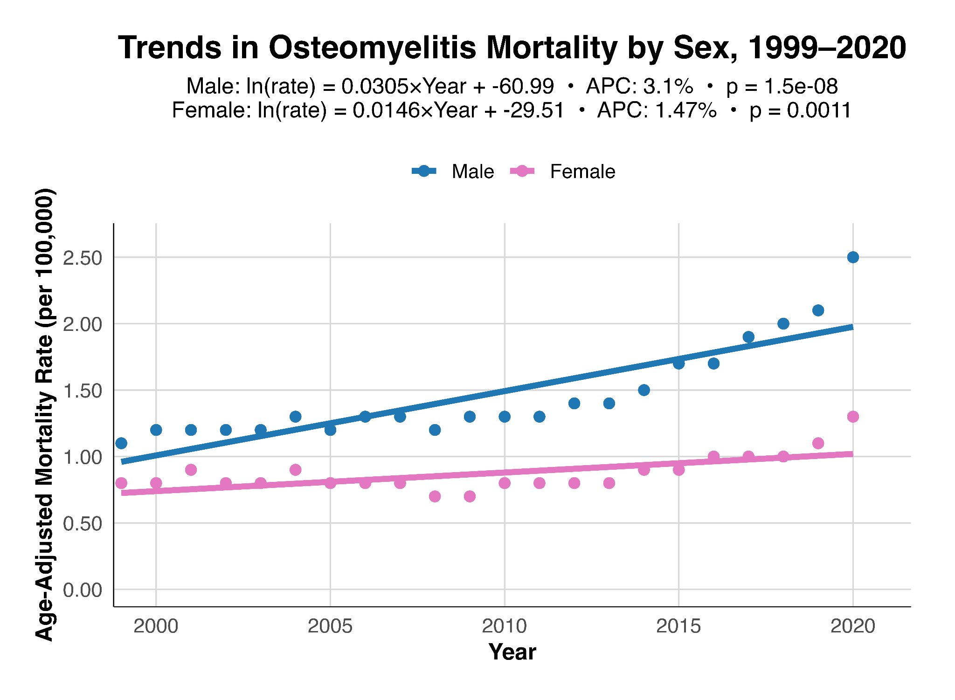
Figure 3. Trends in Osteomyelitis Mortality by Race, United States 1999-2020.
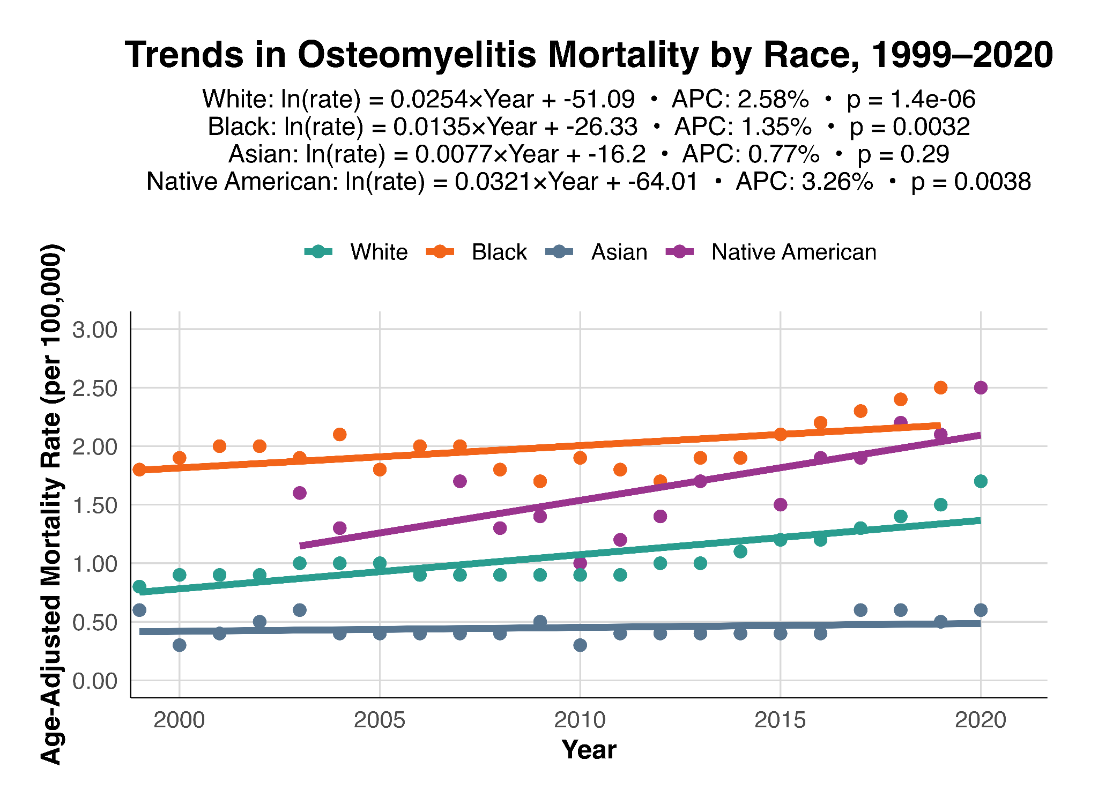
Figure 4. Overall Age-Adjusted Mortality Rates by Demographic Group, United States 1999-2020.
