Introduction

Methods
A population-based, cross-sectional study using national mortality data from the Centers for Disease Control and Prevention (CDC) Wide-ranging Online Data for Epidemiologic Research (WONDER) platform was conducted.¹

Results

Discussion

References
1. Centers for Disease Control and Prevention. CDC WONDER. Centers for Disease Control and Prevention. April 8, 2025. Accessed April 15, 2025. https://wonder.cdc.gov/

Table 1. Descriptive characteristics of osteomyelitis-associated deaths, United States, 1999-2020.
Characteristic | Number (%)
Total deaths with osteomyelitis | 98,770 (100)
Underlying cause of osteomyelitis | 42,495 (43)
Sex
Male | 54,100 (54.8)
Female | 44,670 (45.2)
Race/Ethnicity
Non-Hispanic White | 73,446 (74.4)
Non-Hispanic Black | 16,059 (16.3)
Hispanic | 6,470 (6.6)
Asian or Pacific Islander | 1,505 (1.5)
American Indian/Alaska Native | 982 (1)
Age group (years)
0-34 | 872 (0.9)
35-64 | 21,769 (22)
65+ | 76,126 (77.1)
Comorbidities
Diabetes | 28,671 (29)
Foot infection | 873 (0.9)
Peripheral vascular disease | 9,250 (9.4)
Trauma | 2,648 (2.7)
Decubitus ulcer | 8,922 (9)
Vertebral | 14,431 (14.6)

Table 2. Age-adjusted mortality rates and annual percent changes for osteomyelitis by demographic group.
Group | 1999 AAMR | 2020 AAMR | APC (%) | 95% CI | p-value
Overall | 0.96 | 2.13 | 2.91 | (2.26, 3.57) | <0.01
Sex
Male | 1.17 | 2.88 | 3.4 | (2.7, 4.1) | <0.01
Female | 0.83 | 1.55 | 2.09 | (1.33, 2.85) | <0.01
Race/Ethnicity
NH White | 0.88 | 2.04 | 3.19 | (2.47, 3.91) | <0.01
NH Black | 1.96 | 3.85 | 1.91 | (1.03, 2.8) | <0.01
Hispanic | 0.84 | 1.8 | 2.63 | (1.93, 3.34) | <0.01
Asian or Pacific Islander | 0.74 | 0.73 | 1.1 | (-0.29, 2.51) | 0.11
American Indian/Alaska Native | 1.38* | 2.83 | 3.39 | (2, 4.79) | <0.01
Age group (years)
0-34 | 0.02*† | 0.05† | 4.92 | (3.58, 6.28) | <0.01
35-64 | 0.42† | 1.62† | 5.9 | (5.34, 6.47) | <0.01
65+ | 6.27† | 12.22† | 2.18 | (1.51, 2.85) | <0.01

Table 3. Age-adjusted mortality rates and annual percent changes for osteomyelitis by comorbidity.
Comorbidity | 1999 AAMR | 2020 AAMR | APC (%) | 95% CI | p-value
Diabetes |  |  | 2.85 | (1.97, 3.74) | <0.01
Foot infection |  |  | 0.71 | (-0.5, 1.94) | 0.23
Peripheral vascular disease |  |  | 2.87 | (1.68, 4.08) | <0.01
Trauma |  |  | 5.97 | (3.96, 8.03) | <0.01
Debritus ulcer |  |  | 5.3 | (4.48, 6.12) | <0.01
Vertebral |  |  | 5.93 | (5.21, 6.65) | <0.01

Figure 1. Overall and stratified trends in age-adjusted mortality rates for osteomyelitis in the United States, 1999-2000.
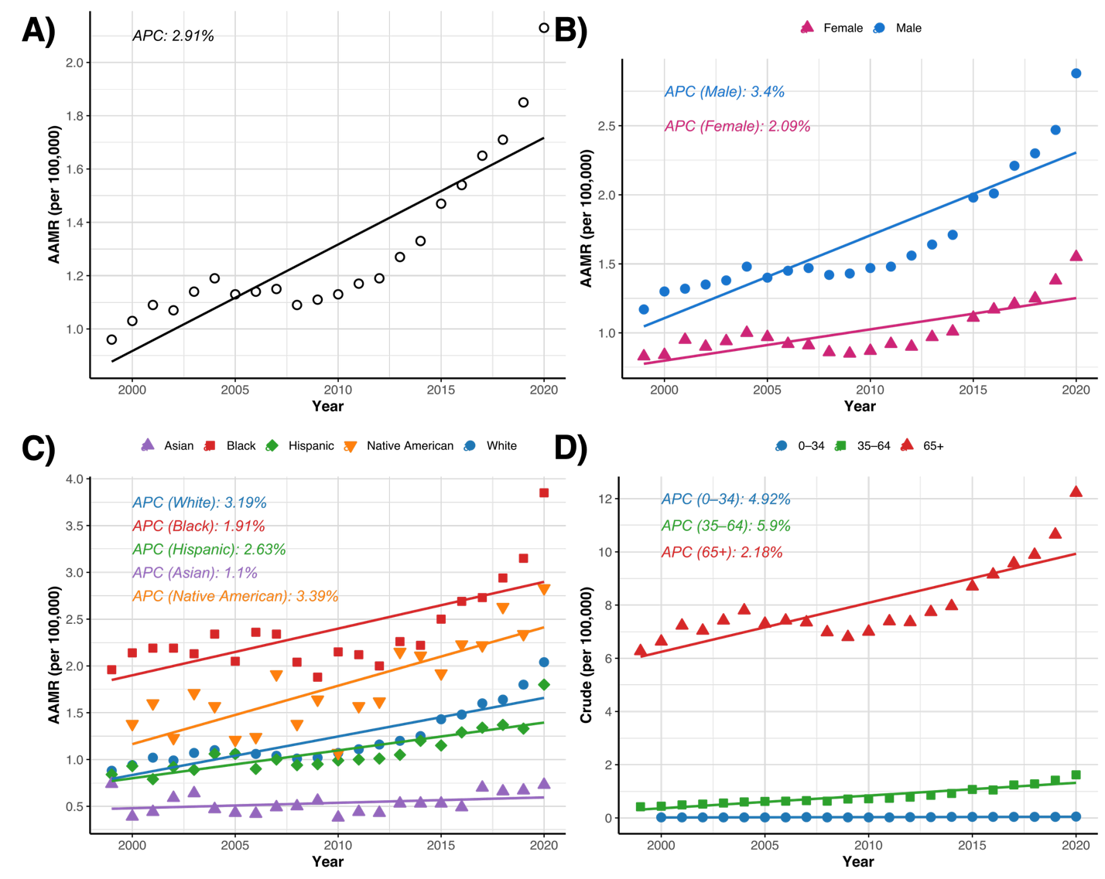

Figure 2. Trends in age-adjusted mortality rates for subtypes of osteomyelitis in the United States, 1999-2000.
