ASSIGNMENT 4

Gonzalez, Kimberly

2020-07-17

# Markdown Basics

## Favorite Foods

1. Pizza
2. Sushi
3. Tacos

## Images

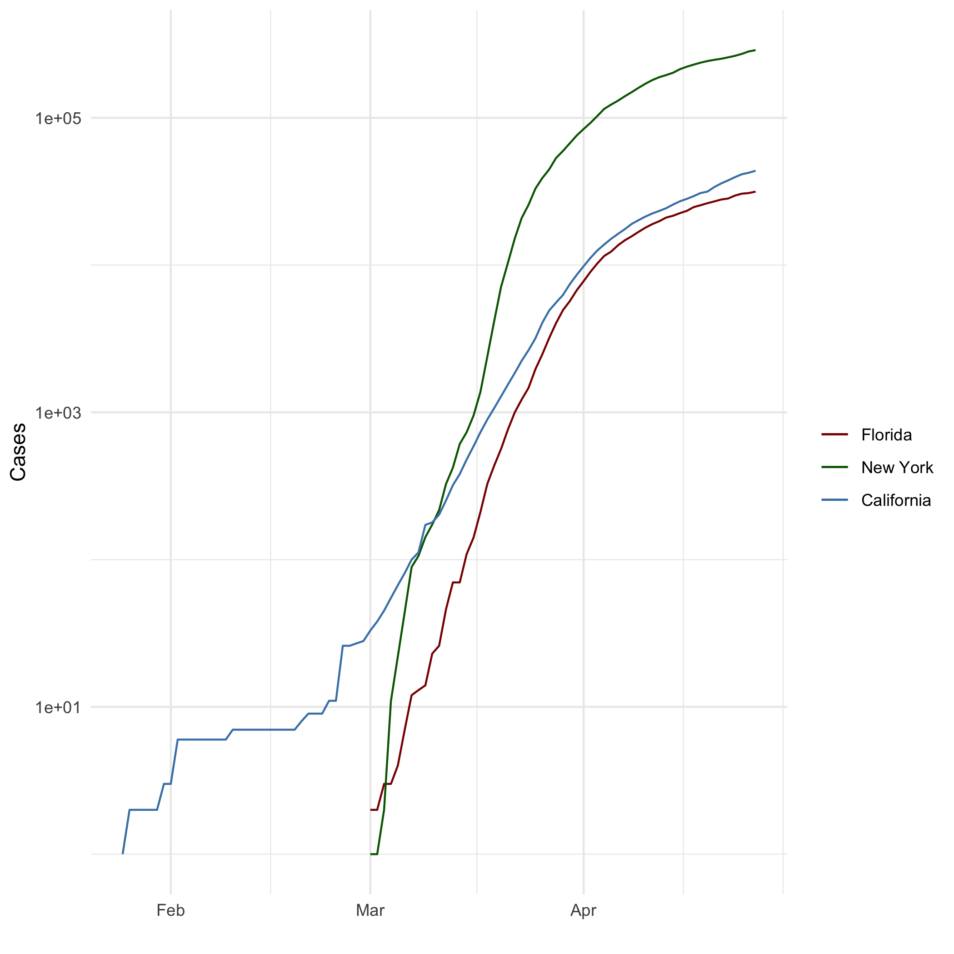

## Add a Quote

“The devil doesn’t come dressed in a red cape and pointy horns. He comes dressed as everything you’ve ever wished for.”

## Add an Equation

$$\sum_{i=1}^{n}{x_{i}}$$

## Add a Footnote

This is a footnote.[1]

## Add Citations

* R for Everyone Lander (2014)
* Discovering Statistics Using R Field, Miles, and Field (2012)

# Inline Code

## NY Times COVID-19 Data

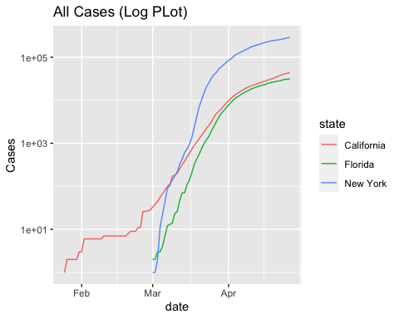

## R4DS Height vs Earnings

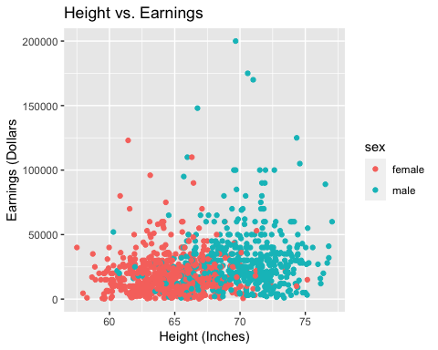

# Tables

One Ring to Rule Them All

|  |  |  |  |  |
| --- | --- | --- | --- | --- |
| name | race | in_fellowship | ring_bearer | age |
| Aragon | Men | TRUE | FALSE | 88 |
| Bilbo | Hobbit | FALSE | TRUE | 129 |
| Frodo | Hobbit | TRUE | TRUE | 51 |
| Galadriel | Elf | FALSE | FALSE | 7000 |
| Sam | Hobbit | TRUE | TRUE | 36 |
| Gandalf | Maia | TRUE | TRUE | 2019 |
| Legolas | Elf | TRUE | FALSE | 2931 |
| Sauron | Maia | FALSE | TRUE | 7052 |
| Gollum | Hobbit | FALSE | TRUE | 589 |

## Pandoc Table

##   
##   
## Name Race In.Fellowship. Is.Ring.Bearer. Age   
## -------- -------- ---------------- ----------------- ------  
## Aragon Men Yes No 88   
## Bilbo Hobbit No Yes 129   
## Frodo Hobbit Yes Yes 51   
## Sam Hobbit Yes Yes 36   
## Sauron Maia No Yes 7052

# References

Field, A., J. Miles, and Z. Field. 2012. *Discovering Statistics Using R*. SAGE Publications. <https://books.google.com/books?id=wd2K2zC3swIC>.

Lander, J. P. 2014. *R for Everyone: Advanced Analytics and Graphics*. Addison-Wesley Data and Analytics Series. Addison-Wesley. <https://books.google.com/books?id=3eBVAgAAQBAJ>.

1. This is a footnote for Week 3, Assignment 4