PRODUCTION OF PLAIN YOGHURT ADDING HAIRY BASIL MUCILAGE AS PREBIOTICS
Piyanoot Noiduang,^{1,}* Areerat Ittakornpan¹, Vasinee Marukatat¹
¹Department of Food Technology, Faculty of Science, Siam University, Bangkok 10160, Thailand
*e-mail: piyanoot.noi@siam.edu

Abstract: The objective of this study was to develop yoghurt using mucilage from hairy basil as a prebiotic and to study the effect of the mucilage on the quality of yoghurt. The production of yoghurt with various levels of the mucilage (0.025, 0.05, 0.075 and 0.1%, w/w) was investigated. The results showed that growth of lactic acid bacteria, viscosity and %acidity increased when the level of mucilage increased, while total soluble solid and pH decreased with increasing level of mucilage. The result showed that the addition of hairy basil mucilage had improved the lactic acid bacteria of yoghurt. The result showed that fermentation time of yoghurt production decreased when the level of mucilage increased. The optimal condition for the yoghurt production was 0.075% (w/w) mucilage concentration, incubated at 45 °C for 2 hours.
Introduction:
Yoghurt is a popular fermented milk product consumed in many parts of the world. Yoghurt may be defined as the solids, custard-like fermented milk product made from fortified high-solids milk using a symbiotic mixture of lactic acid bacteria, including Lactobacillus bulgaricus and Streptococcus thermophilus. ¹ Fermentation of lactose by these bacteria produces lactic acid, which acts on milk protein to give yoghurt its texture and its characteristic tang. Its production and consumption is growing continuously due to its therapeutic properties beside its high nutritive value.²
Prebiotics are defined as non-digestible but fermentable food ingredients that confer a health benefit on the host associated with modulation of microbiota in the colon. Consequently, there is a great deal of interest in the use of prebiotic oligosaccharides as functional food ingredients to manipulate the composition of colonic microflora in order to improve health.³ Many recent studies have shown that incorporation of prebiotic ingredients in probiotic yoghurt would probably leads to enhancement of the survival of those microorganisms. Prebiotics are selectively fermented ingredients that allow specific changes, both in the composition and/or activity in the gastrointestinal microbiota which confer benefits upon host well-being and health.⁴ Seydin et al. (2005)⁵ found that yoghurts containing inulin had a good flavor and a smooth texture. Use of inulin in synbiotic yoghurt containing L.acidophillus and L.casei increased viability of probiotic bacteria and improved organoleptic quality during cold storage.⁶
Hairy basil (Ocimum canum Sims) is one of the common plants consumed by Thais. Its leaves and seeds are used for cooking in various menus. Premwatana et al. (1985)⁷ determined the dietary fiber content by the neutral detergent fiber method in 29 commonly eaten Thai plants consisting of ten kinds of vegetables, ten kinds of fruits, and nine kinds of grains and seeds. Thus, the objectives of this study was to evaluate the effect of hairy basil mucilage on physical and chemical properties during yoghurt production.
Methodology:

1. Preparation of hairy basil mucilage powder
The method of preparing mucilage from hairy basil seeds (Ocimum canum Sims) was as follows. The seeds are soaked in water and it becomes swollen at 60°C within 1 hour. It was blended with blender at low velocity for 1 minutes, separated mucilage with coffee filter or cheese cloth. The mucilage isolated from seeds was dried in an oven at 55°C for 12 hours and stored indried glass boxes until further uses.⁸

2. Production of yoghurt
Unsweetened low-fat natural yoghurt (Yolida®) with live active lactic acid bacteria culture (Lactobacillus bulgaricus and Streptococcus thermophiles) was purchased from a retail supermarket and was used as the yoghurt starter culture. Experimental plain yoghurt was prepared by adding 3% skim milk powder in pasteurized whole milk (Foremost ®), then bring it to heat at 70°C for 30 minutes and subsequently cooled to 45°C. It was then inoculated with 5 levels (5, 10, 15, 20 and 25%, w/w) of starter culture yoghurt. The inoculated mix was incubated at 45°C for 6 hours and was taken every hour for investigation. Viscosity of yoghurt was determined using Brookfield viscometer. Total soluble solids (TSS) was measured using hand refractometer. Acidity was determined by AOAC (2000)⁹ method and pH was measured by pH meter. MRS agar was used to determine lactic acid bacteria count. ³ The experiment was done in 3 replicates according to Completely Randomized Design. The data was tested according to ANOVA. Duncan’s Multiple Range Test was employed to determine significant differences at the 5% level.

3. Effect of hairy basil mucilage powder as prebiotics on yoghurt production
Yoghurt was prepared using milk with 3% skim milk. Milk was preheated to 40 °C, at which stage the skim milk powder and mucilage from hairy basil seeds were added. The level of mucilage addition was 0.025, 0.05, 0.075 and 0.1% (w/w). Milk samples were heated at 70°C for 30 minutes, then cooled down to 45°C for inoculation. The samples were inoculated with yoghurt culture (from Optimum inoculum from experiment in step 2). The inoculated samples were mixed thoroughly and dispensed in 500 mL polystyrene cups with lids then incubated at 45 °C until the % acidity was more than 0.85 or pH dropped to 4.6. The inoculated mix was incubated at 45°C and sample was taken every hour for the measurement. Viscosity of yoghurt were determined using Brookfield viscometer. Total soluble solids (TSS) were measured using hand refractometer. Acidity was determined by AOAC (2000)⁹ method and pH with pH meter. MRS agar was used to determine lactic acid bacteria count.³ The experiment was done in 3 replicates according to Completely Randomized Design. The data was tested according to ANOVA. Duncan’s Multiple Range Test was employed to determine significant differences at the 5% level.
Results, Discussion and Conclusion:

1. Preparation of hairy basil mucilage powder
The dried mucilage powder showed white-cream color (Figure 1). The chemical composition analysis of the mucilage isolated from the hairy basil seeds in dried powder was found to be high fiber content⁸ (Data not showed).
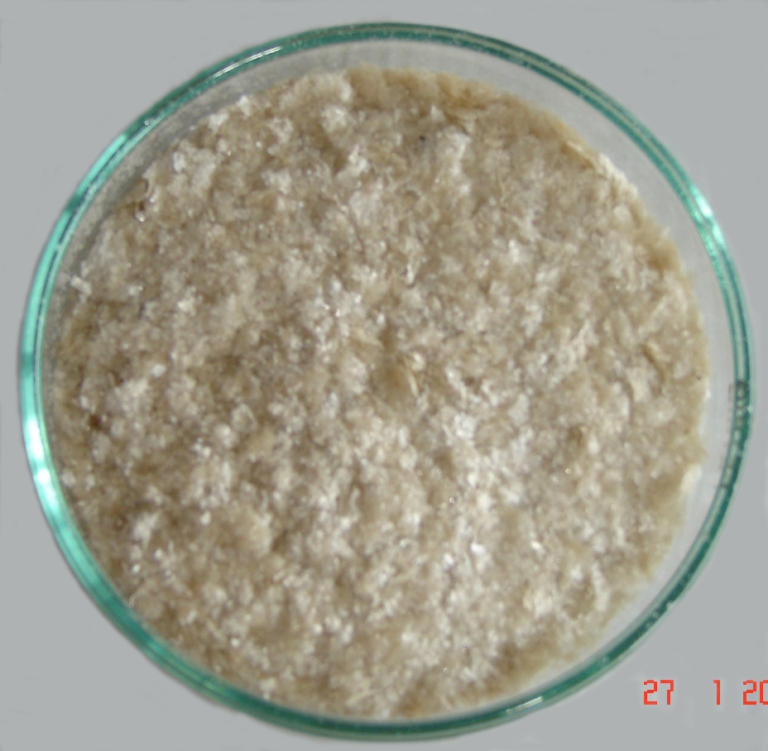

Figure 1 Dried mucilage from hairy basil seeds

2. Production of yoghurt
This study was conducted to produce control yoghurt. It was found that yoghurt starter (Yolida®) contained 8.54 ± 0.25 log10 cfu/ml. The 5 levels of starter culture yoghurt (5, 10, 15, 20 and 25%, w/w) were used to produce yoghurt. The results showed that %acidity increased when the level of starter culture yoghurt increased, while total soluble solid and pH decreased. The result of lactic acid bacteria count of all yoghurt samples ranged from 6.29 ± 0.18 to 8.01 ± 0.21 log10 cfu/ml (Table 1). Viscosity of all yoghurt samples at 6 h ranged from 5,800 to 6333.33 cP. Changes of total soluble solid and %acidity of yoghurt was shown in Figure 2.

Table 1 physical and chemical properties of yoghurt during fermentation (at 0 and 6 hours) and lactic acid bacteria count
Starter culture  (%) | TSS (°Brix) |  | pH |  | % acidity |  | Lactic acid bacteria count  (log10 cfu/ml)
Starter culture  (%) | 0 h | 6 h | 0 h | 6 h | 0 h | 6 h | 0 h | 6 h
5 | 15.5 ± 0.0ª | 8.0 ± 0.0ª | 6.32± 0.01ª | 4.62± 0.02ª | 0.21± 0.01ª | 0.68± 0.02ª | 5.90 ± 0.16ª | 6.29 ± 0.18ª
10 | 15.4 ± 0.2ª | 8.0 ± 0.1ª | 6.21± 0.01^{b} | 4.55± 0.01^{b} | 0.23± 0.01^{ab} | 0.78± 0.01^{b} | 6.23 ± 0.10^{b} | 6.73 ± 0.13^{b}
15 | 15.6 ± 0.1ª | 7.8 ± 0.2ª | 6.13± 0.02^{c} | 4.50± 0.00^{c} | 0.24± 0.01^{b} | 0.80± 0.00^{c} | 6.54 ± 0.13^{c} | 7.28 ± 0.11^{c}
20 | 16.0 ± 0.0^{b} | 8.4 ± 0.0^{b} | 5.71± 0.01^{d} | 4.38± 0.02^{d} | 0.28± 0.02^{c} | 0.89± 0.01^{d} | 6.84 ± 0.09^{d} | 7.67 ± 0.13^{d}
25 | 16.2 ± 0.2^{b} | 8.4 ± 0.1^{b} | 5.63± 0.02e | 4.37± 0.01^{d} | 0.30± 0.02^{c} | 0.91± 0.01^{d} | 7.20 ± 0.16e | 8.01 ± 0.21e
Note: Values with different letters in superscript in columns are significantly different (p≤ 0.05)
Mean ± standard deviation (SD)
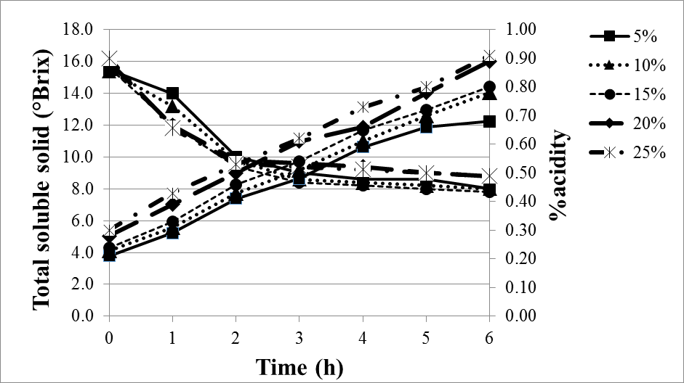

Figure 2 Total soluble solid and %acidity changes of yoghurt with different level of starter culture (5, 10, 15, 20 and 25%, w/w) during fermentation

The results showed that yoghurt fermentation involved the conversion of lactose to lactic acid by bacteria, resulted in total soluble solid reduction. Acidity changes could be evaluated as an indirect characteristic of the growth of lactic acid bacteria. Figure 2 shows the lactic acid content in yoghurt with different level of starter culture yoghurt during fermentation. Generally, the lactic acid content is increasing from the 0 h to 6 h. Yoghurt with 25% (w/w) starter culture showed the highest lactic acid content. The initial content of lactic acid ranged from 0.21 to 0.30% while the final lactic acid content ranged from 0.68 to 0.91% for all samples. From Thai Industrial Standard (TIS 2146-2546)¹⁰ requires that the %acidity (% lactic acid) more than 0.6% and sum of microorganisms constituting the starter culture more than 7 log10 cfu/ml. The results showed that after 6 hours of incubation, the yogurt inoculated with 15, 20 and 25% (w/w) starter culture was based on standard criteria. The acidity of a good finished product is around 0.85-0.9%.¹¹ Thus, the level of yoghurt with 20% (w/w) starter culture which had been incubated for 5 h was used as the optimal condition of control formula.

3. Effect of hairy basil mucilage powder as prebiotics on yogurt production
In this experiment, yoghurt with 20% (w/w) starter culture was used as inoculum and control formula. The production of yoghurt with 4 levels of mucilage (0.025, 0.05, 0.075 and 0.1% (w/w)) was investigated. The physical and chemical properties of yoghurt at 0 and 5 hours (optimal incubation time) was showed in Table 2. Changes of total soluble solid and %acidity of yogurt was shown in Figure 3. In this experiment, the results showed that viscosity and %acidity increased when the level of mucilage increased, while total soluble solid and pH decreased. Viscosity of yoghurt with 4 levels of mucilage (0.025, 0.05, 0.075 and 0.1% (w/w)) was 6200, 6500, 6600, 6900 and 7000 cP, respectively.

Table 2 physical and chemical properties of yoghurt during fermentation (at 0 and 5 hours) and lactic acid bacteria count
Amount of mucilage (%) | TSS (°Brix) |  | pH |  | % acidity |  | Lactic acid bacteria count  (log10 cfu/ml)
Amount of mucilage (%) | 0 h | 5 h | 0 h | 5 h | 0 h | 5 h | 0 h^{ns} | 5 h
0 (control) | 15.6 ± 0.1ª | 9.0 ± 0.0ª | 5.96 ± 0.02ª | 4.49 ± 0.01ª | 0.28 ± 0.01ª | 0.85 ± 0.00ª | 6.58 ± 0.16 | 7.29 ± 0.11ª
0.025 | 17.0 ± 0.0^{b} | 10.2 ± 0.2^{b} | 6.32 ± 0.02^{b} | 4.54 ± 0.01^{b} | 0.30 ± 0.02^{b} | 0.93 ± 0.02^{b} | 6.61 ± 0.18 | 7.35 ± 0.06ª
0.050 | 18.2 ± 0.0^{c} | 11.2 ± 0.1^{c} | 6.45 ± 0.01^{c} | 4.63 ± 0.01^{c} | 0.35 ± 0.01^{c} | 0.97 ± 0.01^{c} | 6.63 ± 0.13 | 7.46 ± 0.14^{ab}
0.075 | 19.2 ± 0.1^{d} | 12.0 ± 0.0^{d} | 6.59 ± 0.01^{d} | 4.68 ± 0.00^{d} | 0.38 ± 0.01^{d} | 1.05 ± 0.01^{d} | 6.70 ± 0.05 | 7.62 ± 0.10^{bc}
0.100 | 20.0 ± 0.0e | 12.6 ± 0.1e | 6.61 ± 0.01^{d} | 4.70 ± 0.02^{d} | 0.45 ± 0.00e | 1.16 ± 0.01e | 6.68 ± 0.20 | 7.79 ± 0.20^{c}
Note: Values with different letters in superscript in columns are significantly different (p≤ 0.05)
ns = not significantly different (p>0.05)
Mean ± standard deviation (SD)

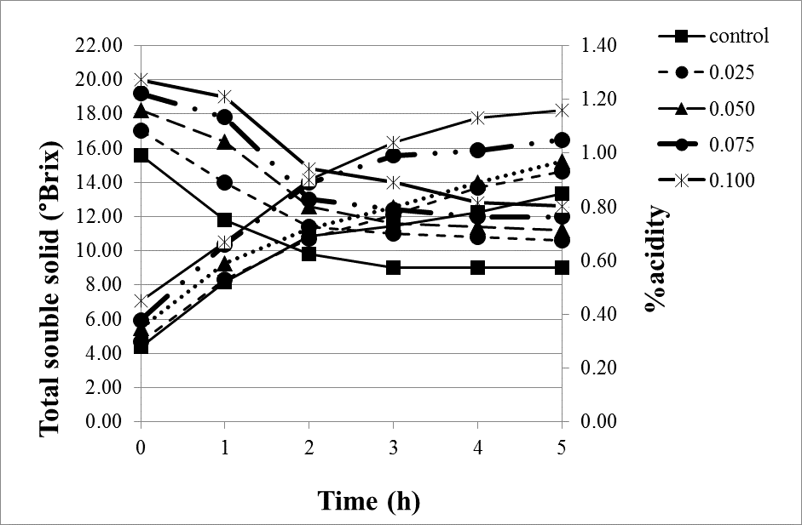

Figure 3 Total soluble solid and %acidity changes of yoghurt with different level of mucilage (0.025, 0.05, 0.075 and 0.1%, w/w) during fermentation

The results showed that the highest lactic acid content up to 1.16% is obtained from 0.1% (w/w) mucilage concentration in yoghurt. The lactic acid content is in agreement with lactic acid bacteria count. The increase in lactic acid bacteria count would lead to the increase in lactic acid content. An increase in concentration of mucilage content of the fermented milk had stimulated the metabolic activities of starter bacteria and improved development of acidity. Therefore, addition of mucilage in the yoghurt contributed to a lowering of pH and may contribute in raising the viability of lactic acid bacteria. The decreased of pH may be attributed to the increase percentage of lactic acid during fermentation.^{3,12} The control yoghurt was incubated at 45°C for 5 hours until the acidity of 0.85-0.9% was obtained. Figure 3 shows that the fermentation period was lower than the control formula. Yoghurt with 0.075 and 0.1% (w/w) mucilage had the shortest fermentation time than other concentration. This may be explained by mucilage from hairy basil seeds leading to the faster consumption by the lactic acid bacteria which results in more lactic acid production and therefore lower pH values. ^{3, 12} Thus, optimal condition for the yoghurt production was 0.075% (w/w) mucilage concentration and it was incubated at 45 °C for 2 hours. This result was consistent with the study of Boeni and Pourahmad (2012). ⁶ The result showed that fermentation time of yoghurt production decreased when the level of mucilage increased.
In conclusion, yoghurt with mucilage showed positive effects in terms of good viable counts of lactic acid bacteria, lactic acid content and pH reduction. Further study on the effect of incubation time of the yoghurt could reduce fermentation time of yoghurt production. The concept of a prebiotic is one that could be included in many food products and it is likely that in the future we will be eating foods that are probiotics that also contain prebiotic ingredients.
References:
- Khalifa MEA, Elgasim AE, Zaghloul AH, Mahfouz MB. Am. J. Food Technol. 2011; 6(1): 31-39.
- Karagul-Yuceer Y, Wilson JC, White CH. J. Dairy Sci. 2004; 84:543-550.
- Rinani Shima AR, Farah Salina H, Masniza M, Hanis Atiqah A. International Journal of Basic & Applied Sciences IJBAS-IJENS 12(1):58-62.
- Aryana K J, Plauche S, Rao RM, Mcgrew and Gibson GR, Probert HM, Van Loo J, Rastall RA, Roberfroid MB. Nutrition Research Review 2004; 17:259-275.
- Seydin ZBG, Sarikus G, Okur OD. Milchwissenschaft 2005; 60(1):51–55.
- Boeni S, Pourahmad R. Annals of Biological Research 2012; 3(7):3486-3491.
- Premwatana P, Chularojmontri V, Tinnarat P, Viseshakul D. Med Assoc Thai. 1985; 68: 584-586.

Noiduang P, Janpong V. Journal of Food Technology, Siam University. 2004; 2(1): 18-27.
- A.O.A.C. Official Method of Analysis. The Association of Official Analytical Chemists, Washington, D.C. 2000; 17thed.
- Thai Industrial Standard (TIS) 2146-2546. Fermented milk. Available from: http: //itc.excise.go.th/tisi/fulltext/TIS2146-2546.pdf Accessed July 20, 2013.
- Tungrugsasut W, Wiwat C, Srisukh1 V, Thoophaew1 K, Tippawat P. Mahidol University Journal of Pharmaceutical Sciences 2012; 39 (3-4):24-31.
- Jariyawaranugoon U. UTCC Journal 2009; 29(4):102-111.
Acknowledgements: We gratefully acknowledge Siam University for funding this research.
Keywords: yoghurt, mucilage, hairy basil, prebiotic

