**PROJECT #2: Ball Balancing Bot**

**TASK 4 (100 Points)**

**PART-A: Mechanical Design Enhancement**

**Q1: Describe the mechanical design, including the number, type, and arrangement of actuators (e.g., linear actuators, rotary motors, air bladders).**  
**Ans:**  
For an ideal ball balancing mechanism with no constraints on hardware, the most effective design would be a Stewart platform, which is a parallel manipulator consisting of six linear actuators. These actuators are arranged in pairs and connect a fixed hexagonal base to a movable top platform through universal joints. The linear actuators can independently extend or contract to tilt and translate the platform in any direction. This 6-DOF setup allows the platform to move along the X, Y, and Z axes and also rotate about those axes (pitch, roll, and yaw), enabling highly responsive and stable control of the ball on its surface.

**Q2: Explain how the additional degrees of freedom improve stability, responsiveness, or control precision.**  
**Ans:**  
The addition of more degrees of freedom significantly enhances the platform’s ability to maintain balance and control. With six degrees of freedom, the system can correct for positional errors in all directions and adapt to any movement of the ball with precision. Translational motion (X, Y, Z) allows the platform to reposition itself beneath the ball, while rotational motion (pitch, roll, yaw) enables subtle angle adjustments that affect the ball's direction and velocity. This leads to better responsiveness to fast ball movements, greater stability in balance, and more accurate control, especially when the ball moves unpredictably or due to external disturbances.

**Q3: Provide a rough sketch of your mechanism, showing actuator placement and platform structure.**  
**Ans:**  
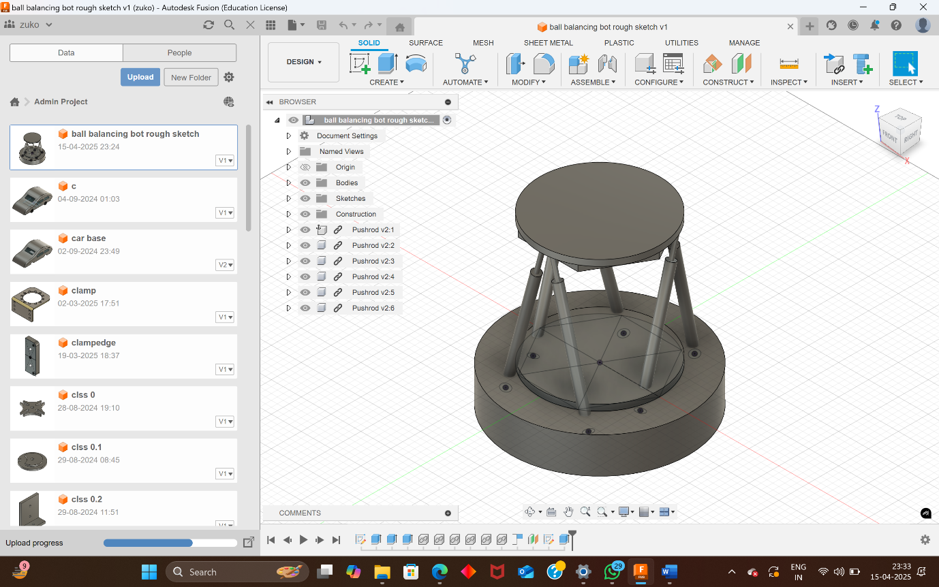 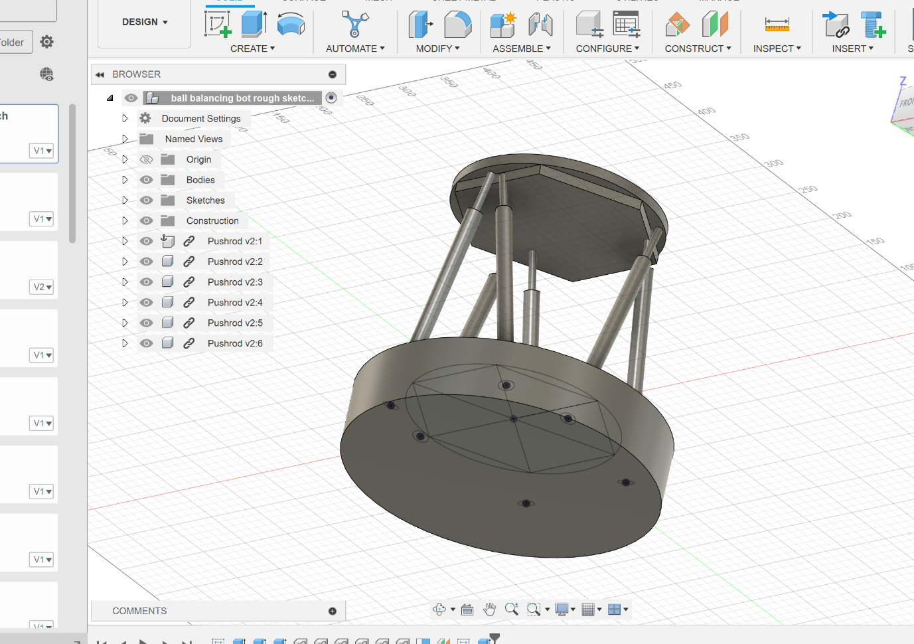

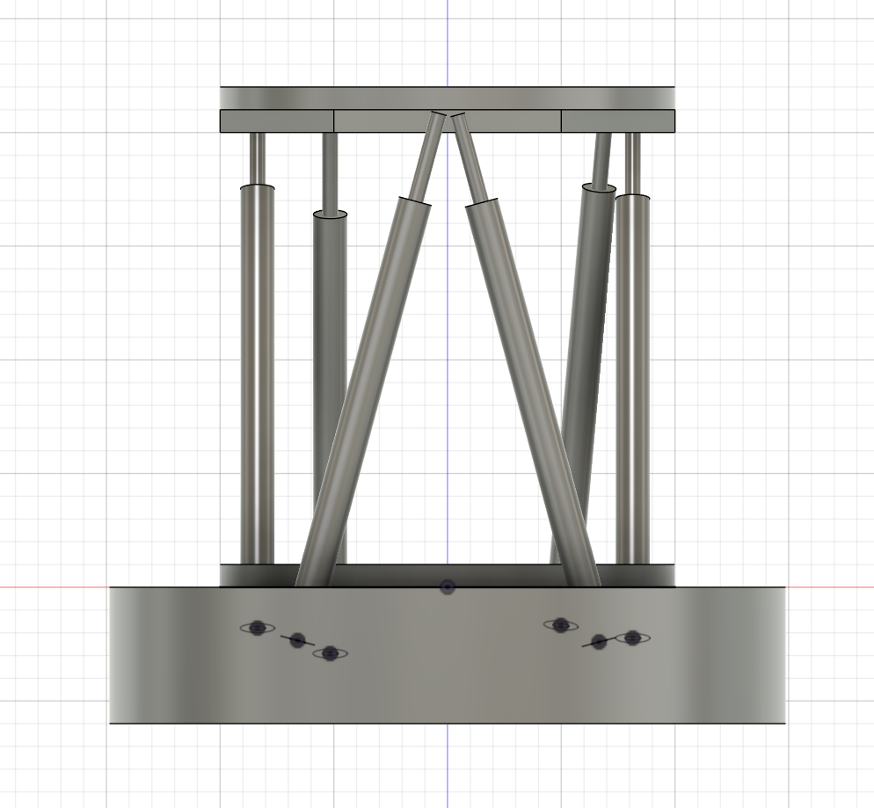

**There are 6 linear actuators that support the top and using PID control we balance the ball**

**I don’t know how to add cad file here.**

**Q4: Discuss the pros and cons of your design in terms of complexity, cost, reliability, and performance.**  
**Ans:**  
The Stewart platform-based design excels in performance, offering precise and dynamic control over the ball’s movement due to its six degrees of freedom. However, this comes at the cost of increased mechanical and computational complexity. Coordinating six actuators in real-time requires advanced algorithms and high-speed control systems. The cost is also higher because of the number of actuators and joints involved, along with the need for accurate sensors and real-time processors. Reliability can be a concern if any actuator fails, although redundancy and maintenance can mitigate this issue. Despite these challenges, the design offers exceptional performance and is highly suitable for high-precision balancing tasks.

**PART-B: Non-Vision Based Ball Tracking**

**Q1: Select appropriate sensors (type and key specifications).**  
**Ans (Approach 1 - Capacitive Touch Grid):**  
One effective method of ball tracking without vision is using a capacitive touch sensor grid. This setup involves an array of capacitive sensors arranged in a matrix under the platform surface. These sensors can detect changes in capacitance caused by the proximity or touch of the ball. Ideal specifications would include a high spatial resolution (for accurate position detection), fast response time (under 10 ms), and a durable, flexible surface to withstand repeated contact. The system should be able to detect the X and Y coordinates of the ball by interpolating the activated regions of the grid.

**Ans (Approach 2 - Force-Sensitive Resistor Grid):**  
Another approach involves using force-sensitive resistors (FSRs) embedded in a grid pattern beneath the platform. These sensors detect the amount of pressure applied by the ball as it rolls over the surface. Key specifications include a pressure detection range between 0.2N to 20N, analog output for variable force measurement, and a response time of less than 5 ms. Each FSR records how much force is applied at its location, allowing the system to estimate the ball’s position and movement based on pressure patterns across the surface.

**Q2: Explain how the system tracks motion.**  
**Ans (Approach 1 - Capacitive Touch Grid):**  
In the capacitive grid approach, the ball’s presence disrupts the local electric field, which changes the capacitance at specific points on the grid. The system continuously scans the grid and identifies which regions have altered capacitance values. By interpolating these values, it can determine the ball’s location in two dimensions. As the ball moves, different grid cells are activated, providing a continuous stream of position data.

**Ans (Approach 2 - Force-Sensitive Resistor Grid):**  
In the FSR grid approach, the rolling ball exerts force on different points of the surface. Each FSR outputs a voltage proportional to the pressure applied. The system reads the voltage from each FSR and determines the ball’s position based on which sensors are activated and how much force they register. As the ball moves, the force pattern shifts across the grid, allowing the system to track its motion in real time.

**Q3: Discuss the pros and cons of your chosen system in terms of accuracy, latency, cost, and implementation complexity.**  
**Ans (Approach 1 - Capacitive Touch Grid):**  
The capacitive touch grid offers high positional accuracy and low latency, making it well-suited for tracking fast or subtle movements of the ball. However, it can be affected by environmental noise, such as electromagnetic interference, and may require shielding and calibration. The cost is moderate to high depending on the size and resolution of the grid. Implementation is moderately complex, requiring signal processing and calibration to maintain accuracy over time.

**Ans (Approach 2 - Force-Sensitive Resistor Grid):**  
The FSR-based system is cost-effective and relatively simple to implement, especially for low-resolution applications. It has very low latency and is robust to environmental interference. However, its accuracy is limited by the spacing and resolution of the sensors. Additionally, the system may struggle to detect fast-moving balls or light touches, and it may require mechanical tuning to evenly distribute force across the grid for consistent readings.