Lab MST

Name: Trimann Kaur | UID: 24BAI70511
Branch: B.E. CSE (AIML) | Section: 24AIT_KRG-1_B
Semester: 5 | Date of Performance: 28.09.2026
Subject Name: ADBMS | Subject Code: 24CSP-310

1.
SELECT D.DEPT_NAME, EMP_NAME, SALARY
FROM
EMPLOYEE AS E
JOIN
(
SELECT DEPT_ID, COUNT(EMP_ID)
FROM EMPLOYEE
GROUP BY DEPT_ID
HAVING COUNT(EMP_ID ) >= 3

)
AS D2
ON
E.DEPT_ID = D2.DEPT_ID

JOIN
DEPARTMENT AS D

ON D2.DEPT_ID = D.DEPT_ID
WHERE
SALARY > (
SELECT AVG(SALARY)
FROM EMPLOYEE
WHERE DEPT_ID=D2.DEPT_ID
)
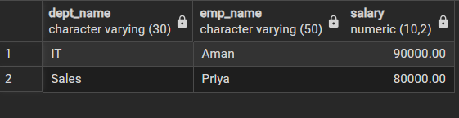

2.
CREATE OR REPLACE FUNCTION T_STORE
RETURNS TRIGGER
LANGUAGE PLPGSQL

AS

$$

BEGIN
INSERT INTO customer_audit
VALUES(

SELECT CUSTOMER_ID, CUSTOMER_NAME,
(
CASE
WHEN
ELSE
END
) AS ACTION,
(

) AS ACTION_TIME

FROM bank_customer

)

END;

$$

