Experiment 10
Name: Trimann Kaur | UID: 24BAI70511
Branch: B.E. CSE (AIML) | Section: 24AIT_KRG-G1
Semester: 4 | Date of Performance: 24.04.2026
Subject Name: Database Management System | Subject Code: 24CSH-298

AIM: To design a trigger that automatically implements the functionality of a primary key, ensuring unique identification of records without manual intervention.
OBJECTIVE:
- To create a database trigger that automatically enforces primary key constraints or generates unique key values, replicating the functionality of a stored procedure.
SOFTWARE REQUIREMENTS:
- Database Management System:
  - PostgreSQL Database
- Database Administration Tool:
  - pgAdmin

PRACTICAL/EXPERIMENT STEPS:
- Identify the table requiring automated primary key enforcement.
- Design a trigger that activates before insert operations.
- Ensure that every new record receives a unique primary key automatically.
- Validate the trigger by inserting multiple records and verifying unique keys.

PROCEDURE:
- The PostgreSQL environment (pgAdmin / psql) was opened and the required database was selected.
- The employees table was created using the CREATE TABLE command with emp_id as the primary key.
- A sequence emp_seq was created using the CREATE SEQUENCE command to generate unique values.
- A trigger function generate_emp_id() was created to assign emp_id automatically using nextval('emp_seq').
- A trigger trg_generate_emp_id was defined to execute BEFORE INSERT on the employees table.
- The trigger was associated with the function to ensure automatic execution during insertion.
- Sample records were inserted into the table without specifying emp_id.
- The table was queried using SELECT to verify that unique primary keys were generated automatically.
CODE:
CREATE TABLE employees (
emp_id INT PRIMARY KEY,
name VARCHAR(100),
department VARCHAR(50)
);

CREATE SEQUENCE emp_seq
START 1;

CREATE OR REPLACE FUNCTION generate_emp_id()
RETURNS TRIGGER AS $$
BEGIN
IF NEW.emp_id IS NULL THEN
NEW.emp_id := nextval('emp_seq');
END IF;
RETURN NEW;
END;
$$ LANGUAGE plpgsql;

CREATE TRIGGER trg_generate_emp_id
BEFORE INSERT ON employees
FOR EACH ROW
EXECUTE FUNCTION generate_emp_id();

INSERT INTO employees (name, department)
VALUES ('Alice', 'HR');

INSERT INTO employees (name, department)
VALUES ('Bob', 'IT');

SELECT * FROM employees;

I/O ANALYSIS:
    - Create Table

The employees table is created with fields emp_id, name, and department, where emp_id is defined as the primary key to ensure unique records.

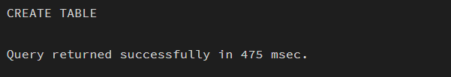
    - Create Sequence

The sequence emp_seq is created successfully to generate unique incremental values for the primary key.

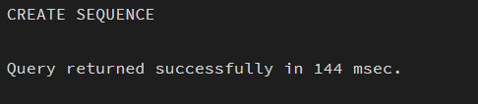
    - Create Trigger Function

The trigger function generate_emp_id() is created to automatically assign a unique emp_id using the sequence before insertion.

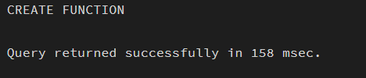
    - Create Trigger

The trigger trg_generate_emp_id is defined to execute BEFORE INSERT on the employees table, enabling automatic key generation.

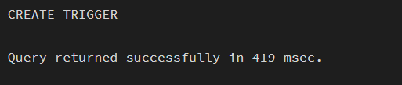
    - Insert Records

Records are inserted without specifying emp_id, and the trigger automatically assigns unique values to each record.

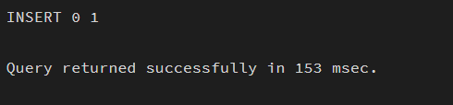
    - Verify Output

The SELECT query confirms that all records have unique emp_id values, ensuring proper trigger execution and data integrity.

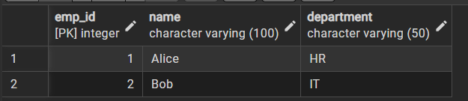

LEARNING OUTCOMES:
- Understood the purpose and working of database triggers.
- Implemented automated primary key functionality using triggers.
- Ensured data integrity without manual key assignment.

