Worksheet 1
Name: Trimann Kaur | UID: 24BAI70511
Branch: B.E. CSE (AIML) | Section: 24AIT_KRG-G1
Semester: 4 | Date of Performance: 09.01.2026
Subject Name: Database Management System | Subject Code: 24CSH-298

AIM: To design and implement a Library Management System database using appropriate tables, primary keys, foreign keys, and constraints, and to perform DML operations along with DCL commands such as role creation, privilege granting, and revoking to ensure database security.

OBJECTIVES:
- To implement Data Definition Language (DBL) commands for creating, altering, and deleting database tables with appropriate constraints.
- To apply Data Manipulation Language (DML) commands to insert, update, retrieve, and manage records while maintaining data integrity.
- To understand Data Control Language (DCL) by creating user roles and managing database security through granting and revoking privileges.

SOFTWARE REQUIREMENTS:
- Database Management System:
  - PostgreSQL
- Database Administration Tool
  - pgAdmin

PROBLEM STATEMENT:
- A Library wants to develop a Library Management System database to manage information about books, members, and book issue records efficiently. The database should be designed using appropriate tables, primary keys, foreign keys, and constraints to ensure data integrity.

- The system must support basic database operations such as inserting records, updating existing data, and deleting obsolete entries. To ensure database security.

- To ensure database security, a database role named Librarian must be created. This role should be password protected and granted SELECT, INSERT, and DELETE permissions on the required tables. The system administrator (pgAdmin) should also have the ability to revoke these permissions when required using role-based access control.
CODE:
CREATE TABLE BOOKS (
BOOK_ID INT PRIMARY KEY,
BOOK_NAME VARCHAR(20) NOT NULL,
AUTHOR_NAME VARCHAR(20) NOT NULL
)

SELECT * FROM BOOKS

ALTER TABLE BOOKS
ADD BOOK_COUNT INT CHECK(BOOK_COUNT > 0) NOT NULL

SELECT * FROM BOOKS

INSERT INTO BOOKS VALUES(101, 'Harry Potter', 'Rowling', 3)
INSERT INTO BOOKS VALUES(102, 'The Alchemist', 'Paulo', 5)

SELECT * FROM BOOKS

CREATE TABLE LIBRARY_VISITORS (
USER_ID INT PRIMARY KEY,
NAME VARCHAR(20) NOT NULL,
AGE INT CHECK(AGE >= 17) NOT NULL,
EMAIL VARCHAR(20) NOT NULL UNIQUE
)

SELECT * FROM LIBRARY_VISITORS

INSERT INTO LIBRARY_VISITORS(USER_ID, NAME, AGE, EMAIL)
VALUES(501, 'vansh', 19, 'vansh@gmail.com')
INSERT INTO LIBRARY_VISITORS(USER_ID, NAME, AGE, EMAIL)
VALUES(502, 'ansh', 19, 'ansh@gmail.com')

SELECT * FROM LIBRARY_VISITORS

CREATE TABLE BOOK_ISSUE(
BOOK_ISSUE_ID INT PRIMARY KEY,
BOOK_ID INT NOT NULL,
USER_ID INT NOT NULL,
FOREIGN KEY(USER_ID) REFERENCES LIBRARY_VISITORS(USER_ID),
FOREIGN KEY(BOOK_ID) REFERENCES BOOKS(BOOK_ID)
)
INSERT INTO BOOK_ISSUE VALUES(10001, 101, 501)

SELECT * FROM BOOK_ISSUE

ALTER TABLE BOOK_ISSUE
ADD ISSUE_DATE DATE

SELECT * FROM BOOK_ISSUE

UPDATE BOOK_ISSUE
SET ISSUE_DATE='2026-01-08'
WHERE BOOK_ID=101

SELECT * FROM BOOK_ISSUE

CREATE ROLE LIBRARIAN
WITH LOGIN PASSWORD '12345678'

SELECT CURRENT_USER

GRANT SELECT, INSERT, DELETE, UPDATE ON BOOKS TO LIBRARIAN
GRANT SELECT, INSERT, DELETE, UPDATE ON BOOK_ISSUE TO LIBRARIAN
GRANT SELECT, INSERT, DELETE, UPDATE ON LIBRARY_VISITORS TO LIBRARIAN

-- LIBRARIAN
SELECT * FROM BOOKS
SELECT * FROM BOOK_ISSUE
SELECT * FROM LIBRARY_VISITORS

REVOKE SELECT, INSERT, DELETE, UPDATE ON BOOKS, BOOK_ISSUE, LIBRARY_VISITORS FROM LIBRARIAN

SELECT * FROM BOOKS

TRUNCATE TABLE BOOK_ISSUE
SELECT * FROM BOOK_ISSUE

DROP TABLE BOOK_ISSUE
SELECT * FROM BOOK_ISSUE

I/O ANALYSIS:
- Create table BOOKS.
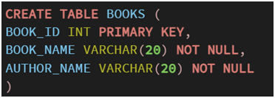
· Alter and insert into table BOOKS.

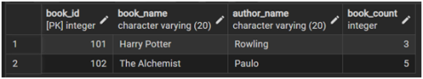

· Create table LIBRARY_VISITORS.
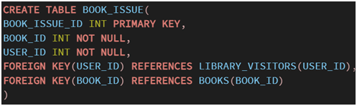
· Insert into LIBRARY_VISITORS.
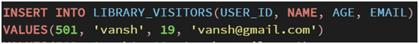
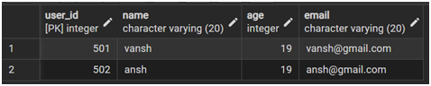
· Create table BOOK_ISSUE with foreign key. Alter and update it.
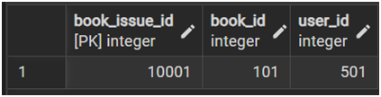
· Alter table BOOK_ISSUE.
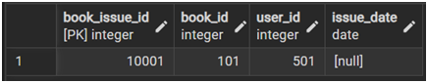
· Update BOOK_ISSUE.
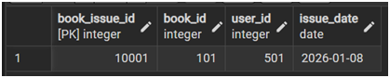
· Creating a new role, and granting access.
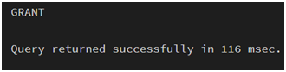
· Revoke access.
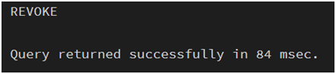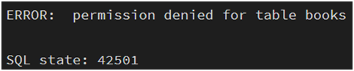
· Truncate table BOOK_ISSUE.

· Drop table BOOK_ISSUE.

LEARNING OUTCOMES:
- Understanding of creating and managing database structures using DBL commands.
- Inserting, updating, and retrieving data using DML queries while maintaining data integrity.
- Knowledge of controlling database access by creating roles and applying DCL commands.

