Experiment 5
Name: Trimann Kaur | UID: 24BAI70511
Branch: B.E. CSE (AIML) | Section: 24AIT_KRG-G1
Semester: 4 | Date of Performance: 11.03.2026
Subject Name: Database Management System | Subject Code: 24CSH-298

AIM: To understand and apply conditional logic in SQL by using the modulus operator (MOD / %) to analyze numerical data and classify employee salaries as odd or even, thereby improving data analysis and decision-making skills in SQL.

OBJECTIVES:
- To write and execute SQL queries that use the MOD (%) operator to check employee salaries and display odd and even salary values separately from an employee table.

SOFTWARE REQUIREMENTS:
- Database Management System:
  - PostgreSQL Database
- Database Administration Tool / Client Tool:
  - pgAdmin

PRACTICAL/EXPERIMENT STEPS:
- An employees table was created in the database with columns such as emp_id, emp_name, and emp_sal to store employee information and salary details.
- Sample employee records were inserted into the table to provide data for testing the SQL queries.
- The MOD / % (modulus) operator was studied to understand how it can be used to determine whether a salary value is odd or even.
- SQL queries were written using the modulus operator to evaluate employee salaries and apply conditional logic.
- A CASE statement was used in the SELECT query to display a new column indicating whether the salary is Even Salary or Odd Salary.
- The queries were executed using PostgreSQL, and the results were verified to ensure that the salaries were correctly classified.

PROCEDURE:
- The pgAdmin (PostgreSQL) application was opened to access the database environment.
- A new employees table was created in the database with fields such as emp_id, emp_name, and salary to store employee salary information.
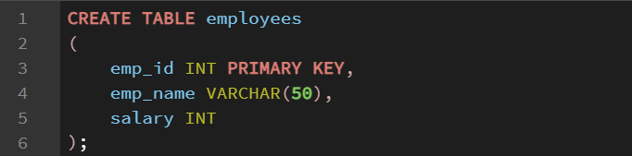
- Sample employee records were inserted into the table using INSERT statements to provide data for testing the SQL queries.

- A SELECT query using the MOD / % operator was written to determine whether each employee’s salary is odd or even.
- A CASE statement was used in the SELECT query to display an additional column indicating “Even Salary” or “Odd Salary” based on the modulus operation.

- The SQL queries were executed in the database environment to check the classification of salaries as odd or even.
- The output results were observed and verified to ensure that the modulus operator correctly identified even and odd salary values.
- The results were recorded and the queries and outputs were saved for documentation and reference.
CODE:
CREATE TABLE employees
(
emp_id INT PRIMARY KEY,
emp_name VARCHAR(50),
salary INT
);

INSERT INTO employees VALUES
(1, 'Charles', 67000),
(2, 'Max', 55501),
(3, 'George', 82000),
(4, 'Daniel', 75003);

SELECT emp_name, salary,
CASE
WHEN salary % 2 = 0 THEN 'EVEN'
ELSE 'ODD'
END AS salary_type
FROM employees;

I/O ANALYSIS:
- Creating the Employees Table
Creates a table to store employee details such as employee ID, employee name, and employee salary.

- Inserting Employee Records
Inserts sample employee data into the employees table for testing and analysis.
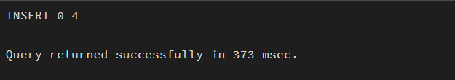
- Using the Modulus Operator (MOD / %) and CASE Statement
Applies the MOD or % operator to check whether the employee salary value is odd or even and uses a CASE statement in the SELECT query to display whether the salary is Even Salary or Odd Salary.
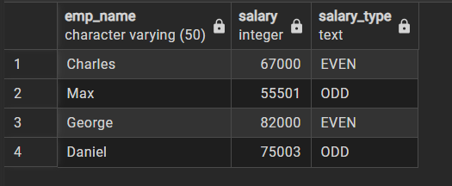

LEARNING OUTCOMES:
- Understood the use of the modulus operator (MOD / %) in SQL to analyze numerical values.
- Learned how to apply conditional logic using CASE statements in SQL queries.
- Gained practical experience in writing and executing SQL queries to classify employee salaries as odd or even.

