Worksheet 2
Name: Trimann Kaur | UID: 24BAI70511
Branch: B.E. CSE (AIML) | Section: 24AIT_KRG-G1
Semester: 4 | Date of Performance: 16.01.2026
Subject Name: Database Management System | Subject Code: 24CSH-298
AIM: To understand and implement SQL SELECT queries using various clauses such as WHERE, ORDER BY, GROUP BY, and HAVING to retrieve and manipulate data efficiently from relational database tables.

OBJECTIVES:
- To practice writing SQL SELECT statements.
- To apply filtering conditions using the WHERE clause.
- To sort query results using the ORDER BYclause.
- To group records using the GROUP BY clause.
- To filter grouped data using the HAVING clause.
- To analyze data using aggregate functions like COUNT(), SUM(), AVG(), MIN(), and MAX().

SOFTWARE REQUIREMENTS:
- Database Management System
  - PostgreSQL
- Database Administration Tool
  - pgAdmin
PRACTICAL/EXPERIMENT STEPS:
- Display the department name and the average salary of employees for each department.
- Consider only those employees whose salary is greater than 20,000.
- Display only those departments where the average salary is greater than 30,000.
- Arrange the final output in descending order of average salary.

PROCEDURE:
- Open PostgreSQL and create a new database.
- Execute the following command to create a table EMPLOYEE.
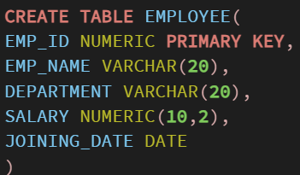
- Using INSERT command, insert records into table EMPLOYEE.
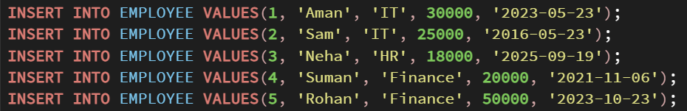
- Display the department name and average salary of employees for each department using using SELECT and GROUP BY command, and AVG() function.
- Filter employees having salary greater than 20,000 using HAVING. 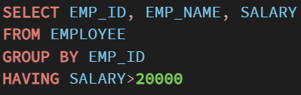
- Display only departments where average salary is greater than 30,000 using HAVING.
- Sort the result in descending order of average salary using ORDER BY.

I/O ANALYSIS:
- The EMPLOYEE table was created successfully.
- Records inserted into EMPLOYEE table.
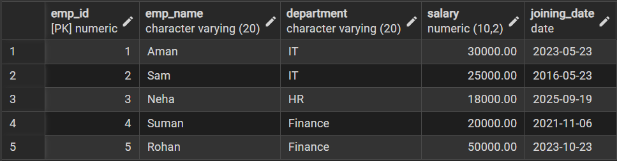
- Department-wise average salary was calculated and displayed.
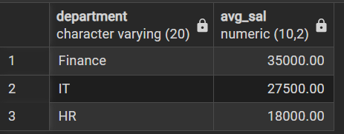
- Employees having salary greater than 20,000 were retrieved.
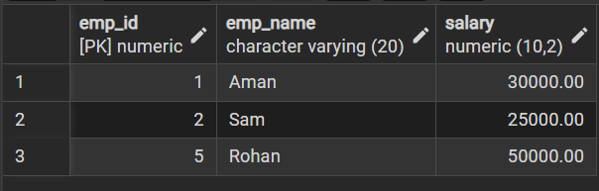
- Departments with average salary above 30,000 were displayed.

- The final output was sorted in descending order of average salary.
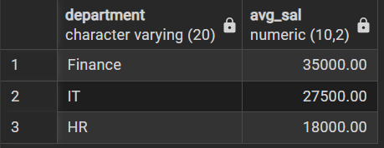

LEARNING OUTCOMES:
- Filter records using the WHERE clause.
- Group records using GROUP BY.
- Apply conditions on grouped data using HAVING.
- Sort query results using ORDER BY.

