Experiment 3
Name: Trimann Kaur | UID: 24BAI70511
Branch: B.E. CSE (AIML) | Section: 24AIT_KRG-G1
Semester: 4 | Date of Performance: 28.01.2026
Subject Name: Database Management System | Subject Code: 24CSH-298

AIM: To understand the basic structure of a PL/SQL program by creating and executing a simple PL/SQL block that includes declaration and execution sections, and to display output using built-in procedures.

OBJECTIVES:
- To create a simple PL/SQL program demonstrating Declaration Section and Execution Section.
- To understand the use of conditional statements (like IF-ELSE, IF–ELSIF–ELSE) in PL/SQL for performing decision-based operations.

SOFTWARE REQUIREMENTS:
- Oracle FreeSQL

PRACTICAL/EXPERIMENT STEPS:
- The PL/SQL block is started using the DECLARE keyword to define required variables.
- Variables such as employee ID, employee name, employee salary, and bonus are declared with appropriate data types and initialized with values.
- Employee details like ID, name, and salary are displayed using the DBMS_OUTPUT.PUT_LINE procedure.
- An IF–ELSIF–ELSE conditional structure is used to calculate the bonus based on different salary ranges.
- If the salary is greater than or equal to 100000, the bonus is calculated as 20% of the salary.
- If the salary is greater than or equal to 75000, the bonus is calculated as 15% of the salary.
- For all other cases, the bonus is calculated as 12% of the salary.
- The calculated bonus amount is displayed as output.
- The PL/SQL block ends successfully after execution.

PROCEDURE:
- Start the Oracle FreeSQL environment.
- Write the following code to declare the variables.
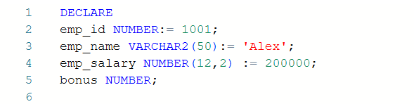
- Inside the BEGIN block, write the following code to display the employee data using DBMS_OUTPUT.PUT_LINE.
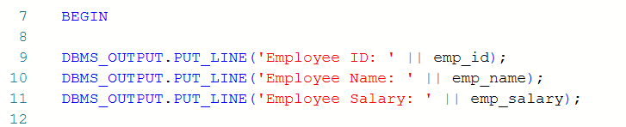
- Use IF-ELSIF-ELSE conditional statement to determine the bonus percentage based on the employee salary.
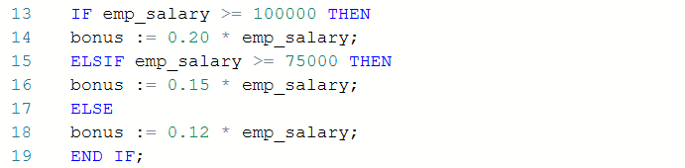
- Display the final bonus using DBMS_OUTPUT.PUT_LINE.
- End the PL/SQL block using the END; statement and execute the program.
- Verify the output displayed on the screen.

CODE:
DECLARE
emp_id NUMBER:= 1001;
emp_name VARCHAR2(50):= 'Alex';
emp_salary NUMBER(12,2) := 200000;
bonus NUMBER;

BEGIN

DBMS_OUTPUT.PUT_LINE('Employee ID: ' || emp_id);
DBMS_OUTPUT.PUT_LINE('Employee Name: ' || emp_name);
DBMS_OUTPUT.PUT_LINE('Employee Salary: ' || emp_salary);

IF emp_salary >= 100000 THEN
bonus := 0.20 * emp_salary;
ELSIF emp_salary >= 75000 THEN
bonus := 0.15 * emp_salary;
ELSE
bonus := 0.12 * emp_salary;
END IF;
DBMS_OUTPUT.PUT_LINE('Bonus: '||bonus);

END;

I/O ANALYSIS:
This PL/SQL program demonstrates the basic structure of a PL/SQL block. It declares variables for employee details under the DECLARE block, and calculates a bonus using conditional statements. Based on the employee’s salary, the bonus percentage is determined using IF–ELSIF–ELSE. The program displays employee ID, name, salary, and the calculated bonus using DBMS_OUTPUT.PUT_LINE.
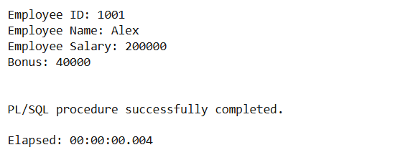
LEARNING OUTCOMES:
- Understand the basic structure of a PL/SQL block, including the Declaration section and Execution section.
- Gain hands-on experience in declaring variables and performing simple operations within a PL/SQL program.
- Learn to display output using built-in PL/SQL procedures (such as DBMS_OUTPUT.PUT_LINE) to verify program execution.

