Starting University amid a pandemic can be unmotivating, lonely, and outright boring without peers, professors, or much face-to-face stimulation. Something that has helped me pass time, and start enjoying my quarantine was playing video games. I’ve always loved to play games but never found enough time between school, teams, and part-time jobs. Luckily, quarantine granted me more free time than ever before, allowing me to finally get to playing games I downloaded months before. I found my niche in RPG Adventure games like the Zelda franchise, Super Mario Galaxy, and now Genshin Impact. The rush of fulfillment and accomplishment after defeating an extremely difficult boss fight is addictive. However, the effort and hours spent leading to that moment can be twice as frustrating. While I continued clearing dungeons and expanding my knowledge about in-game mechanics, I wondered if there was a way to make boss fights less taxing and more fun without watching a direct playthrough on YouTube. So when we were given creative freedom over our final project, I decided to try making an application that can help guide new or returning players in boss fights.

My Windows Application for Assignment 5 is an automated ‘Strategist’ for the open-world RPG game, Genshin Impact. There is an “Instructions” button on the homepage, which displays useful information about using the application and important terminology for new players (see figure 1). After clicking the “START” button, the main screen (see figure 2) will appear from which users can select one of the 4 infamous bosses in the game to generate a custom guide to defeating. Next, they can choose their preferred party composed of Main DPS, Sub DPS, Support, and Healer characters which are separated by party role. Once they submit their selections and the data is validated, a success message will appear on the screen (see figure 3) and a custom guide will be saved to the same folder (see figure 4). The custom guide consists of tips and tricks to defeat each boss, their weak points and attack patterns, as well as the most efficient way to use each character they selected. Also included in the word document is a chart comparing the Resin costs to fight each of the 4 bosses.

**(Figure 1)**

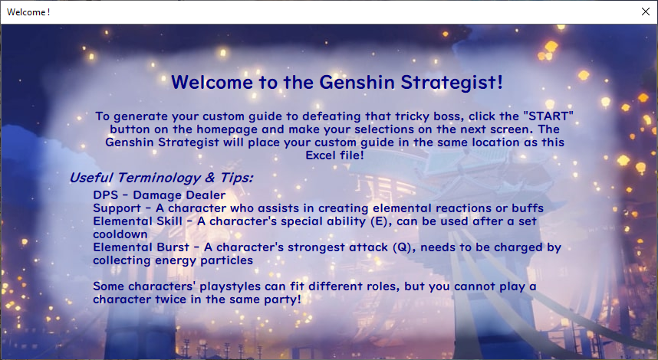

**(Figure 2)**

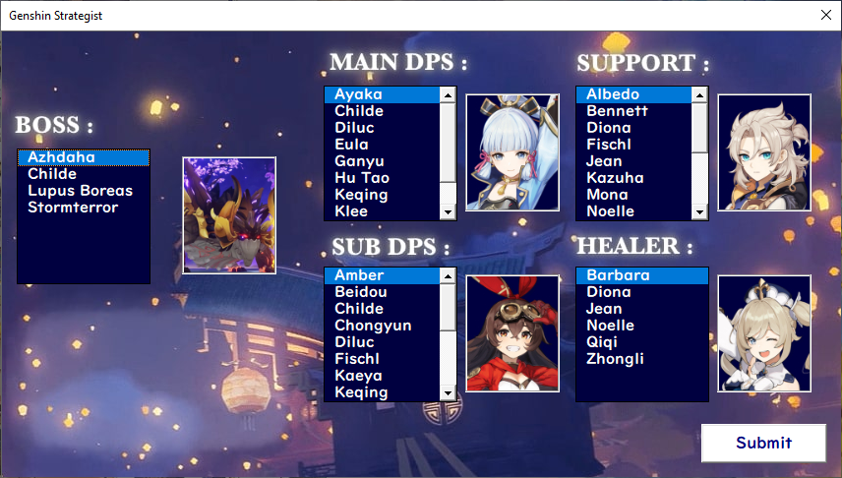

**(Figure 3)**

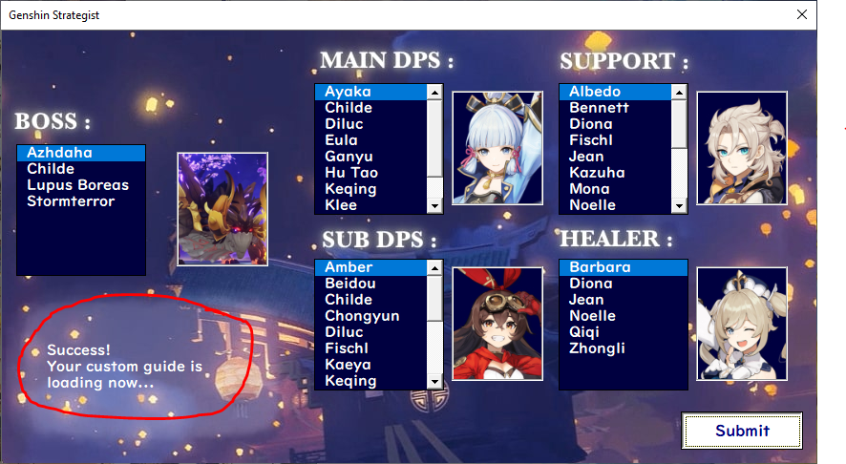

**(Figure 4)**

