Contents
Layer 7 – Application Layer (Lab 1) 2
Layer 6 – Presentation Layer 4
Layer 5 – Session Layer 4
Layer 4 – Transport Layer (Lab 2) 4
Layer 3 – Network Layer: Data Plane (Lab 3) 11
Layer 3 – Network Layer: Control Plane (Lab 4) 15
Layer 2 – Data Link Layer (Lab 5) 17
Layer 1 – Physical Layer (Lab 6) 20
Suschtige Other Stuff 23
Wichtige Infos aus den Vorlesungen (Von Urs während sem) 24

Layer 7 – Application Layer (Lab 1)
- Was ist ein iterative DNS? (Funktion etc)
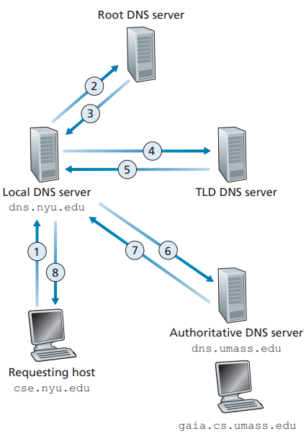
An iterative query is one in which a DNS client expects a DNS server to respond with the best answer it can give without querying another DNS server. Instead, the DNS server gives a list of nameservers for the requested domain which the client queries itself.
- Was ist ein recursive DNS? (Funktion etc)
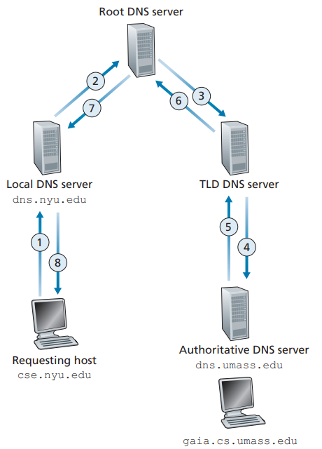
With a recursive DNS the DNS client expects a full resolution of a DNS name from a DNS server, which means the query gets sent to the next server until the answer has been reached.

- Was sind die Unterschiede von iterative/recursive DNS?
Step | Recursive | Iterative
Client to Resolver | Client asks the recursive resolver for example.com. | Client queries the root server for example.com.
Next Step | Recursive resolver queries the root, root queries the TLD server, TLD queries the authoritative servers on behalf of the client. The authoritative servers replies to the TLD servers, the TLD replies to the root servers and root then responds to the recursive resolver | Root server provides the address of the .com TLD server, which then provides the address of the authoritative nameservers.
Client’s Role | Waits for a single, final response. | Client queries the .com TLD server, then the authoritative server.
Final Step | Recursive resolver returns the resolved IP address to the client. | Client eventually reaches the authoritative server for the IP address.

Advantages & Features Recursive:
- Faster for client
- Simple for client
- Commonly used by end-users (via ISP or public DNS)
- Recursive resolvers cache answers for efficiency
Advantages & Features Iterative:
- Gives the client more control
- Used in low-level DNS infrastructure
- More complex for clients
- Slower since client has to perform multiple lookups
- Iterative servers typically don’t cache

- Was macht der local DNS/resolver? Wieso macht das nicht das Gerät selbst?
Its like a librarian who is asked to find a book in a library. This server is designated to receive queries from a client. The DNS resolver then makes a recursive DNS request to get the name/ip address. The resolver also caches the responses for a certain amount of time.

The client doesn’t do this itself because the process of querying is very complex. The devices are designed to send DNS queries to a centralized source. This is a huge optimization in larger networks with many queries. Multiple hosts can access the same cache of the local DNS/resolver, which makes it more efficient as less queries are needed.

- Was ist ein Socket? Wie ist er aufgebaut? Wieso brauchen wir Port und IP zusammen?
A socket is an IP together with the port of the desired application. It is structured as follows:
ClientIP:ApplicationPort – 192.168.0.2:34567
which sends to a ServerIP:ApplicationPort – 192.168.0.3:443

This is necessary because the same server (same ip) might have multiple applications/processes running (each with a different port) and we need to know which application we are talking to.
Examples of common ports:
- 192.168.0.1:25 for SMTP
- 192.168.0.2:80 for HTTP
- 192.168.0.3:443 for HTTPS
- 192.168.0.4:143: for IMAP
- 192.168.0.5:53 for DNS

- Für was ist SMTP? Für was sind POP3/IMAP (inkl. unterschiede)?
SMPT: Simple Mail Transfer Protocol
It is used to transfer emails between different servers and networks. SMTP is used for sending emails.

IMAP: Internet Message Access Protocol
Is used to connect to the server and downloads messages on request. The mails are stored on a server and the user can access them from anywhere.

POP3: Post Office Protocol 3
Is used to connect to the server and downloads all received messages. Once the download is complete all the emails will be deleted from the server. POP3 is device dependent.

Layer 6 – Presentation Layer
No lab on this

Layer 5 – Session Layer
No lab on this

Layer 4 – Transport Layer (Lab 2)
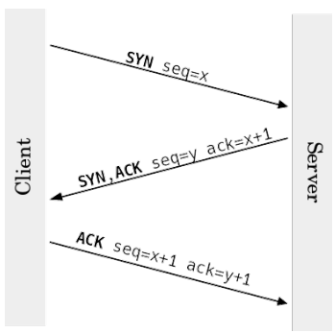
- Erkläre TCP flow (syn, ack iteration)
- Connection Establishment (Three-Way Handshake):

1. The client sends a SYN packet to the server, marked with a random sequence number x
2. Server answers with an ACK, telling the client to accept the connection. The packet contains an ACK number, which is x+1. It also contains another SYN with a new random sequence number y
3. The client acknowledges the SYN of the server by increasing y by one (y+1), the old ack is used as the sequence number

Example:
1. SYN, seq num = 4567
2. SYN+ACK, ack num = 4568 seq num = 12998
3. ACK, ack num = 12999 seq num = 4568
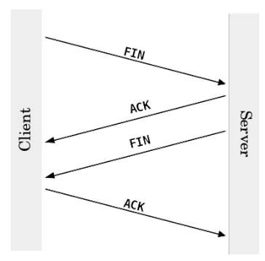
- Connection Termination (Four-Way Handshake):
To tear down a connection every station sends a FIN request and confirms the others FIN with an ACK.
The two packets in the middle could be combined into a single FIN ACK packet, which would result in a three-way handshake. The connection does not have to be terminated by both stations. Half-open connections can exist in case only one station sends the FIN. The open connection can still send data but the one who terminated cannot.
If the side that sent the FIN does not process or acknowledge incoming data, any data sent by the non-terminating side will eventually time out and may be retransmitted based on TCP's retransmission logic. However, if acknowledgments never arrive (e.g., the FIN-sending application has terminated), the connection will eventually be reset or closed.
(A half-open connection might be used for a server shutdown grace period, where the server wants to stop sending data but allows clients to finish their operations or send final data.
-> muss no vo wiiter obe verified werde)

- Data Transfer
After the connection is established, we still need to maintain the connection by using the sequence and acknowledgement number.
Example:
- Packet of 1460B is sent with a random sequence number 10 001
- Receiver confirms packet by sending ACK (seq+leng) of 11 461
- Another 298 540B need to be sent, which will be broken down in many 1460B packets. The next 1460B are sent with the seq nr. 11 461

- (TCP) Erkläre sliding window / Was passiert beim Sliding Window Mechanismus?
The sliding window is a field in the TCP header. The participants inform each other about the window size in every TCP segment transmitted. The window size is the amount of payload bytes a receiver can handle. When the window size is fully utilized it waits for an ACK and window size update of the receiver before transmitting more data. A windows size of 0 means that the sender stops delivering data.
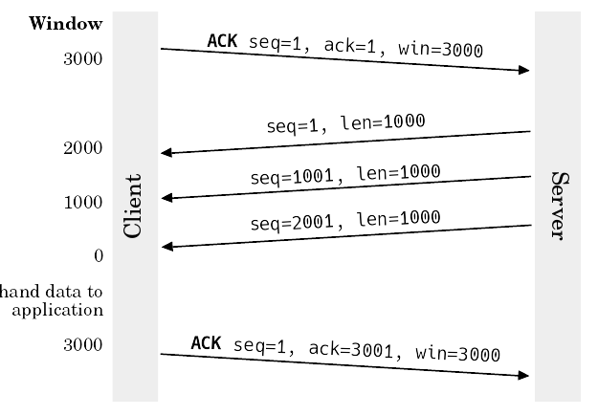
- Client communicates window size of 3000 bytes and starts a syn/ack sequence
- Starts sending a packet with length 1000 and sequence 1
- Another load of 1000 bytes is sent, sequence number is now +1000 making it a total of 1001
- Another load of 1000 bytes is sent, another 1000 is added to the seq making it 2001
- The client has now received a total of 3000 bytes, it acknowledges the last seq received by adding the length of 1000 to it, making it 3001.
- The client also sends an updated window size

- (TCP) Was ist der Unterschied zwischen congestion control und sliding window
Sliding Window:
- Sender communicates the windows size before payload is sent
- Communicated with a header field
- Window size is communicated with every TCP segment transmitted
Congestion Control:
- Doesn’t need any additional fields (makes use of ACK packets, as well as MSS (Maximum Segment Size))
- TCP: Does not prevent congestion, but congestion avoidance is done by most systems around
- Sender maintains a congestion window for its own use. Before sending any TCP packet, it is set to 1 MSS. After sending the first packet with 1 MSS, it waits until it receives an ACK from the receiver. The increase of the transmission rate stops as soon as congestion is detected (that is the case if a packet loss occurs or a duplicate ACK is received).

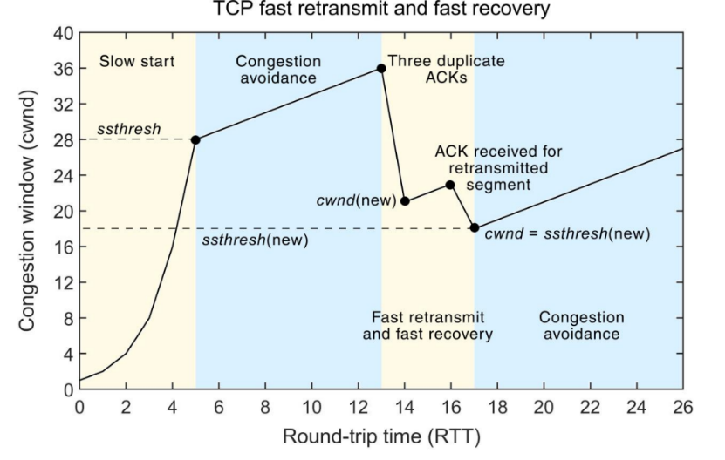
Example (Slow start strategy):
- Before sending any packet, the MSS (maximum segment size) is set to 1
- After sending the first packet with MSS 1, it waits for an ack from the receiver
- When the ack arrives the congestion window size will be increased to 2, now the next two segments can be sent
- With every received ACK the sender increases the congestion window size by 1
ssthresh (slow start threshold): When the congestion window reaches this value it enters the congestion avoidance state
While in the congestion avoidance state, the congestion window only grows for MSS/congestion window. The increase of the transmission rate stops as soon as congestion is detected (packet loss or duplicate ack). After this occurs a fast retransmit is performed. It sets half of the current congestion window as the new sstresh value and reinitiates slow start.
Note: this is only one of many such algorithms

Aspect | Congestion Control | Sliding Window
Purpose | Prevent network congestion | Manage reliable data transfer
Focus | Network capacity | Receiver capacity
Scope | End-to-end (network side) | Point-to-point (sender-receiver)
Mechanism | Adjusts congestion window (cwnd) | Manages send/receive window sizes
Feedback source | Network conditions (loss, delay) | Receiver acknowledgments

- (TCP) Was ist der Unterschied zwischen flow control und congestion control? (Welche Protokolle gehören zu welchen Mechanismen und wie funktionieren sie?)
Flow Control:
- After the connection is established the data flow must be controlled by both workstations to fully optimize it. It ensures the sender transmits data at a rate that the receiver can process, preventing buffer overflow and data loss
Ways to optimize flow:
- Delayed ACK
  - Avoid ACKs for every single frame received
  - Recommended to wait half a second or less to send ACKs
  - Causes further problems
Example:
    - Seq x=1, length=1000
    - Server waits half a second until it sends an ACK
    - In this time it receives 7 segments with leng=1000
    - It sends an ack=7001
- Duplicated ACK
  - Can happen when a data segment gets lost during delayed ACK
Example:
- Packet nr. 40 gets lost
- Last ack was sent for packet nr. 37
- Receiver notices it cannot reorder segments by their seq nr.
- It sends an ack for packet nr. 37 again
- Ack can also get lost, so it is sent over and over again
- After the third ack for packet 37 in a row, the missing packet and all following packets get retransmitted
- Fast Retransmit
  - If duplicated ACKs are activated, the sender waits for retransmission timeout
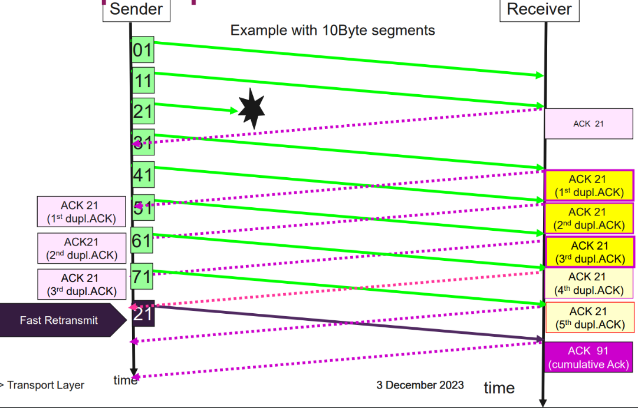
  - If fast retransmit is activated, it immediately sends a packet when duplicate ACKs arrive at the sender’s station

- Selective ACKs
  - A process to retransmit only the packets that actually got lost
- Sliding Window (-> explained below)
- Window Scaling (-> explained below)
Congestion Control:
- Slow Start
- Congestion Window
- Congestion Avoidance
Differences:
Flow control is about protecting the receiver while congestion control is about protecting the network.
Feature | Flow Control | Congestion Control
Concern | Receiver capacity | Network capacity
Focus | End-to-end connection | Entire network
Trigger | Receiver buffer nearing capacity | Network congestion (packet loss)
Implementation | Advertised window (rwnd) | Congestion window (cwnd)

- (TCP) Wird die Bandwidth grösser oder kleiner, wenn man das Sliding window verkleinert?
The bandwidth gets smaller if you decrease the window size.

- (TCP) Wieso wird die Bandwidth kleiner, wenn das Sliding Window kleiner wird?
With a smaller window size, less payload can be received per round trip (cap on max data rate) because a smaller window size limits the amount of unacknowledged data the sender can transmit, reducing the pipeline of in-transit packets. This means less of the bandwidth gets utilized and more packets need to be sent. This makes the bandwidth (amount of data transferred) smaller.

- (TCP) What is Window Size Scale und wie beeinflusst die Window Scale den Datenverkehr?
The maximum window size is very small. The window scale option is a way to make it bigger. It is shared during the TCP handshake and describes how far the window size field should be shifted to the left (between 0-14).
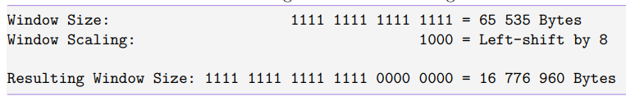
This makes the overall data transfer more efficient as it gives us a higher bandwidth and latency. It also causes less overhead since less acks need to be sent.
Aspect | Without Window Scale | With Window Scale
Max window size | 65’535 bytes | Up to 1GB (2¹⁴)
Effect of latency | High | Lower
Bandwidth | Low | Full usage possible
Overhead (ACKs) | High (more acks needed) | Reduced (less acks)

- (UDP & TCP) Wenn sehr gute Bandwidth vorhanden ist: Was passiert, wenn RTT-Issues vorhanden sind?
- Delays in establishing a connection
- Slow buffering which delays the start of the video (video needs a buffer to start), as higher RTT slows down response times
- RTT delays the requests to adapt bandwith, which in return can lead to more delay
- Delay in receiving live information, because high RTT increases the time to acknowledge packets, causing delays in sending additional data
- More packets get dropped

- Explain Delay
Delay refers to the time for one-way travel. The term delay is often used interchangeably with the term latency. This is not to be confused with RTT, which in addition to the one-way travel also includes the response (RTT). Delay is a more general term.
There are different types of delays, to mention a few:
- Propagation Delay:
  - Time taken for a signal (packet) to travel across the physical medium (e.g cable),
  - Propagation Delay = Distance between sender and receiver / Propagation Speed (e.g speed of light).
- Transmission Delay:
  - Time required to push all the bits of a packet onto the link,
  - Transmission Delay = Packet Size / Bandwidth.
In addition to delay, we have a few additional terms that are relevant in the context of delay but aren’t delay as such:
- Bandwidth:
  - Maximum amount of data that can be transmitted over a communication channel in a given amount of time in bits per second.
- Jitter:
  - Is the variation in packet delay. It is basically the difference in latency between packets arriving at their destination.
- Throughput:
  - Is the actual measured performance of a system when delay is considered,
  - Average amount of data that actually passes through over a given period of time.

- What affects the quality of a streaming device more? Bandwidth or RTT?
Bandwidth (Throughput):
- The maximum data transfer rate of the network (measured in Mbps)
- Determines the maximum resolution and bitrate of the stream that can be delivered without buffering
- Higher bandwith = more data being transmitted per second = better video quality (4k etc)

RTT (Round Trip Time):
- The time it takes for a data packet to travel to the server and back (measured in ms)
- Affects the responsiveness of the connection, which is critical for interactive applications
- Can cause delays (especially bad in real-time use cases like streaming) such as acknowledgment delays or buffering and synchronization delays
- High RTT can increase the time required to recover from a buffer underrun which impacts smooth playback. A buffer underrun is when a buffer is fed with data at a lower speed than the data is being processed.

RTT affects the quality more than bandwidth because it directly impacts latency-sensitive tasks, such as real-time communication or streams. No matter how good the bandwidth is, if you have high RTT, it can introduce buffering regardless of sufficient bandwidht.
Example:
In a video call, even with high bandwidth, a high RTT causes noticeable delays between when one person speaks and the other hears it, making conversations awkward. In contrast, low RTT ensures real-time responsiveness, even on a moderate bandwidth connection.

- Erkläre die Connection ID (quic/http3)
Why do we need a connection ID:
In QUIC the session ID is a way to keep the connection even if the IP changes. This change in IP can happen if a user leaves their house and switches from wifi to mobile, or if the user is in a train and switches from antenna to antenna. A change in IP usually also means the session has to be reestablished (TCP handshake). The connection can also be broken due to a NAT rebinding.

What is the Connection ID:
Can vary in length and is unique. When CID changes, both client and server are informed through the QUIC protocol. This does not jeopardize the connection.

- Wie funktioniert QUIC?
Quic is an alternative way to encrypt TCP connections based on UDP instead of TCP, because of TCP head-of-line blocking, which causes delays in processing. This also avoids a costly handshake and is implemented on the application level (making it easier to develop because it’s not embedded into the kernel of the OS). Quic is encrypted by default.

Key features:
- Uses UDP
- Encrypted by default
- Establishing a connection only uses 1 RTT (round trip time) and known connections need 0 RTT (TLS 1.3: 2RTT/1RTT, TLS 1.2: 3RTT/2RTT)
- Webserver advertises HTTP3 or it can be told using DNS (service bindings)

Layer 3 – Network Layer: Data Plane (Lab 3)

- IPv4: DHCP - Was macht DHCP und wieso brauchen wir DHCP?
DHCP = Dynamic Host Configuration Protocol
DHCP ensures that we don’t have to manually assign an IP to every client. It automatically distributes IP addresses (and additional information such as DN) to the clients.

- IPv4 Helper-Adressen - Was ist das und wo braucht man Helper-Adressen?
An IPv4 helper address is a configuration on a router that forwards broadcast packets such as DHCP requests. It is commonly used to enable devices to communicate with a DHCP server.
An IP helper is needed to relay DHCP. E.g:
- DHCP is configured on core router
- Clients are connected to a L2 access switch which connect to a L3 core switch
- The core Switch is connected to the router
- A new client is added to the L2 switch and needs an IP address from the DHCP server (which is inside a different subnet)
For the client to find the DHCP in this scenario we need a helper address on the L3 switch. The DHCP request gets sent to the gateway of the L3 switch and then the L3 switch can forward the request to the router.
- Welche Adresstypen verwendet DHCP bei der Kommunikation in IPv4 und IPv6?
Broadcast Adressen bei IPv4 und Multicast Adressen bei IPv6

- Wieso gibt es private und public IPv4 Adressen?
IPv4 only has a limited amount of IP addresses. Which is why not every client can have a public IP. This is a measure taken to prolong the runout of IPv4.

- Wieso gibt es beim IPv6 einen Prefix?
This is used for subnetting. Each Client in the subnet generates its own IP based on the prefix given. The prefix identifiers the network portion of an address, enabling efficient routing.

- Wie bekommt man diesen Prefix bei DHCPv6?
The router advertises the prefix with the following process:
  - Solicit - Request from Router (Client) to the DHCPv6 Server
    - Solicit Message
    - Please give me a prefix
  - Advertisement - Response from the DHCPv6 Server
    - Advertise Message
    - Can also give lease information (time, config, etc)
    - Here is prefix: 2001:db8:abcd::/48
  - Request – Router (Client) formally asks to use that prefix from the advertisement
    - Request Message
    - May I use 2001:db8:abcd::/48?
  - Reply – Server confirms the allocation of the prefix
    - Reply Message
    - Yes, you may use prefix
  - Router uses the Prefix to configure local subnets (divided into /64 nets)
    - Router can now use SLAAC or DHCPv6 to administer IPv6 addresses within the subnet to the end clients
SLAAC: Stateless Address Autoconfiguration
SLAAC requires no manual configuration of hosts, minimal (if any) configuration of routers and no additional servers. The stateless mechanism allows a host to generate its own addresses using a combination of locally available information and information advertised by routers. Routers advertise prefixes that identify the subnet associated with the link while them hosts generate an interface identifier. An address is formed by combining the two. In the absence of routers, a host can only generate link-local addresses, but they are sufficient for allowing communication among the nodes attached to the same link. SLAAC is stateless, meaning it only provides an address but does not store any configuration state on the server
DHCPv6: Dynamic Host Config Protocol for IPv6
A client-server protocol that helps manage the config of devices of an IPv6 network. DHCPv6 not only assigns IPv6 addresses but also can deliver additional configuration details through options, as well as the automatic delegation of IPv6 prefixes, which allows a router to assign blocks of IP addresses to other routers that request them. DHCPv6 is stateful.
The stateless approach is used when a site is not particularly concerned with the exact addresses hosts use, so long as they are unique and properly routable. On the other hand, Dynamic Host Configuration Protocol for IPv6 (DHCPv6) RFC 3315 is used when a site requires tighter control over exact address assignments. Both stateless address autoconfiguration and DHCPv6 may be used simultaneously, using SLAAC to configure basic IPv6 addresses on devices automatically and DHCPv6 to provide additional config details.

- Wie funktioniert Subnetting bei IPv6: von /36 zu /48 zu /64
Prefix: How many bits are reserved for the network e.g /36-Prefix reserves the first 36 Bits of the network

If an ISP gives a space of /36 you will have lots of free space for subnetting. To get to /48 we know that 48-36=12 Bits can be used for subnetting. This gives us 2¹² (4096) Subnets with a /48 prefix.
From /48 to /64 we get an additional 16 bits for subnetting. In IPv6 /64 is the standard-prefix for subnets. Each network gets its own /64 address space. This is supported for use with SLAAC.

Example:
- 2001:db8:1000::/36

Split into /48:
- 2001:db8:1000:0000::/48
- 2001:db8:1000:0001::/48
- 2001:db8:1000:0002::/48
- ...
- 2001:db8:1000:0FFF::/48

Now each /48 block can be further split into /64 subnets. We will take the first /48 as an example:
- 2001:db8:1000:0000:0000::/64
- 2001:db8:1000:0000:0001::/64
- 2001:db8:1000:0000:0002::/64
- ...
- 2001:db8:1000:0000:FFFF::/64

- Was ist End-to-end connectivity und was hat es mit NAT zu tun?
PAT or NAT breaks end-to-end connectivity because the router modifies IP addresses, making direct communication between devices impossible.
End-to-end connectivity refers to the ability of two devices in a network to communicate directly with each other where every step – like routers, switches or firewalls – do not disrupt, change or drop the data. As soon as the IP gets modified, end-to-end connectivity is broken.

- Stateless Address Autoconfiguration: Unterschied vom Stateless und Stateful
Stateless (SLAAC):
- Requires no manual configuration of hosts, minimal configuration on routers and no additional server.
- Allows a client to generate its own address using locally available information and information advertised by routers
- Router advertises the prefix
- Used when addresses used by host don’t matter
Stateful DHCPv6:
- Used when a site requires tighter control over exact address assignments (logs which ip is leased to which client)
- May be used simultaneously with SLAAC
Merkmal | Stateless (SLAAC) | Stateful (DHCPv6)
Address Lease | Automatically generated by the end device | Assigned by the DHCP Server
Management | No central management | Central management with a DHCP Server
Complexity | Simple, almost no administration | More complex with the additional server to manage
Additional Info | Optionally administered with a stateless DHCP | Fully over the DHCP
Usage | Smaller and simpler networks | Bigger networks that need to be monitored more

- Fundamentale Unterscheidung IPv4 und IPv6 Discovery
Discovery in IPv4:
Wird durch zwei Protokolle ermöglicht:
- ARP
- DHCP
Discovery in IPv6:
Wird durch das Neighbor Discovery Protocol (NDP) ermöglicht
- Neighbor Solicitation/Advertisement
- Router Solicitation/Advertisement
- Duplicate Address Detection (DAD)
- Neighbor Unreachability Detection
The fundamental difference between the discovery lies in the modernization and simplification with IPv6. It uses one protocol (NDP) only while IPv4 needs separate protocols.
- Was ist der Unterschied von Neighbor Solicitation zu ARP?
The most fundamental difference is that neighbor solicitation is used in IPv6 only. Meanwhile IPv6 has no use for ARP. ARP is used in IPv4.

ARP:
- Used to map IPv4 addresses to MAC addresses and populate the ARP table.
- Sends broadcast with an ARP request to all hosts in the subnet
- The correct recipient answers with a unicast message containing the MAC

Neighbor Solicitation:
- Part of neighbor discovery protocols (NDP), which is based on ICMPv6
- Discovers MAC-addresses of a host based on its ipv6, checks for the reachability of its neighbor or performs a duplicate address detection
- Sends the request to a solicited-node multicast address, which is derived from the destination address
- The request is only sent to a multicast group
- The answers is also a unicast message containing the mac
Feature | ARP (IPv4) | Neighbor Solicitation (IPv6)
Protocol | Standalone | Part of ICMPv6 (NDP)
Addressing | Broadcast to all hosts | Multicast to solicited-node group
Network scope | IPv4 only | IPv6 only
Functionality | Address resolution only | Address resolution, reachability, DAD
Security | ARP spoofing possible

- Was ist die Rolle von Relay Agents?
A Relay Agent forwards DHCP requests to the DHCP sever. This is needed when the client and DHCP server are in a different subnet, because it helps in extending the reach of local subnet. When a DHCP client sends a request, the relay agent forwards the request to a DHCP server on another subnet.
A DHCP relay agent is required in case the DHCP server is in a different network than the Client. During the address configuration with DHCP broadcast messages are transmitted which are not propagated out of the local network. This also applies to DHCPv6 in case the link-scoped multicast address ff02::1:2 is used.

Layer 3 – Network Layer: Control Plane (Lab 4)
- Was ist static route konfiguration? Welchen Command braucht man dafür?
The path/route to each subnet is manually added to each router or L3 switch. This can be very time consuming. The routes are not influenced by network changes (e.g link failure, topology change), which brings a lack of flexibility. No routing protocols are required. Using a static configuration is difficult to manage in large networks.

Commands:
ipv4: ip route <dest-network> <subnet-mask> <next-hop>
ipv6: ipv6 route <destination-network>/<prefix-length> <next-hop-ip>

- Was passiert in einem Netzwerk, welches statisch konfiguriert wurde, wenn ein Link down ist?
The client might not be able to send a package to the desired destination anymore. It could be possible that the path to the destination is down, but the router doesn’t know about the alternative way to the destination, as it has not been manually configured.

- Wie entsteht ein Loop in einem statisch konfigurierten Netz?
If a link fails, the traffic might still be forwarded based on the now unavailable link (as no alternative route has been configured). Example:
- Router A is down
- Only Router B has a route to Router A configured
- Router C wants to send to Router A
- The package from Router C goes to Router B
- Router B knows that A is down and send the package back to Router C
- Router C wants to resend the package and sends it to Router B again
- A loop is born

- Was ist OSPF und welche Vorteile bringt es?
OSPF: Open Shortest Path First
OSPF is a link-state routing protocol that is used to find the best path between the source and the destination router using its own Shortest Path First (SPF). It automatically discovers and maintains routes within an IP network. It operates within an Autonomous System (AS) and is a link-state routing protocol. It uses the Dijkstra algorithm to calculate the shortest path to each node.

Advantages are:
- Scalability
  - Efficiently handles large and complex networks by segmenting them into areas, reducing routing overhead
- Fast convergence
  - Quickly adapts to network changes, ensuring minimal downtime in the event of link failures or topology changes
- Loop prevention
  - By maintaining a detailed map of network, OSPF efficiently prevents routing loops
- Hierarchal design
  - Supports hierarchical structure with the use of area, improving manageability and reducing routing table size

- Wie kann man OSPF enablen? (Aufgabenspezifisch, Zahlen können nicht direkt übernommen werden in allfällig neuen Aufgaben)
Auf allen Geräten, damit aktiv ist:
ip routing
ipv6 unicast-routing
router ospf <process-id>
ipv6 router ospf <process-id>

Auf jedem Interface:
interface GigabitEthernet0/0/?
ip address <network id> <subnet mask>
ip ospf 1 area 0
ipv6 address <network id> <subnet prefix>
ipv6 ospf 1 area 0

- Was passiert bei OSPF, wenn ein Pfad down ist?
Only the two routers affected by the link failure know about the network change. Thus, they will send an update to their neighbors, the neighbors update their routing tables accordingly and inform their neighbors. This process continues until all routers know about the change. The process of bringing the network into a consistent state is called convergence.

- Wie muss ich eine statische Route für ein Client Netzwerk einrichten, damit es an den Router kommt (annahme: zwei L3 switches dazwischen)?
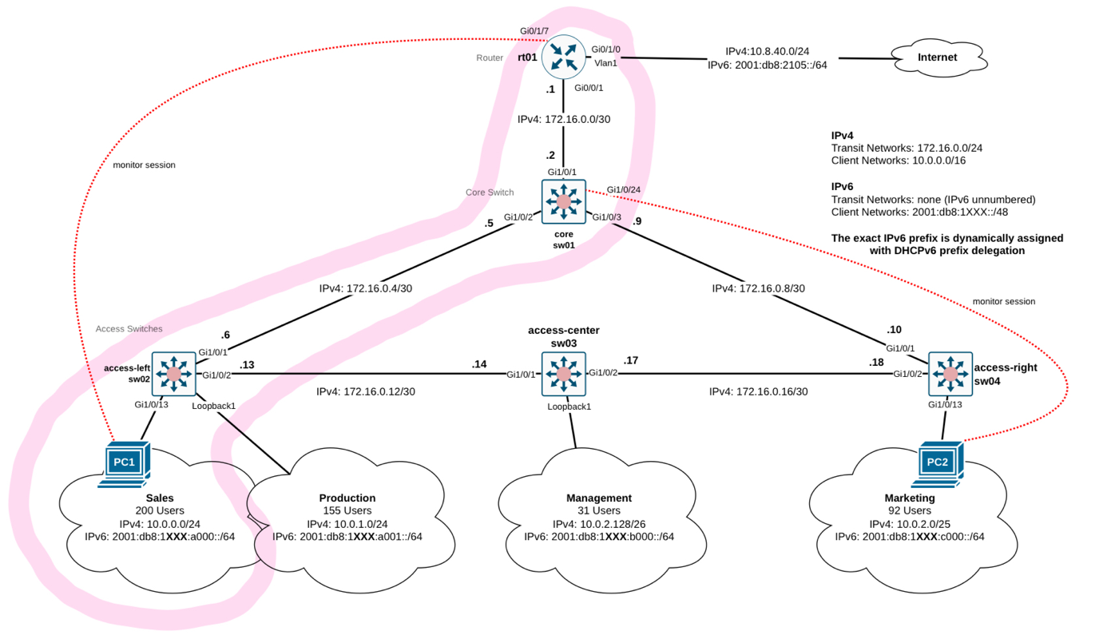
Sw02:
ip route 172.16.0.0 255.255.255.254 172.16.0.5

Sw01:
ip route 10.0.0.0 255.255.254.0 172.16.0.6

rt01:
ip route 10.0.0.0 255.255.252.0 172.16.0.2

- Was für eine Route muss ich hinzufügen, dass die Clients ins Internet kommen (statisch & ospf)?
Static:
Sw02:
ip route 0.0.0.0 0.0.0.0 172.16.0.5

Sw01:
ip route 0.0.0.0 0.0.0.0 172.16.0.6

rt01:
ip route 0.0.0.0 0.0.0.0 Vlan1

OSPF:
rt01:
ip route 0.0.0.0 0.0.0.0 Vlan1
interface Vlan1
default-information originate

- Was passiert bei OSPF, wenn es zwei Pfade mit gleicher Cost evaluiert hat? (Load Balancing)
If the cost of two paths is the same, then the load of the traffic gets distributed across both paths equally, which is called Equal-Path-Multi-Path (ECMP), and enables load balancing.

Layer 2 – Data Link Layer (Lab 5)
- Why are VLANs created?
VLANs are created to break broadcast domains into smaller, isolated logical networks, improving traffic management, security, and efficiency. They map to subnets and can span multiple switches using VLAN trunking (e.g., 802.1Q), enabling flexible network segmentation across locations.

- Differentiate between switchport modes (access and trunk)
Access:
- Only one VLAN per port
- Use case: To put an end device into a VLAN
Trunk:
- Multiplte VLANs per port
- Use case: Propagate VLANs from switch to switch over one link only

- What are the 2 way to create inter domain vlan routing?
- <Enable routing> on a L3 switch
- Router-on-a-Stick, which is a network configuration where a single router interface is used to route traffic between multiple VLANs on a switched network.

- What is logical reasoning behind making router subinterfaces?
Each subinterface is associated with a VLAN. This means that one physical interface can be associated with multiple subinterfaces.

- How does port channeling help in improving bandwidth?
It groups multiple physical links together which gives a combined bandwidth of both links.

- What are active and passive modes in context of LACP?
Active: Enables LACP only if a LACP device is detected. It places the port into an active negotiating state in which the port starts negotiations with other ports by sending LACP packets
Passive: Enables LACP on the port and places it into a passive negotiating state in which the port responds to incoming LACP packets. However, it does not start LACP packet negotiation (Default)

If both ports are in the passive mode, no link aggregation can take place

- STP makes loop free topologies. How?
It identifies redundant links and disables them.

- What are 5 different port states of STP?
- Disabled: Port does not participate in STP
- Blocking: Port listens to BPDUs but discards any other frame
- Listening: Port moves from blocking state to the listening state. Receives BPDUs and redirects them for processing. Frames still get discarded
- Learning: Port moves from listening to learning state. It listens and processes BDPUs. Frames still get discarded
- Forwarding: Port moves from learning state to the forwarding state. It starts forwarding frames across the network segments. The port also continues to receive and process BPDUs

- Why is STP vulnerable to attacks and what is the improvement made to have faster convergence?
Cisco invented rapid STP to combat the issues of STP. The vulnerability arise from the lack of authentication and slow convergence.

- PC 1 & PC 2 sind über eine Switch miteinander verbunden. Wenn Traffic zwischen den beiden PCs mitgesnifft wird, dann kann man im Wireshark das Type Field ansehen. Was ist die Funktion von diesem Type Field?
Protokoll Identifikation: IPv4, IPv6 oder ARP (oder so)

- Zu welchem Layer gehört ARP?
ARP ist ein Layer 2 Protokoll. Obwohl es die MAC-Adresse zu der dazugehörigen IP-Adresse mappt, nutzt es keine IP-Adressen. Jegliche Kommunikation von ARP läuft über Layer 2.

- Wieso kann ein Enduser mit der exakten IP- und MAC-Adresse von einem anderen Enduser diesen nicht finden, wenn sich beide in einem anderen VLAN befinden?
VLANs müssen getrennt bleiben und dürfen nur im eigenen VLAN kommunizieren (verschiedene Broadcast Domains). Das VLAN schafft eine logische Trennung auf L2. Solange keinen Tag auf den Frames für das andere VLAN ist, wird die Switch oder der Router nicht in dem anderen VLAN einen MAC-Adressen Lookup machen. Falls nur ein Switch vorhanden ist, muss man zusätzlich Routing Abilities (L2 zu L3 switch) aktivieren, denn sonst kann der Traffic nicht in das entsprechende VLAN geroutet werden, falls ein Tag auf den Frames ist.
Conclusion: Pro VLAN gibt es einen separaten MAC-Address-Table

- Neighbor Solicitation & Neighbor Advertisment: Was macht es und wieso gibt es das?
Neighbor Solicitation & Advertisment ist grundsätzlich das Konzept von ARP für IPv6. Es erfüllt dieselben Funktionen und mappt die MAC-Adresse zur IP-Adresse. NS/NA sind teil vom Neighbor Discovery Protocol (NDP).
Beispiel:
- Node will packet an IPv6 Adresse schicken, weiss aber MAC nicht
- Schickt ein NS zum traget solicited-node multicast address
  - FF02::1:FFXX:XXXX, wobei x für die letzten 24bit der IPv6 Adresse stehen
- Target schickt NA mit MAC
- Node updated neighbor cache mit erhaltenen Infos
Achtung: Ist nicht dasselbe wie Router Solicitation & Advertisement, diese Felder werden für SLAAC benötigt.

- Monitoring Session: Was hat man beobachtet bei PC1 pingt PC2?
Es gibt zweimal Traffic. Einmal über die Monitoring Session & einmal über die normale Route (paket geht über denselben router wie die monitoring session zurück). Die MAC-Adresse vom Ping ändert sich erst beim/nach dem Routing, wenn es dann in Richtung PC2 geht.

- Wieso gibt es Link Aggregation?
Logical aggregation of identical links: Simplifying the topology, because it is viewed as one logical link. In short: two cables get bundled together to appear as one.
- Used for Switch-Level load balancing
- Redundancy in case one path is down
- Can increase bandwidth because the shared link can accept more data

- Wieso macht es keinen Sinn dst-mac zu nutzen, wenn man ins Internet routet? (Load Balancing)
- dst-ip: load distribution is based on the destination-host IP address
- src-ip: load distribution is based on the source-host IP address
- src-dst-ip: load distribution is based on the source-and-destination host-IP address
- src-mac: load distribution is based on the source-MAC address of the incoming packet
- dst-mac: load distribution is based on the destination-host MAC address of the incoming packet
- src-dst-mac: load distribution based on the source-and-destination host-MAC address

Die Verwendung von dst-mac führt dazu, dass der gesamte Traffic immer denselben Port nimmt, weil die Ziel-MAC-Adresse immer gleich ist. -> sehr ineffizient, da Load Balancing sinnvoll ist

- Under which circumstances does it make sense to use the dst-ip load balancing strategy?
When the end systems connect to many different destination IP addresses. An example could be an uplink for an internet connection.

- Direct Link Failure und Indirect Link Failure: Wieso dauert das eine länger als das andere? Und wieso dauert es spezifisch 20 Sekunden länger?
STP timers:
- Hello timer: 2s
  - Rate at which configuration BPDUs are issued from the root switch
- Max age: 20s
  - If the age of the last BPDU exceeds the max timer value the comparison algorithm will have to be rerun
  - Reset after every BPDU received
- Forward delay: 15s
  - The time spent in each of the transitional port states
  - Plug in of PC to receiving a link light -> Blocking, then listening for 15s, then learning for another 15s and finally forwarding
In the event of a direct link failure both ports immediately know about the change in topology. In the event of an indirect link failure, the max. age of 20s first has to expire.

Layer 1 – Physical Layer (Lab 6)

Keine Knowledge-Check Questions vom letzten Lab. Meli improvisiert Fragen basierend auf Austausch mit Fabio: Keine Garantie!!

Was ist der Unterschied von Lin zu Log?
Merkmal | Lin (Linear) | Log (Logarithmisch)
Skalierung | Gleichmässige Abstände (additiv) | Gleichmässige Verhältnisse (multiplikativ)
Beispiel | 10Hz, 20Hz, 30Hz, …. | 10Hz, 100 HZ, 1000 Hz
Wahrnehmung | Unnatürlich | Menschlich
Anwendung | Messtechnik | Musik, Audioverarbeitung, Wissenschaft
Die lineare Darstellung ist mehrheitlich nur eine Messtechnik. Die logarithmische Darstellung entspricht der menschlichen Wahrnehmung und wird für Musik, Audioverarbeitung und wissenschaftliches Arbeiten.
What is the difference between frequency and amplitude?
The frequency describes how high or low a sound is, whereas the amplitude describes how loud or quite a sound it. This can be dangerours, because if the loudness stays the same, but you cannot hear the tone exceeding a certain frequency, you can damage your ears.
Please calculate how much the signal is at the end. (Bring kei gueti Frage ane – sorry!)
- Calculate how many dBm the signal has at the receiver.
The transmitter starts with 20 dBm. For every loss, we subtract the given number and for every gain we add the given number.
- You now have the signal at the receiver. At the moment, it is irrelevant if the result is negative or positive. This endresult can be broken down into groups of 10dB and groups of 3dB. It is important, that you use 10 dB and 3dB, because we’ll utilize the rule of 3 and rule of 10 in the next step.
- For every added 3, we will use factor 2 and for every added 10, we’ll use factor 10. (Rule of 3, rule of 10). Instead of the addition, we’ll now use multiplication. It is possible, that you have to subtract a 3 or a 10. Instead of factor 2 or factor 10, we divide by 2 or 10, depending on if we subtract 3 or 10.
Rule of 3: if added, we use factor 2. if subtracted, we use divisor 2
Rule of 10; if added, we use factor 10. If subtracted, we use divisor 10
- Only now is it important, if the result at the receiver was positive or negative. Add the respective operator in front of the result. In the case below, it would be -32000 because the result at the receiver was -45dBm
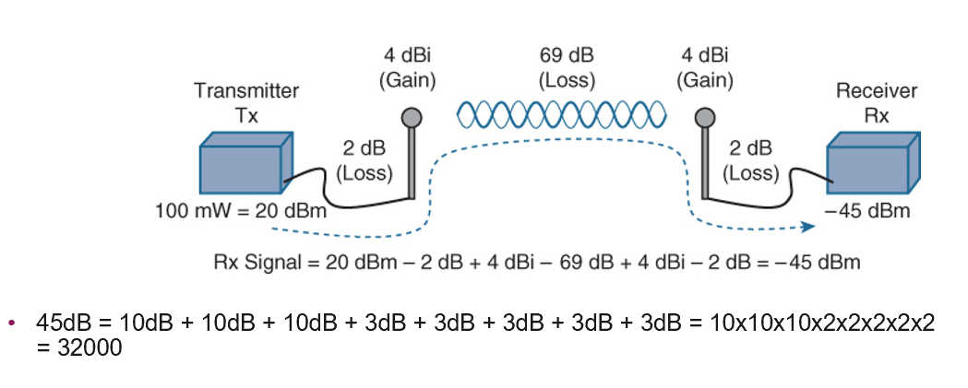
When would you use a High-Pass Filter? What does a typical high-pass-filter look like?
High-pass filters cut off low frequencies and pass frequencies that are higher than a certain level. Frequencies below that

When would you use a Low-Pass-Filter? What does a typical high-pass-filter look like?
A low-pass filter enables you to cut off high frequencies and to past frequencies which are lower than a certain level. The frequency is in Hz, while the Rolloff is in dB per octave. With frequency, you define a maximum value of a frequency which should be untouched. Only frequencies above this value will be filtered, while the lower frequencies can pass the filter. Higher frequencies get decreased by the Rolloff value in amplitude for each octave above the cutoff frequency.

What is Baud and how can you calculate it?
Baud (bd) is the unit we use, when measuring the speed of communication over a data channel. The baud rate is the symbol rate in symbols per second.

What is the difference between bit and baud?
Bit rate measures the total number of bits transmitted per second, representing the volume of data. Baud rate measures the number of signal changes or symbols transmitted per second and can be lower than the bit rate if each symbol carries multiple bits.

What is the baud rate in this signal?
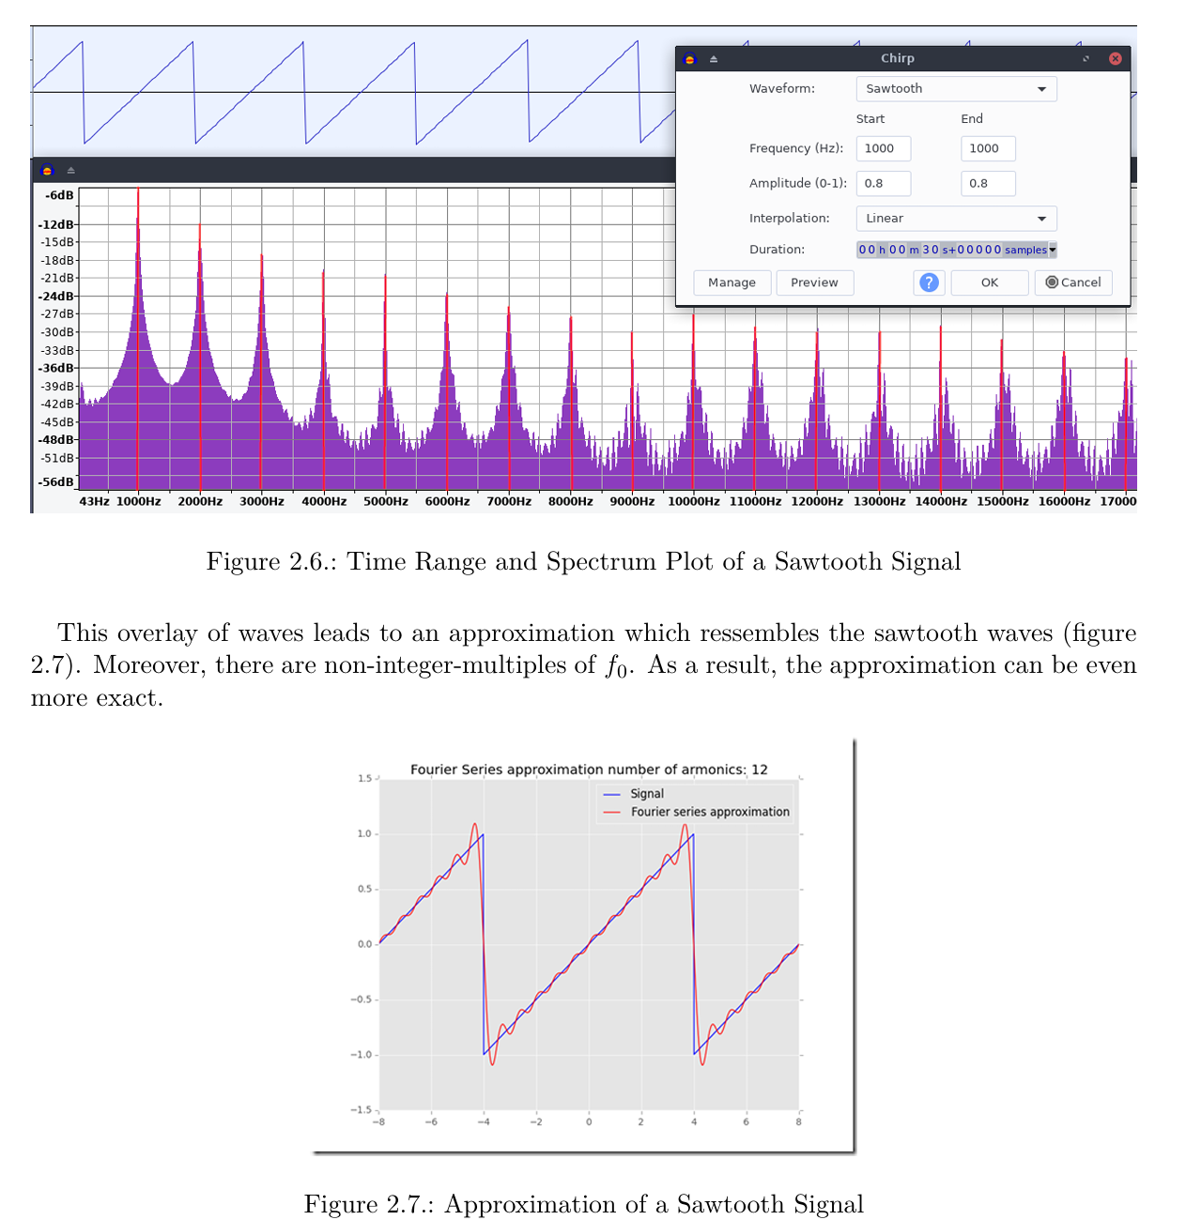
• Signal Nature: The given plot shows a sawtooth waveform, and the Fourier series approximation suggests it's a periodic signal.
• Period (T): A sawtooth wave typically has a well-defined period. In the graph, the waveform seems to repeat every T=2T = 2T=2 units on the x-axis.
• Baud Rate: For a periodic signal like this, if we consider each period to correspond to one symbol in a digital communication system, the baud rate (RRR) is defined as:
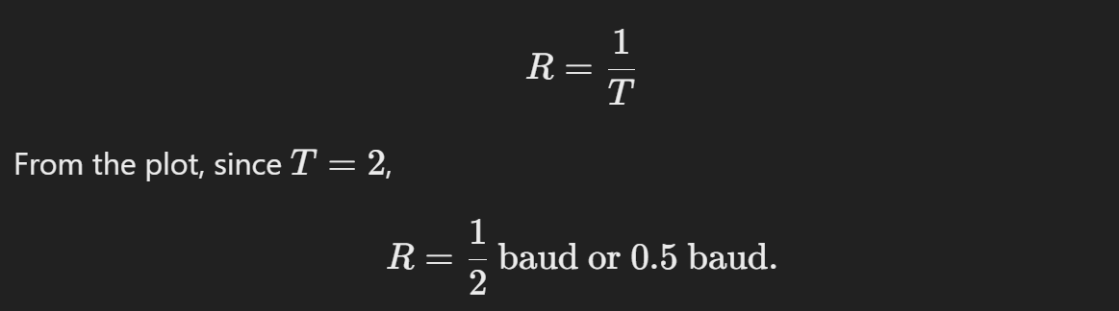

Analyze this «eye»-diagram. Explain the differences and from where do they come from?
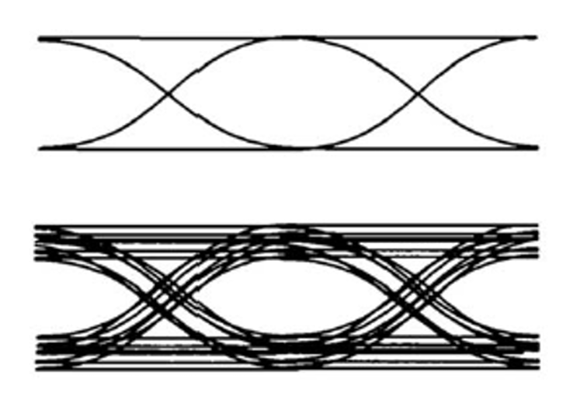

The upper eye diagram is the ideal case, which is rarely found. The lower eyer diagram indicates weak points in the transmission, but is still usable since the eye is still quite recognizable.
- Different amplitudes indicate noise or large differences in runtime
- The horizontal shift (jitter) could be caused by imprecise clocks.

Suschtige Other Stuff
Was ist der Unterschied zwischen einem Router und einem Switch?
Router:
- Function: A router connects different networks together and routes data between them. It directs traffic based on IP addresses.
- Use: Connects local networks (broadcast domain) to other networks, such as the internet and determines the best path for data to travel between devices across different networks
- Operates on the Network Layer (3) (to be more specific it operates on the Control Plane)

Switch:
- Function: A switch connects devices within the same network (broadcast domain) and facilitates communication between them by forwarding data to the appropriate device using MAC addresses
- Use: Interconnects devices like computer, printers and server within a single network. It also ensures efficient data transfer between devices on the same network
- Operates at the Data Link Layer (2) (although some switches have L3 options)
Key Differences:
Aspect | Router | Switch
Purpose | Connects networks (e.g LAN to WAN) | Connects devices within a single network (LAN)
Addressing | Uses IP addresses to forward data | Uses MAC addresses to forward data
Layer | Network Layer 3 | Data Link Layer 2
Complexity | Handles inter-network communication | Focused on intra-network communication

Wieso gibt es die Unterteilung in Control Plane und Data Plane?
The Layer 3 (Network Layer) can be further divided into a Control Plane and Data Plane. This division is essential because of technical and functional reasons.
Data Plane:
- Is responsible for the forwarding of data packets. It works on an operative layer and ensures that packets arrive at the correct location based on routing or switching rules.
Control Plane:
- Is responsible for the controlling and management of the network. Here we decide if traffic needs to be routed using routing tables.
Was ist channel bonding?
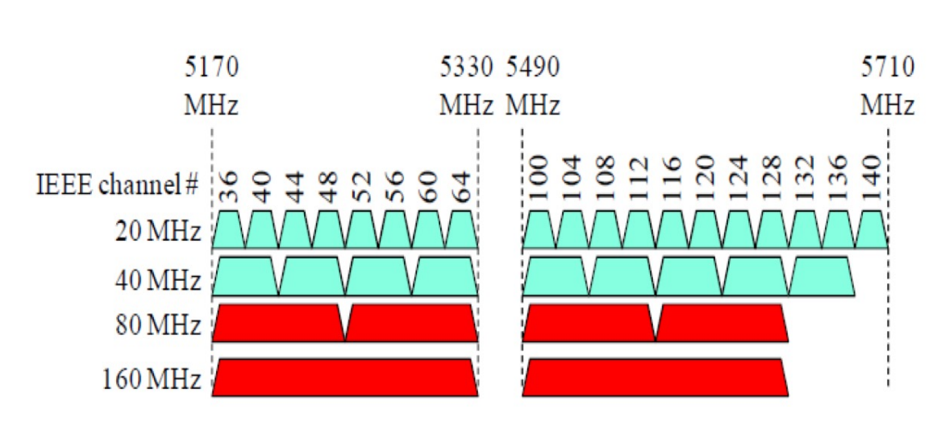
Previously wifi (802.11) transmissions were transmitted using 20MHz data channels. Each channel was single and non-overlapping. With 802.11n two channels can be bonded, which more than doubles the bandwidth because the guard channels in between are also used.

Wieso braucht man 3-4 mac Adressen im WLAN?
Address 1: MAC address of receiver (wireless host or AP)
Address 2: MAC address of transmitter (wireless host or AP)
Address 3: MAC address of router interface to which AP is attached.
Address 4: Used only in ad hoc mode.

Which address is which depends on the scenario.
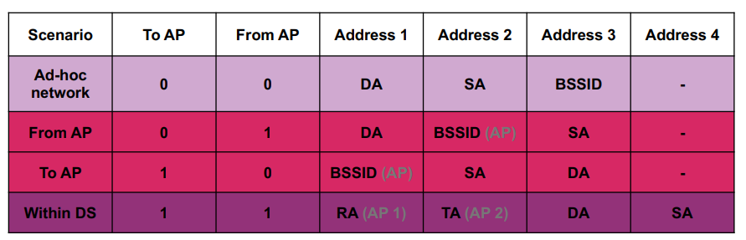
Further relevant keywords:
BSSID:
- Basic Service Identifier
- MAC address of the radio interface the client device is currently connected to.
AP: Access Point
DS: Distribution System was genau gmeint ???
DA: Destination Address
RA: Receiver Address
SA: Source Address
TA: Transmitter Address
Ad hoc network:
- No base stations,
- Nodes can only transmit to other nodes within link coverage,
- Nodes organize themselves into a network: route among themselves,
- Example: Bluetooth
Destination
Source
BSSID
Receiver/Transmitter

Why differentiate Intra-, Inter-AS routing?
Policy:
- Inter-AS: admin wants control over how its traffic routed, who routes through its network
- Intra-AS (OSPF): single admin, so policy less of an issue
Scale:
- Hierarchical routing saves table size, reduced update traffic
Performance:
- Intra-AS: Can focus on performance
- Inter-AS: Policy dominates over performance

Wichtige Infos aus den Vorlesungen (Von Urs während sem)
V12/13
- Zu schema wie regeneration: muss nicht komplett auswendig gelernt werden, aber Konzept erklären muss man können
V10/11
- MAC address table kommt an prüfung (wie letztes jahr) -> im anderen Dokument erklärt
V8/9
- ICMP types muss man für Prüfung nicht auswendig kennen
- Kein SDN an Prüfung
V6/7
IPv4:
- Output port queuing really important
- IP in binär auswendig für Prüfung
- Subnetting kommt an der Prüfung
- Fragmentierung anschauen

IPv6:
- Multicast addresses
- Solicited note multicast adresse anschauen wichtig, gut verstehen

V4/5
- Question to fast retransmit might be on exam

Prüfung:
- Clock recovery should be something you know (even without summary)
- Full/half duplex - nothing said about it not comming
- dBi calc on exam for sure
- Dispersion etc terms don’t need to be memorised
- Collision domain circle drawing should be looked at
- MAC addresse aufgabe on exam for sure
- First wifi wireshark not on exam
- STP kommt
- MTU frage mit which fragment eher schwierig
- Fragmentierung ipv6 muss man wissen
- Subnetz kommt, genau eine richtige Lösung
- A16 muss man können, kann aber auch der Rückweg fehlen
- Dijkstra kommt
- TCP Problem zu dropped packet anschauen
- Grafiken/gleiche pcap von übung kann verwendet werden
- DHCP könne mit mac learning kombiniert werden
- DNS muss man können (recursive/iterative/relay agent)
- Warum hat IPv6 eine checksum? → possible way to ask a question
- Verständnis von den headern muss da sein und unterschiede zwischen IPv4 und IPv6
- HTTP mehr wichtig wie es an sich funktioniert (GET, 404, 200, 400, 302, 201, 418)
- Wireshark HTTP ausschnitt möglich
- rdt versionen nicht relevant
- Windows categories lernziel in abklärung
- Warum dauert es ca. 31s bis der client eine IP hat (ipv4 dhcp) → Spanning tree (listening/learning)

Joker Session Notizen
- Er hat über port queueing gesprochen im kontext von full und half duplex (buffer)
  - Hat dann jedoch selber gemeint es geht eher sehr ins detail
- Wir haben über Hubs gesprochen (Hub macht flooding, dass macht dann die collisions)
- Hubs muss man nicht gut wissen für die Prüfung (dass was gesagt wurde reicht, also was er macht)
- Solicited node address wird verwendet, weil es potentiell eben diese Adresse schon gibt (duplicates) und dann hätten wir einen Adressen Konflikt das wollen wir ja genau überprüfen
- Router kann mit Prefix zusammen auch DNS infos mitgeben bei SLAAC
- EUI-64 anschauen für link-local Adressen Generierung (ramon gesagt wäre gut)
- MAC multicast addressen evt auch noch anschauen (33:33:….)
- Verständnis von mapping solicited node to ethernet II (beides an multicast Gruppen)
- 4G/5G für Prüfung nicht von besonderer Relevanz
- Icmp ist ausschliesslich auf dem network layer
- Unterschied von MAC und ARP table
  - MAC table, ist auf switch, switch speichert keine IP weil ist auf L2, deshalb merkt er sich auf welchem Interface
  - ARP table ist auf endgerät mit IP und mac
- STP Aufgabe kommt so nicht an der Prüfung (die mit dem t+)
- CRC: Polynomdivision kommt nicht, aber der Begriff sollte bekannt sein
- Wieso macht man error detection und nicht error correction? Zu viel overhead, günstiger eine retransmission zu machen
- Latency: Zeit von A nach B, nur in eine Richtung, also ein synonym zu delay, wobei delay halt spezifisch auf die Verzögerung bezogen ist (er hets sogar z’erscht au falsch gseit)
- DHCP: Beim Zeitpunkt vom request darf er seine addresse noch nicht verwenden, erst nach dem finalen ack, vorher hat er keine addresse und kann deshalb nur einen broadcast machen
  - Dies gilt auch für DAD & NS/NA. Dort ist die source address :: (unspecified address), weil er ja eben noch keine hat, die er verwenden darf. (frage: was ist die source ip bei ipv4 dhcp request?
- Encoding: Wissen für was es ist in Bezug auf clocking etc.. Man muss es nicht einzeichnen können selber, aber einfache NRZ etc hat er nicht explizit gesagt, dass wir es nicht können müssen
- Attenuation: nicht auswendig
- Physical layer: Eher reduziert dieses Jahr. Es kommt ist aber nicht Schwerpunkt
- Single mode, multimode nicht prio, andere Dinge besser anschauen (fiber)
- Es gibt keine doppelten Links bei STP Aufgabe
- Wie gut flags: nicht nötig auswendig, aber wissen das es flags gibt
- Wichtig: Verständnis für wieso verschiedene icmp gesendet werden
- Tipp: video von marcel zu fragmentation gut zu schauen
- Unterschied chromatic dispertion etc nicht auswendig
- Dijkstra: spielt keine rolle welche tabelle man nimmt (letztes jahr oder dieses jahr), theoretisch darf man es auch direkt auslesen
TCP:
- Send windows (receive, usable etc) war in der Vorlesung (nur nicht in der übung), deshalb nochmals anschauen (gelbe + blaue balken zusammen sind die window size)
- Was ist mit Window categories gemeint:
  - Sliding window gemeint mit receive, usable etc
- Evt. AIMD noch anschauen (alternative zu slow start?)
- Slow start muss nicht so in der tiefe angeschaut werden, es muss eher der Begriff eingeordnet werden. Das heisst, wofür wird es verwendet und wozu gehört es
- Was hat Einfluss auf die Window Size?

