Version 1.1
January 2, 2025
CN1
Katharina Tschirky
katharina@tschirky.ch

Zusammenfassung

Inhaltsverzeichnis
Inhaltsverzeichnis 1
1 HTTP 4
1.1 HTTP methods 4
2 DNS 5
2.1 Iterative DNS 5
2.2 Recursive DNS 6
2.3 Local DNS / resolver 6
3 TCP 6
3.1 Send Window 6
3.2 Receive Window 6
3.3 Window Size 7
3.4 Window Categories 7
3.5 Acknowledgment System 7
3.6 Slow Start 8
3.7 Congestion Control 9
3.8 Flow Control 9
4 IPv4 and IPv6 Configuration 10
4.1 DHCP 10
4.2 DHCPv6 12
4.3 SLAAC 12
5 IPv6 Address Scopes 12
5.1 Global Scope 12
5.2 Link-Local Scope 13
5.3 Unique Local Scope 13
5.4 Multicast address 13
6 IPv4 and IPv6 Subnetting 14
6.1 IPv6 Subnetting 14
6.2 IPv4 Subnetting 15
7 Dijkstra Algorithm 16
7.1 Goal 16
7.2 Link costs 16
7.3 Example 16
8 Static Routing 18
8.1 How to create static routing tables 18
8.2 How to summarize routes/subnets 19
9 Dynamic Routing (BGP and OSPF) 21
9.1.1 Use Cases: 22
9.2 Link state algorithms 22
9.2.1 OSPF 23
9.3 OSPF hierarchy 23
9.4 BGP 24
9.4.1 BGP basic algorithm 24
9.4.2 BGP route selection 25
9.4.3 BGP path advertisement 25
9.4.4 BGP messages 26
9.5 Why differentiate Intra-, Inter-AS routing? 26
9.6 Distance vector algorithms 26
9.7 Comparison of LS and DV algorithms 27
10 Distinguish Network Layer Control Plane and Network Layer Data Plane responsibilities 27
10.1 Data Plane 27
10.2 Control Plane 28
11 Switching and Link Layer Technologies in general 28
11.1 LACP 28
11.2 VLAN 29
11.2.1 Access Ports 30
11.2.2 VLAN Trunking 30
11.2.3 Router on a stick 31
11.3 Ethernet 31
11.3.1 Ethernet II frame 31
11.3.2 IEEE 802.3 frame 31
11.3.3 MTU 31
11.3.4 Ethernet framing 31
11.3.5 MAC Address / Ethernet Address 32
11.4 ARP 34
11.4.1 ARP tables 34
11.4.2 ARP in action - LAN 34
11.4.3 ARP in action – Outside of LAN 35
11.4.4 Example last year exam 36
11.5 Neighbor Discovery 36
11.5.1 Neighbor Solicitation & Neighbor Advertisement 37
11.5.2 Router Advertisement 37
11.5.3 DAD: Duplicate Address Detection 37
11.5.4 Solicited-node multicast address 37
11.6 Error Detection and Correction 38
11.6.1 FCS: Frame Check Sequence 38
11.6.2 Parity Checking 38
11.6.3 Internet checksum 39
11.6.4 Cyclic Redundancy Check (CRC) 39
11.7 Multiple Access Protocols 39
11.7.1 Multiple Access Control – Klassen 40
11.7.2 CSMA (carrier sense multiple access) 40
11.7.3 TDMA – Time division multiple access 42
11.7.4 FDMA – frequency division multiple access 42
11.7.5 Slotted ALOHA 43
11.7.6 Pure ALOHA (unslotted) 43
12 Spanning Tree Protocol 44
12.1 Usage 44
12.2 BPDU 45
12.3 Port states 45
12.4 Process (how to solve practical) 45
12.5 Timers 46
12.6 Topology Changes 47
13 OSI Layers and how they work together (a day in the life of a web request) 48
13.1 A day in the life of a web request 49
13.2 Encapsulation and decapsulation 52

HTTP
It is the foundation of any data exchange on the Web and it is a client-server protocol, which means requests are initiated by the recipient, usually the Web browser. Clients and servers communicate by exchanging individual messages (as opposed to a stream of data). The messages sent by the client are called requests and the messages sent by the server as an answer are called responses.
- HTTP (HyperText Transfer Protocol) is a foundational communication protocol used on the web to transfer data, such as HTML files, between a client (like a browser) and a server.
- HTTPS (HyperText Transfer Protocol Secure) is a secure version of HTTP that uses encryption via SSL/TLS to protect the confidentiality and integrity of data exchanged between a client and a server.

HTTP methods
There are 4 main types of HTTP request messages:
- POST: web page often includes form input and user input is sent from client to server in the entity body of HTTP POST request message
- GET: is used for sending data to server. It includes data in URL field of HTTP GET request message following a ‘?’
- HEAD: requests headers only, that would be returned if specified URL were requested with an HTTP GET method
- PUT: uploads a new file (object) to the server and completely replaces the file that exists at specified URK with content in entity body of POST HTTP request message
HTTP Status Codes
- 200 OK: request succeeded, requested object later in this message
- 301 Moved Permanently: requested object moved, new location specified in the Location field
- 400 Bad Request: request message not understood by server
- 404 Not Found: requested document not found on this server
- 505 HTTP Version Not Supported: klar, ne

HTTP GET/response interaction is stateless because there is no notion of multi-step exchanges of HTTP messages to complete a Web “transaction”. There is no need for client/server to track the state of a multi-step exchange and all HTTP requests are independent of each other. Additionally, there is no need for client/server to “recover” from a partially-completed-but-not-fully transaction.

What cookies can be used for:
- Authorization
- Shopping carts
- Recommendations
- User session state (Web Mail)

Web caching
A web cache acts as both client and server. It is the server for the original requesting client, but client to the origin server. Typically, cache is installed by ISP. Reasons for Web caching:
- Reduces response time for client requests, since a cache is closer to the client
- Reduces traffic on an access link

DNS

Iterative DNS
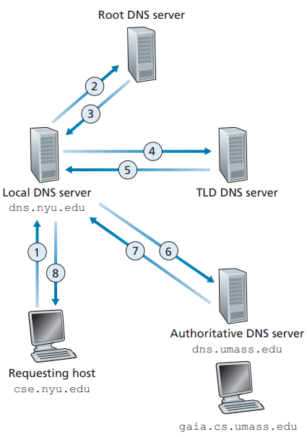
An iterative query is one in which a DNS client expects a DNS server to respond with the best answer it can give without querying another DNS server. Instead, the DNS server gives a list of nameservers for the requested domain which the client queries itself.

Recursive DNS
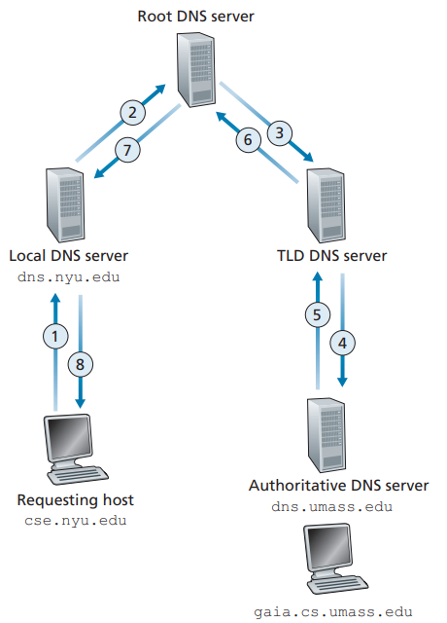
With a recursive DNS the DNS client expects a full resolution of a DNS name from a DNS server, which means the query gets sent to the next server until the answer has been reached.

Local DNS / resolver
Its like a librarian who is asked to find a book in a library. This server is designated to receive queries from a client. The DNS resolver then makes a recursive DNS request to get the name/ip address. The resolver also caches the responses for a certain amount of time.

TCP

Send Window
The TCP send window is the portion of data that the sender is allowed to transmit without receiving an acknowledgment, determined by the receiver's advertised window and network conditions. The TCP usable window is the portion of the send window that currently has available space for sending new data, considering both the receiver's advertised window and unacknowledged data in transit. The send window is the number of bytes that the recipient is allowing the transmitter to have unacknowledged at one time. The window is what determines how many bytes the sender is allowed to transmit and is equal to the sum of the number of bytes in category 2 and category 3.

Receive Window
The TCP receive window in a TCP connection is a flow control mechanism that specifies the amount of buffer space available at the receiver for incoming data. It is advertised by the receiver to the sender in every acknowledgment packet, allowing the sender to adjust its transmission rate accordingly. A larger receive window allows for higher throughput, while a smaller window signals the sender to slow down to prevent buffer overflow. This dynamic adjustment ensures efficient data transfer and prevents congestion at the receiver's end.

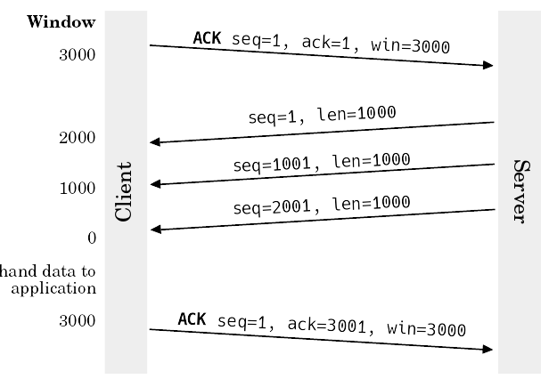
Window Size
The window size is the amount of payload bytes a receiver can handle. When the window size is fully utilized it waits for an ACK and window size update of the receiver before transmitting more data. A windows size of 0 means that the sender stops delivering data.

- Client communicates window size of 3000 bytes and starts a syn/ack sequence
- Starts sending a packet with length 1000 and sequence 1
- Another load of 1000 bytes is sent, sequence number is now +1000 making it a total of 1001
- Another load of 1000 bytes is sent, another 1000 is added to the seq making it 2001
- The client has now received a total of 3000 bytes, it acknowledges the last seq received by adding the length of 1000 to it, making it 3001.
- The client also sends an updated window size

Window Categories
Was ist damit gemeint? Window Size Scale?

Acknowledgment System
- Connection Establishment (Three-Way Handshake):
1. The client sends a SYN packet to the server, marked with a random sequence number x
2. Server answers with an ACK, telling the client to accept the connection. The packet contains an ACK number, which is x+1. It also contains another SYN with a new random sequence number y
3. The client acknowledges the SYN of the server by increasing y by one (y+1), the old ack is used as the sequence number

Example:
1. SYN, seq num = 4567
2. SYN+ACK, ack num = 4568 seq num = 12998
3. ACK, ack num = 12999
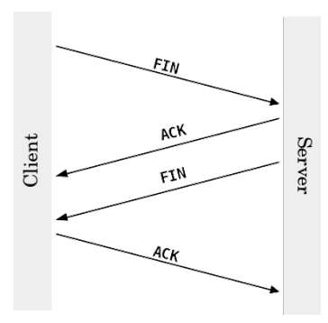
- Connection Termination (Four-Way Handshake):
To tear down a connection every station sends a FIN request and confirms the others FIN with an ACK.
The two packets in the middle could be combined into a single FIN ACK packet, which would result in a three-way handshake. The connection does not have to be terminated by both stations. Half-open connections can exist in case only one station sends the FIN. The open connection can still send data but the one who terminated cannot.
If the side that sent the FIN does not process or acknowledge incoming data, any data sent by the non-terminating side will eventually time out and may be retransmitted based on TCP's retransmission logic. However, if acknowledgments never arrive (e.g., the FIN-sending application has terminated), the connection will eventually be reset or closed.
(A half-open connection might be used for a server shutdown grace period, where the server wants to stop sending data but allows clients to finish their operations or send final data.
-> muss no vo wiiter obe verified werde)

- Data Transfer
After the connection is established, we still need to maintain the connection by using the sequence and acknowledgement number.
Example:
- Packet of 1460B is sent with a random sequence number 10 001
- Receiver confirms packet by sending ACK (seq+leng) of 11 461
- Another 298 540B need to be sent, which will be broken down in many 1460B packets. The next 1460B are sent with the seq nr. 11 461

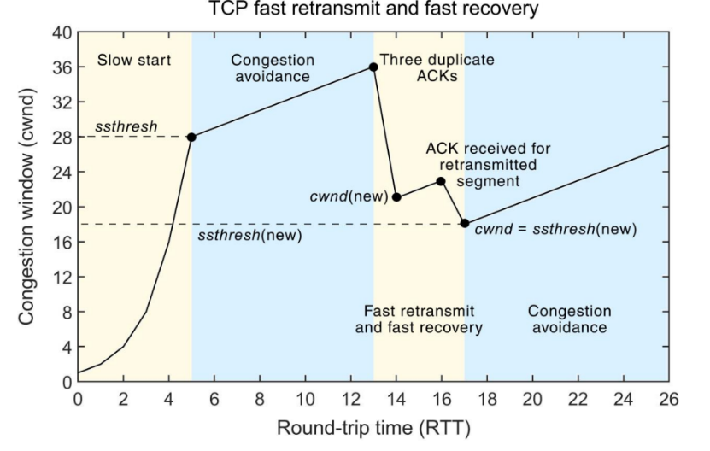
Slow Start
- Before sending any packet, the MSS (maximum segment size) is set to 1
- After sending the first packet with MSS 1, it waits for an ack from the receiver
- When the ack arrives the congestion window size will be increased to 2, now the next two segments can be sent
- With every received ACK the sender increases the congestion window size by 1
ssthresh (slow start threshold): When the congestion window reaches this value it enters the congestion avoidance state
While in the congestion avoidance state, the congestion window only grows for MSS/congestion window. The increase of the transmission rate stops as soon as congestion is detected (packet loss or duplicate ack). After this occurs a fast retransmit is performed. It sets half of the current congestion window as the new sstresh value and reinitiates slow start.
Note: this is only one of many such algorithms

Congestion Control
- Doesn’t need any additional fields (makes use of the sliding window and ACK packets, as well as MSS (Maximum Segment Size)
- TCP: Does not prevent congestion, but congestion avoidance is done by most systems around
- Sender maintains a congestion window for its own use. Before sending any TCP packet, it is set to 1 MSS. After sending the first packet with 1 MSS, it waits until it receives an ACK from the receiver. The increase of the transmission rate stops as soon as congestion is detected (that is the case if a packet loss occurs or a duplicate ACK is received).

Flow Control
After the connection is established the data flow must be controlled by both workstations to fully optimize it. It ensures the sender transmits data at a rate that the receiver can process, preventing buffer overflow and data loss.
Ways to optimize flow:
- Delayed ACK
  - Avoid ACKs for every single frame received
  - Recommended to wait half a second or less to send ACKs
  - Causes further problems
Example:
    - Seq x=1, length=1000
    - Server waits half a second until it sends an ACK
    - In this time it receives 7 segments with leng=1000
    - It sends an ack=7001
- Duplicated ACK
  - Can happen when a data segment gets lost during delayed ACK
Example:
- Packet nr. 40 gets lost
- Last ack was sent for packet nr. 37
- Receiver notices it cannot reorder segments by their seq nr.
- It sends an ack for packet nr. 37 again
- Ack can also get lost, so it is sent over and over again
- After the third ack for packet 37 in a row, the missing packet and all following packets get retransmitted
- Fast Retransmit
  - If duplicated ACKs are activated, the sender waits for retransmission timeout
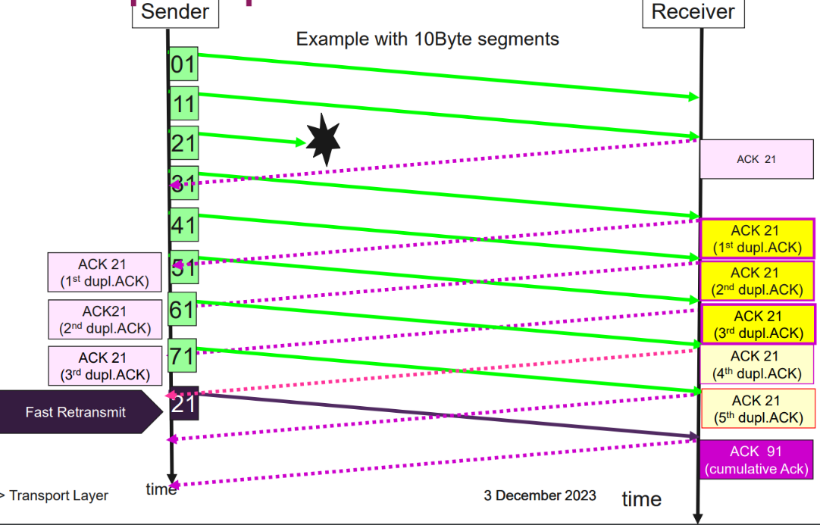
  - If fast retransmit is activated, it immediately sends a packet when duplicate ACKs arrive at the sender’s station

- Selective ACKs
  - A process to retransmit only the packets that actually got lost
- Sliding Window
- Sender communicates the windows size before payload is sent
- Communicated with a header field
- Window size is communicated with every TCP segment transmitted
- Window Scaling

IPv4 and IPv6 Configuration

DHCP
Goal of dhcp:
- Can renew its lease on address in use
- Allows reuse of addresses (only hold address while connected/on)
- Support for mobile users who join/leave network

DHCP overview:
- Hosts broadcasts DHCP discover msg [optional]
- DHCP server responds with DHCP offer msg [optional]
- Host requests IP address: DHCP request msg
- DHCP server sends address: DHCP ack msg
DHCP additional use cases:
- Can return address of first-hop router for client
- Return name and IP address of DNS server
- Return network mask (indicating network versus host portion of address)

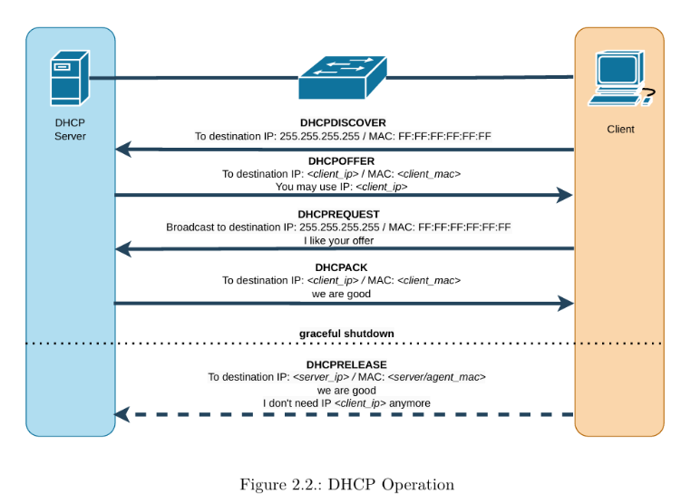
DHCPDISCOVER Client broadcast to locate available servers.
DHCPOFFER Server to client in response to DHCPDISCOVER with offer of configuration parameters.
DHCPREQUEST Client message to servers either
• (a) requesting offered parameters from one server and implicitly declining offers from
all others
• (b) confirming correctness of previously allocated address after, e.g., system reboot, or
• (c) extending the lease on a particular network address.
DHCPACK Servertoclient with configuration parameters, including committed network address.
DHCPRELEASE Client to server relinquishing network address and cancelling remaining lease.

Example:
- Connecting laptop will use DHCP to get IP address, address of first-hop router, address DNS server
- DHCP REQUEST message encapsulated in UDP, encapsulated in IP, encapsulated in ethernet
- Ethernet frame broadcast (dest: FF:FF:FF:FF:FF:FF) on LAN, received at router running DHCP server
- Ethernet demux’ed to IP demux’ed, UDP demux’ed to DHCP
Example:
- DHCP server formulates DHCP ACK containing client’s IP address, IP address of first-hop router for client name & IP address of DNS server
- Encapsulated DHCP server reply forwarded to client, demuxing up to DHCP at client
- Client now knows its IP address, name and IP address of DNS server, IP address of its first-hop router

DHCPv6
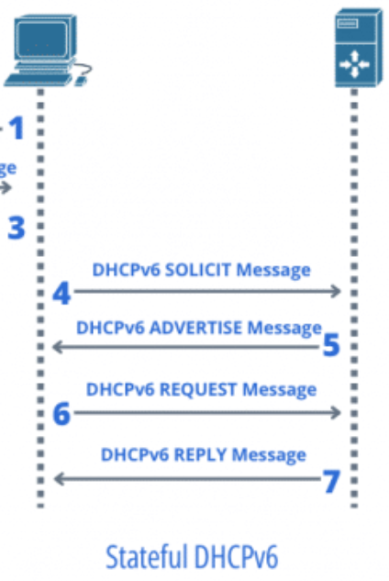
A client-server protocol that helps manage the config of devices of an IPv6 network. DHCPv6 not only assigns IPv6 addresses but also can deliver additional configuration details through options, as well as the automatic delegation of IPv6 prefixes, which allows a router to assign blocks of IP addresses to other routers that request them. DHCPv6 is stateful.

SLAAC
SLAAC requires no manual configuration of hosts, minimal (if any) configuration of routers and no additional servers. The stateless mechanism allows a host to generate its own addresses using a combination of locally available information and information advertised by routers. Routers advertise prefixes that identify the subnet associated with the link while them hosts generate an interface identifier. An address is formed by combining the two. In the absence of routers, a host can only generate link-local addresses, but they are sufficient for allowing communication among the nodes attached to the same link. SLAAC is stateless, meaning it only provides an address but does not store any configuration state on the server.

IPv6 Address Scopes

Global Scope
- Globally routable
- Default global range 2000::/3
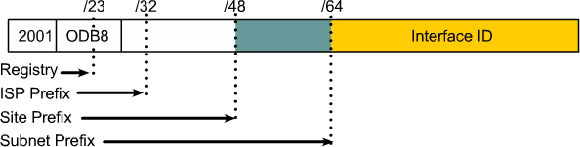
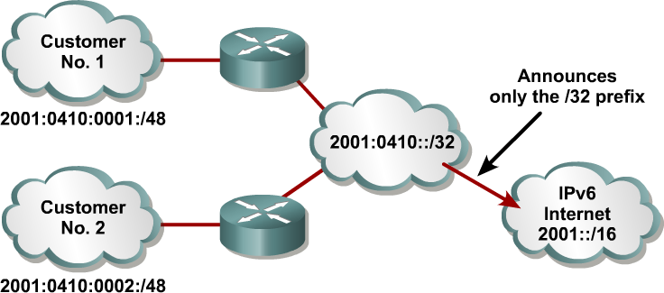

Link-Local Scope
- Used locally on a data link or ethernet segment
- Default link-local subnet FE80::/10
- Mandatory Address for Communication between two IPv6 device (like ARP but at layer 3)
- Automatically assigned by router as soon as IPv6 is enabled
- Also used for Next-Hop calculation in Routing Protocols
- Remaining 54 bits could be Zero or any manual configured value
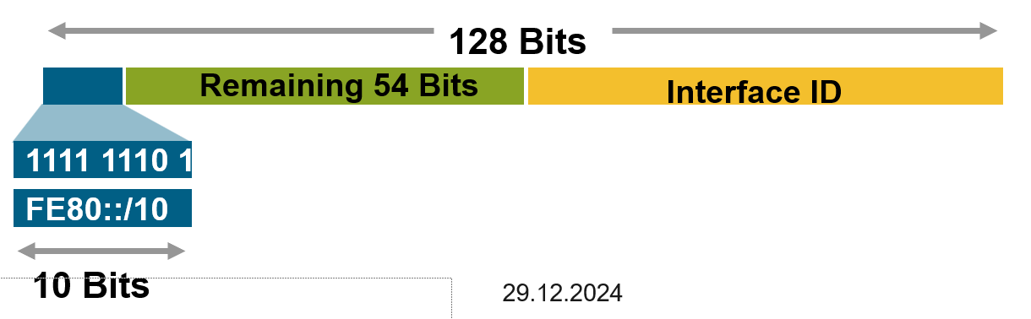

Unique Local Scope
- Localhost
  - 0:0:0:0:0:0:0:1=> ::1
- Unspecified address
  - 0:0:0:0:0:0:0:0=> 0::0 => :: => ::/128
- Documentation Prefix
  - 2001:0db8::/32
- Discard Prefix
  - 0100::/64
- Default Route
  - ::/0

Multicast address
IP multicast address has a prefix FF00::/8 (1111 1111); the second octet defines the lifetime and scope of the multicast addresss. Some well-know multicast addresses:
FF02::1 = All nodes on a segment
FF02::2 = All routers on a segment
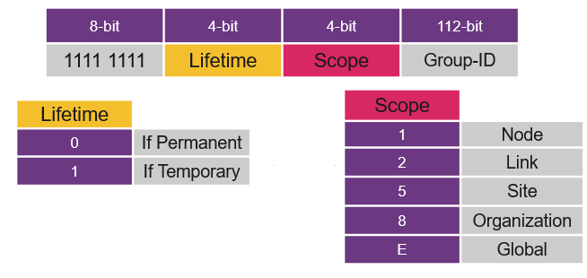

IPv4 and IPv6 Subnetting
A subnet is a smaller network inside a network. Subnets make networks more efficient, by reducing the size of broadcast domains. They are configured on routers or L3 switches. Devices on the same subnet can communicate without a router.

IPv6 Subnetting
Prefix: How many bits are reserved for the network e.g /36-Prefix reserves the first 36 Bits of the network

If an ISP gives a space of /36 you will have lots of free space for subnetting. To get to /48 we know that 48-36=12 Bits can be used for subnetting. This gives us 2¹² (4096) Subnets with a /48 prefix.
From /48 to /64 we get an additional 16 bits for subnetting. In IPv6 /64 is the standard-prefix for subnets. Each network gets its own /64 address space. This is supported for use with SLAAC.

Example:
- 2001:db8:1000::/36

Split into /48:
- 2001:db8:1000:0000::/48
- 2001:db8:1000:0001::/48
- 2001:db8:1000:0002::/48
- ...
- 2001:db8:1000:0FFF::/48
Now each /48 block can be further split into /64 subnets. We will take the first /48 as an example:
- 2001:db8:1000:0000:0000::/64
- 2001:db8:1000:0000:0001::/64
- 2001:db8:1000:0000:0002::/64
- ...
- 2001:db8:1000:0000:FFFF::/64

IPv4 Subnetting
Subnetzmaske: Jedes 1 das gesetzt wird heisst, dass dieses bit zum Netzanteil gehört. Die restlichen bits sind der Hostanteil
Hostanteil: Diese bits stehen zur Verfügung für IP-Adressen
Netzadresse: Immer die erste Adresse des Subnetz (e.g 192.168.1.0)
Broadcastadresse: Die letzte Adresse im Subnetz (e.g 192.168.1.255)
Verfügbare Adressen: In jedem Subnetz sind die zwei Adressen für Netzwerk und Broadcast reserviert
- Die IP Adresse wird in Netzanteil und Hostanteil aufgeteilt
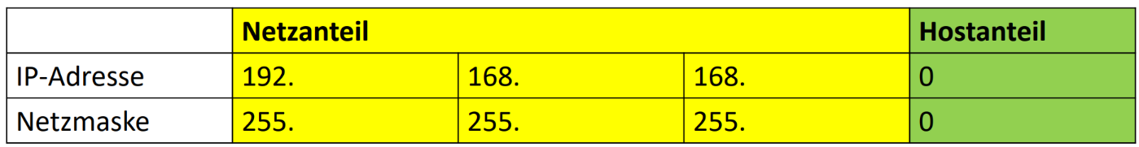
Nun muss sich entschieden werden, welche Subnetzgrösse wir brauchen. Die Anzahl IPs pro Subnetz erhält man in 2er Potenzen, d.h 2²=4 IPs, 2³=8 IPs, 2⁴=16 IPs usw. bis 256
Achtung: Wenn man 7 Desktops hat, braucht man ein Subnetz der Grösse 2⁴(16), weil 2 Adressen reserviert werden müssen
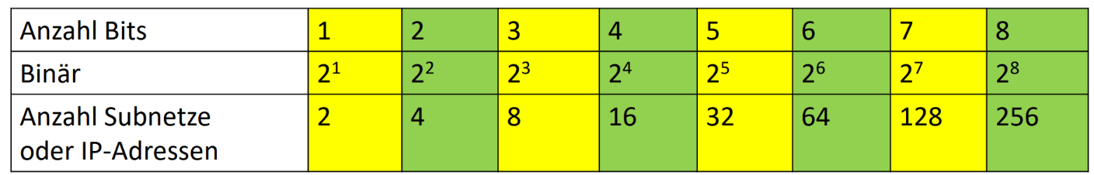
- In dem Beispiel werden wir 4 Subnetze erstellen
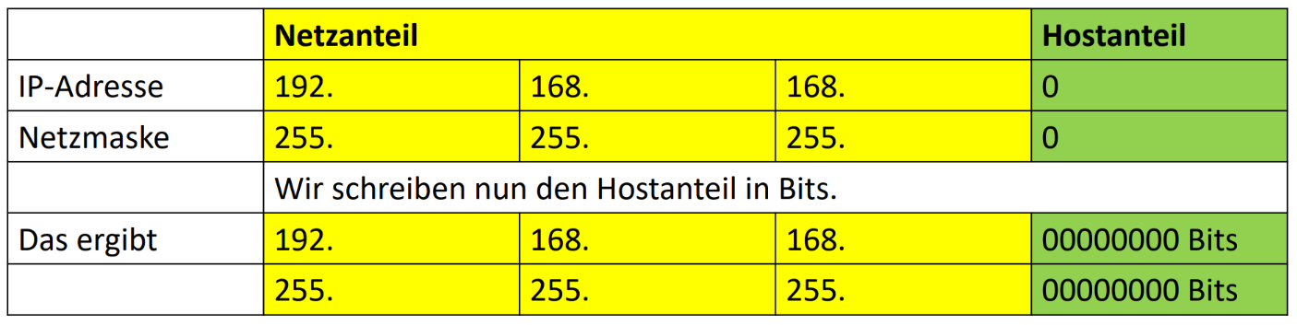
Da wir 4 Subnetze erstellen, wird nun der Netzanteil um 2 bits erweitert. Somit besteht unser Hostanteil nun aus 6 Bits, also 64 IPs, wovon 62 verfügbar sind.
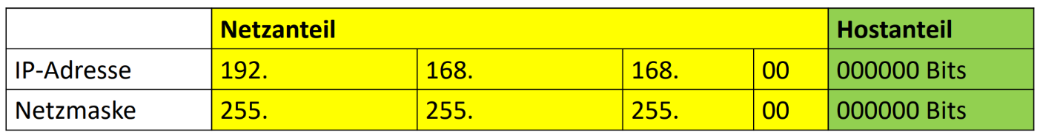
- Nun werden für die neue Subnetzmaske die erweiterten bits auf 1 gesetzt
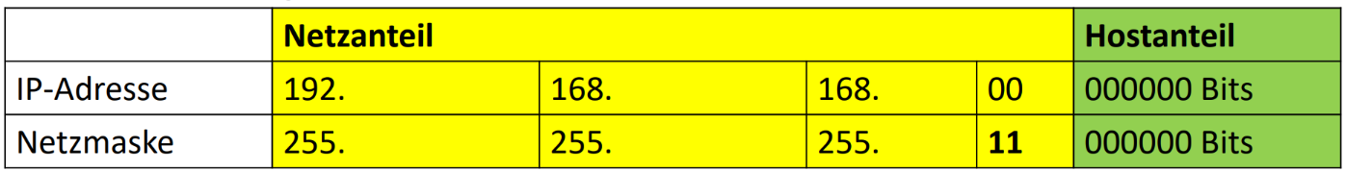
Die neue Subnetzmaske ist umgerechnet nun also 255.255.192.0
- Als nächstes berechnen wir die Broadcast-IP vom 1. Subnetz. Dazu werden alle Hostbits auf 1 gesetzt
Daraus ergibt sich, dass 192.168.168.63 unsere 1. Broadcast Adresse ist
Wir kennen also bereits unser ganzes 1. Netz.
- Unser nächste Netz-ID ist folglich die letzte Broadcast Adresse + 1. Wir können für die weiteren Subnetze einfach +64 (Anzahl IP pro Subnetz) rechnen
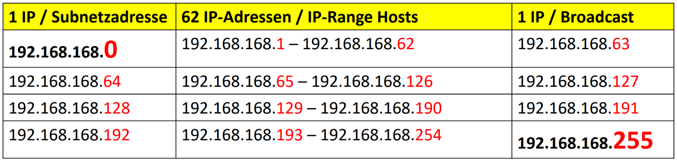

Dijkstra Algorithm

Goal
Determine the fastest (least cost and least congested) paths from sending hosts to receiving host, through network of routers.
Path: Sequence of routers packets traverse from given initial source host to final destination host

Link costs
C_{a,b}: Cost of direct link connecting a and b
- The cost defined by network operator
- Or inversely related to bandwidth
- Or inversely related to congestion
- Centralized: network topology, link costs known to all nodes
  - Link state broadcast
  - All nodes have same info
- Computes least cost paths from one node

Example
Dijkstra depends on the perspective. We will calculate the shortest path tree from z.
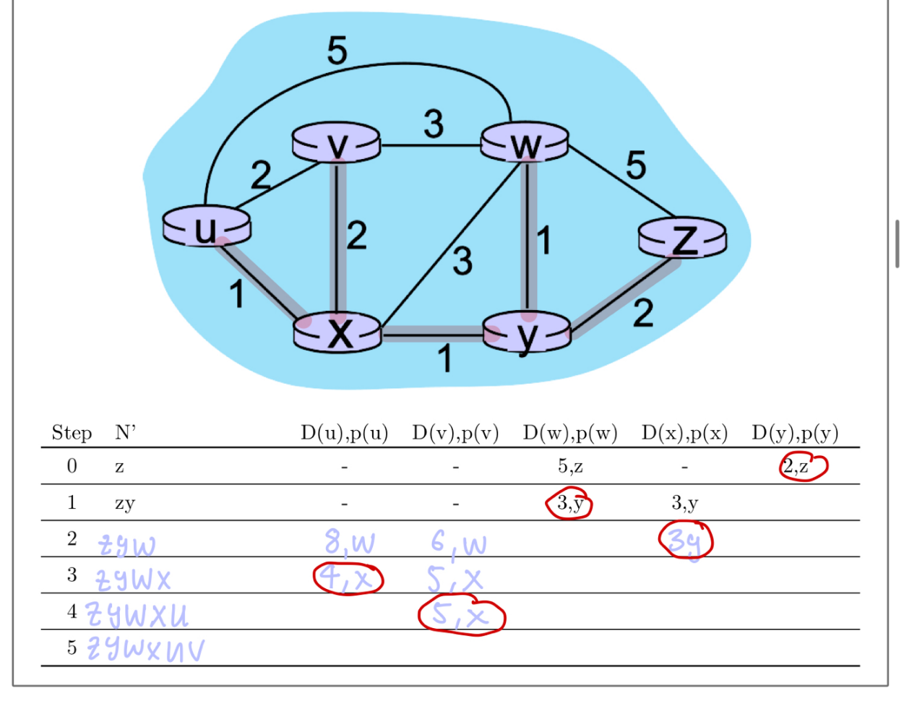
- We only look at the directly connected relationships
- For z we note the cost to w and y
- Since the cost to y is lower than the cost to w, we will note y as our next router
- We don’t need to write down a cost for y as we are currently on it
- y is directly connected to w and x (we already took care of z)
- Each path has a cost of 1. We now need to add the cost of the path until y to the cost. In this case 2. We note the cost of each path
- Since we now have two routes with the same cost, we chose the one that is lower in the alphabet (but it really doesn’t matter)
- We now continue to router w and repeat the whole process
How to draw the links:
- For each router we now have the information, where we can find the shortest path
  - Router u can be found on router x
  - Router v can be found on router x
  - Router w can be found on router y
  - Router x can be found on router y
  - Router y can be found on router z

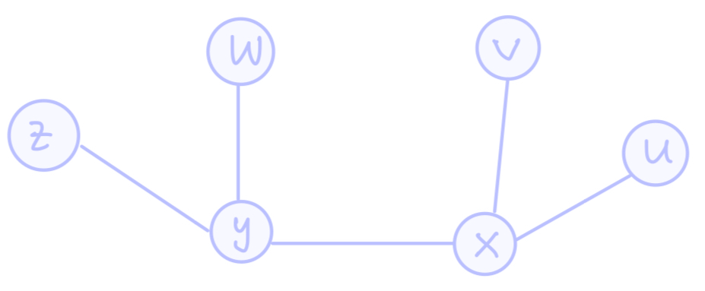

Static Routing
A router’s routing table contains:
− Directly-connected routes: These routes come from the active router interfaces configured with IP addresses.
− Remote routes: These routes come from remote networks connected to other routers. They are either configured manually or learned through a dynamic routing protocol.
– Default route: This is where the packet is sent when a route does not exist in the routing table.

How to create static routing tables
A route is structured like this:
- ip route <network-id> <subnet mask> <next-hop ip>
- ipv6 route <destination-network>/<prefix-length> <next-hop ip>
Each router needs to be informed about a network (static route) if packets to that network need to be forwarded.
In the following example we will enable connectivity between the network 10.0.0.8/8 and the network 15.0.0.8/8
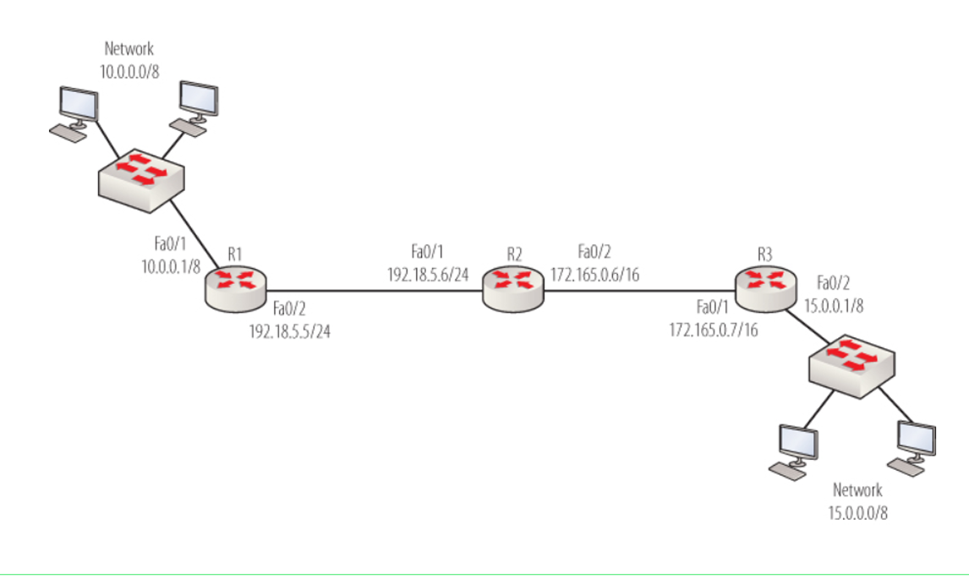

Example 1 (no default routes): | Example 2 (with default routes):
R1:  Ip route 15.0.0.0 255.0.0.0 192.18.5.6  R2:  Ip route 15.0.0.0 255.0.0.0 172.165.0.7  Ip route 10.0.0.0 255.0.0.0 192.18.5.5  R3:  Ip route 10.0.0.0 255.0.0.0 172.165.0.6 | R1:  Ip route 0.0.0.0 0.0.0.0 192.18.5.6  R2:  Ip route 15.0.0.0 255.0.0.0 172.165.0.7  Ip route 0.0.0.0 0.0.0.0 192.18.5.5  (either one can be the default route, but we can’t have more than one default route)  R3:  Ip route 0.0.0.0 0.0.0.0 172.165.0.6

How to summarize routes/subnets
To make configuring static routes more efficient we want to summarize smaller subnets into bigger chunks. The router will know where to find them using the bigger subnet mask. 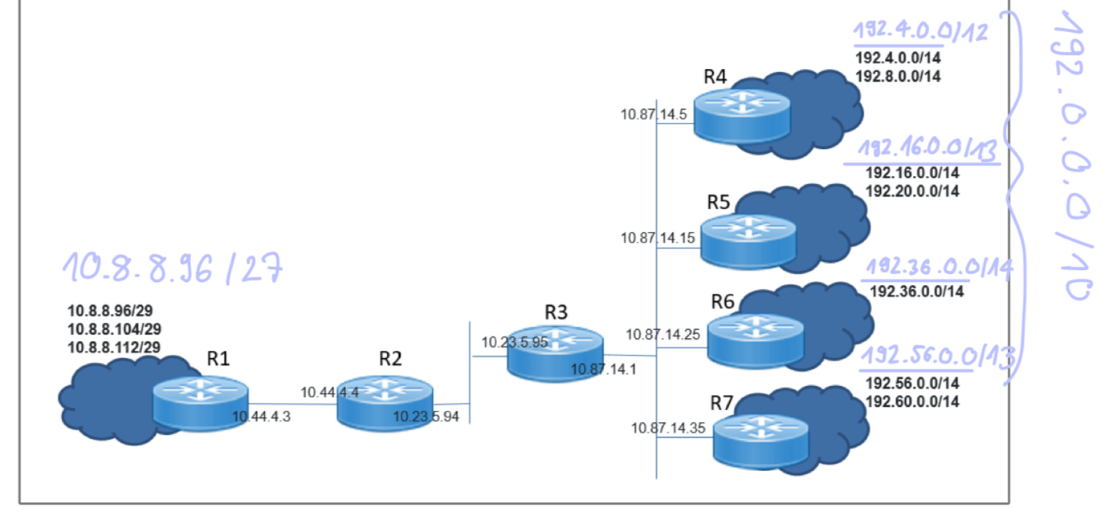
We always start summarizing the smaller subnets first and then combine them into even bigger pieces
- We first start summarizing the subnets on R1
  - /29 cidr means we have 2³²⁻²⁹ = 8 host addresses
    - This can also be seen by looking at the 3 subnets, each are 8 apart.
  - If we add all add all addresses together, we get 3x8=24 addresses. This means our new grand subnet needs to support 24 addresses.
  - We have to choose a subnet with 32 (2⁵) addresses. This gives us a new cidr of 32-5=27
  - Our new network starts at the lowest network: 10.8.8.96/27
- Now we look at R4
  - /14 2³²⁻¹⁴ host addresses, this number is pretty big, so we only look at the relevant block
Network ID | 192. 0000 0100.0.0
Subnet Mask | 1111 1111. 1111 1100. 0000 0000.0000 0000 | 2² = 4
  - This means that within the second block we get an increment of 4 for each Network-ID
  - Our two blocks are between 192.4.0.0 – 192.11.255.255, meaning we need a total of 8 bits, this leads us to a problem. The first block of 8 would be starting from 192.0.0.0-192.7.255.255. Thus, we have not covered our whole network and we need to increase to 16 bits.
  - We decrease our cidr by 2, this gives us a summarized network of 192.0.0.0/12
- R5
  - Just as above we have 4 bits, this time we can use 8 bits to summarize the network
    - 0-7,8-15,16-23
  - Meaning we extend the cidr by 1, which gives us 192.16.0.0/13
- R6 no need to summarize as we only have one network
- R7
  - Since 56/8 gives us an even number, we can assume that an extension to 8 bits will be sufficient
  - 192.56.0.0/13
- Summarization of R4-R7
  - Further it is possible to summarize these routes so R3 doesn’t need 4 individual routes
  - Our lowest subnet is 192.0.0.0 and our highest is 192.63.255.255 aka 64 addresses
  - 65 needs to be extended to 128 (2⁷)
  - To get our new cidr we look out our subnet mask again
Subnet Mask | 1111 1111. 1100 0000. 0000 0000.0000 0000 | 2⁶ = 64
So we get 192.0.0.0/10
Now we can go on to configure this on each router, so we can sure each network can communicate with each other.
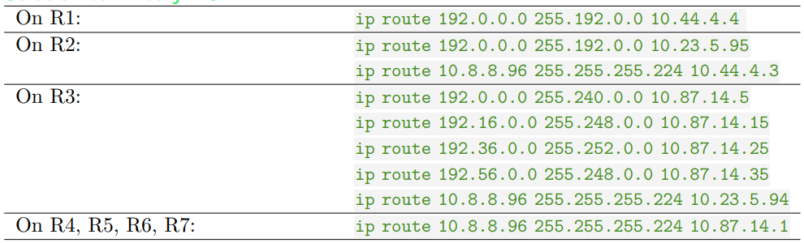

Dynamic Routing (BGP and OSPF)
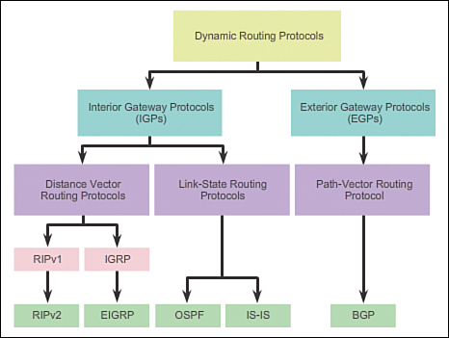
Path Determination: Directly Connected & Next-Hop

Dynamic routing refers to the process by which routers automatically adjust their routing tables based on network conditions. It offers several key benefits:
- Convergence: Dynamic routing protocols quickly adapt to network changes, ensuring that routers have the most up-to-date information about the best available paths.
- Load Balancing: Traffic is distributed across multiple paths to optimize bandwidth usage and avoid congestion on any single route.
- Equal Cost Multipath (ECMP): This technique allows multiple paths with the same cost to be used simultaneously, improving network efficiency and performance.
- Redundancy: Dynamic routing provides fault tolerance by allowing traffic to be rerouted through alternative paths if one path fails, ensuring continuous network operation.
- Scalability: It helps handle increased traffic loads by leveraging multiple paths, preventing bottlenecks that could arise from relying on a single route.

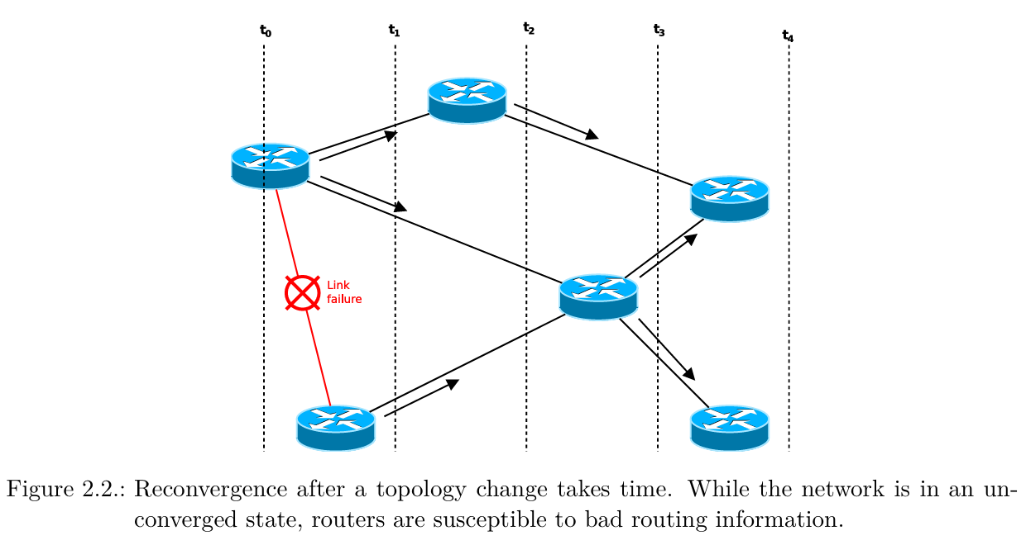

Use Cases:
Data Center Networks In data centers, ECMP is commonly used in spine-leaf architectures to balance traffic between multiple paths, ensuring high availability and efficient use of network resources. Internet Service Providers (ISPs) ISPs use ECMP to manage and distribute traffic across mul tiple backbone links, enhancing performance and reliability for their customers. Enterprise Networks Enterprises deploy ECMP to ensure high availability and load balancing across redundant links, improving overall network performance and fault tolerance.

Link state algorithms
Link State Protocols provide routers with a comprehensive and accurate view of the network topology. Each router has a detailed topology database (or "map") that includes information about all other routers, links, and the costs associated with those links. This database consists of nodes (routers), paths (connections between nodes), and their respective costs. The process starts with the Hello Protocol, which helps routers determine their directly attached paths and the state of each path (up/down, cost, round-trip time).

Once the initial path information is gathered, Link State Advertisements (LSAs) are used to distribute this information across the network through controlled flooding, ensuring all routers receive the updates. Routers then use the Shortest Path First (SPF) algorithm to calculate the best path between any two nodes, based on the topology database. The SPF algorithm builds a tree by selecting the lowest-cost path from the root router to all other routers, continually updating the Candidate database until the optimal path is determined. This process ensures that each router knows the best path to every other router in the network, allowing for efficient and accurate routing decisions.

Step 1: Hello Protocol
Step 2: Controlled Flooding of Link State Advertisements (LSA)
Step 3: calculate the “best” path between any two nodes & building the link state database

The SPF algorithm Create a table of three columns:
• Candidate LSAs/links
• Cost from the candidate LSAs to the root
• Tree (chosen link)

OSPF
OSPF offers a large level of scalability and fast convergence. Despite its relatively simple configuration in small and medium-size networks, OSPF implementation and troubleshooting in large-scale networks can at times be challenging.

OSPF Features Independent transport
• OSPF works on top of IP and uses protocol number 89.
• It does not rely on the transport layer protocols TCP or UDP Efficient use of updates
When an OSPF router first discovers a new neighbor, it sends a full update with all known link-state information.
• All routers within an OSPF area must have identical and synchronized link-state information in their OSPF ink-state databases.
• When an OSPF network is in a converged state and a new link comes up or a link becomes unavailable, an OSPF router sends only a partial update to all its neighbors.
• This update will then be flooded to all OSPF routers within an area.
OSPF uses a metric that is based on the cumulative costs of all outgoing interfaces from source to destination. The interface cost is inversely proportional to the interface bandwidth and can be also set up explicitly. (Cost is a 16-bit integer (1-65535)
Thanks to OSPF, packets take the route with the lowest cost (usually the largest bandwidth) and not the route with the fewest hops. If a link fails, this information is communicated to all routers. Each router can then calculate the new routes based on the new network topology and update its routing tables. Although the connection between R1 and R3 failed, all PCs were still able to communicate with each other after the routing tables were updated.

OSPF hierarchy
Two-level hierarchy: local area, backbone
- Link-state advertisements flooded only in area or backbone
- Each node has detailed area topology; only knows direction to reach other destinations
- The boundary router connects to other AS (using BGP)
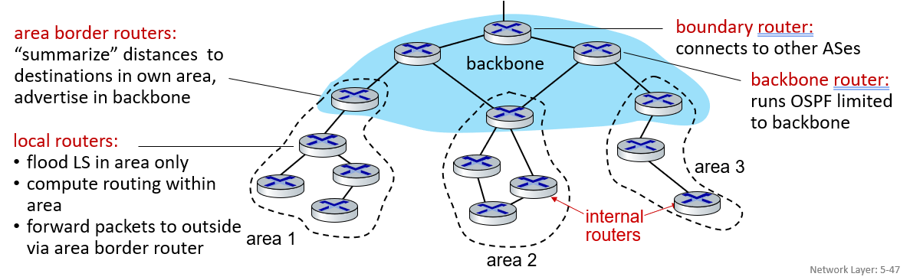

BGP

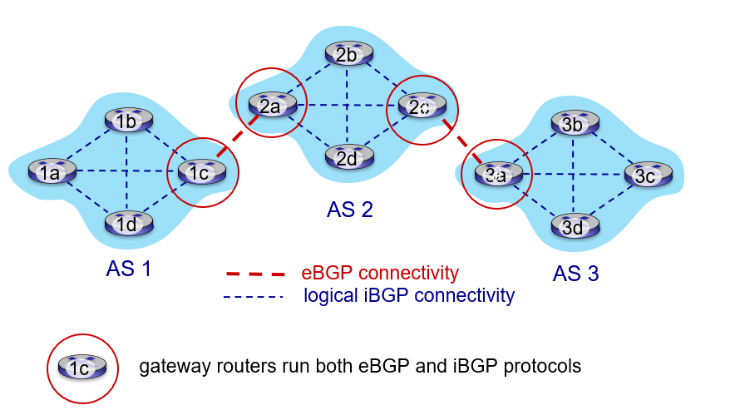
BGP is a routing protocol designed to exchange routing information between different autonomous systems (AS) on the internet. It is a path-vector protocol that uses AS-path information to determine the best routes for data transmission. BGP enables scalability by allowing multiple connections and handling large routing tables across global networks. The protocol is crucial for maintaining the stability and efficiency of internet routing by ensuring data is delivered through the optimal paths. BGP also includes various attributes, such as local preference and next-hop, to make more informed routing decisions. BGP works by advertising its existence and the destinations it can reach, to the rest of the internet: “I am here, here is who I can reach, and how”

BGP basic algorithm
- BGP sessions: two BGP routers (“peers”) exchange BGP messages over semi-permanent TCP connection:
  - Advertising paths to different destination network prefixes (BGP is a “path vector” protocol)
- When AS3 gateway 3a advertises path AS3, X to AS2 gateway 2c:
  - AS3 promises to AS2 it will forward datagrams towards X
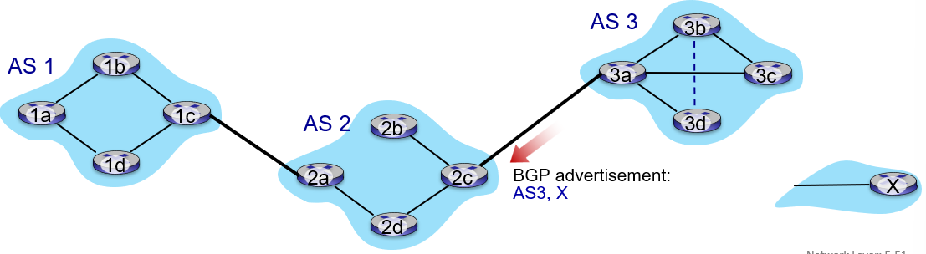

BGP route selection
Router may learn about more than one route to destination AS, selects route based on:
- Local preference value attribute: policy decision
- Shortest AS-PATH (list of AS through which prefix advertisement has passed)
- Closest NEXT-HOP (indicates specific internal-AS router to next-hop AS) router: hot potato routing
- Additional criteria
Policy-based routing:
- Gateway receiving route advertisement uses import policy to accept/decline path (e.g, never route through AS Y)
- AS policy also determines whether to advertise path to other neighboring AS

BGP path advertisement
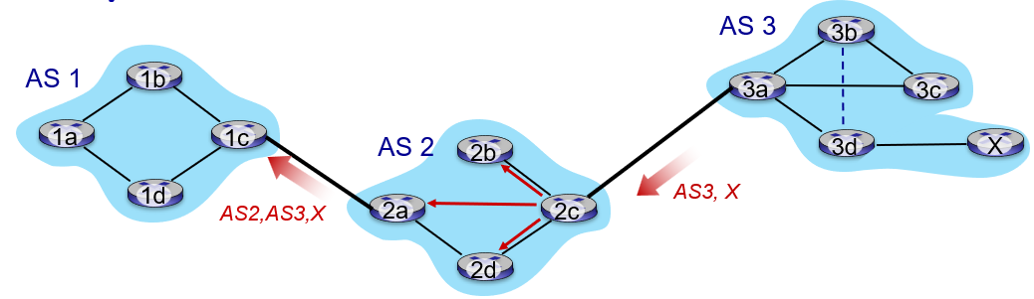
- AS2 router 2c receives path advertisement AS3, X (via eBGP) from AS3 router 3a
- Based on AS2 policy, AS2 router 2c accepts path AS3, X, propagates (vie iBGP) to all AS2 routers
- Based on AS2 policy, AS2 router 2a advertises (via eBGP) path AS2, AS3, X to AS1 router 1c
A gateway router may learn about multiple paths to destination:
- AS1 gateway router 1c learns path AS2, AS3, X from 2a
- AS1 gateway router 1c learns path AS3, X from 3a
- Based on policy, AS1 gateway router 1c chooses path AS3, X and advertises path within AS1 via iBGP
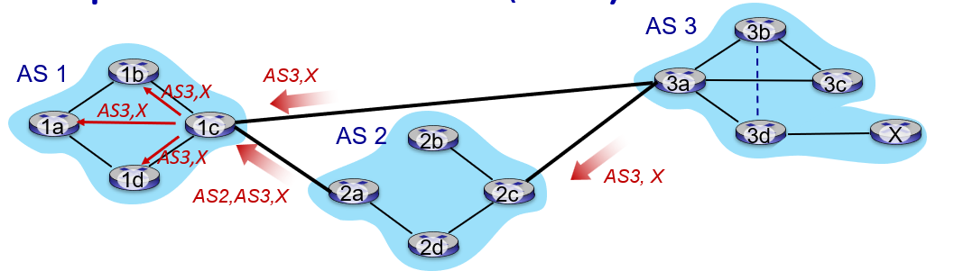

BGP messages
BGP messages exchanged between peers over TCP connection
BGP messages:
- OPEN: opens TCP connection to remote BGP peer and authenticates sending BGP peer
- UPDATE: Advertises new path (or withdraws old)
- KEEPALIVE: Keeps connection alive in absence of Updates; also ACKs OPEN request
- NOTIFICATION: Reports errors in previous msg; also used to close connection

Why differentiate Intra-, Inter-AS routing?
Policy:
- Inter-AS: admin wants control over how its traffic routed, who routes through its network
- Intra-AS (OSPF): single admin, so policy less of an issue
Scale:
- Hierarchical routing saves table size, reduced update traffic
Performance:
- Intra-AS: Can focus on performance
- Inter-AS: Policy dominates over performance

Distance vector algorithms
Key idea:
- From time to time, each mode sends its own distance vector estimate to neighbors
- When x receives new DV estimate from any neighbor, it updates its own DV using B-F equation
- Iterative, asynchronous: each local iteration caused by:
  - Local link cost change
  - DV update message from neighbor
- Distributed, self-stopping: each node notifies neighbors only when its DV changes
  - Neighbors then notify their neighbors – only if necessary
  - No notification received, no action taken

Comparison of LS and DV algorithms
Message complexity:
LS: n routers, O(n²) messages sent
DV: exchange between neighbors; convergence time varies

Speed of convergence:
LS: O(n2) algorithm, O(n2) messages, may have oscillations (Schwingung)
DV: convergence time varies, may have routing loops, count to infinity problem

Robustness: What happens if router malfunctions, or is compromised?
LS:
- Router can advertise incorrect link cost
- Each router computes only its own table
DV:
- DV router can advertise incorrect path cost (“I have a really low cost path to everywhere”): black-holding
- Each router’s table used by others: error propagate thru network

Distinguish Network Layer Control Plane and Network Layer Data Plane responsibilities
The Layer 3 (Network Layer) can be further divided into a Control Plane and Data Plane. This division is essential because of technical and functional reasons.
Data Plane:
- Is responsible for the forwarding of data packets. It works on an operative layer and ensures that packets arrive at the correct location based on routing or switching rules.
Control Plane:
- Is responsible for the controlling and management of the network. Here we decide if traffic needs to be routed using routing tables.

Data Plane
The Data Plane handles the actual forwarding of packets based on routing decisions. It processes incoming data packets and directs them to the correct output interface, functioning in real-time and focusing on speed. In contrast, the Control Plane manages the logic behind routing by maintaining routing tables and network policies, determining the path that data should take. The Data Plane is a local, per-router function.

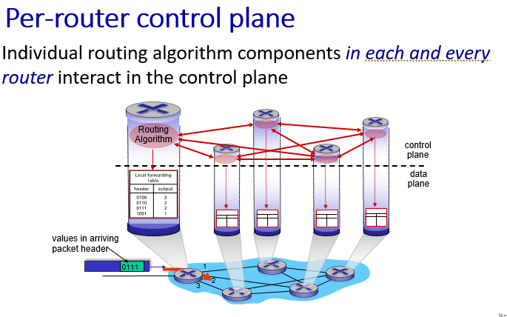
- Purpose: The data plane is responsible for forwarding data packets from one network interface to another based on pre-established rules and routing tables.
- Functionality: move packets from router’s input to appropriate router output
- Performance Focus: Highly optimized for speed and efficiency since it directly impacts data throughput and latency.
- Examples: Sending a packet from a source to a destination based on the routing table entries.

Control Plane
The Control Plane is responsible for determining the optimal path that data packets should take through the network. It includes tasks such as managing routing tables, handling protocol functions, and making decisions about which path data packets should follow to reach their destination efficiently. Essentially, the Control Plane acts as the “decision-making” layer in networking, using algorithms and protocols (like OSPF, BGP, and RIP) to dynamically adjust routes based on network conditions. The Control Plane is network-wide logic, which determines how datagrams is routed among routers along end-to-end path from source to destination.

- Purpose: The control plane is responsible for making decisions about how packets should be forwarded. It establishes the rules and configurations used by the data plane.
- Functionality: determine route taken by packets from source to destination
  - Routing protocols (e.g., OSPF, BGP).
  - Building and updating routing and forwarding tables.
  - Managing network topology and addressing.
- Performance Focus: Less performance-critical compared to the data plane but vital for ensuring correct and efficient network behavior.
- Examples: Updating a routing table when a link goes down or establishing a path for data using MPLS.

Switching and Link Layer Technologies in general

LACP
The LACP is a networking protocol used to combine multiple physical network links into a single logical link, known as a link aggregation group (LAG). It enables increased bandwidth and redundancy by allowing traffic to be distributed across the aggregated links while maintaining failover capabilities. LACP automatically detects and configures the links in the LAG, ensuring that only compatible links are grouped together. LACP is commonly used in switches, routers, and network devices to enhance network performance and reliability.
LACP active mode: the switch actively asks a far-end switch to negotiate an EtherChannel
LACP passive mode: the switch negotiates an EtherChannel only if the far end initiates it.

VLAN
A VLAN is a logical grouping of devices within a physical network, segmented to improve performance, security, and management. It allows devices to communicate as if they were on the same physical network, even if they are geographically dispersed. VLANs help reduce broadcast traffic and can isolate different network segments for better control.

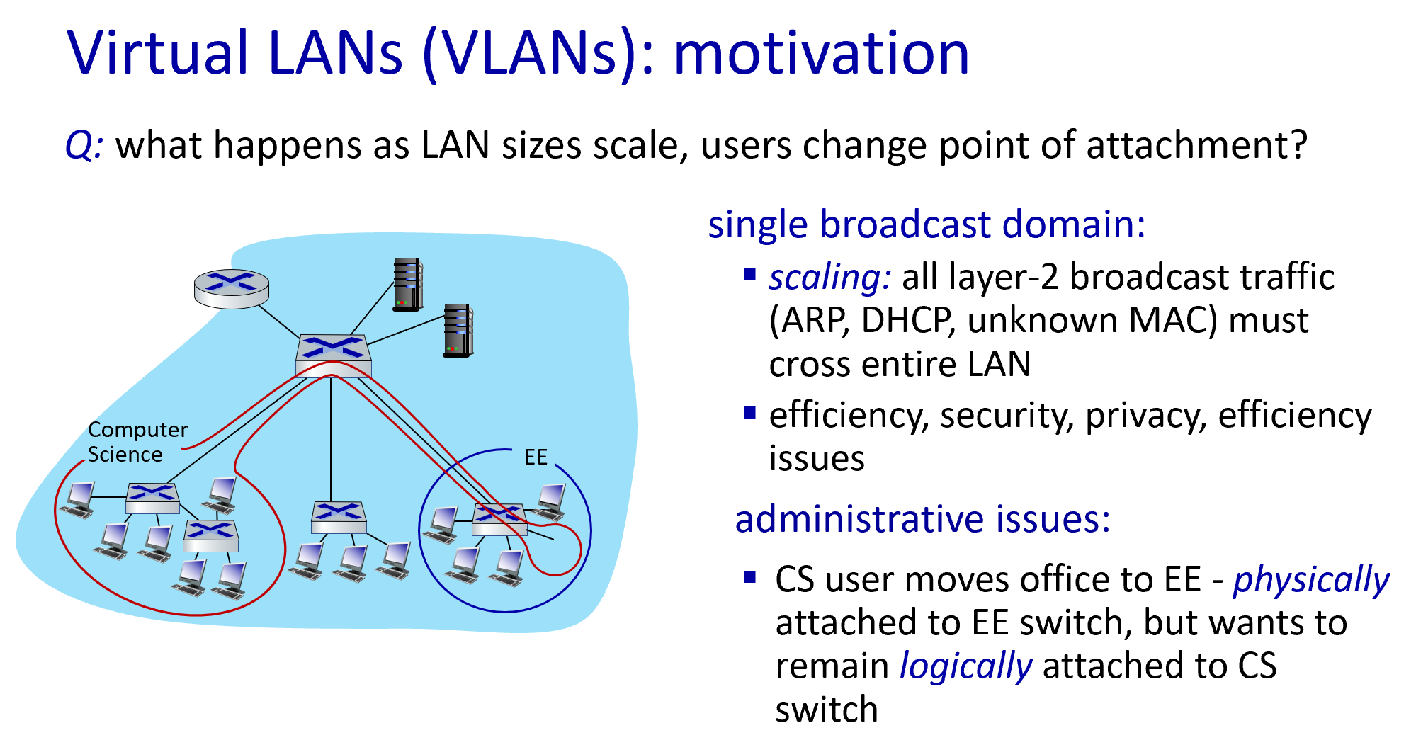
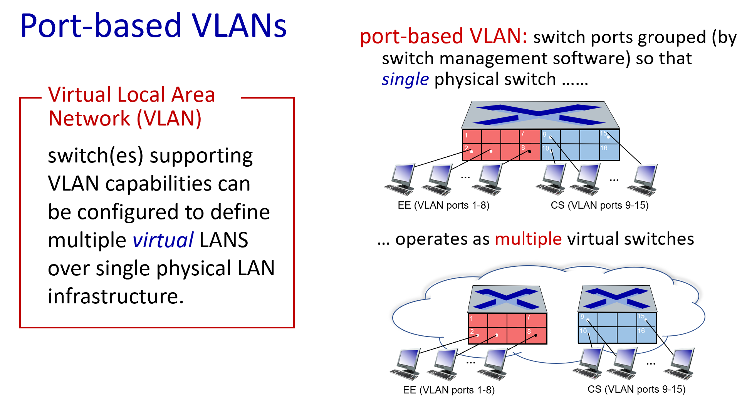
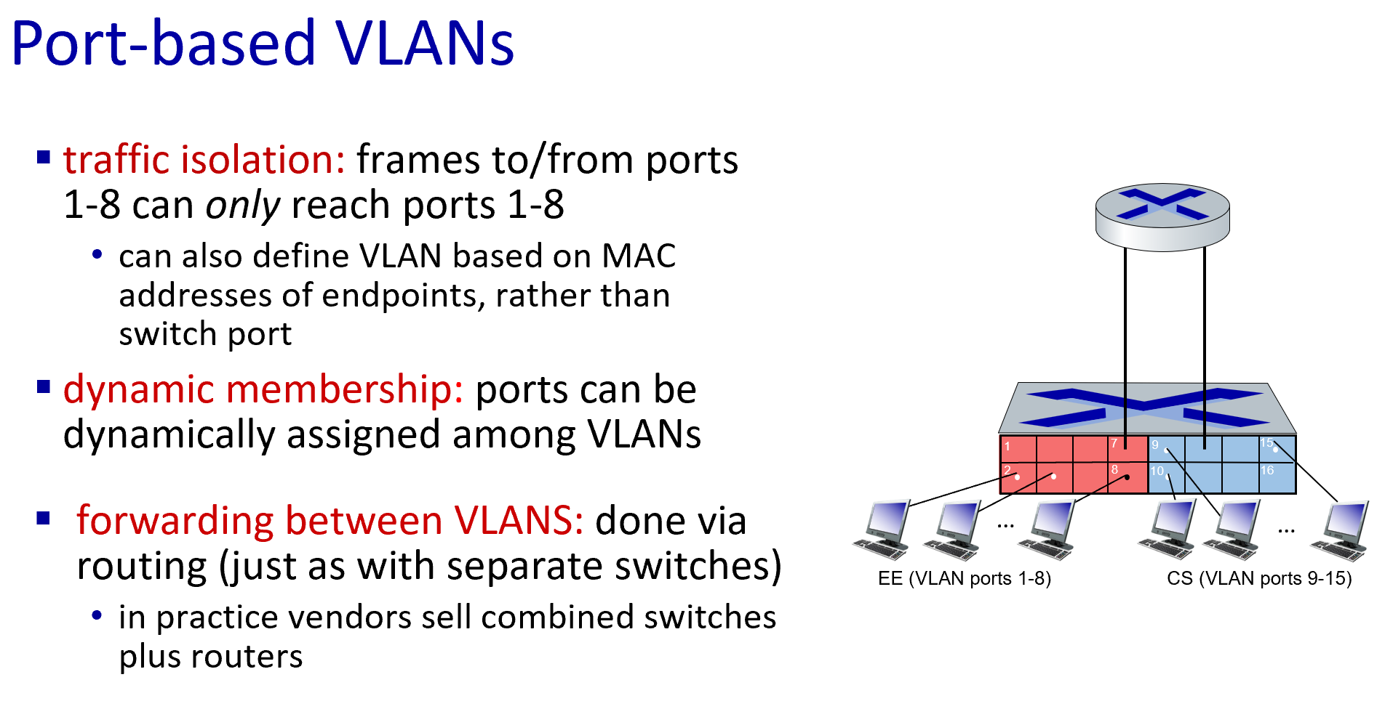

Access Ports
This is the concept of one VLAN per port. No tagging in the frame is required.

VLAN Trunking
VLAN trunking is a method used to carry traffic from multiple VLANs over a single physical link between network devices, such as switches or routers. It allows a single connection to support multiple VLANs by tagging each frame with the appropriate VLAN identifier, ensuring the correct delivery to the right VLAN. The most common protocol for VLAN trunking is IEEE 802.1Q, which adds a 4-byte tag to the Ethernet frame to distinguish between VLANs. Trunk links typically connect switches to other switches or routers, enabling inter-VLAN communication. This method helps optimize network infrastructure by reducing the need for additional physical connections.

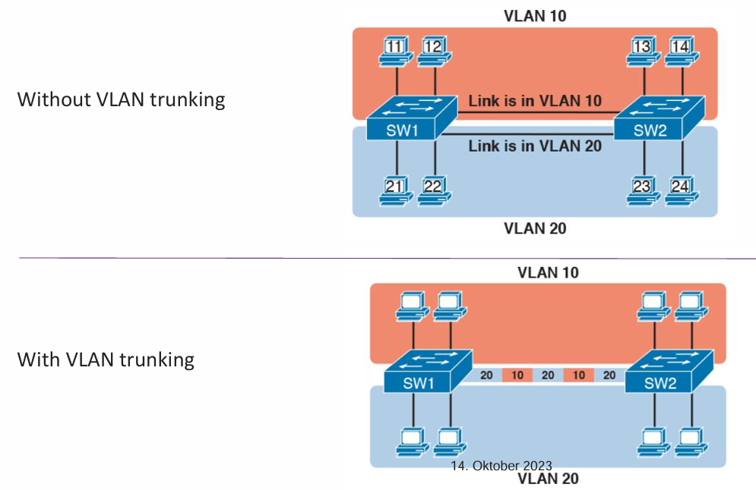

Router on a stick
Router on a stick is an effective solution for intern-VLAN communication. It describes the concept of a single physical router interface that is used to manage traffic between multiple VLANs. The router is configured with subinterfaces, each acting as a gateway for a specific VLAN. By using a single trunk link between the router and a switch, multiple VLANs can share a single physical connection while maintaining logical separation. This avoids the need for multiple router interfaces and simplifies the hardware requirements.

Ethernet
The data link layer bridges the gap between the network layer above and the physical transmission of data below. The data link layer ensures that data is reliably transmitted over individual links. The ethernet frame structure adds a header and a trailer around Layer 3 PDUs to encapsulate the message being sent. Each section of the frame is called a field.

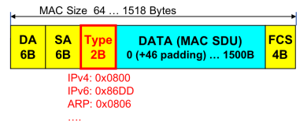
Ethernet II frame
The MAC PDU size must be at least 64B to guarantee that all collisions can be detected. In case it is smaller padding bytes need to be added.
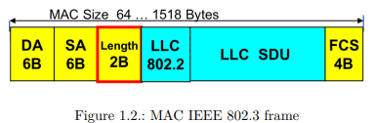

IEEE 802.3 frame
LSB is transmitted first.

MTU
The maximum size or length of the MAC Service Data Unit (SDU) is limited to 1500B. The limitation ensures that the communication channel is not used too long by anyone. The MAC PDU amounts to 1518B because the 14B header and 4B trailer must be added. The MTU size can be bigger, so called jumbo frames can reach up to 9000B SDU.

Ethernet framing
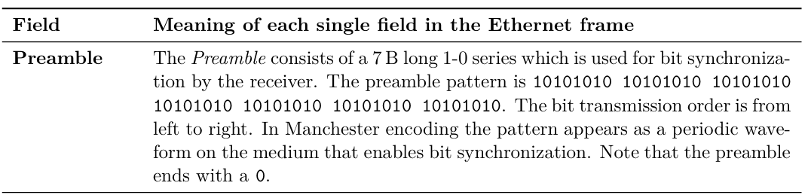
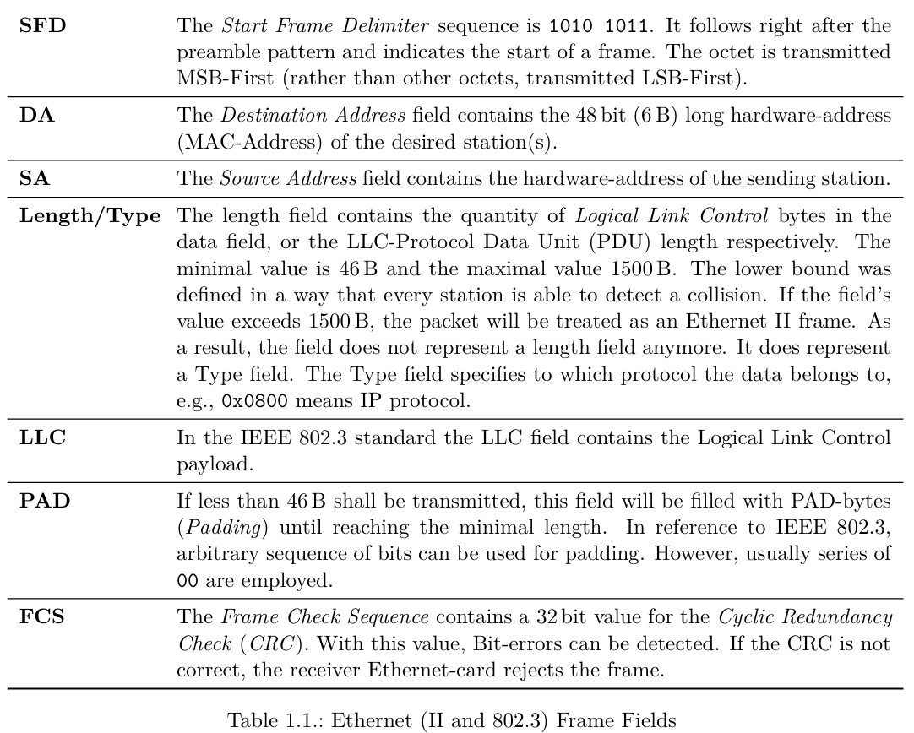

MAC Address / Ethernet Address
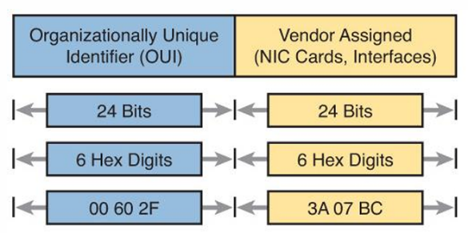
- 32-bit IP address:
  - Network-layer address for interface
  - Used for layer 3 forwarding
- MAC address:
  - Function: used “locally” to get frame from one interface to another physically-connected interface (same subnet, in IP-addressing sense)
  - 48-bit MAC address (for most LANs) burned in NIC ROM, also sometimes software settable
  - E.g: 1A-2F-BB-76-09-AD
Individual or Group Bit: The first transmitted bit, which is the least significant bit) of the first octet of the destination address is the individual or Group bit. It I/G = 0, only a single (individual) station will be addressed. If I/G = 1, then a
group of stations will be addressed, such as in a broadcast or a multicast group.

LSB: Least significant Bit: the Least Significant Bit (LSB) of the first byte of a destination address determines whether the frame is unicast or multicast. If the LSB is 0, the frame is intended for a single recipient (unicast); if it is 1, the frame is addressed to multiple devices (multicast).

MSB: Most significant Bit: the Most Significant Bit (MSB) of the first byte of a destination address determines whether the address is universally or locally administered. If the MSB is 0, the address is universally administered by the IEEE (globally unique); if it is 1, the address is locally administered by the network administrator.

To read the MSB and LSB, convert the first byte to binary, where the MSB is the leftmost bit indicating universal or local administration, and the LSB is the rightmost bit indicating unicast or multicast addressing. To read the LSB and MSB of the first byte in a MAC address, follow these steps:
- Convert the First Byte to Binary:
  - Take the first byte of the destination address (e.g., in AA:BB:CC:DD:EE:FF, the first byte is AA).
  - Convert it to binary. For AA (hex), the binary representation is 10101010.
- Extract the MSB:
  - The MSB is the leftmost bit of the binary representation.
  - In 10101010, the MSB is 1.
- Extract the LSB:
  - The LSB is the rightmost bit of the binary representation.
  - In 10101010, the LSB is 0.

Universally or locally administrated address
This is the bit which is transmitted in the second place. It specifies whether the address is a globally administered address (U, Universal, U/L=0) or a locally assigned address (U/L=1).

Universally (Globally) administrated Address
A universally administered address is the one assigned by the NIC’s manufacturer. A locally administered address, in turn, consists of MAC addresses defined by software or operators of a system, overriding the address burnt in the physical hardware.
Locally administrated address
A locally administered address is assigned to a device by a network administrator, overriding the burned-in address. It is distinguished from universally administered addresses by setting the second-least-significant bit of the first octet of the address.
Broadcast Address
A layer 2 broadcast address is a MAC address with the format FF:FF:FF:FF:FF:FF. When a station wants to address all the stations in a LAN, it sends a frame with the MAC broadcast address as destination address. Broadcasts are sent to all stations in the same broadcast domain.

Multicast Address
Multicast addresses allow a source device to send a packet to a group of devices. Therefore, multicast addresses represent a group of addresses (sometimes called a host group)
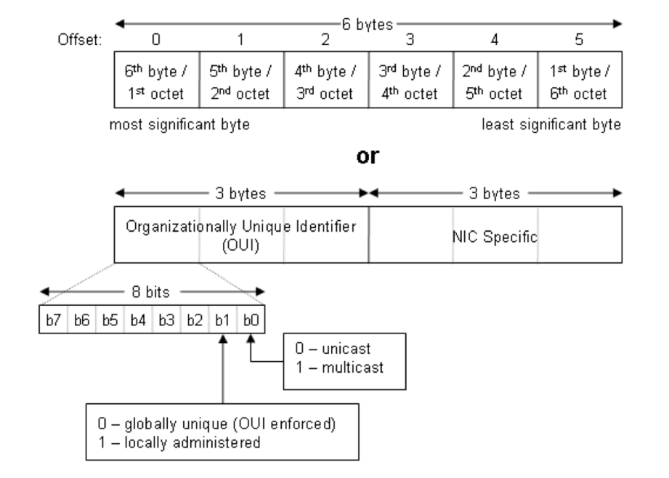

ARP
ARP is a network protocol used to map an IP address to a device's MAC address within a local network. When a device wants to communicate with another device on the same network, it uses ARP to find the corresponding MAC address by broadcasting a query. The target device responds with its MAC address, enabling communication at the data link layer. Even though it connects IP addresses (which are an inherent part of layer 3) to MAC addresses (which are inherent to layer 2) it is a layer 2 protocol, because the whole process works on layer 2 via the switch, with no routing involved.

ARP tables
Each IP node (host, router) on LAN has a table. The tables have IP/MAC mappings for some LAN nodes:
<IP address; MAC address; TTL>
TTL (time to live): time after which address mapping will be forgotten

ARP in action - LAN
A wants to send datagram to B (they don’t know each other)
- A broadcasts ARP query containing B’s IP addr
  - Destination MAC address = FF-FF-FF-FF-FF-FF (broadcast mac address)
  - All nodes on LAN receive ARP query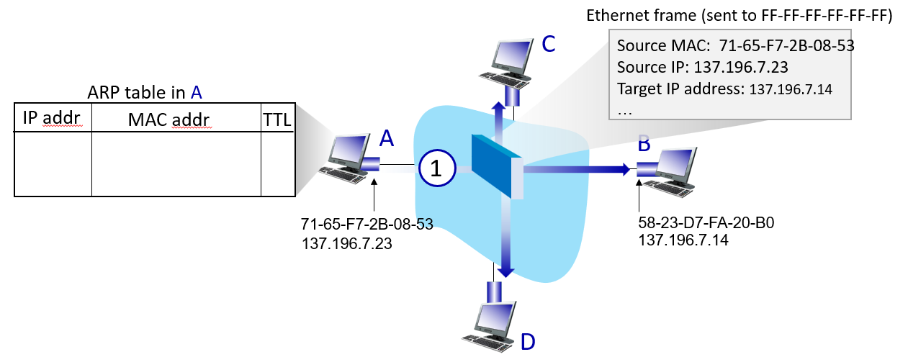
- B replies to A with ARP response giving its MAC address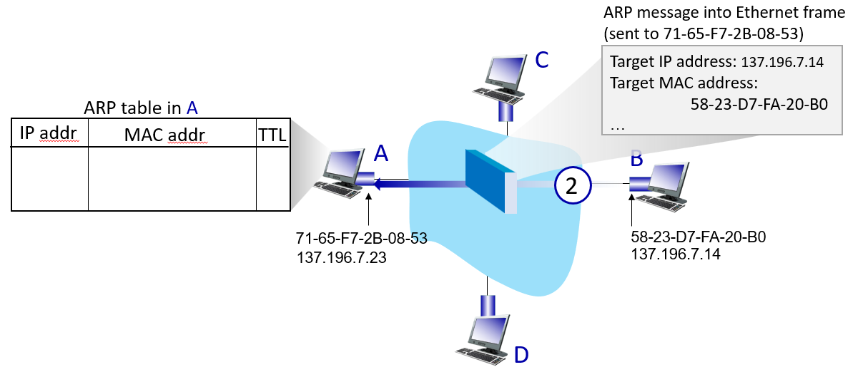
- A receives reply and adds it to its MAC address table
- 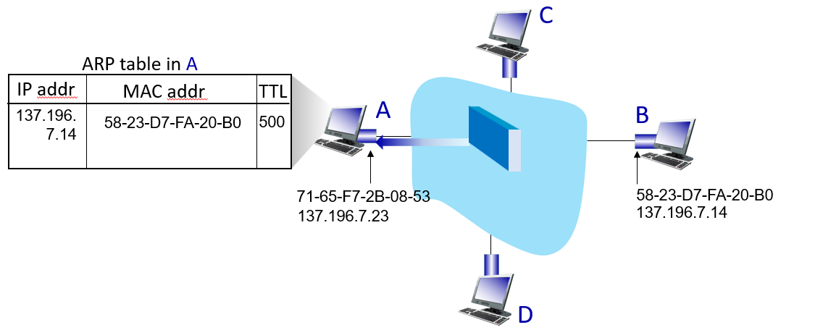

ARP in action – Outside of LAN
A wants to send a datagram to B via R. Assume that:
- A knows B’s IP
- A knows IP address of first hop router (how?)
- A knows R’s MAC address (how?)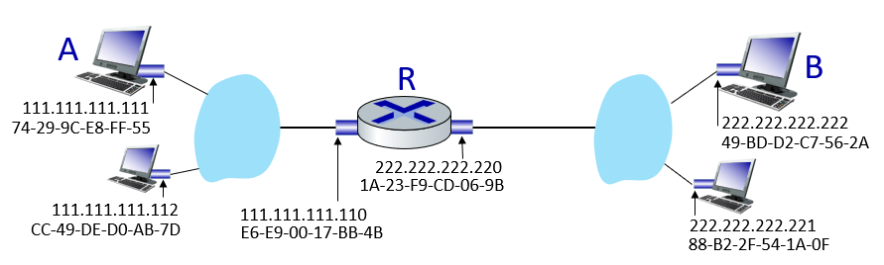
- A creates datagram with IP source A, destination B and creates link-layer frame containing A-to-B IP datagram
  - R’s MAC address is frame’s destination
  - 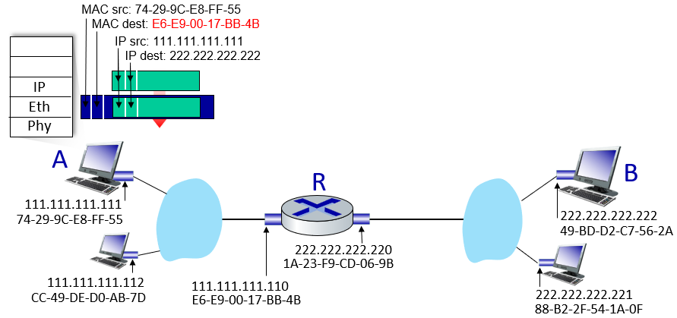
- Router receives frame, removes the datagram and passes up to IP
- R determines outgoing interface, passes datagram with IP source A, destination B to link layer. R creates link-layer frame containing A-to-B IP datagram. Frame destination address: B’s MAC address. Then transmits link-layer frame

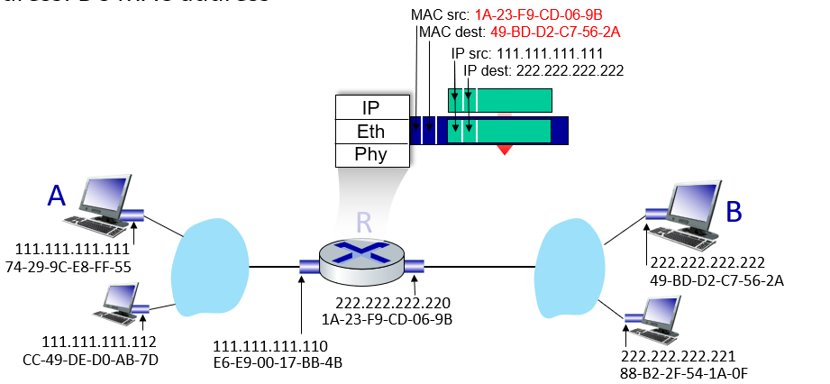
- B receives frame, extracts IP datagram destination B. B passes datagram up protocol stack to IP.

Example last year exam

Neighbor Discovery
ICMPv4 and ICMPv6 share common roles such as host confirmation, reporting destination or service unreachable, time exceeded errors, and router redirection. ICMPv6 adds specific functionalities for messaging between IPv6 routers and devices, such as Router Solicitation (RS) and Router Advertisement (RA) messages. It also includes messaging between IPv6 devices with Neighbor Solicitation (NS) and Neighbor Advertisement (NA) messages, as well as Duplicate Address Detection (DAD). ICMPv6 replaces IPv4's ARP (Address Resolution Protocol) for layer-2 address resolution and introduces enhanced features like finding routers, redirecting traffic, and enabling stateless address autoconfiguration.

Neighbor Solicitation & Neighbor Advertisement
Neighbor Solicitation & Advertisement ist grundsätzlich das Konzept von ARP für IPv6. Es erfüllt dieselben Funktionen und mappt die MAC-Adresse zur IP-Adresse. NS/NA sind Teil vom Neighbor Discovery Protocol (NDP).
Beispiel:
- Node will packet an IPv6 Adresse schicken, weiss aber MAC nicht
- Schickt ein NS zum traget solicited-node multicast address
  - FF02::1:FFXX:XXXX, wobei x für die letzten 24bit der IPv6 Adresse stehen
- Target schickt NA mit MAC
- Node updated neighbor cache mit erhaltenen Infos
Achtung: Ist nicht dasselbe wie Router Solicitation & Advertisement, diese Felder werden für SLAAC benötigt. y

Router Advertisement
Router Advertisements (RA) are periodically sent by routers, and on request, to all their configured interfaces. These messages are sent to the all-nodes multicast address and contain information such as one or more prefixes that can be used on the link, the lifetime of those prefixes, flags for autoconfiguration, and default router information. RAs enable the autoconfiguration of hosts by providing the necessary prefix and configuration details. Additionally, the prefix lifetime allows for host renumbering, as deprecated prefixes will have their lifetime reduced to zero, while new prefixes are assigned a normal lifetime. Router settings for timing and other parameters can be configured, and RAs can be sent immediately in response to a Router Solicitation (RS) from hosts. RS messages, typically sent at boot time, request an immediate RA from the router and are sent to the all-routers multicast address. To avoid network flooding, RS messages are limited to being sent three times at boot time.

DAD: Duplicate Address Detection
Duplicate Address Detection (DAD) is a process used in IPv6 to ensure that an IP address is unique on the local network before it is assigned to a device. When a device generates an address, it sends a Neighbor Solicitation (NS) message to check if any other device is already using that address. If no response is received, the address is considered unique and can be assigned. If another device responds, indicating the address is already in use, the device must generate a new address. DAD helps prevent address conflicts on an IPv6 network.

Solicited-node multicast address
Solicited-node addresses in IPv6 are multicast addresses used for efficient neighbor discovery and address resolution. They are derived from the prefix FF02::1:FF00:0/104, followed by the last 24 bits of the target node's unicast or anycast address. Unlike IPv4, which uses broadcast ARP requests to resolve addresses, IPv6 uses the Neighbor Solicitation message directed to the solicited-node address, minimizing network disruption by only targeting the relevant node. This approach ensures that only a few nodes are disturbed during address resolution. For example, the solicited-node address for FE80::2AA:FF:FE28:9C5A would be FF02::1:FF28:9C5A, and the node with this address listens for multicast traffic to respond efficiently.

Error Detection and Correction

FCS: Frame Check Sequence
Ethernet uses the Frame Check Sequence (FCS) field in the data-link trailer for the purpose of error detection. The sender applies a complex math formula to the frame before sending it, storing the result of the formula in the FCS field. The receiver applies the same math formula to the received frame. The receiver then compares its own results with the sender’s results. If the results are the same, the frame did presumably not change. If the results are different, an error occurred, and the receiver discards the frame (The bits could change because of some kind of electrical interference or a bad NIC). Error detection does not mean error recovery. If there is an error, the Ethernet device can simply discard the frame and does not attempt to recover the lost frame.

Parity Checking
Single bit parity:
- Detect single bit errors
- 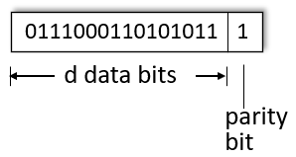
- Even Parity: set parity bit so there is (in total) an even number of 1’s
Two-dimensional bit parity:
- Detect and correct single bit errors
- 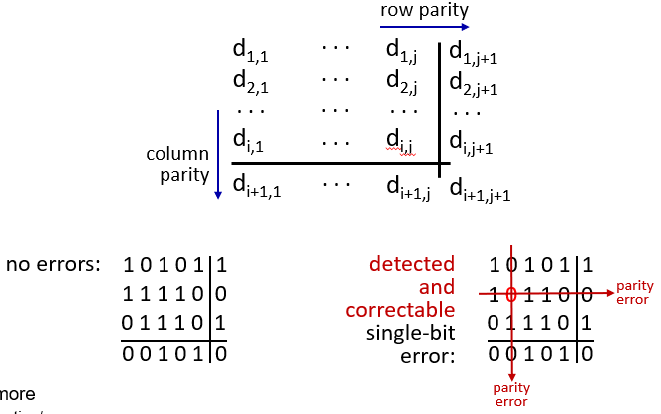

Internet checksum
Goal: detect errors (i.e, flipped bits) in transmitted segment
Sender:
- Treat contents of UDP segment (including UDP header fields and IP addresses) as sequence of 16-bit integers
- Checksum: addition (one’s complement sum) of segement content
- Checksum value put into UDP checksum field
Receiver:
- Compute checksum of received segment
- Check if computed checksum equals checksum field value:
  - Not equal – error detected
  - Equal – no error detected (there can still be errors)

Cyclic Redundancy Check (CRC)
This is a more powerful error-detection coding. It is widely used in practice, for example in ethernet and 802.11 WiFi. Blocks of data entering these systems get a short check value attached, based on the remainder of a polynomial division of their contents. On retrieval, the calculation is repeated and, in the event the check values do not match, corrective action can be taken against data corruption.

Multiple Access Protocols
There are two types of “links”:
- Point-to-point
  - Point-to-point link between ethernet switch, host
  - PPP for dial-up access
- Broadcast (shared wire or medium)
  - Old-fashioned ethernet
  - Upstream HFC in cable-based access network
  - 802.11 wireless LAN, 4G/4G. satellite
Multiple access protocols are essentially a distributed algorithms that determines how nodes share a channel, i.e they determine when nodes can transmit. The communication about channel sharing also utilizes said channel. This stems from single shared broadcast channels since two or more simultaneous transmissions by nodes can lead to interference. We call it a collision if a node receives two or more signals at the same time. In Wi-Fi there is no collision detection, only collision avoidance. Collision detection is very difficult, because even thought there might have been a high transmitting signal, it can end in a weak received signal due to fading or interruptions through a hidden node. Proper multiple access management is crucial for maintaining data flow and network congestion. There are multiple techniques to make multiple access in Wi-Fi possible:
- CSMA/CA: Carrier Sense Multiple Access with Collision Avoidance
- TDMA: Time Division Multiple Access
- FDMA: Frequency Division Multiple Access

Multiple Access Control – Klassen
- Channel partitioning
  - Divide channel into smaller pieces(time slots, frequency, code)
  - Allocate piece to node for exclusive use
  - Choice of protocol depends on network traffic, channel conditions and the need for real-time data delivery
  - Essential for maintaining order and efficiency in shared communication systems such as WiFi
  - Share channel efficiently and fairly at high load
  - Inefficient at low load: delay in channel access, 1/N bandwidth allocated even if only 1 active node
  - E.g TDMA, FDMA, CDMA
- Random access (how to detect and recover from collisions)
  - Channel not divided, allow collisions
  - Recover from collisions
  - Efficient at low load: single node can fully utilize channel
  - High load: collision overhead
  - E.g ALOHA, CSMA, CSMA/CD, CSMA/CA
- “taking turns” (controlled access)
  - Nodes take turns, but nodes with more to send can take longer turns

CSMA (carrier sense multiple access)
Simple CSMA: listen before transmit:
- If channel sensed idle: transmit entire frame
- If channel sensed busy: defer transmission
Collisions can still occur with carrier sensing:
- Propagation delay means, two nodes may not hear each other’s just-started transmission

Collision: entire packet transmission time wasted
- Distance & propagation delay play role in determining collision probability

CSMA/CD
CSMA with collision detection
- Collisions detected within short time, which reduces the amount of time wasted
- Colliding transmissions aborted, reducing channel wastage
- Collision detection easy in wired, difficult with wireless
Example:
- NIC receives datagram from network layer, creates frame
- NIC senses channel:
  - If idle: start frame transmission
  - If busy: wait until channel idle, then transmit
- If NIC transmits entire frame without collision, NIC is done with frame
- If NIC detects another transmission while sending: abort, send jam signal
- After aborting NIC enters binary (exponential) backoff:
  - After mth collision, NIC chooses K at random from {0,1,2..,2^m-1}. NIC waits K*512 bit times, returns to step 2
  - More collisions: longer backoff interval

CSMA/CA
Wireless doesn’t have collision detection. This is due to the hidden node problem and further it is difficult to sense collision. 802.11 has high transmitting signal and weak received signal due to fading.
Carrier-sense multiple access with collision avoidance is a network protocol used in wireless communication to minimize data collisions. The device assembles a frame. Before transmitting the frame, a device checks the channel to ensure it is idle. If the channel is busy, it waits for a random backoff (algorithm) before trying again. If the channel is idle, the device sends a RTS: Request-to-Send. If the channel is clear, the device will receive a CTS: Clear-to-Send and can start transmitting the application data. If no CTS is received, the device will have to backoff for a random time again.
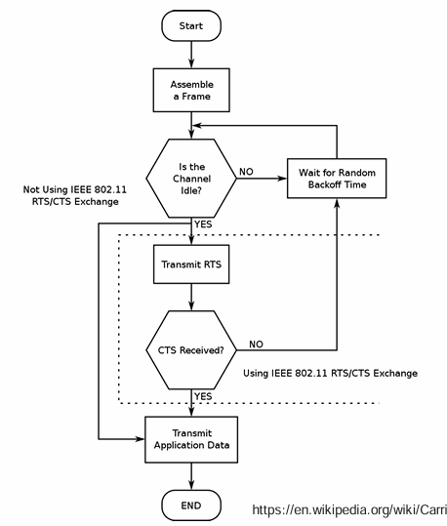

Hidden Node
- B, A hear each other,
- B, C hear each other,
- A, C can not hear each other means A, C unaware of their interference at B.
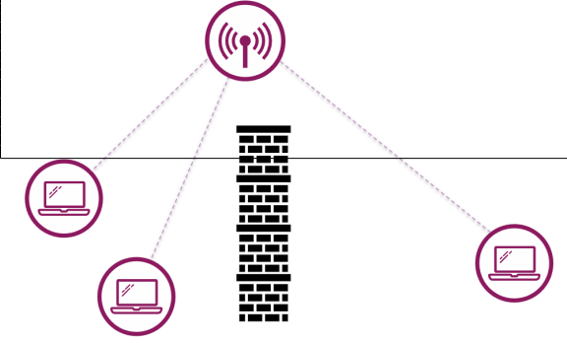
Attenuation can also cause hidden nodes:
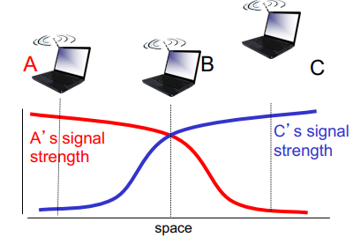

TDMA – Time division multiple access
- Access to channel in rounds
- Each station gets fixed length (packet transmission time) slot in each round
- Unused slots go idle
- Example: 6-Station LAN, 1,3,4 have packets to send, slots 2,5,6 idle
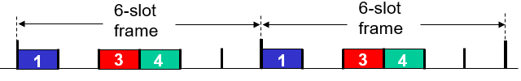

FDMA – frequency division multiple access
- Channel spectrum divided into frequency bands
- Each station assigned fixed frequency band
- Unused transmission time in frequency bands go idle
- Example: 6-Station LAN, 1,3,4 have packets to send, frequency bands 2,5,6 idle
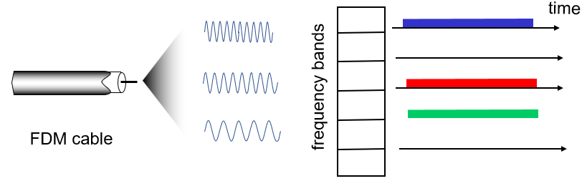

Slotted ALOHA
Assumptions:
- All frames same size
- Time divided into equal size slots (time to transmit 1 frame)
- Nodes start to transmit only slot beginning
- Nodes are synchronized
- If 2 or more nodes transmit in slot, all nodes detect collisions
Operation:
- When node obtains fresh frame, transmits in next slot
  - If no collision: node can send new frame in next slot
  - If collision: node retransmits frame in each subsequent slot with probability p until success
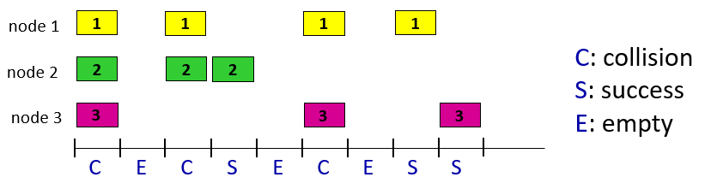
Pros:  - single active node can continuously transmit at full rate of channel  - highly decentralized: only slots in nodes need to be in sync  - simple | Cons:  - collisions, wasting slots  - idle slots  - nodes may be able to detect collision in less than time to transmit packet  - clock synchronization
Efficiency= 37%

Pure ALOHA (unslotted)
- Simpler, no synchronization
  - When frame first arrives: transmit immediately
- Collision probably increases with no synchronization
  - Frame sent at t_0 collides with other frames sent in [t_0-1, t_0+1]
  - 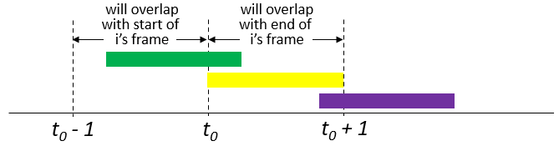
- Pure aloha efficiency: 18%

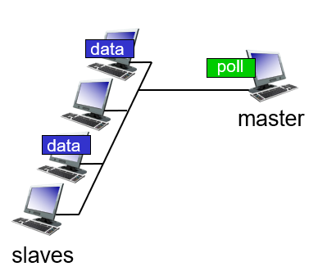
Take turns MAC protocols
Polling:
- Master node invites other nodes to transmit in turn
- Typically used with dumb devices
- Concerns:
  - Polling overhead
  - Latency
  - Single point of failure (master)
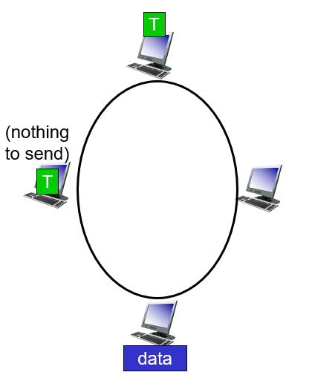
Token passing:
- Control token passed from one node to next sequentially
- Token message
- Concerns:
  - Token overhead
  - Latency
  - Single point of failure (token)

Spanning Tree Protocol

Usage
The Spanning Tree Protocol (STP) is a network protocol that prevents loops in Ethernet networks by dynamically disabling redundant paths. It ensures a single active path between switches by designating roles for switch ports (e.g., root, designated, or blocked) based on the lowest-cost path to the root bridge. This creates a loop-free topology, improving network stability and preventing broadcast storms.

The protocol dynamically reconfigures the network in response to changes, such as link failures, by reactivating redundant paths as needed. Despite its effectiveness, STP has limitations: its convergence time — the time it takes to adapt to changes in the network — can be slow, leading to temporary disruptions. Additionally, its default configuration may not always optimize traffic flow, potentially leading to inefficiencies in complex topologies.

Bridging loops occur any time there is a redundant path and when the topology is connected back to itself. Ethernet does not have any builtin protection and it cannot prevent frames from continuously circulating when a loop is present. The Spanning Tree Protocol is active by default.

BPDU
STP uses messages called bridge protocol data units (BPDU): Two types of BPDUs:
- Hello or configuration BPDU sent by the root bridge
- Topology Change Notification (TCN) BPDU used to announce changes in the network topology. A switch sends a TCN back to the root

Port states
Blocking: The block port receives but not transmits BPDUs It does not transmit or forward data frames
Listening: The port receives and processes BPDUs but does not forward data frames Port starts sending BPDUs
Learning: This state is similar to listening except that the port is MAC learning
Forwarding: It starts forwarding frames across the network segments. The port also continues to receive and process BPDUs

Process (how to solve practical)
Root Bridge:
- Is the only switch that sends BPDUs
- Controls STP timers
- Informs L2 of topology changes
Root Port:
- The ports are in the forwarding state
Designated port:
- The ports are in the forward state
Nondesignated (blocking) port):
- The ports are in the blocking state

How to select:
- Elect Root Bridge (one per network)
  - All bridges exchange BPDUs with each other
  - The bridge priority value is viewed and compared
  - If one bridge has a numerically lower bridge priority than all the others, the election process stops and that bridge is elected the spanning-tree root bridge
  - If all the bridge priority values are identical, the switches compare each others MAC address
  - Because each bridge is guaranteed to have unique MAC address, one of them is numerically lower than all the others, and the bridge is elected the spanning-tree root bridge
- Root Ports and Cost
  - In general: the lowest value always wins and higher bandwidth = lower cost
  - Each bridge needs one root port
  - Each collision domain needs a designated port
  - The ports on the root bridge need to be designated ports
  - All bridges calculate the root path cost
    - Lowest root path cost (sum of connections until root)
    - Lowest bridge ID
    - Lowest port ID
  - All ports opposite of the root port are designated ports
  - The remaining connections get compared (cost, bridge ID and lowest port) and the loser gets the blocking port
  - The ports opposite of the blocking port are designated ports (the one with the lower mac)

Timers
Hello: This timer controls the rate at which configuration BPDUs are issued from the root switch By default 2 seconds
Max age: If the age of the last BPDU exceeds the max age timer value (20 seconds) the comparison algorithm will have to be rerun Eventually the receiver would have to find a new path to the root The current age timer is reset every time new information is received via a BPDU
Forward delay: This timer monitors the time spent in each of the transitional port states By default 15 seconds When plugging in a computer and receiving a link light, the ports come up blocking, then listening for 15 seconds, then learning for another 15 seconds, and finally forwarding

Ablauf Gerät einstecken: 20s Blocking – 15s Listening – 15s Learning – Kommunikation (insg. 50s bis forwarding)
Ein Switch der nicht root ist, sendet nur BPDUs weiter welche auf dem Root-Port erhalten wurden.
Wenn Links up/down gehen oder ein neuer Switch eingesteckt wird passiert folgendes:
- Betroffener Switch sendet einen Topology Change Notification (TCN) BPDU via RP an die Root Bridge
- Root Bridge setzt Topology Change Flag in BPDUs, welche alle Hello Timer an alle Switches gesendet werden
- Alle anderen Switches setzen das TTL ihrer Bridge Table von Default 300s auf den Forward Delay Timer
- STP-Algorithmus wird ausgeführt

Topology Changes
Direkter Link Failure / Topology Change:
- 2x Forward Delay Unterbruch (Listening à Learning à Forwarding)
- The total time that users on Switch lost connectivity is the time that port spent in the Listening and Learning state
Indirekter Link Failure / Topology Change (wird von Timers bemerkt):
- Hello + Max age + 2x Forward Delay Unterbruch
- STP can detect and recover from indirect failures thanks to timer mechanisms.
PortFast: Kann bei Clientports aktiviert werden, keine TCNs und Port geht direkt in Forwarding State

OSI Layers and how they work together (a day in the life of a web request)
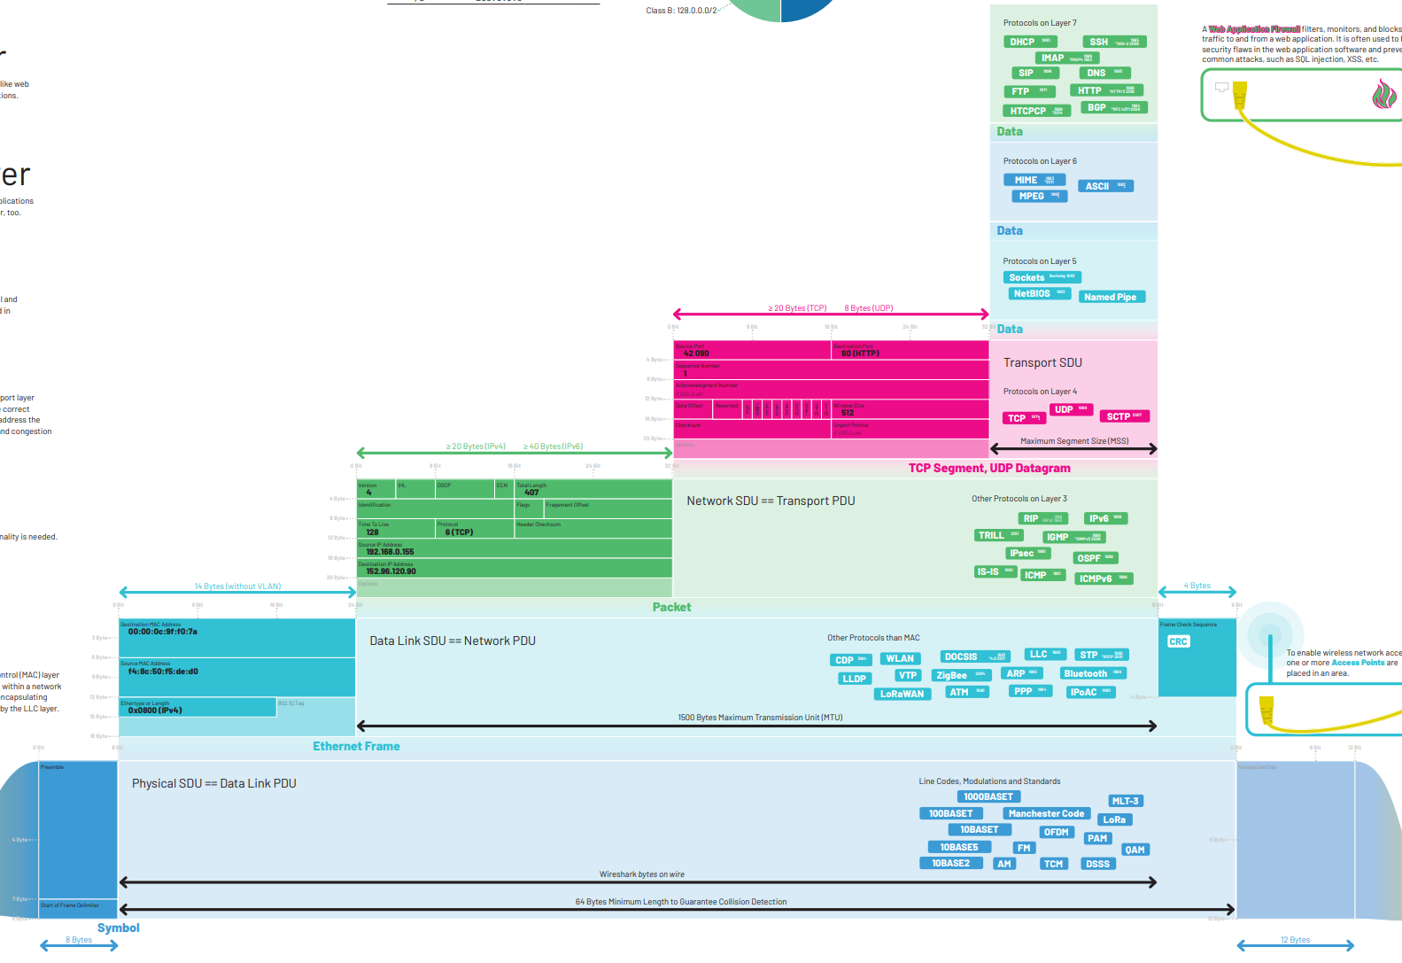
https://moodle.ost.ch/pluginfile.php/673185/mod_resource/content/1/OSI-Layer_1.2.pdf

A day in the life of a web request
- 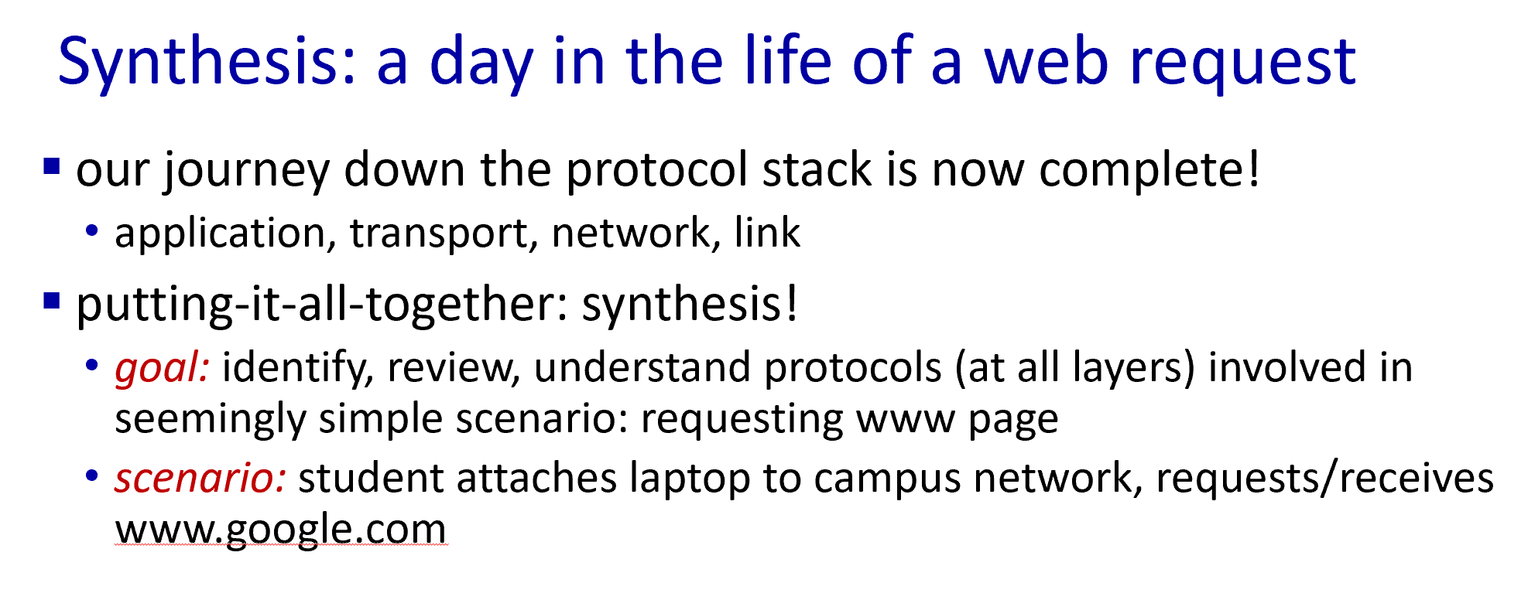
- 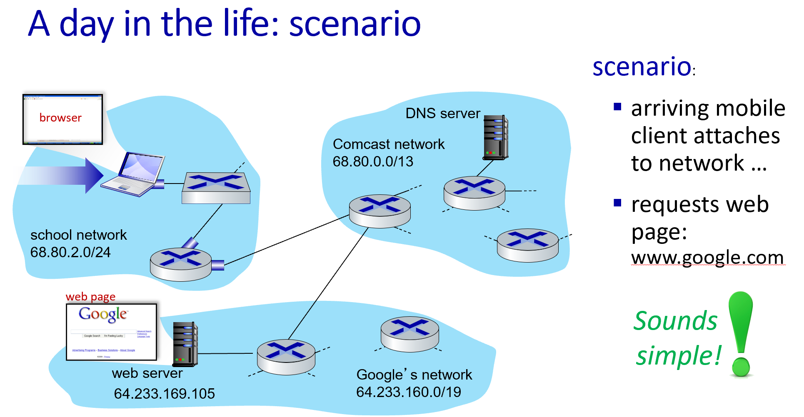
- 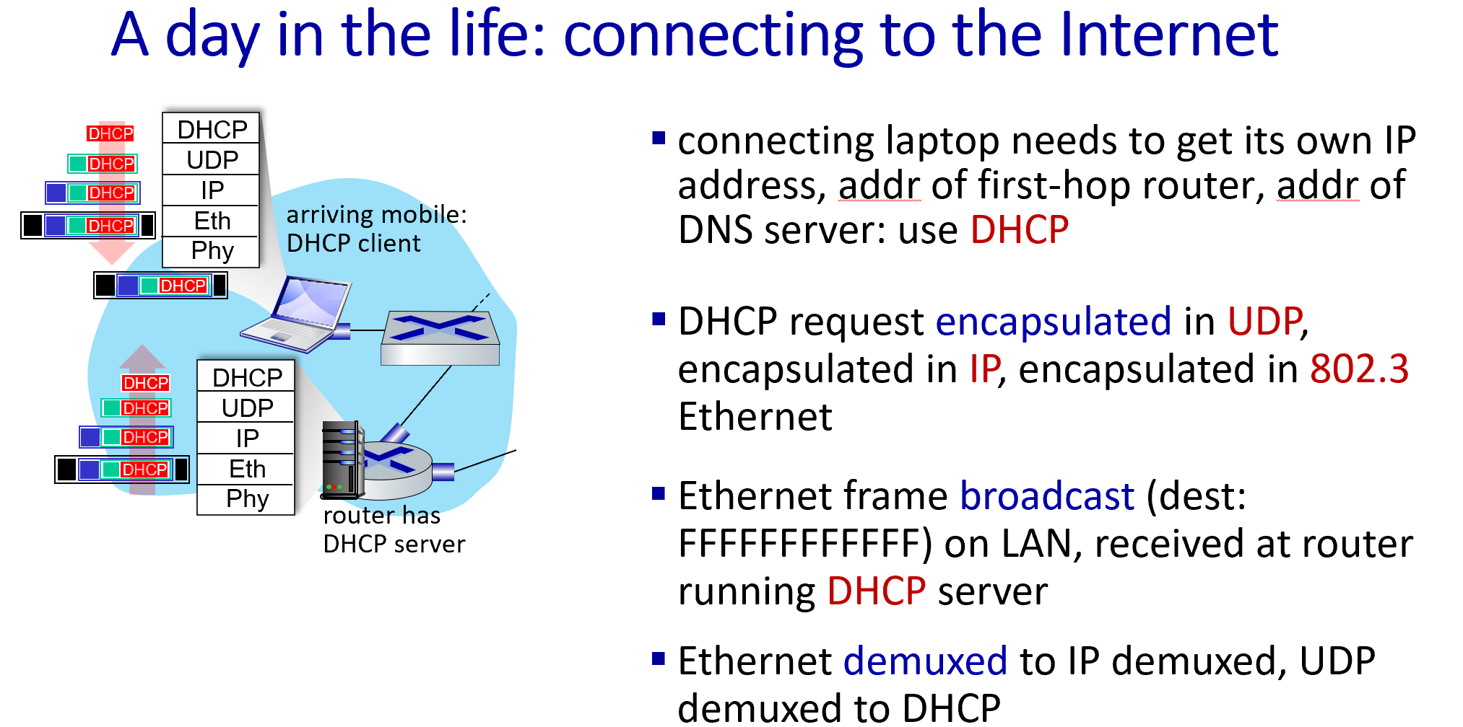
- 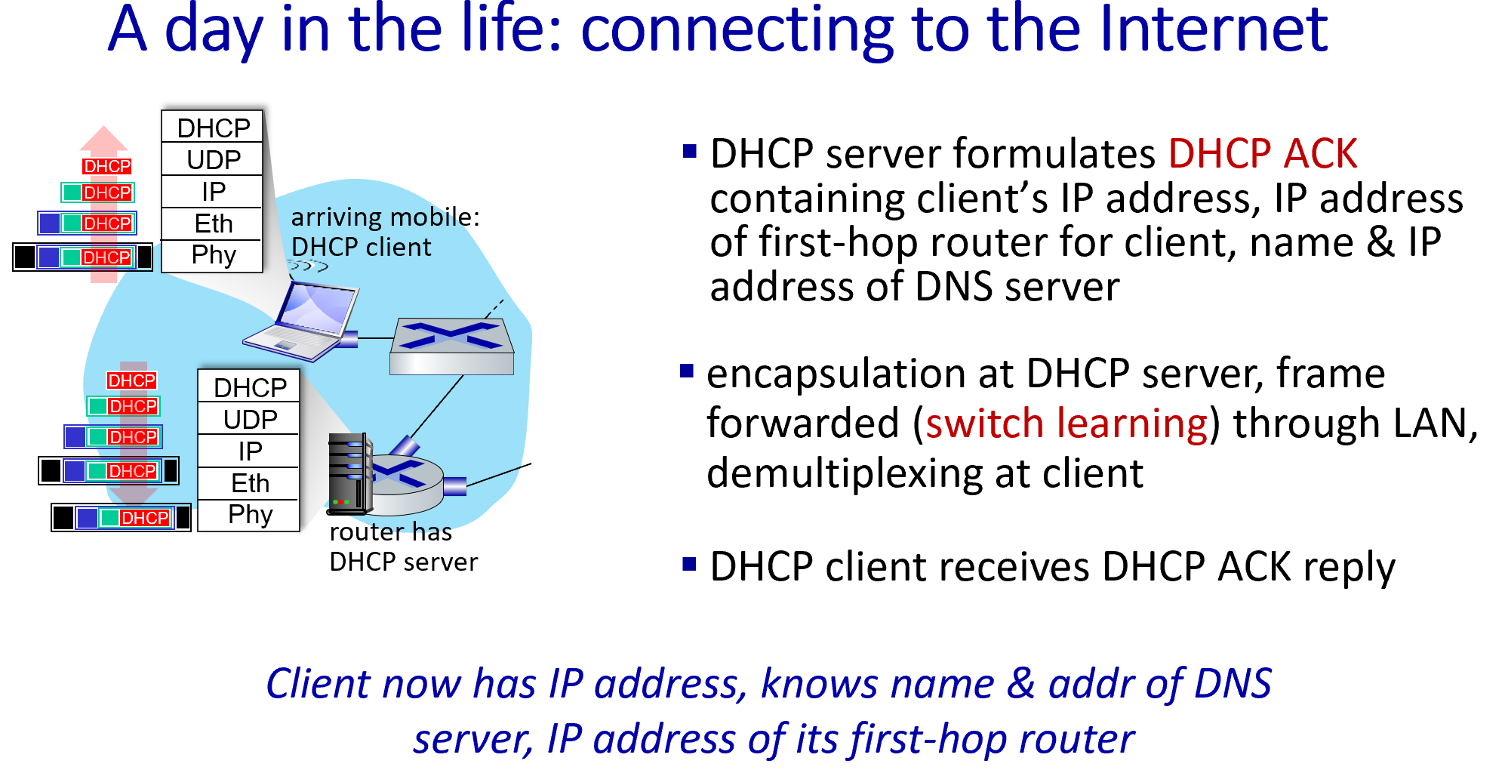

- 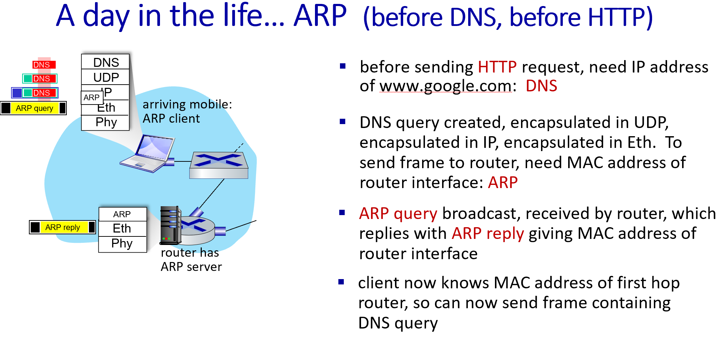
- 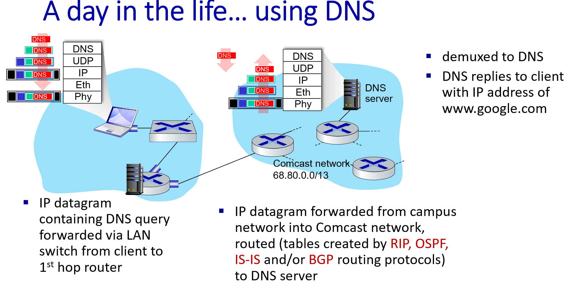
- 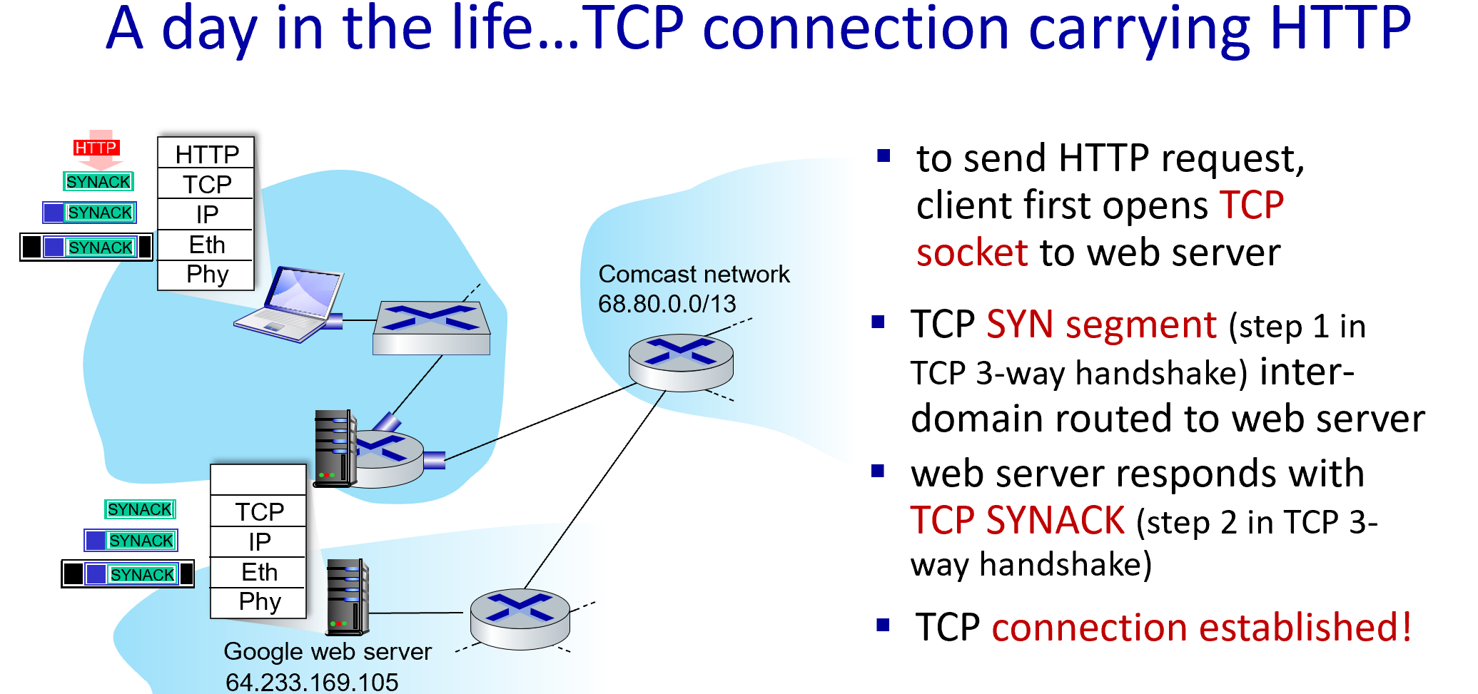
- 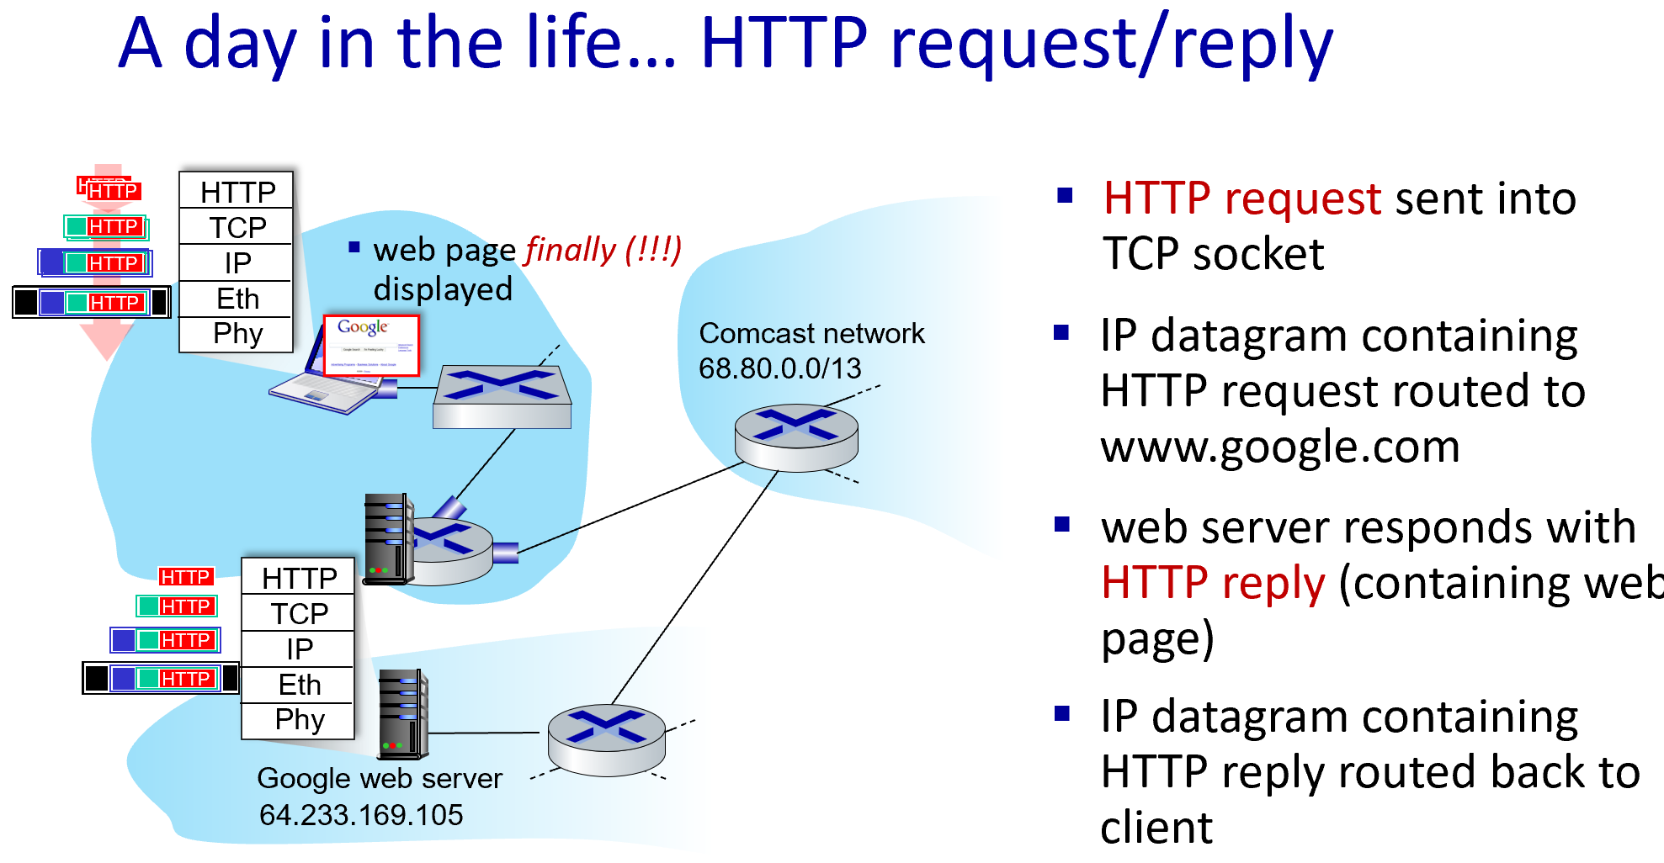

Encapsulation and decapsulation
Encapsulation: The level above, starting at the application layer, does its process and then passes it down to the next level of the model. This process is repeated by each layer until it is sent out as a bit stream.

Decapsulation: Data is de-encapsulated as it moves up the stack, starting at the physical layer. When a layer completes its process, that layer strips off its header and passes it up to the next level to be processed. This is repeated at each layer until it is a data stream that the application can process the packet and present the user with the requested data.

