OSPF  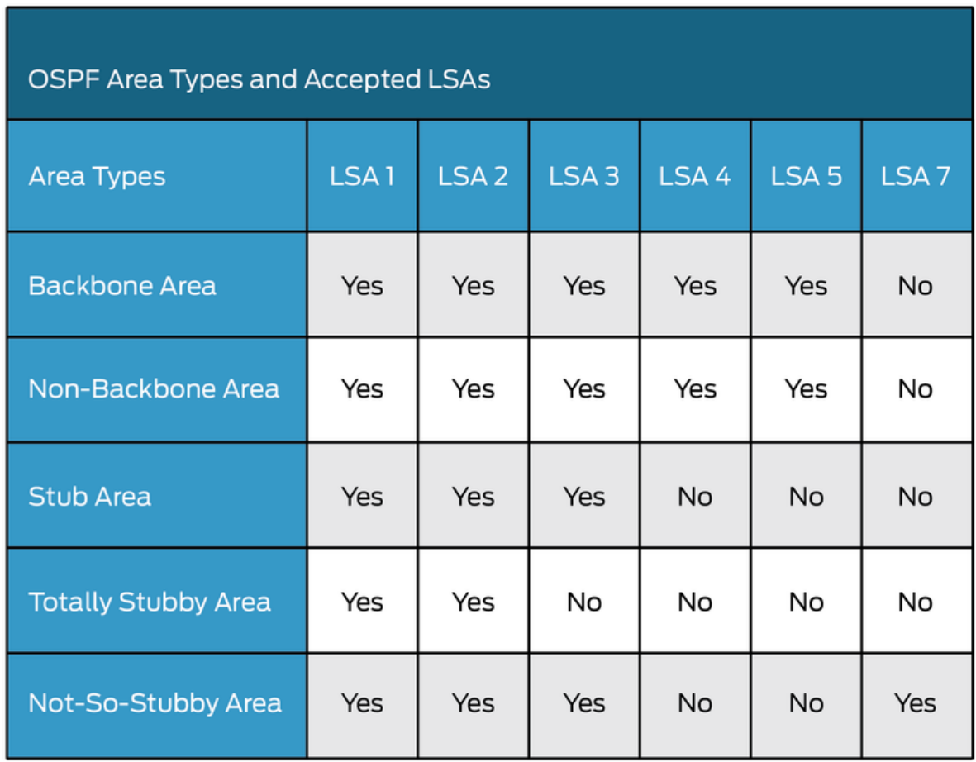  LSA – Link State Advertisement: Sent by each router to describe state of a router (Interfaces, Networks, Adjacencies)  Router LSA (Type Code=1)  - Generated by every router to list all the routers outgoing interfaces  - For each interface state and cost are included  - For point-to-point links  - Flooding is restricted to the area where they originate  Network LSA (Type Code=2)  - Applicable in broadcast and non-broadcast networks  - Network LSA represents a LAN  - Flooding is restricted to the area where they originate  Network Summary LSA (Type Code=3): Generated by area border routers  - Used for advertising destinations outside the area  - Flooding into all areas that are not totally stubby  AS External LSA (Type Code=5) : Generated by AS border routers  - Destinations external to an OSPF are advertised  - Flooding into all areas that are neither stub nor totally stubby  AS External LSA (Type Code=7): NSSA do not allow type 5 external LSA  OSPF Packet Types:  - Type 1 - hello: Establish/maintain adjacencies. DR/BDR election. Neighbors.  - Hello Interval: P-to-P: 10s, else 30s. Sender/receiver need same value.  - Router Dead Interval: default: 4x hello. Needs to be larger than hello  - Type 2 - database description (DBD): Summary of all LSA the neighbor has in LSDB. Contains MTU. E-bit when attached area is capable of AS-external LSA.  - I-bit (Initial Bit): 1 for first packet, else 0  - M-bit (More Bit): Not last packet: 1, last: 0  - MS-bit (master-slave bit): Originator master: 1, slave: 0  - Type 3 - Link state request (LSR): Request missing LSA in LSDB.  - Type 5 - Link state acknowledgment (LSAck): Can be implicit, respond to LSA  LSU – Link State Update Packet: Response to LSR  Preference:  1. Intra-area routes (O): originated and learned in same local area  2. Inter-area routes (O IA): originate in other areas, inserted into local area  3. External Type 1 (E1): Sum of internal/external(remote AS) OSPF metrics (LSA Type 5)  4. NSSA Type 1 (N1): externe Kosten + interne OSPF Kosten zum ASBR (LSA Type 7)  5. External Type 2 (E2): Default external routes for OSPF, no internal metrics  6. NSSA Type 2 (N2): Nur externe Kosten  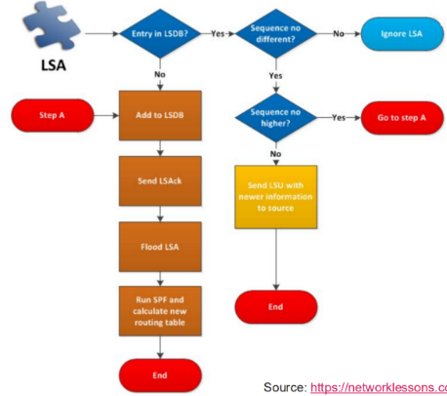  Multicast: 224.0.0.5 & 224.0.0.6  Flooding:  Database Synchronization:  Establish neighbor adjacencies: 1. Down State, 2. Init State, 3. Two-Way State  Synchronize OSPF Database: 4. ExStart State (DBD), 5. Exchange State (DBD), 6. Loading State (LSR/LSU) 7. Full State (LSA) | OSPF Areas:  -Standard: All routes redistributed  -Stub area: No external route. Default external route. No ASBR.  -Totally stubby area: Default route outside this area. No ASBR.  -Totally not-so-stubby: Default route for destinations outside (Block LSA type 3), allows external injection (LSA type 7)  -Not-so-stubby: Extension of stub area. Can import external routes. Must be at edge.  Route Summarization: Helps minimize frequent LSA flooding. ABR and ASBR (only these two are allowed to summarize) consolidate multiple routes into a single advertisement. Summarizes type 3 LSA. A summary is created if at least one subnet within the area falls in the summary address range. The summarized route metric is equal to the lowest cost of all subnets within the summary.  Router Classification:  - Area Border Routers (ABR), between OSPF areas, one interface in backbone.  - Internal Routers, only connected with other routers in the same low-level area.  - Backbone Routers, router in area 0, one+ interface connected to other backbones.  - AS Boundary Router (ASBR), connected to other AS, connected with backbone/low-level area.  IS-IS  L1: Local area only, shares LSPDB, uses L1/L2 to reach external networks.  L1/L2: Has separate LSPDBs; "attached" bit shows backbone reachability.  L2: Forms a contiguous stretch, sees only other L2 routers. (Backbone)  ISH – Intermediate System Hello, ESH – End System Hello  LSP: Similar to OSPF LSA type 1. They distribute routing information using a flexible TLV format and are flooded throughout an area via unicast or multicast to share states, path costs, and reachable prefixes. Types: Level 1 and Level 2.  IIH: IS-IS Hello, made from 3 different hello packets: Hello discover, Hello build, Hello maintain.  Hello Interval: Sent every 10s (Cisco) and every 3.3s by the DIS on multi-access links.  Hello Multiplier: Defines how many Hello packets can be missed before declaring a neighbor dead. The holdtime = Hello Interval × Hello Multiplier (e.g., 3 × Hello).  Multicast for Hellos:  01-80-C2-00-00-15 for Level 2 adjacencies (AllL2ISs)  01-80-C2-00-00-14 for Level 1 adjacencies (AllL1ISs)  DIS – Designated Intermediate System: Ensures LSDB accuracy by sending CSNP periodically. Responsible for the pseudonode LSP (broadcast setups only).  Pseudo-Node: Virtual node, minimizes complexity of managing multiple adjacencies on multiaccess media.  DIS-Election:  1. Highest interface priority (configurable from 0-127)  2. Highest SNAP address (MAC address)  DIS-Preemption: If enabled, router not guaranteed to remain DIS. Adjacent router with higher priority automatically takes over. IS-IS doesn’t have Backup DIS.  Administrative Distances  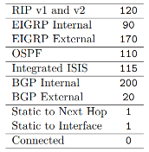  IS-IS Routing preference: 1. Most specific, 2. Lowest AD, 3. Static default.  Path Selection:  1. L1 intra-area routes  2. L2 intra-area routes  3. Leaked routes (L2 -> L1) with internal metrics  4. L1 external routes with external metrics  5. L2 external routes with external metrics  6. Leaked routes (L2 -> L1) with external routes  CLNS – Connectionless Network Services: Alternative to IP, consists of the following protocols: CLNP, ES-IS, IS-IS  CLNP – Connectionless Network Protocol: Ethernet protocol type 0xFEFE  NSAP: Equivalent to an IP. Consists of: Area identifier (area ID), system identifier (sysID), N-selector. Example of an NSAP address:  49.0001.0000.0000.0001.00.  • A value of 49 is prefixed to the intended area information (0001) to form the Area ID (49.0001).  • The next 12 digits represent the 6-byte SysID.  • The last 2 digits represent the NSEL (N-selector) byte.  SNAP – Subnetwork points of attachment: Alternative to MAC address  Sequence number packets (SNP):  CSNP (complete): Summary of LSP in LSDB Similar to DBD  PSNP (partial): Request/Acknowledge specific pieces of link-state information  TLV – Type, Length, Value: Present in every IS-IS packet.  Type: Identifies the information being sent (IP address, metric, hostname)  Length: Specifies the length of the value field, Value: The actual data.  Route-Leaking: refers to the process of redistributing routes between different levels. It is used to allow L1 routers to access L2 destinations (control path selection) and support Prefix summarization. UP bit in L1 leaked route needs to be set to avoid redistribution. Route-Leaking-Process: enable route-leaking on L1/l2 router, use route-maps or prefix lists to control what is leaked. Avoid leaking all L2 routes into L1, because this might break scalability.  TLV Name Description  1 Area Address to which the IS (Router) is connected  2 IS Neighbors Includes all the IS-ISs running interfaces  8 Padding used in the IS-IS Hello (IIH) packets to detect the maximum transmission unit (MTU) inconsistencies. Default: fullest MTU of interface  10 Authentication The information that is used to authenticate the PDU  129 Protocols supported Carries the Network Layer Protocol Identifiers (NLPID) for Network Layer Protocols that the IS is capable. | BGP  Private Ranges:  • ASN 64’512-65’535 in the old 16-bit range  • ASN 4’200’000’000-4’294’967’294 in the new extended 32-bit range  Path Attributes:  • Well-known mandatory: attributes must be included with every prefix advertisement.  - Network and mask  - Origin (IGP, EGP, Incomplete)  - AS Path can influence inbound traffic shortest path wins  - Next Hop  • Well-known discretionary: attributes may or may not be included with the prefix advertisement.  - Atomic Aggretate  - Local Preference Influences outbound traffic highest wins  • Optional transitive: attributes stay with the route advertisement from AS to AS.  - Community  - Aggregator  • Optional nontransitive: attributes are nontransitive and cannot be shared from AS to AS.  - MED influences inbound traffic lowest wins  - Weight  - Cluster ID  - Originator ID  - Cluster List  AS-path: Includes complete list of all the ASNs that have been traversed., thus preventing loops. AS-override can be done if AS are stretched over multiple locations.  BGP Messages:  OPEN: Establishes BGP session (adjacency) and negotiates capabilities. Includes version, ASN, hold time, BGP ID, and optional params.  -Hold Time: Heartbeat timeout (default 180s); reset by KEEPALIVE/UPDATE.  -BGP Identifier: 32-bit RID, usually a loopback IP; should be set manually.  KEEPALIVE: Ensures neighbor is alive; sent every 1/3 of Hold Time (e.g., 60s if 180s Hold Time).  UPDATE: Advertises new routes, withdraws old ones. Contains NLRI (prefix + path attributes). Acts as keepalive.  NOTIFICATION: Sent on errors (e.g., expired hold timer, capability mismatch). Terminates the session.  NLRI – Network Reachability Information: Routing update that consists of the network prefix, prefix length, and any BGP prefix attributes for that specific route.  iBGP Full Mesh Requirement: Each iBGP router needs to be in a full mesh or use a route reflector. The reason being that iBGP cannot advertise to another iBGP peer (no AS_PATH prepending). eBGP uses AS_PATH prepending for loop prevention. TTL in eBGP is set to 1 to avoid multihop session attempts. Advertised routes change next-hop value in eBGP.  Next Hop Manipulation: NHOP must be resolvable globally, else it needs to be configured with next-hop-self (within iBGP).  Route Reflectors:  The RR reflects routes to its clients based on these rules:  Rule 1: NLRI from non-RR client → advertised to all clients.  Rule 2: NLRI from RR client → advertised to all (clients + non-clients), sender ignores its own route (but does receive it).  Rule 3: NLRI from eBGP → advertised to all clients and non-clients.  Only the RR needs special config - clients remain unaware of route reflection. This eliminates the need for full iBGP mesh.  Transit: Fees, ISP provides for customers.  Peer: Equals, e.g larger ISPs with each other.  IXP – Internet Exchange Point: Creates direct connections.  Public: Peer with a route server (e.g Equinix). Route server injects its AS into AS_PATH. NEXT_HOP is preserved.  Private: Members peer on one-to-one basis. Can be over private/public infrastructure. Peers can manage policy, but more contracts needed.  Enterprise Connectivity Options:  Single Homed: One Customer to one ISP (with BGP or static).  Dual-Homed: One Customer to one ISP with redundant routers (primary/backup).  Multihomed: One Customer to multiple ISP. Only advertise routes originating in own AS to ISP Customer doesn’t wanna be transit  RPKI – Resource Public Key Infrastructure: Verifies association between internet resource and its holder. Prevents unauthorized prefix hijacking. Building Blocks: 1. Trust Anchor, 2. Route Origin Authorization (ROA(Prefix+ASN)), 3. RPKI Validators (Relying Party Software, contains trust anchors). ROA states can be: Valid, Invalid and Not Found. Fetches data from Trust Anchor (TA) (provides infrastructure to sign and verify subnet and ASN). Pakistan Incident: Instead of blocking YouTube domestically by filtering traffic locally, Pakistan Telecom announced a more specific prefix—a subnet of the YouTube network—via BGP to its upstream provider, which caused YouTube traffic from around the world to be redirected through that more specific route. Vulnerabilites in BGP System: Trust-based routing: ISPs regularly accept BGP announcements without validating legitimacy. Prefix specificity manipulation: Attackers or misconfigured operators can hijack traffic by announcing more specific prefixes. Solutions: Prefix Filtering, RPKI deployment and route-validation measures | BGP best path selection:  1. Prefer highest weight (local to router)  2. Prefer highest local preference (global within AS)  3. Prefer routes that the router originated (NHOP 0.0.0.0)  4. Prefer shorter AS paths (only length is compared)  5. Prefer lowest origin code (IGP < EGP < Incomplete)  6. Prefer lowest MED (also called metric)  7. Prefer external (EBGP) paths over internal (IBGP)  8. For IBGP paths, prefer path through closest IGP neighbor  9. For EBGP paths, prefer oldest (most stable) path  10. Prefer paths from router with the lower BGP router-ID  11. Prefer the path that comes from the lowest neighbor IP address  EVPN/VXLAN  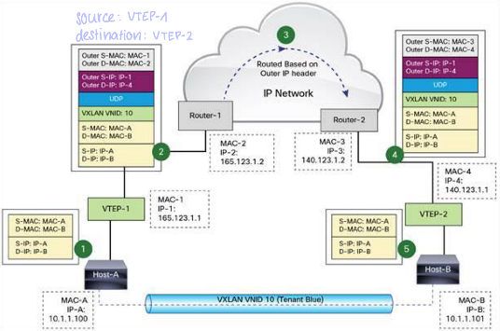  VXLAN: Tunnelling protocol over UDP encapsulation (UDP, because it works with BUM traffic. TCP cannot use Multicast). Contents of packet:  - Ethernet header: Outer MAC (src/dst), VLAN/Ether Type, VLAN ID  - IP header: Outer IP (src/dst), Protocol, Header, Checksum  - UDP header: Src Port, VXLAN Port, Length, Checksum  -VXLAN header: VXLAN, VNID  -Original L2 frame (inner): Inner IP & MAC (src/dst) etc.  -FCS  VNID: 24 bit segment ID that defines the broadcast domain.  VTEP – Virtual Tunnel Endpoint: Does the encapsulation and de-encapsulation. Connect over-/underlay. Available as Soft-/Hardware.  VTEP Interface: Connects VTEP to underlay network with a unique IP. Encapsulates and de-encapsulates.  VNI Interface: A virtual interface that keeps network traffic separated on the physical interface. Each VNI has an interface (just like VLAN interfaces).  EVPN NLRI: EVPN uses MP-BGP (multiprotocol extensions) (AFI/SAFI) to advertise various route types and attributes. Unsupported routes are dropped by BGP. Uses MP_REACH_NLRI and MP_UNREACH_NLRI.  AFI – Address Family Identifier: Identify protocol (IP). SAFI – Subsequent Address Family Identifier: Type of NLRI (Multicast, Unicast, VPNv4).  Overlay (encapsulation part): Virtual on top, uses VXLAN, ~16mio virtual networks due to VNIs, multi-tenancy support.  Underlay (IP part): Traditional protocols (OSPF etc), efficient packet forwarding between VTEP, simply get packet from A to B.  Control Plane Tasks: Which VTEP exist, which VNI to use, MAC learning.  BUM: Broadcast, unknown Unicast, Multicast: Different from ARP, crucial for VXLAN.  Route Target: Used during export/import of routes. Set on the exporting node, used to decide if it should be imported (and where to in VRF).  - First value is ASN, second value is often VNI (can also be encoded VNI)  Route Distinguisher: Used to uniquely identify a route  - First value is either ASN or IP, second value can be any value. Looks like a socket. | VTEP MAC learning methods:  - VXLAN with static unicast VXLAN tunnels: Requires manual VTEP IP configuration; poor scalability and inefficient BUM traffic handling.  - VXLAN with multicast underlay: VTEPs join multicast groups; BUM traffic is efficiently distributed via multicast.  - VXLAN with MP-BGP EVPN: Uses BGP as a control plane for dynamic MAC learning and VXLAN mapping; scalable and efficient solution.  - Flood and Learn: Original learning method, data plane MAC address learning, VTEPs learn by observing, can be paired with multicast or static.  1. Host sends an ARP request (as BUM traffic) to resolve the MAC address of a known IP.  2. The switch forwards the ARP via multicast to all VTEPs and local ports in the VNI.  3. VTEPs cache the IP-MAC info and forward the ARP to their local VNI ports.  4. The correct host replies with a unicast ARP response.  5. The local VTEP encapsulates the reply and sends it to the requesting VTEP.  6. The original VTEP delivers the response to the host, enabling unicast communication.  EVPN: Overcome flood and learn, no reliance on dataplane learning. Utilizes MP-BGP, works with VXLAN and MPLS, scalable, L2/L2  EVPN Route Types:  - Route Type 2: MAC/IP advertisement: Advertise MAC/IP within EVPN Control plane learning. E.g advertises Host A.  - Route Type 5: IP prefix route: Advertise IP prefixes for inter-subnet connectivity across datacenters.  MP-BGP EVPN: Reduced traffic flooding through control-plane learning.  EVPN L2: Datacenter interconnections, WAN connectivity, L2 bridging.  EVPN autodiscovery for Route Reflectors: No explicit EVPN config required on RR, just enable BGP EVPN address familiy. RRs have no pseudowires.  Early ARP termination: ARP gets stopped by the VTEP who queries the BGP EVPN control plane. If the VTEP finds the mapping, then it sends traffic directly and thus bypasses the ARP broadcast. If early ARP cannot be used Static Ingress Replication (replicate ARP at VTEP, send response to RR also).  VRF: Creates multiple routing instances with a single physical router. Benefits: Isolation of customers, independent routing (one table per VRF), security/privacy (no unauthorized access between tenants), scalability (accommodate multiple customers).  Integrated Routing and Bridging - IRB: Only used in L3 VNI  Without IRB: Inefficient Traffic Forwarding, Lack of seamless inter-subnet communication, scalability, suboptimal routing models, poor failure handling.  Symmetric IRB: Routing and bridging on both the ingress and egress. Each tenant uses a L3 VNI.  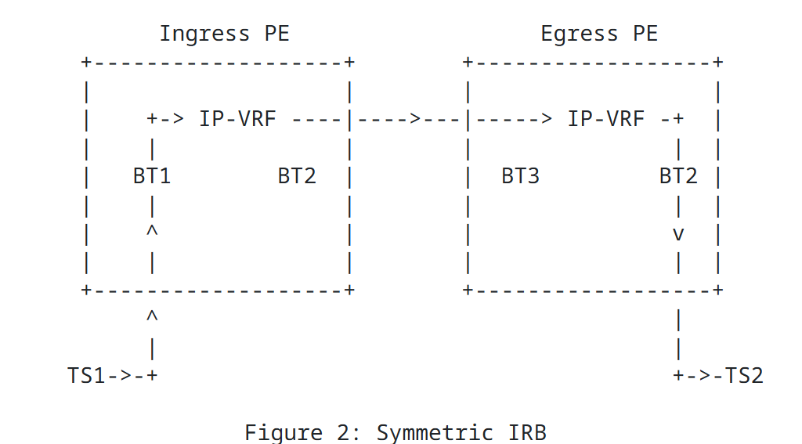  Asymmetric IRB: Use destination VNI in both directions. Requires config of all VLANs and VNIs on each leaf device, even those without traffic.  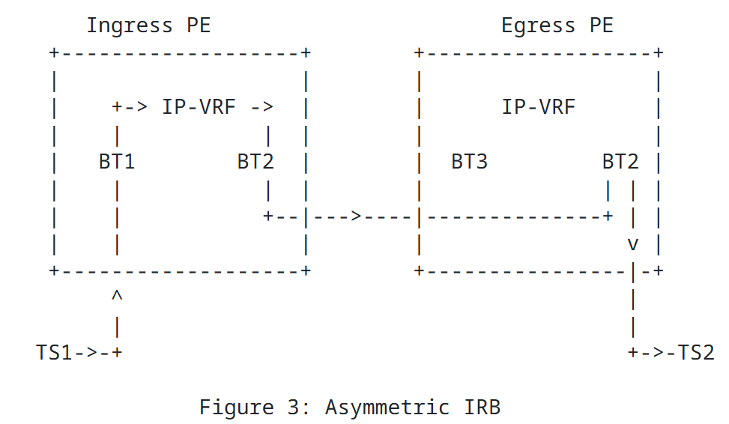  Distributed Anycast Gateway – DAG: Every device in the network (EVPN/MPLS) acts as the default gateway. Enables host mobility, flexible workload placement and optimal traffic forwarding Gateway doesn’t have to be adjusted each time you move a VM.  OSPF - DR/BDR Election:  Highest interface priority → if tie, highest Router ID.  Priority 0 = ineligible for DR/BDR. No preemption. BDR = same rules, second best candidate
Multicast  Reserved Multicast Addressing:  -Reserved link-local: 224.0.0.0. – 224.0.0.255 are transmitted with TTL = 1  -Reserved IANA addresses: 224.0.1.0 – 224.0.1.255  -Administratively scoped addresses: 239.0.0.0 – 239.255.255.255 (Private Address Space)  -SSM (Source Specific Multicast range): 232.0.0.0 – 232.255.255.255  Layer 2 Multicast: MAC Address Mapping:  1. Get IP Address: 239.5.5.5  2. Convert to binary and take only the last 23 bits: 11101111.00000101.00000101.00000101  3. Map the last 23 bits to the well-known multicast MAC prefix: From 00000001.00000000.01011110.0  4. Convert the Result into Hex: 0100.5E & 05.0505 = 0100.5E05.0505  IGMP: Manage group subscriptions  IGMPv1: Hosts can’t leave, source of multicast is always unknown to receiver  IGMPv2: Addition of leave process, source of multicast is always unknown to receiver  IGMPv3: Addition of specific source filtering, SSM can now be used  IGMP Snooping: Without = traffic is broadcast, with = switch listens for IGMP  RPF Check: Keep topology loop free, incoming traffic interface needs to match the routing table entry else RPF Check fails  RPF - Reverse-Path Forwarding:  Multicast forwarding process using PIM Sparse Mode:  1. The receiver sends an IGMP join to the Last-Hop Router (LHR), which sends a (*,G) PIM Join towards the Rendezvous Point (RP).  2. The source sends multicast traffic to the First-Hop Router (FHR), which encapsulates it in a PIM Register and sends it to the RP.  3. The RP, knowing a receiver exists via the (*,G) entry, sends a (S,G) Join to the FHR and a Register-Stop message.  4. The FHR then sends native multicast traffic (S,G) to the RP.  5. The RP forwards the traffic towards the LHR; the LHR checks its unicast table for a better path.  6. If a shorter path exists, the LHR sends a (S,G) Join to the source, and once direct flow is established, it sends a Prune to the RP, switching to the shortest path tree (SPT). -> SPT Join Timer triggered  Shared Tree (*, G):  - IGMP hosts sends an IGMP membership report also called IGMP Join  - The router adds the (*,G) entry to the mroute table  - The * means that the source of the multicast stream has not been specified, meaning that it can be any source  Source-Based Tree (S, G):  - In order to build a tree with an (S,G) the router needs to receive an (S,G) join or (S,G) membership report from hosts via IGMP.  - After a source for a group is known by the router, it adds the (S,G) to the multicast routing table  PIM: Protocol Independent Multicast Any routing protocol of choice can be used, way of population irrelevant  PIM DM: PIM Dense Mode: Push Model. Multicast traffic is initially flooded based on the routing table. A shared distribution tree forwards traffic across the network. Uninterested routers send prune messages to leave the tree. Routers track multicast group state to manage forwarding.  PIM SM: PIM Sparse Mode: Pull Model, only forward on request. Join/Prune explicitly received by router. Forward to G only when explicit join was done.  PIM Sparse-Dense Mode: Push and Pull, either can be used  ASM: Any Source Multicast (IGMP v1 or v2)  - Receiver sends IGMP Join (*,G) to first hop router  - First hop router forwards (*,G) hop-by-hop to RP  - RP is meeting point for source/receivers  - Source initially sends to RP using PIM-register tunnel. Every router needs to know RP location  SSM: Source Specific Multicast (IGMP v3)  - No RP, no shared trees (*,G), SSM uses (S (source addr.), G(group addr.)) and requires the receiver to send an explicit join.  - Multicast uses an SPT (shortest path tree) to the source.  - IGMPv3 gives the first-hop router both source and group addresses.  Rendezvous Point: In a Shared Tree, the RPF check uses the Rendezvous Point as the reference, since it knows the source. | MPLS  Dark Fiber: Physical fiber leased from ISP. Expensive. Lambdas preferred  Point-to-point lines: Leased from ISP. Monthly lease to use line.  Remote Access VPN: Individual users who connect from remote.  Site-to-Site VPN: Connect entire networks to each other through an IPSec tunnel  Packet Switching: A packet-switched network splits traffic data into packets that are routed over a shared network -> connectionless packet-switching = MPLS, Internet.  MPLS VPN: Point-to-Cloud Topology.  Why MPLS: Multiprotocol (L2 und L3), switching based on Labels instead of IP.  Different Databases:  RIB: Learn prefixes from other routers and store them.  FIB: Built based on RIB, only store what is needed.  LIB: Built using global routing table. Store labels. One label = one prefix.  LFIB: Built based on LIB, store what is needed. Decisions based on LFIB.  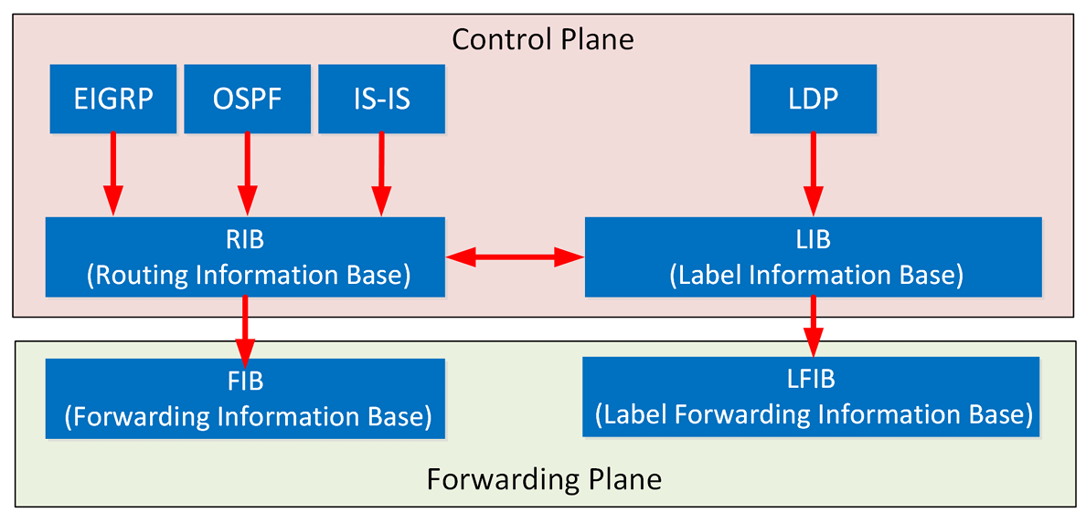  Data Plane: Responsible for forwarding of packets. Does as told by control plane. Add remove labels. MPLS routers inject (push), remove (pop) and forward (swap) based on labels.  MPLS header: 4-byte located before IP header. Contains: MPLS label (20 bit), EXP (3) for QoS, S-bit to allow MPLS router to recognize the last MPLS header before IP header begins, TTL.  Control Plane: Responsible for building tables/routing. Learn labels (LDP).  LDP – Label Distribution Protocol: IP routing builds the IP routing table. Each LSR assigns a label to every destination in the IP routing table. LSR advertises labels for each prefix in the routing table. Each router has its own local labels. Labels need to be advertised to all neighbors. Each MPLS router must choose the best label and outgoing interface to populate the FIB and LFIB. LDP uses multicast via UDP.  -> MPLS Hello messages via UDP |-> establish session with hello-source via TCP  LSP- Label-Switched-Path: predetermined path across MPLS networks  Terminology: PE can be divided into ingress/egress (e.g. used for TTL).  - Customer edge (CE): Doesn’t know about MPLS, doesn’t send labels, directly connected to PE.  - Provider edge (PE): Shares at least one link with a CE. Uses iBGP & LDP. Duty: VRF table.  - Provider (P): No direct link to CE. Forwards labeled packets. iBGP & LDP.  VRF – Virtual Routing & Forwarding: Store routes separately for different customers. Creates separate virtual routers on a physical router. Contains: RIB, separate instance of routing protocol to exchange routes with the CEs. Overlapping IP address spaces of customers each in a different VRF are allowed. 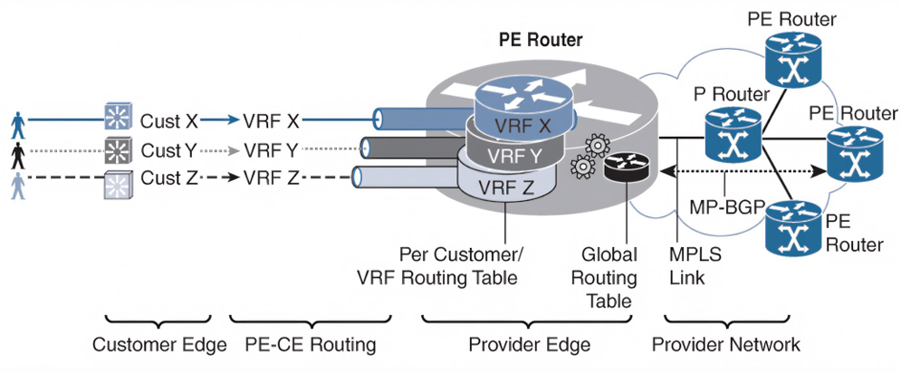  VRF Routing control with MP-BGP RT:  VPNv4 (NLRI): 64-bit route distinguisher, 32-bit IPv4 prefix.  RD: The route distinguisher is an arbitrary value configured inside the VRF on the Provider Edge (PE) router. Unique ID  MPLS L3VPN Control Plane: Separation of customer routing via virtual VPN routing table. In PE router: customer interfaces connected via virtual routing table. Between PE router: customer routes exchanged via BGP using RR.  MPLS L3 Data Plane: VPN packets have 2 headers.  - Outer label: Transport label, learned through LDP, identifies segments of LSP between ingress/egress PE. Transport label will be popped in MPLS domain at P router via PHP.  - Inner Label: VPN (VRF) learned over MP-BGP. Service label will be popped in MPLS domain at PE router without PHP.  Penultimate Hop Popping – PHP: Second-to-last route removes MPLS label, to decrease workload on egress, enabled by default. Without PHP, there will be a double lookup, which is not an optimal way of forwarding labeled packets.  MPLS TTL: Doesn’t change IP TTL. ISPs disable this, so visibility of MPLS Network is hidden.  MPLS L3 VPN Route Propagation: CE1 advertises Prefix through traditional routing protocol. PE1 injects the prefix into the respective VRF routing table. VPNv4 route is propagated to egress PE2. PE2 strips RD from route and imports the route into the corresponding VRF routing table based on the RT value. | Network Design  Pillars of ND: Scalability, Speed, Availability, Security & Manageability -> each network has its own requirements: balance is key, but availability is most important.  Availability: Mean Time Between Failures (MTBF), Mean Time to Repair (MTTR). -> MTBF/(MTBF+MTTR) = Availability  Reasons for Downtime: Hardware Failure, Human Error, Software Failure & Natural Disaster  Redundancy: More links = increased MTTR (increased convergence time). Adds complexity  Backup Paths: Duplicate devices/links on primary path  Load Balancing: ECMP, Ether-/Port Channel  Hierarchical design: Core-, Distribution-, Access Layers. Easier to manage.  - Core: Backbone, simple/fast, only layer 3, design: scalability, capacity, redundancy.  - Distribution: Full-Mesh, Security Policy/QoS, usually layer 3 (load balance, inter-vlan routing, fast convergence, loop protection), HSRP etc here, terminate layer 2 Design: scalability, small fault domain, redundancy. - Access: Connect end users, high ports, layer two, QoS marking – L2 features: VLAN; STP, IGMP Snooping, DHCP snooping, etc. Collapsed Core: Core & Distribution combined. Limited scalability, but reduced complexity  Access STP: L3 ports do not participate in STP (L2)  Flat Design: Small networks, any-to-any communication such as MPLS or LAN.  Fabric Design: Newer technologies, uses Underlay/Overlay (EVPN, MPLS).  Enterprise Campus: Multiple buildings, one location, multiple LANs.  Access Issues L2: Scalability, Security, STP, Loop  Fixes: STP, FHRP, Security Features  Access Issues L3: No STP, no FHRP, Load Balancing, Convergence  Software Defined Access: Overlay Protocols (VXLNA EVPN), Decoupling L2/L3, Anycast Gateway  Switch Stacking: Stack of switches behave like one virtually.  Virtual Router Redundancy Protocol - VRRP:  - Shared virtual IP, each router has its own MAC  - One master router forwards traffic, others are backups  - Multivendor support  Hot Standby Router Protocol – HSRP (Cisco only):  - Shared virtual IP and MAC  - One active router, others in hot standby  Gateway Load Balancing Protocol – GLBP (Cisco only):  - Like HSRP but supports load balancing  - Shared virtual IP, multiple virtual MACs (group functions as one router)  - Roles:  - AVG: Replies to ARP  - AVF: Forwards packets  First Hop Redundancy Protocol – FHRP:  - Ensure resilient default gateway  - Use fast failover timers to reduce traffic loss during transitions  Data Center: Campus requirements + Agility, Multitenancy, Scalability  TOR: Top of Rack Design, EOR: End of Row Design  North-South Traffic: Between devices in different networks, client-server, enter/leave DC. East-West Traffic: Between devices in the same network, traffic between servers (storage), inside DC.  Three-Tier DC: Same as hierarchical: Access-Aggregation-Core, Problem: East-West traffic over all layers. Designed for North-South traffic (not ideal nowadays).  Leaf Spine Architecture: Two-tier architecture, easy expansion, reduced latency, Load-Balancing through ECMP. No L2 problem, thanks to Fabric (EVPN/VXLAN or similar). Solution for modern workloads. | QoS  QoE: Good Quality of Experience (Network meets the needs of end users).  Bottlenecks: Speed mismatch, packets are queued.  Queue at incoming buffer: cannot be filled up in case of a CPU overload: will drop packets.  Queue at outgoing buffer: filled with packets waiting for transmission.  Route Pinning: Mechanism to keep a flow path fixed for a duration (don’t switch immediately if better path is found, can lead to oscillation)  Performance of the network:  Latency / Delay [ms]:  Delay is the time packets take to travel from source to destination.  - End-to-End Delay: Total time from sender to receiver.  - One-Way Delay: Time from first bit sent to last bit received.  Delay Components:  - Transmission Delay: Time to push packet onto the wire (negligible on fast links).  - Processing Delay: Time for queueing, lookups, etc.  - Propagation Delay: Time for signal to travel over the medium.  Jitter (Delay Variation) [ms]: Difference between highest/lowest delay measured, does not impact TCP-based applications as much as it does UDP-based applications. Throughput: Data that reaches the destination successfully, Packet loss [%], Bandwidth [Gbit/s]: Maximum transferrable data rate. Drops: number of packets to be queued continues to increase until the memory of the device is filled up.  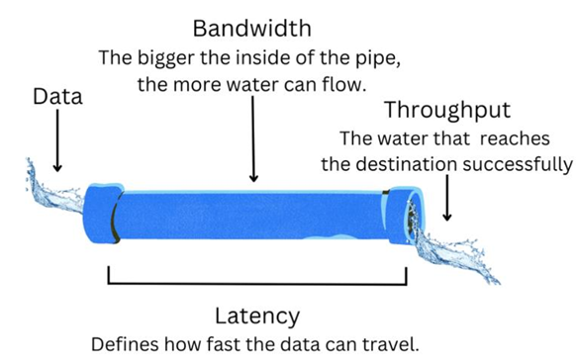  Bursty Traffic Type Pattern: inconsistent traffic levels, sudden short-duration spikes.  Greedy Traffic Type Pattern: source continuously sends data at the maximum possible rate with no regard for network congestions or fairness.  Queuing algorithms:  - First in First Out (FIFO)  - Priority Queuing: Multiple Queues, empties queue before going to the next other queues can starve. Allows prioritization.  Round-robin: Multiple Queues, one packet from each queue in a circle  Weighted round-robin (WFQ): Round-Robin with weight to queue (e.g dispatch 2 packets from queue 1 then dispatch 4 from queue 2 etc.)  Class-Based Weighted fair queuing (CBWFQ): Extends WFQ with user defined classes (customize prio with: max. Bandwidth, queue limit, max. Percentage of Bandwidth).  Low Latency Queuing (LLQ): Adds a priority queue to CBWFQ.  Queue Management:  Tail Dropping: Packet that gets dropped when queue is full, no prio.  TCP global synchronization: When congestions occurs, dropping might affect TCP sessions, which will simultaneously back off and restart again, which causes inefficient link utilization.  TCP starvation: TCP slows down, UDP does not, which suppresses TCP.  Random Early Detection – RED: Randomly drop packet to reduce window size, helps with fairness and bursty traffic. Weighted Random Early Detection (WRED): Selective drops based on priority markings.  Policing: Is applied to inbound traffic. Discard packets in accordance with policy. Shaping: Delay packets to conform to traffic profile.  QoS models:  Best Effort: Follows net neutrality, ISP isn’t allowed to differentiate traffic  Integrated Services (IntServ): Provides guaranteed connection-oriented end-to-end QoS by reserving resources for individual data flows (microflows), offering high precision but poor scalability.  Differential Services (DiffServ): Offers scalable, class-based traffic management without strict guarantees, prioritizing cost-efficiency over precision.  Markings at L3: ToS bit (DSCP & Precedence), Marking at L2: in dot1q  Modular QoS CLI (MQC): Three components of a QoS Policy:  1. Class Map What traffic we care about (define class)  2. Policy Map What will be done to this traffic (define policy)  3. Service Policy Where will this policy be implemented (apply it) | CDN – Content Delivery Network  Components of a CDN: Three main building blocks:  - Origin Server: Original version of content, in a central datacenter  - Edge / Cache or CDN Server (POP): Geographically distributed, holds copies of content, Point-of-Presence. Can be a collection of several servers. Resolved by DNS servers or BGP, allows for load-balancing traffic outside the POP. Requires 1 IP address per POP  - DNS Infrastructure: Helps guide user to appropriate edge  Dedicated load balancer: Expensive, takes long, wasted compute space.  ECMP: Triggers rehash of ECMP group if server number changes. Leads to misrouting. ECMP doesn’t consider server load. Maintain availability: Misrouted packets get encapsulated and forwarded, cache host acts as L4 load balancer.  Benefits of CDN: reduced Latency, throughput, availability, scalability, cost, DDoS, load reduction, TLS Termination at Edge.  Summarized: CDNs help to scale for demand, use Unicast and Anycast. ECMP and packet tunneling for host load balancing.  Overview: POP reports load. Aggregate by DNS Resolver and allocate each DNS Resolver to a POP, send the precomputed table to the DNS fleet.  Request routing: Process to pick an edge server find best one.  DNS-Based Geo-Routing: Most used, DNS is responsible for the distribution of the right IP. Each edge has its own IP. Health, server load and geo estimation can influence the decision process. Typical flow:  1. DNS query is sent to local DNS resolver (ISP).  2. Resolver reaches authoritative DNS of domain.  3. Authoritative DNS estimates geo location of the resolver (not end client) and gets the additional metrics of the edge. sends to resolver  4. Resolver forwards final IP to client and client initiates connection to edge IP.  Anycast with BGP: BGP routing decisions are responsible to send users to the nearest CDN server (nearest doesn’t refer to geo location). CDN operators have little control over traffic distribution and server load doesn’t get accounted for.  Load-Balancing Anycast: In contrast to unicast, you cannot specify in which Edge Location or POP the traffic lands upfront. To ensure that POPs don’t get overloaded, some BGP announcements are withdrawn.  Keep in Mind: Respect connectivity with ASNs  eDNS: extended DNS improves user-to-edge server mapping for better performance and localization. EDNS Client Subnet (ECS) adds part of the client’s IP address to the DNS query, which helps CDN authoritative DNS servers estimate the client’s location more accurately. The CDN can then return the IP of an edge server closer to the issuer, even if the DNS resolver is far away. (Privacy Tradeoff because ECs leaks part of the user’s IP)  Overlay Technologies  SID = Segment Identifier (router), Instruction = Segment  In SR-MPLS labels get replaced with segments, that are distributed over IGP or BGP (no LDP).  Segment List Operations:  - Push: Insert segment to the packet header and set active segment  - Continue: The active segment is not finished and remains active  - Next: The active segment ends, the next SID is activated.  Segment Significance:  Global Segments: All SR-enabled nodes in the SR domain support these instructions. Each node installs the segment in the forwarding table.  Local Segments: Only originating notes support them and write about them into the forwarding table. Other nodes must know about their existence and meaning.  Segment Routing Control Plane Types  - IGP Prefix Segment:  o Global segment, associated with an IGP prefix.  o Usually, a multi-hop path  o Each node installs the forwarding entry for each prefix-SID  - IGP Node Segment  - IGP Anycast Segment  - IGP Adjacency segment  - Layer-2 Adjacency-SID  Why segment routing?  - Simplification: Simpler Ops, remove unnecessary protocols  - Enhanced traffic engineering: Delay, bandwidth etc.  - Seamless deployment: built on usual control plane, reuse data plane  - Robustness: TI-LFA, Micro-Loop avoidance  - Network Innovation: Service function chaining, container networking

